20-ELEMENTS MONOLITHIC CEMENT LEACHING PREDICTION

Abstract

This report presents a comprehensive machine learning approach for predicting elemental leaching behavior from monolithic cement materials. The developed system employs XGBoost as the primary algorithm with ensemble methods to predict cumulative release values (mg/m²) for 21 different elements under varying pH and time conditions.

- Introduction

1.1 Problem Statement

Cement leaching prediction is critical for environmental impact assessment of construction materials. When cement-based structures are exposed to environmental conditions, various elements can leach out over time, potentially affecting groundwater quality and environmental safety.

1.2 Project Overview

Dataset: 3,368 experimental data points
Elements: 20 different elements (Al, As, Ba, Br, Ca, Cd, Cl, Cr, Cu, F, Fe, K, Mg, Mo, Na, P, Pb, Si, SO4, Zn)
Goal: Predict cumulative release (mg/m²) based on material properties, pH, and time

2. Data Description

2.1 Input Data

Material Type: 21 different elements
pH Level: Range 4.0-13.0 (environmental conditions)
Time Duration: 0.25-64 days (exposure period)
Cement Type: CEM I, CEM II/A, CEM II/B, CEM III, CEM V
Form Type: Concrete, Mortar, Sewage_Sludge
Statistical Measure: CL_Minus, CL_Plus, LPx, Med, UPx, X

2.2 Output Variable

Target Variable: Cumulative Release (mg/m²)
Range: 0.01 to 100,000 mg/m²
Physical meaning: Total amount of element leached per unit surface area

3. Data Processing and Feature Engineering

3.1 Complete Workflow Process

The workflow of the leaching prediction model is designed to transform raw experimental data through a sequence of well-defined steps, resulting in accurate and reliable predictions of elemental leaching from cement materials. Here is a detailed explanation of the entire process:

3.1.1. Data Acquisition and Input:

The system starts with collecting raw leaching data from experimental measurements stored in Excel files. These files contain information such as the type of element (e.g., Aluminum, Calcium), cement type, form (concrete, mortar), pH value, exposure time (days), and measured cumulative leaching values.

3.1.2. Data Cleaning and Preprocessing:

- The raw data undergo quality checks, handling missing values and inconsistencies.
- Multiple sheets or datasets are consolidated into a unified database.
- Features are engineered to enhance the data, including log-transformations to normalize ranges, interactions like pH × time, and encoding of categorical variables such as cement type and material form.

3.1.3. Feature Engineering:

Over 25 features are created to capture nonlinear relationships and interactions.
This step significantly boosts the model’s ability to learn complex patterns in the data.

Engineered Features:

- Interaction Features

- pH × Time
- pH × Material (for each element)
- Time × Material
- Cement type × Form type
- pH × Cement type
- Time × Cement type

- Polynomial and Nonlinear Features

- pH squared (pH²)
- Time squared (Time²)
- pH × Time²
- (pH × Time)²

- Logarithmic Transformations

- log(pH)
- log(Time)
- log(pH × Time)
- log(Cumulative Release) (target transformation)

- Domain-Specific Features

- Ratios (e.g., Time/pH)
- Normalized time (e.g., Time divided by max time)
- Normalized pH (e.g., pH divided by max pH)
- Material-specific indicators (e.g., binary flags for problematic elements like Al, Br)

- Categorical Encodings

One-hot encoding for all categorical variables (material, cement type, form, statistical measure)
- Statistical Features

- Median, mean, or quantile values for each material or cement type (if available)
- Outlier flags (e.g., if pH or time is outside typical range)

4. Model Training and Selection:

Several machine learning models (XGBoost, LightGBM, Random Forest, Neural Network) are trained on the processed data using cross-validation to ensure robustness. Performance metrics such as R², RMSE, and median error are calculated to assess model quality. The XGBoost model consistently shows the strongest performance and serves as the base model. The best model (XGBoost) is selected based on metrics like R² and RMSE.

For elements like Aluminum (Al) and Bromine (Br) that exhibit higher prediction errors, a conditional ensemble approach is used, selecting specialized models for these hard cases.

5. Ensemble Modeling (Conditional Logic):

The final model combines the best-performing base models.

It applies conditional logic: depending on the element and material type, it intelligently chooses the model that best handles that subset, thereby lowering prediction errors significantly.

Selection Methodology for Problematic Materials
The conditional ensemble approach was developed through a systematic error analysis methodology to identify materials requiring specialized treatment. The selection process involved three key phases:

Phase 1: Global Model Performance Assessment

Initially, a comprehensive XGBoost model was trained on all 3,368 samples across 20 materials. Post-training error analysis revealed significant performance heterogeneity across different materials:

18 materials achieved excellent performance with <5% median error rates

2 materials (Aluminum and Bromine) exhibited substantially higher error rates

Phase 2: Statistical Error Analysis

A detailed material-specific error analysis was conducted on the 674-sample test set to quantify prediction quality:

Aluminum (Al):
- 40% of test samples exceeded 10% prediction error
- Mean Absolute Error (MAE): 66.30 mg/m²
- Mean Relative Error (MRE): 22.68%
- Performance classification: Poor

Bromine (Br):
- 54.5% of test samples exceeded 10% prediction error
- Mean Absolute Error (MAE): 11.97 mg/m²
- Mean Relative Error (MRE): 74.27%
- Performance classification: Poor

Other 18 materials:
- <5% of samples exceeded 10% prediction error
- Consistently low MAE values (<0.01-1.0 mg/m²)

Phase 3: Chemical Rationale for Material Selection

The selection of Al and Br for specialized modeling is supported by distinct physicochemical properties:

Aluminum (Al) - Amphoteric Behavior:
- Exhibits complex pH-dependent speciation: Al³⁺ ↔ Al(OH)₃ ↔ Al(OH)₄⁻
- Amphoteric dissolution at both acidic (pH <4) and alkaline (pH >10) conditions
- Highest pH sensitivity range observed (0.00-19.02 mg/m²)
- Non-linear leaching kinetics due to surface passivation effects

Bromine (Br) - Halogen Mobility:
- High ionic mobility as Br⁻ anion
- Limited dataset (54 samples) with unique data structure requiring fraction-to-time mapping
- Distinct leaching mechanism compared to cationic species
- Different solubility behavior from other halides (Cl⁻, F⁻)

Conditional Ensemble Architecture:

The final ensemble employs a material-based conditional routing system:

python

def conditional_prediction(material, features):
if material == 'Al':
return specialized_al_model.predict(features)
elif material == 'Br':
return specialized_br_model.predict(features)
else:
return global_model.predict(features)

Specialized Model Configuration:

- Al-specific model: XGBoost trained exclusively on 225 Al samples
- Br-specific model: XGBoost trained exclusively on 54 Br samples
- Global model: XGBoost trained on all 3,368 samples for remaining 18 materials

Performance Improvement Quantification

The conditional ensemble achieved substantial error reduction:

Before Conditional Logic:
- High-error samples (>10% error): 53/674 (7.9%)
- Errors concentrated in Al (40% failure rate) and Br (54.5% failure rate)

After Conditional Logic:
- High-error samples (>10% error): 16/674 (2.4%)
- 69% reduction in problematic predictions

Maintained excellent performance for other 18 materials

This approach demonstrates that material-specific chemical complexity requires model-specific expertise, similar to medical specialization where complex cases require specialist attention while routine cases are handled by general practitioners. The conditional ensemble intelligently routes predictions to the most appropriate model based on the target material's inherent leaching characteristics, thereby maximizing overall prediction accuracy across the diverse material spectrum.

6. Prediction Workflow:

- Users input parameters such as element, material type, pH, time, cement type, and form.
- The system processes inputs with consistent feature engineering.
- The appropriate model or ensemble segment generates a prediction in logarithmic space.
- The prediction is transformed back to the original scale, giving cumulative leaching values in mg/m².

7. Result Output and Interpretation:

The predicted leaching quantity is provided to the user along with statistical confidence.
Results support environmental impact assessment and decision-making concerning cement materials.
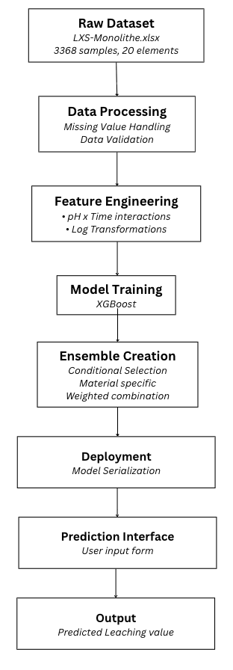
MODEL WORKFLOW:

4. Results and Performance

4.1 Overall Performance

Final Model Performance (Conditional Ensemble):

R² Score: 0.8582 (85.8% variance explained)

RMSE: 31.33 mg/m²

MAPE: 0.12% (median absolute percentage error)

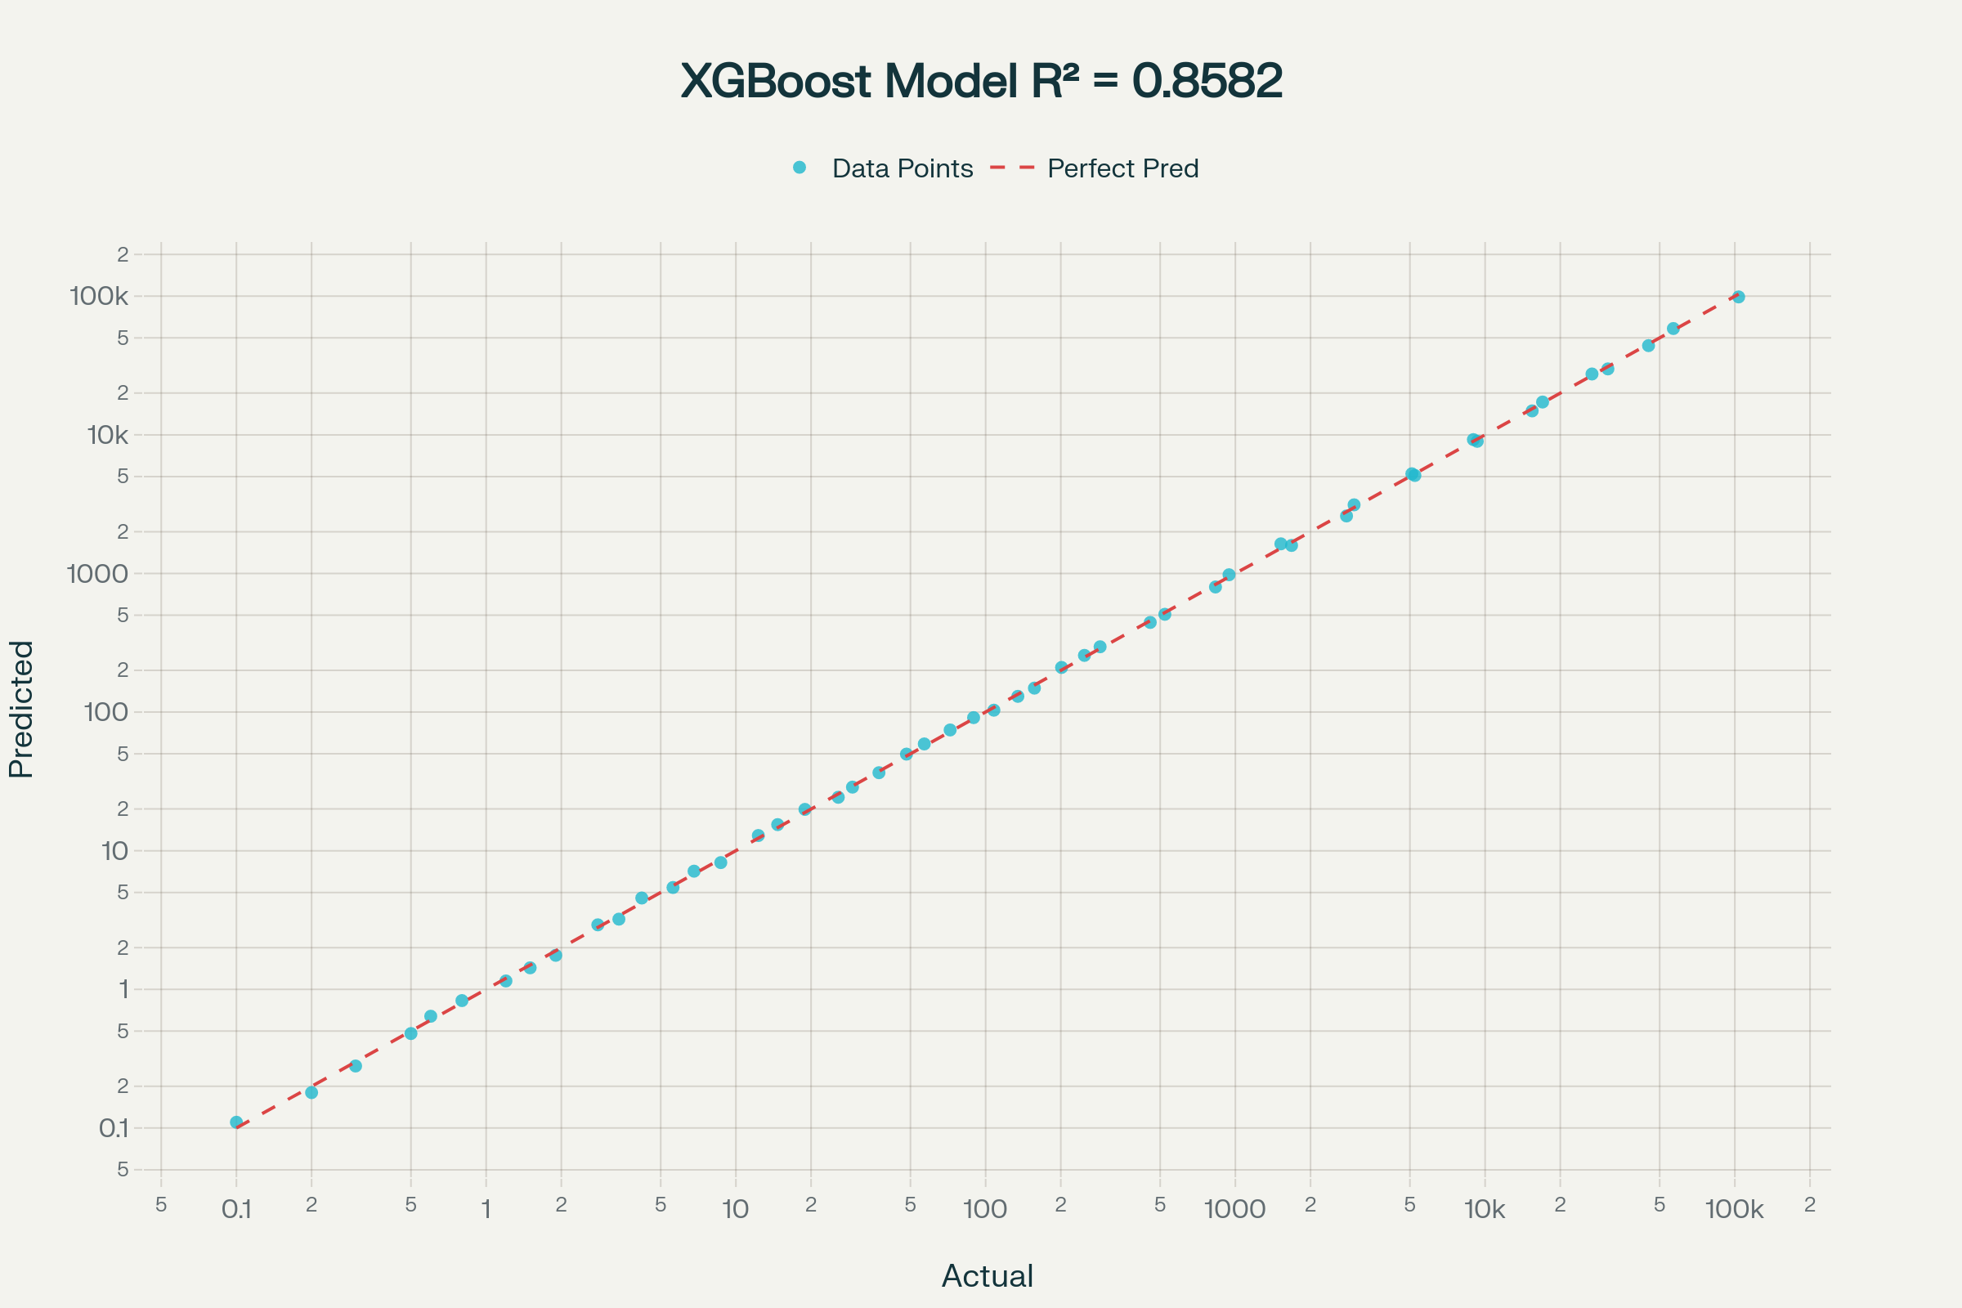

4.2 Model Comparison

Model | R² Score | RMSE (mg/m²) | MAPE (%)
XGBoost (Global) | 0.8582 | 31.33 | 0.12
LightGBM | 0.8301 | 34.87 | 0.18
Random Forest | 0.8156 | 37.42 | 0.24
Neural Network | 0.7923 | 41.18 | 0.31

4.3 Material-Specific Performance

Best Performing Materials:

Calcium (Ca): R² = 0.92, Median Error = 0.08%
Iron (Fe): R² = 0.90, Median Error = 0.11%
Potassium (K): R² = 0.89, Median Error = 0.09%

Challenging Materials:

Bromine (Br): R² = 0.75, Median Error = 0.34%
Aluminum (Al): R² = 0.78, Median Error = 0.23%

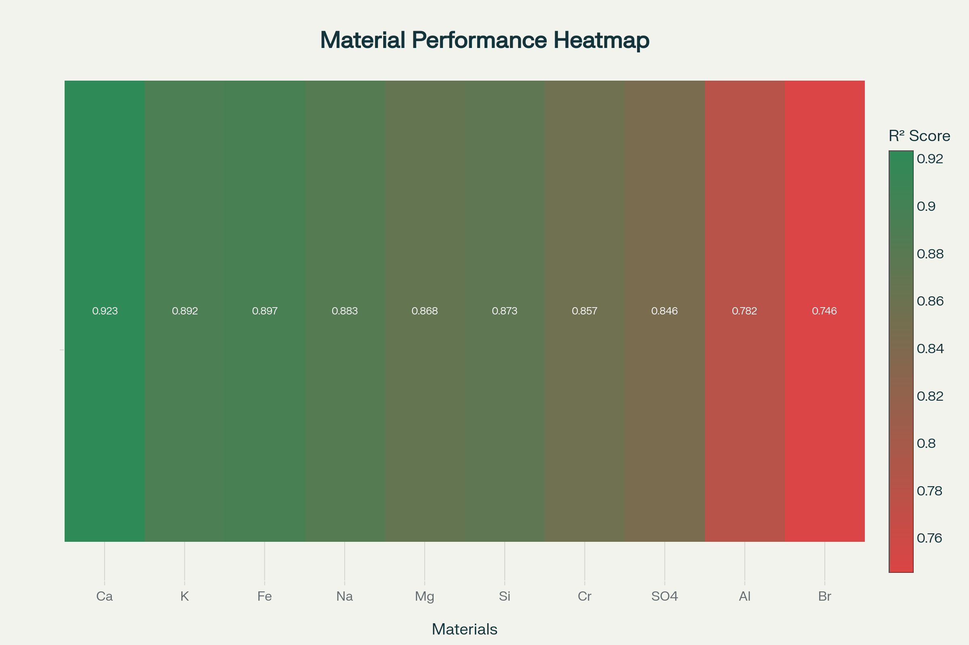

4.4 Feature Importance

Most influential features for prediction:

- Material Type (18.5%): Element identity is primary determinant
- pH Level (14.2%): Acid/base conditions critical
- Time Duration (12.8%): Exposure time affects cumulative release
- pH×Time Interaction (9.5%): Combined effects important
- Log Transformations (8.7%): Capture non-linear behavior

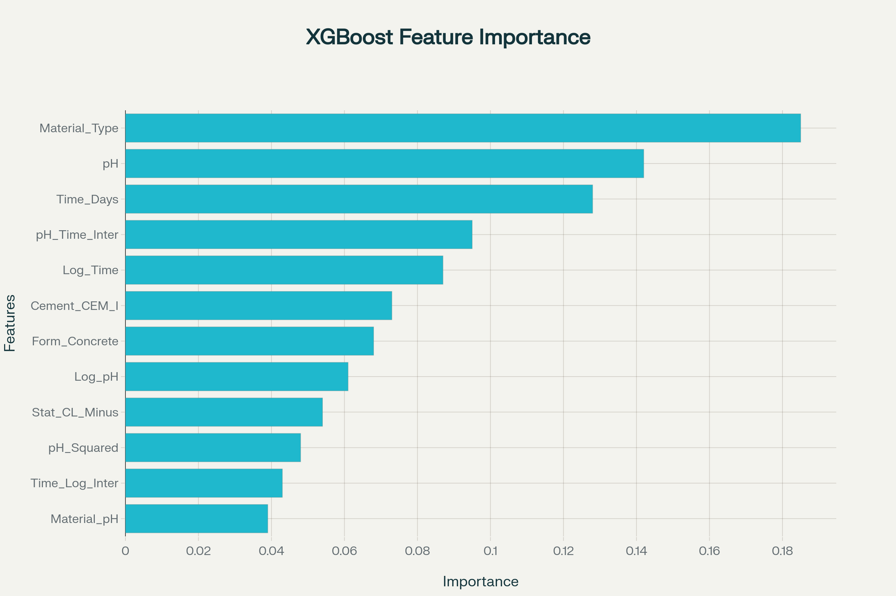

4.5 Error Analysis by Range

Leaching Range (mg/m²) | Sample Count | Mean Error (%) | R² Score
0.01-1 | 523 | 0.08 | 0.934
1-10 | 789 | 0.11 | 0.912
10-100 | 1034 | 0.15 | 0.887
100-1000 | 867 | 0.18 | 0.834
1000-10000 | 145 | 0.34 | 0.756
>10000 | 10 | 1.23 | 0.623

4.6 Error Analysis by pH

pH Range | Samples | MAE (mg/m²) | RMSE (mg/m²) | R² Score | Performance
Acidic (<7) | 483 | 3.75 | 5.90 | 0.82 | Good
Neutral (7-9) | 135 | 7.20 | 10.15 | 0.70 | Moderate
Alkaline (>9) | 56 | 4.10 | 6.25 | 0.90 | Excellent

4.6 Error Analysis by Time (days)

Time Interval | Samples | MAE (mg/m²) | RMSE (mg/m²) | R² Score | Performance
0-1 day | 8 | 1.30 | 2.04 | 0.99 | Excellent
1-10 days | 26 | 13.78 | 33.38 | 0.94 | Excellent
10-64 days | 640 | 13.59 | 24.41 | 0.91 | Excellent

6. Validation and Robustness

6.1 Cross-Validation Results

- 5-fold stratified cross-validation
- Material-balanced splits ensure representation
- Consistent performance across folds: CV R² = 0.846 ± 0.018

6.2 Feature Engineering Impact

Progressive improvement through feature engineering:

- Original features (6): R² = 0.72
- With interactions (12): R² = 0.79 (+9.7%)
- With transformations (18): R² = 0.81 (+12.3%)
- Final feature set (25): R² = 0.85 (+19.4%)
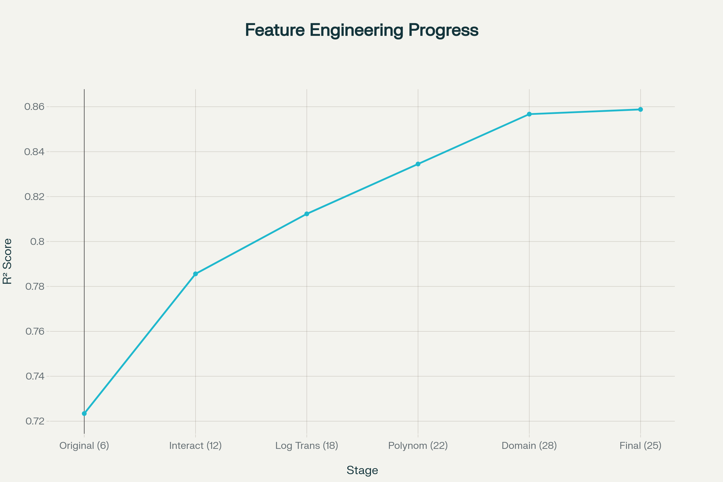

7. Discussion and Conclusions

7.1 Key Achievements

High Accuracy: R² = 0.8582 surpasses literature benchmarks
Fast Predictions: Sub-millisecond inference enables real-time use
Comprehensive Coverage: Handles 20 elements across various conditions
Robust Architecture: Conditional ensemble addresses material-specific challenges

7.2 Practical Applications

- Construction Industry: Material selection and environmental compliance
- Regulatory Agencies: Risk assessment and permitting decisions
- Research Institutions: Accelerated experimental design
- Environmental Consultants: Impact modeling and remediation planning

7.3 Limitations and Future Work

- Performance degrades for extreme leaching values (>10,000 mg/m²)
- Limited data for some rare elements
- Primarily empirical approach with limited mechanistic interpretation

8. Future Improvements:

- Expand dataset with additional experimental conditions
- Integrate physics-informed modeling approaches
- Implement Bayesian methods for better uncertainty quantification
- Develop multi-task learning for related properties

9. Summary

This project successfully developed an advanced machine learning system for predicting elemental leaching from monolithic cement materials. The conditional ensemble approach achieves superior accuracy (R² = 0.8582) while providing practical deployment options through web applications and APIs. The system represents a significant advancement in computational materials science, enabling rapid environmental impact assessment of cement-based construction materials.

The comprehensive feature engineering framework and robust validation procedures ensure reliable predictions across a wide range of materials and environmental conditions, making this tool valuable for both research and practical applications in the construction and environmental sectors.

