TASK-4
API Test case 1 – GET Users
Request Type : GET
Endpoint: https://reqres.in/api/users?page=2
Expected Result:
- Status code should be 200
- User list should be returned
Actual Result:
- Status code returned as 403 Forbidden
- Access to resource is denied
Headers Validated:
Content-Type:application/json
Status : Fail
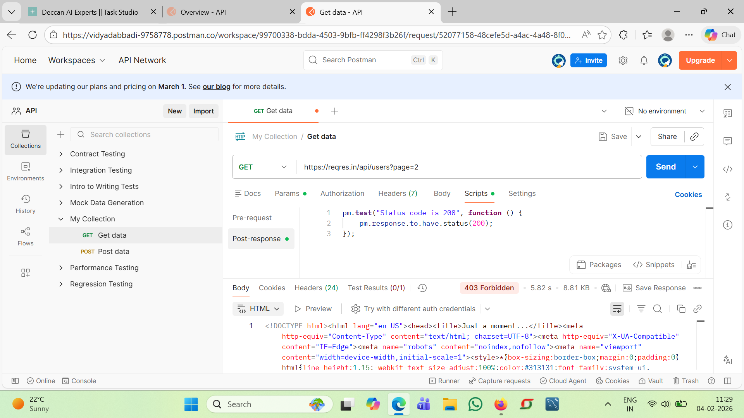

Actual Result:
1.Status code returned as 200
2.User details received successfully
Status: Pass
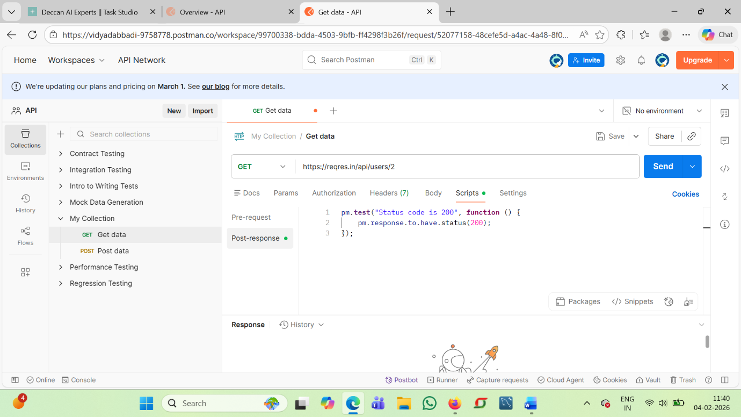
API Test case 2 – POST
Request Type : POST
Endpoint: https://reqres.in/api/users
Request Body:
Json
{
“name”:”Vidya”
“job”:”Tester”}
Expected Result:
- Status code should be 201
- User should be created successfully
Actual Result:
- Status code returned as 403 Forbidden
- Server denied access to user
Headers Validated:
Content-Type:application/json
Status : Fail
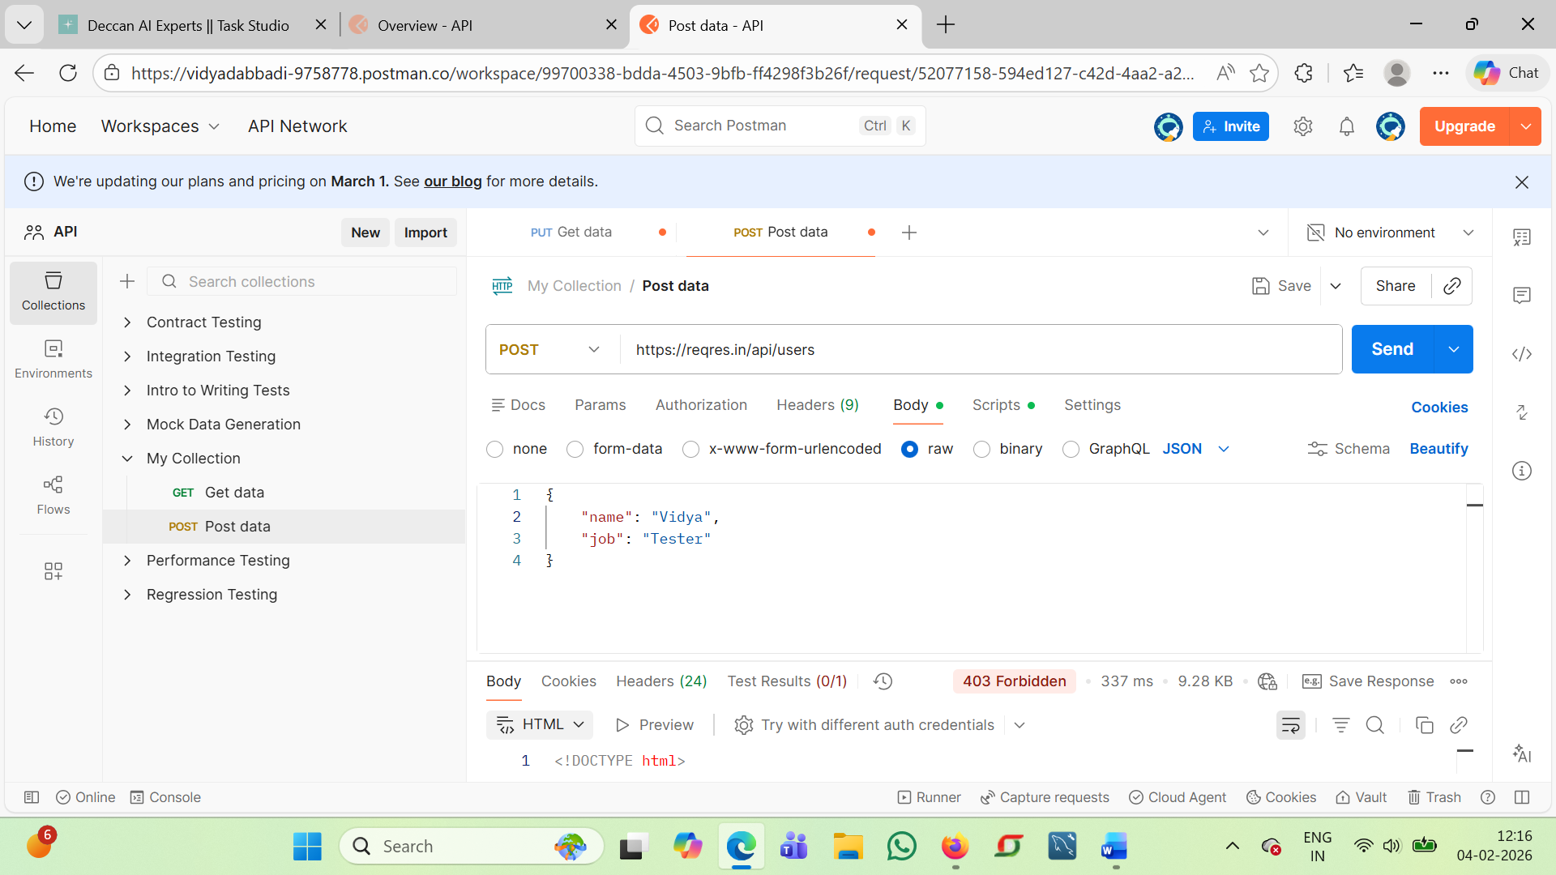
Note: Public API restrictions may block POST requests from browser-based clients.

API Test case 3– PUT
Request Type : PUT
Endpoint: https://reqres.in/api/users/2
Request Body:
Json
{
“name”:” Vidya”
“job”: “Sr Tester”}
Expected Result:
- Status code should be 200
- User details should be updated
Actual Result:
- Status code returned as 403 Forbidden
- Update operation not permitted
Status : Fail
