Tasks
Objective Questions:

- What is the total no. of tables present in the data?
- There are total 18 tables present in the data.
- What is the total no. of attributes present in the data?
- There are total 24 attributes present in the Main Data Table
- Restaurant ID
- Restaurant Name
- Country Code
- City
- Address
- Locality
- Locality Verbose
- Longitude
- Latitude
- Cuisines
- Currency
- Has table booking.
- Has online delivery
- Is delivering now.
- Switch to order menu.
- Price range
- Votes
- Average cost for two
- Rating
- Date key opening.
- Year Opening.
- Currency abbreviation.
- Avg. currency cost for two
- Conversion rate
- Average cost for two.
- Total cost of two in INR.

- How many categorical columns are there in the data? [Search about categorical and continuous data, and try to answer this question]
- There are 10 categorical columns in the Main Data Table
- Country Code
- City
- Cuisines
- Currency
- Has table booking
- Has online delivery
- Is delivering now
- Switch to order menu
- Date key opening
- Country
- There are 3 continuous data
- Price range
- Votes
- Rating

- The data consists of some inconsistent and missing values so that the data used for further analysis is cleaned.
During the data cleaning process, the following steps were followed:
- First highlighted all the column's name and their values and use the sort and filter options in Home tab searched for empty values in the search option then removed those empty cells from the sheet.
- After that, the sheet was checked for duplicate values, and unnecessary data was removed or cleared.
- Later, the Date column was changed according to the format needed. In which the format was changed to DD-MM-YYYY.
- Currency column was changed using text-to-columns.
- Currency abbreviation column was created and abbreviation for currency was mentioned using the right string function.
- The Avg-cost-for-two column was created and updated where its cost column and abbreviation column were concatenated.
- Year opening colum was added and year value was selected using the right string function from the Datekey-opening column.
- Total Cost of two in INR column was created and the curriencies were converted to INR as twice the Avg cost of two.

- Using the Lookup functions, fill up the countries in the original data using the country code.
- =VLOOKUP ($C2,'country description'!$A$2:$B$16,2,0)

- Create a table to represent the number of restaurants opened in each country.
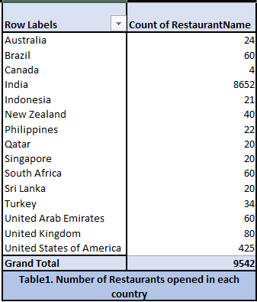
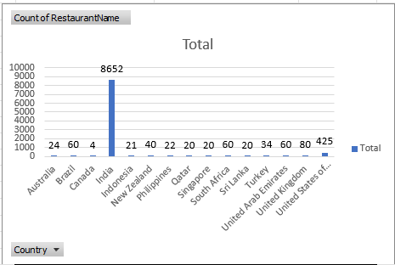
(Spreadsheet: Objective Analysis)

- Also, the management wants to look at the number of restaurants opened each year, so provide them with something here.
Count of RestaurantName | Column Labels
Row Labels | Australia | Canada | Indonesia | Qatar | South Africa | Grand Total
2010 | 4 |  | 1 | 4 | 4 | 13
2011 | 1 | 1 | 5 | 1 | 4 | 12
2012 | 3 |  |  | 2 | 7 | 12
2013 | 6 | 1 | 1 | 4 | 8 | 20
2014 |  |  | 4 | 2 | 5 | 11
2015 | 4 | 1 | 3 | 2 | 7 | 17
2016 | 2 |  | 1 | 4 | 10 | 17
2017 | 1 | 1 | 1 |  | 9 | 12
2018 | 3 |  | 5 | 1 | 6 | 15
Grand Total | 24 | 4 | 21 | 20 | 60 | 129

(Spreadsheet: Objective Analysis)

- What is the total number of restaurants in India in the price range of 4?
Price-range | 4
Row Labels | Count of RestaurantName
India | 388
Grand Total | 388
Table3. Total number of restaurants in India in the price range of 4

(Spreadsheet: Objective Analysis)

- What is the average number of voters for the restaurants in each country according to the data?
Row Labels | Average of Votes
Australia | 111.4166667
Brazil | 19.61666667
Canada | 103
India | 137.212552
Indonesia | 772.0952381
New Zealand | 243.025
Philippines | 407.4090909
Qatar | 163.8
Singapore | 31.9
South Africa | 315.1666667
Sri Lanka | 146.45
Turkey | 431.4705882
United Arab Emirates | 493.5166667
United Kingdom | 205.4875
United States of America | 430.8752941
Grand Total | 156.7720604

(Spreadsheet: Objective Analysis)

- Calculate the average rating for all the restaurants that have price_range < 4 and provide online delivery. Use only the “IF” function, Logical Operators, and Aggregation functions to solve this problem. [Note: Don’t use Conditional aggregation in this question.]
The Average rating for all restaurants that have prince range < 4 and provides online delivery | 3.151147541

Formula: =AVERAGEIFS('Updated Raw Data'!$T:$T,'Updated Raw Data'!$T:$T,"<4",'Updated Raw Data'!$N:$N,"Yes")

- Using Conditional formatting highlight the rows of restaurants that are located in the countries or cities that you’ve suggested to the management for opening new restaurants.

(Spreadsheet: Suggested Countries Analysis)
Row Labels | Count of RestaurantName | Average of Rating
Australia | 24 | 3.658333333
Armidale | 1 | 3.5
Balingup | 1 | 3.2
Beechworth | 1 | 4.6
Dicky Beach | 1 | 3.6
East Ballina | 1 | 4.1
Flaxton | 1 | 3.5
Forrest | 1 | 3.7
Hepburn Springs | 2 | 3.8
Huskisson | 1 | 4.1
Inverloch | 1 | 3.7
Lakes Entrance | 1 | 3.8
Lorn | 1 | 3.6
Macedon | 1 | 3.5
Mayfield | 1 | 2.9
Middleton Beach | 1 | 3.8
Montville | 1 | 2.4
Palm Cove | 1 | 4.4
Paynesville | 1 | 2.6
Penola | 1 | 3.4
Phillip Island | 1 | 3.7
Tanunda | 1 | 4.4
Trentham East | 1 | 4.1
Victor Harbor | 1 | 3.6
Canada | 4 | 3.575
Chatham-Kent | 1 | 3.7
Consort | 1 | 3
Vineland Station | 1 | 4.3
Yorkton | 1 | 3.3
Indonesia | 21 | 4.295238095
Bandung | 1 | 4.2
Bogor | 2 | 3.85
Jakarta | 16 | 4.35625
Tangerang | 2 | 4.3
Qatar | 20 | 4.06
Doha | 20 | 4.06
Sri Lanka | 20 | 3.87
Colombo | 20 | 3.87
Grand Total | 89 | 3.942696629

- Highlighted cities are the places where suggestions are given to the management to open new restaurants using conditional formatting.
Row Labels | Average of Rating | Count of City
Australia | 3.658333333 | 24
1918 Bistro & Grill | 4.4 | 1
5 Little Pigs | 4.1 | 1
Anchorage Cafe Restaurant Wine Bar | 3.6 | 1
Beach Box Cafe | 3.7 | 1
Bespoke Harvest | 3.7 | 1
Blue Bean Love Cafe | 3.8 | 1
Bridge Road Brewers | 4.6 | 1
DiVine | 3.4 | 1
Flaxton Gardens | 3.5 | 1
Funkey Monkey | 3.8 | 1
La Trattoria of Lavandula | 3.8 | 1
Mad Cowes Cafe | 3.7 | 1
Mr. | 3.5 | 1
Pier 70 | 2.6 | 1
Pig and Whistle | 4.1 | 1
Poets Cafe | 2.4 | 1
Star Buffet | 2.9 | 1
Stillwater on Belmore | 3.6 | 1
Taste of Balingup | 3.2 | 1
The Belle General | 4.1 | 1
The Giggling Goat | 3.6 | 1
Three Anchors | 3.8 | 1
Vivo Bar and Grill | 4.4 | 1
Whitebull Hotel | 3.5 | 1
Canada | 3.575 | 4
Arigato Sushi | 3.3 | 1
Consort Restaurant | 3 | 1
Lake House Restaurant | 4.3 | 1
Tokyo Sushi | 3.7 | 1
Indonesia | 4.295238095 | 21
3 Wise Monkeys | 4.2 | 1
Avec Moi Restaurant and Bar | 4.3 | 1
Fish Streat | 3.7 | 2
Flip Burger | 4.4 | 1
Lemongrass | 4 | 1
Lucky Cat Coffee & Kitchen | 4.3 | 1
Momo Milk | 3.7 | 1
MONKS | 4.2 | 1
Noah's Barn Coffeenery | 4.2 | 1
OJJU | 3.9 | 1
Onokabe | 3.7 | 1
Satoo - Hotel Shangri-La | 4.6 | 1
Skye | 4.1 | 1
Sushi Masa | 4.9 | 1
Talaga Sampireun | 4.9 | 3
Toodz House | 4.6 | 1
Union Deli | 4.6 | 1
Zenbu | 4.4 | 1
Qatar | 4.06 | 20
7st by Mumbai Spices | 3.4 | 1
Aalishan | 3.8 | 1
Applebee's | 3.8 | 1
Coral - InterContinental Doha | 3.7 | 1
Eatopia | 3.9 | 1
Gokul Gujarati Restaurant | 4.3 | 1
Gymkhana | 4.7 | 1
Indian Coffee House | 3.4 | 1
Mainland China Restaurant | 4.9 | 1
MRA Bakery Sweets & Restaurant | 4 | 1
Paper Moon | 4.5 | 1
Ponderosa | 3.6 | 1
Punjab Restaurant | 3.8 | 1
Roti & Boti | 3.9 | 1
Sabai Thai - The Westin Doha Hotel & Spa | 4.3 | 1
Texas Roadhouse | 4 | 1
The Manhattan FISH MARKET | 4 | 1
Vine - The St. Regis | 4.4 | 1
Zaffran Dining Experience | 4.6 | 1
Zaoq | 4.2 | 1
Sri Lanka | 3.87 | 20
Arabian Knights | 4.2 | 1
Burger's King | 4.1 | 1
Butter Boutique | 4.2 | 1
Cafe Beverly | 4.1 | 1
Cafe Shaze | 3.8 | 1
Carnival Ice Cream | 4.1 | 1
Chinese Dragon Cafe | 3.4 | 1
CIOCONAT Lounge | 3.7 | 1
Cricket Club Cafe | 4.2 | 1
Elite Indian Restaurant | 2.4 | 1
Malay Restaurant | 3.5 | 1
Ministry of Crab | 4.9 | 1
Queen's Cafe | 2.5 | 1
Simply Strawberries By Jagro | 4.5 | 1
T.G.I. Friday's | 4 | 1
The Commons | 4 | 1
The Manhattan FISH MARKET | 4 | 1
The Paddington | 3.6 | 1
The Sizzle | 4.2 | 1
Upali's | 4 | 1
Grand Total | 3.942696629 | 89
Table 7. Name of the restaurants in the countries selected with their average ratings.

- During creating Table 7. given above, the Pivot table was created using the pivot table option, and the range was selected from the raw data using the filed list given table was created, in rows country and restaurant names were inserted whereas in columns values were given and in values ratings and city were inserted and an average of ratings was calculated, and count of cities were calculated.

- After that, all the restaurants with ratings 4 and above were selected across all the countries mentioned in the table and were highlighted with green color to distinguish the given selected data.

- Create a new customized price column that consists of the abbreviation/symbol of the currency along with the Average_cost_for_two values. [Use string operations to do this task]
Spreadsheet: ( Updated Raw Data)

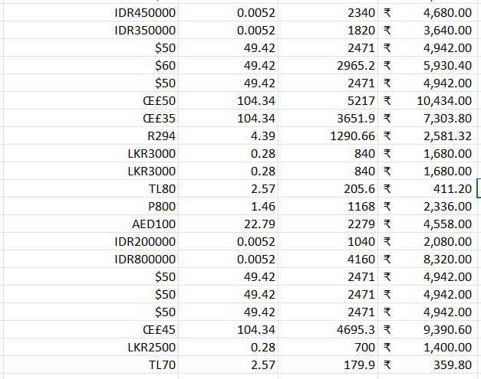

- How can you create an array formula in Excel or Google Sheets to count the number of restaurants listed that do not offer online delivery, are in the lowest price range, and have an average cost for two people less than or equal to 250 Indian Rupees?
- Formula: =COUNTIFS('RAW DATA CLEANED'!$Q:$Q,"1",'RAW DATA CLEANED'!$N:$N,"No",'RAW DATA CLEANED'!$Z:$Z,"<=250")

Subjective Question:

- Suggest a few countries where the team can open newer restaurants with lesser competition. Which visualization/technique will you use here to justify the suggestions?

(Spreadsheet: Suggested Countries)

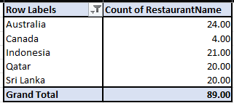

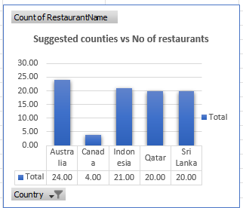
Insights and Recommendations for Restaurant Count in Selected Countries
1. Distribution Analysis
- Australia (24 restaurants): Leads the list, indicating a strong representation in the restaurant sector.
- Canada (4 restaurants): Significantly underrepresented compared to other countries.
- Indonesia (21 restaurants), Qatar (20 restaurants), Sri Lanka (20 restaurants): These countries have a similar number of restaurants, showcasing a balanced presence.

2. Key Observations
- Australia stands out with the highest count, suggesting a higher focus on this market or potentially larger market demand.
- Canada's low count could reflect either lower market penetration, fewer opportunities, or prioritization of other regions.
- The numbers for Indonesia, Qatar, and Sri Lanka are comparable, which might indicate a targeted strategy for these regions.

3. Recommendations
- Canada
  - Opportunity for Expansion: The low count of restaurants suggests untapped potential. Explore market feasibility studies to understand consumer preferences and competition.
  - Localized Offerings: Adapt the menu or dining experience to cater to Canadian preferences to boost appeal.
- Australia
  - Strengthen Market Presence: Since Australia has the highest number, focus on maintaining service quality and exploring untapped cities or niche markets within the country.
  - Leverage Success: Use Australia's success as a model for market expansion strategies in other countries.
- Indonesia, Qatar, Sri Lanka
  - Optimize Operations: Maintain consistent quality and explore opportunities to stand out in competitive markets.
  - Cultural Adaptation: Highlight regional flavors and dining experiences to cater to local preferences.
  - Growth Potential: Assess the feasibility of adding more restaurants in high-demand urban areas or emerging suburban markets.
- General Recommendations
  - Market Research: Conduct in-depth analysis of customer demographics, spending patterns, and competitive landscape in each country.
  - Brand Positioning: Tailor marketing campaigns to reflect cultural nuances and enhance brand affinity.
  - Partnerships and Franchises: Collaborate with local partners to streamline operations and scale efficiently in underrepresented regions.
Prioritization for Growth
- Focus on expanding in Canada and leveraging the strong foothold in Australia.
- Evaluate regional demands in Indonesia, Qatar, and Sri Lanka for targeted growth opportunities.

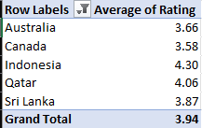

1. Country-specific Observations
- Indonesia (4.30): Stands out with the highest average rating, reflecting strong customer satisfaction and effective operations.
- Qatar (4.06): Exceeds the global average, suggesting good performance but with some potential for further improvement.
- Sri Lanka (3.87): Close to the global average but slightly under the ideal 4.0 benchmark.
- Australia (3.66) and Canada (3.58): Lagging other countries, these scores indicate relatively lower customer satisfaction. Australia is slightly ahead of Canada, but both require significant focus.

Recommendations

1. Leverage Strength in Indonesia and Qatar:
- Maintain Quality Standards: Focus on service quality and customer experience to sustain high ratings.
- Replicate Success Strategies: Analyse what works well in these countries (e.g., popular dishes, pricing strategies) and apply similar principles in underperforming markets.

- Continuous Monitoring:
- Use analytics tools to track rating trends over time, both globally and regionally.
- Focus on real-time issue resolution to prevent small issues from impacting ratings significantly.

- Come up with the names of States and cities in the suggested countries suitable for opening restaurants.

Australia:
        - Beechworth - 4.6
        - East Ballina – 4.1
        - Huskisson – 4.1
        - Palm cove – 4.4
        - Tanunda – 4.4
        - Trentham East – 4.1
Insights:
- Beechworth (4.6): High rating; indicates potential for strong customer satisfaction and a thriving market.
- Palm Cove (4.4) and Tanunda (4.4): Excellent ratings; suggests these locations are attractive tourist or lifestyle areas with high demand for quality dining.
- East Ballina, Huskisson, Trentham East (4.1): Reasonable ratings; these locations might have niche markets or growth potential.

Recommendations:
- Prioritize Beechworth, which shows the highest rating, indicating strong market viability.
- Expand into Palm Cove and Tanunda for their high ratings and likely tourist appeal.
- Approach East Ballina, Huskisson, and Trentham East to conduct market research to identify specific opportunities.

Canada:
- Vineland station -4.3
Insights:
- Vineland Station (4.3): Above-average rating; suggests this area has demand for restaurants with quality offerings.
Recommendations:
- Consider opening a restaurant in Vineland Station focusing on local tastes and premium service to leverage its strong rating and potential for a niche market.

Indonesia:
        - Banding – 4.2
        - Jakarta – 4.35625
        - Tangerang – 4.3
Insights:
- Jakarta (4.35625): Strong rating, likely driven by urban density and diverse customer base.
- Tangerang (4.3): Another good rating; proximity to Jakarta suggests potential spillover benefits.
- Bandung (4.2): Moderate rating; could be a secondary location with local charm and tourist appeal.
Recommendations:
- Jakarta should be the primary target, as its strong rating and metropolitan nature provide the most robust opportunities.
- Consider Tangerang as a complementary market due to its proximity and solid rating.
- Use Bandung as a third option, potentially targeting a more relaxed, tourism-driven demographic.

Qatar:
- Doha – 4.06
Insights:
- Doha (4.06): Slightly above average; being the capital, it offers significant urban and expatriate dining markets.
Recommendations:
- Focus on a premium or specialized dining experience in Doha to differentiate from existing competition and cater to the urban, affluent market.

Sri Lanka:
- Colombo – 3.87
Insights:
- Colombo (3.87): Below-average rating; competition or market challenges could exist.
Recommendations:
- Conduct thorough market research before investing in Colombo. Explore unique culinary themes or underserved niches to attract attention and build a competitive edge.

High Priority Locations:
- Beechworth (Australia), Jakarta (Indonesia), Palm Cove (Australia).
Secondary Targets:
- Vineland Station (Canada), Tanunda (Australia), Tangerang (Indonesia).
Cautious Entry:
- Doha (Qatar), Colombo (Sri Lanka), and smaller Australian towns with ratings of 4.1.

- According to the countries you suggested, what is the current quality regarding ratings for restaurants that are open there?

Row Labels | Count of RestaurantName | Average of Rating
Australia | 24 | 3.658333333
Canada | 4 | 3.575
Indonesia | 21 | 4.295238095
Qatar | 20 | 4.06
Sri Lanka | 20 | 3.87
Grand Total | 89 | 3.942696629
- Based on the table above the quality of the restaurants in the suggested countries based on their ratings are as follows:
- Australia has a rating of average of 3.658 which compared to other suggested countries ranks 4th for its quality which can be improved.
- Canada has ratings of an average of 3.575 which has the lowest quality as per the ratings which has lots to improve in the future.
- Indonesia has a rating of an average of 4.295, the highest of all the countries selected for opening new restaurants and has the best quality.
- Qatar has a rating of average 4.06, the second best among the restaurants selected as an outstanding quality.
- Sri Lanka has a rating of an average of 3.87, the third best of all the restaurants selected.
- It is recommended that restaurants to opened in Indonesia as it has the best ratings for overall restaurants on average.

- Also, what is the current expenditure on food in the suggested countries, so we can keep our financial expenditure in control?

(Spreadsheet: Suggested Countries)

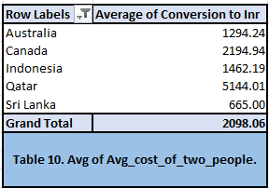

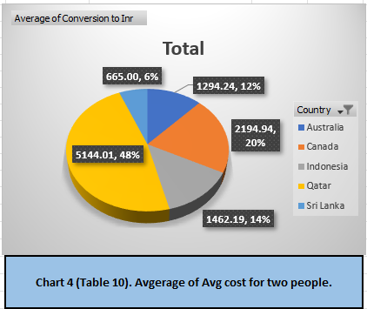

- While comparing the chart, the given data says that the average cost for two people is the highest in Qatar and lowest in Sri Lanka.
- It would be recommended to control expenditure if countries like Sri Lanka are targeted. Less money would be invested in opening new restaurants as maintenance costs would be less, followed by countries like Australia, Canada, and Qatar.

- Come up with the names of restaurants from the recommended states that are our biggest competitors and those rated in the lower brackets, i.e. 1-2 or 2-3.

(Spreadsheet: Competitor Analysis)

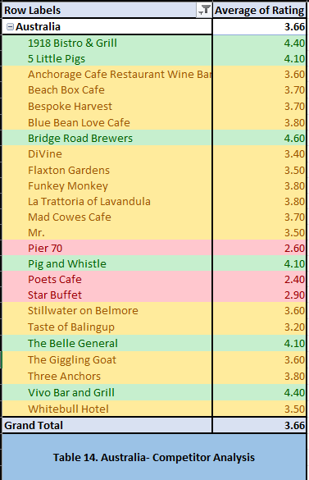

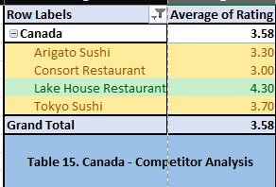

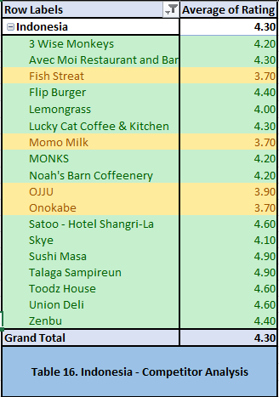

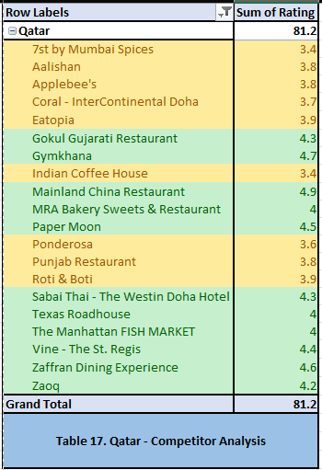

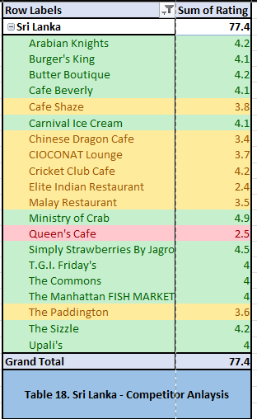

- During analysis, it could be seen that Indonesia has a higher number of restaurants with ratings > 4, Thus it is recommended that Indonesia is a better country to open new restaurants.
- Whereas the tables for all selected countries show that the restaurants with green colour grading have ratings > 4 and are very good recommendations for the customers, restaurants having orange colour grading have ratings between 4 and 3 and red colour states restaurants having ratings less than 3.

- Which cuisines should we focus on in the newer restaurants to get better feedback? Does the choice of cuisines affect the restaurant ratings?

Row Labels | Average of Rating
Australia | 3.658333333
Asian | 2.9
Australian | 4.1
Bar Food, Modern Australian | 3.8
Bar Food, Steak | 3.5
Breakfast, Coffee and Tea | 3.7
Breakfast, Coffee and Tea, Modern Australian | 3.7
Breakfast, Modern Australian | 4.1
Burger, Coffee and Tea, Modern Australian | 3.7
Cafe | 3.8
Cafe, Australian | 3.7
Cafe, Coffee and Tea, Modern Australian | 3.8
Cafe, Coffee and Tea, Sandwich | 3.4
Coffee and Tea, Modern Australian | 2.4
Coffee and Tea, Tapas, Australian | 3.6
Coffee and Tea, Tea, Modern Australian | 3.6
Italian, Fusion, Cafe | 3.8
Mediterranean, Seafood | 4.4
Modern Australian | 2.9
Modern Australian, Australian | 4.4
Pizza, Bar Food | 4.6
Tea, Modern Australian | 3.5
Canada | 3.575
Asian | 3.3
Chinese, Canadian | 3
Italian, Mediterranean, Pizza | 4.3
Japanese, Sushi | 3.7
Indonesia | 4.295238095
Asian, Indonesian, Western | 4.6
Burger | 4.4
Cafe, Coffee and Tea, Western | 4.2
Cafe, Desserts, Beverages | 3.7
Cafe, Italian, Coffee and Tea, Western, Indonesian | 4.6
Cafe, Western | 4.3
Desserts, Bakery, Western | 4.6
French, Western | 4.3
Indonesian | 3.7
Italian, Continental | 4.1
Japanese | 4.2
Japanese, Sushi, Ramen | 4.4
Korean | 3.9
Peranakan, Indonesian | 4
Seafood, Western | 3.7
Sunda, Indonesian | 4.9
Sushi, Japanese | 4.9
Western, Asian, Cafe | 4.2
Qatar | 4.06
American, Tex-Mex | 3.8
Chinese | 4.9
European, Arabian, Japanese, Bakery, Desserts | 3.9
Indian | 4.18
Indian, Street Food | 3.4
International | 4.05
Italian | 4.5
Kerala, Indian, Chinese, Bakery | 4
North Indian, Chinese, Turkish | 3.8
Pakistani | 4
Seafood, American | 4
Steak | 3.6
Steak, American | 4
Thai | 4.3
Sri Lanka | 3.87
American, Chinese, North Indian | 2.5
American, Fast Food, Steak, Beverages | 4.2
American, Steak | 4
Cafe, Fast Food, Beverages | 3.8
Cafe, Italian | 3.6
Cafe, Sri Lankan, Continental, American | 4
Chinese | 3.4
Continental, American | 4.1
Continental, American, Seafood | 4.2
Desserts, Bakery | 4.2
Desserts, Ice Cream | 4.1
Fast Food | 4.1
Italian, Cafe, Desserts | 3.7
Juices, Desserts | 4.5
Malaysian, North Indian, Sri Lankan | 3.5
Middle Eastern, Arabian | 4.2
North Indian, Chinese, Sri Lankan | 2.4
Seafood | 4.9
Seafood, Italian | 4
Sri Lankan | 4
Grand Total | 3.942696629
Table 13. Avg Rating for the cusinies in selected Countries

(Spreadsheet: Cuisines Analysis)

Insights
- High Ratings for Australian Cuisines
  - Australia-focused cuisines consistently receive high ratings, such as Australian (4.1), Modern Australian (3.2–4.4), and Breakfast, Modern Australian (4.1).
  - Pizza, Bar Food (4.6) is a standout under Australian cuisine themes.
2.Impact of Fusion Combinations
- Fusion cuisines like Italian, Mediterranean, Pizza (4.3) and Cafe, Italian, Coffee and Tea, Western, Indonesian (4.6) indicate strong performance when blending familiar and local preferences.
- However, overly complex combinations like Modern Australian, Coffee and Tea (2.4) tend to receive lower ratings.

Recommendations
- Focus on High-Performing Cuisines
  - Prioritize Indonesian, Chinese, Indian, and Italian cuisines in new restaurants.
  - Emphasize Australian themes for restaurants targeting local audiences, especially combinations involving Pizza, Bar Food, and Modern Australian elements.
- Streamline Fusion Options
  - Introduce fusion cuisines sparingly and ensure a clear, harmonious theme. Avoid overly broad combinations that dilute the core focus.

- According to our current data, should we go for online delivery and table booking? Does that affect the customer’s ratings?

(Spreadsheet: Delivery Analysis)

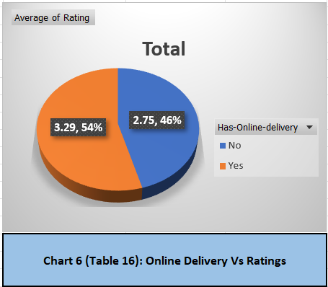

Insights:
- Higher Ratings for Online Delivery:
  - Customers who used online delivery have a higher average rating of 3.29 compared to 2.75 for those who did not.
  - This indicates a positive correlation between the use of online delivery and customer satisfaction.
- Overall Average Rating:
  - The grand total average rating is 2.89, showing a moderate satisfaction level overall, but the difference between "Yes" (online delivery) and "No" (non-online delivery) highlights an area of focus.

Recommendations:
- Promote Online delivery Features:
  - Highlight the ease and benefits of online delivery through marketing campaigns, especially for customers who currently avoid it.
- Enhance non-online delivery Experience:
  - Investigate why non-online deliveries are rated lower. Consider improving the process, such as shorter wait times, better customer service, or easier walk-in systems.

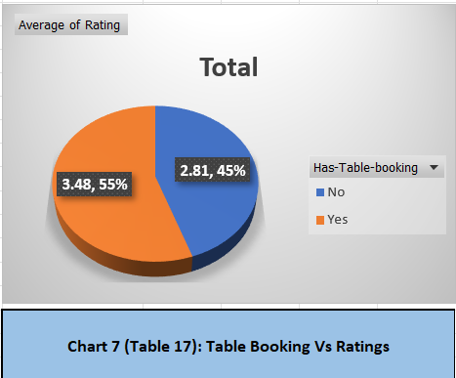

Insights:
- Higher Ratings for Table Bookings:
  - Customers who made table bookings have a significantly higher average rating of 3.48 compared to 2.81 for those who did not.
  - This suggests that table bookings are associated with a better customer experience and satisfaction.
- Overall Average Rating:
  - The grand total average rating is 2.89, slightly above the "No" group rating, indicating that table bookings pull the overall satisfaction level upward.

Recommendations:
- Encourage Table Bookings:
  - Promote table booking options prominently through advertisements, social media, and on the company website to increase adoption.
- Investigate Pain Points for Walk-ins (No Booking):
  - Conduct surveys or gather feedback from customers who did not book tables to identify areas for improvement, such as long wait times, unavailability of preferred seating, or less efficient service.

- Should the team keep the rate of cuisines higher? Will that affect the feedback? According to our data are the rates of cuisines and ratings, correlated?

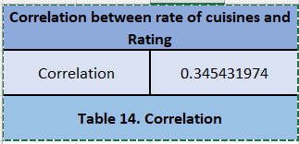

(Spreadsheet: Correlation)

Insights:
- Positive but Weak Correlation:
  - The correlation coefficient between the rate of cuisines and ratings is 0.345, indicating a positive but weak relationship. This means that as the rate (price) of cuisines increases, ratings tend to increase slightly, but the effect is not very strong.

Recommendations:
- Maintain Competitive Pricing:
  - While a slight price increase might not negatively impact ratings, the team should ensure that prices remain competitive and reflect the quality of the offerings to avoid alienating price-sensitive customers.
2. Highlight Quality with Pricing:
- When pricing cuisines higher, emphasize the quality, uniqueness, or premium ingredients in marketing materials to justify the cost and appeal to customers' perception of value.

- What is the distribution of the number of restaurants of different price ranges in all the countries?
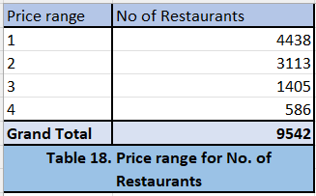

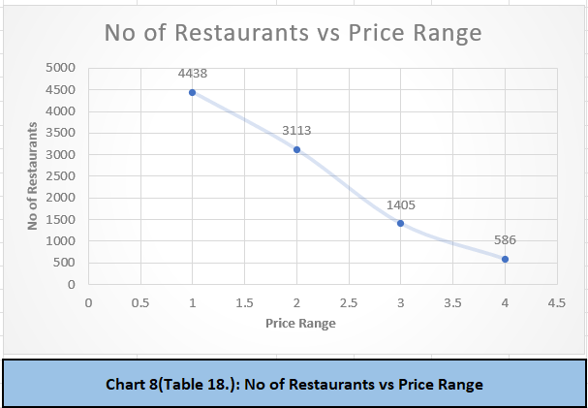
(Spreadsheet: Price Range)

- Explain your approach in brief for suggesting countries/cities to open new restaurants, if the objective and subjective questions would have not been given to assist you. [you must give bullet pointers in order to answer this question]
- If the objective and subjective questions would have not been given, then the approach I would have followed be as follows:
- First, I would have read the data given properly and would have started cleaning the raw data in the dataset.
- I would have used Sort and filter options and removed duplicates and blanks from the data.
- Then, I would make notes on the data which is present and how can be analyse it and what attributes of the data can be compared where I can get the data to open new restaurants.
- Later, by following this new path I would Start making pivot tables and charts and according to the requirements I would be adding new columns and use string functions, Aggregation and conditional aggregation and use conditional formatting to highlight the cities and its values which are selected to open the new restaurants.
- Thus, using these functions, I would make the pivot tables and charts accordingly.
- After this I would start making the dashboard on a new worksheet and make sure that all the data collected in form of tables and chart would be displayed visually and properly and make sure that the other people understand it properly. Dashboard is used to make the data more visual and easier to understand.
- In this way I would analyse the data by myself.

