SENTINELOPS
SOC ALERT-TRIAGE MODULE
DEBUGGING AND OPTIMIZATION
CSA06 — Design and Analysis of Algorithms
CO2 Debugging and Optimisation Task | 50 Marks
  - Department of Computer Science and Engineering
Python 3 | Individual Assignment
Measured environment: Linux-6.8.0-1064-azure-x86_64-with-glibc2.39 | Python 3.14.2

Contents
- Scenario and method
- Part A — Reproduce and identify defects
- Part B — Systematic corrections
- Part C — Optimized alternatives
- Part D — Experiments and complexity
- Part E — Testing
- Conclusion and engineering recommendations
- Viva preparation
- Limitations

Scenario and Method
SentinelOps processes SOC alerts by severity, checks IP blocklists, scans log text for signatures, and compares login locations measured in kilometres. The supplied faulty program was preserved with its logic unchanged and executed before corrections. Each correction was tested independently through boundary cases; separate optimized implementations were compared using reproducible input data. Timings use time.perf_counter and are environment-specific. Operation counts are reported independently because instrumentation affects elapsed time.
The sequence followed was reproduce → isolate → correct → validate → optimize → measure → compare. All benchmark CSV rows include the runtime environment and deterministic seeds.

Part A — Reproduce and Identify Defects
The original faulty file is retained at Source_Code/original_faulty_module.py. It was executed with the supplied five alerts, three blocklist queries, FAILFAIXFAIL text, FAIL pattern, and six login coordinates. The exact actual results follow:
ORIGINAL SUPPLIED PROGRAM OUTPUTS (logic unchanged)
sort_alerts -> [('A4', 9), ('A3', 5), ('A3', 5), ('A5', 1), ('A5', 1)]
is_blocked -> [('10.0.0.9', False), ('10.0.0.5', False), ('8.8.8.8', False)]
find_signature('FAILFAIXFAIL', 'FAIL') -> [0, 4]
closest_logins -> pair=(0, 2), distance_km=60.440052945046
find_signature('abc', '') -> UnboundLocalError: cannot access local variable 'j' where it is not associated with a value
The original code returns plausible values rather than raising for most defects: corrupt sorting, false blocklist outcomes, a false string hit and missing final hit, and a farthest pair. Only the empty-pattern probe raises UnboundLocalError.
The nine assignment-level categories below are supported by the supplied source. The insertion-sort row groups two related faulty index expressions; statement-level count is therefore ten, as disclosed below the table.
ID | Function | Fault | Observed effect | Fix and verification
D01 | sort_alerts | `j > 0`; `alerts[j] = key` | Index 0 is skipped and key is restored one slot too early; alerts are lost/duplicated. | Use `j >= 0` and restore at `j+1`; stable supplied output A2,A4,A3,A1,A5.
D02 | is_blocked | Found branch returns False | Listed IPs are reported unblocked. | Return True on equality; supplied 10.0.0.9 and .5 -> True.
D03 | is_blocked | `else: return False` inside loop | Search ends after first mismatch, so later entries never match. | Return False after loop; last-position and missing tests pass.
D04 | find_signature | `range(n - m)` | Final valid alignment is omitted. | Use `range(n-m+1)` after length checks; end-match test passes.
D05 | find_signature | Empty pattern reaches `if j...` | UnboundLocalError because the inner loop never sets j. | Define empty pattern as all n+1 boundaries; empty tests pass.
D06 | find_signature | `if j == m - 1` | A mismatch at the final pattern character is falsely accepted. | Accept only after m successful comparisons; output [0,8].
D07 | closest_logins | `min_dist = 0` | No positive distance is initially a valid upper bound on the minimum. | Initialize squared best distance to infinity.
D08 | closest_logins | `if d > min_dist` | Selects the farthest pair, not the closest. | Minimize squared distance; supplied result indices (0,5), sqrt(2) km.
D09 | closest_logins | Both loops range over all n | Includes self-pairs and both orders of each unordered pair. | Scan `j > i`; pair count is n(n-1)/2.

Count clarification: the expected nine categories are present. D01 has two faulty expressions that jointly violate the insertion-step invariant; counting individual fault locations gives ten. This report does not conceal that distinction or invent an unrelated defect to force the expected count.
Other absent input validation is documented as a boundary-condition omission. Quadratic pair scanning and repeated linear lookup are performance limitations, not additional correctness defects.

Part B — Systematic Corrections
Corrected code preserves the original algorithms: in-place insertion sort, index-based sequential scan, alignment-by-alignment matching, and nested pair scan. Changes are limited to boundaries, result conventions, match completion, pair initialization/direction/enumeration, and required input validation. The empty signature convention returns all n+1 boundaries.

Stable descending alert sort
SORT-ALERTS(alerts)
for i = 1 to length(alerts) - 1
key = alerts[i]
j = i - 1
while j >= 0 and alerts[j].severity < key.severity
alerts[j + 1] = alerts[j]
j = j - 1
alerts[j + 1] = key
return alerts
Strict comparison preserves the arrival order of equal severities; the input list is mutated.

Sequential blocklist search
IS-BLOCKED(blocklist, ip)
for each entry in blocklist from first to last
if entry = ip
return true
return false
A hit returns True; only a complete miss returns False.

Brute-force signature matching
FIND-SIGNATURE(text, pattern)
if pattern is empty
return boundaries 0 through length(text)
if length(pattern) > length(text)
return empty list
hits = empty list
for start = 0 to length(text) - length(pattern)
offset = 0
while offset < length(pattern) and text[start + offset] = pattern[offset]
offset = offset + 1
if offset = length(pattern)
append start to hits
return hits
Every valid alignment is examined, overlaps are retained, and success requires all m characters.

Closest login pair
CLOSEST-LOGINS(events)
require at least two events
bestSquared = infinity
for i = 0 to n - 2
for j = i + 1 to n - 1
squared = squaredDistance(events[i], events[j])
if squared < bestSquared, or equal with lexicographically smaller (i,j)
save squared and pair (i,j)
return pair, squareRoot(bestSquared)
The corrected baseline scans unique pairs and uses lexicographic index-pair tie-breaking.

Observed insertion and alignment traces
(descending severity)
iteration=1 key=('A2', 9)
comparisons=["('A1', 3) vs key ('A2', 9)"]
shifts=["move ('A1', 3) from 0 to 1"]
insertion_position=0; array=[('A2', 9), ('A1', 3), ('A3', 5), ('A4', 9), ('A5', 1)]
iteration=2 key=('A3', 5)
comparisons=["('A1', 3) vs key ('A3', 5)", "('A2', 9) vs key ('A3', 5)"]
shifts=["move ('A1', 3) from 1 to 2"]
insertion_position=1; array=[('A2', 9), ('A3', 5), ('A1', 3), ('A4', 9), ('A5', 1)]
iteration=3 key=('A4', 9)
comparisons=["('A1', 3) vs key ('A4', 9)", "('A3', 5) vs key ('A4', 9)", "('A2', 9) vs key ('A4', 9)"]
shifts=["move ('A1', 3) from 2 to 3", "move ('A3', 5) from 1 to 2"]
insertion_position=1; array=[('A2', 9), ('A4', 9), ('A3', 5), ('A1', 3), ('A5', 1)]
iteration=4 key=('A5', 1)
comparisons=["('A1', 3) vs key ('A5', 1)"]
shifts=['none']
insertion_position=4; array=[('A2', 9), ('A4', 9), ('A3', 5), ('A1', 3), ('A5', 1)]
BRUTE-FORCE ALIGNMENT TRACE text='FAILFAIXFAIL' pattern='FAIL'
start=0 comparisons=["text[0]='F' vs pattern[0]='F'", "text[1]='A' vs pattern[1]='A'", "text[2]='I' vs pattern[2]='I'", "text[3]='L' vs pattern[3]='L'"] mismatch_offset=None match=True
start=1 comparisons=["text[1]='A' vs pattern[0]='F'"] mismatch_offset=0 match=False
start=2 comparisons=["text[2]='I' vs pattern[0]='F'"] mismatch_offset=0 match=False
start=3 comparisons=["text[3]='L' vs pattern[0]='F'"] mismatch_offset=0 match=False
start=4 comparisons=["text[4]='F' vs pattern[0]='F'", "text[5]='A' vs pattern[1]='A'", "text[6]='I' vs pattern[2]='I'", "text[7]='X' vs pattern[3]='L'"] mismatch_offset=3 match=False
start=5 comparisons=["text[5]='A' vs pattern[0]='F'"] mismatch_offset=0 match=False
start=6 comparisons=["text[6]='I' vs pattern[0]='F'"] mismatch_offset=0 match=False
start=7 comparisons=["text[7]='X' vs pattern[0]='F'"] mismatch_offset=0 match=False
start=8 comparisons=["text[8]='F' vs pattern[0]='F'", "text[9]='A' vs pattern[1]='A'", "text[10]='I' vs pattern[2]='I'", "text[11]='L' vs pattern[3]='L'"] mismatch_offset=None match=True
The full original/corrected logs are retained in Output_Screenshots. On the supplied log, the alignment at start 4 compares the final character X against L and fails; start 8 matches through the end.

Part C — Optimized Alternatives
Alert sorting retains stable insertion sort for nearly ordered batches and adds bottom-up stable merge sort for larger/random inputs. Merge sorting preserves equal-severity order by choosing the left run on equal keys. Public optimized functions preserve the corrected APIs' return types; separately named instrumented functions expose counters to the benchmark. A set-backed blocklist index is constructed once and then reused across queries; construction and lookup costs are separated. Signature matching remains straightforward brute force; mismatch exit and a correct match condition reduce avoidable work but do not change the O(nm) worst case.
For login locations, the brute-force baseline compares squared distances for unique pairs. The optimized method sorts points and applies exact divide-and-conquer: recursively solve each side, merge y-order, then inspect the strip within the best-distance bound. The packing argument limits each point to the next seven strip points. Duplicate coordinates are detected before recursion and return the lexicographically earliest zero-distance pair. Squared distances alone would only reduce per-pair cost; the observed calculation reduction comes from spatial pruning.

Supplied optimized demonstration
OPTIMIZED MODULE DEMONSTRATION
stable insertion sort -> [('A2', 9), ('A4', 9), ('A3', 5), ('A1', 3), ('A5', 1)]; counts=OperationCounts(comparisons=7, movements=8)
indexed blocklist queries -> [True, True, False]; counts=SearchCounts(index_build_operations=3, lookups=3)
counted brute-force signatures -> [0, 8]; comparisons=18
closest pair brute -> (0, 5), 1.414213562373 km, distances=15
closest pair divide-and-conquer -> (0, 5), 1.414213562373 km, distances=6, preprocessing=27

Part D — Experiments and Complexity
Sorting uses seeded identical datasets at n=100, 1,000, and 5,000. Nearly sorted inputs are generated from descending severity order with deterministic adjacent perturbations; random inputs use seed 8821; reverse input is the opposite severity order. Every result is checked against Python's stable descending sort.
Dataset | n | Algorithm | Comparisons | Movements | Seconds | Stable/correct
nearly_sorted | 100 | insertion | 197 | 197 | 0.000035115 | True
nearly_sorted | 100 | stable_merge | 375 | 1400 | 0.000250318 | True
random | 100 | insertion | 2632 | 2637 | 0.000415696 | True
random | 100 | stable_merge | 562 | 1400 | 0.000235470 | True
reverse_sorted | 100 | insertion | 4942 | 5005 | 0.000850368 | True
reverse_sorted | 100 | stable_merge | 334 | 1400 | 0.000214681 | True
nearly_sorted | 1000 | insertion | 1010 | 1010 | 0.000252161 | True
nearly_sorted | 1000 | stable_merge | 5052 | 20000 | 0.003280714 | True
random | 1000 | insertion | 241765 | 241769 | 0.044766729 | True
random | 1000 | stable_merge | 8736 | 20000 | 0.003658970 | True
reverse_sorted | 1000 | insertion | 495309 | 495408 | 0.143309093 | True
reverse_sorted | 1000 | stable_merge | 5665 | 20000 | 0.005531274 | True
nearly_sorted | 5000 | insertion | 5000 | 5000 | 0.001090104 | True
nearly_sorted | 5000 | stable_merge | 33356 | 130000 | 0.027422946 | True
random | 5000 | insertion | 6126799 | 6126804 | 0.836288691 | True
random | 5000 | stable_merge | 56813 | 130000 | 0.013081768 | True
reverse_sorted | 5000 | insertion | 12376956 | 12377055 | 1.898640324 | True
reverse_sorted | 5000 | stable_merge | 34593 | 130000 | 0.012016761 | True

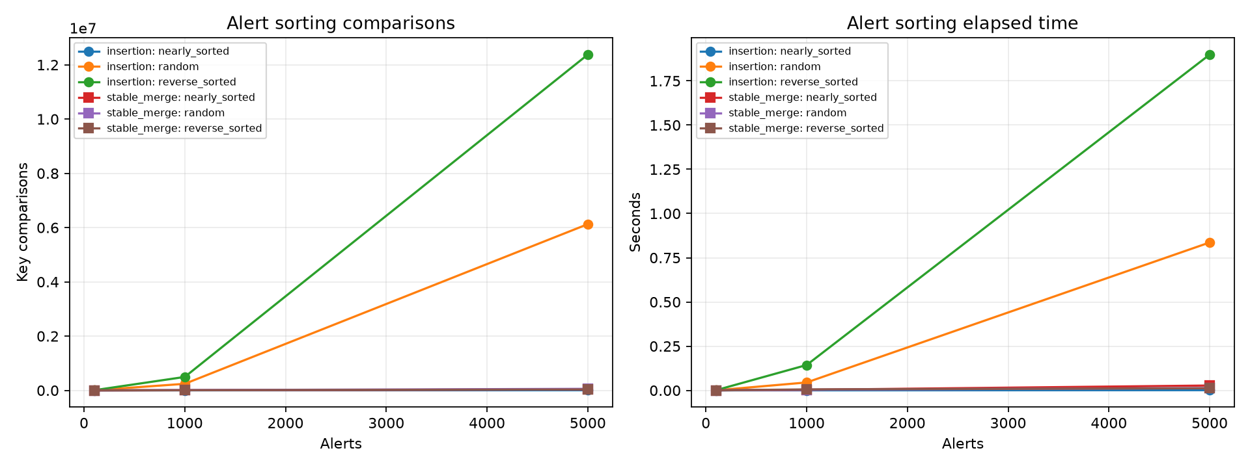
Figure 1. Sorting comparison counts and measured elapsed time from sorting_benchmarks.csv.
On nearly sorted n=5,000 input, insertion used 5000 comparisons and 0.001090 s; stable merge used 33356 comparisons and 0.027423 s. On random n=5,000, insertion used 6126799 comparisons and 0.836289 s, versus merge's 56813 comparisons and 0.013082 s. On reverse input insertion used 12376956 comparisons and 1.898640 s. Recommend insertion for small, nearly sorted batches; use a stable O(n log n) alternative when batch size or disorder grows.

Repeated blocklist queries
Entries | Queries | Sequential comparisons | Sequential s | Index build s | Indexed query s | Correct
100 | 500 | 37884 | 0.001123550 | 0.000013055 | 0.000037821 | True
1000 | 500 | 380682 | 0.012014415 | 0.000044213 | 0.000036819 | True
10000 | 500 | 3803143 | 0.121902678 | 0.000744009 | 0.000048590 | True

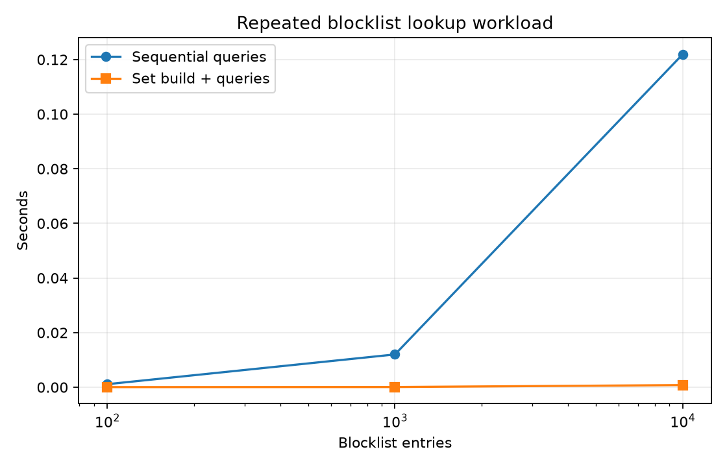
Figure 2. Total measured repeated-query workload, including index construction.
At 10000 entries and 500 mixed queries, sequential scanning made 3803143 comparisons in 0.121903 s; set construction took 0.000744 s and indexed queries 0.000049 s. For very few lookups, index setup and memory may not be worthwhile; expected constant lookup is not a worst-case guarantee.

Signature matching workloads
Case | n | m | Character comparisons | Matches | Seconds | Correct
early_match | 4000 | 9 | 4000 | 1 | 0.000423350 | True
repetitive_near_match | 6000 | 100 | 590100 | 0 | 0.041431965 | True
missing_pattern | 4000 | 3 | 3998 | 0 | 0.000376683 | True
overlapping_matches | 4000 | 3 | 7996 | 1999 | 0.000705406 | True

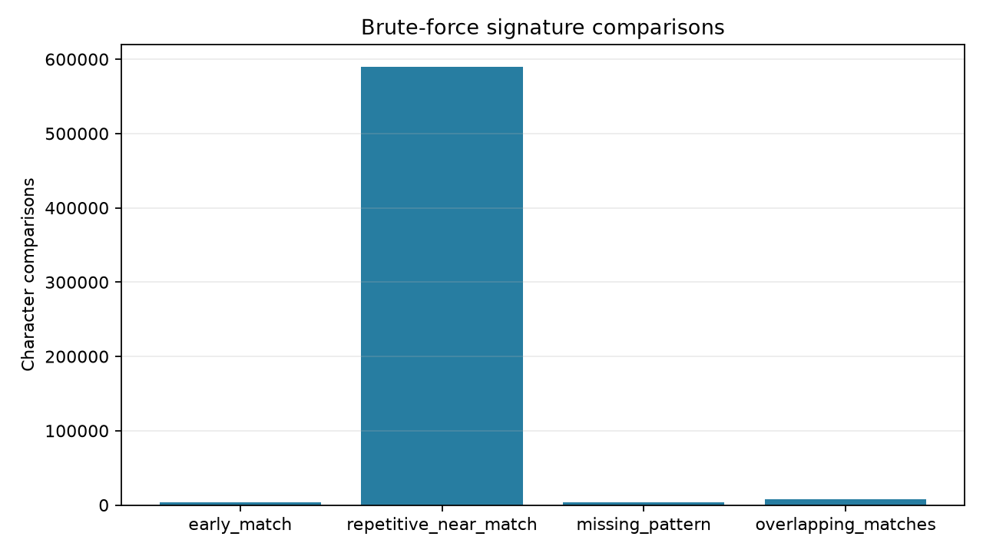
Figure 3. Counted character comparisons by deliberate input structure.
The repetitive near-match case has long common prefixes and reaches 590100 character comparisons; the early-match, missing-first-character, and overlapping cases have different work despite comparable text lengths. This illustrates why text length alone is insufficient to predict comparisons.

Closest-pair batch comparison
n | Theoretical pairs | Brute distance calculations | Optimized distance calculations | Preprocessing ops | Brute s | Optimized s | Same result
1000 | 499500 | 499500 | 915 | 28058 | 0.095256083 | 0.008108986 | True
2000 | 1999000 | 1999000 | 1854 | 62085 | 0.330356033 | 0.024963155 | True
4000 | 7998000 | 7998000 | 3733 | 136132 | 1.598185661 | 0.037607256 | True
8000 | 31996000 | 31996000 | 7417 | 296258 | 5.587078836 | 0.081627552 | True

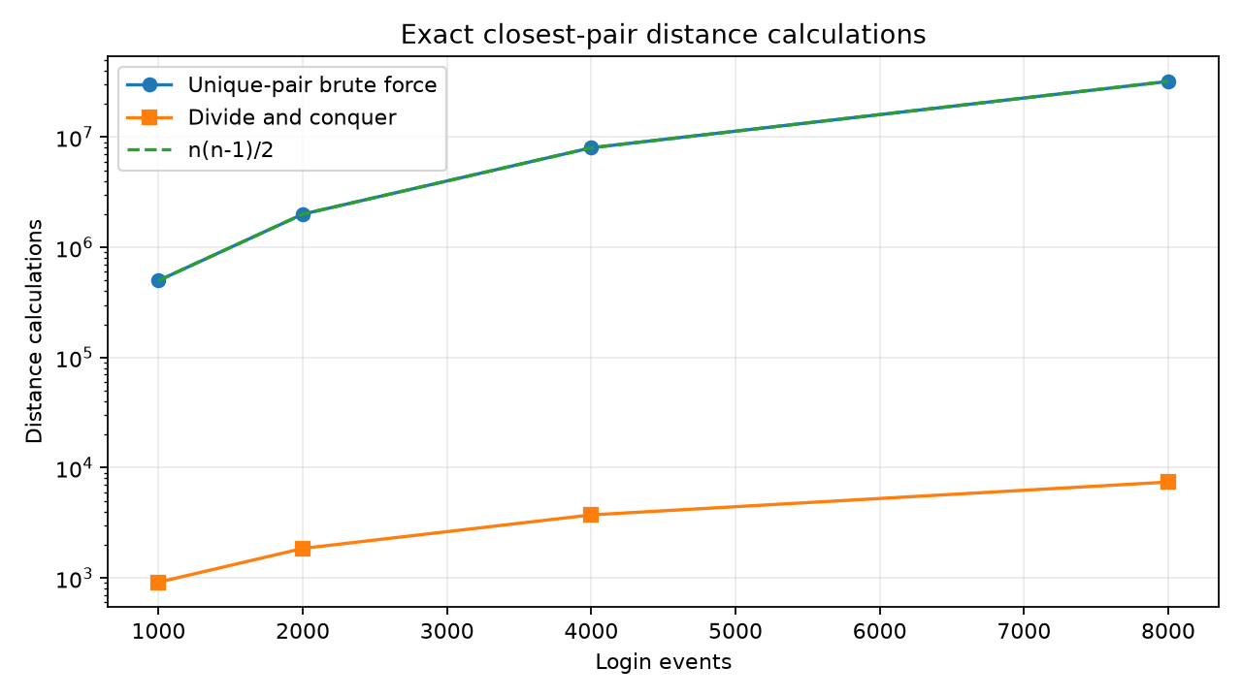
Figure 4. Unique-pair baseline and exact divide-and-conquer counts.
The brute theoretical/actual count is n(n-1)/2. At 8000 events, brute force performed 31996000 distance calculations in 5.5871 s; divide-and-conquer performed 7417 in 0.0816 s with 296258 counted preprocessing/point-processing operations. All four seeded batches agreed exactly in pair and distance. This measured method provides the required largest-batch comparison without substituting theoretical counts for actual baseline work.

Complexity summary
Algorithm | Time | Auxiliary space
Alert insertion | O(n) best; O(n²) average/worst | O(1)
Stable merge sort | O(n log n) all cases | O(n)
Sequential search | O(1) best; O(n) average/worst | O(1)
Set index + lookup | O(n) expected build; O(1) expected lookup, O(n) hash worst case | O(n)
Brute string matching | O((n-m+1)m) worst | O(output)
Closest brute baseline | Θ(n²) | O(1)
Exact divide-and-conquer | O(n log n) | O(n)

Full operation definitions and trade-offs are in Supporting_Files/complexity_analysis.md. Timings are a single-machine measurement; counters are more portable and instrumentation changes runtime.

Part E — Testing
Test | Status
test_brute_and_divide_conquer_closest_pair_agree | PASS
test_closest_pair_duplicates_ties_negative_and_two_events | PASS
test_closest_pair_rejects_small_inputs | PASS
test_corrected_closest_pair_supplied_and_known_answer | PASS
test_optimized_sorts_match_corrected_and_are_stable | PASS
test_optimized_string_comparison_counter | PASS
test_original_faulty_behaviour_is_preserved | PASS
test_sequential_search_boolean_convention_and_boundaries | PASS
test_sort_empty_single_sorted_reverse_and_stability | PASS
test_string_matching_supplied_and_all_boundaries | PASS

The standard-library harness ran 10 tests; 10 passed and 0 failed. It covers empty/singleton/sorted/reverse/stable sorting, first/last/missing/empty blocklist, supplied/end/overlap/empty/too-long signatures, duplicate/tied/negative/two-event closest pairs, invalid input, and baseline-versus-optimized agreement.

Conclusion and Engineering Recommendations
The supplied code's errors were reproducible and primarily arose from incorrect loop bounds, early returns, an incomplete match condition, and reversed closest-pair state updates. Minimal corrections restore the intended four algorithms. The measured alternatives are workload-sensitive: insertion sort is appropriate for small nearly sorted alert batches, a hash index benefits repeated lookups after amortizing construction, and exact divide-and-conquer sharply reduces distance calculations for large event batches. Keep simple brute-force versions as auditable references and retain the regression harness for future changes.

Viva Preparation
Q: Why does insertion sort need j >= 0? A: The held key may belong before the first item, so index zero must be compared.
Q: How does strict severity comparison preserve stability? A: Equal-severity existing items are not shifted past the later key.
Q: Why did the original blocklist fail for later entries? A: It returned False at the first nonmatch, ending the scan.
Q: Why must the matcher use n-m+1 alignments? A: The range end is exclusive, and start n-m is a valid final alignment.
Q: Why was index 4 a false string hit? A: The final comparison mismatched, but j still equalled m-1.
Q: Why use j > i for pairs? A: It excludes self-pairs and visits each unordered pair once.
Q: Does squared distance improve brute-force asymptotic time? A: No; it removes per-pair square roots but still examines Θ(n²) pairs.
Q: Why is the strip bound exact? A: After each half has a distance bound d, 2-D packing limits possible closer cross-boundary neighbors to seven next points in y-order.
Q: When does a set index pay off? A: When enough repeated queries amortize construction and memory; expected lookup is O(1), not worst-case guaranteed.
Q: Does instrumentation affect timing? A: Yes; operation counters add work, so counts and wall-clock measurements are reported separately.

Limitations
Automated terminal screenshot capture was unavailable; genuine execution logs and a manual Windows capture procedure are supplied instead. The figures are actual Matplotlib plots generated from benchmark CSVs, not terminal screenshots. Performance measurements were taken on the recorded Linux container, and should not be read as Windows timings. Duplicate coordinates are handled explicitly; coordinate inputs are assumed to be finite real numbers.

