CSA06
DESIGN AND ANALYSIS OF ALGORITHMS
  - Assignment 2 | Course Outcome 2

Brute-Force Sorting, Searching, Geometry, and Exact Search
  - Individual Assignment | Total: 50 marks | Python 3
Evidence generated on Linux-6.8.0-1064-azure-x86_64-with-glibc2.39 with Python 3.14.2.

Contents
- Objectives and methodology
- Q1 Sorting (6)
- Q2 Sequential search (4)
- Q3 String matching (6)
- Q4 Closest pair (6)
- Q5 Convex hull (7)
- Q6 Exhaustive knapsack (8)
- Q7 Day-4 redesign (13)
- Overall conclusions
- Viva preparation

Objectives and Methodology
The assignment applies brute-force techniques to sorting, searching, string matching, closest pair, convex hull, and knapsack, then evaluates an exact branch-and-bound redesign. Each experiment follows Predict, Design, Implement, Measure, Analyse, Evaluate, Diagnose, Redesign, Validate. Deterministic datasets, explicit operation counters, independent correctness checks, CSV source data, and saved plots support reproducibility. Timings use time.perf_counter; small timings are noisy and environment-specific.
Measurement environment: Linux-6.8.0-1064-azure-x86_64-with-glibc2.39; Python 3.14.2. Values in the tables are read from the generated CSV files. The Q1–Q7 execution_output.txt files are program logs, not screenshots. A terminal capture procedure is documented in the README.

Q1. Sorting Under Different Data Conditions (6 marks)
Problem and design: sort dispatch scores using independent Selection, early-exit Bubble, and Insertion implementations. Each method receives a fresh copy. A swap is three element movements; Insertion counts each shift and key write. Predictions were recorded before measured results: Selection's comparisons depend only on n, while Insertion and early-exit Bubble should benefit on nearly ordered data.
The 95% already-correct-order operating context makes Insertion Sort a plausible choice for small periodic batches, because shifting a few out-of-place items can be inexpensive. In the measured nearly-sorted case it used 54 comparisons versus Selection Sort's fixed 780. This experiment does not model every batch arrival pattern; actual batch size and the cost of integrating new orders determine the deployment choice. Selection Sort uses O(n^2) comparisons and O(1) auxiliary space. Bubble Sort is O(n) best case and O(n^2) average/worst, with O(1) extra space. Insertion Sort is O(n) best and O(n^2) average/worst, with O(1) extra space.
SELECTION-SORT(A)
for start = 0 to length(A) - 2
minimum = start
for i = start + 1 to length(A) - 1
comparisons = comparisons + 1
if A[i] < A[minimum]
minimum = i
if minimum != start
swap A[start], A[minimum]
swaps = swaps + 1; movements = movements + 3
Input | Method | n | Comparisons | Movements | Seconds
reverse_sorted | selection | 40 | 780 | 60 | 0.000067345
reverse_sorted | bubble_early_exit | 40 | 780 | 2340 | 0.000121336
reverse_sorted | insertion | 40 | 780 | 819 | 0.000071824
nearly_sorted | selection | 40 | 780 | 9 | 0.000039033
nearly_sorted | bubble_early_exit | 40 | 219 | 45 | 0.000012994
nearly_sorted | insertion | 40 | 54 | 54 | 0.000006753
empty | selection | 0 | 0 | 0 | 0.000001292
empty | bubble_early_exit | 0 | 0 | 0 | 0.000001202
empty | insertion | 0 | 0 | 0 | 0.000001112

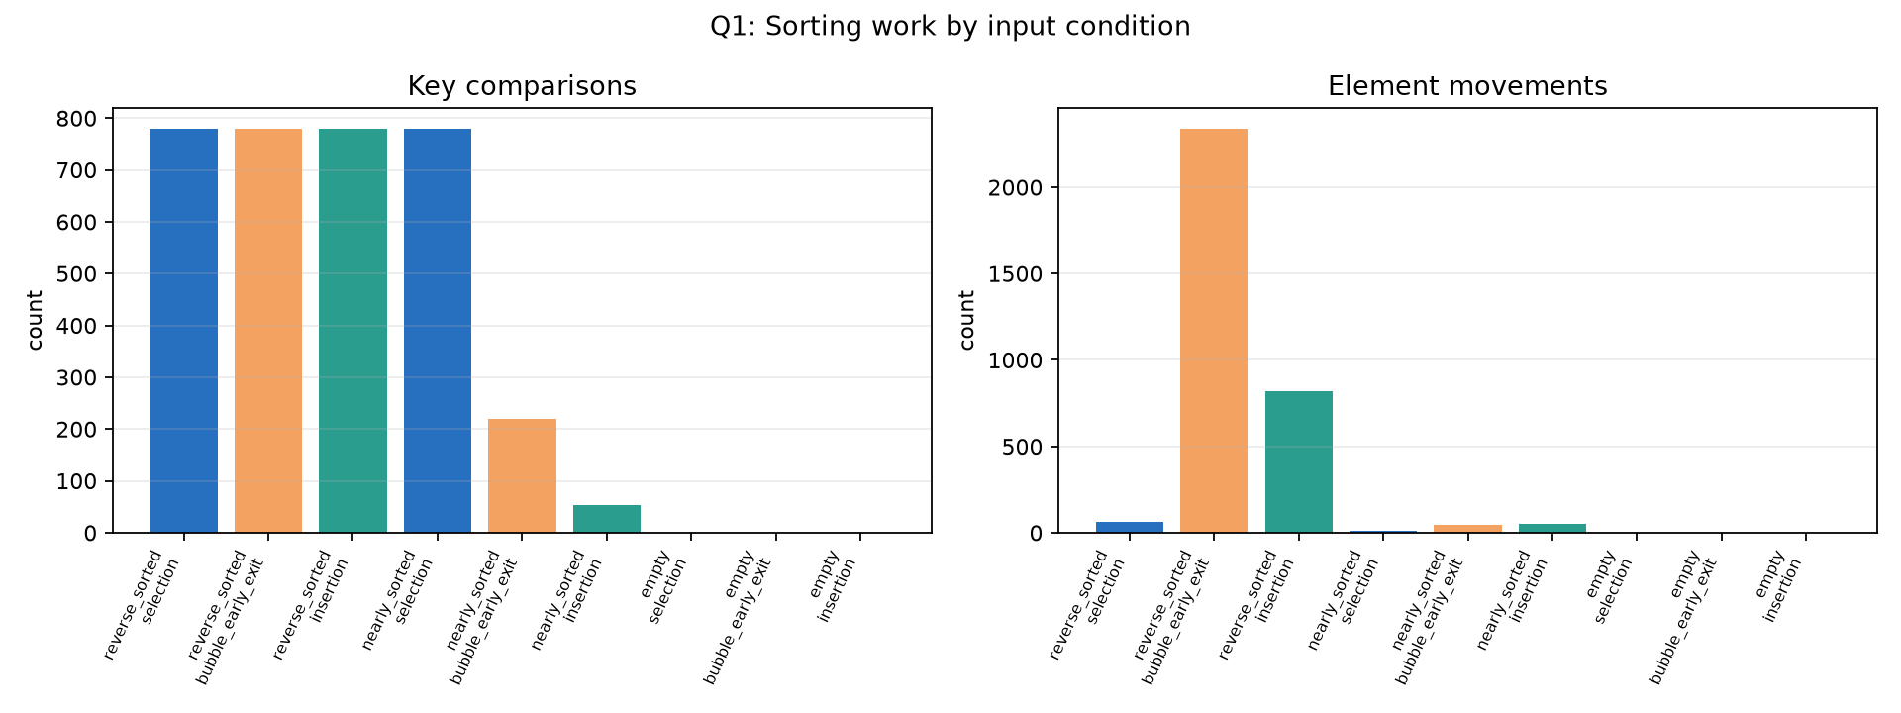
Figure 1. Measured comparisons and element movements.
Conclusion: operation counts are the primary comparison evidence; these small timings are sensitive to runtime noise. The run log and CSV provide exact cases and correctness checks.

Q2. Sequential Search (4 marks)
Tool issue records contain tool ID, technician ID, issue time, and work bay. Search compares tool IDs in list order and returns the first matching record. A successful target at zero-based position p requires p+1 comparisons; a miss scans all n records. Best/average/worst time is O(1)/O(n)/O(n); auxiliary space is O(1). Sequential search is simple for small or infrequently queried unsorted collections. Frequent queries across 20 facilities may warrant a hash index, but building and maintaining that index costs time and memory and must be compared with the actual lookup workload.
SEQUENTIAL-SEARCH(records, target)
comparisons = 0
for index = 0 to length(records) - 1
comparisons += 1
if records[index].tool_id = target
return (index, comparisons)
return (NOT-FOUND, comparisons)
n | Case | Target position | Found | Comparisons | Correct
10 | first | 0 | True | 1 | True
10 | middle | 5 | True | 6 | True
10 | final | 9 | True | 10 | True
10 | miss | not_found | False | 10 | True
1000 | first | 0 | True | 1 | True
1000 | middle | 500 | True | 501 | True
1000 | final | 999 | True | 1000 | True
1000 | miss | not_found | False | 1000 | True

The deterministic record generator makes first, middle, final, and absent target behavior directly reproducible. The sequential lookup count excludes any preprocessing cost of alternative indexes.

Q3. Brute-Force String Matching (6 marks)
At each possible start offset the matcher compares characters left-to-right and stops that alignment at its first mismatch. It advances by one after a match, so overlaps are retained. The documented empty-pattern convention returns all n+1 text boundaries with zero comparisons; a pattern longer than the text has no matches and incurs zero comparisons. Positions are zero-based.
Prediction: a repetitive text with a long matching prefix followed by a mismatch should approach the worst-case O((n-m+1)m) character comparisons for nonempty patterns, while an early easy match uses fewer. For n >= m this bound is O(nm). Length alone is insufficient to predict work because mismatch location and shared prefixes govern the comparisons per alignment.
BRUTE-FORCE-MATCH(text, pattern)
if pattern is empty
return every boundary 0..length(text), 0 comparisons
if length(pattern) > length(text)
return no matches, 0 comparisons
matches = []; comparisons = 0
for start = 0 to length(text) - length(pattern)
offset = 0
while offset < length(pattern)
comparisons += 1
if text[start + offset] != pattern[offset]
break
offset += 1
if offset = length(pattern)
append start to matches
return matches, comparisons
Case | n | m | Zero-based matches | Comparisons | Validated
easy_early | 17 | 5 | 3 | 18 | True
repetitive_worst_style | 80 | 21 |  | 1260 | True
overlapping_multiple | 8 | 3 | 0;2;5 | 13 | True

Reported positions are independently checked using repeated standard-library find calls with a one-character increment, which allows overlapping matches.

Q4. Brute-Force Closest Pair (6 marks)
The nested loops use j > i, so every unordered pair is examined exactly once. There are (n-1)+(n-2)+...+1 = n(n-1)/2 pairs. Squared Euclidean distance is compared without square roots; one square root produces the final distance. Strict improvement preserves the first input-order pair on ties; duplicate coordinates yield distance zero. Fewer than two points raise ValueError.
Time is O(n^2), auxiliary space O(1) excluding input storage. Before measurement the local acceptance criterion was set to 1.0 second per run. It is an environment-specific budget, not a universal hardware limit; the tested sizes establish only a local observation.
CLOSEST-PAIR(points)
require at least two points
best_squared = infinity; pairs = 0
for i = 0 to n - 2
for j = i + 1 to n - 1
dx = points[i].x - points[j].x
dy = points[i].y - points[j].y
squared = dx*dx + dy*dy
pairs += 1
if squared < best_squared
best_squared = squared; best_pair = (points[i], points[j])
return best_pair, sqrt(best_squared), pairs
n | Expected pairs | Measured pairs | Distance calculations | Seconds | Within 1s
10 | 45 | 45 | 45 | 0.000032691 | True
100 | 4950 | 4950 | 4950 | 0.000807495 | True
500 | 124750 | 124750 | 124750 | 0.018981139 | True
1500 | 1124250 | 1124250 | 1124250 | 0.173948976 | True
3000 | 4498500 | 4498500 | 4498500 | 0.684973734 | True
5000 | 12497500 | 12497500 | 12497500 | 1.852080745 | False

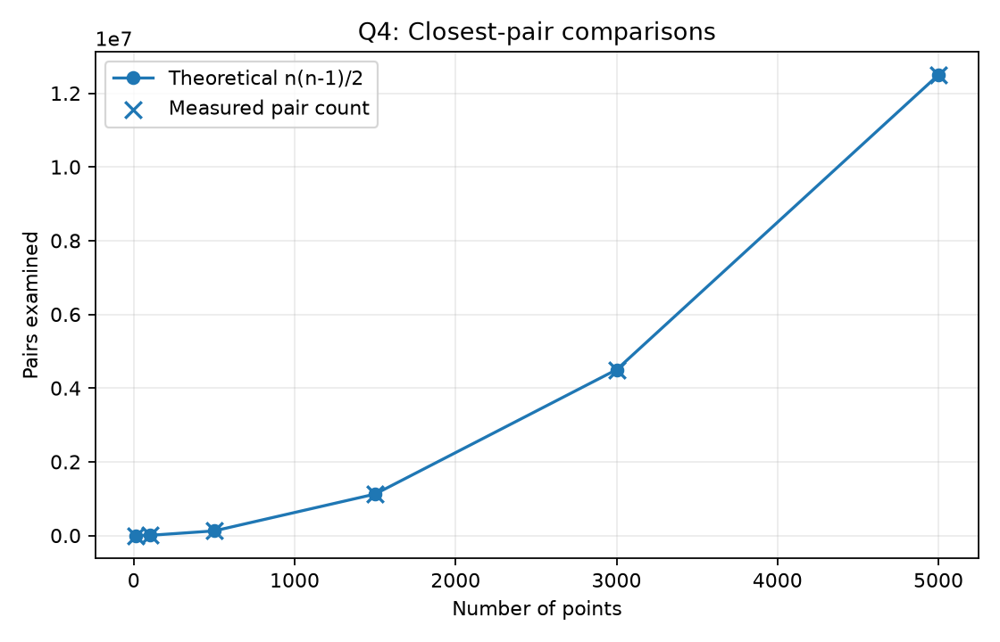
Figure 2. Theoretical pair counts coincide with measured pair counts.
Observed local response boundary: n=3,000 completed in 0.662 s, while n=5,000 took 1.844 s and exceeded the predeclared 1.0-second budget. Thus the tested crossover lies between those sampled sizes for this environment and dataset generator; it is not a hardware-independent limit. A divide-and-conquer closest-pair strategy could avoid evaluating all pairs; this assignment measures the requested brute-force baseline.

Q5. Brute-Force Convex Hull (7 marks)
For A=(x1,y1), B=(x2,y2), P=(x3,y3), cross(A,B,P)=(x2-x1)(y3-y1)-(y2-y1)(x3-x1). Positive and negative signs indicate opposite sides of the directed line; zero means collinear. A candidate pair supports a hull line when all remaining points lie on one side or on the line. The implementation deduplicates coordinates, identifies the extremes of collinear boundary sets, handles fully collinear inputs, and angle-orders unique corners around their centroid. The angle-ordering argument assumes the identified set is the boundary of a convex polygon.
The all-pairs/all-other-points approach is O(n^3) in the worst case; ordering h identified vertices costs O(h log h). A supporting line contains a convex-hull boundary segment because it separates all input points into a closed half-plane. Collinear points belong to an edge but only its two extremes are polygon corners.
BRUTE-HULL(points)
remove duplicate coordinates
handle 0, 1, and 2 unique points directly
boundary_extremes = empty set
for every unordered pair (A, B)
evaluate cross(A, B, P) for every other P
if nonzero signs occur on both sides
continue: line is not supporting
collect all points collinear with A-B
add the two extreme collinear points to boundary_extremes
if all points are collinear
return the two lexicographic extremes
order unique boundary extremes by polar angle around their centroid
return ordered extremes
Configuration | Input | Unique | Hull vertices | Pairs | Orientation tests | Correct
boundary_and_interior | 7 | 7 | 0:0;4:0;4:3;0:3 | 21 | 58 | True
collinear_duplicates_symmetric | 11 | 10 | 0:0;4:0;4:4;0:4 | 45 | 213 | True

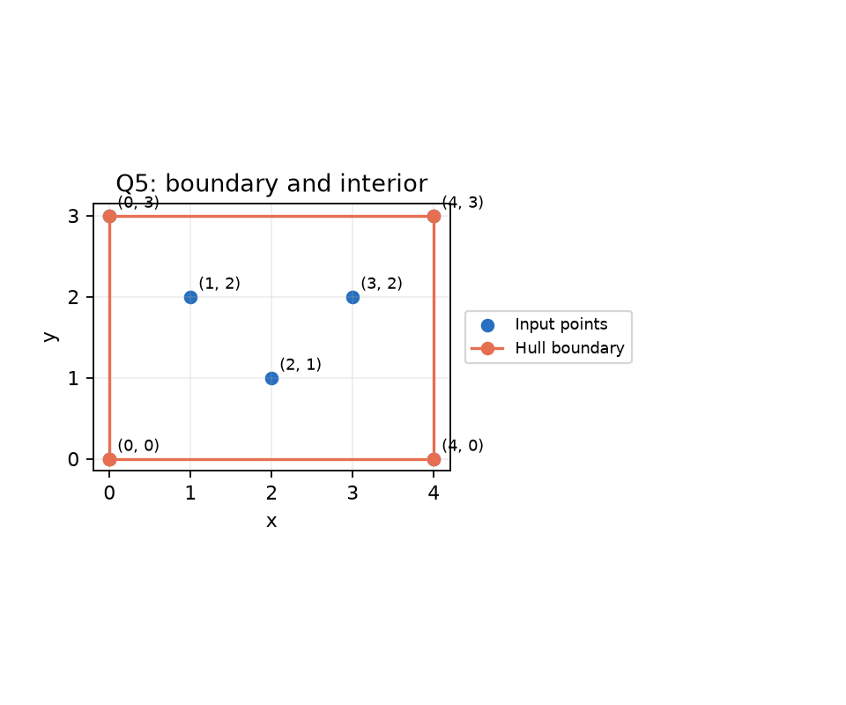
Figure 3. Boundary and interior monitoring stations.
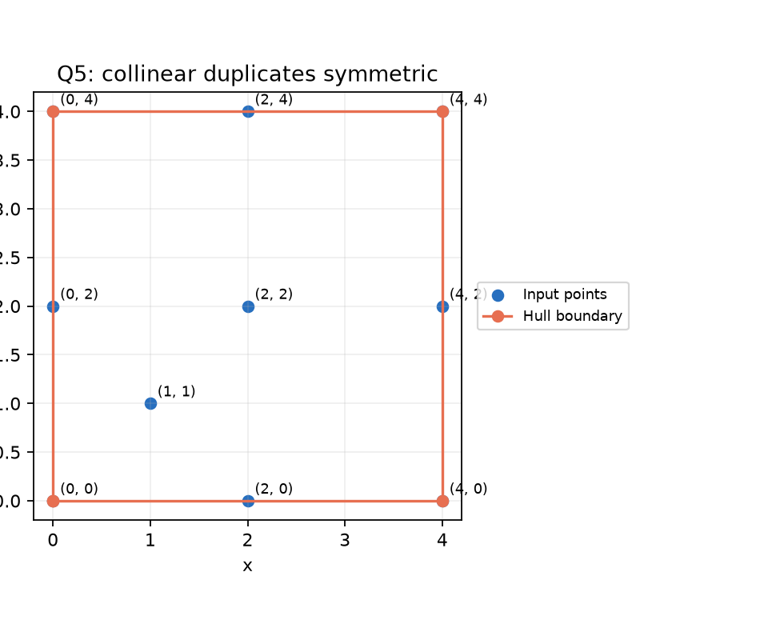
Figure 4. Duplicate, symmetric, and collinear boundary points.

Q6. Exhaustive Knapsack Search (8 marks)
Each bitmask represents one subset, including mask zero for the empty subset. For n packages there are 2^n masks. Each candidate is fully summed, and only feasible subsets compete for best value. Tie-breaking is maximum value, then lower weight, then lexicographically smaller sorted IDs. Positive weights, nonnegative values, unique IDs, and nonnegative capacity are validated. A three-package hand-check has optimum value 7 from weights 2 and 3 under capacity 5, independently verified in unit tests.
The measured growth prediction is doubling per added package. The local response budget was set to 2.0 seconds before running the n=10, 15, and 20 cases. A practical limit may be inferred only for this environment and these instances; runtime also depends on implementation, package values/weights, and the available time budget. Adding k packages multiplies the subset count by 2^k.
EXHAUSTIVE-KNAPSACK(packages, capacity)
best = empty subset with value 0 and weight 0
for mask = 0 to 2^n - 1
weight = value = 0; selected = empty list
for i = 0 to n - 1
if bit i of mask is set
add package i's weight and value; record its ID
if weight <= capacity
feasible += 1
if candidate improves value, then lower weight, then lexical ID tie-break
save candidate as best
return best, 2^n subsets examined, feasible
n | Capacity | Subsets | Feasible | Best value | Seconds | Within budget
10 | 40 | 1024 | 145 | 414 | 0.002058318 | True
15 | 85 | 32768 | 3238 | 514 | 0.053266296 | True
18 | 112 | 262144 | 16764 | 518 | 0.697467170 | True
19 | 113 | 524288 | 37107 | 512 | 1.022484494 | True
20 | 133 | 1048576 | 66440 | 658 | 2.240329769 | False

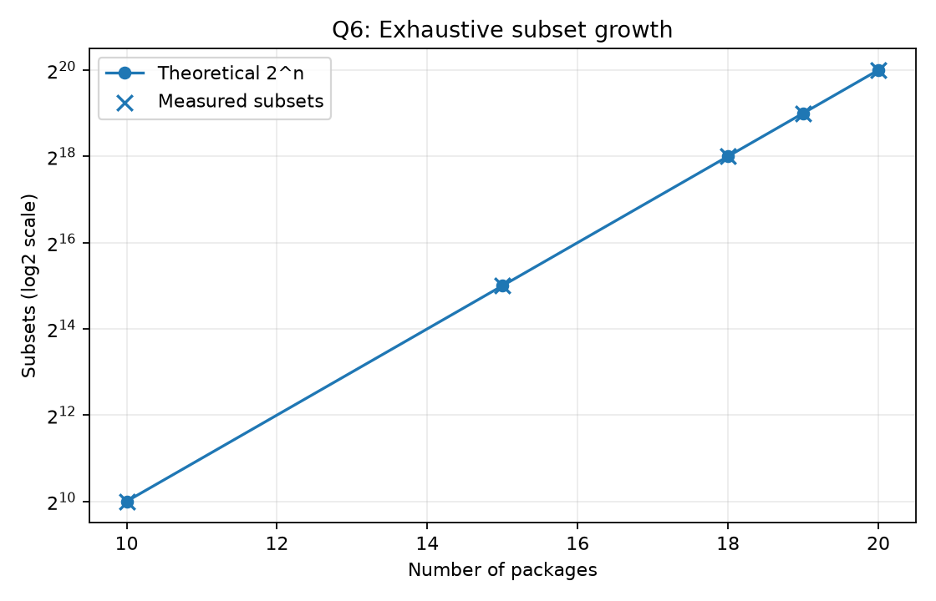
Figure 5. Exhaustive subset counts grow exponentially.
Observed local response boundary: n=19 completed in 1.065 s within the 2.0-second budget; n=20 took 2.190 s and exceeded it. The data therefore bracket the sampled transition between 19 and 20 packages on this machine and generated instances only. Because the instances are independently seeded by size, this is a practical observation, not a universal package-count guarantee.

Q7. Day-4 Design Challenge (13 marks)

A. Diagnose the bottleneck (2 marks)
The baseline repeatedly evaluates complete subsets, with exactly 2^n candidates. In Q6, n=20 required 1,048,576 complete subsets and took 2.190 s, exceeding the declared 2.0-second budget; n=19 took 1.065 s. This exponential growth, rather than a single expensive arithmetic operation, is the limiting repeated work.

B. Define the design objective (2 marks)
Objective: reduce complete candidates considered while returning the same maximum value and a feasible package set on the same packages and capacity. Correctness requires matching the exhaustive optimum and respecting capacity; counts, preprocessing, memory, and elapsed time are reported separately.

C. Design the revised strategy (4 marks)
Branch-and-bound sorts items by value/weight ratio. A node stores its ordered index, weight, value, and original-index selection mask. The fractional-knapsack relaxation fills remaining capacity greedily and fractions the final item to produce a valid upper bound. Only a bound strictly below the current best value is pruned, preserving tie-break candidates. Nodes, expansions, and prunes are counted. The search uses O(n) recursion and ordering storage, plus O(n log n) preprocessing; worst-case time remains exponential, and equal-ratio instances may prune poorly.
BRANCH-AND-BOUND(items, capacity)
sort by descending value/weight ratio
best = empty subset
SEARCH(index=0, weight=0, value=0, chosen=empty)
SEARCH(index, weight, value, chosen)
visited += 1
if weight > capacity
pruned += 1; return
if fractional_relaxation_upper_bound(index, weight, value) < best.value
pruned += 1; return
if index = n
compare feasible leaf with best using the documented tie-break; return
expanded += 1
SEARCH(index+1, weight+items[index].weight,
value+items[index].value, chosen plus item)
SEARCH(index+1, weight, value, chosen)

D. Predict before implementation (1 mark)
Prediction recorded before running the redesigned comparison: diverse ratios will support effective pruning, while equal ratios will leave the fractional bound loose and approach exhaustive node counts.

E. Implement and validate (2 marks)
Dataset | n | Exhaustive subsets | BnB leaves | BnB visited | Pruned | Original s | BnB total s | Same optimum
diverse_ratios_effective_pruning | 20 | 1048576 | 2 | 71 | 34 | 2.295860570 | 0.000094797 | True
equal_ratio_weak_pruning | 17 | 131072 | 35750 | 136135 | 32318 | 0.257754419 | 0.142441987 | True

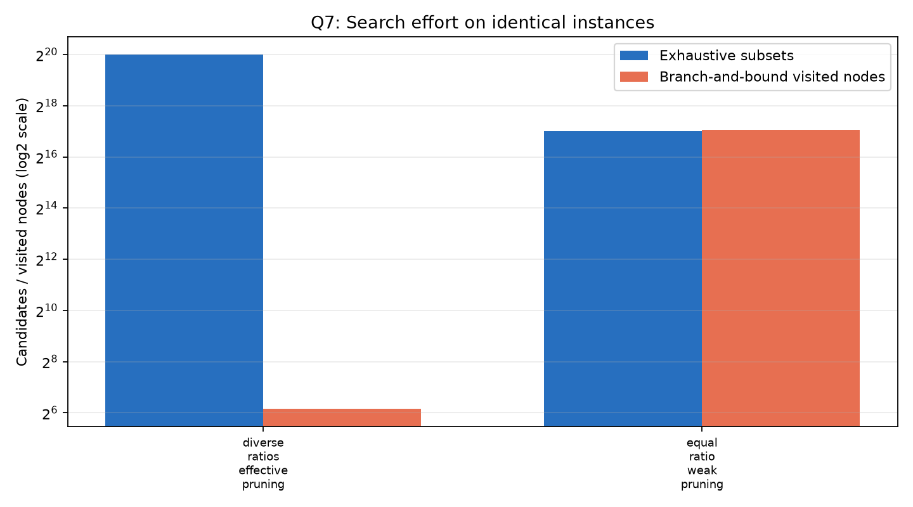
Figure 6. Search effort on identical original and redesigned instances.
Both methods receive the same generated packages and capacity in each row. Output IDs are checked against the input set and both weights against capacity; values must agree.

F. Defend the final design (2 marks)
diverse_ratios_effective_pruning: BnB evaluated 2 complete leaves versus 1048576 exhaustive subsets (100.0% fewer complete candidates), visited 71 total nodes, and pruned 34 nodes. One measured run took 2.295861s exhaustive and 0.000095s including BnB preprocessing (observed ratio 24218.7x). In the equal-ratio case, BnB visited more total nodes than there are baseline subsets despite evaluating fewer leaves, illustrating weak pruning and per-node overhead. Timing ratios from tiny single runs are noisy; the candidate counts are stronger evidence. BnB remains exponential in the worst case, and exhaustive search remains competitive for sufficiently small n.
equal_ratio_weak_pruning: BnB evaluated 35750 complete leaves versus 131072 exhaustive subsets (72.7% fewer complete candidates), visited 136135 total nodes, and pruned 32318 nodes. One measured run took 0.257754s exhaustive and 0.142442s including BnB preprocessing (observed ratio 1.8x). In the equal-ratio case, BnB visited more total nodes than there are baseline subsets despite evaluating fewer leaves, illustrating weak pruning and per-node overhead. Timing ratios from tiny single runs are noisy; the candidate counts are stronger evidence. BnB remains exponential in the worst case, and exhaustive search remains competitive for sufficiently small n.

Overall Conclusions
Elementary algorithms remain useful when inputs are small or structurally favorable: insertion sort fits nearly ordered batches, sequential search fits small unsorted records, and brute-force geometric methods provide auditable baselines. Their operation counts expose where input structure matters. Exhaustive knapsack is exact but scales as 2^n; fractional-bound branch-and-bound reduced search on favorable instances while retaining exponential worst-case behavior. Choose a method from the measured workload and resource budget rather than a universal timing threshold.

Viva Preparation
Q: Why does insertion sort perform well on nearly sorted input? A: Its shifts are proportional to inversions; a small number of displaced items causes relatively little work.
Q: Why does selection sort still make many comparisons on sorted data? A: It scans the remaining suffix to find each minimum regardless of input order.
Q: Why does a sequential-search miss take n comparisons? A: Every record must be ruled out in the absence of an index.
Q: How are overlapping string matches found? A: The next alignment starts one position later, not after the matched pattern.
Q: Why compare squared distances? A: Squaring preserves nonnegative distance order and avoids repeated square roots.
Q: What does a zero orientation determinant mean? A: The three points are collinear.
Q: How many unordered pairs are there among n points? A: n(n-1)/2, by summing the inner-loop lengths.
Q: Why include the empty knapsack subset? A: It is always feasible for nonnegative capacity and establishes value zero as a baseline.
Q: Why is the fractional bound valid? A: Allowing a fraction of an item relaxes the 0/1 constraint, so the relaxed optimum cannot be below the 0/1 optimum.
Q: Does branch-and-bound guarantee polynomial time? A: No. Its worst case remains exponential when the bound cannot prune enough.
Q: Why are operation counts useful alongside timing? A: They are less sensitive to machine load and expose the algorithm's measured work.
Q: When could a hash table improve sequential lookup? A: With frequent repeated lookups, if indexing/maintenance and memory costs are justified by the workload.

References
No external algorithmic sources were consulted. Definitions, pseudocode, and complexity arguments are presented as part of this assignment; measured results are generated by the included code.

