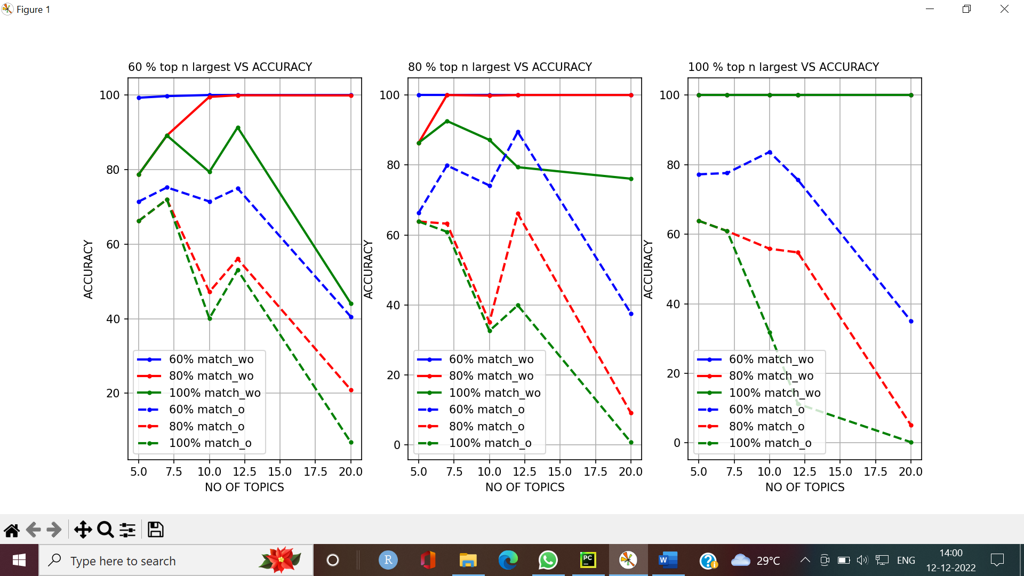

OBSERVATIONS:

* We have taken 60 %, 80 % and 100 % of the top n largest values from the probability distribution and plotted line graphs (NO OF TOPICS vs ACCURACY).
* This is done for three instances of each (60%,80%and 100% of the top n largest value selected)
* The above interpretation using line plots was done for two different criteria.
* These are done for topics **5,7,10,12 and 20**

1)TOPIC PROBABILITIES **WITH OUT CONSIDERING ORDER**

2)TOPIC PROBABILITIES **CONSIDERING ORDER**

**And our observations are as follows:**

**60 % of top n largest: (A)**

|  |  |
| --- | --- |
| **60 % of A** |  |
| **1: without order:** | **1: with order** |
| Max accuracy of 100 %(topic 5 to topic 20) | Max accuracy when no: of topics equals  **7 and 12)** |
| **80 % of A** |  |
| Max accuracy of 100 % from topic 10 to topic 20 | Max accuracy at topic 7, decreases, increases again  At topic 12, then decreases |
| **100 % of A** |  |
| Max accuracy at topic 7 | Max accuracy at topic 7, again a slight increase at  topic 12 then decreases. |
|  |  |

**80 % of top n largest:**

|  |  |
| --- | --- |
| **60 % of B** |  |
| **1: without order:** | **1: with order** |
| Max accuracy of 100 %(topic 5 to topic 20) | Max accuracy at topic 12. |
|  |  |
|  |  |
| **80 % of B** |  |
| Max accuracy of 100 % from topic 7 to topic 20 | Max accuracy at topic 7 and 12. |
|  |  |
|  |  |
| **100 % of B** |  |
| Max accuracy at topic 7 and topic 12 | Max accuracy at topic 7 |
|  |  |

**100 % of top n largest:(C)**

|  |  |
| --- | --- |
| **60 % of C** |  |
| **1: without order:** | **1: with order** |
| 100% accuracy from topic 5 to topic 20 | Max accuracy of 100 % at 10 topics |
|  |  |
|  |  |
| **80 % of C** |  |
|  | Max accuracy at 5 topics |
| 100% accuracy from topic 5 to topic 20 |  |
|  |  |
| **100 % of C** |  |
|  | Max accuracy at topic 5 |
| 100% accuracy from topic 5 to topic 20 |  |

**INTERPRETATION:**

**The best accuracies are obtained at:**

**1:without order:**