Task 1:

Docker hub link: <https://hub.docker.com/repository/docker/vkalaiaz/helloworld>

GCP screenshots

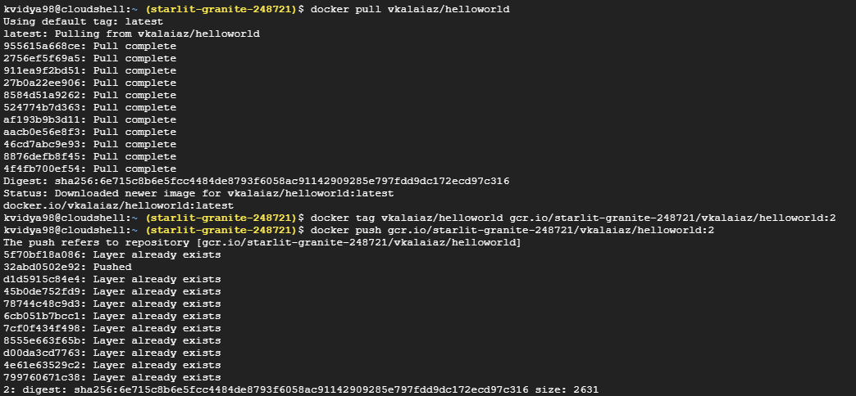

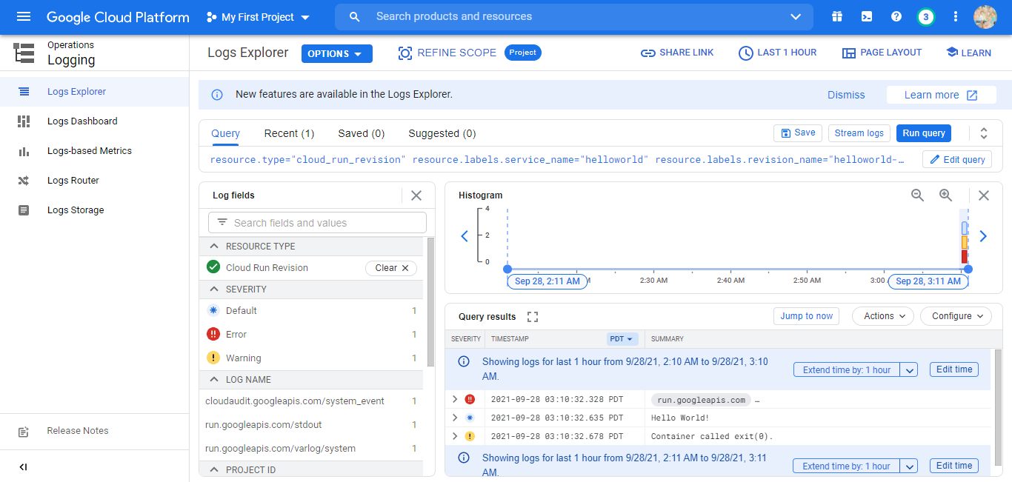

Dockerfile

FROM python:latest

COPY . /usr/src/myapp

WORKDIR /usr/src/myapp

CMD ["python","hello.py"]

hello.py

print("Hello World!")

Task 2

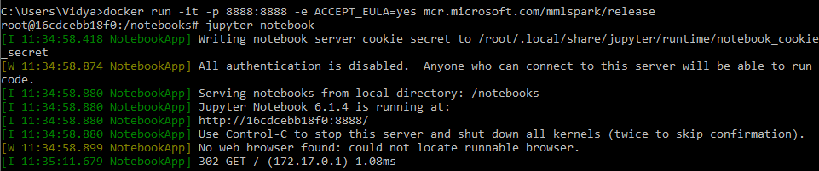

Output of running http://localhost:8888

