QUERY 1:

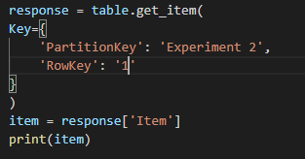

RESPONSE

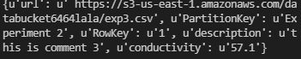

QUERY 2:

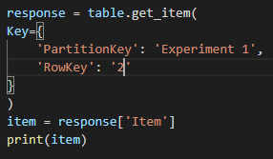

RESPONSE

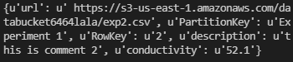

QUERY 3:

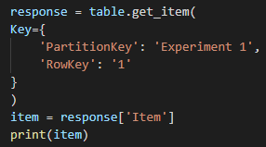

RESPONSE

