1.Write a Python program which accepts the

user's first and last name and print them in

reverse order with a space between them

fname = input("Enter the First name: ")

lname = input("Enter the last name: ")

print (lname,fname)

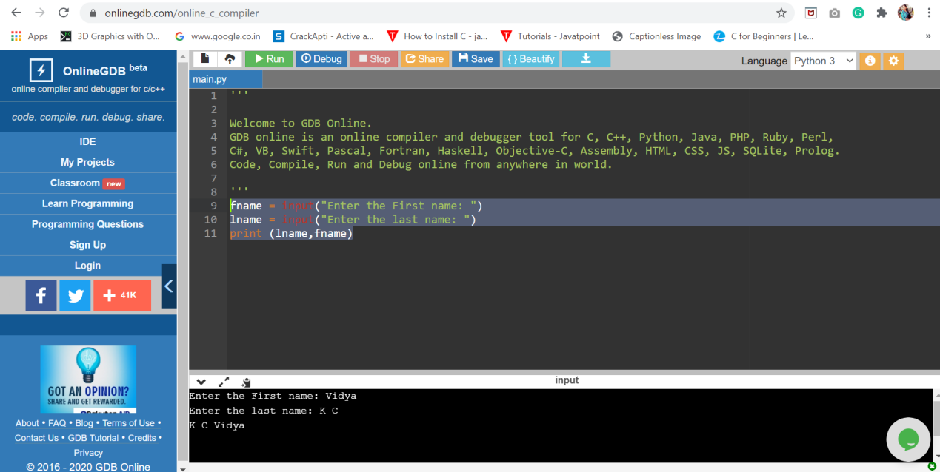

1. Write a Python program to calculate number of days between two dates.

from datetime import date

d1 = date(2020, 2, 16)

d2 = date(2020, 6, 22)

totaldays = d2 - d1

print(totaldays.days,"days")

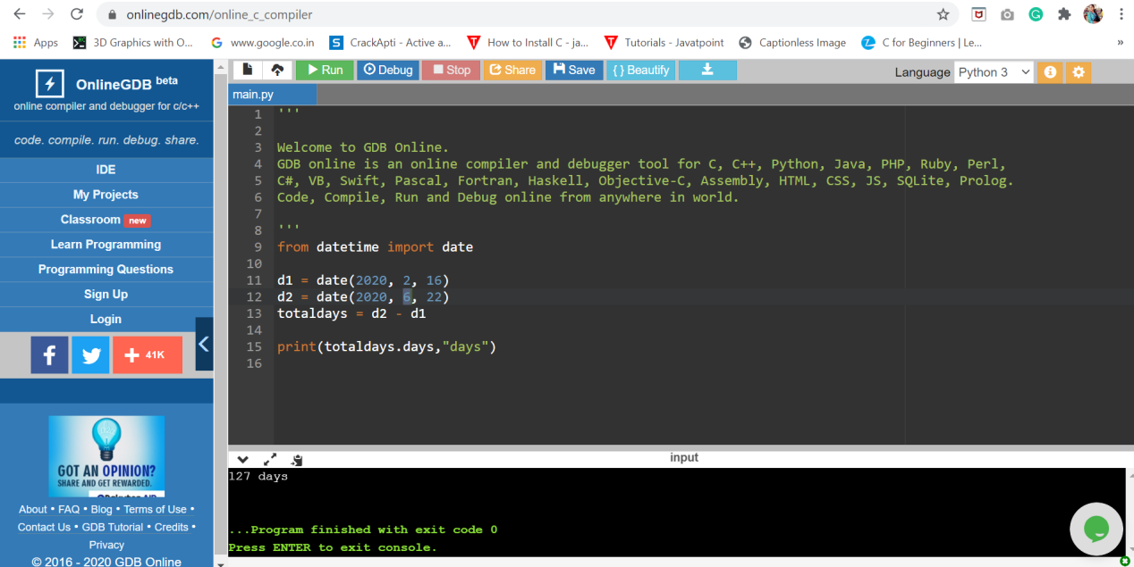

3.Write a Python program to test whether a

passed letter is a vowel or not

c = input("Enter the letter: ")

if(c=='a' or c=='e' or c=='i' or c=='o' or c=='u' or c=='A' or c=='E' or c=='I' or c=='O' or c=='U'):

print("The given letter is a vowel")

else:

print("The given letter is not a vowel")

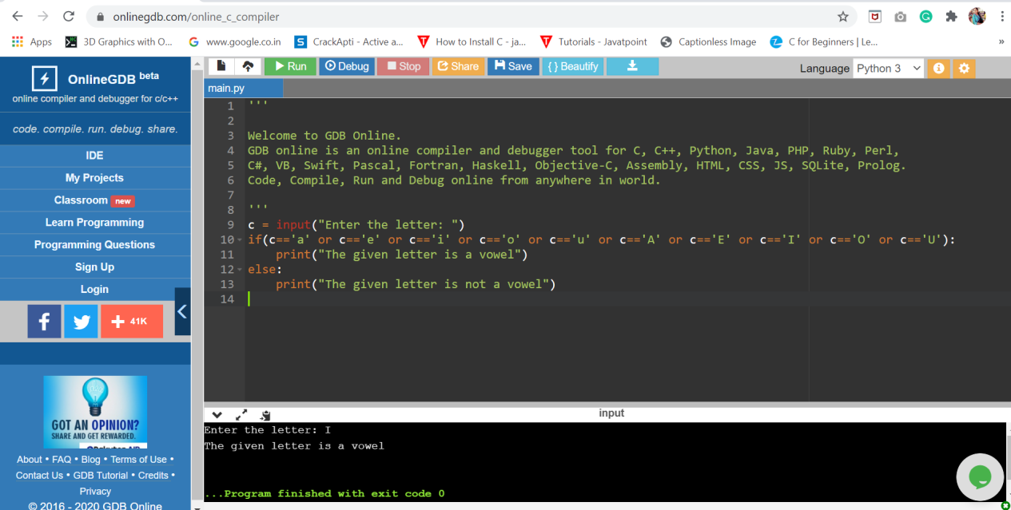

4.Write a Python program to sum of three given integers. However, if two values are equal sum will be zero.

a = int(input("Enter the 1st number: "))

b = int(input("Enter the 2nd number: "))

c = int(input("Enter the 3rd number: "))

if(a==b or a==c or b==c):

print("Sum = 0")

else:

sum=a+b+c

print("Sum=",sum)

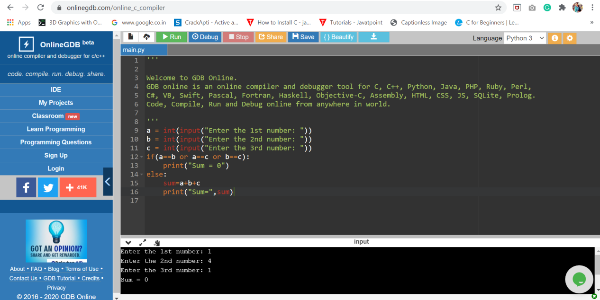

1. Write a Python program to count the number of characters (character frequency) in a string.

str = input("Enter the string: ")

frequency = {}

for char in str:

if char in frequency:

frequency[char] += 1

else:

frequency[char] = 1

print ("character frequency in",str,"is:\n",frequency)

