1.Write a Python program to count the occurrences of each

word in a given sentence.

s=str(input("Enter the sentence: "))

d={}

for word in s.split():

if word in d:

d[word]+=1

else:

d[word]=1

print (d)

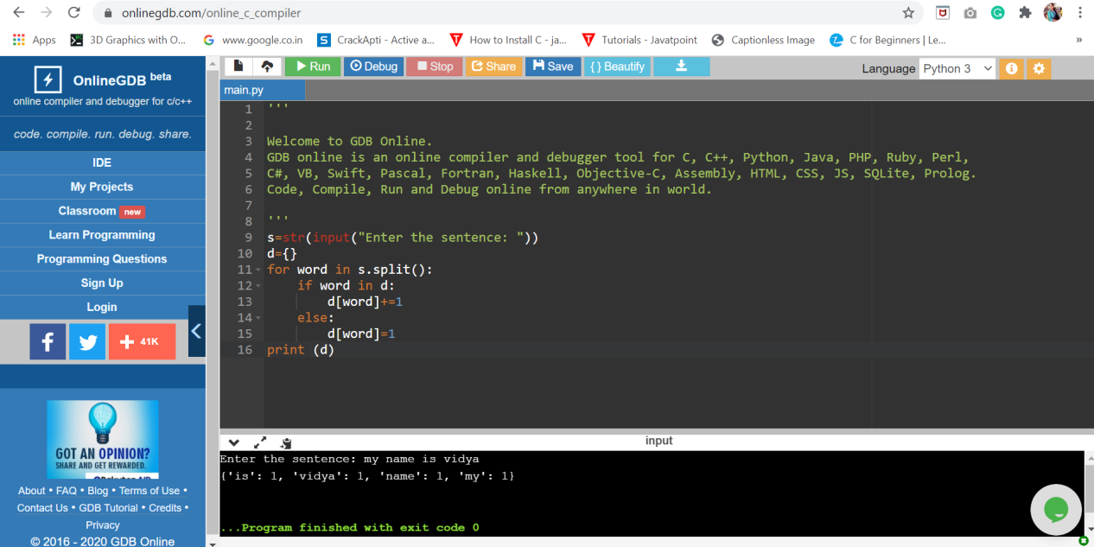

2.Write a Python program to remove duplicates from a list.

l=[1,2,4,9,4,1,5]

unique_list=list()

for i in l:

if i not in unique_list:

unique_list.append(i)

print(unique_list)

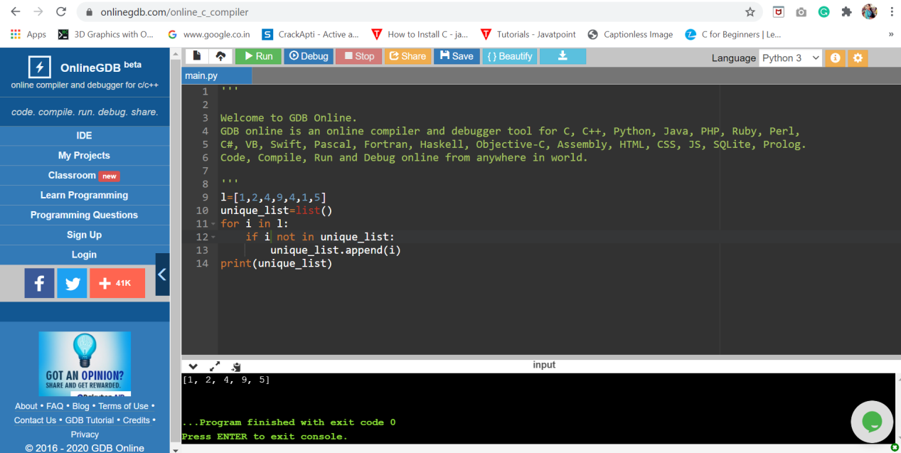

1. Write a Python program to count the number of elements in a list within a specified range.

m=int(input("Enter the staring range: "))

n=int(input("Enter the ending range: "))

count=0

l=[90,10,12,14,20,15,50,94,85]

for i in l:

if i>=m and i<=n:

count+=1

print("Number of elements with in the given range is ",count)

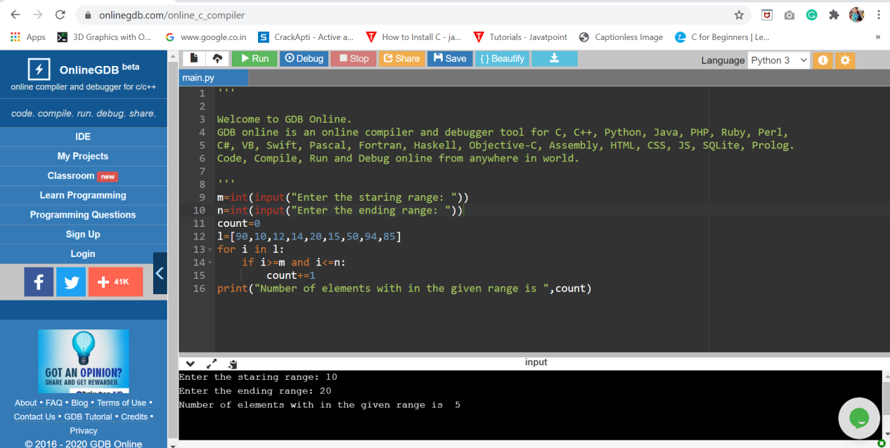

4.Write a Python script to merge two Python dictionaries

d1={'a':97,'b':98,'c':99}

d2={'d':100,'e':101}

d=d1.copy()

d.update(d2)

print(d)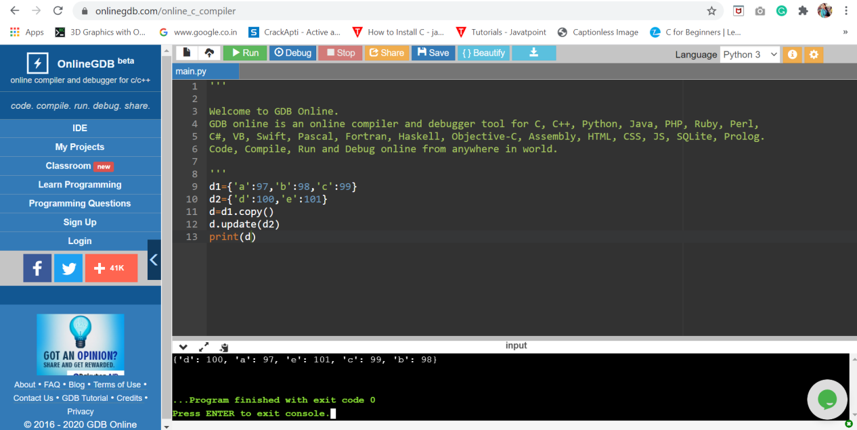

5.Write a Python program to find the highest 3 values in a dictionary.

from collections import Counter

# Initial Dictionary

my_dict = {'A': 67, 'B': 23, 'C': 45,

'D': 56, 'E': 12, 'F': 69}

k = Counter(my_dict)

# Finding 3 highest values

high = k.most_common(3)

print("Initial Dictionary:")

print(my_dict, "\n")

print("Dictionary with 3 highest values:")

print("Keys: Values")

for i in high:

print(i[0]," :",i[1]," ")

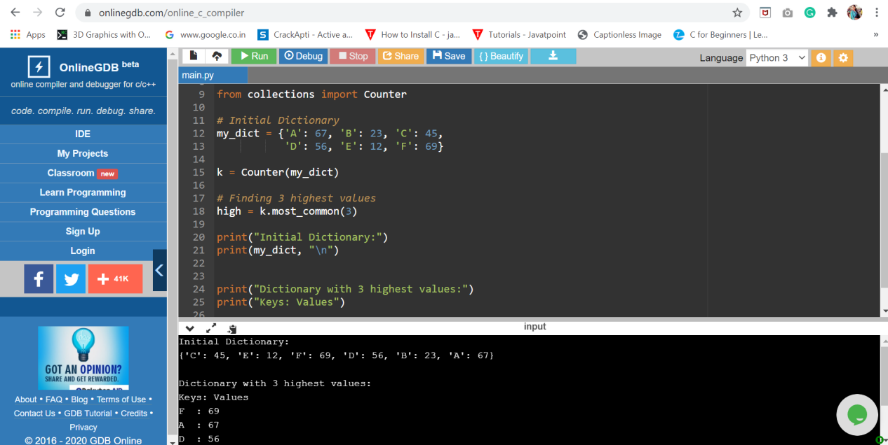

6.Write a Python program to convert a tuple to a string.

t=('v','i','d','y','a')

str="".join(t)

print(str)

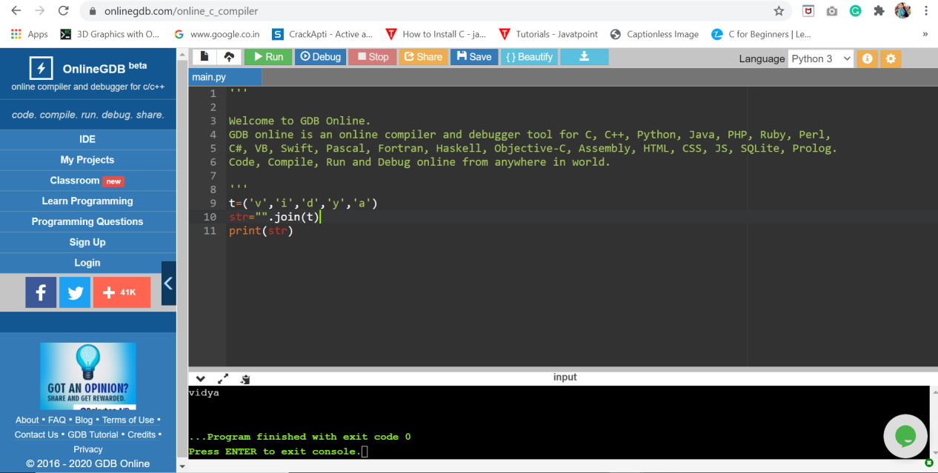

1. Write a Python program to reverse a tuple.

t1=('v','i','d','y','a')

t2=(10,20,30,40,50)

print("The reversed tuples are")

print(t1[::-1])

print(t2[::-1])

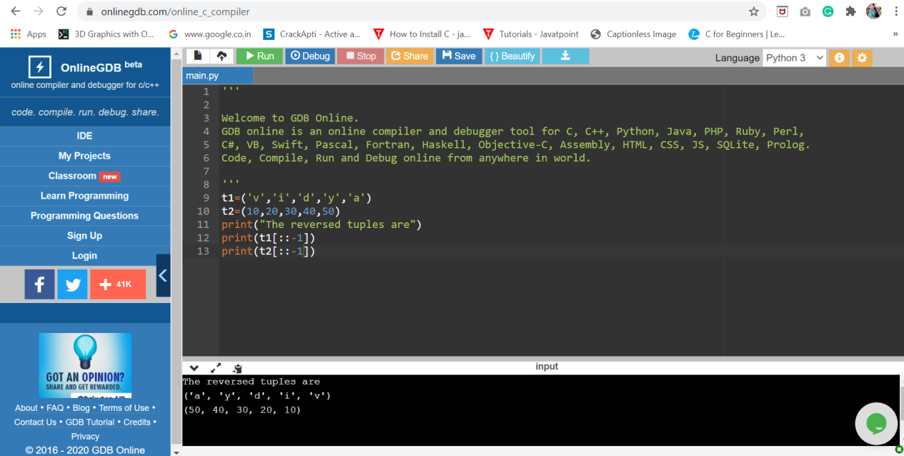

8.Write a Python program to remove existing indentation

from all of the lines in a given text.

import textwrap

sample_text = '''

Python is a widely used high-level, general-purpose, interpreted,

dynamic programming language. Its design philosophy emphasizes

code readability, and its syntax allows programmers to express

concepts in fewer lines of code than possible in languages such

as C++ or Java.

'''

text_without_Indentation = textwrap.dedent(sample_text)

print()

print(text_without_Indentation )

print()

