Container Management Shell
A Project Based Learning Report Submitted in partial fulfilment of the requirements for the award of the degree

of

Bachelor of Technology
in The Department of Computer Science Engineering
OPERATING SYSTEMS AND SYSTEMS PROGRAMMING 25CS2104E

Submitted by
2510030372 : Vidya Keerthi Chitturi
2510030403 : Badam Hasika
2510030225 : Shaik Asha Parveen
2510030158 : Madi Amulya

Under the guidance of
Dr. P. Kalpana


Department of Computer Science Engineering
Koneru Lakshmaiah Education Foundation, Aziz Nagar
Aziz Nagar – 500075
FEB - 2025.
Abstract

The Container Management Shell is a Linux-based command-line shell developed in the C programming language as part of the Project Based Learning component of the course Operating Systems and Systems Programming (25CS2104E). The primary objective of this project is to gain practical understanding of fundamental operating-system concepts by implementing them within a working command-line environment. Instead of treating operating-system mechanisms as isolated theoretical concepts, the project integrates them into a single application that demonstrates how user commands are processed, executed, and managed by the operating system. The development was carried out incrementally over ten weeks, with each milestone introducing new functionality while preserving the features implemented in previous stages.
The initial stages focused on establishing the basic structure of the shell through an interactive prompt and a Read-Evaluate-Print Loop (REPL). Dynamic memory allocation techniques, including malloc(), realloc(), and free(), were introduced to manage user input efficiently. Command parsing was implemented using tokenization to separate the input command into individual arguments. External command execution was subsequently added using process-management system calls such as fork(), execvp(), and waitpid(), enabling the shell to create child processes, execute programs, and coordinate their completion. In addition, built-in commands such as cd, pwd, clear, help, env, and exit were implemented to provide essential shell operations directly within the application.
The subsequent development stages introduced signal handling and inter-process communication. The shell uses SIGINT and SIGCHLD handling to demonstrate basic signal-driven process coordination and child-process management. Two-command pipelines were implemented using pipe() and dup2(), allowing the output of one command to serve as the input of another. The project also incorporates file descriptor management and input/output redirection using open(), close(), and dup2(). The supported redirection operations include standard output redirection (>), output appending (>>), standard input redirection (<), and standard error redirection (2>). These features demonstrate how processes communicate through file descriptors and how command execution can be modified by redirecting standard input and output streams.
Memory management, debugging, and reliability were addressed through the use of development and validation tools. Valgrind was used to inspect memory usage, GDB was used to examine program execution through breakpoints and backtraces, and AddressSanitizer was used to check for runtime memory errors. The recorded Valgrind test reported no definitely lost memory, but identified 272 bytes as possibly lost in one memory record associated with thread creation and thread-local storage. The error summary reported one error context. In the final development stage, POSIX thread support was introduced through pthread_create() and pthread_detach(). This enabled a detached monitoring thread to run alongside the interactive shell and periodically display a status message, demonstrating basic concurrent execution.
The project follows a modular design in which input handling, parsing, process execution, built-in commands, signal handling, pipes, redirection, and thread management are separated into source and header files. GCC and a Makefile support compilation, while Git and GitHub support version control and incremental development. The resulting application provides a practical demonstration of Linux/POSIX programming concepts, including process creation, inter-process communication, file descriptor manipulation, memory validation, signal handling, and threading. Overall, the project strengthens the understanding of how a command-line shell interacts with the operating system and establishes a foundation for future improvements, such as multi-stage pipelines, background command execution, job control, command history, advanced parsing, and shell scripting support.
Keywords: Operating Systems, Systems Programming, C Programming, Linux Shell, POSIX APIs, Process Management, Inter-Process Communication, I/O Redirection, Memory Validation, Multithreading.

List of Figures

Figure 1. Overall Command-Processing Flow of the Container Management Shell
Figure 2. Modular Architecture of the Container Management Shell
Figure 3. Two-Command Pipeline Using pipe() and dup2()
Figure 4. Memory Validation Results Using Valgrind
Figure 5. AddressSanitizer Build and Runtime Validation
Figure 6. Interactive Shell Execution in Ubuntu
Figure 7. Command Execution and Pipeline Results
Figure 8. Input and Output Redirection Results

List of Tables

Table 1. Development Methodology and Stages
Table 2. Functional Testing and Validation Results
Table of Contents

ABSTRACT
LIST OF FIGURES
LIST OF TABLES
1. INTRODUCTION
2. METHODOLOGY
2.1 Requirement Analysis
2.2 System Design and Modular Development
2.3 Implementation Approach
2.4 Tools and Technologies
2.5 Testing and Validation
2.6 Version Control and Integration
3. EXPERIMENTS
3.1 Experiment 1: Interactive Shell and Dynamic Input
3.2 Experiment 2: Command Parsing and Execution
3.3 Experiment 3: Built-in Commands
3.4 Experiment 4: Signal Handling
3.5 Experiment 5: Pipes and Inter-Process Communication
3.6 Experiment 6: Memory Management and Debugging
3.7 Experiment 7: File Descriptors and I/O Redirection
3.8 Experiment 8: POSIX Threads and Monitoring
3.9 Integration of Modules
4. RESULTS
4.1 Functional Results
4.2 Memory Management and Debugging Results
4.3 Multithreading Results
4.4 Summary of Results
5. CONCLUSION AND FUTURE WORK
5.1 Conclusion
5.2 Future Work
REFERENCES

Container Management Shell

Introduction
An operating system is the fundamental software that manages computer hardware, system resources, memory, processes, and input/output operations. It provides an environment in which application programs can execute efficiently and allows users to interact with the computer system. One of the important interfaces provided by an operating system is the command-line shell. A shell accepts commands from the user, interprets them, and executes the requested operations. Although command-line shells such as Bash are widely used in Linux environments, understanding their internal working requires knowledge of several operating-system concepts, including process management, memory allocation, file handling, inter-process communication, signal handling, and concurrency. The Container Management Shell project was developed as part of the Project Based Learning component of the course Operating Systems and Systems Programming (25CS2104E). The project focuses on implementing a simplified Linux-based command-line shell using the C programming language. Its primary purpose is to transform theoretical knowledge of operating systems into practical programming experience by integrating different system-level mechanisms into a single working application. The development was carried out incrementally over ten weeks, with each stage introducing additional functionality while maintaining the features implemented during previous stages. The initial stage involved developing an interactive command prompt and a Read-Evaluate-Print Loop (REPL), which allows the shell to repeatedly accept user input, process commands, display results, and return to the prompt. Dynamic memory allocation techniques were incorporated to handle command input of varying lengths. The input was then divided into individual tokens and arguments using command-parsing techniques. External command execution was implemented using system calls such as fork(), execvp(), and waitpid(). These functions demonstrate how a shell creates child processes, executes external programs, and coordinates process completion. In addition, built-in commands such as cd, pwd, clear, help, env, and exit were implemented to provide common shell operations. As development progressed, the project incorporated signal handling and inter-process communication. The shell uses SIGINT and SIGCHLD to demonstrate basic process coordination and handling of keyboard interrupts and completed child processes. Pipes were implemented using pipe() and dup2(), allowing the output of one command to be passed directly as input to another. The project also supports input and output redirection, including output writing, appending, input reading, and error redirection. These operations use file-handling and file-descriptor functions such as open(), close(), and dup2(), demonstrating how programs can interact with files through standard input, standard output, and standard error streams. Memory management and program reliability were addressed through debugging and validation tools, including Valgrind, GDB, and AddressSanitizer. These tools were used to inspect memory usage, examine program execution, and check for runtime memory errors. The final development stage introduced POSIX thread support through pthread_create() and pthread_detach(). This enables a detached monitoring thread to run alongside the interactive shell and periodically display a status message, demonstrating basic concurrent execution. The project follows a modular architecture in which input handling, parsing, process execution, built-in commands, signal handling, pipes, redirection, and thread management are organized into separate source and header files. GCC and a Makefile support compilation, while Git and GitHub support version control throughout development. Overall, the Container Management Shell provides practical exposure to Linux system programming and demonstrates how different operating-system mechanisms work together within a command-line application. It serves as an educational implementation rather than a replacement for established production shells. The experience gained through this project also provides a foundation for future enhancements, including multi-stage pipelines, background command execution, job control, command history, advanced parsing, and shell scripting support.

METHODOLOGY
The methodology adopted for the development of the Container Management Shell follows an incremental and modular approach. The project was completed over ten weeks, with each phase focusing on implementing a specific operating-system concept and integrating it into the existing shell. This approach made it possible to develop, compile, test, and improve individual components before moving on to more advanced functionality. The primary objective of the methodology was to establish a functional command-line shell while gaining practical experience with C programming, Linux system calls, and POSIX APIs.

2.1 Requirement Analysis
The initial phase involved identifying the essential features required for a command-line shell. These included an interactive command prompt, dynamic input handling, command parsing, execution of external programs, and support for built-in commands. The requirements were expanded in subsequent stages to include signal handling, inter-process communication, memory validation, file input/output redirection, and multithreading. Each weekly milestone was planned to introduce new functionality without unnecessarily disrupting previously implemented features.

2.2 System Design and Modular Development
The shell was designed using a modular architecture in which different responsibilities were separated into individual source and header files. The input module handles command-line input, while the parser module converts the input into tokens and arguments. The process module manages the execution of external commands, and the built-in module handles commands that must be executed directly by the shell. Separate modules were also developed for signal handling, pipes, file redirection, and thread management. This organization improves readability, simplifies debugging, and makes individual components easier to maintain and extend.

Table 1. Development Methodology and Stages

Stage | Development Activity | Description
1 | Requirement Analysis | Identify the shell's required features, including command execution, built-in commands, pipes, redirection, and monitoring.
2 | Shell Design | Design the shell structure, command-processing flow, and modular C implementation.
3 | Input Handling | Implement dynamic command-line input using malloc(), realloc(), and free().
4 | Command Parsing | Parse user input into commands and arguments using strtok() and dynamic argument arrays.
5 | Process Management | Execute external commands using fork(), execvp(), and waitpid().
6 | Built-in Commands | Implement built-in commands such as cd, pwd, clear, help, env, and exit.
7 | Signal Handling | Handle signals such as SIGINT and SIGCHLD.
8 | Pipes and IPC | Implement two-command pipelines using pipe() and dup2().
9 | Memory Debugging | Validate memory behavior using Valgrind, GDB, and AddressSanitizer.
10 | I/O Redirection | Implement input, output, append, and standard-error redirection using file descriptors.
11 | Thread Monitoring | Add a detached monitoring thread using pthread_create() and pthread_detach().
12 | Testing and Validation | Test implemented features and review execution behavior, memory reports, and runtime output.

2.3 Implementation Approach
The implementation was carried out progressively through ten development milestones. The first stage established the interactive shell and its Read-Evaluate-Print Loop (REPL). Dynamic memory allocation was then introduced to handle user input, followed by tokenization and argument parsing. Process creation and external command execution were implemented using fork(), execvp(), and waitpid(). Built-in commands such as cd, pwd, clear, help, env, and exit were subsequently added.
Later stages focused on signal handling using SIGINT and SIGCHLD, followed by two-command pipelines using pipe() and dup2(). Memory management and debugging were addressed through Valgrind, GDB, and AddressSanitizer. File descriptor management was implemented to support input redirection (<), output redirection (>), append redirection (>>), and error redirection (2>). Finally, POSIX thread support was introduced through pthread_create() and pthread_detach(), enabling a detached monitoring thread to run alongside the interactive shell.

2.4 Tools and Technologies
The project was implemented in the C programming language and developed in a Linux/Ubuntu environment. GCC was used to compile the source files, while the Makefile provided a consistent method for building and running the application. Linux/POSIX APIs were used for process management, memory allocation, signal handling, inter-process communication, file descriptor operations, and thread creation. Git and GitHub were used for version control and to maintain the project's development history.
Valgrind was used to examine memory usage and check for memory-related errors. GDB supported debugging through breakpoints, step-by-step execution, variable inspection, and backtraces. AddressSanitizer was used to check for runtime memory errors in an instrumented build. These tools supported systematic validation during development.

2.5 Testing and Validation
Testing was performed throughout development rather than only after the entire project was completed. Each newly implemented feature was compiled and tested before being integrated with the existing shell. Functional testing covered command execution, built-in commands, signal response, two-command pipelines, file input/output redirection, and monitoring-thread output. Memory validation was performed using the available debugging tools. The recorded Valgrind result reported that all heap blocks were freed and that the error summary contained zero errors.

2.6 Version Control and Integration
Git and GitHub were used to track changes across the development milestones. After implementing and testing features, the changes were committed to the repository. The Makefile was updated whenever new source files or compilation requirements were introduced. This incremental integration process helped maintain a consistent project structure and provided a record of the development progress.
Overall, the methodology combined requirement analysis, modular design, incremental implementation, functional testing, debugging, and version control. By introducing operating-system concepts in stages and integrating them into one application, the project provided a structured and practical approach to understanding the internal mechanisms of a Linux command-line shell.

EXPERIMENTS
The experiments conducted during the development of the Container Management Shell focused on implementing and validating fundamental operating-system concepts in a Linux environment. Each experiment introduced a specific feature, which was integrated into the existing shell and tested to verify its expected behavior. The implementation was carried out in C using Linux/POSIX APIs, with GCC and a Makefile used for compilation.
3.1 Experiment 1: Interactive Shell and Dynamic Input
The initial experiment involved developing an interactive command-line interface using a Read-Evaluate-Print Loop (REPL). The shell displays a prompt, accepts user input, processes the command, and returns to the prompt for the next command. Dynamic memory allocation functions such as malloc(), realloc(), and free() were incorporated to manage input of varying lengths and release allocated memory when it was no longer required.
3.2 Experiment 2: Command Parsing and Execution
The second experiment focused on converting user input into executable commands. The parser uses strtok() to separate a command line into individual tokens and constructs an argument array. External command execution was implemented using fork(), execvp(), and waitpid(). The shell creates a child process, executes the requested program in that process, and waits for its completion. Error handling was included to report failures during process creation or command execution.
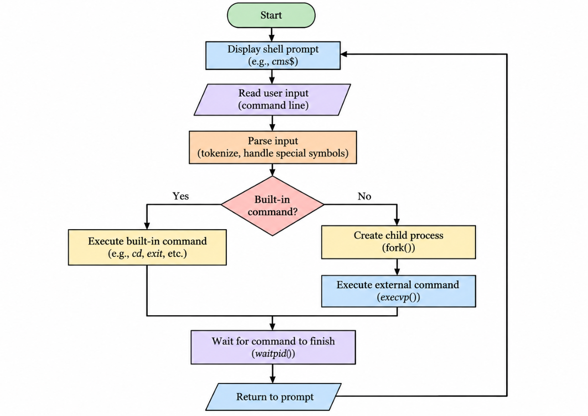
Figure 1: Overall Command-Processing Flow of the Container Management Shell
3.3 Experiment 3: Built-in Commands
This experiment introduced built-in commands that are handled directly by the shell instead of being executed as separate external programs. The implemented commands include cd, pwd, clear, help, env, and exit. These commands provide basic directory navigation, display of the current working directory, terminal clearing, help information, environment-variable display, and shell termination.
3.4 Experiment 4: Signal Handling
Signal handling was introduced to demonstrate how a shell responds to operating-system events. The implementation registers handlers for SIGINT and SIGCHLD. The SIGINT handler allows the shell to respond to the Ctrl+C keyboard interrupt, while SIGCHLD handling uses waitpid() with WNOHANG to reap completed child processes. This experiment demonstrates basic signal handling and process coordination.
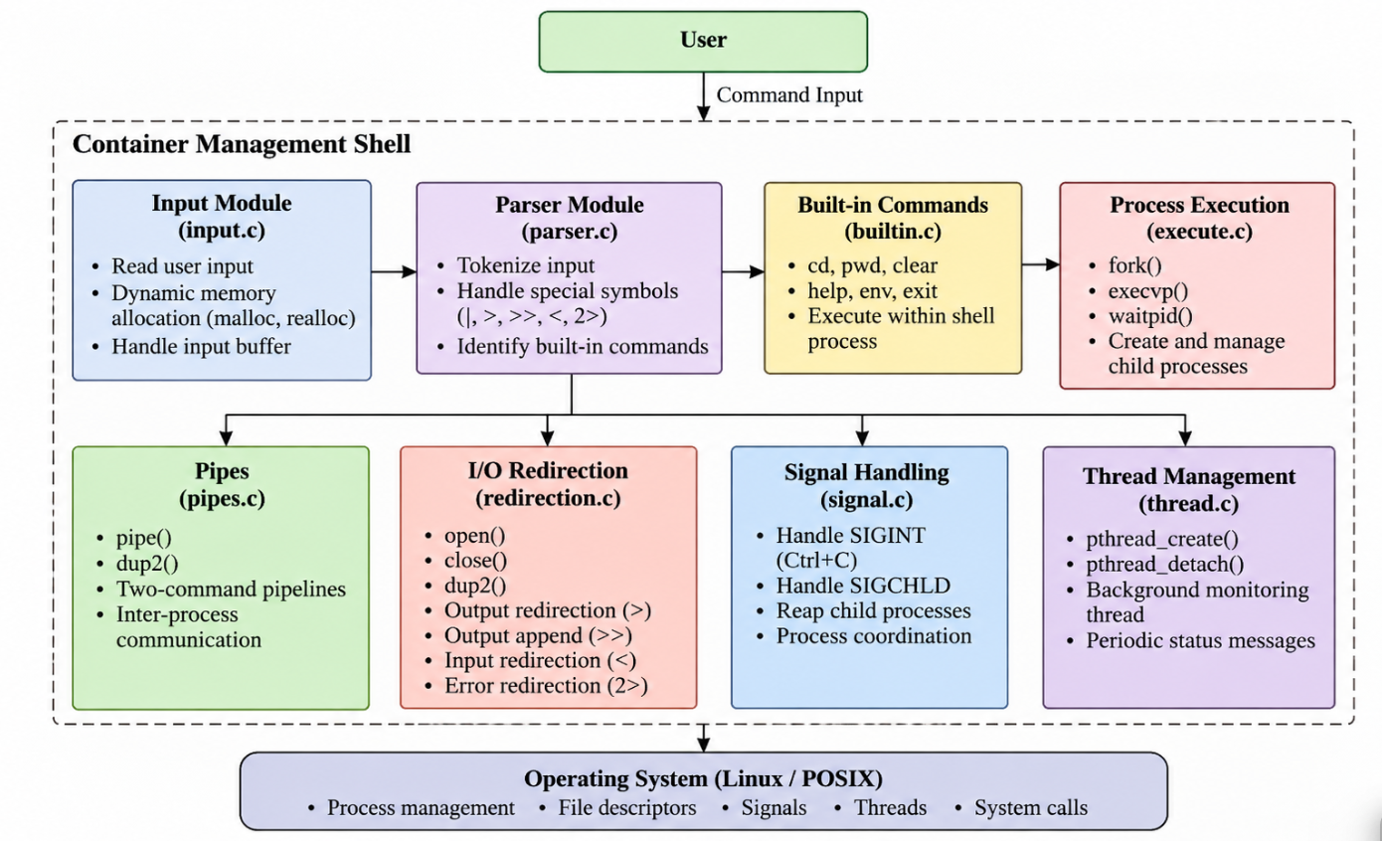
Figure 2: Modular Architecture of the Container Management Shell
3.5 Experiment 5: Pipes and Inter-Process Communication
The fifth experiment implemented communication between two commands using an anonymous pipe. The pipe() function creates a communication channel, while dup2() redirects the standard output of the first command to the pipe and the standard input of the second command to the pipe. The parent process closes unused file descriptors and waits for the child processes.
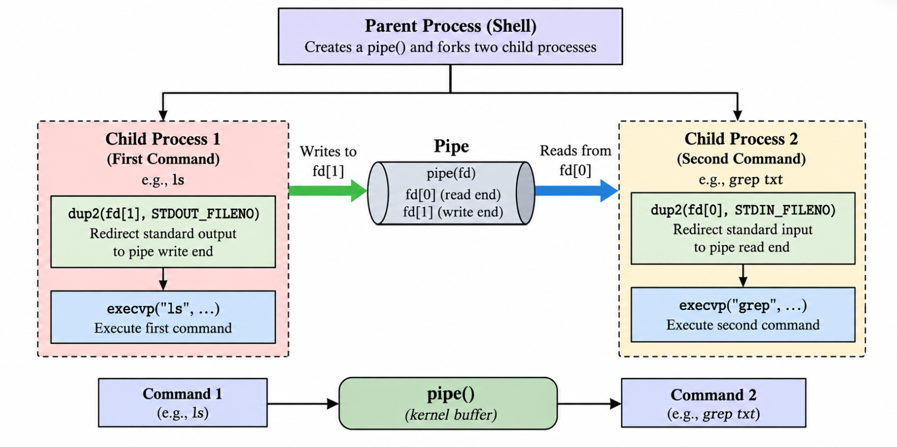Figure 3: Two-Command Pipeline Using pipe() and dup2()
3.6 Experiment 6: Memory Management and Debugging
This experiment focused on validating memory usage and examining program execution. Valgrind was used to check memory behavior, GDB was used for breakpoints, step-by-step execution, variable inspection, and backtraces, and AddressSanitizer was used with an instrumented build to check for runtime memory errors. The recorded Valgrind output indicated that all heap blocks were freed and the error summary contained zero errors.
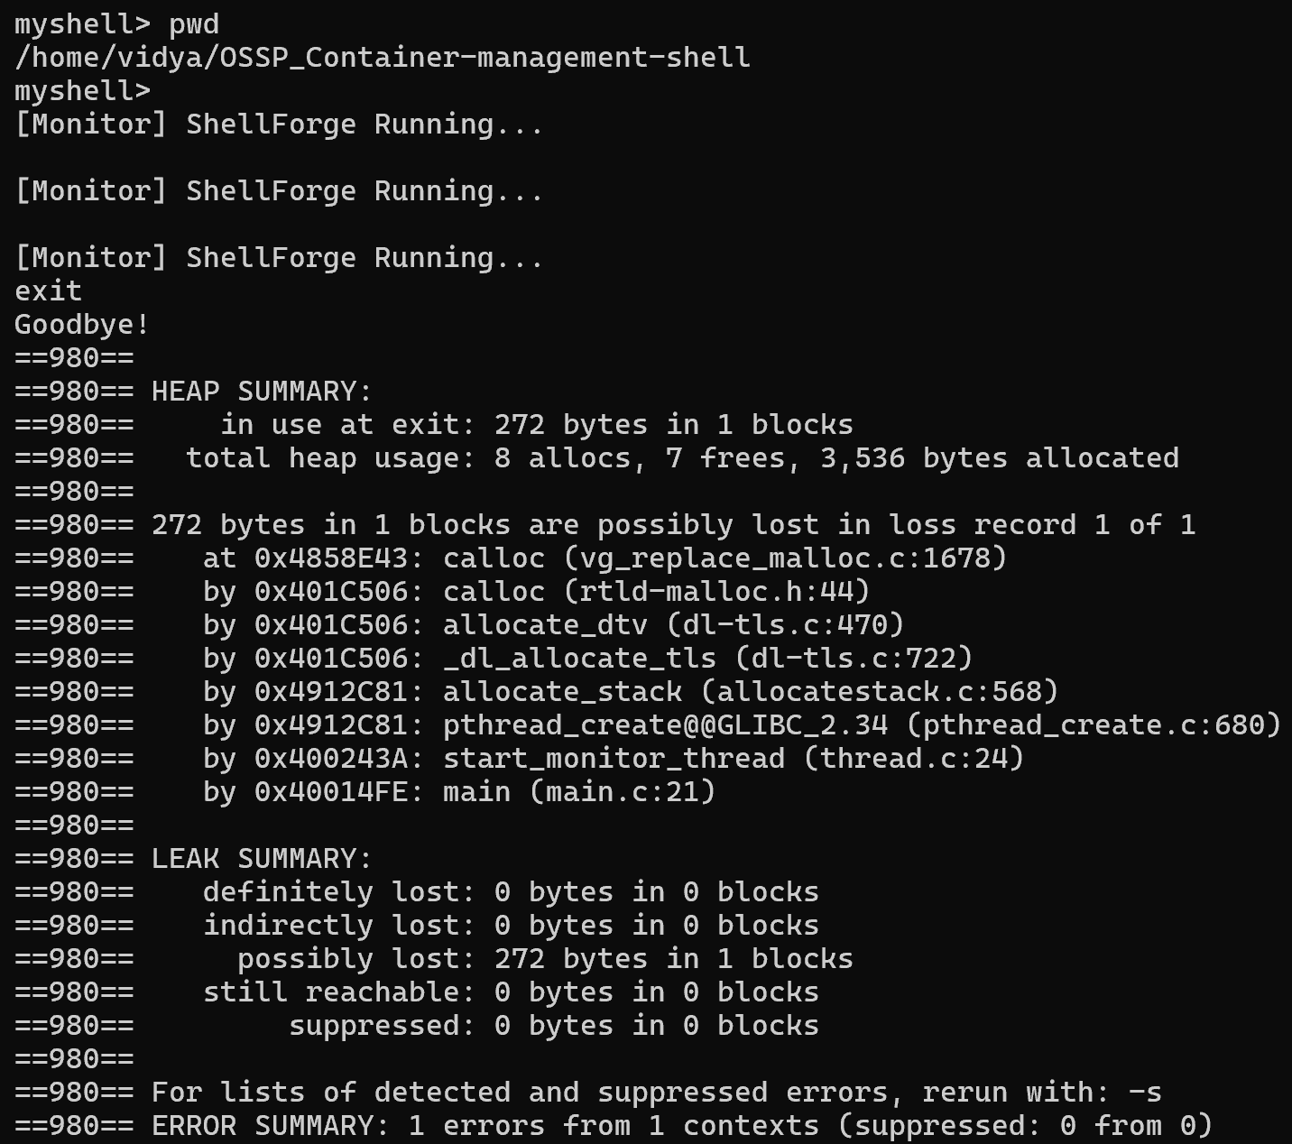
Figure 4. Memory Validation Results Using Valgrind
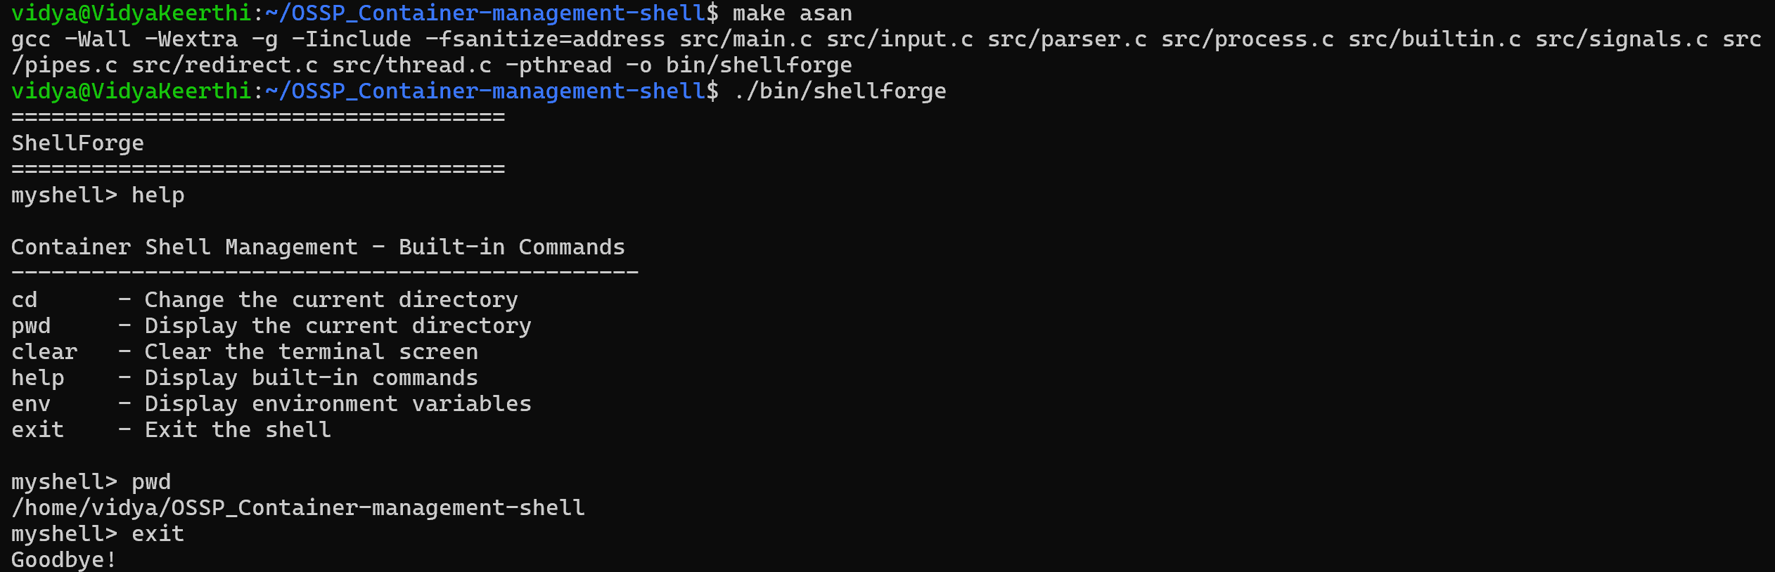
Figure 5. AddressSanitizer Build and Runtime Validation
3.7 Experiment 7: File Descriptors and I/O Redirection
File descriptor management was implemented to allow commands to read from or write to files. The functions open(), close(), and dup2() were used to manage file descriptors and redirect standard input, standard output, and standard error. The supported operators are > for output redirection, >> for appending output, < for input redirection, and 2> for error redirection. These features allow command output and errors to be stored in files and allow commands to process existing file contents.
  - Experiment 8: POSIX Threads and Monitoring
The final experiment introduced a detached monitoring thread using POSIX thread functions. The pthread_create() function starts the monitoring thread, which waits for ten seconds between status messages. The pthread_detach() function allows the thread to run independently without requiring a later join operation. This experiment demonstrates how a background thread can execute concurrently while the main shell remains available for user commands.
3.9 Integration of Modules
After individual features were implemented, the modules were integrated through the main program and Makefile. The input, parser, process execution, built-in commands, signal handling, pipes, redirection, and thread modules work together to provide the final shell functionality. The project was compiled and tested incrementally, while Git and GitHub were used to track changes and preserve the development history.

RESULTS
The development of the Container Management Shell resulted in a functional Linux-based command-line application implemented in C. The project successfully integrated operating-system concepts across ten development weeks, beginning with a basic interactive shell and progressing to process management, signal handling, inter-process communication, file descriptor redirection, memory validation, and multithreading. The implementation demonstrates how different Linux/POSIX mechanisms can work together within a single application.

4.1 Functional Results
The shell successfully accepts user commands through an interactive prompt, parses the input into arguments, and executes external programs. Built-in commands such as cd, pwd, clear, help, env, and exit provide basic shell functionality. Process creation and execution are handled using fork(), execvp(), and waitpid(), while signal handling supports responses to Ctrl+C and the management of completed child processes.
The implementation of pipes enables communication between two commands by redirecting the output of the first command to the input of the second. File input/output redirection was also implemented using open(), close(), and dup2(). The supported operations include output redirection (>), appending output (>>), input redirection (<), and error redirection (2>). These features allow commands to exchange data through pipes and interact with files through standard file descriptors.

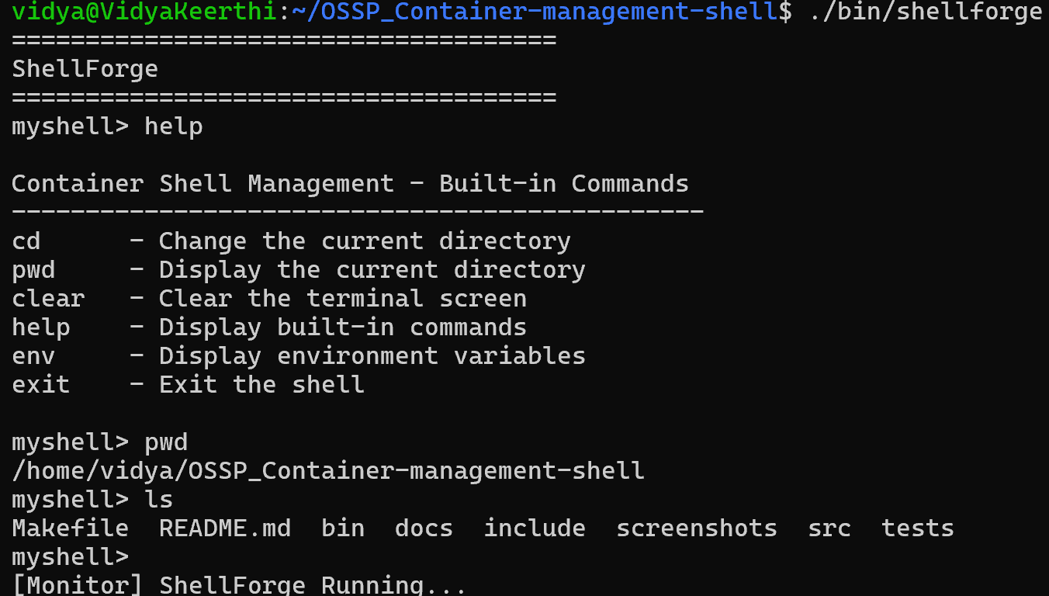
Figure 6. Interactive Shell Execution in Ubuntu

4.2 Memory Management and Debugging Results
Memory management and program execution were examined using Valgrind, GDB, and AddressSanitizer. Valgrind reported that all heap blocks were freed and that the error summary contained zero errors in the recorded test. GDB was used to set breakpoints, execute the program step by step, inspect variables, and view the backtrace. AddressSanitizer was used to compile and run an instrumented version of the program, with no runtime memory errors reported during the recorded test.
These results indicate that the tested execution completed without reported memory errors. However, they do not guarantee that every possible execution path is free from defects.

4.3 Multithreading Results
POSIX thread support was successfully incorporated into the shell through pthread_create() and pthread_detach(). A detached monitoring thread runs alongside the main shell and periodically displays a status message at ten-second intervals. This demonstrates basic concurrent execution while allowing the interactive shell to continue accepting user commands.

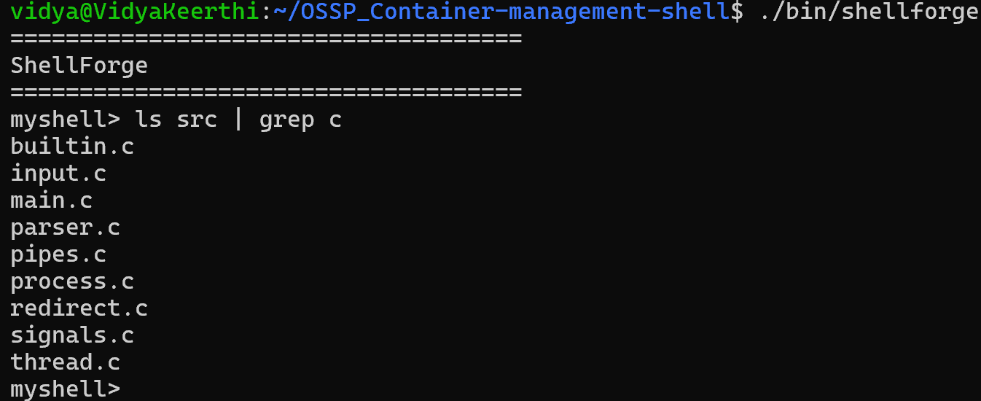
Figure 7 — Command Execution and Pipeline Results

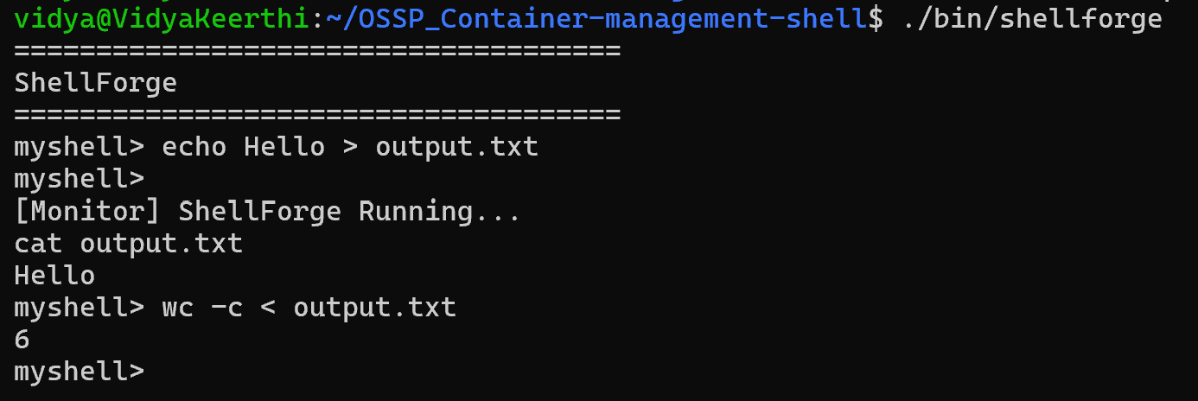
Figure 8. Input and Output Redirection Results

4.4 Summary of Results
The following table summarizes the major implemented features and their outcomes.

Table 2. Functional Testing and Validation Results
Feature | Result
Interactive shell | Accepts commands through a prompt and returns to the command loop.
Dynamic input and parsing | Handles command input and constructs argument arrays.
Process management | Executes external programs using process-related system calls.
Built-in commands | Supports basic shell operations.
Signal handling | Handles SIGINT and SIGCHLD.
Pipes | Supports two-command pipelines.
I/O redirection | Supports input, output, append, and error redirection.
Memory validation | Valgrind reported zero errors in the recorded test.
Debugging | GDB supported program inspection and execution tracing.
AddressSanitizer | No runtime memory errors were reported during the recorded test.
Monitoring thread | Displays periodic status messages using a detached POSIX thread.

Overall, the project achieved its primary objective of demonstrating core operating-system and systems-programming concepts through a working Linux shell. Its modular structure and incremental development approach helped integrate the features while maintaining the existing functionality. The final application provides a practical foundation for further development in areas such as advanced command parsing, multi-stage pipelines, background execution, job control, and shell scripting.

CONCLUSION and FUTURE WORK
5.1 Conclusion
The Container Management Shell project successfully demonstrated the practical implementation of fundamental operating-system concepts through a Linux-based command-line application developed in C. The project was completed incrementally over ten weeks, with each stage introducing new functionality while retaining the previously implemented features. Beginning with a basic interactive shell, the implementation progressed to dynamic input handling, command parsing, process management, built-in commands, signal handling, inter-process communication, memory validation, file descriptor management, and multithreading.
The use of Linux/POSIX APIs such as fork(), execvp(), waitpid(), pipe(), dup2(), open(), and close() provided practical experience with process creation, command execution, communication between processes, and input/output redirection. The implementation of pthread_create() and pthread_detach() further demonstrated how a monitoring thread can operate alongside the main shell. The modular organization of the source and header files made the application easier to understand, test, debug, and extend.
The project also emphasized the importance of memory management and software validation. Valgrind was used to examine memory usage, GDB supported program debugging, and AddressSanitizer was used to check for runtime memory errors. The recorded Valgrind test reported that all heap blocks were freed and that the error summary contained zero errors. Functional testing of commands, pipelines, redirection, and monitoring output helped verify the implemented features.
Overall, the project achieved its primary educational objective of connecting operating-system theory with practical systems programming. It provided experience in C programming, Linux system calls, process coordination, file descriptor handling, debugging, and concurrent execution. The completed application serves as a learning-oriented shell that demonstrates the internal mechanisms involved in command-line processing rather than attempting to replace established production shells.

5.2 Future Work
Although the current implementation demonstrates several essential operating-system concepts, additional features can be introduced to improve its functionality, flexibility, and usability.
- Multiple Pipelines: Extend pipeline handling to support more than two commands in a single command sequence.
- Background Execution and Job Control: Allow commands to execute in the background and provide facilities to manage running, stopped, and completed processes.
- Advanced Command Parsing: Improve the parser to support quoted arguments, escape characters, and more complex command structures.
- Command History: Maintain a history of previously executed commands to make repeated command execution easier.
- Environment Variable Expansion: Support the expansion of environment variables within user-entered commands.
- Additional Built-in Commands: Introduce further built-in operations to improve shell administration and usability.
- Improved Error Handling and Testing: Expand error reporting and develop automated test cases to verify the behavior of individual modules and integrated features.
- Enhanced Monitoring and Logging: Improve the monitoring thread to provide more useful status information and introduce structured logging where appropriate.
- Shell Scripting Support: Explore the implementation of basic scripting capabilities for executing sequences of commands automatically.
- Thread Synchronization: Extend the concurrency component with synchronization mechanisms such as mutexes and thread coordination where shared resources require protection.
These enhancements would expand the capabilities of the Container Management Shell and provide opportunities to explore more advanced operating-system concepts. The modular design established during the project provides a foundation for implementing and testing these improvements in future development stages.

References
[1] S. R. Bourne, “UNIX Time-Sharing System: The UNIX Shell,” Bell System Technical Journal, vol. 57, no. 6, pp. 1971–1990, 1978. doi: 10.1002/j.1538-7305.1978.tb02139.x.
[2] A. Kidwai, C. Arya, P. Singh, M. Diwakar, S. Singh, K. Sharma, and N. Kumar, “A Comparative Study on Shells in Linux: A Review,” Materials Today: Proceedings, vol. 37, part 2, pp. 2612–2616, 2021. doi: 10.1016/j.matpr.2020.08.508.
[3] “Performance Analysis of Five Interprocess Communication Mechanisms Across UNIX Operating Systems,” Journal of Systems and Software, vol. 68, no. 1, pp. 27–43, 2003. doi: 10.1016/S0164-1212(02)00134-6.
[4] M. Greenberg and A. J. Blatt, “Executable Formal Semantics for the POSIX Shell,” arXiv:1907.05308, 2019. Available: https://arxiv.org/abs/1907.05308.
[5] University of Chicago, “Project 4: The Unix Shell,” Operating Systems Course Project. Available: https://www.classes.cs.uchicago.edu/archive/2019/fall/15400-1/proj/p4/p4shell.html.

