Business Requirement Document
Table of Contents
Contents
Version Control 4
Revision History 4
Key Stakeholders 4
Executive Summary 4
Overview 4
Background 5
Objectives 5
Scope 5
Business Process of Import & Domestic purchase 6
Import Purchase 6
Domestic Purchase Process 9
Functional Requirements 11
Import Purchase Process: 12
Domestic Purchase Process: 13
Delivery Tracking: 14
Claims Management: 15
Sales Section: 16
Reporting & Analytics 17
General Application Features: 19
Non-Functional Requirements 19
Related Documents 20

Version Control

Revision History
Version | Date | Authorization | Responsibility (Author) | Description
1 | 13-09-2025 | Vidyalaxmi singh | Vidyalaxmi Singh

Key Stakeholders
No. | Designation | Name
1 | CEO
2 | Manager
3 | Developer

Executive Summary
The proposed web application aims to streamline the management of import and domestic purchases, sales tracking, and goods movement monitoring. By integrating automated tracking through APIs and providing structured forms for data entry, this solution will enhance the visibility of order details, shipment status, and claims management. The key objective is to centralize all critical data related to purchases, deliveries, claims and sales into one application to improve production planning and operational efficiency.

Overview
This project focuses on developing a comprehensive web-based application designed to manage import and domestic purchases, track delivery movements, handle claims effectively, record sales, and provides reporting with visual analytics through a dashboard. The system will allow users to input purchase details, upload necessary documents, and track shipments using container numbers, bill of landing number, etc., with automated updates through integrated APIs. It will also handle claims in case of any discrepancies in the received goods and display reports as visual insights on the dashboard.

Background
Currently, the processes for managing purchases, tracking shipments, and recording sales are handled separately, often relying on manual methods such as excel, which causes inefficiencies. Import purchases are especially complex due to international supply and documentation requirements. Meanwhile, domestic purchases and sales data are managed differently, leading to gaps in tracking and delays in production planning. The proposed system will consolidate all this data, making the process smoother, reducing errors, and improving overall coordination.

Objectives
The primary objective of this project is to create a single application that effectively manages:
- Import and domestic purchases of raw materials.
- Shipment tracking with real-time updates.
- Inspection details
- Claims related to purchase discrepancies.
- Sales records linked to the purchases
In other words, an integrated system for better material management, production and supply chain planning.

Scope
This subsection provides a brief description of the business areas covered by the project:
- Deal Management: Managing all aspects of both import and domestic deals, including order creation, tracking, and updating of deal-related information.
- Import Management: Handling the entire import process, from order placement to shipment tracking, documentation, and managing discrepancies in received goods.
- Invoice Processing: Managing and tracking invoices related to details, including the ability to upload, store, and review invoice documents for both imports and domestic purchases.
- Delivery Tracking: Monitoring the status and location of shipments, with real-time updates and milestone tracking for deliveries from international suppliers.
- Reporting and Analytics: Generating reports and providing insights through dashboards on key metrics such as deal progress, delivery status, invoice tracking, and overall system performance.
- User Access Management: Managing roles and permissions for different users within the system, ensuring appropriate access levels and security for sensitive data.

Business Process of Import & Domestic purchase

In practice, managing an import and domestic purchase involves several detailed steps and interactions between various teams within the buying and supplying organizations. Here's a step-by-step breakdown of how this process works:

Import Purchase
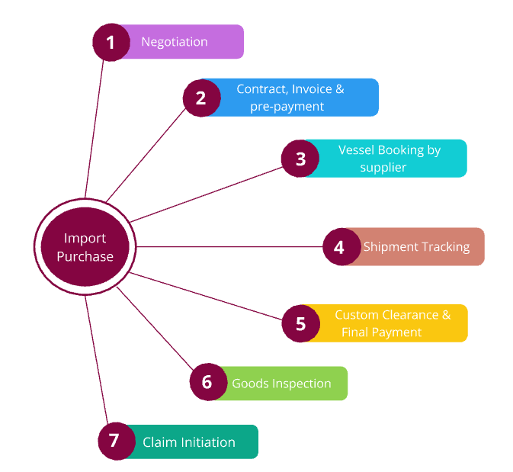
Fig.1 - Import Purchase
Negotiation Phase:
The process starts when the procurement team from the buyer company contacts an international supplier to negotiate the terms of the purchase. Let’s assume the buyer is looking to purchase 100 metric tons of foil scrap from a U.S.-based supplier at a negotiated price of $2,000 per ton.
After negotiations, the supplier sends a sales contract and proforma invoice (PI) to the buyer. These documents include the price, quantity, payment terms, shipping details, and expected timelines. These documents are crucial because they serve as the initial contract between the buyer and the supplier.

Documentation & Pre-payment:
The buyer reviews the proforma invoice and, based on the payment terms, makes an initial prepayment, which is typically around 10-20% of the total value. For instance, if the prepayment is 10%, the buyer pays $20,000.
The prepayment is made via bank transfer or another agreed method, and the buyer receives a payment receipt. This is an important document for both financial and tracking purposes.
After making the prepayment, the buyer logs this transaction in the system, recording the prepayment date, transaction code, and other relevant details.

Vessel Booking:
The supplier then begins the process of finding a vessel to ship the goods. This step can take several days to weeks, depending on vessel availability and shipping schedules.
Once a vessel is secured, the supplier sends the buyer the container number, vessel name, loading date, and other shipping details. This information is essential for tracking the shipment’s journey from the port of dispatch to the destination port.
The buyer inputs this shipping information into the system to begin tracking the shipment. The system will use APIs from shipping companies or third-party logistics providers to automatically update the container’s location in real-time as it moves across the ocean.

Shipment Tracking:
The shipment tracking process begins once the vessel leaves the port. The buyer can monitor the Estimated Time of Sailing (ETS) and the Estimated Time of Arrival (ETA), ensuring that everything is on schedule.
The system updates the buyer with real-time location data, which includes stops at intermediate ports, any delays due to weather or customs, and the container’s progress towards the final port.
Some aspects of tracking may still require manual entry, such as customs clearance or other local handling steps that the system’s APIs cannot cover.

Final Payment and Customs Clearance:
Once the shipment arrives at the destination port in India, the buyer is required to make the final payment before the goods can be cleared through customs. The supplier sends the buyer a final invoice, reflecting any additional costs, such as shipping or handling fees.
The buyer settles this invoice and logs the payment into the system. Afterward, the buyer works with a customs agent to clear the shipment, providing all necessary documentation like the Bill of Lading, import license, and customs declaration forms.

Goods Arrival and Inspection:
Once the shipment clears customs, it is transported to the buyer’s factory. When the goods arrive at the factory, the inspection process begins.
The buyer’s quality control team inspects the materials and compares them with the original order specifications. This inspection includes taking photos and videos to document the condition of the goods upon arrival.
For instance, if the buyer ordered 100 metric tons of foil scrap but received only 90 metric tons, with the remaining 10 metric tons being a different material (e.g., original foil), they document this issue thoroughly with media and written records.

Claims and Discrepancy Resolution:
If there are discrepancies in the shipment (e.g., wrong material, missing quantity, or damaged goods), the buyer initiates a claim with the supplier.
The buyer submits a claim request, attaching all relevant documentation, such as the photos, videos, and inspection report. The system helps track this claim by organizing all the necessary data and communications in one place.
The buyer and supplier then enter a negotiation process to resolve the issue. This could result in a return of the incorrect materials, a discount, or other agreed-upon terms. For instance, if the supplier agrees to replace the incorrect materials, a return shipment is arranged, and this process is recorded in the system.

Completion of Import Process:
The entire import purchase process, from the initial booking of the order to the goods arriving at the factory, typically takes 3-4 months.
During this period, the system tracks all the details, such as the original order date, payment milestones, shipment tracking, and claims, ensuring everything is well-documented and accessible for future reference.

Domestic Purchase Process
In contrast, domestic purchases are far simpler and quicker:
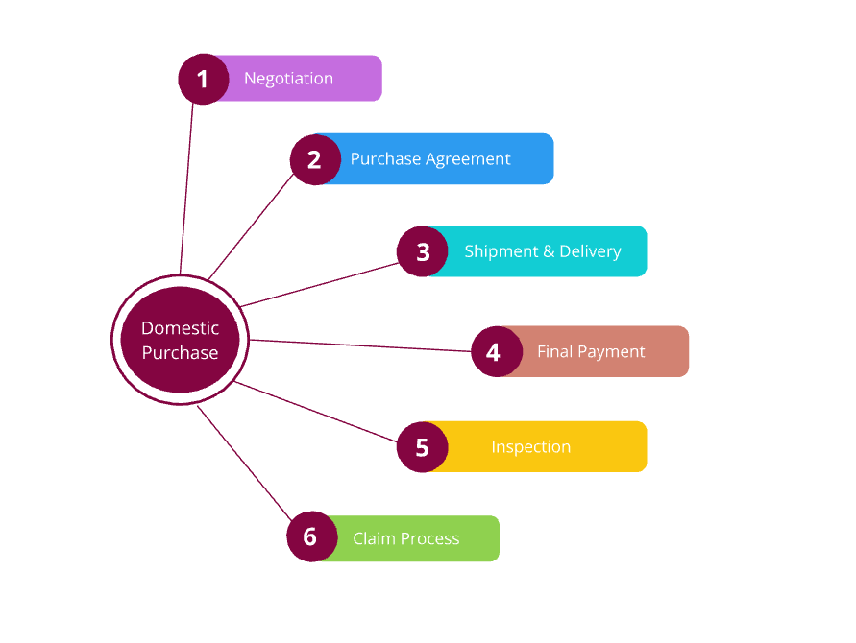
Fig.2 – Domestic Purchase

Purchase Agreement:
The buyer negotiates with a local supplier, agreeing on the price and terms, for example, purchasing raw materials at a rate of ₹50,000 per metric ton.
The supplier sends a purchase order (PO), and the buyer confirms the details. The terms are simpler than import purchases, with local taxes such as GST and INR pricing included in the agreement.

Shipment and Delivery:
The domestic supplier usually delivers the materials directly to the buyer’s factory within a week. There is no customs process, and the shipment tracking is often manual or handled through a simple logistics provider.
The buyer logs the delivery details into the system, including the delivery date, dispatch date, and any relevant payment terms.

Inspection and Claims:
Once the goods arrive, a brief inspection is conducted, similar to the import process. Any discrepancies are noted, and the buyer can initiate a claim if needed. However, domestic claims are typically easier to resolve, involving fewer documents and quicker negotiations.

Completion of Domestic Purchase:
The domestic purchase process is completed within a much shorter time frame—usually within a week or two. The system captures all relevant details, but with fewer complexities compared to import purchases.

Functional Requirements
This subsection of Executive Summary is a brief summary of the requirements addressed in this document.
Website Pages/Sections as per Requirement:
- User Management
- Dashboard
- Import Form - Creation & Update
- Import Transaction Details
- Domestic Form - Creation & Update
- Domestic Transaction Details
- Import Claims
- Domestic Claims
- Sales Details

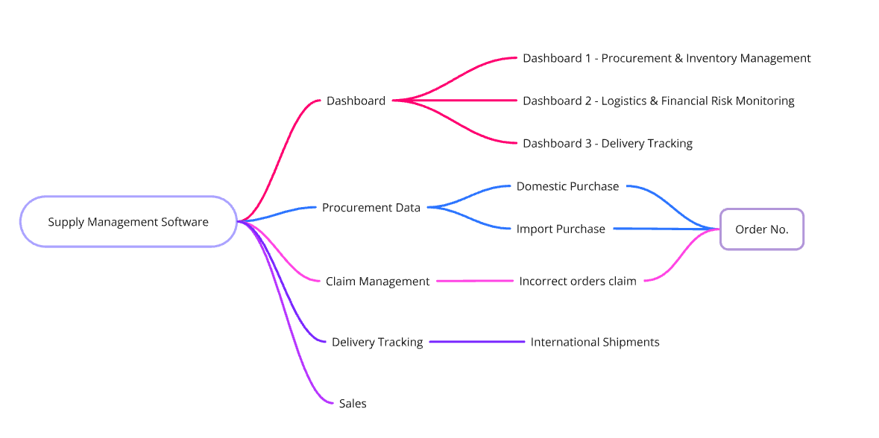
Fig.3 - Website Overview

User Management
User Types:
- The system shall support three user roles: Admin, Buyer, and Supplier.
Admin Role:
- The admin shall have the ability to create new accounts for Buyers and Suppliers by sending invitation links for account creation.
Buyer Role:
- Buyers shall have the ability to create and update their data on the website.
Supplier Role:
- Suppliers shall have the ability to view order details and utilize the delivery tracking section.
- Suppliers shall not have access to dashboards or reports.
- Suppliers shall only be able to access orders that are assigned to them.
- If a Supplier identifies incorrect information on the website, they shall have the option to raise a concern.

Import Purchase Process:
- Dynamic form to record purchase details based on supplier and material types.
- Fields to capture key purchase details such as supplier, material, price, quantity, booking date, pre-payment, etc.
- Option to upload related documents like sales contracts, proforma invoices, prepayment receipts, container numbers, and vessel details.
- Automated tracking of shipments via container numbers, Bill of landing number, vessel no, or booking number. Utilizing available APIs for real-time updates.
- Manual entry fields for locations and delivery progress where required.
- Facility to upload inspection results (photos and videos) upon goods arrival, especially for claims against discrepancies.
- Documentation for the claim process when goods not meet the expectation of the purchase order, including negotiation details and final resolution.
- Price in foreign currency must be converted to local currency in INR

Form of import will Include below fields, where the user can enter the information:
Explanation of each column:
- Order Nr.: Unique identifier for each import purchase order.
- Buyer: The company or entity placing the order.
- Supplier Name: The name of the supplier providing the goods.
- Quantity: The number of units purchased.
- Containers: Number of containers used for shipment.
- Container Type: The type of container (e.g., 20ft, 40ft).
- Date Booked: The date when the order was booked.
- Pre-payment: The percentage of the total payment made before shipment.
- Date of Pre-payment: The date when the pre-payment was made.
- Total Amount: The total value of the order.
- Open Amount: The remaining amount to be paid after pre-payment.
- Forwarder: The logistics company handling the shipment.
- Ship: The name of the vessel transporting the goods.
- Loading Date: The date the goods were loaded onto the ship.
- Port of Dispatch (or Port of Origin): The location from where the shipment is initially dispatched.
- Port of Arrival (or Port of Destination): The location where the shipment is supposed to arrive.
- ETS (Estimate Time of Sailing): The estimated date when the ship will depart.
- ETA (Estimate Time of Arrival): The estimated date when the ship will arrive at its destination.

Below mentioned documents needs to be uploaded for each import process:
- PI
- Sales Contract
- Pre-payment receipt
- Invoice
- Packing List
- COO
- PSIC
- FORM 9
- FORM 6
- Bill of Lading
- Insurance
- Detention receipt
- COA

Domestic Purchase Process:
- Simplified form for entering key details of domestic purchases.
- Limited fields to capture compared to import purchases, focusing on supplier name, material type, rate, GST, etc.
- Fields to upload limited claim documents for domestic purchases.
Explanation of each column:
- Order Nr.: Unique identifier for each domestic purchase order.
- Buyer: The person or department responsible for making the purchase.
- Supplier Name: The name of the supplier or vendor from whom the goods were purchased.
- Material Type: Type of material or product purchased.
- Quantity: Number of units ordered for the purchase.
- Price: The unit price of the material/product.
- Date Ordered: The date the purchase was placed.
- Delivery Date: Expected or actual delivery date for the purchase.
- Payment Status: The current payment status (e.g., Paid, Partially Paid, Unpaid).
- Payment Term: The terms of payment (e.g., Net 30, Net 15).
  - Net 30: The buyer has 30 days from the date of the invoice to make the full payment. Other common variations which user can include Net 15, Net 60, etc., where the number indicates the days allowed for payment.
    - Example: If an invoice is dated September 1st with Net 30 terms, the payment is due by September 30th.
- Total Amount: The total amount for the order, calculated by multiplying quantity and price.
- GST (%): The applicable GST rate for the purchase. In this case, it’s 18%.
- GST Amount: The amount of GST calculated based on the total price before tax.
- Total Amount (incl. GST): The final total amount after including the GST. Calculated as Quantity * Price + GST Amount.

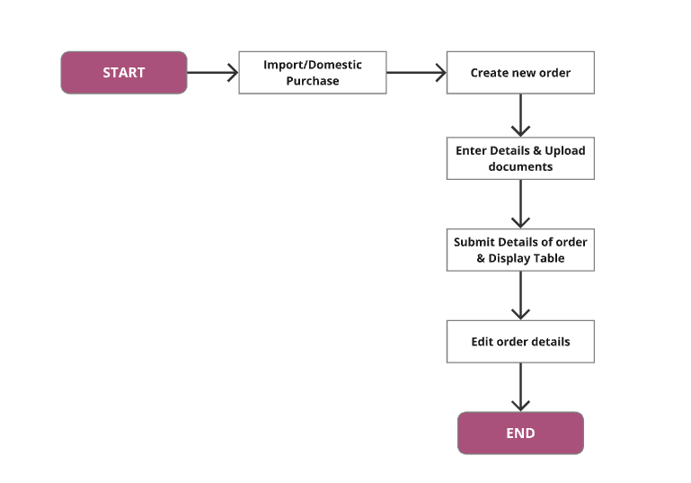
Fig.4 - Functionality of Order creation & updating

Delivery Tracking:
- Integration of automated tracking via APIs for monitoring shipments from the port of dispatch to the port of arrival.
- Fields to capture container numbers, vessel details, and estimated time of sailing (ETS) and arrival (ETA).
- Option to update tracking details manually if API data is unavailable.
Explanation of each column:
- Order No.: A unique identifier assigned to each purchase order. It helps in tracking the specific order through the delivery process.
- Supplier: The name of the vendor or provider who is supplying the goods. This column allows identification of the origin of the goods.
- Forwarder: Refers to the freight forwarder responsible for the shipment logistics. The forwarder arranges transportation and manages all shipping details.
- Bill of Lading Number: A unique number assigned to the Bill of Lading (BL), which is the key document used for tracking shipments. It serves as a contract between the shipper and the carrier.
- Containers No.: A unique identification number assigned to each container used for shipping goods. This is useful for tracking the movement of specific containers.
- Booking Number: A reference number provided by the shipping line or carrier when the shipment is booked. It is used to identify and confirm the shipment details.
- Delivery Milestone: Important stages or events in the delivery process, such as loading, departure, arrival, customs clearance, etc. Each milestone helps to track the progress of the delivery.
- Ship Name: The name of the vessel carrying the goods. It helps in identifying the ship involved in transporting the order.
- Vessel No.: A unique identifier for the vessel. Similar to the ship name, it helps in tracking the specific ship during its journey.
- ETS (Estimate Time of Sailing): The estimated date and time when the ship is scheduled to depart from the port of origin. This helps in planning and predicting when the shipment will reach its destination.
- Delivery Date: The actual or expected date when the goods are delivered to the final destination.
- Current Status: The current status of the delivery, such as "In Transit," "Delivered," or "At Port." This helps in monitoring the real-time progress of the shipment.
- Dispatch Date: The date when the goods were dispatched or sent from the supplier's location. This marks the starting point of the shipment's journey.

Claims Management:
- Structured process for initiating claims against suppliers for discrepancies in delivered goods.
- Upload section for documentation, including inspection photos, videos, and communication between buyer and supplier.
- Automated updates to reflect the resolution of claims once finalized.
- Claims must be mapped with order number.
Explanation of each column:
• Order Nr.: Unique identifier for each import purchase order.
• Claim Id: Unique identifier for each claim.
• Supplier: Name of the supplier involved in the claim.
• Material Type: Type of material or product involved in the claim.
• Quantity: Number of units affected by the claim.
• Price: Unit price or total price of the goods involved in the claim.
• Claim Amount: Monetary amount being claimed for compensation.
• Claim Reason: Reason for the claim (e.g., damaged goods, missing items).
• Claim Type: Classification of the claim (e.g., damage, loss, discrepancy).
• Inspection Date: Date when the goods were inspected to verify the issue.
• Settlement Amount: Amount agreed upon for settlement after reviewing the claim.
• Settlement Date: Date when the claim was resolved and compensation provided.
• Settlement Status: Current status of the claim (e.g., pending, approved, resolved).

Sales Section:
- A simple form to record sales transactions, capturing key details such as buyer name, material type, material quantity, price, delivery date, dispatch date, payment terms and many more.
Explanation of each column:
- Sales ID
- Buyer Name: The name of the customer or company purchasing the goods. This helps identify who made the purchase.
- Material Type: Specifies the type or category of material being sold. This is important for record-keeping and inventory tracking.
- Material Quantity: The amount or volume of the material being sold. This ensures accurate billing and inventory management.
- Price: The cost of the material, either per unit or total for the transaction. This is necessary for financial records and billing.
- Delivery Date: The agreed-upon date for delivering the goods to the buyer. It helps ensure timely fulfillment of orders.
- Dispatch Date: The date when the goods are sent from the seller’s location. This tracks when the shipment process began.
- Payment Terms

Reporting & Analytics

Dashboard 1 – Procurement & Inventory management
- Transit (Import)
  - Tracking current imports in transit
  - Formula: Sum of order quantity
  - Condition: Loading date is not null and delivery date is not “Delivered” and purchase type is Import
- Daily Order (Domestic)
  - Formula: Sum order quantity
  - Condition: Date booked is today and purchase type is domestic
- Material to be received in Factory today
  - List of Material type coming to factory Today
  - Formula: Distinct Material type, sum of order quantity
  - Condition: Delivery date is today
- Containers with claim
  - Formula: Count of containers
  - Condition: claim-id is not null
- Weekly order
  - Formula: Sum of order quantity
  - Condition: loading
- Stock in Factory
  - Formula: Sum of purchase.order quantity – sales.quantity
  - Condition: purchase in (Import, Domestic) and purchase.delivery status is deliverd and ?
- Funds needed this week
  - Formula: Sum of open amount
  - Condition: Delivery date is current week
- Upcoming Payments
  - Formula: Sum (Pre-payment), Sum(Open amount), Sum (Detention Amount)
  - Condition: Pre-payment is null OR Detention date is null OR Open amount is null
- Metal booked this month
  - Formula: Sum of quantity
  - Condition: Material type is metal and date booked is current (Month)

Dashboard 2 - Logistics & Financial Risk Monitoring
- Delay in Pre-Payment
  - Formula: Sum (Containers)
  - Condition: Pre-payment timeline <= 2 days
- Delay in Performa Invoice approval
  - Formula: Sum (Containers)
  - Condition: Performa Invoice approval status should be approved
- 30 day loading breached
  - Formula: Sum (Containers)
  - Condition: Date Prepayment >= 30 days and Loading date is null
- Breach expected India arrival
  - Formula: Sum (Containers), count (Delayed_Date) in number of days
  - Condition: Arrival date <= Delay_date
- Delay in cleaning expected detention
  - Formula: Sum (Containers), count (Overdue days)
  - Condition: Remaining Days=Container Free Days − (Current Date−Booked Date)
  - If Remaining Days <= 2 days, flag those containers in this KPI
- Containers in Detention
  - Formula: Sum (Containers)
  - Condition: Container overdue days is not NULL
- Detention amount paid this week
  - Formula: Sum (detention amount Paid)
  - Condition: Detention paid date in this week
- Upcoming Payments
  - Formula: Sum (Pre-payment), Sum(Open amount), Sum (Detention Amount)
  - Condition: Pre-payment is null OR Detention date is null OR Open amount is null
- Daily LME Avg, Max, Min
  - Formula:
    - Avg (Material Price ordered) VS Avg (LME of that material)
      - Avg Material Price Ordered = Sum of Material Prices Ordered/Number of Material Orders
      - Avg LME Price = Sum of LME Prices/Number of LME Price Points
    - Maximum (Material price orderd) vs Maximum (LME of that material)
      - Max Material Price Ordered = Highest Material Price Ordered on the Day
      - Max LME Price = Highest LME Price Recorded on the Day
    - Minimum (Material Price ordered), Minimum (LME of that material)
      - Min Material Price Ordered = Lowest Material Price Ordered on the Day
      - Min LME Price = Lowest LME Price Recorded on the Day

- Purchased Material Price vs. LME Price (4 months)
  - Formula: Percentage of LME Bought=(Ordered Material Price per quantity Today’s LME Price of that material​)×100
  - Condition: Between (Date booked >= 4 months and Date booked <= 7 days)

- Materials in Transit (Arriving in 7 Days) vs. LME Price
  - Formula: Percentage of LME Bought=(Ordered Material Price per quantity Today’s LME Price of that material​)×100
LME Price of Today.
  - Condition: Delivery status = Intransit and expected_arrival_date <= 7 days

- Daily MCX Avg, Max, Min
This KPI compares the average, maximum, and minimum ordered material prices with the MCX prices of the same material.
Formula:
- Average (Material Price Ordered) VS Average (MCX of that material)
Avg Material Price Ordered = Sum of Material Prices Ordered / Number of Material Orders
Avg MCX Price = Sum of MCX Prices / Number of MCX Price Points
- Maximum (Material Price Ordered) VS Maximum (MCX of that material)
Max Material Price Ordered = Highest Material Price Ordered on the Day
Max MCX Price = Highest MCX Price Recorded on the Day
- Minimum (Material Price Ordered) VS Minimum (MCX of that material)
Min Material Price Ordered = Lowest Material Price Ordered on the Day
Min MCX Price = Lowest MCX Price Recorded on the Day

- Purchased Material Price vs. MCX Price (4 months)
This KPI helps to monitor the trend in material purchase prices compared to the MCX prices over a specific period.
  - Formula: Percentage of MCX Bought = (Ordered Material Price per quantity / Today’s MCX Price of that material) × 100
  - Condition: Between (Date booked >= 4 months ago) AND (Date booked <= 7 days ago)

- Materials in Transit (Arriving in 7 Days) vs. MCX Price
This KPI tracks the price of materials currently in transit, scheduled to arrive within a week, and compares it with the MCX price.
  - Formula: Percentage of MCX Bought = (Ordered Material Price per quantity / Today’s MCX Price of that material) × 100
  - Condition: Delivery status = In transit & Expected Arrival Date ≤ 7 days

Dashboard 3 – Shipment Timelines & Detention Overview
- Arrival as per defined timeline visual
  - Early arrivals (count & Trend arrow)
    - Formula: count(ship)
    - Condition: Delivery date > arrival date
  - Late arrivals (count& Trend arrow)
    - Formula: count(ship)
    - Condition: Delivery date < arrival date
  - Ontime
    - Formula: count(ship)
    - Condition: Delivery date = arrival date
- Departure as per defined timeline visual
  - Early departures
    - Formula: count(ship)
    - Condition: Dispatch date = Loading date
  - Late departures
    - Formula: count(ship)
    - Condition: Dispatch date > loading date
  - On time
    - Formula:count(Ship)
    - Condition: Expected_arrival_date = Delivery date
- No. of non-trackable Shipments
  - Formula: Count (Orders no.)
  - Condition: Container no. is null

General Application Features:
- Input forms for both import and domestic purchases with easy-to-navigate sections for uploading documents and tracking payments.
- Centralized dashboard to provide an overview of all ongoing purchases, shipments, and sales, allowing for better production planning and decision-making.

Non-Functional Requirements
- Performance:
  - The system should support at least 10 concurrent users without any degradation in performance.
  - The website should load within 3-5 seconds on an average with good broadband connection.
  - All database transactions (deal creation, invoice submission, etc.) should be processed quickly.
- Scalability:
  - The website should be able to handle a 100% increase in traffic over the next two years without requiring major architectural changes.
  - The system should allow seamless addition of new modules or features without impacting the core functionality.
- Security:
  - User authentication and data access must be implemented using role-based access control (RBAC).
  - The website should comply with industry-standard security protocols to protect against data breaches.
- Availability:
  - The website should maintain 99.9% uptime to ensure availability for users across different time zones.
  - Scheduled maintenance windows should be minimized and communicated to users in advance.
- Usability:
  - The system should provide an intuitive user interface with easy navigation and clear labelling of functionalities.
  - The interface should be responsive and fully functional on desktops, tablets, and mobile devices.
- Reliability:
  - The system should have an automated backup mechanism that performs daily backups of critical data.
- Maintainability:
  - The system should be built with a modular architecture to allow easy maintenance and updates.
  - Detailed documentation must be provided for all system components to facilitate smooth handover to the support team.
- Disaster Recovery:
  - A disaster recovery plan must be in place to restore full functionality within few hours of a critical failure.

Related Documents
- Data mapping sheet – Sheet to refer Data Mapping for Import, Data Mapping for Domestic, Master List
- Procurement form
- Diagrams & Low-fidelity Wireframe

