System Requirement Specification

Contents
Document Control 2
1. Introduction 3
1.1 Purpose 3
1.2 Scope 3
1.3 Definitions, Acronyms and Abbreviations 3
1.4 References 3
1.5 Overview 4
2. Overall Description 4
2.1 Product Perspective 4
2.2 Product Functions 5
2.3 Constraints 5
2.4 Assumptions & Dependencies 6
3. Specific Requirements 7
3.1 Interface Requirements 7
3.1.1 User Interfaces 18
3.1.2 Hardware Interfaces 29
3.1.3 Software Interfaces 30
3.1.4 Communication Interfaces 30
3.2 Functional Requirements 30
3.6.1 Scalability 40
Use Case Diagrams 41
Reference Document 43

Document Control

Version | Date | Author | Approver | Status
1 | 25-09-2025 | Vidyalaxmi Singh

1. Introduction

1.1 Purpose
The proposed web application is designed to improve the management of both import and domestic purchases, track sales, and monitor the movement of goods. By integrating automated tracking systems through APIs and structured forms for data entry, the application will centralize critical data related to orders, shipments, claims, and sales. This will enhance production planning and operational efficiency.

1.2 Scope
The scope of this system covers the development of a comprehensive web-based application designed to manage the following areas:
- Import and Domestic Purchases: The system will allow users to input purchase details and upload necessary documents for both domestic and international orders.
- Shipment Tracking: Automated tracking of shipments will be integrated through APIs, using key identifiers such as container numbers and bills of lading to provide real-time updates on the shipment’s status.
- Claims Management: The system will facilitate handling claims for discrepancies in received goods, allowing users to document issues and track resolution progress.
- Sales Recording: The system will link sales records to the corresponding purchases, providing a comprehensive view of sales activity related to the materials procured.
- Reporting and Analytics: A dashboard will present key metrics in visual format, including deal progress, delivery tracking, and invoice processing performance.
The system will centralize all these processes into a single platform, reducing manual tasks and improving the coordination and efficiency of operations related to material procurement, delivery, and sales management.

1.3 Definitions, Acronyms and Abbreviations

Terms | Description
SMS | Supply Management Software
KPI | Key Performance Metric

1.4 References
The references of this document are:
- Business Requirement Document
- Data Modelling
- Procurement Form
- Diagram & Low-Fidelity wireframe document

1.5 Overview
This system requirement specification document is organized as flows:
- Overall description of Supply Management Software which include product perspective, product functions, SMS’ user characteristics, constraints, assumptions & dependencies and apportioning of requirements
- Specific Requirements which include, interface requirements, functional requirements, performance requirements, logical database requirements, design, constraints and Software system attributes

2. Overall Description

2.1 Product Perspective
The SMS system is designed to efficiently support the orders of our company's material, including IT solutions, data management, and other related services, in a faster and more cost-effective manner compared to other alternatives. While well-known SCM systems like those from Oracle and SAP are widely used in large enterprises, offering extensive integrations with other systems, our SMS system focuses on delivering the few similar core functionalities—such as purchase management, shipment tracking, and claims handling—but is tailored specifically to our company's needs.
Unlike broader, more complex solutions, our system is optimized to meet the specific requirements of our operations, providing a streamlined, targeted approach. This allows us to offer a solution that is faster to implement and maintain, with a reduced cost structure while still delivering the core capabilities essential for efficient supply chain management.
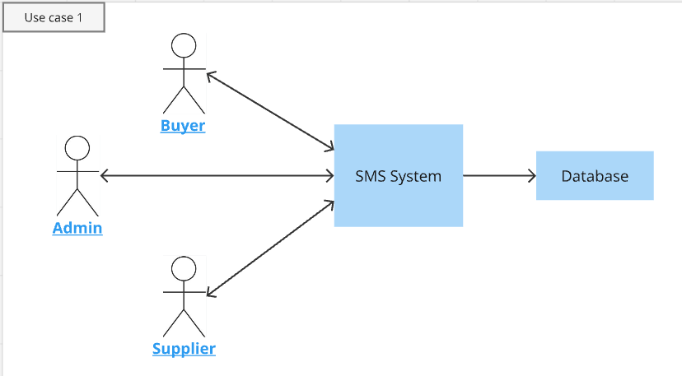

2.2 Product Functions

This web application will contain following functions:
- Manage supplier details
- Maintain Materials & shipment lines information
- Facilitate and manage the procurement data process.
- Track and maintain inspection-related information.
- Generate insights and reports to support ongoing and future business decisions.
- Provide real-time tracking of shipment locations.
- Offer a platform to manage material claims.
- Maintain and record sales data.

2.3 Constraints
- Role-Based Access
  - Suppliers have view-only access, restricting them from creating, editing, or deleting records. Buyers have the authority to create, view, and edit records but cannot delete them. Admins have full access to manage all records.
- Row-Level Security
  - Suppliers can only view data specific to their company. Buyers and Admins can access data across all suppliers, but suppliers are restricted from viewing data not related to their company.
- Data Integrity
  - Suppliers are not permitted to modify procurement, claims, or shipment records. Buyers have restricted access to modify records and are not allowed to delete entries in the system.
- Automated vs. Manual Tracking
  - Shipment tracking data is primarily updated automatically via API integrations. In cases where API data is unavailable, manual updates can be made by authorized users (Buyers or Admins) but not by Suppliers.
- Limited Profile Edits
  - Both Buyers and Suppliers can edit limited profile fields (Name, Role, Phone, Location), but cannot modify critical fields such as Account Type or Company Name.
- Data Access via Invite Only
  - Suppliers and Buyers must be invited by Admins to access the platform. They cannot self-register without an official invitation, ensuring access control.
- Supplier Transaction View
  - Suppliers can only access transactions and shipments they are directly involved with. They cannot view or access details about other suppliers' transactions.

2.4 Assumptions & Dependencies
Supplier Participation
- It is assumed that Suppliers will actively participate in the platform for viewing shipment details, procurement records, and claims, but their involvement is restricted to view-only functions.
Data Accuracy
- All data entered into the system (procurement details, claims, shipment updates) is assumed to be accurate and timely. The platform relies on Buyers and Admins to ensure data accuracy.
Automated API Data
- The system assumes reliable API integration for tracking shipment status updates. In cases where API data is missing or delayed, manual updates will be made by authorized users.
Platform Security
- It is assumed that the platform will maintain robust security measures, including user authentication, data encryption, and access control, to protect sensitive information related to transactions and shipments.
User Management System
- Dependency: Proper user management is necessary for controlling access rights and permissions for Buyers, Suppliers, and Admins.
- Impact: If the user management system fails or is incorrectly configured, roles and permissions may be misallocated, compromising data integrity and access control.
API Integrations for Shipment Tracking
- Dependency: The system depends on external APIs to automatically update shipment details (ETA, ETS, container status, etc.).
- Impact: If the APIs fail or experience delays, shipment information will not be updated in real-time, potentially affecting the accuracy of shipment tracking and delivery timelines.
API Integration for LME Data Retrieval
- Dependency: The system depends on the LME API or a similar external data source to retrieve real-time and historical price data for metals. This data is crucial for calculating KPIs such as daily average, maximum, and minimum material prices compared to LME prices, as well as for tracking trends over specific timeframes (e.g., 4-month price comparisons).
- Impact: If the LME API fails, experiences delays, or returns incomplete data, the KPIs that rely on real-time LME prices will not be accurate. This could lead to discrepancies in material pricing comparisons, distorted financial risk assessments, and incorrect decision-making based on outdated or incorrect market data. Additionally, historical trends may be incomplete if the API fails to return past data.

3. Specific Requirements

3.1 Interface Requirements
Requirement 1: User Login, Signup & Access Permissions
Requirement ID | Summary | Description
S1 | Buyer Admin Login | - Admin must be able to log in using a valid username and password.  - Admin Successful login should redirect Admin to their landing page of dashboard where user management controls are accessible.  - Admin will control the user management on the system.
S2 | Admin signup invitation to buyers and suppliers | - Admin must be able to add users by selecting the account type (Buyer or Supplier).  - Admin must be able to enter the supplier's company name when adding a Supplier account.  - After creating a user account, Admin must be able to generate and share an invite link with the user via email.  - The invite link must allow the recipient to create an account.
S3 | Buyer Signup | - Buyer should be able to sign up using the invite link sent by Admin.  - Buyer must use the same email ID provided in the invitation.  - Buyer must create a new username and password.  - After account creation, Buyer must be prompted to enter profile details (Name, Role, Employee ID, Phone).  - Successful signup should grant the Buyer access to the system.
S4 | Supplier Signup | - Supplier should be able to sign up using the invite link sent by Admin.  - Supplier must use the same email ID provided in the invitation.  - Supplier must create a new username and password.  - After account creation, Supplier must be redirected to update their profile details (Name, Role, Location, Phone, supplier company name - this field should be non-editable).  - Successful signup should grant the Supplier access to the system.
S5 | Forgot Password | - If user forgot their password, then allow user to reset the password using OTP via Email.
S7 | Change Password | - If any user wants to change the password, then allow them to change the password by entering their current password.  - This change password option must be present in the profile option for all users.
S8 | Create, View, Edit and Delete access | - Create, View, Edit & Delete: Admin should have the authority to create, edit and delete access within the system  - Create, View & Edit: Buyers should have the authority to create and edit access within the system  - View: Suppliers should have the authority to view within the system.  - Supplier must be able to see only data with respect to their company.  - Suppliers should not have the ability to create, edit, or delete.

Requirement 2: Menu >> User Management
Requirement ID | Summary | Description
S1 | Addition of new user | - As an Admin, I must be able to add new user within the application.  - A button must be there to invite new members to signup  - Once clicked on the invite button, admin will receive a pop-up which asks for details i.e., Email id, account type (Buyer or Supplier), Supplier company.  - Supplier company option will only be visible when the account type is selected as “Supplier”  - Once invited, the user will receive invitation link on mentioned email id, they can click on the link to go to the website signup page.  - User will be asked to enter new username and password.
S2 | Admin can view, edit and disable user details | - Admin must be able to edit the user details.  - Below mentioned columns are allowed for the admin to edit/update: Supplier company name  - Admin can disable any user other than other admin user  - Admin can view profile and details of any user

Requirement 3: Profile Edit
Requirement ID | Summary | Description
S1 | Profile Details Editing | - As a user, irrespective of the app role, I must be able to edit/ update the allowed fields within the My profile.  - Navigation: When user will click on the profile pic at the top right corner then they will get the option of “My profile”.  - User must be able to Update the below mentioned columns: Name, Role, Phone, Location  - Not editable fields for buyers and suppliers will be Account Type and supplier company

Requirement 4: Master List
Requirement ID | Summary | Description
S1 | Master list | - As an Admin & Buyer, I want to view, edit the existing master list present and able to add the new values in the list in the web app.  - Navigation: When user will click on main menu, they will get option of “Master list”.  - In the Master list all type of master tables will be present.  - We will have 3 master table for now i.e., Shipment line, Material type, Supplier Details.  - When user will navigate to a table for e.g., shipment line, then they’ll get the view of each record present.  - Now in the table there will be 3 options presents i.e., Edit existing record, Disable/Enable toggle and add new record.  - Adding new record will be separate depending on in which master table user is in.  - Toggle will be used to disable/enable records as we will not provide option of delete from master list.
S2 | Master list – Shipment line | - This table will contain following fields: Shipment line name, Code, Free days allowed for containers.  - “Add Shipment line” option  - Edit, enable, disable record
S3 | Master list – Material Type | - This table will contain following fields: Material ID (Auto-generated id for table primary key), Material Type.  - “Add Material” option  - Edit, enable, disable record
S4 | Master list – Supplier Details | - This table will contain following fields: Supplier ID, Company name, Description, Location.  - “Add Supplier” option  - Edit, enable, disable record

Requirement 5: Procurement – Import Purchase
Requirement ID | Summary | Description
S1 | Create new order for Import purchase | - Admin & buyer can create new record.  - There will be a button available under Procurement -> Import purchase section, which will say “Add Order”  - Once the user will select on the add order, they will be redirected to the import form page.  - All the Fields names and documents names which needs to be uploaded in the form is mentioned in the “Procurement form.xlsx”  - Some of the fields will not allow user to enter the values such as “Total Amount”. In the “Data_Mapping.xlsx” document formula’s has been mentioned.
S2 | Update import purchase order | - Allow user to update the order details.  - Order ID field will not be editable
S3 | View Single order | - Allow Admin, buyer & supplier users to view all the details of a record
S4 | View overall record for domestic purchase | - Allow Admin & buyer users to View overall records  - Allow supplier user to view only their company associated records

Requirement 6: Procurement – Domestic Purchase
Requirement ID | Summary | Description
S1 | Create new order for Domestic purchase | - Admin & buyer can create new record.  - There will be a button available under Procurement -> Domestic purchase section, which will say “Add Order”  - Once the user will select on the add order, they will be redirected to the Domestic form page.  - All the Fields names and documents names which needs to be uploaded in the form is mentioned in the “Procurement form.xlsx”  - Some of the fields will not allow user to enter the values such as “Total Amount”. In the “Data_Mapping.xlsx” document formulas has been mentioned.
S2 | Update Domestic purchase order | - Allow user to update the order details.  - Order ID field will not be editable
S3 | View Single order | - Allow Admin, buyer & supplier users to view all the details of a record  - When user will be redirected to detailed view of single order form, at that time on the top place the order ID for granular.
S4 | View overall record of Domestic purchase | - Allow Admin & buyer users to View overall records  - Allow supplier user to view only their company associated records
Requirement 7: Claim
Requirement ID | Summary | Description
S1 | Create new claim for Import/Domestic purchase | - Admin & buyer can create new record.  - There will be a button available under Claim section, which will say “Add Claim”  - Once the user will select on the add order, they will be redirected to the claim form page.  - All the Fields names and documents names which needs to be uploaded in the form is mentioned in the “Procurement form.xlsx”  - Some of the fields will not allow user to enter the values such as “Claim Amount”. In the “Data_Mapping.xlsx” document formulas have been mentioned.
S2 | Update Claim order | - Allow user to update the order details.  - Order ID & Claim id field will not be editable
S3 | View Single Claim | - Allow Admin, buyer & supplier users to view all the details of a record
S4 | View overall record | - Allow Admin & buyer users to View overall records  - Allow supplier user to view only their company associated records

Requirement 8: Sales
Requirement ID | Summary | Description
S1 | Create new sales for any order within the web application | - Admin & buyer can create new sales record.  - There will be a button available under sales section, which will say “Add sales record”  - Once the user will select on the add sales, they will be redirected to the sales form page.  - All the Fields names and documents names which needs to be uploaded in the form is mentioned in the “Data_mapping.xlsx”
S2 | Update Sales order | - Allow user to update the order details.  - Order ID & Sales id field will not be editable
S3 | View Single Sales | - Allow Admin & buyer users to view all the details of a record
S4 | View overall record | - Allow Admin & buyer users to View overall records

Requirement 9: Delivery Tracking
Requirement ID | Summary | Description
S1 | Automated tracking updates via API | - Integrate APIs from company which provides API tracking to automatically update shipment status (e.g., location, delays).  - Users can also manually enter customs clearance or any other information where API data is unavailable
S2 | View ongoing- shipment details | - Landing page of Tracking delivery section will be this.  - Allow Admin, Buyer, and Supplier to view all ongoing shipment details.  - Details will include current shipment location, ETA, ETS, container number, and shipping status (e.g., in-transit, delayed), and other fields which is present in "Data Mapping.xlsx".
S3 | Update shipment details | - Allow users to update shipment details.  - Fields like "Shipment ID" & "Order ID" will not be editable.  - Users can update fields such as ETA, ETS, container number, Bill of Landing number, Booking number, Vessel name, Vessel number, Discharge port, Arrival port, custom clearance status and Delivery status.
S4 | View shipment status | - Allow Admin, Buyer, and Supplier to view the current status of a shipment.  - Real-time tracking updates will be provided for the shipment using integrated API data for location tracking.
S5 | View shipment history | - Allow Admin, Buyer & supplier to view historical data for completed shipments.  - Provide filters to sort shipments by updated date, and supplier. - Notify Buyers and Admins of key shipment milestones (e.g., departure, arrival, customs clearance).  - Users will receive email and in-app notifications at each milestone.
S6 | Notification for shipment milestones | - Notify Buyers and Admins of key shipment milestones (e.g., departure, arrival, customs clearance).  - Admin & Buyer users will receive in-app notifications at each milestone.
S7 | User management for shipment tracking | - Admin can manage user roles for accessing shipment tracking.  - Buyers will have full access, while Suppliers will only view the shipments related to them.
S8 | Track any other shipment | - Any user can track other shipments with container number, bill of landing number and booking number

Requirement 10: Reports & Insights
Requirement ID | Summary | Description
S1 | Dashboard | - There will be 3 types of dashboards.  i.e.,  Dashboard 1 – Procurement & Inventory management  Dashboard 2 - Logistics & Financial Risk Monitoring  Dashboard 3 – Shipment Timelines & Detention Overview  - Admin & Buyer can view all the 3 dashboards. Whereas supplier will be able to see Dashboard 2 & Dashboard 3  - All the KPIs which will be included in these dashboards are mentioned in the BRD
S2 | Dashboard 1 – Procurement & Inventory management | - KPIS included in this dashboard will be:  1. Transit (Import Purchase)  2. Daily Order (Domestic Purchase)  3. Material to be received in Factory today  4. Containers with claim  5. Weekly order  6. Stock in Factory  7. Funds needed this week  8. Upcoming payments  9. Metal booked this month  - Transit (Import Purchase): This will be a tile visual  - Daily Order (Domestic Purchase): This will be a tile visual  - Material to be received in Factory today: This will be a bar graph or any other visual that can represent list of material.  - Weekly Order: This will be a tile visual  - Stock in Factory: This will be a tile visual  - Funds needed this week: This will be a tile visual  - Upcoming Payments: This will be a tile visual  - Metal booked this month: This will be a tile visual  NOTE: All the calculation & condition will be available in file name “MSTS_BRD.docx”
S3 | Dashboard 2 – Logistics & Financial Risk Monitoring | - KPIS included in this dashboard will be:  1.Delay in Pre-Payment  2. Delay in Perform Invoice approval  3. 30 day loading breached  4. Breach expected India arrival  5. Delay in cleaning expected detention  6. Containers in Detention  7. Detention amount paid this week  8. Upcoming payments  9. Daily LMW average, maximum, minimum  10. Purchased Material Price vs. LME Price (4 months)  11. Material in Transit (Arriving in 7 days) vs. LME Price  12. Daily MCX Avg, Max, Min  13. Purchased Material Price vs. MCX Price (4 months)  14. Materials in Transit (Arriving in 7 days) vs. MCX Price  - Delay in Pre-Payment: This will be a tile visual  - Delay in Performa Invoice approval: This will be a tile visual  - 30-days loading breached: This will be a tile visual.  - Breach expected India Arrival: This KPI can be implemented on Bar graph or any other related visual.  - Delay in cleaning expected detention: This KPI can be implemented on Bar graph or any other related visual.  - Containers in detention: This will be a table visual or any other related visual.  - Daily LME average, maximum, minimum: This will be a table visual  - Purchased Material Price vs. LME Price (4 months): This will be tile or graph showing comparison.  - Materials in Transit (Arriving in 7 days) vs LME Price: This will be a table visual  - Daily MCX average, maximum, minimum: This will be a table visual  - Purchased Material Price vs. MCX Price (4 months): This will be tile or graph showing comparison.  - Materials in Transit (Arriving in 7 days) vs MCX Price: This will be a table visual  NOTE: All the calculation & condition will be available in file name “MSTS_BRD.docx”  - This dashboard will include Row level security where Suppliers will only be able to see KPIs related to their company’s orders
S4 | Dashboard 3 – Shipment Timelines & Detention Overview | - KPIS included in this dashboard will be:  1.Arrival as per defined timeline visual  2. Departure as per defined timeline visual  3. No. of non-trackable shipments  - Arrival as per defined timeline visual: This will be a pie-chart visual  - Departure as per defined timeline visual: This will be a Pie-chart visual  -No. of non-trackable shipments: This will be a tile visual.  NOTE: All the calculation & condition will be available in file name “MSTS_BRD.docx”  - This dashboard will include Row level security where Suppliers will only be able to see KPIs related to their company’s orders

3.1.1 User Interfaces
Login Page:
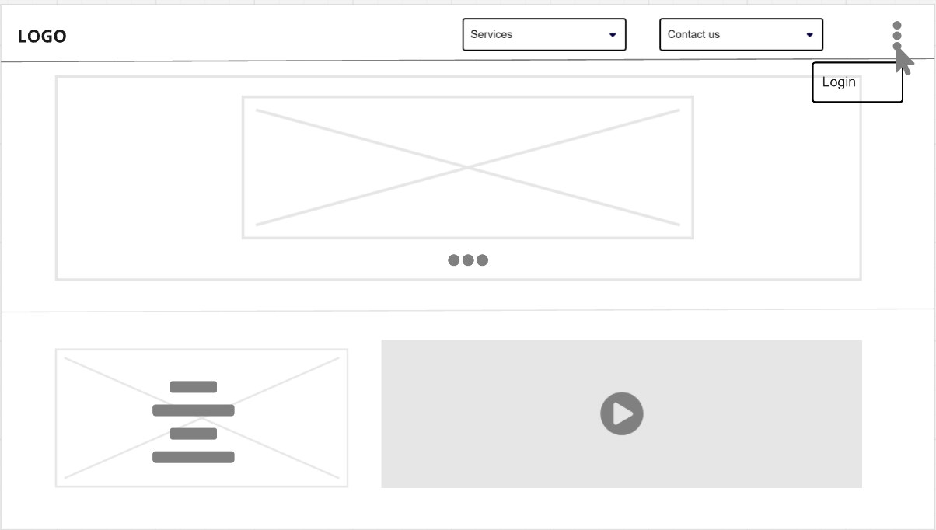

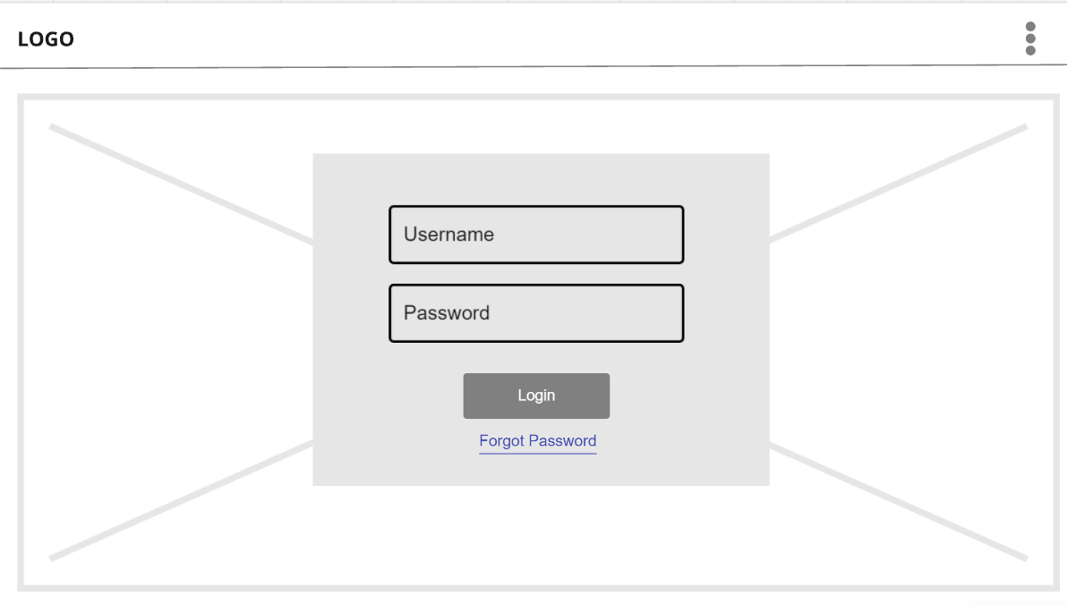

Admin: User Management:
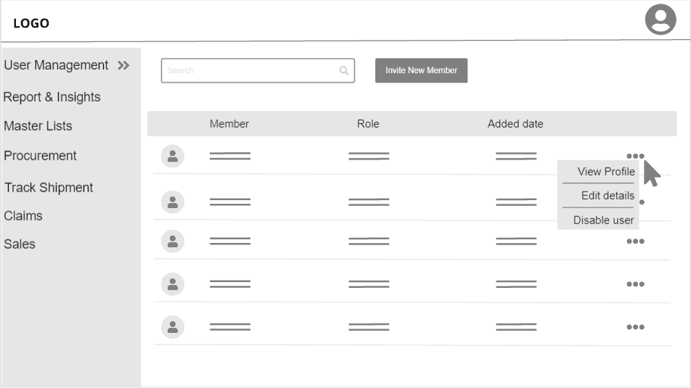

Admin: New user addition
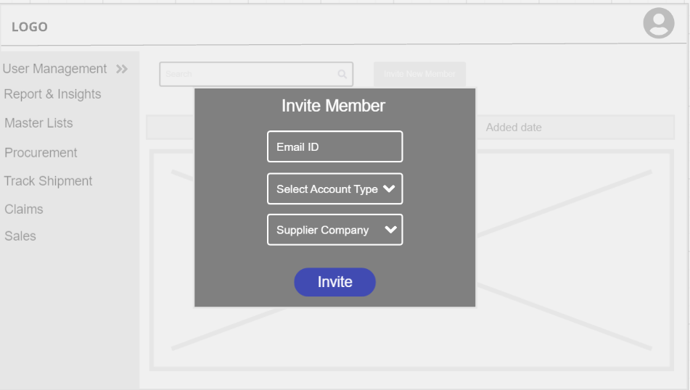

Admin: Master list -> Shipment line
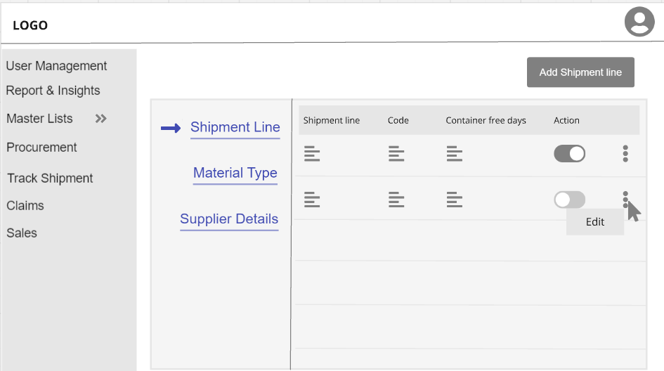

Admin: Master list -> Material Type
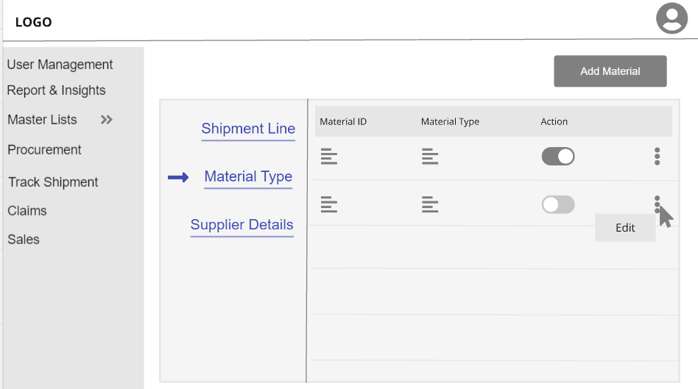

Admin: Master list -> Supplier Details
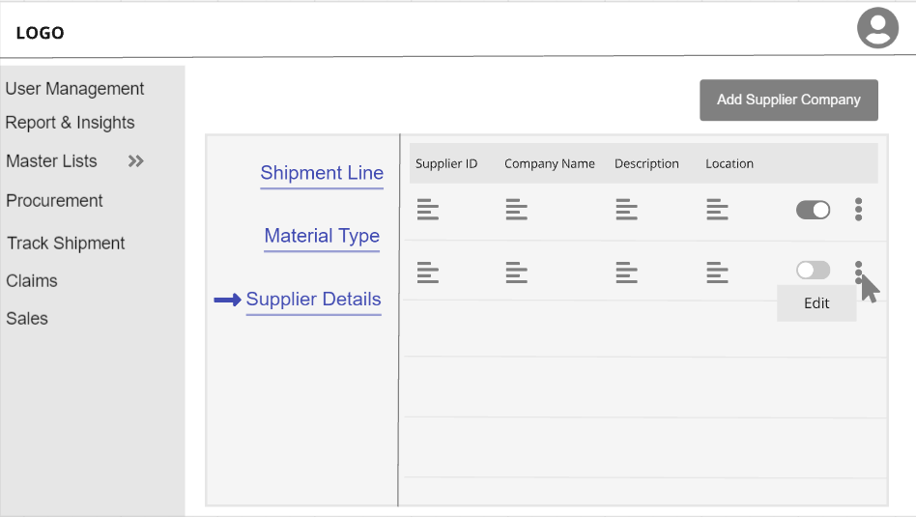

Admin: Import Purchase/Domestic Purchase Screen for order details
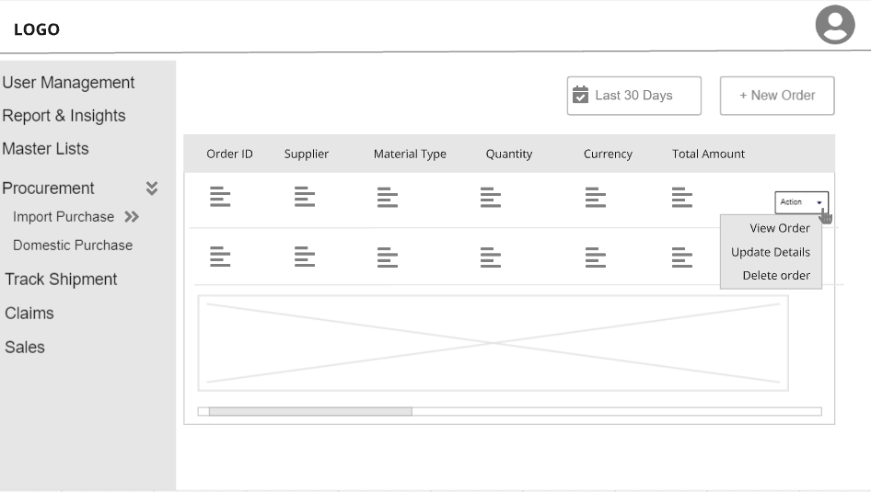

Admin: Procurement – Import Purchase/Domestic Purchase – New Order
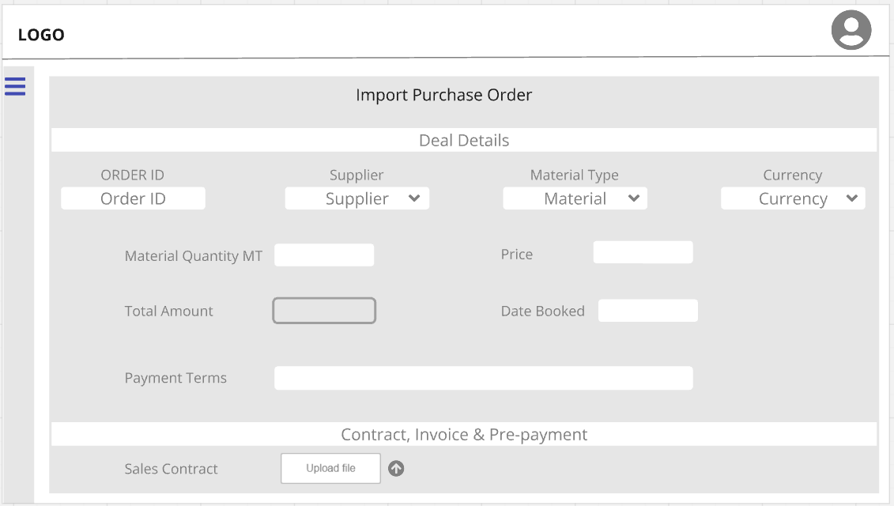

Admin: Procurement – Import Purchase/Domestic Purchase – Edit Order
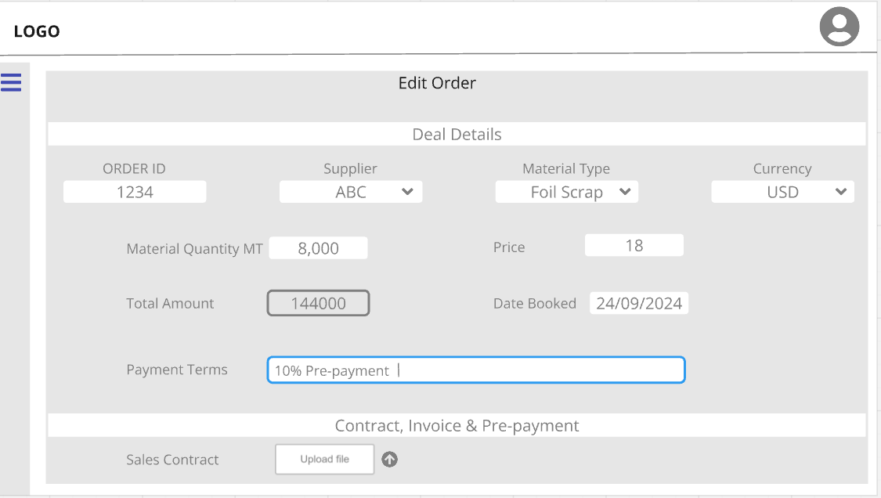

Admin: Procurement – Import Purchase/Domestic Purchase – View single order
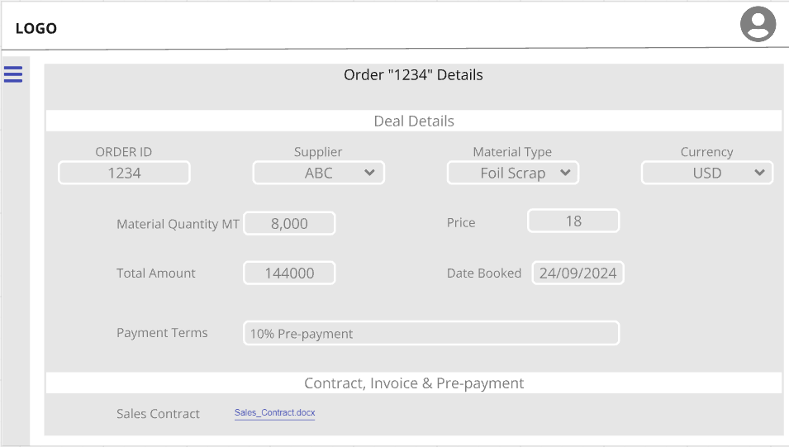

Admin: Track Shipment:
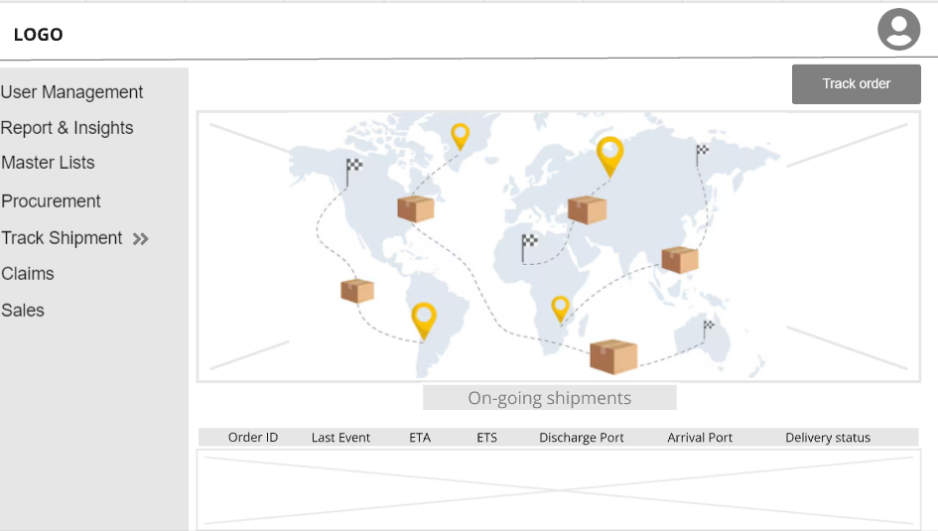

Admin: Claim:
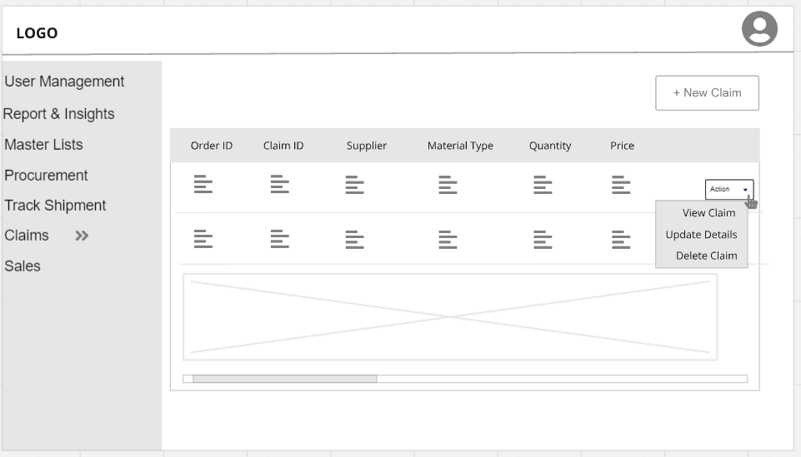

Admin: Sales:
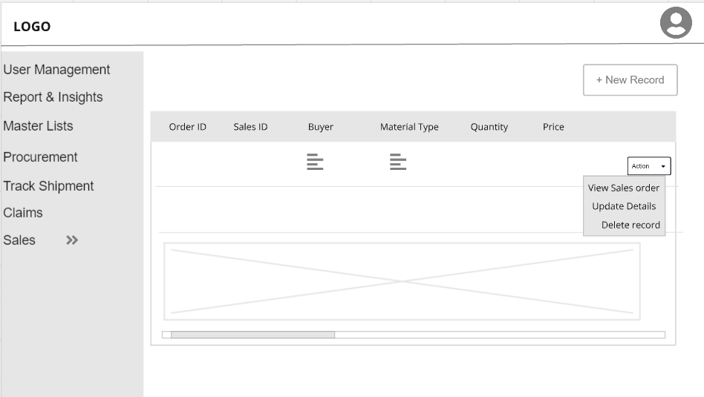

Admin: Reports & Insights:
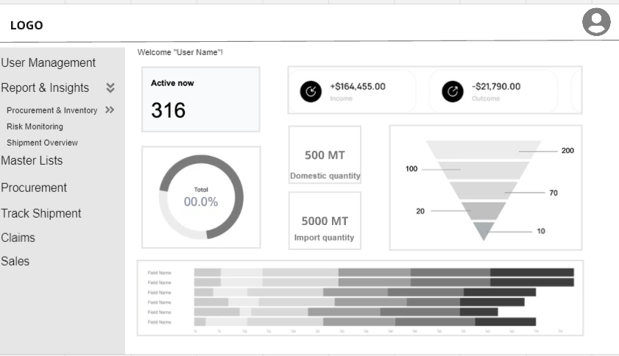

Buyer Signup:
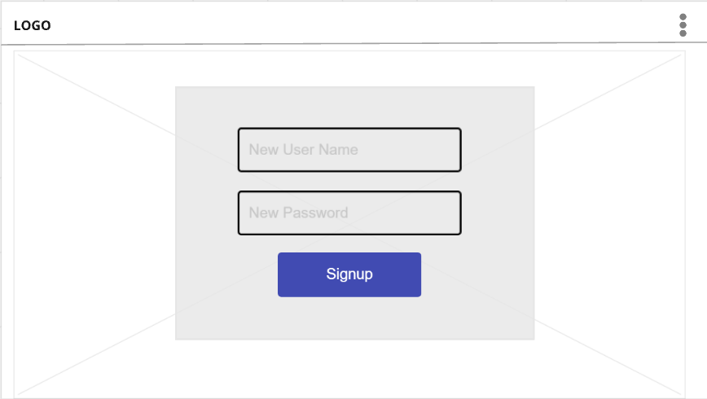

Buyer’s Edit Profile:
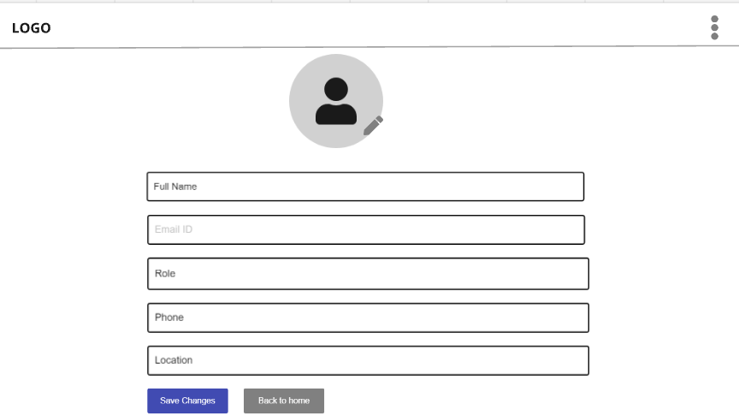

Buyer: Master list for Shipment line:
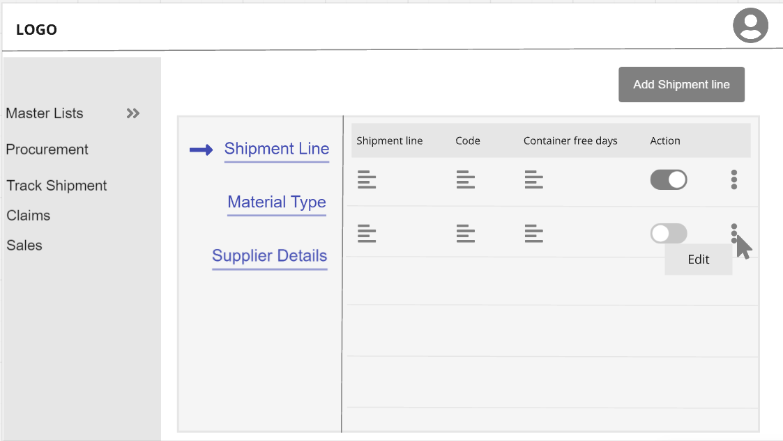

Buyer: Master list for Material Type:
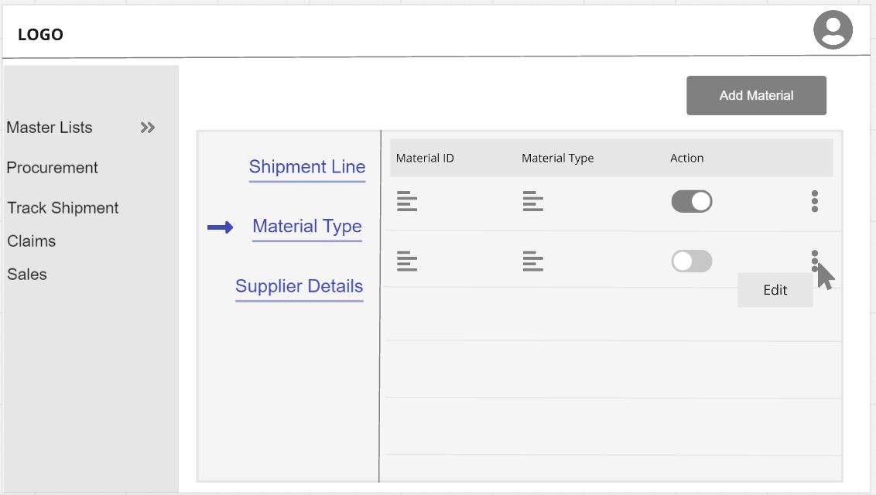

Buyer: Master list for Supplier details:
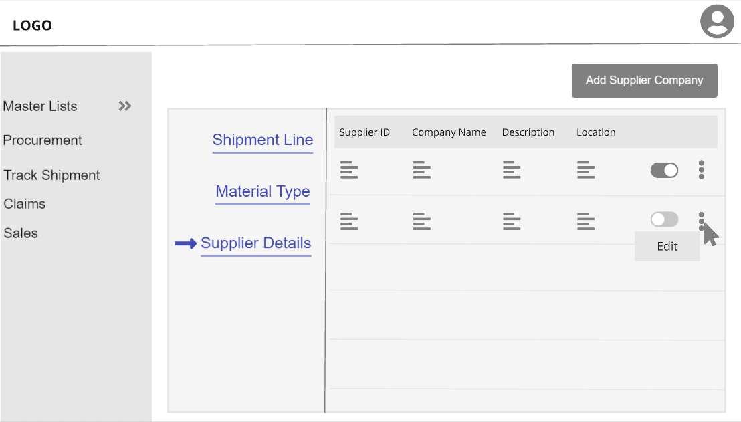

Buyer: Import Purchase/Domestic Purchase Screen for order details
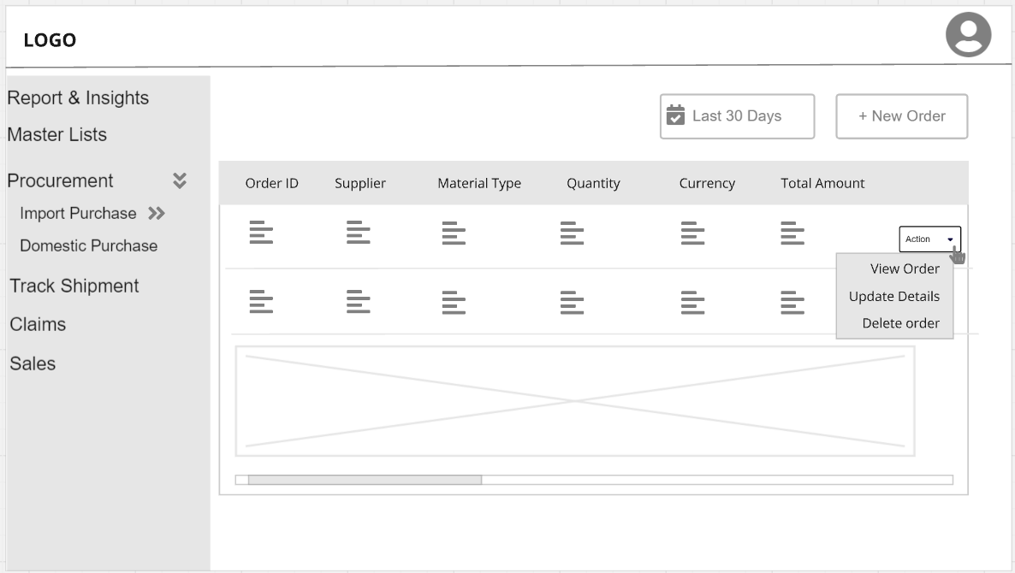

Buyer: Import Purchase/Domestic Purchase Screen for - New Order
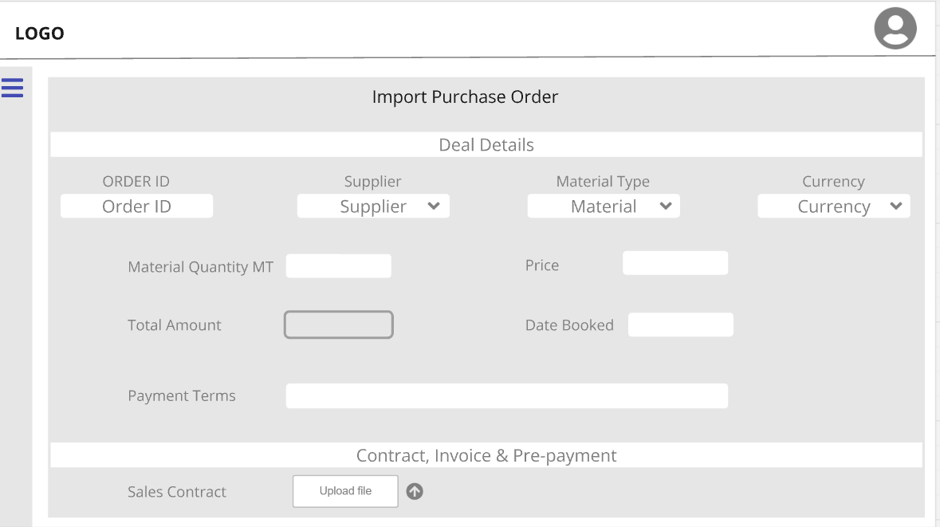

Buyer: Import Purchase/Domestic Purchase Screen for – Edit Order
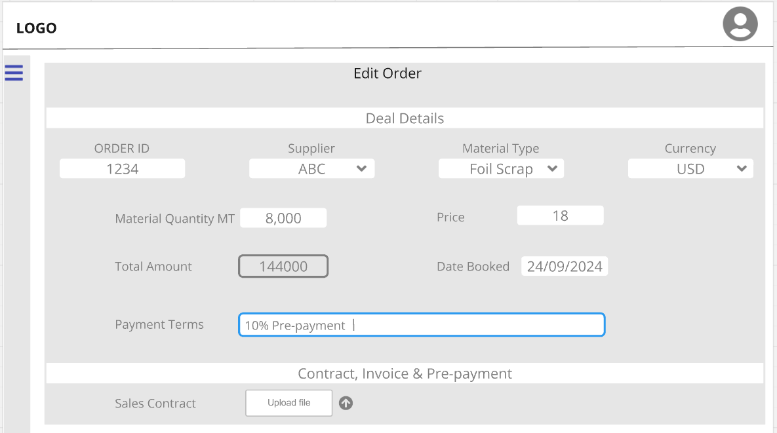

Buyer: Import Purchase/Domestic Purchase Screen for – View single order
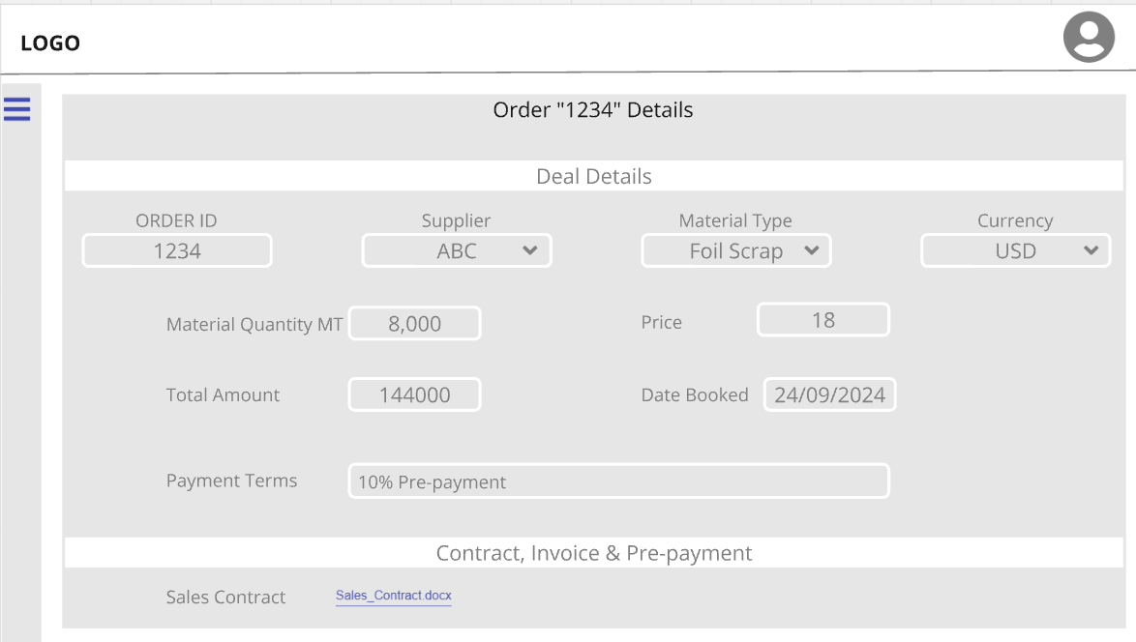

Buyer: Track shipment
Buyer: Claims
Buyer: Sales
Buyer: Reports & Insights

Supplier Signup:
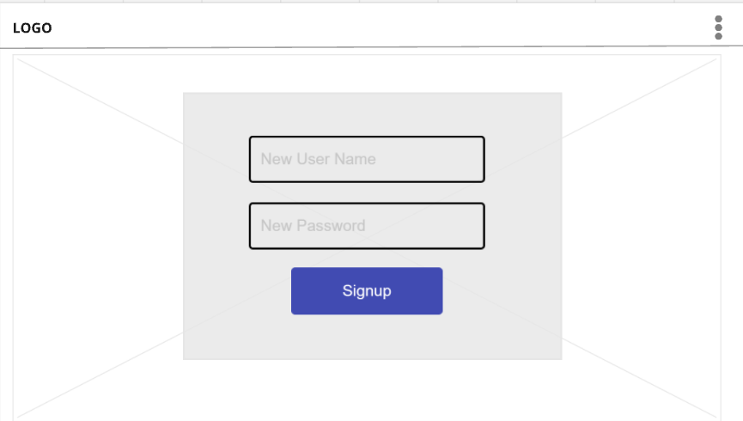

Supplier Edit Profile:
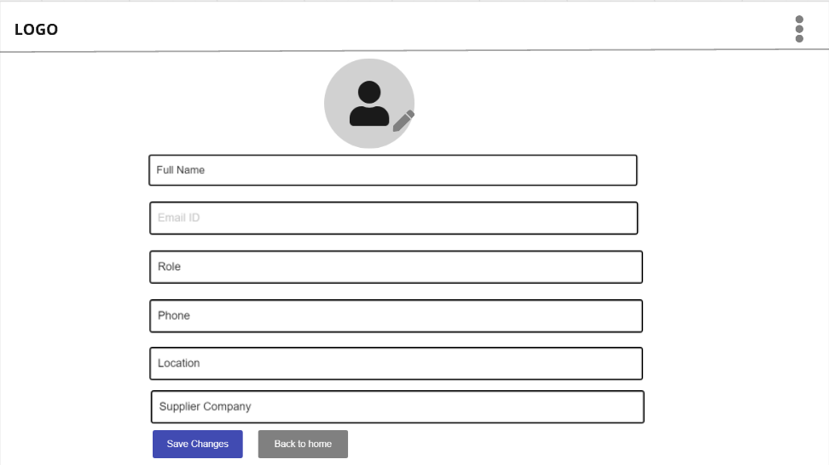

Supplier: Import Purchase/Domestic Purchase Screen for order details
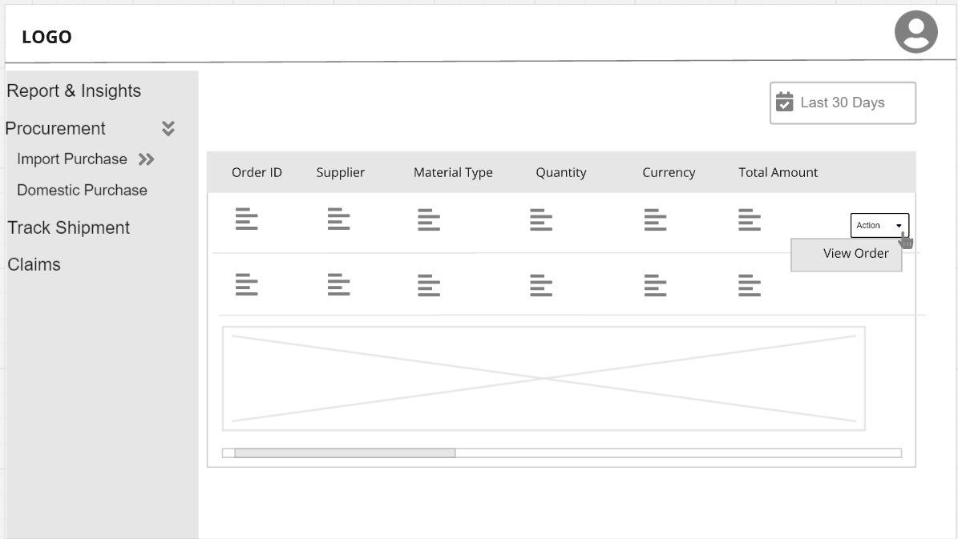

Supplier: Import Purchase/Domestic Purchase Screen for – View single order
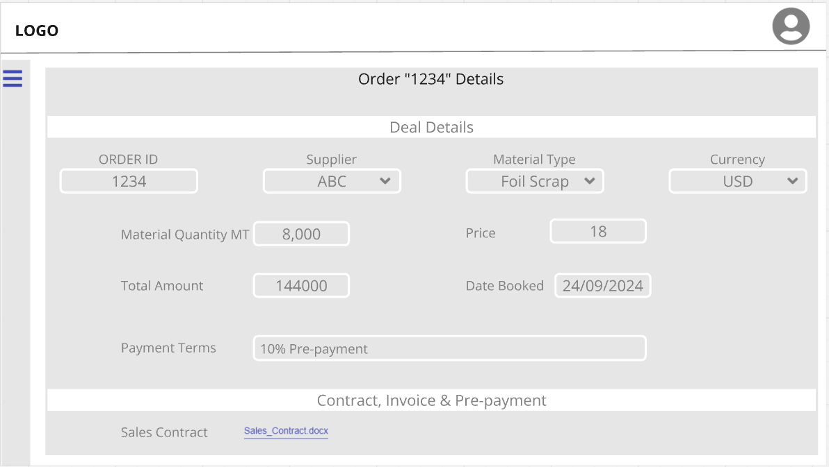

Supplier: Track shipment
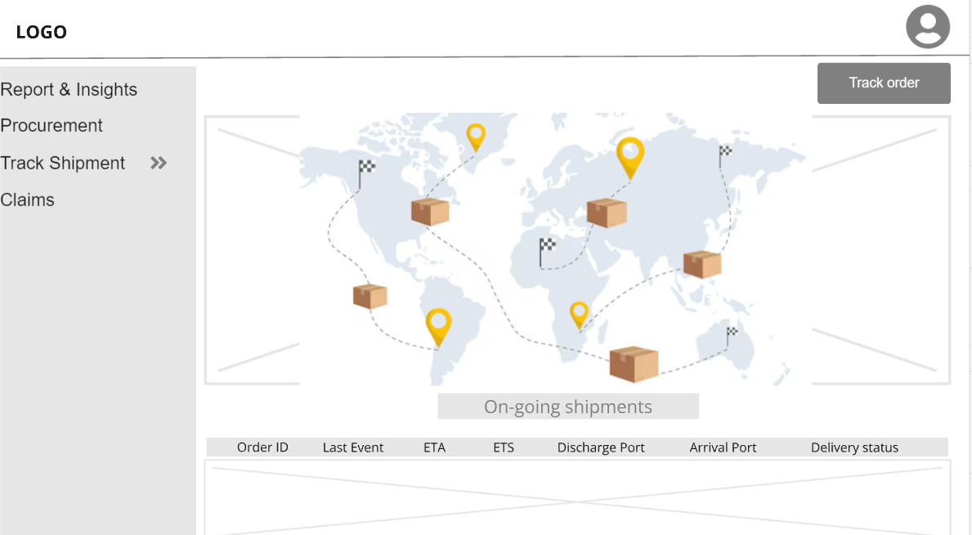

Supplier: Claims
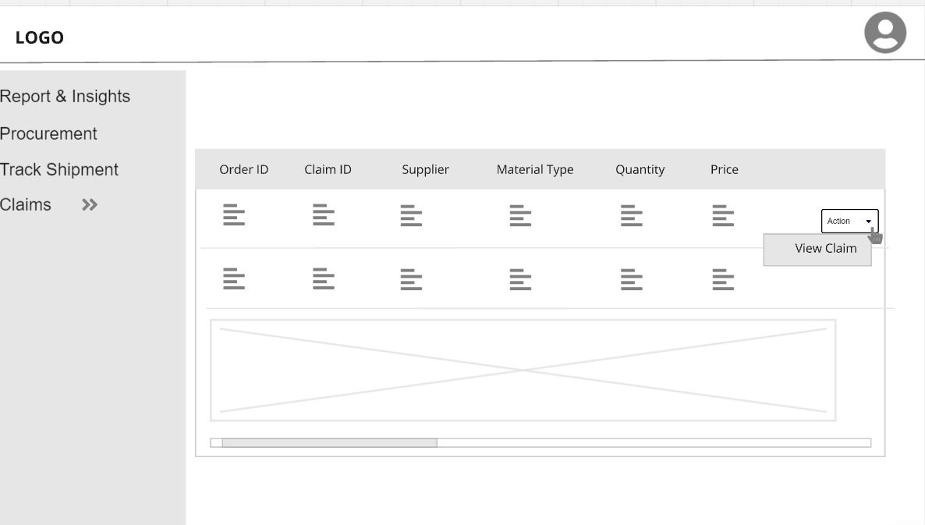

Supplier: Reports & Insights
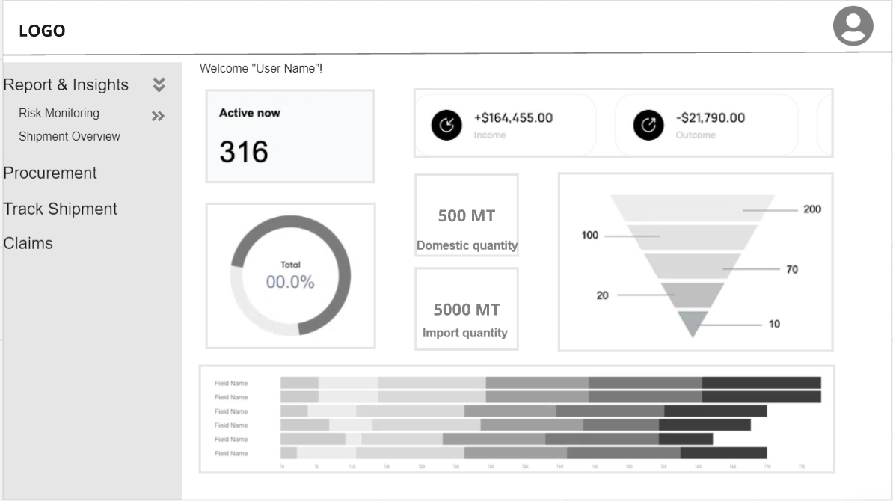

3.1.2 Hardware Interfaces

3.1.3 Software Interfaces

3.1.4 Communication Interfaces

3.2 Functional Requirements
Admin User Journey
- Admin Login
  - Admin enters their username and password.
  - Upon successful login, Admin is redirected to the Admin Dashboard, where they can manage users, profiles, master lists, and access controls.
  - Admin can reset their password via the "Forgot Password" option if required.
- Inviting Buyers and Suppliers
  - Admin navigates to User Management.
  - Admin clicks the Invite New User button, selects either Buyer or Supplier, and enters the user’s email ID.
  - For Suppliers, Admin provides the Supplier Company Name.
  - Upon submission, the user receives an invite link via email to complete registration.
- User Management
  - Admin can view, edit, and disable user details via the User Management Dashboard:
    - Admin can update fields like Supplier Company Name for suppliers.
    - Admin can disable any user, except other Admins.
    - Admin can edit details such as Name, Role, and Phone, but cannot modify Account Type or Supplier Company for Buyers and Suppliers.
  - Admin can manage master records such as Shipment Lines, Material Types, and Supplier Details through the Master List.
- Full CRUD Access
  - Admin has complete Create, Read, Update, and Delete (CRUD) access throughout the system:
    - Admin can create, update, or delete entries in the Master Lists and manage all user details.
    - Admin can add new records, such as Shipment Lines, Material Types, and Supplier Details, and enable/disable existing records.
- Profile Editing
  - Admin can edit their own profile by navigating to My Profile via the profile icon in the top right corner.
  - Fields like Name, Role, Phone, and Location can be updated, but Account Type or Supplier Company fields remain non-editable.
- Master List Management
  - Admin can manage the Master Lists for the system:
    - Admin can view, edit, add, and enable/disable records for Shipment Lines, Material Types, and Supplier Details.
    - Example fields in these lists include:
      - Shipment Line: Name, Code, Free Days for containers.
      - Material Type: Material ID, Material Type.
      - Supplier Details: Supplier ID, Company Name, Location.
- Password Management
  - Admin can reset their password using the Forgot Password option or change their password from profile settings by entering the current password and setting a new one.
- Procurement – Import Purchase
  - Create New Import Purchase Order:
    - Admin navigates to Procurement > Import Purchase and clicks the Add Order button.
    - Admin fills in the required fields in the Import Purchase form (referencing "Procurement form.xlsx"). Fields such as Total Amount are auto-calculated.
    - Upon submission, a new order is created.
  - Update Import Purchase Order:
    - Admin can update details of any import order except the Order ID, which remains non-editable.
  - View Single Order:
    - Admin can view detailed records of any specific import purchase order.
  - View Overall Record:
    - Admin has access to the entire list of import purchase records.
- Procurement – Domestic Purchase
  - Create New Domestic Purchase Order:
    - Admin navigates to Procurement > Domestic Purchase and clicks the Add Order button.
    - Admin completes the Domestic Purchase form fields (referencing "Procurement form.xlsx"). Calculations like Total Amount are automated.
  - Update Domestic Purchase Order:
    - Admin updates any details in a domestic purchase order except for the non-editable Order ID.
  - View Single Order:
    - Admin can view specific domestic purchase orders in detail.
  - View Overall Record:
    - Admin has access to view all domestic purchase records.
- Claims Management
  - Create New Claim for Import/Domestic Purchase:
    - Admin navigates to the Claims section and clicks Add Claim.
    - Admin completes the Claim Form for both import or domestic purchases. Certain fields, like Claim Amount, are auto-calculated.
  - Update Claim Order:
    - Admin can update claims except for the Order ID and Claim ID.
  - View Single Claim:
    - Admin can view the details of any specific claim.
  - View Overall Record:
    - Admin can access all claim records across import and domestic purchases.
- Sales Management
  - Create New Sales Record:
    - Admin navigates to the Sales section and clicks the Add Sales Record button.
    - Admin fills in the Sales Form (referencing "Data_Mapping.xlsx") and submits it.
  - Update Sales Order:
    - Admin can update the sales details, though Order ID and Sales ID remain non-editable.
  - View Single Sales Record:
    - Admin can view details of individual sales records.
  - View Overall Sales Record:
    - Admin has access to all sales records within the system.
- Delivery Tracking
  - Automated Tracking Updates:
    - Admin views shipment tracking information automatically updated via integrated APIs.
    - Manual updates are allowed if API data is unavailable.
  - View Ongoing Shipment Details:
    - Admin can view all ongoing shipment details, including location, ETA, ETS, and shipment status.
  - Update Shipment Details:
    - Admin can manually update shipment information such as ETA and vessel name, though Shipment ID and Order ID remain non-editable.
  - View Shipment Status:
    - Admin has access to real-time shipment status updates.
  - View Shipment History:
    - Admin can view historical shipment data and use filters to sort by date or supplier.
    - Admin receives notifications for key shipment milestones like departure or customs clearance.
  - Track Other Shipments:
    - Admin can track other shipments using container number, bill of landing, or booking number.
- Dashboard Overview
  - Admin has access to all three dashboards:
    - Dashboard 1: Procurement & Inventory Management.
    - Dashboard 2: Logistics & Financial Risk Monitoring.
    - Dashboard 3: Shipment Timelines & Detention Overview.
  - Admin can view all KPIs across procurement, logistics, and shipment timelines for comprehensive system performance monitoring.
- Specific Dashboards
  - Dashboard 1 – Procurement & Inventory Management:
    - Admin can track procurement-related KPIs such as Transit, Daily Order, and Stock in Factory.
  - Dashboard 2 – Logistics & Financial Risk Monitoring:
    - Admin monitors KPIs related to logistics delays and financial risks, such as Delay in Pre-Payment and Detention Amount Paid.
  - Dashboard 3 – Shipment Timelines & Detention Overview:
    - Admin can track shipment timelines, including KPIs such as Arrival as per Timeline and Non-trackable Shipments.

Buyer User Journey
- Buyer Signup
  - The Buyer receives an invitation email from Admin and clicks the invite link.
  - On the Signup Page, the Buyer’s email is pre-filled, and they create a username and password.
  - After successful account creation, the Buyer fills in profile details such as Name, Role, Employee ID, and Phone.
  - The Buyer is granted access to their dashboard upon successful signup.
- Buyer Login
  - The Buyer logs in using their username and password.
  - Successful login redirects the Buyer to their dashboard.
  - If needed, the Buyer can use the Forgot Password feature to reset their password.
- Create, View, and Edit Access
  - Buyers have the authority to create, view, and edit records in specific areas:
    - Buyers can add and edit data within the Master List (e.g., Shipment Lines, Material Types, Supplier Details), but cannot delete records.
    - Buyers can enable or disable records using toggle functionality.
  - Buyers cannot access or modify records belonging to Suppliers unless they are involved in the same transactions.
- Profile Editing
  - Buyers can edit their own profile by navigating to My Profile.
  - Buyers can update fields like Name, Role, Phone, and Location, but cannot edit their Account Type or Supplier Company.
- Master List Management
  - Buyers can view and edit entries in the Master Lists, such as Shipment Lines, Material Types, and Supplier Details:
    - Buyers can add new shipment lines, material types, or supplier details.
    - Buyers can edit and toggle records but do not have the ability to delete them.
- Password Management
  - Buyers can reset their password via the Forgot Password option or change their password from the profile settings by entering their current password and setting a new one.
- Procurement – Import Purchase
  - Create New Import Purchase Order:
    - The Buyer navigates to Procurement > Import Purchase and clicks Add Order.
    - The Buyer fills out the Import Purchase form using specified fields, while few columns are auto-calculated.
  - Update Import Purchase Order:
    - The Buyer can update order details, except for the Order ID.
  - View Single Order:
    - The Buyer can view all details of any import purchase order.
  - View Overall Record:
    - The Buyer can view all records for import purchases in the system.
- Procurement – Domestic Purchase
  - Create New Domestic Purchase Order:
    - The Buyer navigates to Procurement > Domestic Purchase and clicks Add Order.
    - The Buyer fills out the form, with specific fields auto-calculated.
  - Update Domestic Purchase Order:
    - The Buyer can update order details, except for the Order ID.
  - View Single Order:
    - The Buyer can view detailed records for any domestic purchase order.
  - View Overall Record:
    - The Buyer can view all domestic purchase records in the system.
- Claims Management
  - Create New Claim for Import/Domestic Purchase:
    - The Buyer navigates to the Claims section and clicks Add Claim.
    - The Buyer fills in claim details, and Claim Amount is auto-calculated.
  - Update Claim Order:
    - The Buyer can update the claim, except for Order ID and Claim ID.
  - View Single Claim:
    - The Buyer can view all claim details for any specific record.
  - View Overall Record:
    - The Buyer can view all claim records for import and domestic purchases.
- Sales Management
  - Create New Sales Record:
    - The Buyer navigates to the Sales section and clicks Add Sales Record.
    - The Buyer fills in the sales form fields as specified.
  - Update Sales Order:
    - The Buyer can update sales details but cannot edit Order ID or Sales ID.
  - View Single Sales Record:
    - The Buyer can view details of any specific sales record.
  - View Overall Sales Record:
    - The Buyer can view all sales records.
- Delivery Tracking
  - Automated Tracking Updates:
    - The Buyer views shipment details automatically updated via API integration. Manual entries can also be made if API data is unavailable.
  - View Ongoing Shipment Details:
    - The Buyer can view all ongoing shipment details.
  - Update Shipment Details:
    - The Buyer can manually update shipment fields, except for Shipment ID and Order ID.
  - View Shipment Status:
    - The Buyer can view the real-time status of ongoing shipments.
  - View Shipment History:
    - The Buyer can view shipment history and filter by date or supplier.
  - Notifications for Shipment Milestones:
    - The Buyer receives notifications for key shipment milestones like departure, arrival, and customs clearance.
  - Track Other Shipments:
    - The Buyer can track additional shipments using container, booking, or bill of lading numbers.
- Dashboard Overview
  - The Buyer has access to all three dashboards:
    - Dashboard 1 – Procurement & Inventory Management.
    - Dashboard 2 – Logistics & Financial Risk Monitoring.
    - Dashboard 3 – Shipment Timelines & Detention Overview.
  - The Buyer can view procurement, logistics, and shipment-related KPIs relevant to their role, enabling better decision-making and order management.
- Specific Dashboards
  - Dashboard 1 – Procurement & Inventory Management:
    - The Buyer views KPIs related to procurement activities, material delivery, stock levels, and financial commitments.
  - Dashboard 2 – Logistics & Financial Risk Monitoring:
    - The Buyer tracks logistics KPIs to manage potential delays and risks, particularly for upcoming orders.
  - Dashboard 3 – Shipment Timelines & Detention Overview:
    - The Buyer monitors shipment timelines and detention KPIs, assisting in shipment tracking and discrepancy resolution.

Supplier User Journey
- Supplier Signup
  - The Supplier receives an invitation email from Admin and clicks on the invite link.
  - On the Signup Page, the Supplier’s email is pre-filled, and they create a username and password.
  - The Supplier fills in their profile details, such as Name, Role, Location, and Phone. The Supplier Company Name is pre-filled and not editable.
  - Successful signup grants the Supplier access to the system, where they can view relevant data.
- Supplier Login
  - The Supplier logs in using their username and password.
  - After successful login, the Supplier is redirected to their dashboard, which contains data specific to their company.
  - If needed, the Supplier can use the Forgot Password feature to reset their password.
- View-Only Access
  - Suppliers have view-only access within the system:
    - They can view data relevant to their own company (e.g., shipment lines, material types, supplier details) but cannot create, edit, or delete records.
    - They are restricted from accessing or viewing data outside their company’s scope.
- Profile Editing
  - Suppliers can edit their own profile by navigating to My Profile.
  - They can update fields such as Name, Role, Phone, and Location but cannot edit Account Type or Supplier Company.
- Password Management
  - Suppliers can reset their password via the Forgot Password feature or change their password from the profile settings by entering their current password and setting a new one.
- Procurement – Import & Domestic Purchase
  - View Single Order:
    - The Supplier can view details of any import or domestic order related to their company.
  - View Overall Record:
    - The Supplier can view all purchase records associated with their own company.
- Claims Management
  - View Single Claim:
    - The Supplier can view detailed information for any claim related to their company.
    - Suppliers cannot create or update claims but can view claim records relevant to their business.
  - View Overall Record:
    - The Supplier can view all claims associated with their company but will not have access to records from other companies.
- Delivery Tracking
  - View Ongoing Shipment Details:
    - The Supplier can view details such as shipment location, ETA, ETS, container number, and shipping status, but only for shipments related to their company.
    - The Supplier has view-only access and cannot update shipment details.
  - View Shipment Status:
    - The Supplier can view the real-time status of shipments related to their company, with status information updated automatically via API.
  - Track Other Shipments:
    - The Supplier can manually track shipments using identifiers like container number, bill of lading number, or booking number for shipments related to their business.
- Dashboard Overview
  - The Supplier has access to:
    - Dashboard 2 – Logistics & Financial Risk Monitoring.
    - Dashboard 3 – Shipment Timelines & Detention Overview.
  - Suppliers can view KPIs related to logistics, shipment timelines, and detention, but only for shipments related to their company, thanks to row-level security.
  - Dashboard 2 – Logistics & Financial Risk Monitoring:
    - Suppliers can view relevant logistics KPIs but cannot create, edit, or delete records. They can monitor delays and risks that may impact their company’s logistics.
  - Dashboard 3 – Shipment Timelines & Detention Overview:
    - Suppliers can track KPIs related to shipment timelines and detention for their company’s orders, helping them ensure that shipments are on time and track any potential issues.

Consolidated Summary of Access Control
- Admin: Full Create, View, Edit, Delete access to all system resources (users, master lists, etc.). Can manage user accounts, invite users, and edit all records.
- Buyer: Limited to Create, View, edit access within the system, particularly in managing Master Lists and their own profile. Cannot delete records.
- Supplier: View-only access, restricted to data specific to their company. Cannot create, edit, or delete records.

Overall Summary of Supplier Permissions
- Create/Update Restrictions: Suppliers do not have the ability to create or modify records across Procurement, Claims, or Delivery Tracking. They are limited to viewing records relevant to their company only.
- View Permissions: Suppliers can view relevant information in all key areas, such as import and domestic purchase orders, claims, and delivery tracking. They have access only to data that is associated with their own company, ensuring that sensitive information from other businesses is not visible.
- Shipment Tracking: Suppliers have view-only access to ongoing and past shipment details, including manual tracking using shipment identifiers when necessary. They receive real-time updates on the status of shipments relevant to their business.

Overall Summary of Reports & Insights
- Admin has complete access to all three dashboards and all KPIs across procurement, logistics, and shipment tracking.
- Buyer also has full access but focuses on procurement, material delivery, and financial monitoring, making sure orders and shipments are running smoothly.
- Supplier is restricted to logistics and shipment dashboards, viewing only KPIs relevant to their company’s orders, with no access to procurement or editing capabilities.

Retrieving Data from LME (London Metal Exchange) for KPI Calculation
To calculate the KPIs related to material prices and LME (London Metal Exchange) prices, we need to establish a reliable process for retrieving LME data from the LME website or through an API, if available. This section details how LME price data will be integrated into the system for KPI calculations.
Step-by-Step Data Retrieval Process from LME
- LME API or Data Source Identification:
  - Source: Identify the API or data feed from the LME that provides real-time or historical prices for relevant materials. This could include metals such as copper, aluminium, lead, zinc, nickel, and tin, depending on the materials involved in the company's procurement.
  - Access: Obtain necessary API keys or permissions from LME to enable data retrieval for regular KPI calculations. If LME provides CSV, XML, or other downloadable formats, those can also be parsed and stored in the system.
  - Frequency: The system will need to retrieve data either in real-time or at scheduled intervals (daily) based on business requirements to keep LME prices up to date.
- Data Parsing and Storage:
  - Data Types: The system will collect LME prices, including:
    - Average Price
    - Maximum Price
    - Minimum Price
    - Spot Price
    - Historical Prices
  - Data Format: Ensure that the retrieved data is in a format that can be parsed (e.g., JSON, XML, CSV).

- Scheduled Jobs for Data Retrieval:
  - Automation: Implement scheduled jobs (system schedulers) to automatically fetch the latest LME prices on a daily basis. These jobs will ensure that the system has up-to-date LME data for KPI calculations.
  - Error Handling: Set up error handling mechanisms to ensure that data retrieval failures are logged and addressed without disrupting KPI calculations. This may include retry mechanisms or alerts to system administrators.

3.3 Software System attributes

3.3.1 Scalability
Considerations:
- Data Growth: As the platform scales, it will need to handle large volumes of transactional data (e.g., purchase orders, shipments, claims) and real-time data streams (e.g., LME pricing, shipment tracking) without performance degradation.
- Concurrent Users: The system should be able to support a growing number of users (buyers, suppliers, and admins) simultaneously accessing, querying, and updating data.
- Database Scalability: The database architecture should support partitioning, indexing, and optimization strategies to handle a large influx of data without compromising query speed or reliability.
- API Load Handling: External integrations (e.g., LME API, shipment tracking APIs) must be able to scale with traffic increases. Rate-limiting and batching strategies should be employed to ensure the system remains stable as it scales.
- Web Application Future Release: The architecture of this application should be flexible enough to accommodate future enhancements and feature releases without requiring a complete overhaul of the existing system.

Use Case Diagrams
System users:
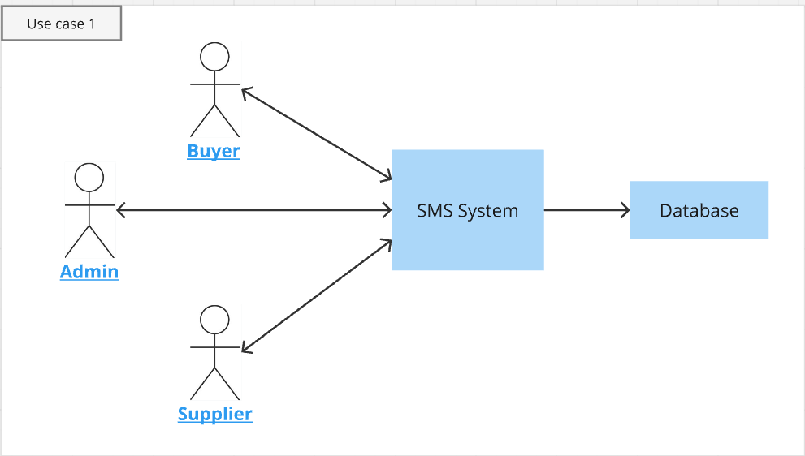
Admin: 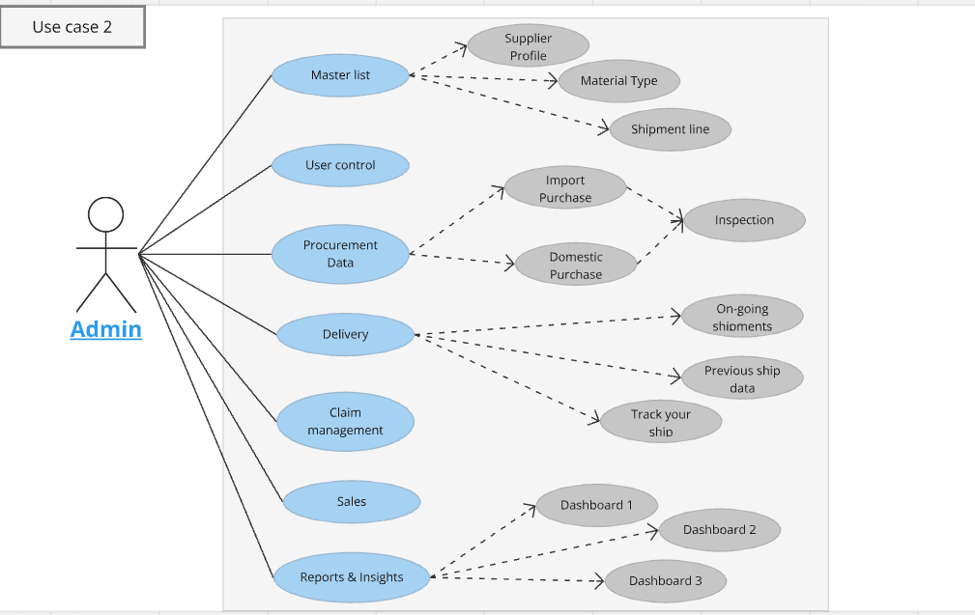

Buyer:
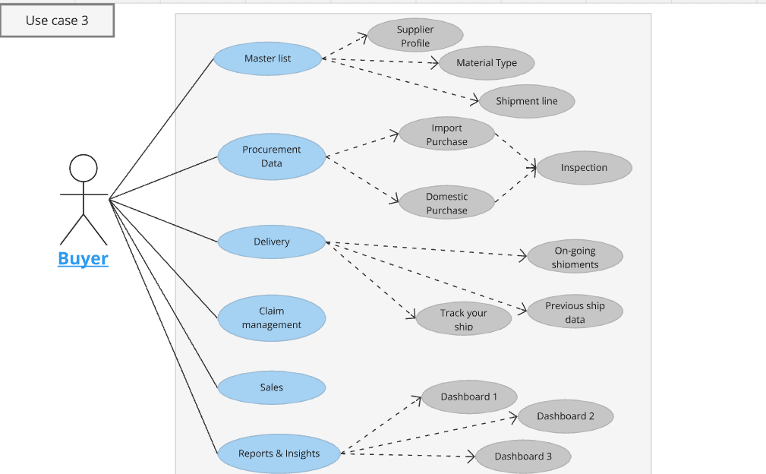

Supplier:
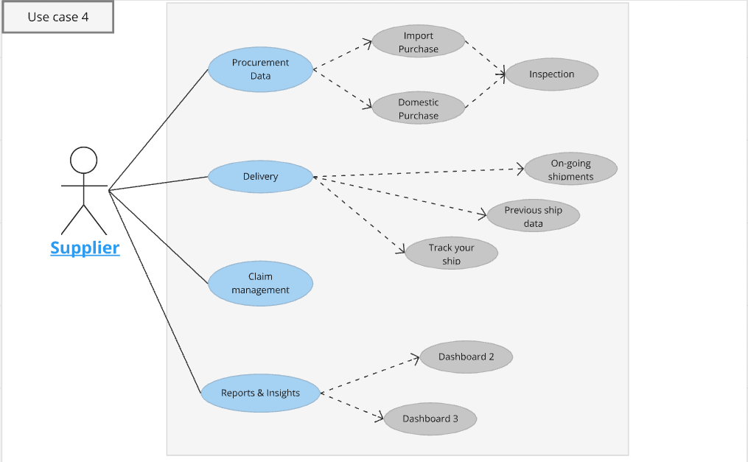

Workflow for Filing a Form and Updating a Challan on the Website
Below is a detailed workflow designed for a user-friendly process on a TDS compliance website.

Step 1: User Login
- Action:
  - User logs in using credentials (TAN, email, or registered username, and password).
  - Option for multi-factor authentication (MFA) for enhanced security.
- Outcome:
User is redirected to the homepage/dashboard.

Step 2: Accessing the Form Filing Section
- Action:
  - Navigate to the Forms section in the top navigation bar.
  - Select Form 26Q under the appropriate category (Regular or Correction).
- Features:
  - Filter options for regular/correction forms.
  - Tooltips explaining each form type.
- Outcome:
The Form 26Q preparation page loads.

Step 3: Enter Deductor Details
- Action:
  - User inputs deductor information such as TAN, PAN, and contact details.
  - These details may be auto-populated for registered users.
- Validation:
  - System verifies TAN/PAN format.
  - Any mismatches trigger error prompts.
- Outcome:
Deductor details are saved for the session.

Step 4: Add Challan Details
- Action:
  - Click on Add Challan to open a form for challan data entry.
  - Input fields include:
    - BSR Code
    - Challan Date
    - Challan Serial Number
    - Amount Paid
  - Option to add multiple challans.
- Features:
  - A summary table lists added challans with an Edit option.
  - System checks for duplicate BSR codes or serial numbers.
- Outcome:
Challan details are saved and associated with the session.

Step 5: Add Deductee Details
- Action:
  - Input deductee details including:
    - Deductee PAN
    - Payment Amount
    - TDS Deducted
  - Select the appropriate Section Code (e.g., 194C, 194J).
  - Map deductee payments to the relevant challans via a dropdown menu.
- Features:
  - Bulk upload via a pre-formatted Excel/CSV template.
  - Validation for PAN correctness (using government APIs).
  - Tooltip assistance for section codes.
- Outcome:
Deductee details are linked to challans and validated for correctness.

Step 6: Form Validation
- Action:
  - Click Validate Form to initiate system checks.
  - The system runs validations, including:
    - Mismatch between challan amount and deductee TDS totals.
    - Incorrect PAN/BSR formats.
- Outcome:
  - Validation errors are displayed, with actionable suggestions to fix them.
  - If no errors, a confirmation message appears.

Step 7: Generate and Submit FVU File
- Action:
  - Click Generate File to create an FVU (File Validation Utility) file.
  - Download the FVU file for record-keeping.
  - Option to directly submit to the government portal via API integration.
- Outcome:
  - Submission status is displayed (Success/Failure).
  - Acknowledgment receipt is generated for successful submissions.

Step 8: Update Challan Information (If Needed)
- Action:
  - Navigate to the Forms section and select the relevant Form 26Q entry from the filing history.
  - Click Edit Challan to update challan details.
  - Modify fields like BSR Code, Serial Number, or Amount Paid.
- Features:
  - Audit trail logs track and display all changes made to challan details.
  - Option to resubmit updated data.
- Outcome:
Challan information is updated, and validation ensures consistency.

Step 9: Reporting and Status Tracking
- Action:
  - Navigate to the Reports & Analytics section to view filing statuses, challan details, and TDS compliance reports.
  - Filters allow users to search by Form Type, Quarter, or Filing Date.
- Outcome:
Users can track the status of their filings, review error corrections, and download reports for audits.

Workflow Diagram
- User Login
→ 2. Select Form
→ 3. Enter Deductor Details
→ 4. Add Challan
→ 5. Add Deductee
→ 6. Validate Form
→ 7. Generate & Submit FVU
→ 8. Update Challan (Optional)
→ 9. Track Status & Reports

Reference Document
- Business Requirement Document
- Data Mapping
- Procurement Forms
- Diagrams and wireframes

