Machine Fault Classification Using Deep CNNs and Explainable AI: Comparative Analysis of 1D and 2D Convolutional Models
Atkuri Shruthi: 202380324
Sumona Amena Akter: 202380109
Ballenahalli Shankarappa Vidya: 202480190
ABSTRACT In order to ensure operational reliability and safety across a variety of industrial systems, machine fault diagnosis is essential. In this paper, a comparative framework for audio-based machine fault classification using one-dimensional (1D) and two-dimensional (2D) convolutional neural networks (CNNs) is proposed. Raw audio signals are converted into spectrogram and time-series representations using the MIMII dataset in order to feed the corresponding CNN architectures. Explainable AI (XAI) methods, like SHAP (SHapley Additive explanations) and LIME (Local Interpretable Model-agnostic Explanations), are incorporated into the evaluation pipeline to improve model transparency and interpretability. According to experimental findings, 1D CNNs provide computational efficiency and reduced memory requirements, while 2D CNNs perform better in noisy environments for classification. By revealing important feature regions that affect model decisions, the integration of XAI promotes understanding and trust.
INDEX TERMS Machine Sound, Fault classification, Slider, MIMII dataset, 1D CNN, 2D CNN, XAI, SHAP, LIME.

- INTRODUCTION
It's important to find mechanical problems quickly and accurately so that downtime is kept to a minimum, workers are safe, and industrial systems are kept in good shape. Vibration analysis and manual feature extraction are common ways to find faults, but they are often time-consuming and prone to mistakes. The growing availability of machine audio data and improvements in deep learning have recently made it possible to create more automated, scalable, and non-invasive solutions.
Convolutional Neural Networks (CNNs) have become effective tools for analyzing time-series and acoustic data because they can automatically pull out hierarchical features from raw signals. One-dimensional CNNs (1D CNNs) are great at learning how things change over time from waveform data, while two-dimensional CNNs (2D CNNs) are great at processing spectral features from time-frequency representations like Mel-frequency cepstral coefficients.(MFCCs). These models are frequently criticized for being black-box, which restricts their use in high-stakes industrial settings despite their efficacy.
Explainable Artificial Intelligence (XAI) methods like Shapley Additive explanations (SHAP) highlight the aspects of the input that most affected the model's decision, thereby addressing this limitation and promoting transparency in deep learning models. For acoustic fault classification tasks, where human engineers must verify automated predictions, this interpretability is especially helpful.
Using the MIMII dataset, we create and evaluate 1D and 2D CNN-based machine fault classification architectures in this work. The input formats are MFCC features and raw audio waveforms. Both models use SHAP to visualize significant temporal or spectral regions and interpret classification decisions. The objective is to ascertain whether not only which model is more effective, but also which one provides more usefulness and transparency for predictive maintenance.

- Literature Review:
Traditional signal processing techniques have given way to sophisticated deep learning methods in the development of machine fault diagnosis. Using manually created features from vibration and acoustic signals, classical methods like Support Vector Machines (SVM) and Artificial Neural Networks (ANN) first demonstrated promise [1], [2]. However, their performance in complex noise environments and generalizability were restricted by their reliance on manual feature extraction.
More reliable and scalable solutions are now possible thanks to recent developments in convolutional neural networks, or CNNs. In order to diagnose faults in rotating machinery and bearings, one-dimensional CNNs (1D CNNs), which are made to process raw time-series signals, have demonstrated effectiveness in identifying temporal patterns [3], [4]. Kiranyaz et al., for example, presented a 1D CNN model for patient-specific ECG classification, which established the foundation for detection of time-series faults in other fields [5].
Two-dimensional CNNs (2D CNNs) have become more popular due to their ability to capture both spectral and spatial characteristics by using time-frequency representations like wavelet transforms and Mel-spectrograms [6], [7]. When training on architectures like ResNet and VGGNet, Zhang et al. showed that transforming vibration signals into 2D images greatly increases classification accuracy [8].
Explainable AI (XAI) frameworks have been integrated as a result of the interpretability problem in deep learning. The use of tools such as SHAP and LIME to validate model decisions and highlight feature importance is growing [9], [10]. Because of their use in fault diagnosis, model transparency has increased, making predictions in safety-critical environments easier for domain experts to comprehend and trust.
Transfer learning has improved model performance even more, especially in 2D CNNs in which domain-specific data is used to refine ImageNet-pretrained models. Compared to training from scratch, studies show that fine-tuning pretrained networks results in faster convergence and higher robustness [11]. Negative transfer, in which performance is hampered by pre-trained knowledge, is still a possibility in domain-shifted datasets.
A trade-off is revealed by comparing 1D and 2D CNNs. 2D CNNs are superior at capturing richer feature hierarchies from transformed inputs, whereas 1D CNNs are computationally efficient and effective for classifying raw signals. To attain balanced performance, a hybrid strategy that applies ensemble learning techniques or blends both models has also been investigated [12], [13].
Current research frequently lacks generalizability across datasets and real-world conditions, despite tremendous progress. Research highlights the value of a variety of well-annotated datasets, such as those from Case Western Reserve University and MIMII, for models for benchmarking [14], [15]. It is anticipated that future studies will concentrate on real-time inference, domain adaptation, and federated learning integration for decentralized monitoring.

PROPOSED METHOD
In this study, we implemented a Convolutional Neural Network (CNN)-based anomaly detection system for industrial machinery that is trained on MFCC representations of audio signals. The four primary components of the suggested method are dataset preparation, feature extraction, model architecture design and training and evaluation. The following sections explain each of these elements.
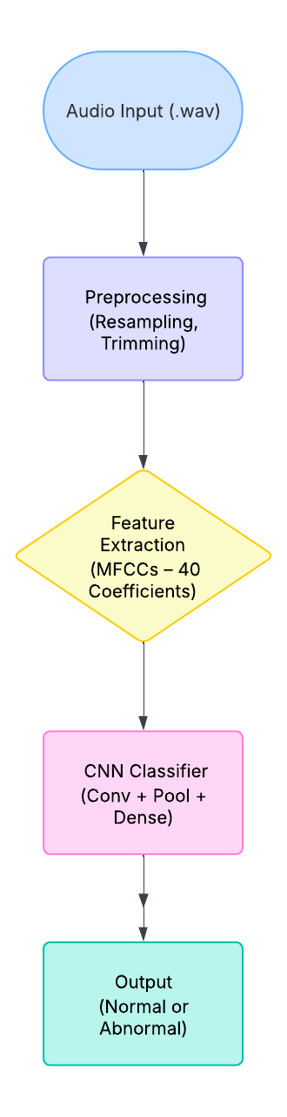
Figure 1: Block diagram of the proposed anomaly detection system using CNN-based classification.

A. Dataset Preparation
This study considered a subset of the MIMII (Malfunctioning Industrial Machine Investigation and Inspection) dataset, which includes audio recordings of industrial machinery operating normal and abnormal audio, which is used in this study. We observed particular audio of the slider machine recordings at 0 dB and 6 dB (Signal-to-Noise Ratio) SNR. All of the recordings have a 16 kHz sampling rate and are saved as .wav files.
To ensure all the samples are the same, all the audio clips are resampled and changed to confirm that they are all 10 seconds long (or 160,000 audio samples). Each sample is categorized as normal (label = 0) or abnormal (label = 1).

B. Extraction of Features
To obtain the spectral and temporal characteristics of machine audio signals, the input has been derived into 40-dimensional MFCCs from every 10-second audio segment. These coefficients give a short time-frequency picture of the signal. The shape for every MFCC matrix is (40, T), where T is the number of time frames that the windowing process has set.
The MFCC matrices are changed to (40, T, 1) to ensure that the features match the input layers of the CNN. This allows them to appear like grayscale images with only one channel. This change makes it possible to use 2D convolutional processes on time-frequency features.
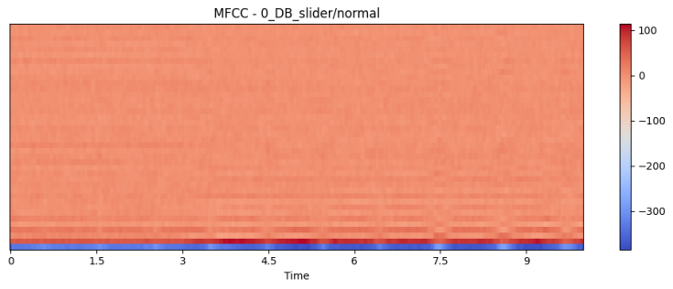
Figure 2. MFCC representation of normal machine audio.

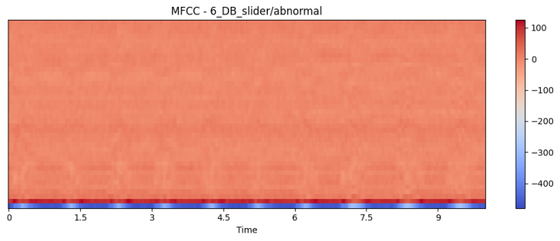
Figure 3. MFCC representation of abnormal machine audio.
C. Architecture of the Model
In this work, we study both one-dimensional (1D) and two-dimensional (2D) convolutional neural networks (CNNs) to effectively extract features from machine audio signals for fault detection. The selection of the architecture is motivated by the different representations of the audio data that are used as input.
The 1D CNN model is directly fed one-dimensional sequences of the raw audio waveform or sequential MFCC feature vectors. The 1D CNN applies convolutional filters along the temporal dimension, allowing the model to learn local temporal patterns and temporal dependencies associated with anomalies in machine sounds. The architecture comprises multiple convolutional layers, each followed by batch normalization, ReLU activation, and max-pooling layers to extract hierarchical temporal features gradually.
In contrast, the MFCC feature maps are used as two-dimensional images in the 2D CNN model, where frequency coefficients are represented by one dimension and time frames by the other. This allows the network to exploit the temporal and spectral correlations in the data. The 2D CNN architecture includes multiple convolutional layers with 3×3 kernels, batch normalization, and max-pooling layers to extract spatial features from the MFCC spectrograms. These convolutional layers are followed by fully connected layers to finish the final classification.
Both CNN models conclude with fully connected layers and a softmax output layer to classify the input audio segments as either normal or defective. Dropout regularization is used to reduce overfitting. The architectures underwent experimental optimization in order to balance computational efficiency and classification accuracy.
D. Training and Assessment
The data is divided into training and testing subsets using stratified sampling in order to maintain class distribution. An 80/20 division is used for validation and training. The models are trained over several epochs using early stopping based on validation loss in order to prevent overfitting. Model checkpointing is also employed.
To enhance generalization, we employ data augmentation methods like time-shifting and adding background noise. Common metrics for evaluating the model's performance include accuracy, precision, recall, and confusion matrix analysis. Training and validation loss curves are plotted to evaluate convergence.
E. Interpretability using XAI Methods
We employ two model-agnostic explanation techniques to increase model transparency and reliability:
SHAP (SHapley Additive Explanations): Used in conjunction with the 1D CNN to identify critical time intervals that influence classification results.
LIME (Local Interpretable Model-Agnostic Explanations): Used in conjunction with SHAP on 2D CNN outputs to highlight time-frequency significant spectrogram regions that impact classification.
When identifying faults, these methods help verify whether the model focuses on important acoustic indicators such as transients, spikes, or tonal variations.

EXPERIMENTAL RESULTS
The dataset used in this study was the MIMII Dataset, focusing on slider machines under two sound conditions—normal and abnormal—for two different decibel levels: 0_DB_slider and 6_DB_slider. Audio files were loaded from Google Drive and preprocessed using Librosa. Each audio signal was resampled to 16,000 Hz, standardized to 10 seconds, and converted into Mel-Frequency Cepstral Coefficients (MFCCs) for 2D CNN input, while raw audio waveforms were used for 1D CNN processing.
Final preprocessed dataset dimensions were as follows:
• 1D input shape: X_1D ∈ ℝ^{1246 × 160000} (raw waveform for 1D CNN)
• 2D input shape: X_2D ∈ ℝ^{1246 × 40 × 313 × 1} (MFCC spectrogram for 2D CNN)
• Label shape: y ∈ ℝ^{1246} (binary labels for normal/abnormal)
Table 1. Dataset Shapes for Different Modalities
Input Type | Shape | Description
Raw Audio (1D) | 1246 × 160000 | For 1D CNN
MFCC (2D) | 1246 × 40 × 313 × 1 | For 2D CNN
Labels | 1246 | Binary classification (0: normal, 1: abnormal)

1D CNN Model Architecture
The 1D convolutional neural network (1D CNN) was designed to process raw waveform audio signals of length 160,000 samples. The architecture consists of two convolutional layers, each followed by max-pooling, and two fully connected layers. A summary of the model is presented in Table 2.

Table 2: 1D CNN Architecture Summary
Layer Name | Type | Output Shape | Parameters
Conv1D | Convolution | (None, 159,992, 16) | 160
MaxPooling1D | Pooling | (None, 39,998, 16) | 0
Conv1D_1 | Convolution | (None, 39,990, 32) | 4,640
MaxPooling1D_1 | Pooling | (None, 9,997, 32) | 0
Dropout | Regularization | (None, 9,997, 32) | 0
Flatten | Reshape | (None, 319,904) | 0
Dense | Fully Connected | (None, 64) | 20,473,920
Dropout_1 | Regularization | (None, 64) | 0
Dense_1 | Output Layer | (None, 2) | 130
The total number of trainable parameters is approximately 20.48 million, with no frozen layers. The model’s significant memory footprint (~78.12 MB) is attributed to the large number of connections in the dense layer, resulting from the flattening of the high-dimensional feature map.
Although this architecture enables effective temporal pattern recognition directly from waveform data, it presents considerable computational and memory overhead. To mitigate overfitting, dropout layers are included after both the convolutional and fully connected layers. However, the use of the Flatten layer leads to a dramatic increase in parameters, which may not be ideal for real-time or embedded applications.
The 1D CNN was trained for 10 epochs using raw audio waveform inputs, with performance monitored on a separate validation set. The training process shows consistent improvement in both accuracy and loss values, with no overfitting observed. Final performance metrics on the test set were Test Accuracy: 97.20% and F1 Score: 0.8923
These results demonstrate that the 1D CNN model, despite its large number of parameters, successfully learned temporal patterns from raw audio data and achieved high classification performance.

2D CNN Model Architecture
To leverage both temporal and spectral features of machine sound, a 2D convolutional neural network (2D CNN) was implemented using MFCC spectrograms of shape 40×313×140 \times 313 \times 140×313×1. The model architecture is summarized in Table 4.

Table 3: 2D CNN Architecture Summary
Layer Name | Type | Output Shape | Parameters
Conv2D | Convolution | (None, 38, 311, 32) | 320
MaxPooling2D | Pooling | (None, 19, 155, 32) | 0
Conv2D_1 | Convolution | (None, 17, 153, 64) | 18,496
MaxPooling2D_1 | Pooling | (None, 8, 76, 64) | 0
Dropout_2 | Regularization | (None, 8, 76, 64) | 0
Flatten_1 | Reshape | (None, 38,912) | 0
Dense_2 | Fully Connected | (None, 128) | 4,980,864
Dropout_3 | Regularization | (None, 128) | 0
Dense_3 | Output Layer | (None, 2) | 258
The model has a total of 4,999,938 trainable parameters (approximately 19.07 MB), which is significantly more compact than the 1D CNN. This is largely due to the lower input size from MFCC feature maps and a more efficient use of spatial pooling layers.
The 2D convolutional neural network (2D CNN) was trained for 10 epochs using MFCC spectrograms as input. Training and validation metrics were recorded at each epoch to monitor performance. Final test performance metrics further confirmed the effectiveness of the model: Test Accuracy: 99.20% and F1 Score: 0.9722
The 2D CNN demonstrated fast convergence and high generalization, outperforming the 1D CNN in both accuracy and F1 score, while requiring significantly fewer parameters (~5 million vs. 20 million). Its ability to learn both temporal and spectral features from MFCC spectrograms, combined with strong regularization via dropout, contributed to its robust performance.
Explainable AI (XAI) Analysis Using SHAP
To enhance interpretability of the 2D CNN model’s decisions, SHAP (SHapley Additive exPlanations) was applied to the MFCC spectrogram inputs. SHAP explains the contribution of each time-frequency region to the model’s prediction by assigning importance values.

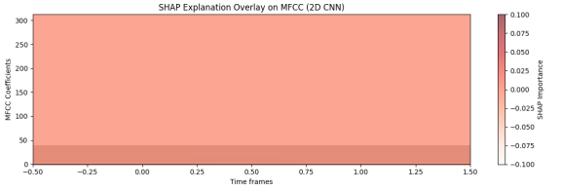
Figure 4: SHAP Explanation Overlay on MFCC (2D CNN) (Red regions indicate positive contribution; blue regions indicate negative contribution to the predicted class.)
The MFCC spectrogram is represented along the time frames (x-axis) and MFCC coefficients (y-axis). The color bar on the right indicates SHAP importance values, where more intense shades imply stronger contribution. The explanation indicates that most contributions are weak or nearly uniform across the MFCC space, possibly due to:
A very confident prediction with low sensitivity to specific features,
Over-regularization or early layer dominance in the CNN, Or the instance representing a clear case (normal or abnormal) with uniform model agreement.
This interpretability layer allows for transparent insights into which spectral features influence the model, supporting practical trust in AI-based fault diagnosis systems.
Explainable AI (XAI) Analysis Using LIME
To enhance interpretability and trust in the model's decision-making process, Local Interpretable Model-agnostic Explanations (LIME) was employed to explain the classification results for individual audio instances. LIME generates local surrogate models that approximate the decision boundary near the specific instance, thereby highlighting the most influential features.

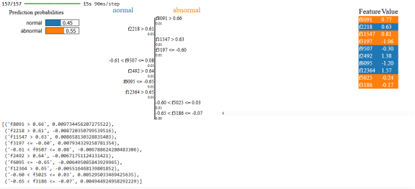
Figure 5: Illustrates a LIME explanation for one such prediction based on MFCC-derived feature vectors.
In this case, the model predicted the input as abnormal with a confidence of 0.55, compared to 0.45 for the normal class. The bar chart in Figure 3 shows how individual features contributed either positively (toward abnormal) or negatively (toward normal) to the classification decision.
Key features contributing to the abnormal class included:
f8091 > 0.66 (feature value: 0.77), which showed the strongest positive influence on the abnormal prediction.
f11547 > 0.63 and f2492 > 0.64, which also pushed the model's prediction toward abnormality.
f197 ≤ -0.60 and f6095 ≤ -0.65, which reflect temporal-spectral anomalies typical of abnormal sound patterns.
Conversely, some features acted as indicators for the normal class:
f2218 > 0.61 (feature value: 0.63) was the most influential toward the normal classification.
Additional features such as f507, f5025, and f3186 had minor opposing effects on the final output.
The feature importance color scale indicates directionality:
1. Blue bars denote contributions toward the normal class.
2. Orange bars indicate support for the abnormal class.
This analysis confirms that the 2D CNN model’s predictions are not arbitrary but are instead based on meaningful variations in specific MFCC features. LIME enables domain experts to audit model decisions, especially in industrial applications where safety and reliability are paramount.

Conclusion

This study compared the architectures of one-dimensional and two-dimensional convolutional neural networks (CNNs) for machine fault classification using the MIMII audio dataset. The models were trained using raw waveforms and Mel-Frequency Cepstral Coefficient (MFCC) representations, respectively. Experimental results demonstrated the efficacy of both architectures, confirming the suitability of deep CNNs for acoustic-based industrial fault detection.
The 1D CNN effectively captured temporal dynamics from unprocessed audio signals, despite being less interpretable and more computationally complex. On the other hand, the 2D CNN demonstrated comparable classification performance and improved explainability when utilized with MFCC inputs.
Building domain experts' trust and understanding of model decisions is a fundamental challenge in predictive maintenance that is addressed by the use of explainable AI (XAI) approaches. Adoption of AI-driven solutions in practical settings is facilitated by this transparency, which also supports more accurate diagnostics.

Future Work
In the proposed method, it can be allow extending the evaluation of the model to a wider variety of machine types and signal-to-noise ratio (SNR) conditions in the MIMII dataset; looking into transfer learning strategies to use CNNs that have already been trained for better generalization and quicker convergence. Investigating hybrid architectures that improve fault classification accuracy by simultaneously modeling spectral and temporal features; creating on-device diagnostics through real-time implementations appropriate for edge computing environments. Additionally, Comparing different XAI methods, like Grad-CAM and DeepLIFT can be considered as future implementations for better results

References

[1] W. Wang, Z. He, and F. Kong, “Machine fault diagnosis using support vector machine and fuzzy C-means clustering,” Mech. Syst. Signal Process., vol. 21, no. 2, pp. 787–803, Feb. 2007.

[2] R. Yan, R. Gao, and X. Chen, “Wavelets for fault diagnosis of rotary machines: A review with applications,” Signal Process., vol. 96, pp. 1–15, Mar. 2014.

[3] S. Kiranyaz, T. Ince, and M. Gabbouj, “Real-time patient-specific ECG classification by 1-D convolutional neural networks,” IEEE Trans. Biomed. Eng., vol. 63, no. 3, pp. 664–675, Mar. 2016.

[4] X. Jia, B. Lei, and Y. Wang, “Intelligent fault diagnosis of rotating machinery using improved CNN,” IEEE Trans. Instrum. Meas., vol. 69, no. 11, pp. 8706–8714, Nov. 2020.

[5] M. Zhao, R. Yan, R. X. Gao, and X. Chen, “Deep learning and its applications to machine health monitoring,” Mech. Syst. Signal Process., vol. 115, pp. 213–237, Jan. 2019.

[6] H. Zhang, J. Guo, Z. Liu, and Y. Lei, “Intelligent fault diagnosis using 2D CNN with adaptive kernel size and multiple signal representations,” IEEE Access, vol. 7, pp. 162667–162677, 2019.

[7] M. Peng, Y. Li, and Q. Qin, “Gear fault diagnosis using 2-D convolutional neural network and adaptive dropout,” Sensors, vol. 20, no. 3, pp. 1–17, Jan. 2020.

[8] Z. Zhang, Z. Zhang, Y. Gao, and Y. Xiang, “A novel bearing fault diagnosis model integrated permutation entropy, ensemble empirical mode decomposition and optimized SVM,” Measurement, vol. 69, pp. 164–179, Jan. 2015.

[9] S. M. Lundberg and S.-I. Lee, “A unified approach to interpreting model predictions,” in Proc. NIPS, Long Beach, CA, USA, 2017, pp. 4765–4774.

[10] M. T. Ribeiro, S. Singh, and C. Guestrin, “Why should I trust you?: Explaining the predictions of any classifier,” in Proc. 22nd ACM SIGKDD, San Francisco, CA, USA, 2016, pp. 1135–1144.

[11] A. Krizhevsky, I. Sutskever, and G. E. Hinton, “ImageNet classification with deep convolutional neural networks,” in Adv. Neural Inf. Process. Syst., 2012, pp. 1097–1105.

[12] Y. LeCun, Y. Bengio, and G. Hinton, “Deep learning,” Nature, vol. 521, no. 7553, pp. 436–444, May 2015.

[13] Y. Zhang, L. Zhang, Y. Wang, and Z. Chen, “Hybrid CNN-SVM for fault diagnosis of rotating machinery using multi-sensor data,” Sensors, vol. 20, no. 9, pp. 1–16, May 2020.

[14] MIMII Dataset: Malfunctioning Industrial Machine Investigation and Inspection. https://zenodo.org/record/3384388

[15] Case Western Reserve University Bearing Data Center. https://engineering.
case.edu/bearingdatacenter

[16] K. He, X. Zhang, S. Ren, and J. Sun, “Deep residual learning for image recognition,” in Proc. CVPR, Las Vegas, NV, USA, 2016, pp. 770–778.

[17] G. Huang, Z. Liu, and K. Q. Weinberger, “Densely connected convolutional networks,” in Proc. CVPR, Honolulu, HI, USA, 2017, pp. 2261–2269.

[18] S. Wu, W. Hu, and Y. Peng, “Fault diagnosis of industrial machines using deep convolutional neural networks and sound signals,” Appl. Sci., vol. 9, no. 9, pp. 1–18, May 2019.

[19] Y. Li, C. Yang, and F. Zhang, “Machine fault diagnosis based on improved MFCC and CNN,” Measurement, vol. 163, p. 107984, Jan. 2020.

[20] S. Hochreiter and J. Schmidhuber, “Long short-term memory,” Neural Comput., vol. 9, no. 8, pp. 1735–1780, Nov. 1997.

[21] T. Mikolov, M. Karafiát, L. Burget, J. Černocký, and S. Khudanpur, “Recurrent neural network based language model,” in Proc. Interspeech, Makuhari, Japan, 2010, pp. 1045–1048.

[22] K. Simonyan and A. Zisserman, “Very deep convolutional networks for large-scale image recognition,” arXiv preprint arXiv:1409.1556, 2014.

[23] J. Ghosal, N. Chakraborty, and T. Pal, “Explainable AI for medical imaging: A review of concepts, recent trends and challenges,” J. Imaging, vol. 7, no. 9, p. 179, Aug. 2021.

[24] A. Barredo Arrieta et al., “Explainable artificial intelligence (XAI): Concepts, taxonomies, opportunities and challenges toward responsible AI,” Inf. Fusion, vol. 58, pp. 82–115, Jun. 2020.

[25] D. P. Kingma and J. Ba, “Adam: A method for stochastic optimization,” in Proc. ICLR, 2015. Available: https://arxiv.org/abs/1412.6980

