**Task1: Git command with explanation and screenshot**

1. Git clone: To clone the new project from git hub into local system, below clone project by default from master/main branch

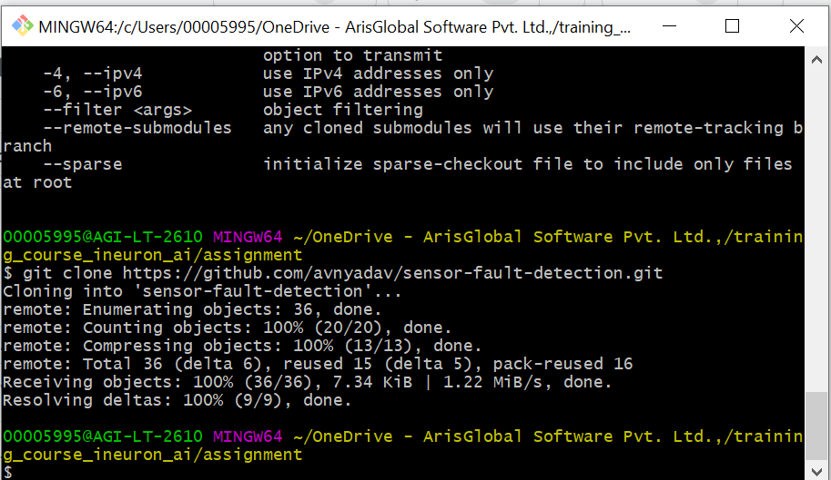

1. Git log: To get the history of who and all committed the code for given project in git hub

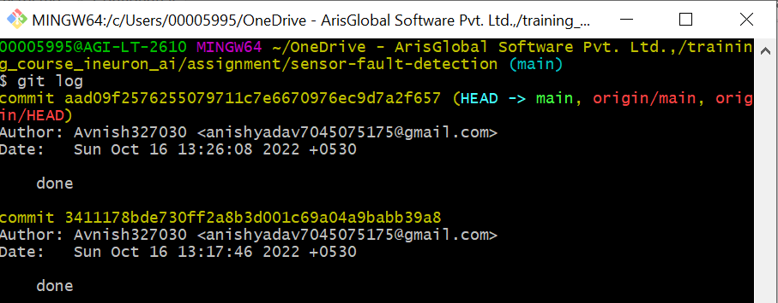

1. Git help : To see and get all the commands from git , if any error in our executable command

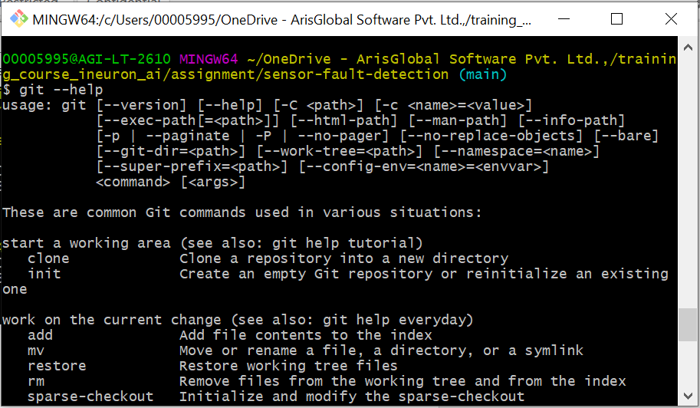

1. Git branch : To list out all available branches in locally

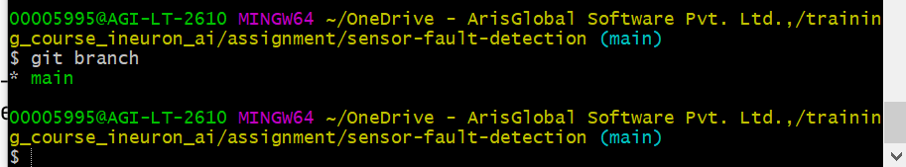

1. Git checkout -b new-branch-name: To create a new branch from current branch and switch to it in local system

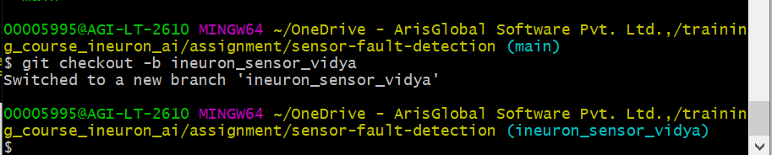

1. Git checkout branch-name: To simply switch to other required branches in local system

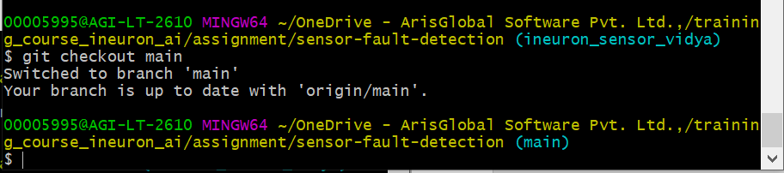

1. Git stash: To save the changes locally

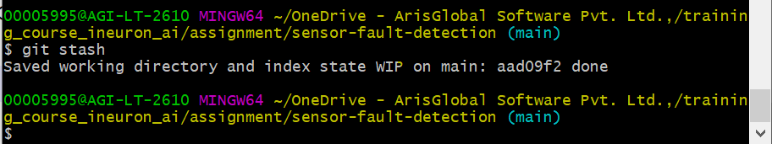

1. Git stash pop: To pop out the locally saved changes to particular opened branch

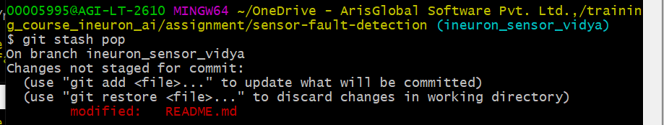

1. Git reset –hard: To discard local changes to all files, permanently

1. Git stash list: To list out all stashed changes

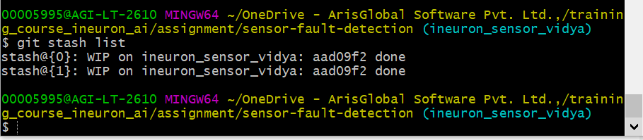

1. Git stash show:To get brief summary of changes of files

1. Git show stash@{}: To get difference of selected stash with main/head

1. Git push: To push the locally created new branch and its changes to git hub repo

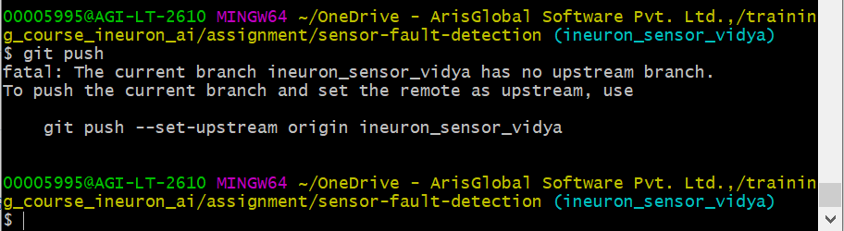

1. Git merge: To merge the different branches commits

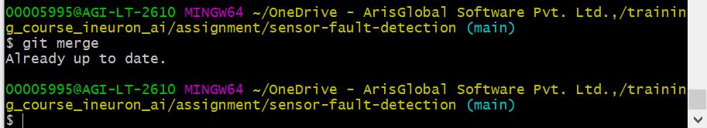

1. Git show: To get details of repo and its recent changes and about the author

