Assessment Agent Token Allocation and Pricing
Short Description
AI Agent Metering/ Pricing
Status REVIEW

Prepared by:
Vidya Sagar
24-Oct,2025

This document consists of
PRD
TechSpec

Contents

PRD 3
Feature Summary 3
User Stories 3
Planning the launch 3
Customer Adoption/Migration Strategy 3
Product Marketing Plan 3
Product Tour 3
FAQ 3
Tech Spec 3
Overview 4
Version-Based Optimistic Locking Approach 5
Concurrency Example 6
Use Cases 6
Background Job 6
API 6
API Summary 6
API Details 7
API Data Model <Fix me> 7
Data Model 7
Audit Log 10
Error Message 10
Checklist 10
Deployment 10
Technical Specification 10
Testing 11
Test Strategy 12
Test Plan 12
Test Case 12
Test Data 12

AI Agents Metering – Requirements

Assessment Agent will be available as part of the Assessments Product. Agents incur costs for every prompt and its response; this is primarily from the LLM token costs.
Our goal is to limit the variable GenAI token costs that Corestack incurs and pass any additional cost to the Customer/Partner Account Master account.

User Stories
User Story ID | AIP – 1: Token Allocation Based on pricing for any product
User Story | As an AI product admin, I want to automatically allocate Assessment Agent token credits equal to 10% of the total value of “Licensed Assessments and Appsecops” purchased by a customer,  so that the account master’s available credit is calculated fairly based on purchased products (Assessments and Appsecops).
Acceptance Criteria | - Introduce a new filed in the Account master page “AI Agent Credits” and the value has the available credit. This field needs to be entered/updated by the product admin with the total available credit. The value of this is about 10% of the value of the product purchased  - The “AI Agent Credits” will appear under Credits tile in “Agent Usage” tab in Account Management  - The credit can be used by users across the tenants under that Account master.  - There is no expiry for the credits and they last until they exhaust.

User Story ID | AIP – 2: Addition of new Credits
User Story | As an account admin, I want to contact sales@corestack.io to add additional credits when exhausted,  so that the users continue using Agents beyond the allocated quota.
Acceptance Criteria | - Account admin can reach out to aisupport@corestack.io via email to request additional credits.  - Additional credits added should reflect in the “Credits” tile in Account management. Credits tab value should always show the net credits available (Current Credits + Additional Credits added = Credits)

User Story ID | AIP – 3: Token Pricing and Conversion
User Story | As a system, I want to meter token consumption in real time and convert it to a $ value, so that I can deduct it from the account’s available dollar credit balance.  Token Pricing:  I want to apply Corestack-defined pricing for Input, Cached Input, and Output tokens,  so that token consumption costs align with internal pricing rules.  Note: this pricing can be updated as and when needed based on the price changes of LLM we use.  Corestack  Input:  $5 / 1M tokens  Cached input:  $1.25 / 1M tokens  Output:  $ 30.000/ > 1M tokens
Acceptance Criteria | - Follow a bottom-up approach:  - Track token usage per prompt/response.  - Convert token usage to $ at that time’s rate.  - Deduct from $ balance.  - Maintain precision up to 2 decimal places.  - Round up fractional tokens beyond 2 digits.

User Story ID | AIP – 4: Error When Tokens Exhausted
User Story | As a user, I want to receive a clear error message when token credits are exhausted, so that I know I can’t use the Agents until tokens are added.
Acceptance Criteria | - An error message ribbon shows for the users who attempt to submit a prompt when the credits are not available  - “No available credits to submit the prompt. Please contact your account admin to add credits”

User Story ID | AIP – 4: Credit consumptions details in Account Management
User Story | As an admin, I want to see various consumption information so that I know where the consumption is happening
Acceptance Criteria | Charts as per the figma link - https://www.figma.com/proto/FaLgEcqifM2burzfUjX3co/Account-Management?page-id=0%3A1&node-id=1-7&viewport=-268%2C350%2C0.5&t=6npDPtsOFSmA8PMC-1&scaling=min-zoom&content-scaling=fixed&starting-point-node-id=1%3A7

Tech Spec

Overview
System Design Diagram
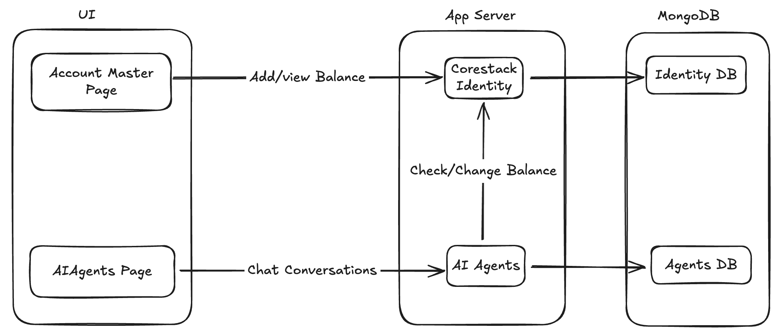

Balance Addition / Manual Change (Product Admin via UI)
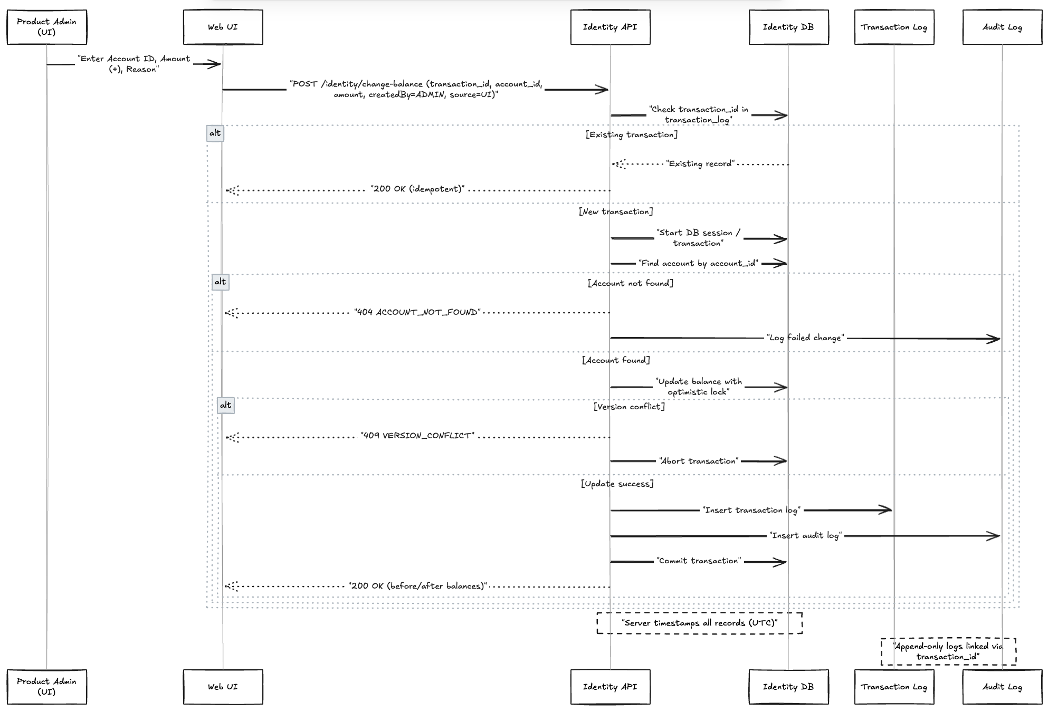
Balance Deduction (Agent / SubAgent)

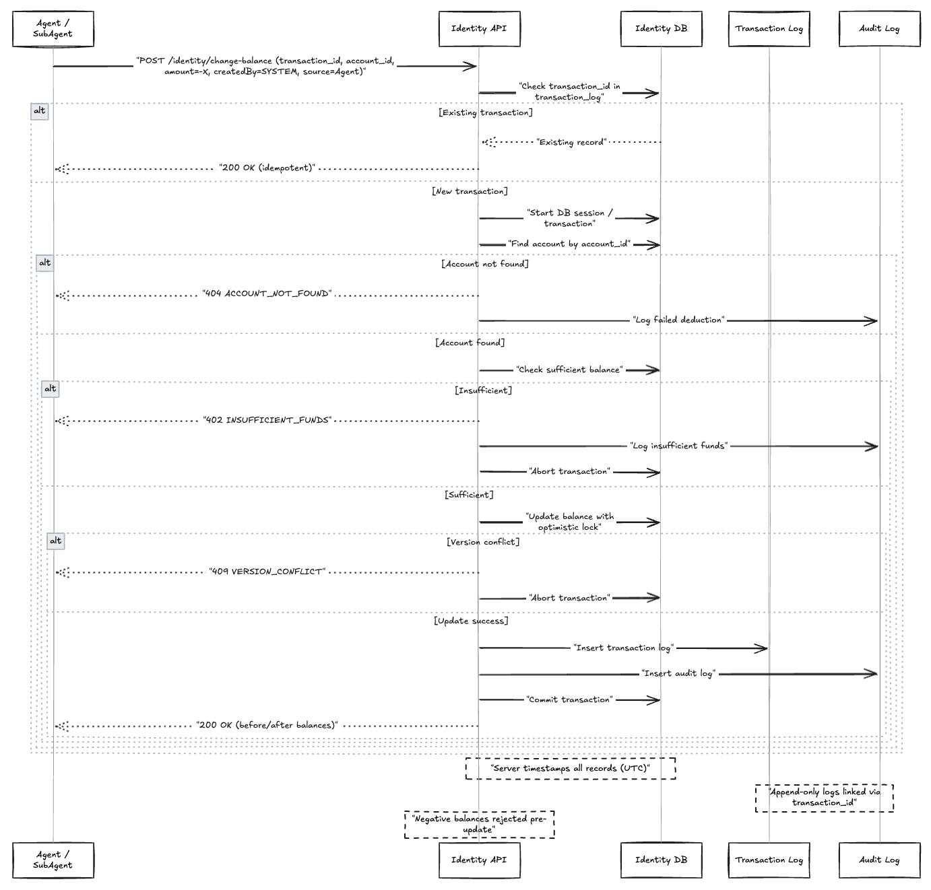

Version-Based Optimistic Locking Approach

- Version-based approach eliminates race conditions between read and write operations, ensuring data consistency under high concurrency.
- Version-based approach provides explicit conflict detection enabling intelligent retry strategies with exponential backoff, preventing system overload during high concurrency periods
- Version-based approach supports complex multi-step transaction workflows with rollback capability
- Version-based approach allows for complex transaction workflows with rollback capabilities. findOneAndUpdate can't handle multi-step operations safely.

Concurrency Example

User A and User B try to update the same account simultaneously:
Time | User A | User B | Database State
T1 | Reads: balance=100, version=5 | Reads: balance=100, version=5 | balance=100, version=5
T2 | Calculates: new_balance=150 | Calculates: new_balance=80 | balance=100, version=5
T3 | Updates WHERE version=5 ✅ | Updates WHERE version=5 ❌ | balance=150, version=6
T4 | Success! | Gets version_conflict | balance=150, version=6
T5 | - | Retries: Reads version=6 | balance=150, version=6
T6 | - | Updates WHERE version=6 ✅ | balance=130, version=7

Use Cases
- Balance Addition / Manual Change (Product Admin via UI)
- Balance View (Account Admin via UI and API)
- Balance Deduction (Agent / SubAgent)

Background Job
N/A.

API

API Summary
Item | Yes/No/NA | Impact Details if yes
Identity | No Impact | No Impact
External API | No Impact | No Impact

API Details

Item | Description
API Name | Change Balance API (Add or Deduct)
Purpose | Api to add or deduct the balance from the master account
Is New Api | Yes
Endpoint | /v1/master_account/item/<master_account_id>/billing/transaction
Method | POST
Authentication | Follows the same authentication mechanism as the existing api JWT mechanism
Authorization | Only the product admin is authorized to perform this activity or from other internal service ie to update the balance
Headers | x-auth-token
Query Strings | Not Applicable
Request | {  "transaction_id": "string (UUIDv4, client-generated)",  "amount": "number (fractional USD supported, max 2 decimals)",  "user_id": "string (user_id)",  “transaction_type”:debit/credit  }  MasterAccountBalanceUpdateRequest
Response | {  "before_balance": "number (fractional USD, 2 decimals)",  "after_balance": "number (fractional USD, 2 decimals)",  "transaction_id": "string (UUIDv4, client-generated)"  }  MasterAccountBalanceUpdateResponse
Status Codes | 200, 404, 400,401,402, 403, 409, 500

Item | Description
API Name | Fetch master account billing summary
Purpose | Api to fetch the billing summary of the master account
Is New Api | Yes
Endpoint | /v1/master_account/item/<master_account_id>/billing/summary
Method | GET
Authentication | Follows the same authentication mechanism as the existing api JWT mechanism
Authorization | Only the product admin is authorized to perform this activity or from other internal service ie to update the balance
Headers | x-auth-token
Query Strings | Not Applicable
Request | NONE
Response | {  "current_balance": "number (fractional USD, 2 decimals)",  “total_spend”:”number”  }  MasterAccountBillingSummaryResponse
Status Codes | 200, 404, 400,401,402, 403, 409, 500

Item | Description
API Name | Fetch master account billing Balance
Purpose | Api to fetch the billing balance of the master account
Is New Api | Yes
Endpoint | /v1/master_account/item/<master_account_id>/billing/ balance
Method | GET
Authentication | Follows the same authentication mechanism as the existing api JWT mechanism
Authorization | Only the product admin is authorized to perform this activity or from other internal service ie to update the balance
Headers | x-auth-token
Query Strings | Not Applicable
Request | NONE
Response | {  "balance": "number (fractional USD, 2 decimals)",  }  MasterAccountBillingBalanceGetResponse
Status Codes | 200, 404, 401, 403, 400

API Data Model
public class MasterAccountBalanceUpdateRequest {
private double amount; // Balance amount to be updated for the master account
private String transaction_id; // Transaction id for the balance update
private String user_id; // Id of the user who made the balance update
private String tenant_id; // Id of the tenant where the balance is updated
private String conversation_id; // Id of the conversation where the balance is updated
private String transaction_type; // Billing transaction type (enum)
}

public class MasterAccountBalanceUpdateResponse {
private String transaction_id; // Transaction id for the balance update
private double before_balance; // Balance amount before the update in master account
private double current_balance; // Balance amount after the update in master account
}

public class MasterAccountBillingSummaryResponse {
private double current_balance; // Current balance in the master account
private double total_spend; // Total spend amount from the master account
}

Observability
Here is a clean, concise, and professional Observability section with bullet points, suitable for documentation:

Observability
- All user-initiated and service-initiated transactions are logged and stored in the master_account_transaction collection.
- Each transaction record captures the complete lifecycle, including:
  - Success
  - Failure
  - Pending states
- Detailed logs are generated for every step of the transaction flow, enabling end-to-end traceability.
- These logs provide full visibility into the processing sequence, making it easier to detect anomalies, troubleshoot issues, and validate system behavior.
- Data can be visualized and analyzed through:
  - Application logs
  - Entries stored in the master_account_transaction collection
- Together, the logs and database records offer a comprehensive view of system behavior, ensuring robust observability across all workflows.

Data Model

Item | Yes/No/NA | Impact details If yes
Database Introduced | No
Collection(s) Introduced | Yes | master_account_balance  master_account_transactions
Collections Impacted | No
Document Introduced | Yes | For the above collections.
Field modification or any new possible value | No
Sample new Record |  | master_accunt_balance  { "_id" : ObjectId("6908c1dadb770e7c096b4d14"), "master_account_id" : ObjectId ("66d84bf84451fbab1ccc6b6d"),  "balance" : 100.0,  "version" : 2,  "last_transaction_id" : "b6e0ad24-6aff-4a5e-9449-bc0f9dd2d8a3",  "created_at" : ISODate("2025-11-03T14:53:13.848+0000"),  "updated_at" : ISODate("2025-11-03T15:02:26.092+0000"),  "created_by" : ObjectId("66d6eecd4451fbab1cc4b3db") }  master_account_transactions  { "_id" : ObjectId("6908c4015316fab8c9ec3440"), "transaction_id" : "b6e0ad24-6aff-4a5e-9449-bc0f9dd2d8a3",  "master_account_id" : ObjectId("66d84bf84451fbab1ccc6b6d"),  "amount" : 100.0,  "transaction_type" : "credit", "before_balance" : 0.0,  "after_balance" : 100.0,  "status" : "completed",  "created_by" : ObjectId("66d6eecd4451fbab1cc4b3db"), "tenant_id" : null,  "conversation_id" : null,  "created_at" : ISODate("2025-11-03T15:02:25.543+0000"),  "processed_at" : ISODate("2025-11-03T15:02:26.374+0000"),  "error" : null}
Sample Record with modifications highlighted | N/A
Index Creation | Yes
Index Details |  | master_account_balance  // Ensure unique balance per master account  "master_account_id_1": [("master_account_id", pymongo.ASCENDING)],  "version_1": [("version", pymongo.ASCENDING)],  "tenant_id_1": [("tenant_id", pymongo.ASCENDING)],  "is_active_1": [("is_active", pymongo.ASCENDING)]  master_account_transactions  "transaction_id_1": [("transaction_id", pymongo.ASCENDING)],  "master_account_id_1": [("master_account_id", pymongo.ASCENDING)],  "created_at_-1": [("created_at", pymongo.DESCENDING)],  "conversation_id_1": [("conversation_id", pymongo.ASCENDING)],  "tenant_id_1": [("tenant_id", pymongo.ASCENDING)],  "master_account_id_1_created_at_-1": [ ("master_account_id", pymongo.ASCENDING), ("created_at", pymongo.DESCENDING) ],  "status_1": [("status", pymongo.ASCENDING)]
Is there any backward compatibility? | N/A
Is Migration Required? | May be | To populate initial balances for the existing customer. We will either ask CSM to edit manually or do onetime migration to update the balances
RBAC Changes | No
Will there be any changes to new setup installation scripts? | No
Expected Load / Any Infra changes required? | No | No infra changes are required at this moment. We will revisit based on the usage  Since this is the first rollout – we are expecting the load to be very minimal 1 or 2 RPS (daily avg)

Audit Log
Action | Message added to Audit Log
ADD_BALANCE_MANUAL | admin_user_42 performed ADD_BALANCE_MANUAL on master account MA-1001. Transaction ID: TX-1a2b3c
DEDUCT_BALANCE_AGENT | SYSTEM performed DEDUCT_BALANCE_AGENT on master account MA-1001. Transaction ID: TX-9b2f8c, SubAgent involved: SA-2001.
DEDUCT_BALANCE_SYSTEM | SYSTEM performed DEDUCT_BALANCE_SYSTEM on master account MA-1002. Transaction ID: TX-8c7d6e
FAILED_ADD_BALANCE | admin_user_42 attempted FAILED_ADD_BALANCE on master account MA-1003. Transaction ID: TX-1a2b3c
FAILED_DEDUCT_BALANCE | SYSTEM attempted FAILED_DEDUCT_BALANCE on master account MA-1002. Transaction ID: TX-7f6e5d, SubAgent involved: SA-2003.

Error Message
Message | Description
 | Captured in the above API responses

Checklist
Item | Description
Is External API available | NO – We do not want to expose these to outside
Angular 14 or Angular.js | Angular.js – Since Account Management Screens are not upgraded yet.  Angular 14 – For Agent related pages
Impact on the Other Teams? | None

Deployment
Item | Description
Config Change | No
Dependency with DevOps | No
Firewall Changes | No

Technical Specification
Item | Descriptions
Figma | Yet to be received
UI html | Yet to be received
Third Party Library | Yes/No. If yes, please detail out

Testing

Test Strategy

Test Plan

Test Case

Test Data

