Service Account Summary/List/batch Api Refactoring
Short Description
User Story 118573: Service Account API Optimization
Status: Review

Prepared by:
Seshan K B
2-2-2026

This document consists of
PRD
Technical Specification

Contents

PRD 3
Feature Summary 3
User Stories 3
Planning the launch 3
Customer Adoption/Migration Strategy 3
Product Marketing Plan 3
Product Tour 3
FAQ 3
Tech Spec 3
Overview 4
Use Cases 4
Background Job 4
API 4
API Summary 4
API Details 4
API Data Model 4
Data Model 4
Audit Log 5
Error Message 5
Checklist 5
Deployment 5
Technical Specification 5
Testing 6
Test Strategy 7
Test Plan 7
Test Case 7
Test Data 7

PRD

Feature Summary

User Stories

User Story ID | 118573
User Story Title | Service Account API Optimization
User Story Description | Background  Service Account APIs are currently experiencing higher response times, especially for summary list batch operations. This impacts application performance and user experience.  Objective  Optimize all Service Account APIs to ensure responses are returned within the defined performance threshold.  Business Value  - Faster UI performance  - Improved user experience  - Better system scalability  - Reduced server load  - Supports performance SLAs for Heatstack API consumers
Acceptance Criteria | • Performance Threshold  - All Service Account APIs must respond in ≤ 1 second.  - Measured from API request received to full response returned.  • Scope  - Applies to:  - Service Account Summary API  - Batch/List endpoints  - Detail endpoints (if applicable)  • Load Conditions  - Performance should be validated under:  - Production-like data volume  - Expected concurrent user load  - Typical filters, sorting, and pagination parameters  • Data Handling  - APIs should:  - Return only required fields  - Support pagination for large datasets  - Avoid unnecessary nested objects  • Database Optimization  - Queries should:  - Use proper indexing  - Avoid full table scans  - Avoid N+1 query issues  - Minimize database round trips for batch operations  • System Efficiency  - Reduce external service calls where possible  - Implement caching if applicable  - Optimize business logic processing time  • Monitoring & Validation  - Performance validated using tools (JMeter/K6/APM)  - Capture:  - Average response time  - P95 response time  - Error rate  • Non-Regression  - No functional impact  - No data inconsistencies  - Security and authorization remain intact  Figma: https://www.figma.com/proto/N3Ytg2g8bQfgQ50u20yPSZ/OSCAR-Design-System?page-id=14594%3A62169&node-id=14644-16090&p=f&viewport=104%2C193%2C0.25&t=OcSu0EknMqDv9OrQ-1&scaling=contain&content-scaling=fixed&starting-point-node-id=14644%3A16090

Tech Spec

Overview
System Design Diagram
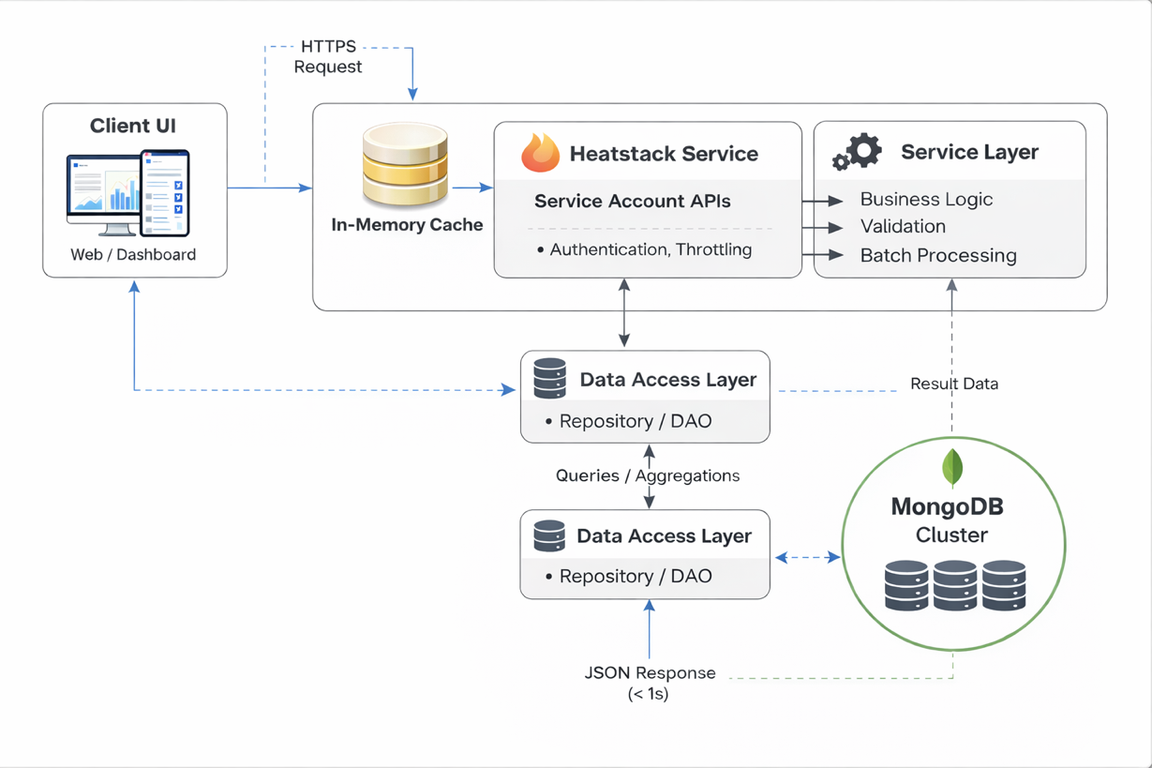
Sequence diagram
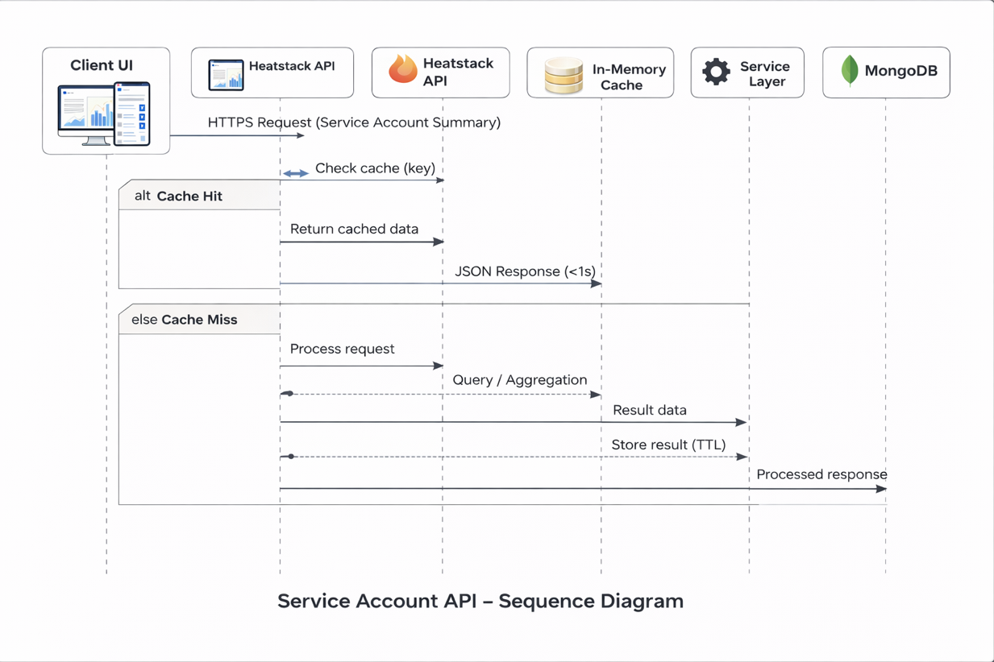

Use Cases

Remove hierarchy build logic from UI

Child count will be passed in API response list

UI will render flat list based on API response

API will return pre-processed summary data (no client-side aggregation)

API will support pagination for large Service Account lists

API response time should be under 1 second

In-memory cache will be used to improve response performance

UI will not make additional calls to fetch child details separately

API will return only required fields to reduce payload size

MongoDB queries will be optimized to avoid multiple database calls

Background Job
N/A

API

API Summary
Item | Yes/No/NA | Impact Details if yes
Module | Heatstack
Internal API | No
External API | No

API Details
Item | Description
API Name | Service Account List API – V2
Purpose | Provides Service Account data in a flat structure with filtering, field projection, and batch pagination.  V2 replaces separate List and Batch APIs and returns child_count and sync_status, enabling the UI to render the list without building hierarchy or making additional calls.
Is New Api | Yes
Endpoint | v2/service-accounts/list
Method | POST
Authentication | Follows the same authentication mechanism as the existing api JWT mechanism
Authorization | (CLOUD_AND_TOOL_ACCOUNTS, READ), (ACCOUNT_GOVERNANCE, READ) – Can access this API
Headers | x-auth-token
Query Strings | Not Applicable
Request | {  "filters": {  "statuses": ["not_onboarded", "validated"],  "parent_ids": ["693936ef3de3754c0c050653"],  "is_active_in_cloud": true  },  "fields": [  "_id",  "name",  "status",  "native_details.cluster_name",  "native_details.type"  ],  "include_child_count": true,  "max_depth": 2,  "list_context": {  "batch_size": 100,  "batch_offset": 0  }  }
Response | {  "total_count": 1240,  "batch_size": 100,  "batch_offset": 0,  "data": [  {  "_id": "693936ef3de3754c0c050653",  "name": "SA-Cluster-01",  "status": "validated",  "sync_status": "synced",  "native_details": {  "cluster_name": "cluster-east",  "cluster_id": "cl-001",  "location": "us-east",  "type": "kubernetes"  },  "is_active_in_cloud": true,  "onboarding_type": "auto",  "created_at": "2025-01-10T10:00:00Z",  "created_by": "admin",  "child_count": [  {  "level": 1,  "type": "namespace",  "count": 12  },  {  "level": 1,  "type": "node",  "count": 6  },  {  "level": 2,  "type": "workload",  "count": 45  },  {  "level": 2,  "type": "service",  "count": 8  }  ]  }  ]  }
Status Codes | 200, 404, 400,401,402, 403, 409, 500

Item | Description
API Name | Existing Summary Api Optimization
Purpose | Summary of Account Count based on the Filter
Is New Api | No
Endpoint | v2/service-accounts/summary
Method | POST
Authentication | Follows the same authentication mechanism as the existing api JWT mechanism
Authorization | (CLOUD_AND_TOOL_ACCOUNTS, READ), (ACCOUNT_GOVERNANCE, READ) – Can access this API
Headers | x-auth-token
Query Strings | Not Applicable
Request | {  "filters": {  "tenant_ids": ["688b56794d58603805560213"],  "master_account_ids": [],  "with_parent": true,  "native_details": [  {  "type": "ServiceAccountNativeDetailsForGcpProject"  }  ],  "statuses": ["active", "inactive"],  "sync_status": {  "credential_validation": {  "status": "failed"  }  }  }  }
Response | [  {  "native_details": {  "type": "ServiceAccountNativeDetailsForGcpProject"  },  "status": "active",  "count": 6  }  ]
Status Codes | 200, 404, 400,401,402, 403, 409, 500

API Data Model
Request Models
public class ServiceAccountListRequest {
private ServiceAccountFilters filters; // Filters for Service Account search
private List<String> fields; // Fields to be projected in response
private Boolean include_child_count; // Flag to include child count aggregation
private Integer max_depth; // Maximum hierarchy depth for child count
private ListContext list_context; // Pagination details
}

Filters
public class ServiceAccountFilters {
private List<String> statuses; // Filter by Service Account status
private List<String> parent_ids; // Filter by parent Service Account IDs
private Boolean is_active_in_cloud; // Filter by cloud active state
}

Pagination
public class ListContext {
private Integer batch_size; // Number of records per batch
private Integer batch_offset; // Offset for pagination
}

Response Models
public class ServiceAccountListResponse {

private Long total_count; // Total matching records
private Integer batch_size; // Batch size returned
private Integer batch_offset; // Current offset
private List<ServiceAccountData> data; // List of Service Accounts
}

Service Account Data
public class ServiceAccountData {
private String _id; // Service Account ID
private String name; // Service Account name
private String status; // Current status
private String sync_status; // Sync state

private NativeDetails native_details; // Cloud native details

private Boolean is_active_in_cloud; // Cloud active flag
private String onboarding_type; // Onboarding type

private String created_at; // Creation timestamp
private String created_by; // Creator

private List<ChildCount> child_count; // Aggregated child counts (optional)
}

Native Details
public class NativeDetails {
private String location; // Region/location
private String type; // Resource type
}

Child Count
public class ChildCount {
private Integer level; // Hierarchy level (1, 2, etc.)
private String type; // Resource type
private Long count; // Number of child resources
}

Observability
- Metrics: API latency (P95/P99), request count, error rate, MongoDB time, cache hit/miss
- Logs: tenant_id, filters, batch_size, include_child_count, max_depth, slow requests (>1s)
- Traces: End-to-end flow (API → Cache → DB → Aggregation)
Key Data
- Total response time and DB time
- Result size and batch details
- Child count usage and depth
- Error details
Visualization
- Dashboard: latency, traffic, error rate, DB performance, cache ratio
- Alerts: P95 latency > 1s, high error rate

Data Model

Item | Yes/No/NA | Impact details If yes
Database Introduced | No
Collection(s) Introduced | No
Collections Impacted | No
Document Introduced | No
Field modification or any new possible value | No
Sample new Record | No
Sample Record with modifications highlighted | No
Index Creation | No
Index Details | No
Is there any backward compatibility? | Yes
Is Migration Required? | No
RBAC Changes | No
Will there be any changes to new setup installation scripts? | No
Expected Load / Any Infra changes required? | No

Audit Log
Action | Message added to Audit Log
 | No new Audit Log Added

Error Message
Message | Description
 | Captured in the above API responses

Checklist
Item | Description
Is External API available | Yes
Angular 14 or Angular.js | Angular 14
Impact on the Other Teams? | None – New Api

Deployment
Item | Description
Config Change | No
Dependency with DevOps | No
Firewall Changes | No

Technical Specification
Item | Descriptions
Figma | -
UI html | -
Third Party Library | No

Testing

Test Strategy

Test Plan

Test Case

Test Data

