Metrics Utilization Dashboard for CloudOps

Prepared by:
Allwin Jayakumar S
11 July 2025

This document consists of
PRD
Tech-Spec

Table of Content

PRD ...................................................................................................................3
Tech Spec...........................................................................................................6
Overview............................................................................................................ 6
BackgroundJob................................................................................................... 7
Flowchart..........................................................................................................10
DataModel........................................................................................................12
API Summary.................................................................................................... 13
API................................................................................................................... 13

PRD
We are introducing a dedicated AI Metrics Utilization Dashboard to provide unified visibility into the performance and health of AI-related resources across major cloud platforms (AWS, Azure, GCP, and OCI). This dashboard will focus solely on monitoring utilization metrics for AI services, including compute instances, training jobs, model endpoints, notebooks, and cognitive APIs.
The dashboard will enable users to:
- Track and analyze key metrics such as CPU utilization, memory consumption, GPU usage, network throughput, and latency for AI workloads.
- Filter and explore metrics data based on:
  - Start Date
  - End Date
  - Metric Name
  - Resource ID
  - Service account id
This initial phase aims to provide actionable insights to help users monitor AI system performance, optimize resource usage, and support capacity planning and troubleshooting for AI services deployed across cloud environments.
Feature Ticket:
https://dev.azure.com/CoreStack-Tech/Product_Mgmt/_workitems/edit/105078/
User Story ID | #1
User Story Title | Background job for AI based metrics to get the metrics data - Phase 1
User Story Description | Background job to get the metrics data in minute level granularity
Acceptance Criteria | The dashboard will support collection and visualization of metrics data for all AI-related resources across AWS, Azure, GCP, and OCI.  New collection – metrics_utilization_data

User Story ID | #2
User Story Title | The system will support data retention and allow dynamic adjustment of metric granularity (e.g., from 1-minute to hourly) based on the selected time period.
User Story Description | The same background job that fetches metrics data should also handle data granularity adjustments by aggregating minute-level data into hourly intervals.
Acceptance Criteria | The system must support multiple levels of granularity, including minute, 5-minute, and hourly intervals.  By default, minute-level data should be retained, and aggregated to hourly based on configuration or query time window.  A single background job must handle both:  1)Fetching fresh metrics data.  2) Aggregating existing minute-level data into hourly data based on configuration.

User Story ID | #3
User Story Title | Creating a New User Interface for the Metrics Utilization Dashboard.
User Story Description | A new Dashboard should be created and it should hold the data for the utilization metrics for the selected accounts and the selected time frame.
Acceptance Criteria | Data Representation:  Data should be presented in the same format provided in the figma / UX design above (Not yet ready)

User Story ID | #4
User Story Title | API Changes for the Metrics Utilization Dashboard
User Story Description | A New Dashboard should be developed to show the utilization of each resources . For this new APIs are introduced .
Acceptance Criteria | Authorization Control:  The API Should be act based up on the rbac permission that it holds and user should be able to fetch the data  Data Validation:  The api data should match all the criteria / filter passed to the API and it should match with the hyper scalars dashboard

Tech Spec

Overview

We are introducing a dedicated AI Metrics Utilization Dashboard to provide unified visibility into the performance and health of AI-related resources across major cloud platforms (AWS, Azure, GCP, and OCI). This dashboard will focus solely on monitoring utilization metrics for AI services, including compute instances, training jobs, model endpoints, notebooks, and cognitive APIs.
The dashboard will enable users to:
- Track and analyze key metrics such as CPU utilization, memory consumption, GPU usage, network throughput, and latency for AI workloads.
- Filter and explore metrics data based on:
  - Service account ids
  - Start Date
  - End Date
  - Metric Names
  - Resource IDs
This initial phase aims to provide actionable insights to help users monitor AI system performance, optimize resource usage, and support capacity planning and troubleshooting for AI services deployed across cloud environments.
Metrics Data Collection
- The system must fetch utilization metrics (CPU, memory, disk, GPU, etc.) for all supported AI resources across AWS, Azure, GCP, and OCI.
- Metrics fetching should support filters for start date, end date, metric name, and resource ID.
- Data should be retrieved from the last available data point up to the current date via a background job.
Granularity Handling
- The system must support multiple levels of granularity, including minute, 5-minute, and hourly intervals.
- By default, minute-level data should be retained, and aggregated to hourly based on configuration or query time window.
Background Job Functionality
- A single background job must handle both:
  - Fetching fresh metrics data.
  - Aggregating existing minute-level data into hourly data based on configuration.
Data Retention
- Minute-level data should be retained for a configurable period (e.g., 7 days), after which only aggregated data is kept.

Background Job
PeriodicMetricUtilizationBackgroundJobHandler

The Metric Utilization Background Job is a scheduled job that runs once every 24 hours. Its purpose is to fetch all service accounts, their associated resources, and corresponding metrics data.
- If metrics sync is not available for a service account, the job will ingest the last 3 months of data.
- Each day, it fetches 1-minute granularity data for the past 1 day.
- It also checks for 1-minute granularity data older than 15 days and converts it to 5-minute granularity.
- Each document is limited to 1,440 data points:
  - For 1-minute data, this covers 1 day.
  - For 5-minute data, this covers 5 days.
- If the last document contains fewer than 1,440 points (e.g., only 1,000), the next run of the background job will:
  - Fill the remaining 440 data points in that document, and
  - Create a new document for the next set of data (up to 1,000 points, in this example).
- After conversion to a higher granularity, the old lower-granularity data will be deleted.

Metrics Storage Size Analysis:
Each metric document is designed to store a maximum of 1,440 data points, regardless of the data granularity. This consistent structure allows efficient querying, predictable storage sizing, and optimized document reads. Depending on the granularity, the document duration varies: for 1-minute granularity, a document stores 1 day's worth of data (1,440 points); for 5-minute granularity, it stores 5 days (288 points/day × 5 = 1,440 points); and for 1-hour granularity, it stores 60 days (24 points/day × 60 = 1,440 points).
Each document contains statistical arrays for average, minimum, maximum, and total, with each array holding 1,440 float values (4 bytes each). This results in approximately 23 KB of metric data, plus ~2 KB of metadata (such as IDs, timestamps and dimensions), totaling around 25 KB per document. Based on this, the estimated storage usage for 15 days of data is:
- 1-minute granularity: 15 documents × 25 KB = ~375 KB
- 5-minute granularity: 3 documents × 25 KB = ~75 KB
- 1-hour granularity: 1 document × 25 KB = ~25 KB
This structure ensures a scalable and efficient storage model, balancing data resolution with performance and long-term trend analysis.
Multi-Account, Multi-Resource, Multi-Metric Query Performance
The system supports efficient querying across multiple service accounts, multiple resources, and multiple metric types by leveraging compound indexing and time-bound document partitioning. Each document is logically grouped by service_account_id, resource_id, metric_name, granularity, and series_start, and a precomputed hash field (identity_sha1) encapsulates this combination for fast lookup and indexing. This enables highly selective queries using $in filters and efficient batch access patterns.

In typical scenarios:
A dashboard querying 5 metrics across 10 resources for 3 service accounts over the past 7 days (at 1-minute granularity) would require reading up to 1,050 documents (5 × 10 × 3 × 7), totaling approximately 25 MB of data (25 KB × 1,050).
To maintain performance, the following indexes are recommended:
Primary index on identity_sha1 for direct point lookups
Secondary compound index on:
service_account_id + resource_id + metric_name + granularity + series_start
Optional range filters on series_start further improve time-based scans.

Flow chart:

System Diagram Overview:

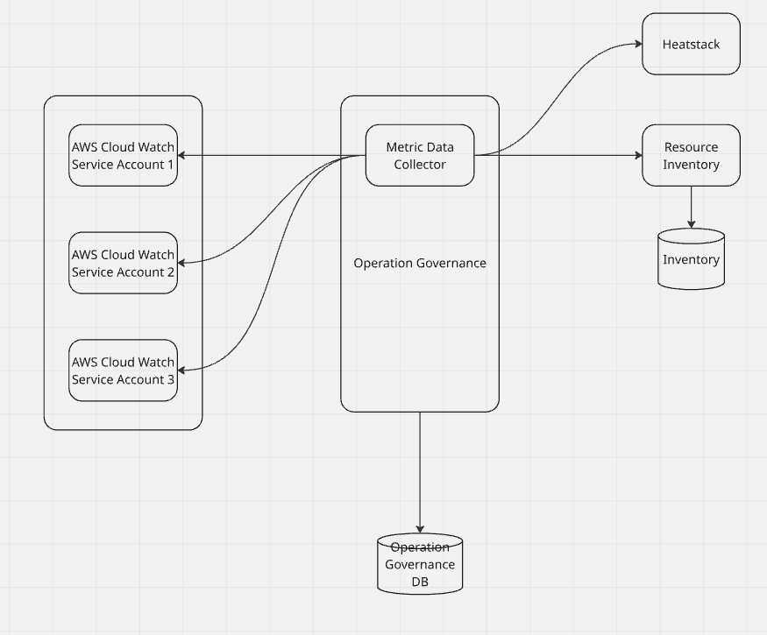

Background Job Flow:

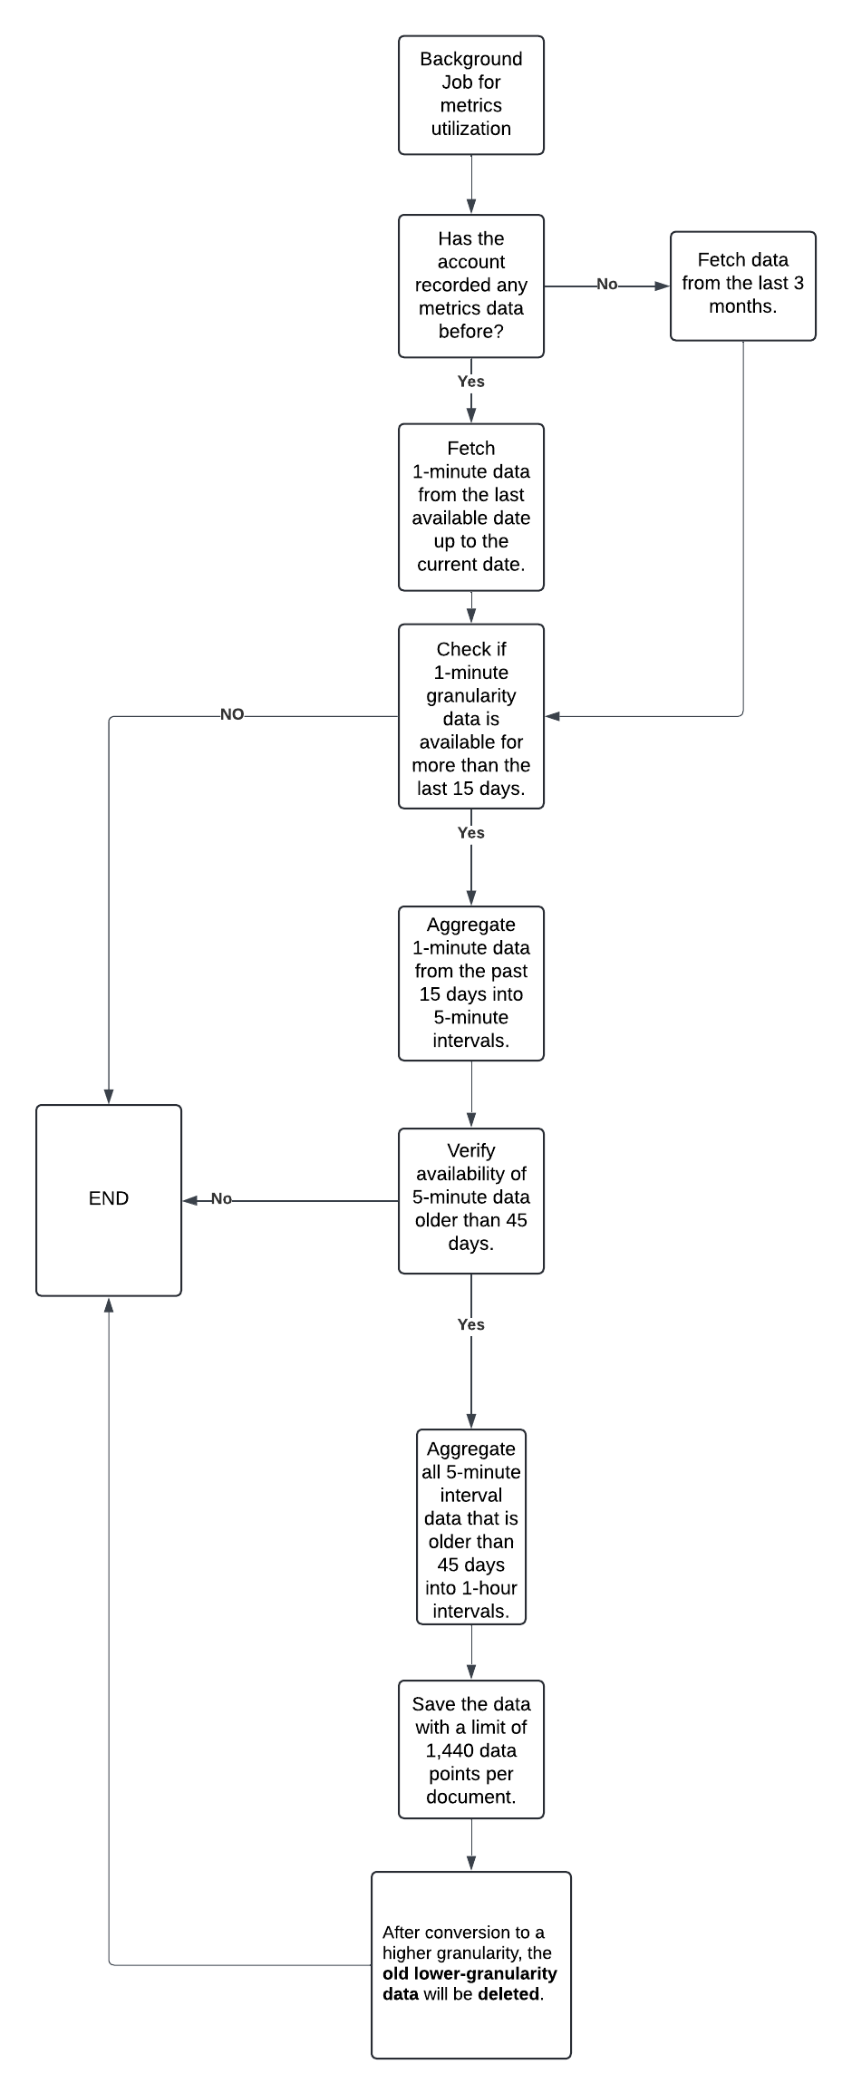

DATA MODEL CHANGES NEEDED:

New Collection: metrics_utilization_data

Data model:
public class MetricsUtilization {

private String id; // _id from MongoDB
private String serviceAccountId;
private String identity_sha; / / for index purpose – with resource_id,metric_name,service_account_id,granularity
private String serviceResourceUri;
private String metricName;
private String resourceId;
private String resourceRegion;
private String resourceFilter;
private int granularity;
private Series series;
private long seriesStart;
private long seriesEnd;
private List<Dimension> resource_dimension;
private Date updatedAt;

// --- Series sub-document ---
public static class Series {
private List<Double> maximum; - all available statistics for that particular metric
private List<Double> minimum;
private List<Double> average;

}

}
// --- Dimension sub-document ---
public static class Dimension{
private String key;
private String value;

// Getters and setters
public String getKey() { return key; }
public void setKey(String key) { this.key = key; }

public String getValue() { return value; }
public void setValue(String value) { this.value = value; }
}

}

Technical Specification
Item | Descriptions
Figma
UI html
Third Party Library | Yes/No. If yes, please detail out

API Summary
Item | Yes/No/NA | Impact Details if yes
Module | Yes | Operations Governance
Internal API | Yes | POST /v1/utilization_metrics/aggregate_trends
External API | Yes | /v1/utilization_metrics/aggregate_trends

Method: Post

URL: https://<host>/v1/utilization_metrics/aggregate_trends

Explanation:

This API is designed to fetch aggregated resource-level data over a specific time frame based on user-defined filters. The client can specify a list of resource_ids along with other filters such as service_account_id, start_date, end_date and additional parameters. The API processes these filters to query and aggregate the relevant data and returns the response based on the requested granularity

Request Body Class:
public class UtilizationMetricsAggregateTrendRequest {
public UtilizationMetricsFilters utilizationMetricsFilters;
public static class UtilizationMetricsFilters {
public string startDate;
public string endDate;
public Integer granularity;
public QueryOperator filters;
}
}
Sample Json
{
"start_date": "2025-02-06T00:00:00.000Z",
"end_date": "2025-02-07T00:00:00.000Z",
"granularity": 60,
"filter": {
"__type": "QueryOperatorBinaryLogic",
"a": {
"__type": "MetricNameQueryOperator",
"metric_name": [
"cpu_utilization"
]
},
"b": {
"__type": "ServiceAccountIdQueryOperator",
"service_account_id": [
"669a32bf05045c7005b81cd8"
]
},
"op": "And"
}
}

Response Class:
public class UtilizationMetricsAggregateTrendResult {
private List<UtilizationMetricAggregateSummaryResponse> metricUtilizationAggregateSummaryResponse;
}
public class UtilizationMetricAggregateSummaryResponse {
private String resourceRegion;
private String serviceAccountId;
private String unit;
private String resourceId;
private String metricName;
private Map<String, Series> series;
}
public class Series {
private List<Float> maximum;
private List<Float> minimum;
private List<Float> average;
private List<DateTime> dateTime;
}
Sample Json
{
"status": "success",
“message”: “Successfuly aggregated the utilization metrics data”
"data": [
{
"resource_region": "string",
"resource_id": "string",
"metric_name": "string",
“unit” : “milliseconds”
"service_account_id": "string",
"metric_data": {
"maximum": [0.0, 1.2, 3.4],
"average": [0.0, 1.0, 2.5],
"minimum": [0.0, 0.8, 1.7]
},
"time_stamp": [
"2025-07-15T10:00:00Z",
"2025-07-15T11:00:00Z",
"2025-07-15T12:00:00Z"
]
}
]
}

Data Model

Item | Yes/No/NA | Impact details If yes
Database Introduced | No
Collection(s) Introduced | Yes | metrics_utilization
Collections Impacted | No
Document Introduced | Yes
Field modification or any new possible value | No
Sample new Record | Yes | { "_id" : ObjectId("67e1978633f968ea4834dba3"),"resource_region" : "us-east-1", "identity_full_sha1" : "b';\x13\xfb\n\x0c2(\xa6\x96I\xbaf\x9dI\xba\xa6\xda\xff\xc74'", "metric_name" : "_ Active Cores ",  "resource_id" : "i-047d165af1ea30764", "series" : { "maximum" : [  0,  0,  0,  0,  0,  0,  -1,  -1,  -1,  -1,  -1,  -1  ],  "average" : [  0,  0,  0,  0,  0,  0,  -1,  -1,  -1,  -1,  -1,  -1  ]  },  "series_start" : 1738368000,  "series_end" : 1742774400,  "service_account_id" : ObjectId("67d2ff1d84fc1d521c9e2e0a"),  "granularity" : 60,  “unit”: “milliseconds”  "resource_dimensions" : [  {  "key" : "workspace_name",  "value" : "/subscriptions/348bb109-6dcb-4d75-95a5-4aea49fe6200/resourceGroups/genai-research/providers/Microsoft.MachineLearningServices/workspaces/azureai-scott-open-ai"  }  ]  "updated_at" : ISODate("2025-03-24T17:33:58.818Z")  }
Index Creation | Yes | "identity_full_sha1_1": [ ("identity_full_sha1", pymongo.ASCENDING) ],  # Recommended compound index for filtering & time scans  "service_account_id_1_resource_id_1_metric_name_1_granularity_1_series_start_1": [  ("service_account_id", pymongo.ASCENDING),  ("resource_id", pymongo.ASCENDING),  ("metric_name", pymongo.ASCENDING),  ("granularity", pymongo.ASCENDING),  ("series_start", pymongo.ASCENDING)  ]
Is there any backward compatibility? | Not Required
Is Migration Required? | NO
RBAC Changes | No
Will there be any changes to new setup installation scripts? | No

