Data Science Assessment

Title:

Exploratory Data Analysis of Patronage Data from April 1st, 2023 to April 30th, 2024

Overview :

This report is to conduct an exploratory data analysis (EDA) of patronage data spanning from April 1st, 2023 to April 30th, 2024.

Data overview :

The dataset contains records of patronage for MyWay and Paper Ticket. Each record includes the date and the number of patrons for each ticket type.

Task 1 :

* Analyse data from 1st April 2023 to April 30th 2024
* Undertake Exploratory Data Analysis
* Undertake any preliminary data analysis as required

**Filter dataset from 1st April 2023 to April 30th 2024**

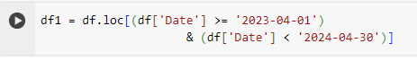

**Descriptive Statistics:**

No of columns: 395

MyWay Patronage:

* + Mean : 48259.36
  + Median : 56693
  + Standard Deviation : 21763

Paper Ticket Patronage:

* + Mean : 4776
  + Median : 4727
  + Standard Deviation: 2531.56

TREND ANALYSIS :  
  
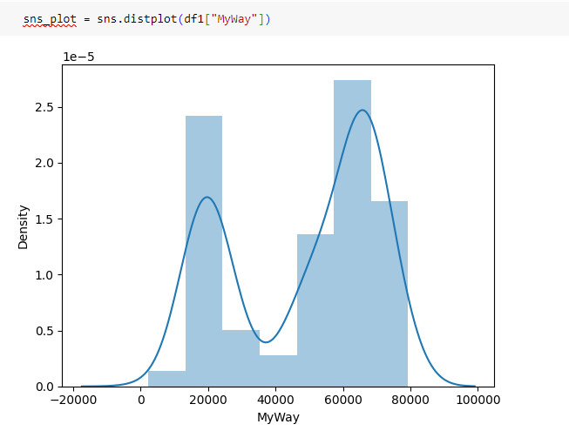

This chart shown that MyWAy that average sales will range of 20k and 70k

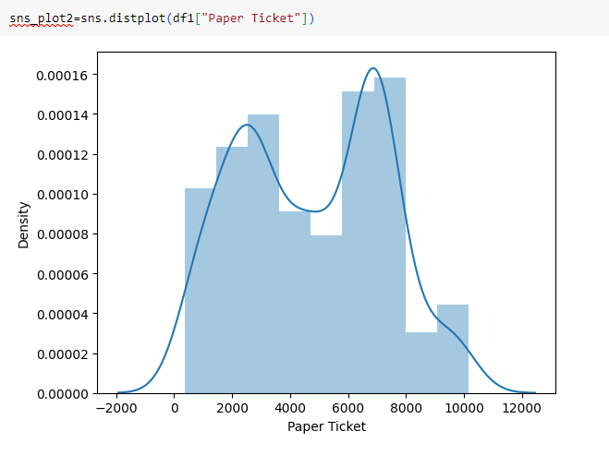

This chart is well distributed Tickets mostly sold in number of 2k to 4k and 6k to 8k.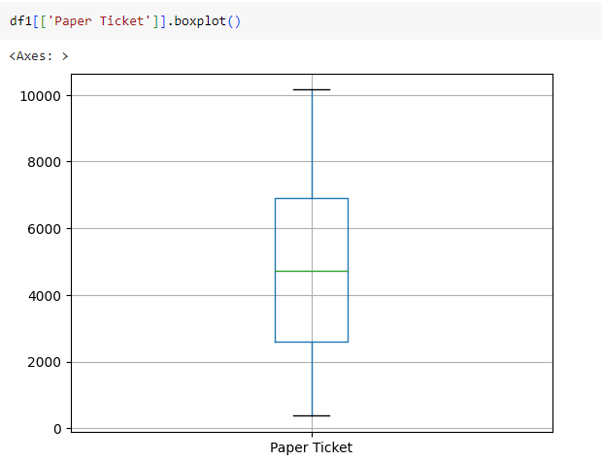

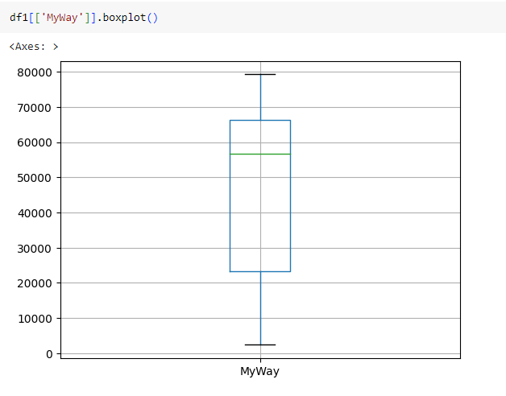

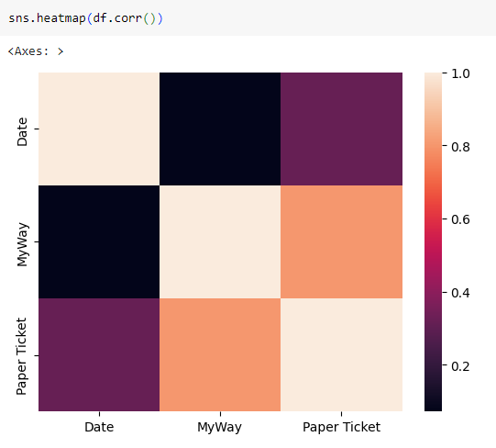

Correlation between MyWay and Paper Ticket Patronage:

* The correlation coefficient between MyWay and Paper Ticket patronage is 0.680496, indicates a positive correlation.

Correlation with Date:

* Both MyWay and Paper Ticket patronage have weak correlations with the Date variable. MyWay patronage has a correlation coefficient of 0.041527 - Paper Ticket patronage has a correlation coefficient of -0.155535.