**Springboard Data Science Bootcamp – Capstone 2 – Predict Customer Churn**



***Objective:***

Customer Churn measures the loss of customers and service provider companies use this metric to understand the customer retention. The objective is to predict behavior to retain customers by analyzing all relevant customer data and develop focused customer retention programs.

***Problem:***

Is the customer going churn?

***Outcome:***

When a customer stops service or company losing customer is referred to as Customer Churn. This is an important measure for any service-based company. The model predictions an provide the propensity of churning and gives the companies with the feature’s importance that leads the customer to churn. With the list of potential customers who are likely to churn, the marketing/retention teams can then take measure to reduce their churn probability. This project helps companies in identifying customer who are at risk of churning and we have used this IBM sample data set provided for a telecom company. We will be using statistical analysis to understand variables that are associated with customer churn.

[***Dataset***](https://www.kaggle.com/c/new-york-city-taxi-fare-prediction/data)***:***

* Customers who left within the last month – the column is called Churn
* Services that each customer has signed up for – phone, multiple lines, internet, online security, online backup, device protection, tech support, and streaming TV and movies
* Customer account information – how long they’ve been a customer, contract, payment method, paperless billing, monthly charges, and total charges
* Demographic info about customers – gender, age range, and if they have partners and dependents

Data set contains 7043 rows and 21 columns, see below for more information:

* *customerID*: Customer ID
* *genderCustomer*: gender (female, male)
* *SeniorCitizen*: Whether the customer is a senior citizen or not (1, 0)
* *PartnerWhether*: the customer has a partner or not (Yes, No)
* *Dependents*: Whether the customer has dependents or not (Yes, No)
* *tenure*: Number of months the customer has stayed with the company
* *PhoneService*: Whether the customer has a phone service or not (Yes, No)
* *MultipleLines*: Whether the customer has multiple lines or not (Yes, No, No phone service)
* *InternetService*: Customer’s internet service provider (DSL, Fiber optic, No)
* *OnlineSecurity*: Whether the customer has online security or not (Yes, No, No internet service)
* *OnlineBackup*: Whether the customer has online backup or not (Yes, No, No internet service)
* *DeviceProtection*: Whether the customer has device protection or not (Yes, No, No internet service)
* *TechSupport*: Whether the customer has tech support or not (Yes, No, No internet service)
* *StreamingTV*: Whether the customer has streaming TV or not (Yes, No, No internet service)
* *StreamingMovies*: Whether the customer has streaming movies or not (Yes, No, No internet service)
* *Contract*: The contract term of the customer (Month-to-month, One year, Two year)
* *PaperlessBilling*: Whether the customer has paperless billing or not (Yes, No)
* *PaymentMethod*: The customer’s payment method (Electronic check, mailed check, Bank transfer (automatic), Credit card (automatic))
* *MonthlyCharges*: The amount charged to the customer monthly
* *TotalCharges*: The total amount charged to the customer
* *Churn*: Whether the customer churned or not (Yes or No)

There are many categorical variables in this data set. The numerical features are Tenure, MonthlyCharges and TotalCharges.

***Descriptive Stats:***

We see that Tenure ranges from 0 (new customer) to 6 years, Monthly charges range from $18 to $118, etc

|  |  |
| --- | --- |
|  |  |

Roughly a quarter of the customers have churned in this data set.

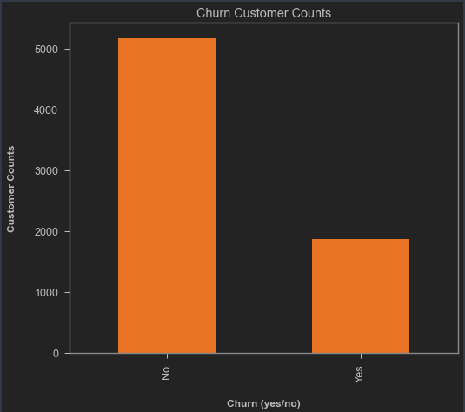

Looking at the coloration matrix, there seems to be some positive correlation between Monthly Charges and Churn and some negative correlation between tenure and Churn.

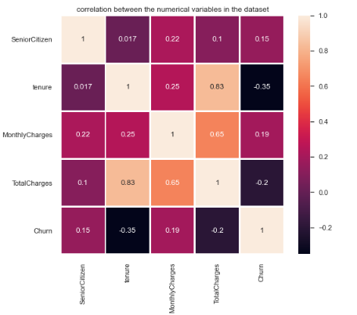

**Data Wrangling:**

* Replacing the Churn string value (yes/no) to numbers (0 – no and 1 – yes)
* Total Charges column was read as object, to fix this, we are converting its data type.
* Then investigate for missing values, it looks like TotalCharges has missing values.

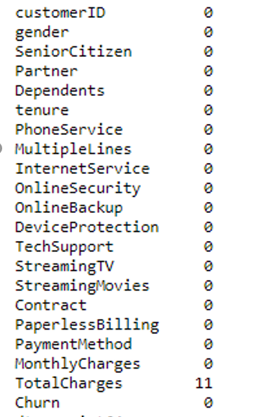

* Applying imputation to fix the issue with missing values with means of TotalCharges using SimpleImputer from sklearn.impute.
* Identified the categorical, numerical and continuous features in the data set.

**EDA - Data visualization:**

* Looking at the churn rate by gender there seems to a very little higher % of female customer churning than compared to male customers, however, I don’t think this is a big enough difference to be considered.

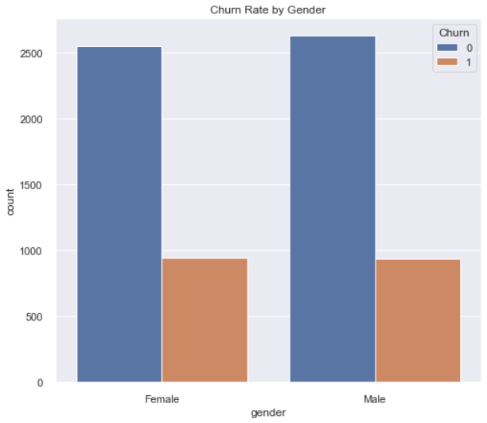

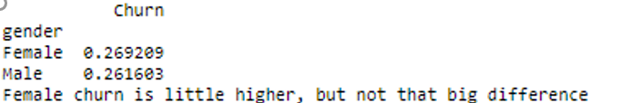

* Looking at the churn rate by Internet service type there seems to a high % of customers churning that are Fiber Optic service. This also could be due to Fiber optic being the most used service type.

*Fiber Optic customers are churning at a higher rate:*

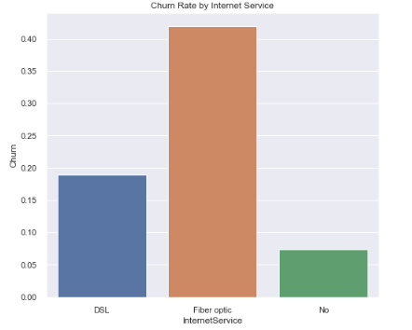

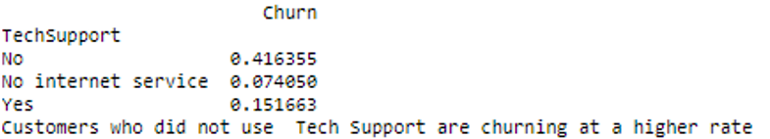

*Month to Month subscribers are churning at a higher rate*

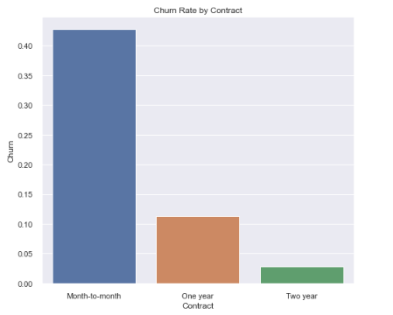

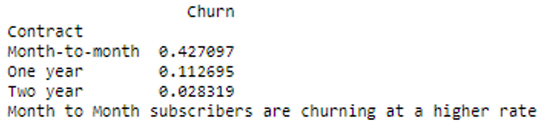

*Customers who did not use Tech Support are churning at a higher rate*

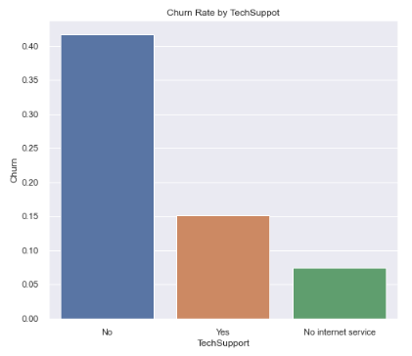

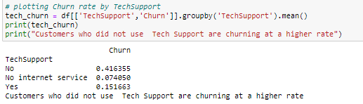

*Customers who use checks as payment method are churning at higher rate*

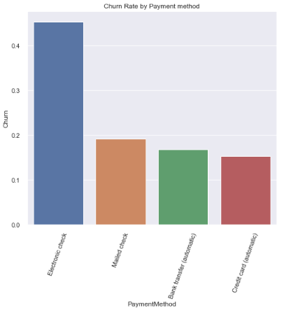

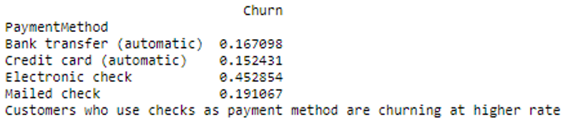

* *Customers who are on paperless billing have a higher churn rate. But this is could be very well because a lot of customers are enrolled into paperless billing.*

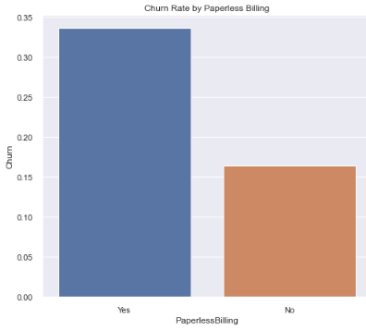

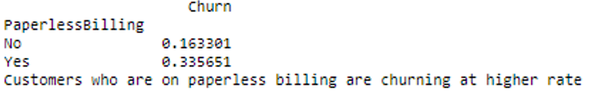

* *Customer who are Steaming movies vs Steaming tv seems to have very similar Churn rates:*

|  |  |
| --- | --- |
|  |  |

* *Let’s look at some summary stats for tenure variable:*

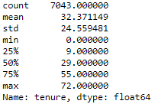

* Now, we will take a look at how mean churn rates are doing when compared with tenure.

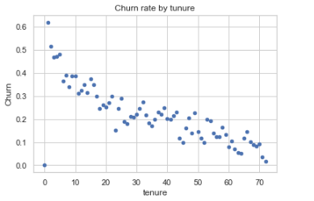

* It shows that if the customer’s tenure is long then churn rate is low.
* Let’s also look at other numerical variables such as MonthlyCharges:

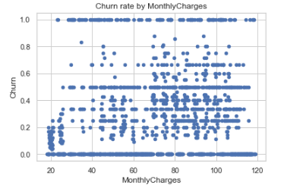

There seems to be no relation for Churn and MonthlyCharges

* Distribution plots for MonthlyCharges and tenure:

|  |  |
| --- | --- |
|  |  |

* Monthly Charges seems to be roughly normal distribution and Tenure Distribution seems to be high at the ends, so a portion of the customers have either had lowest and highest tenure periods.

**EDA Summary**:

* More customers are using Fiber Optic for Internet Service have left the company than compared to DSL.
* Customers who do not use online security have left the company.
* Customers not using technical support have left the company.
* Customers who pay month to month are the most who leave the company.
* Customer's gender has almost equal rates of churn between them.
* The Monthly Charges for customers who churned tends to pay higher monthly fees than those that stay.
* Customers that churn tend to be relatively new customers when looking at tenure distribution.

**Data Pre-processing:**

* Categorical data label encoding
* Machine learning works with only numerical values. Therefore, we need to convert our categorical values to numerical values. By using the Pandas function “get_dummies()”, we can replace the gender column with “gender_Female” and “gender_Male”. We will use df.info() to show us which ones are categorical and numerical.
* Dropping unwanted variables and target variable
* In our dataset, we can see that customer ID is not needed for our model, so we drop the variable. We do not need to treat missing values as there are none in this dataset.
* Train on one set and test and measure on the test set.
* Our model needs to be trained; second our model needs to be tested. Therefore, it is best to have two different datasets.
* Splitting the data 70% for training and 30% for testing.
* Realized that the data set is facing a class imbalance so apply Under Sampling technique to standardize the dataset.

**Machine Learning:**

The customer churn is a classification problem and have choose the following classification models to predict if a customer churns by fitting the training data set and testing on the test set. Used scikit-learn and other libraries in the python machine learning world.

1. Logistic Regression

2. Decision Tree model

3. Random Forest Classifier

4. Extreme gradient boosting (xGBoost)

***Model performance metrics***

Accuracy = Pct of correctly classified predictions (i.e, churn and non-churn)

Precision = Pct of total positive class predictions that were correctly classified

Recall = Pct of total positive class samples that were correctly classified

Logistic Regression:

This type of statistical classification modelling is commonly used for predicting binary variables. It models the log odds of the probability of the target variable.

The accuracy train accuracy and the testing accuracy was around 80%

True positives (TP) - Predicted correctly that customer will churn - 446

True negative (TN) - Predicted correctly that customer would not churn - 1145

False positives (FP) - The model incorrectly predicted that they would churn when in reality they did not - 407

False negative (FN) - the model incorrectly predicted that customer will not churn when in reality they did churn - 115

The models seem to having maintaining recall rate between training and test models.

Evaluation metrics:

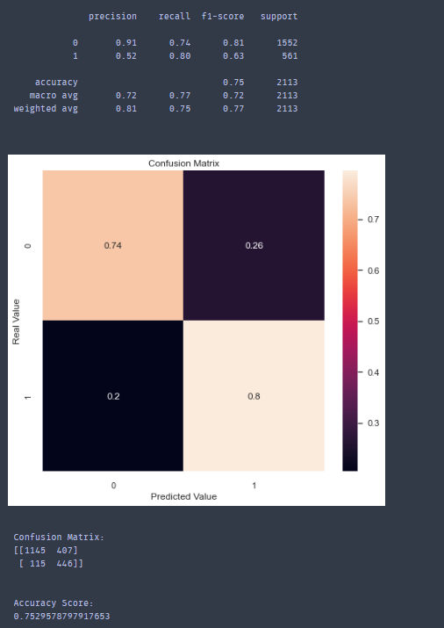

Decision Tree model:

First tree-based model that splits the data multiple times based on the cutoff values defined in the features.

Model parameters: criterion = gini; max_depth=5;random_state=1

The accuracy train accuracy and the testing accuracy was around 79%

TP=1374

TN=303

FP=178

FN=258

The models seem to decent accuracy and precision and recall rates between train and test data set.

Evaluation metrics:

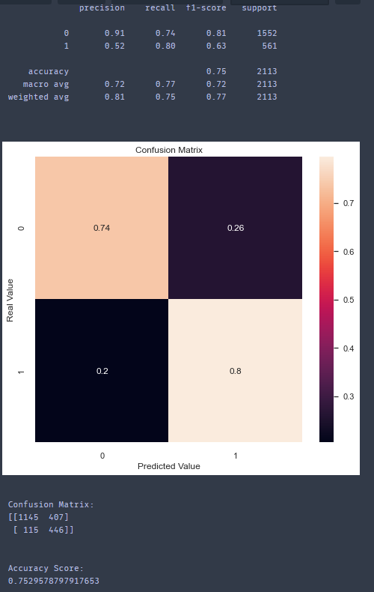

Random Forest

This is the second tree-based classification models we have experiments in the model phase. The difference between the previous model is it using bagging to define the boundaries in Random Forest models.

Model parameters include n_estimators=50; criterion=entropy’ min_samples_split=285

The accuracy train accuracy and the testing accuracy was around 79%

The models seem to have low recall rate and higher precession rate.

The model predicted more False Negatives compared to the previous Decision tree model.

Evaluation metrics:



Feature importance:

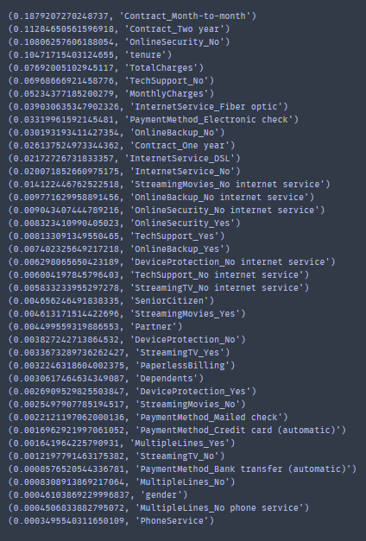

xGBoost (Extreme Gradient Boosting)

This is the second tree-based classification models we have experiments in the model phase. The difference between the previous model is it using bagging to define the boundaries in Random Forest models.

Model parameters include n_estimators=50; criterion=entropy’ min_samples_split=285

The accuracy train accuracy and the testing accuracy was around 79%

The models seem to have low recall rate and higher precession rate.

The model predicted more False Negatives compared to the previous Decision tre

Evaluation metrics:

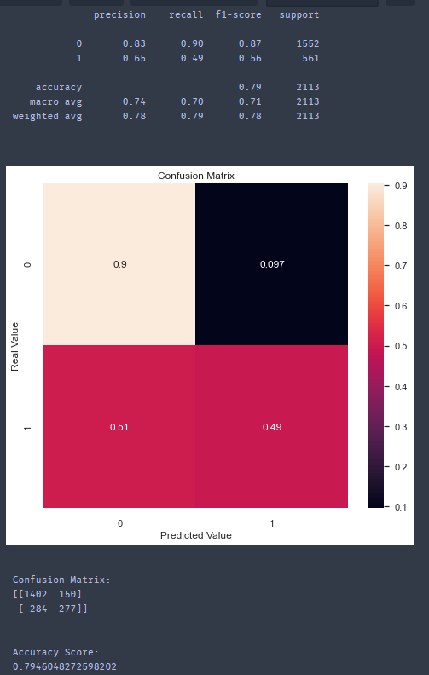

Feature importance’s:

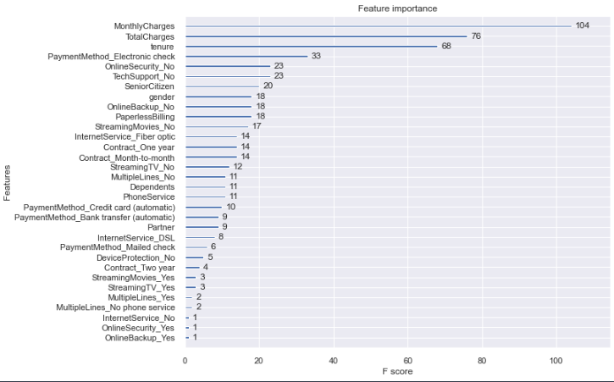

**Final Model – Logistic Regression Tuned**

Model:



Evaluation Metrics:

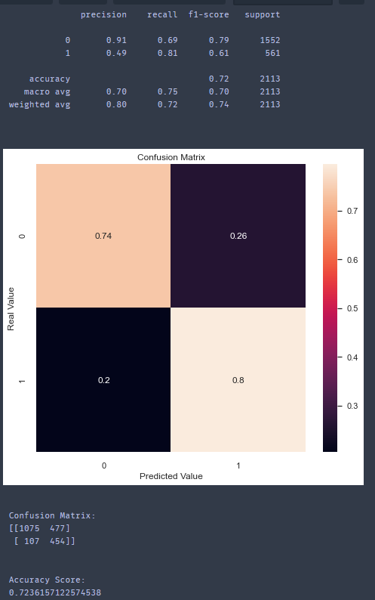

AUC score:

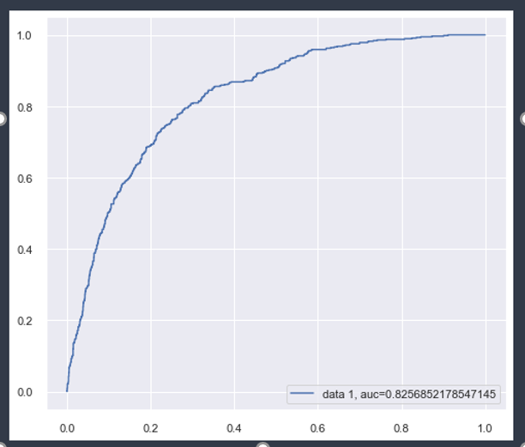

Influence Plot – Final Logistic Regression:

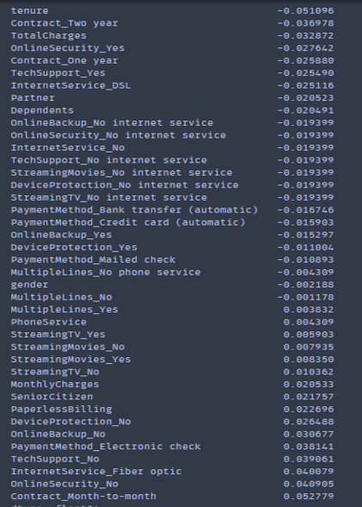

**Summary:**

The Logistic Regression model seems to be showing a balanced performance than compared to the other classification models we have experimented with.

After performing the cross validation on the different classification models that were selected, Logistic Regression model has the highest accuracy with recall and the decision criterion.

Used GridSearchCV to tune the hyper parameters for the Logistic Regression model.

After the final model is run and the influence plotting is completed to understand which features effected the churn most. It can be observed that tenure, Contract_two_year and TotalCharges are the top three feature that can effect customer churn.

**Next Steps:**

This project helped me in getting hands on experience with applying machine learning modelling for answering business questions such as the customer churn. By studying these customer churn probabilities can have various applications in company to better serve their customers.

If time would have permitted, I wanted to dig deeper into the xGBoost models hyper parameter tuning even though the recall metric was higher when used in the model. I believe fine tuning the parameter would result in a optimized xGBoost model.

Also, I would like to try new classification algorithms.