(B) Outdoors, Inc. has, as one of its product lines, lawn furniture. They currently have three items in that line: a lawn chair, a standard bench, and a table. These products are produced in a two-step manufacturing process involving the tube-bending department and the welding department. The time required by each item in each department is as follows:

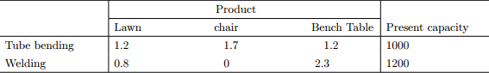

The contribution that Outdoors, Inc. receives from the manufacture and sale of one unit of each product is $3 for a chair, $3 for a bench, and $5 for a table.

The company is trying to plan its production mix for the current selling season. It feels that it can sell any number it produces, but unfortunately production is further limited by available material, because of a prolonged strike. The company currently has 2000 lbs. of tubing on hand. The three products require the following amounts of this tubing: 2 lbs. per chair, 3 lbs. per bench, and 4:5 lbs. per table.

(1) Formulate LP model for this problem.

(2) Solve the problem by SOLVER.

(3) What is the optimal production mix? What contribution can the firm anticipate by producing this mix?

(4) What is the value of one unit more of tube-bending time? of welding time? of metal tubing?

(5) A local distributor has offered to sell Outdoors, Inc. some additional metal tubing for $0.60/lb Should

Outdoors buy it? If yes, how much would the firm’s contribution increase if they bought 500 lbs. and used

it in an optimal fashion?

(6) If Outdoors, Inc. feels that it must produce at least 100 benches to round out its product line, what effect

will that have on its contribution?

(7) The R&D department has been redesigning the bench to make it more profitable. The new design will

require 1:1 hours of tube-bending time, 2:0 hours of welding time, and 2.0 lbs. of metal tubing. If it can sell

one unit of this bench with a unit contribution of $3; what effect will it have on overall contribution?

(8) Marketing has suggested a new patio awning that would require 1:8 hours of tube-bending time, 0.5 hours

of welding time, and 1.3 lbs. of metal tubing. What contribution must this new product have to make it

attractive to produce this season?

(9) Outdoors, Inc. has a chance to sell some of its capacity in tube bending at cost + $1:50=hour: If it sells 200

hours at that price, how will this affect contribution?

(10) If the contribution on chairs were to decrease to $2:50; what would be the optimal production mix and what

contribution would this production plan give?

ANSWERS:

1. The required LP formulation is as follows:

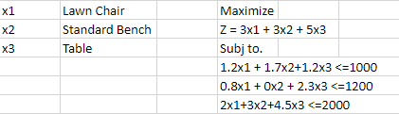

1. The solution that we got using the solver is as follows:

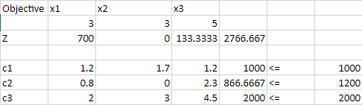

1. 700 units of Lawn Chairs, 0 units of Standard Bench and 133.3333 units of Table need to be manufactured to get the current maximum profit of 2766.667. This is the optimal production mix.
2. According to the shadow price produced by the sensitivity analysis report, the value of one unit more of tube-bending time is 1.166666667, the value of one unit more of welding time is 0, and the value of one unit more of metal tubing is 0.8.



1. Yes, they should buy it as we can clearly see in the sensitivity report that a maximum increase of 555. 555.. Is allowed for the tubing and since the offer of adding 500 is well within the range, it could increase the firm’s profit.

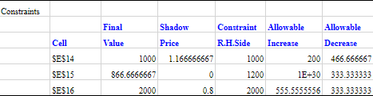

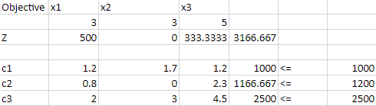

Since we are buying 500lbs of metal-tubing for $0.6/lb, we are spending $300 for it, so we subtract that from the revenue shown there, which is 3166.667 which gives us the new profit of $2866.667. Meaning that our profit increases by $100.