MDSC-103 (P)

Roll No: 23914

ESE Lab Test

1.

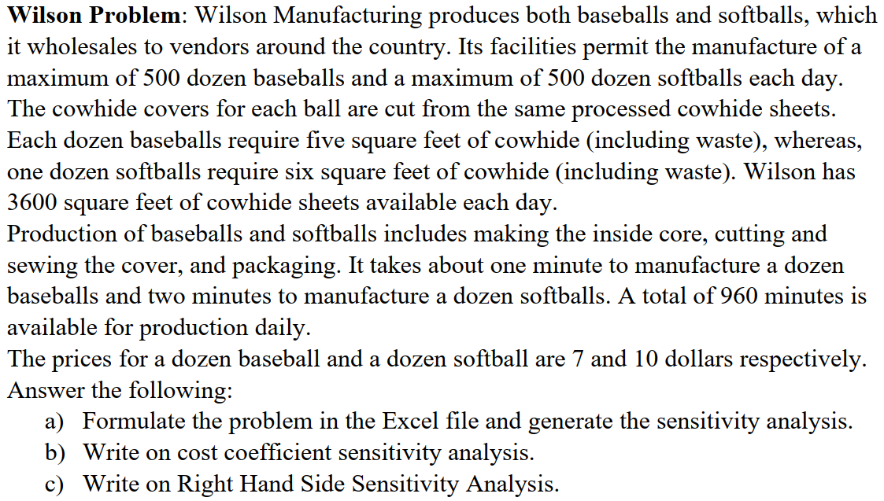

a) The problem has been formulated as follows:

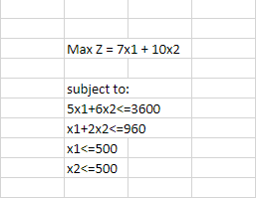

And the optimal solution to the problem has been derived using Excel Solver:

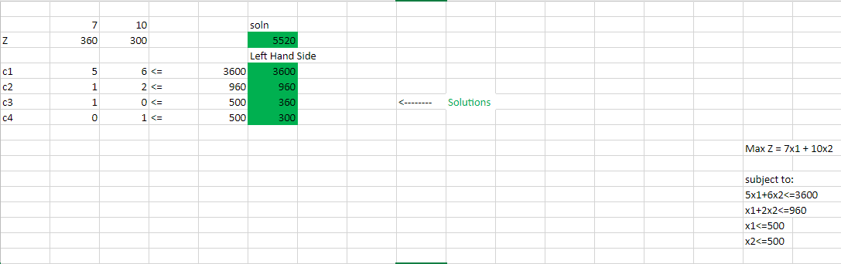

The Sensitivity Report generated by Excel is as follows:

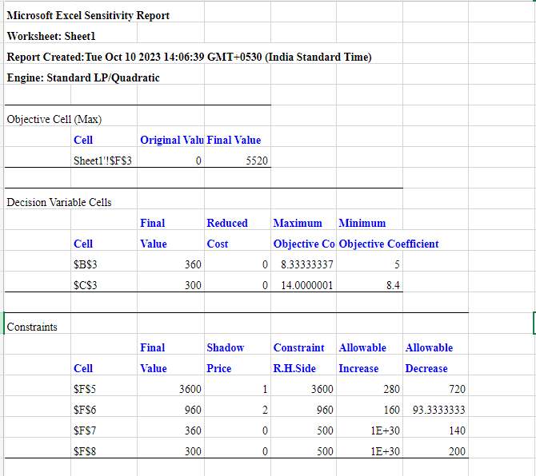

b) The sensitivity report gives us an in-depth detail about how we can make a few changes to the model so that we can reach even better optimum solutions.

The maximum limit of baseballs and softballs that can be produced in a day is 500. The solution we got was that if we produce 360 baseballs and 300 softballs per day we get a profit of 5520 dollars in total.

To reach this solution, 360 baseballs and 300 softballs should be manufactured while exactly using the given resources. That is all the 3600 square feet of cowhide sheets and 960 minutes of available production time per day.

The Ranges for the Objective function (i.e. the prices of baseball and softballs) are given as 5 being the lower bound and 8.33.. being the upper bound for the price of baseball and 8.4 being the lower bound and 14 being the upper bound for the price of softball.

So we can increase or decrease the prices of these two products within the given ranges to obtain better profits. Anything outside the bounds is not recommended as the solution might not stay optimum or in other words, there could be a loss for the company.

c) The unit cost of each product for the company is 1 dollar and 2 dollars respectively (baseball and softball).

The feasibility ranges for the right-hand side constraints, i.e. the resources available is given as 2880 square feet of cowhide covers being the lower-bound and 3880 square feet of cowhide covers being the upper bound.

Also, the lower-bound and upper-bound for the total amount of time allotted for production are 1120 minutes per day and 866.67 minutes respectively.

We were able to reach this conclusion through the sensitivity report as it mentions the Allowable Increase and Allowable Decrease of the constraints.

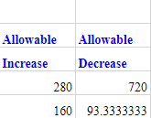

Increasing the amount of cowhide covers over 3880 square feet or decreasing the amount below 2880 will not be profitable for the company. The max profit can be achieved at 3880. So staying within the ranges mentioned above is going to bring profit to the company.

Increasing the amount of production time over 1120 minutes per day or reducing it even further from 866.67 minutes a day will not be profitable for the company. Again staying within this range will bring profit to the company. The max profit can be achieved at 1120 minutes of production a day.

2.

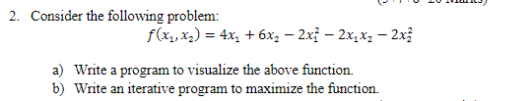

a) We use Numpy and Matplotlib to visualize the function is 3d as it is a two-variable function.

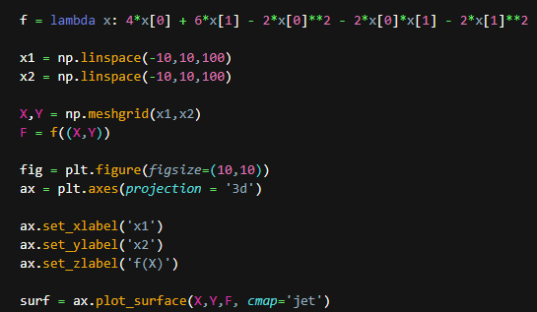

and this code written here will display a 3d plot of the surface.

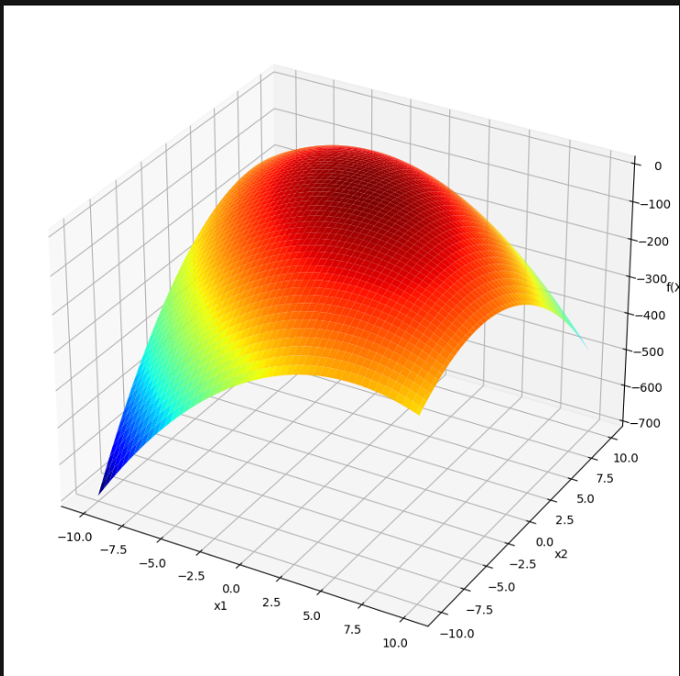

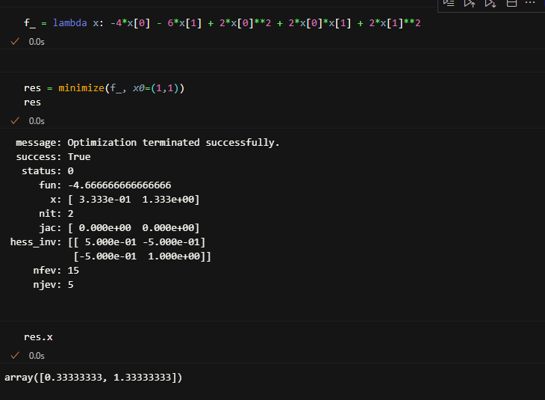

This function from scipy library is used to reach the maxima.

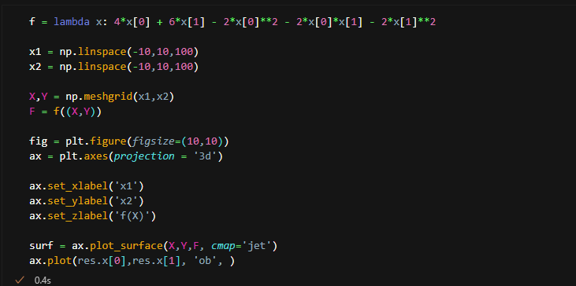

We use this code again but as an addition, we plot the point where maxima is reached.

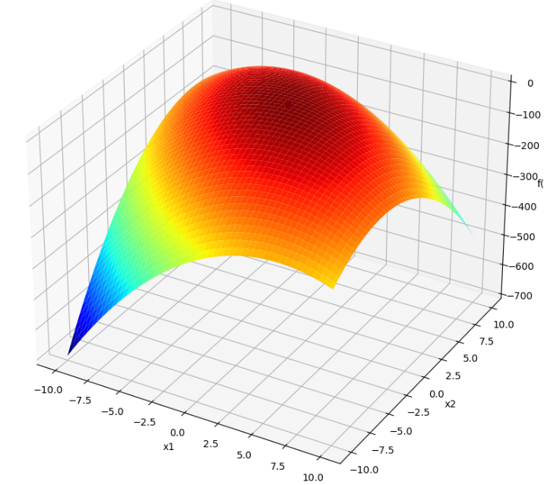

As we can see in the plot, there is a small dot that says z in the graph which is global maxima that we have reached.

