**Learning Report**

**SDLC AND TESTING**

**SMART HELMET WITH SMART LOCKING SYSTEM**

**Report by,**

**Vidyashree C V**

**PS No: 9900249**

Contents

Smart Helmet with Smart Lock System 3

1. Requirements 3

1.1 High Level Requirements 3

1.2 Low Level Requirements 3

2. UML Diagrams 3

2.1 Context flow diagram 3

2.2 Data flow diagram 4

2.3 Use case diagram for IoT interface 4

2.4 Sequence diagram 5

3. Test Cases 5

**List of Figures**

Figure 1: Context Flow Diagram 3

Figure 2: Dataflow Diagram 4

Figure 3: Use case Diagram 4

Figure 4: Sequence Diagram 5

# **Smart Helmet with Smart Lock System**

# **1. Requirements**

## **1.1 High Level Requirements**

* Use of accident sensor to detect accidents.
* Use of alcohol sensor to detect alcohol consumption.
* Interfacing mobile phones with programmable chip.
* A radio frequency module for wireless communication between helmet and bike circuit.

## **1.2 Low Level Requirements**

* Microcontroller.
* Sensors.
* RF Transmitter.
* GSM Module

# **2. UML Diagrams**

## **2.1 Context flow diagram**

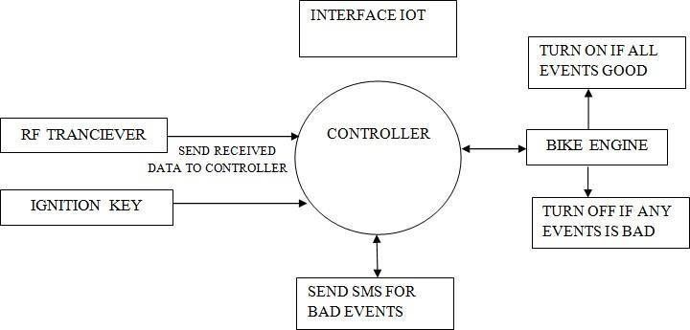

Figure 1: Context Flow Diagram

## **2.2 Data flow diagram**

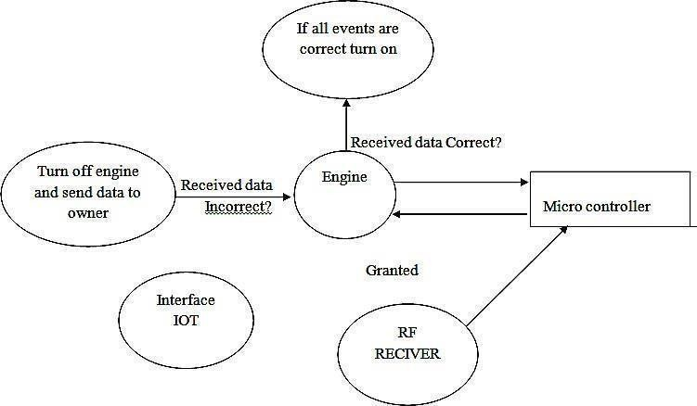

Figure : Dataflow Diagram

## **2.3 Use case diagram for IoT interface**

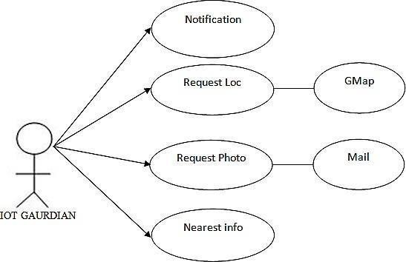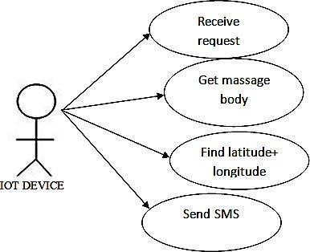

## 

Figure : Use case Diagram

## **2.4 Sequence diagram**

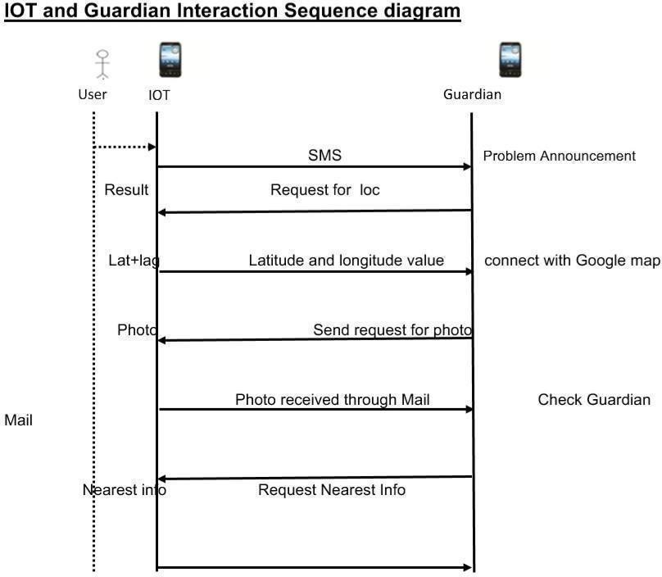

Figure 4: Sequence Diagram

# **3. Test Cases**

|  |  |  |  |  |
| --- | --- | --- | --- | --- |
| ID | DESCRIPTION | EXPECTED I/P | EXPECTED O/P | ACTUAL O/P |
| 1 | Helmet worn & Ignition turned on | Transmission between helmet and bike circuit | Vehicle starts | Vehicle is started |
| 2 | Helmet not worn | No Transmission between helmet and bike circuit | Helmet not worn | Vehicle turned off |
| 3 | Ignition turned off | Ignition key turned off | Vehicle won’t start | Vehicle turned off |
| 4 | Alcohol detection sensor | Functioning of alcohol sensor | * If alcohol consumption detected Vehicle turns off. * If alcohol not detected vehicle is started | * Vehicle is turned off * Vehicle starts |
| 5 | Accident detection sensor | Functioning of accident sensor | * If accident occurs vehicle stops & GSM sends notification rider’s contact. * If there is no accident then vehicle continues to move forward & no notification is sent | |  |  | | --- | --- | | * Vehicle is turned off & notification sent to rider’s contact. |  | | * Vehicle still in moving state | | |
| 6. | Guardian requesting for information | Functioning of gps and camera | * If location is requested GSM sends latitude & longitude value connected to Google. * If request for location photo is received sends the photo through mail | |  |  | | --- | --- | | * Location information is sent to the guardian |  | | * Location photo received to the guardian through mail | | |