1. Analog clock:

Build analog clock, shows hours, minutes and seconds

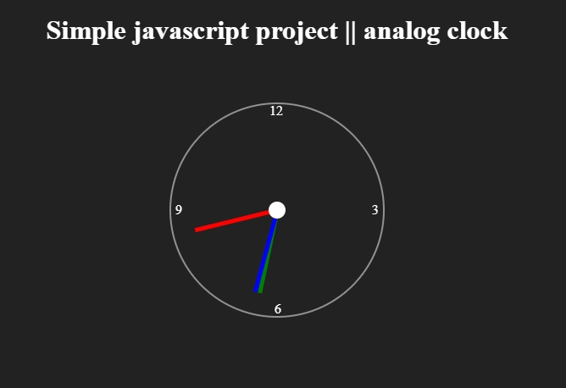

1. Tic Tac Toe game Application:

The user has to build the straight horizontal, vertical or diagonal line with their value. The pc control of the game is also very simple. You just have to use the cursor to click the box where you want to put the value in order to make the straight line.

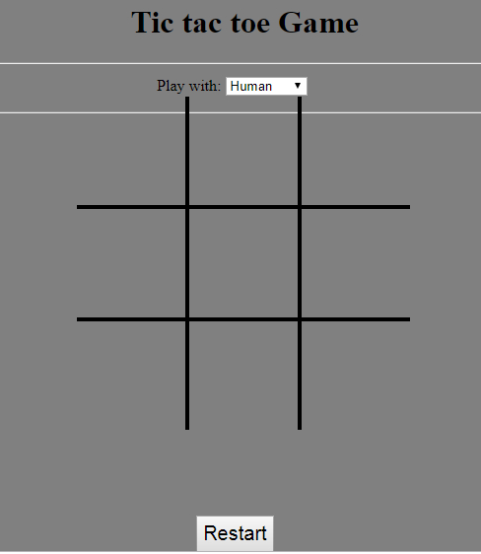

1. By JavaScript building a bookmark application
2. After enter the website name and URL that data store to local Storage and show the bookmark in same page.
3. If we click visit button, that website open in new tab.
4. If we click the delete button, bookmark will delete.

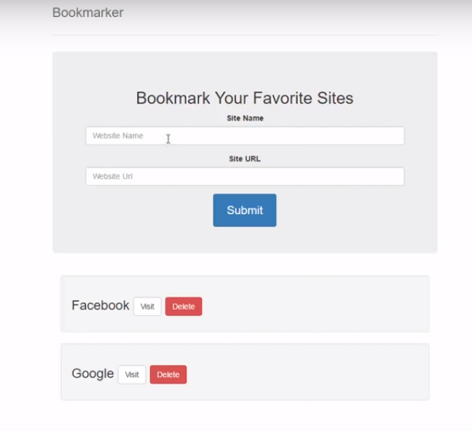

1. Loan Calculator:

Build Loan calculator using JavaScript. If we enter the loan amount , the term(years) and interest rate in the given fields and click calculate. Shows the results in Monthly payment, Total payment, Total Interest.

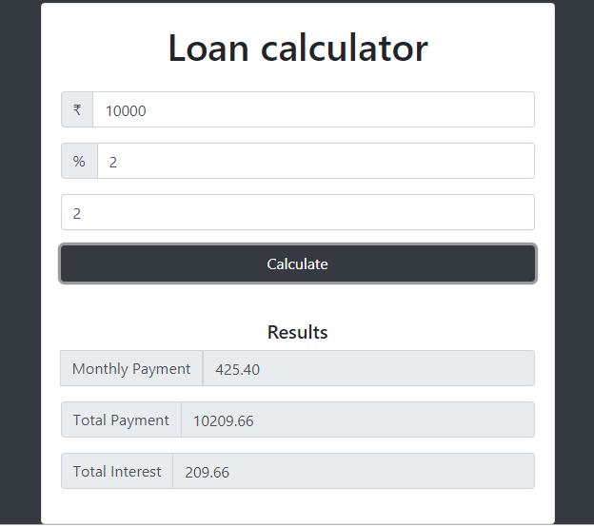

1. Checklist App:

Build checklist using JavaScript. The user can add a list of their daily works that they have to do and keep them as records/remainders. When you click the add button, you just have to type the information in the text fields that appears after clicking the add button.

