Predicting Student Success in Online Learning Environments using Machine Learning

In this project we are employing OULAD dataset to predict grade and score using various machine learning algorithms like Random Forest and gradient boosting. Each algorithm performance is evaluated using accuracy, precision, recall and FSCORE.

Random Forest classifier is used to predict grade and Random Forest Regressor is used to predict score. Similarly Gradient Boosting classifier to predict Grade and Gradient Boosting Regressor to predict score. Regressor algorithm performance is evaluated using RMSE (root mean square error). RMSE refers to difference between true value and predicted value so the lower the difference the better is the value.

To train above algorithm we have utilized below dataset

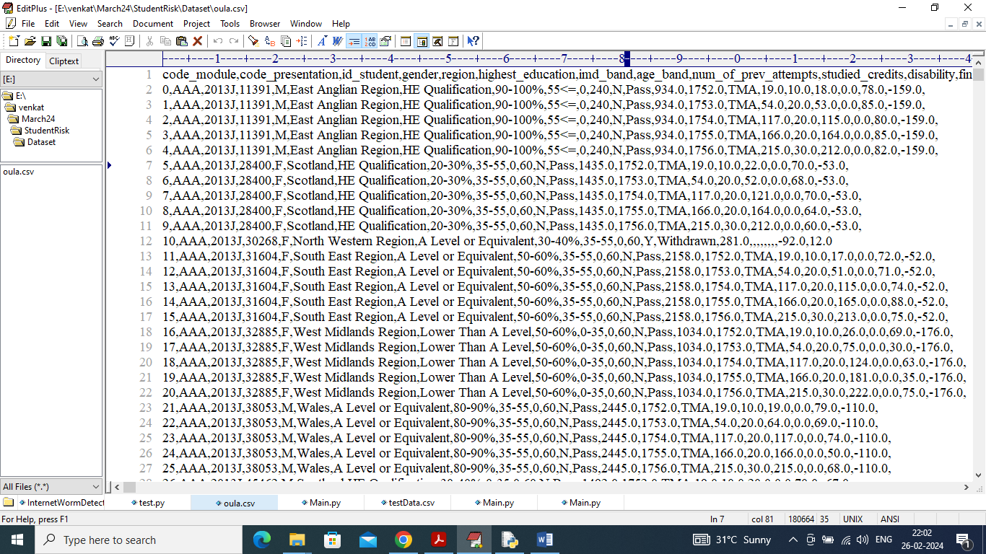

In above dataset first row contains dataset column names and remaining rows contains dataset values. So by using above dataset will train and test each algorithm performance.

To implement this project we have designed following modules

1. Upload OULAD Online Student Dataset: using this module will upload and display dataset values to user and then plot graph of different grade found in dataset
2. Pre-process Dataset: using this module will remove missing values and then convert all non-numeric data to numeric data and then split dataset into train and test where application using 80% dataset for training and 20% for testing
3. Run Random Forest: 80% training dataset will be input to random forest classifier and Regressor to train Grade and Score models and then apply this model on 20% test data to calculate accuracy and RMSE score
4. Run Gradient Boosting: 80% training dataset will be input to boosting classifier and Regressor to train Grade and Score models and then apply this model on 20% test data to calculate accuracy and RMSE score
5. Comparison Graph: will plot comparison graph between both algorithms
6. Predict Grade & Score: will upload test data and then algorithm will predict score and grade

SCREEN SHOTS

To run project double click on run.bat file to get below screen

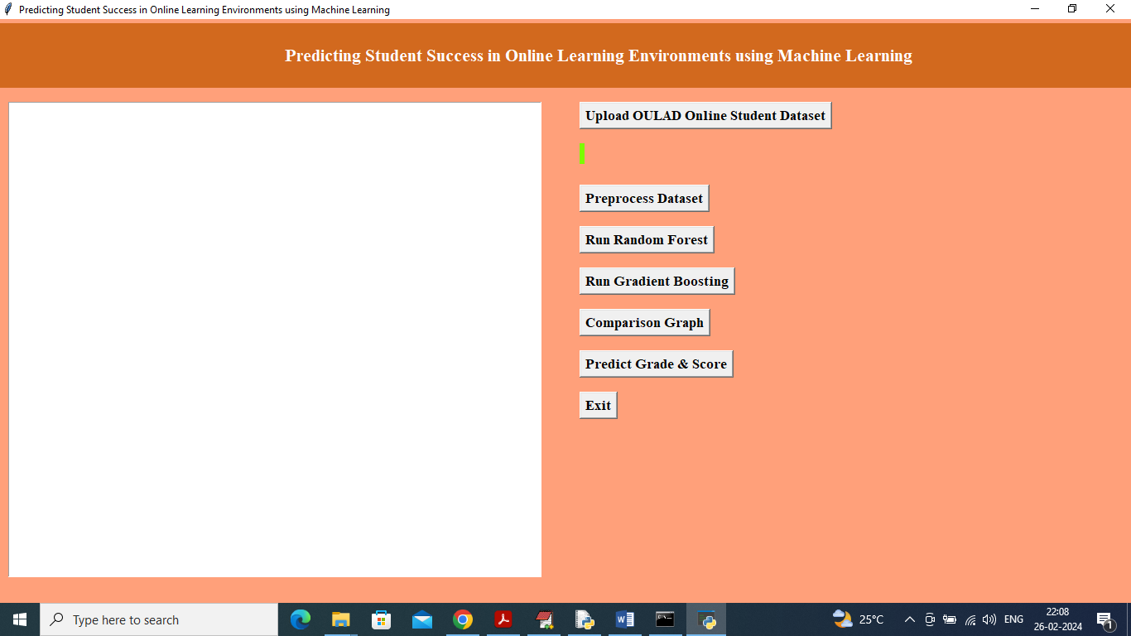

In above screen click on ‘Upload OULAD Online Student Dataset’ button to upload dataset and get below page

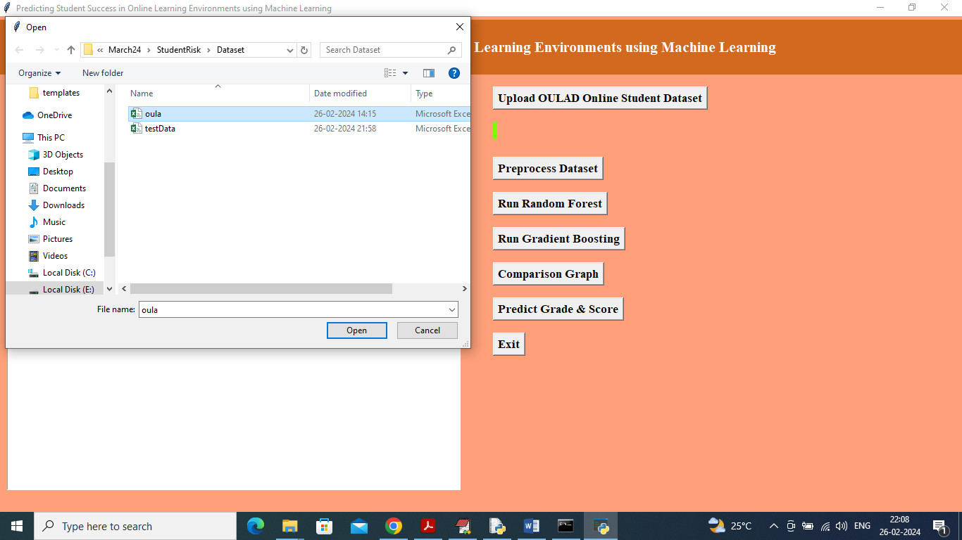

In above screen selecting and uploading OULAD dataset and then click on ‘Open’ button to load dataset and get below page

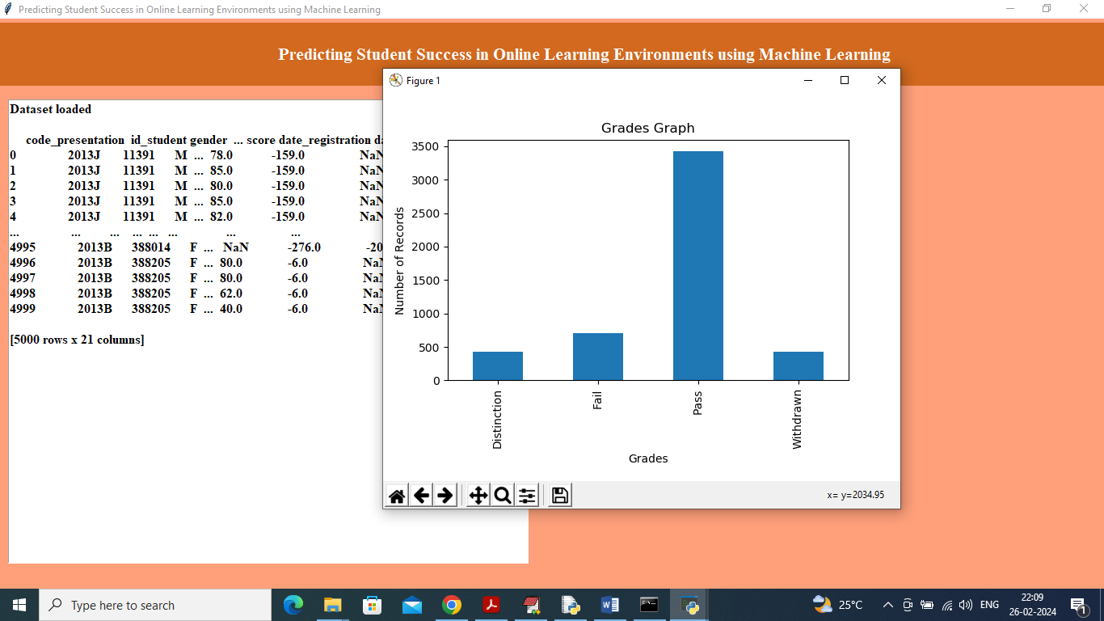

In above screen dataset loaded and can see dataset contains both non-numeric and numeric values and by using processing technique will convert non-numeric to numeric values and in graph x-axis represents Grade and y-axis represents number of records found in that grade and now close above graph and then click on ‘Pre-process Dataset’ button to get below output

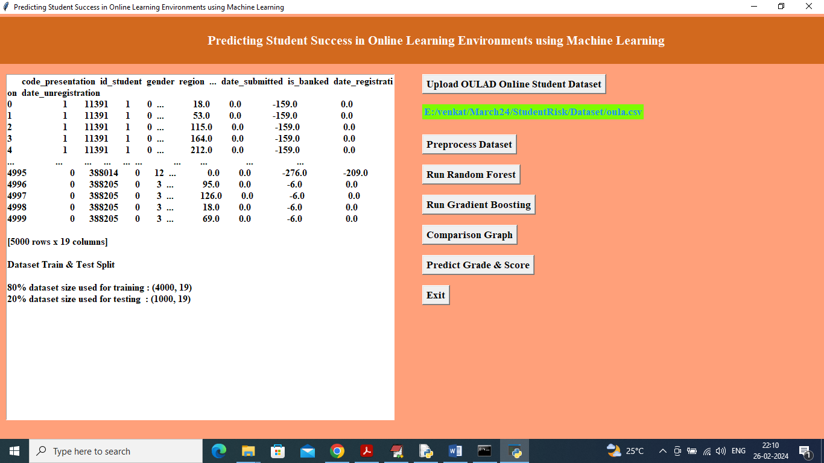

In above screen can see all values are converted to numeric format and then can see train and test data size and now click on ‘Run Random Forest’ algorithm button to get below output

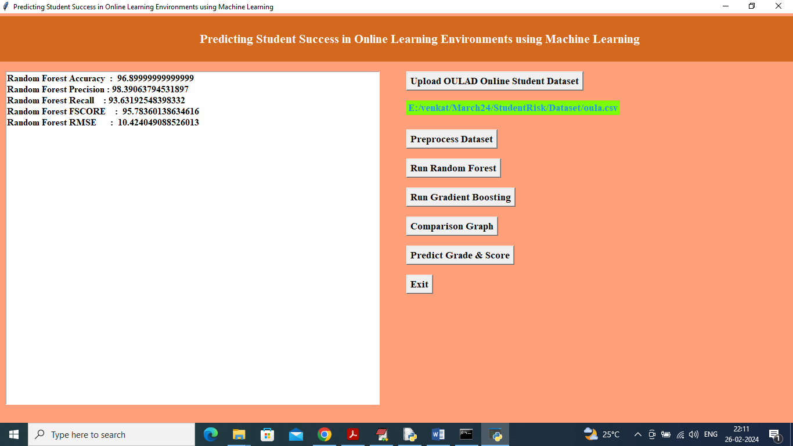

In above screen can see Random Forest accuracy as 96% and RMSE as 10% and can see other metrics like precision, recall and FCSORE. Now click on ‘Run Gradient Boosting’ button to train boosting and get below output

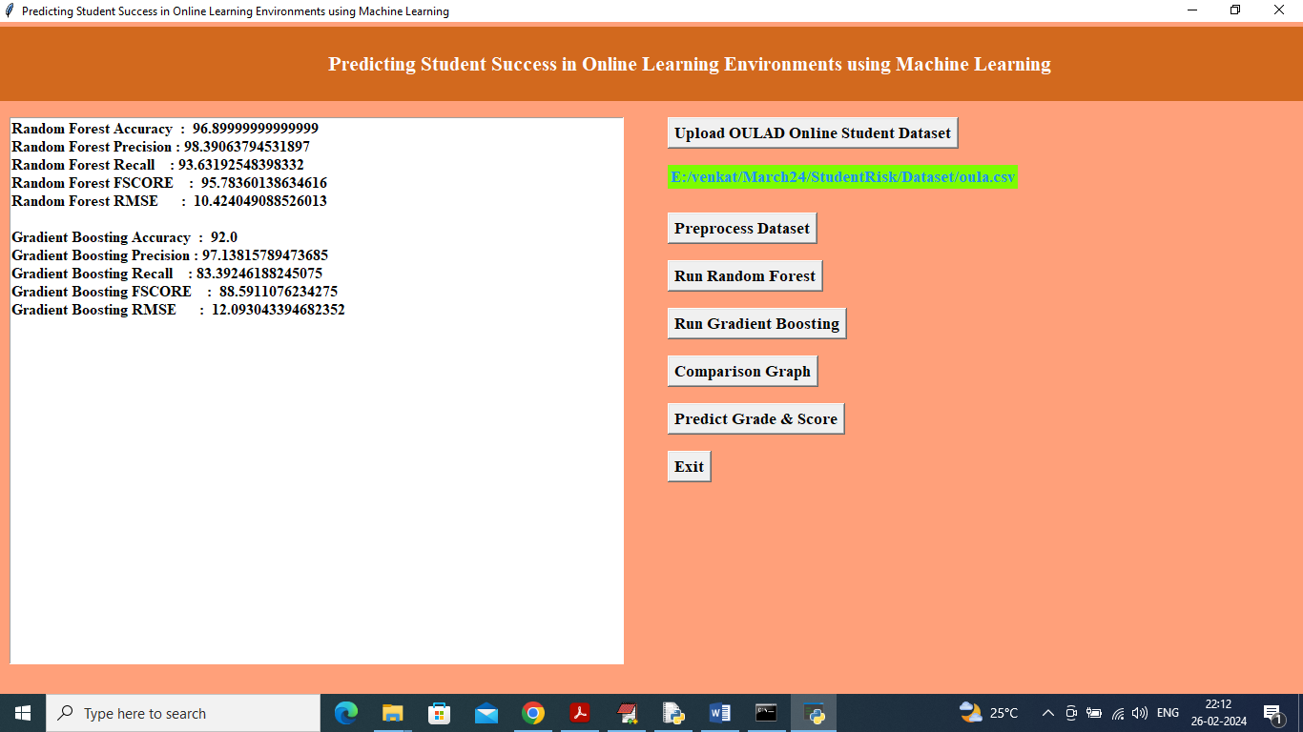

In above screen gradient boosting accuracy is 92% and RMSE is 12% and now click on ‘Comparison Graph’ button to get below graph

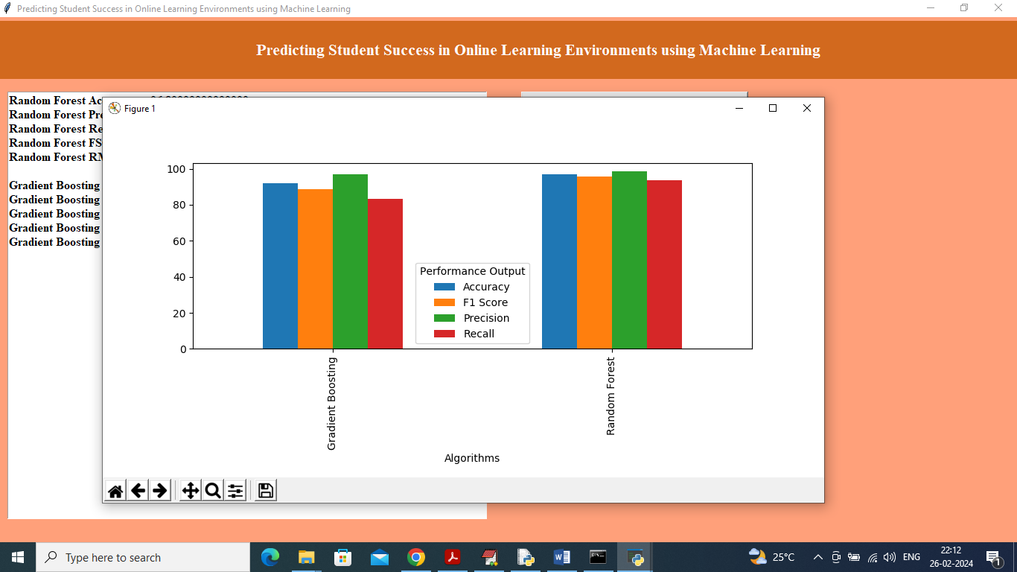

In above graph x-axis represents algorithm names and y-axis represents accuracy and other metrics in different colour bars and in both algorithm Random Forest got high accuracy and less RMSE. Now click on ‘Predict Grade & Score’ button to upload test data and get below output

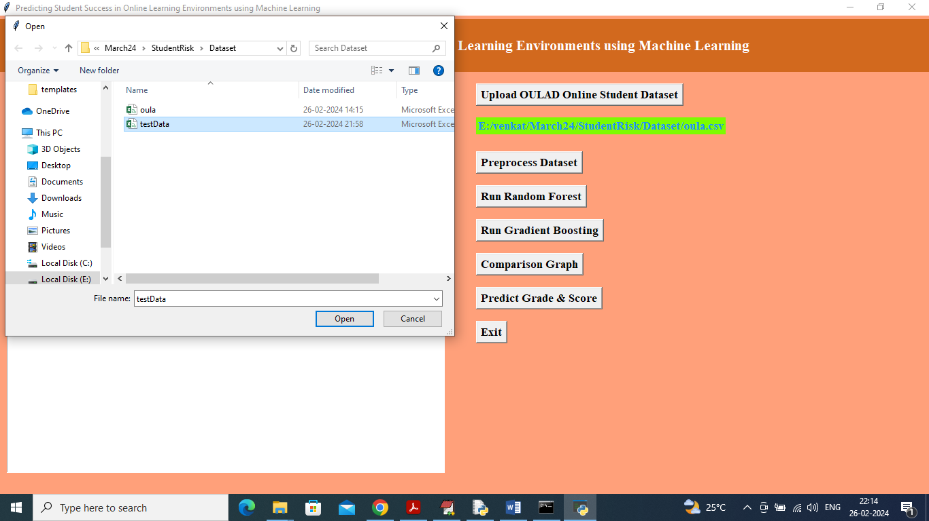

In above screen selecting and uploading test data and then click on ‘Open’ button to get below prediction output

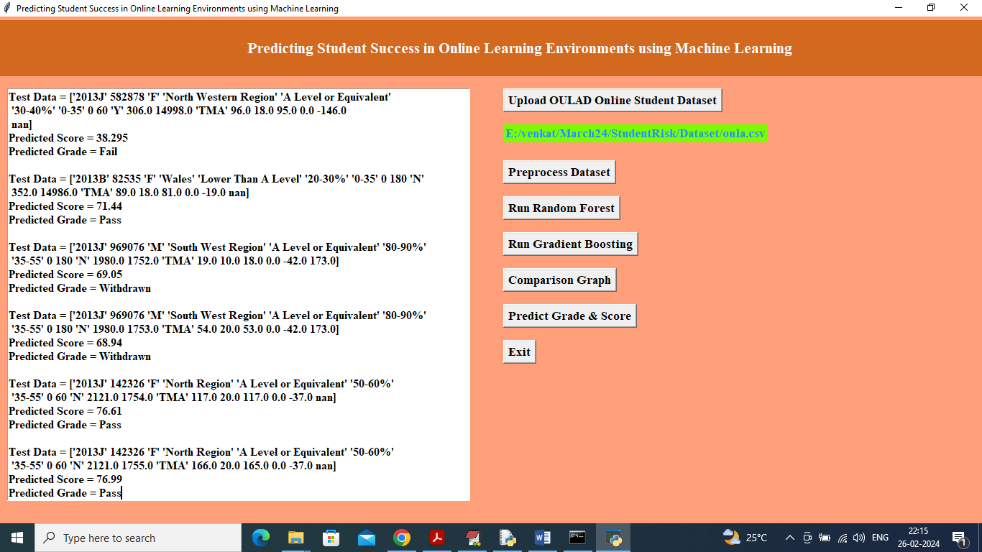

In above screen in square bracket we can see Test data values and then in next two lines can see Predicted score and predicted Grade.