Optimizing Seam Carving for Image Expansion: A
Comparative Study with Image Quality Analysis
A PROJECT REPORT
Submitted by
BL.EN.U4CSE22153 Shreya Mittal
BL.EN.U4CSE22120 Kammari Vidyasri
BL.EN.U4CSE22149 Santhwana Santhosh Kumar
in partial fulfillment for the award of the degree of
BACHELOR OF TECHNOLOGY
IN
COMPUTER SCIENCE AND ENGINEERING

AMRITA SCHOOL OF ENGINEERING, BANGALORE
AMRITA VISHWA VIDYAPEETHAM
BANGALORE 560 035
November-2024
Acknowledgement
We would like to express our sincere gratitude to everyone for our project titled "Optimizing Seam Carving for Image Expansion: A Comparative Study with Image Quality Analysis."
First and foremost, we extend our deepest thanks to our project guide, Ms. Sreebha Bhaskaran ma’am, for her invaluable guidance, constructive feedback, and unwavering support throughout the course of this project. Their expertise and insights were instrumental in shaping our research and implementation.
We are also grateful to Amrita School of Engineering, Bangalore for providing the research papers. The support from the faculty and staff has been pivotal in overcoming challenges and ensuring smooth progress.
Finally, we thank each member of our team for their dedication, collaboration, and perseverance, which were crucial in accomplishing our project goals.

ABSTRACT
This project aims to optimize seam Carving for Image Expansion that covers the efficiencies and effectiveness of backtracking algorithms into optimizing seam carving for image expansion. Seam Carving is a content-aware image resizing algorithm designed to preserve important features while expanding or reducing an image. Four primary algorithms are explored: Greedy Backtracking, Recursive Backtracking, Dynamic Programming-Based Backtracking, and Graph-Based Backtracking. All of these are evaluated in terms of computational efficiency, time complexity, and the ability to preserve the quality of the image. The feature detection methods allow us to measure how well all the seam carving algorithms preserve critical details, edges, and corners inside the images. This is even more significant in content-aware resizing, where the original visual features need to be preserved. In addition, we apply image quality assessment metrics such as Peak Signal-to-Noise Ratio, (PSNR), and Structural Similarity Index, (SSIM), to offer numerical qualities of the image. PSNR estimates the general signal fidelity, while SSIM measures the structural differences between the original and resized images. These quantitative metrics are complemented by subjective visual inspections that provide a comprehensive assessment of the resized images. Our results, carried out on a wide and varied set of images, highlight the tension between computational performance and the kinds of important image features that are preserved. The results convey insight into the applicability of each algorithm to particular classes of image expansion tasks and enable the best approach to be determined for specific resizing needs. This research contributes to developing newer and more efficient image processing techniques for automated resizing, content-aware editing, and digital media preservation. Such new techniques take care of critical content during modifications in an image.

TABLE OF CONTENTS
Page no
ACKNOWLEDGEMENT iii
ABSTRACT iv
LIST OF FIGURES
vi
LIST OF TABLES vii
CHAPTER 1- INTRODUCTION 01
  - INTRODUCTION TO SEAM CARVING 1
  - MOTIVATION 2
  - CONTRIBUTION 3
CHAPTER 2 – LITERATURE SURVEY 3-6
  - LITERATURE REVIEW 3-6
  - LITERATURE SUMMARY 3-6
CHAPTER 3 – REQUIREMENTSAND ANALYSIS 7-10
  - SOFTWARE REQUIREMENTS 9
3.2 HARDWARE REQUIREMENTS 10
CHAPTER 4 – DESIGN 10- 12
SEAM CARVING ALGORITHM HIGH LEVEL DESIGN
CHAPTER 5 – IMPLEMENTATION 13-20
  - Image processing and seam identification 13
  - Algorithm selection 13-18
  - Expansion and quality evaluation of images 18-19
  - Results visualization and user interface 19-20
CHAPTER 6–RESULTS 20-31
CHAPTER 7 – CONCLUSION AND FUTURE ENHANCEMENT 31-32
REFERENCES 32-34

LIST OF FIGURES

Fig 1. Seam carving high level design
Fig 2. Seam carving
Fig 3. Seam detection
Fig 4. Energy map comparison
Fig 5. Metrics comparison chart
Fig 6. Seam removal original image
Fig 7. Comparison table for all algorithms
Fig 8. Seam removal results (Processes images by algorithms)
Fig 9. Runtime comparison (bar chart)
Fig 10. PSNR comparison (bar chart)
Fig 11. SSIM comparison (bar chart)
Fig 12. Best algorithms based on metrics

CHAPTER 1 – INTRODUCTION
1.1 Introduction to Seam Carving:
Seam carving has revolutionized content-aware image resizing by offering a highly adaptive and intelligent method for resizing images while preserving their important visual elements. Unlike traditional scaling methods that stretch or shrink an image uniformly, seam carving identifies and adjusts only the less significant parts of the image. This ensures that critical features, such as objects, faces, or other regions of interest, remain intact while minimizing distortion in less important areas.
The process involves detecting "seams" paths of pixels in an image that traverse areas of minimal visual importance based on an energy function. Pixels with lower energy values are removed or modified during resizing, ensuring that visually significant features remain unaffected. Seam carving is particularly advantageous for tasks such as adjusting images for different display sizes, aspect ratios, or performing content-aware editing, where traditional resizing techniques often introduce undesirable distortions like stretched faces or squished objects.
This study focuses on improving seam carving methods specifically for image expansion, analyzing various algorithms to ensure the preservation of important image features during resizing. It provides a detailed comparison of seam carving approaches, their efficiency, and their effectiveness in preserving image quality.
1.2 Motivation:
The motivation for this work stems from the growing need for efficient and reliable content-aware resizing methods in applications like digital media, web design, and mobile interfaces, where images often need to be adjusted to fit various display sizes or aspect ratios. Traditional resizing methods often degrade the visual aesthetics of images, especially when subjected to drastic size changes, leading to distorted or unnatural appearances of key features.
Seam carving offers a promising alternative by adaptively modifying less significant regions of an image. However, challenges remain in ensuring computational efficiency and preserving image fidelity, particularly during image expansion. By refining seam carving techniques and improving their accuracy, this study aims to address these challenges, providing a robust solution for real-world applications where preserving the visual quality of resized images is paramount.
1.3 Contribution:
The primary contributions of this work are as follows:
- Algorithm Comparison and Evaluation:
A comprehensive evaluation of multiple seam carving algorithms, including Greedy, Recursive, Dynamic Programming-Based, and Graph-Based Backtracking methods, is conducted. The study identifies the optimal algorithm that balances computational efficiency with high-quality feature preservation.
- Integration of Quality Metrics:
To rigorously assess the performance of seam carving algorithms, image quality metrics such as Peak Signal-to-Noise Ratio (PSNR) and Structural Similarity Index Measure (SSIM) are utilized. These metrics provide both pixel-level and perceptual evaluations of the resized images, offering a holistic view of algorithm performance.
- Enhanced Energy Map Calculation:
Refinements in the energy map calculation process are proposed to better capture complex features in images. These refinements enhance the accuracy of seam carving, ensuring that visually significant elements are more effectively preserved.
- Development of an Interactive User Interface:
An interactive UI is designed to allow users to upload images, select algorithms, and visualize resizing results in real-time. The UI provides granular control over the resizing process, enabling manual selection of regions to preserve and offering insights into algorithm strengths and weaknesses.

CHAPTER 2 – LITERATURE REVIEW

Garg et al. [1] introduced an improved seam carving technique that minimized distortions during image resizing by adjusting seam paths to avoid prominent line structures. By applying an energy modification function, the method preserved image quality better than traditional seam carving, achieving higher structural similarity. The approach was validated through both subjective and objective assessments, demonstrating its effectiveness in maintaining luminance, color, and structure. Future work suggested integrating advanced saliency detection, anti-aliasing, and AI/ML for further enhancements, particularly in managing complex shapes and sensitive image regions.

Davidan et al. [2] introduced seam carving, a simple image resizing technique that considers geometric constraints and content. It defines an optimal path of pixels based on an energy function, allowing for reducing and expanding images without distorting essential features. Seam carving can also enhance or remove objects, and by tracking the order of seams, it allows for real-time image adjustments.

Hashemzad et al. [3] introduced a seam carving-based image resizing method that incorporates shadows for a better understanding of image content. The algorithm uses a cluster-based saliency map and a gradient map to highlight important objects and capture background details. Experiments show this method preserves main content, shadows, and important structures, outperforming existing algorithms. A low-pass filter minimizes aliasing effects.

Patel et al. [4] introduced an adaptive method for resizing images for different display devices while maintaining content quality. The method removes or inserts wider batches of pixels during the resizing process, allowing the width of seams to change based on the image’s energy. The method showed a significant reduction in computational time and maintained the important content and structure of the images, with only a slight decrease in quality even as more seams were removed.

eSenturk et al. [5] reported a performance analysis of the seam carving algorithm, revealing that factors such as image size, number of seams, and content significantly influence its efficiency. The energy function used in the algorithm determines its performance, and larger image sizes increase execution time. It suggests expanding the analysis to consider the order of seam removal or addition and exploring efficient energy functions and parallel programming strategies for improved performance.

Shen et al. [6] introduced a depth-aware approach to image resizing through seam carving, using a Kinect depth camera to differentiate essential foreground objects from the background. The algorithm uses a Just Noticeable Difference model and multiscale graph cut-based energy optimization for efficient seam carving. It suggests optimizing runtime with GPU acceleration and enhancing depth map accuracy through inpainting.

Senturk et al. [7] discussed seam carving (SC), a content-aware image resizing method that preserves key elements by removing or adding pixels in less significant areas. It suggests combining multiple measures or user input for better results. The paper also discusses the computational complexity of SC and the challenge of detecting its use, particularly in low-scaling ratios or removed objects. Detection is based on feature extraction and machine learning but requires more time for high-resolution images.

Jadhav et al. [8] discussed advancements in image resizing, focusing on content-aware resizing using seam carving to preserve key areas and minimize distortion. It introduces energy functions, an image importance map, and a new seam selection criterion. Also, it proposes a supervised learning method using features like brightness, color, and texture to guide the resizing process. The approach can be extended for various image types.

Patel et al. [9] introduced a faster method for content-aware image resizing using an improved seam carving technique. The procedure removes wider seams in each iteration, reducing computation time and maintaining image quality. Tests show this method outperforms other methods in speed and visual preservation. Future work should focus on optimizing seam connectivity for improved efficiency and quality.

Ahmadi et al. [10] introduced an improved seam-carving algorithm that reduces distortions in resizing images. This method, which doesn’t require complex pre- or post-processing steps, improves image quality by effectively managing seam placement and suggests tuning seam placements and energy based on image features and expanding the method to video resizing, removing 3D seam-like structures for a seamless retargeting effect.

Narayanan et al. [11] discussed video synopsis, a technique that compresses long videos into shorter versions while preserving important events. It categorizes recent trends, summarizes techniques, and discusses quality standards and challenges in maintaining a clear sequence of events and discusses methods to maintain events in their original order and offers directions for future research.

Dong et al. [12] introduced a content-aware resizing method that combines seam carving and image scaling techniques to achieve balanced resizing. It uses a similarity function based on Euclidean distance and color descriptors to determine optimal seam removal or addition, offering flexibility and potential for complex resizing tasks.
Yin et al. [13] introduced a new method to detect seam carving used for tampering in images. The technique uses local binary patterns to enhance texture variations, highlighting energy changes. It introduces six new “half seam” features and eighteen existing features. The technique improves detection accuracy by 3.5-19.1% compared to previous methods.

Swetha et al. [14] proposed a method for efficient image compression that is content-aware and low in computational complexity, particularly for mobile multimedia devices. The authors combine seam carving with SPIHT, a coding technique, to reduce image size while maintaining visual elements. They apply a multilevel discrete wavelet transform and discrete cosine transform, resulting in a hybrid transformation optimized for data compression. The combined approach achieves a high-quality compressed output with a PSNR score of 46.91 dB, offering a promising solution for multimedia devices.

Celebi et al. [15] examined the effectiveness of deep learning models in detecting image forgeries caused by seam carving. Nine models were tested, with EfficientNet being the top performer. The AdamW optimizer improved detection accuracy and suggests deep learning is promising for image forgery detection in multimedia forensics, particularly in identifying subtle tampering. EfficientNet, LFnet, and SRnet are recommended for detecting seam-carving forgeries.

Ahmadi et al. [16] introduced a new algorithm for image retargeting using seam carving, addressing distortions and improving image quality. The algorithm modifies the energy function used in seam carving, reducing distortions. Future improvements include adjusting energy terms based on image features and extending the method to video retargeting.

Ayubi et al. [17] introduced a new approach to image retargeting, focusing on the seam-carving technique. It proposes a method for extracting the importance map based on information entropy and calculates Lyapunov exponents to select optimal seams. The method outperformed classical and generalized techniques, and user feedback indicated high satisfaction with the visual quality of the retargeted images.

Han et al. [18] presented a new approach to content-aware image resizing, focusing on finding multiple seams simultaneously and ensuring a globally optimal solution. It uses a 3D graph-theoretic approach, modeling the image resizing problem as a maximum flow problem on an arc-weighted graph. The algorithm handles crossing and non-crossing seams, incorporating seam importance and region smoothness. The method operates in polynomial time and achieves consistent results without artifacts.

Guo et al. [19] introduced a new image resizing method that considers texture and color information, using the Neighborhood Inhomogeneity Factor (NIF) to create a saliency map. This map helps identify crucial objects and reduces distortion during resizing. The NIF-based method yields robust results, preserving the original image content and structure. The authors plan to extend this method to video resizing and thank Yu-Shuen Wang for providing image resizing software.

Literature Survey Summary:
Recent studies in seam carving have focused on improving traditional techniques to address issues like structural distortion and shadow preservation. Enhancements include adaptive energy functions, advanced edge and saliency detection, and shadow-specific adjustments to preserve important image features while minimizing distortion during resizing. These methods aim to maintain the integrity of edges and shadows, particularly in challenging scenarios where traditional techniques might struggle.
To optimize computational efficiency, approaches like batch seam removal, adaptive seam width, and forward energy minimization have been developed. These methods accelerate seam detection and removal, reducing computational load and making the process more suitable for real-time or large-scale applications. However, maintaining image quality remains a challenge, especially with complex or detailed images. Advanced seam carving techniques now incorporate content and depth awareness, using saliency maps, depth maps, and clustering techniques to prioritize critical content and ensure proper background separation. Depth-aware seam carving is particularly useful for mobile image resizing, maintaining the shape and detail of key objects in scenes with varying depth. Quality assessment is a key part of seam carving research, with objective metrics like SSIM and PSNR, as well as subjective evaluations, measuring how well resized images retain their original quality. Additionally, techniques like deep learning models and local binary patterns have been explored to detect seam carving manipulations and forgeries. These advancements will be essential for achieving both high-quality resizing and computational efficiency in real-world applications.

CHAPTER 3 – REQUIREMENTS

3.1) Software Requirements:

Seam Carving Algorithm Libraries: The seam carving algorithms in the project are implemented using Python, leveraging libraries like NumPy and SciPy for efficient mathematical operations and matrix manipulation. These libraries facilitate the computation of energy maps and the application of dynamic programming, recursive methods, and graph-based algorithms, ensuring efficient performance even for large images.

OpenCV (Open Source Computer Vision Library): OpenCV is used extensively for image processing tasks. It provides functions for reading, manipulating, and saving images, which are essential for the seam carving process. OpenCV’s robust functions for edge detection, image resizing, and pixel manipulation support the implementation of energy maps and seam identification, making it a core tool for the project.

Pillow (PIL Fork): Pillow, the Python Imaging Library (PIL) fork, is used for handling image I/O operations, such as loading and saving images in various formats. It enables efficient manipulation of image pixels and supports seamless integration with other image processing modules for tasks like resizing and expanding images during the seam carving process.

Streamlit: Streamlit is utilized for developing the GUI, where users can upload images, choose algorithms, visualize the results of seam carving, and assess the performance metrics (such as PSNR and SSIM) in real-time. Streamlit’s simplicity, flexibility, and ease of integration with Python make it an ideal tool for creating an interactive and user-friendly interface, enabling users to interact with the seam carving algorithms and view results instantly.

Matplotlib: Matplotlib is used for data visualization, particularly to graphically display performance metrics like SSIM, PSNR, and computational time. It also helps to visualize how the seams are applied on the images, allowing users to see the effects of different algorithms on image quality and structure. This visualization is critical for comparing algorithms and understanding their impact on image integrity.

Scikit-image: scikit-image is a Python library used for various image processing tasks, including edge detection, feature extraction, and image quality assessment. It provides the functionality to compute metrics like PSNR and SSIM, which are essential for evaluating how well the seam carving algorithms preserve image quality during resizing. These metrics allow a quantitative comparison of different seam carving techniques.

NumPy: NumPy is a core library used for numerical operations in Python. It is essential for manipulating image matrices and arrays, calculating gradients, and performing the matrix operations required for dynamic programming-based seam carving. It ensures efficient handling of large image datasets and complex operations such as energy map generation.

SciPy: SciPy is used in conjunction with NumPy to perform advanced mathematical operations, including optimization techniques, which are crucial for efficient seam detection and backtracking algorithms. SciPy's spatial and signal processing tools further enhance the computational aspects of the seam carving process.

External Libraries for Image Quality Metrics:
SSIM (Structural Similarity Index): The SSIM algorithm, implemented through libraries like scikit-image, is used to measure the structural similarity between the original and resized images, ensuring that important features and structures are preserved during image expansion.

PSNR (Peak Signal-to-Noise Ratio): The PSNR metric, which is also computed using scikit-image, evaluates the quality of the resized image compared to the original, providing a numerical assessment of visual fidelity.

3.2) Hardware Requirements:

Processor and Memory: For optimal performance of the seam carving algorithms, a system with at least an Intel i5 processor and 8 GB of RAM is required. This configuration can efficiently handle moderate image sizes and basic seam carving operations. However, for better performance, especially when working with large or high-resolution images, an Intel i7 processor with 16 GB of RAM or more is recommended. This setup will ensure smooth execution of resource-intensive algorithms like dynamic programming-based seam carving and graph-based methods, which involve complex matrix operations and large image manipulations.

Storage: Seam carving processes can generate large image data files, especially when handling high-resolution images or performing multiple resizing operations. A system should have at least 50 GB of free disk space to accommodate image files, temporary files, and algorithm results. An SSD (Solid-State Drive) is preferred over a traditional Hard Disk Drive (HDD) because of its faster read/write speeds, which significantly reduce the time required for processing large images and saving results. The high-speed data access is crucial for seamless algorithm execution and quick image manipulations.
Operating System: The seam carving tool is designed to be cross-platform and is compatible with Windows 10/11, Ubuntu 20.04 or newer, and macOS Catalina or later. This broad compatibility ensures that the software can be used by a diverse range of users working in different computing environments, whether on personal desktops, research workstations, or laptops running any of the supported operating systems. This flexibility enhances the accessibility of the tool for researchers, educators, and practitioners across various platforms.

CHAPTER 4 – DESIGN
Seam Carving High Level Design:

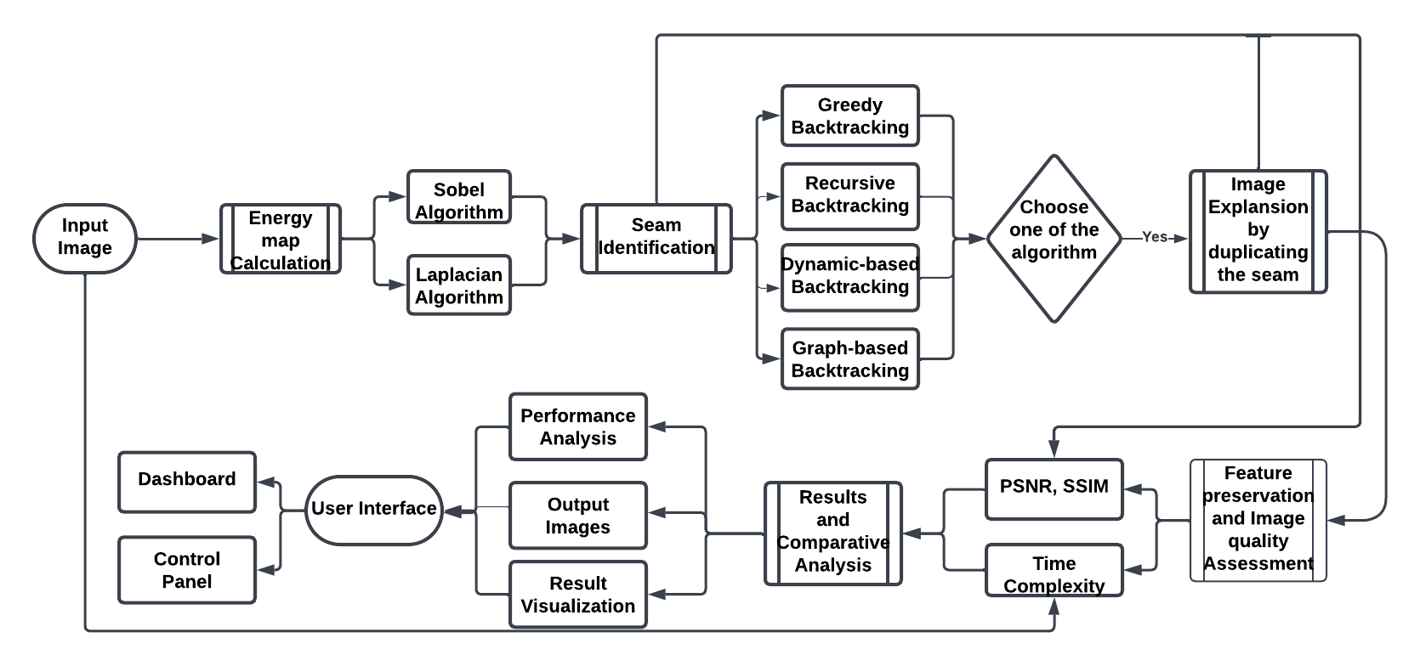
Fig.1. Seam Carving High Level Design

In the above Fig.1. represents the system architecture for optimizing seam carving in image expansion, focusing on algorithm selection and performance analysis. This architecture illustrates the workflow for implementing and evaluating seam carving techniques for image expansion. Seam carving dynamically identifies and adjusts image seams to either remove or duplicate them for resizing while preserving key features. This work aims to compare the efficiency and effectiveness of various backtracking algorithms and analyze the impact on image quality.

Workflow:

1.Input Image:
The system begins with an input image, which is the basis for processing. This image undergoes transformations and evaluations through the subsequent stages.

2.Energy Map Calculation:
The first step in processing is calculating an energy map, which highlights the importance of pixels in the image. Two algorithms are employed:
  - Sobel Algorithm: Detects edges in the image by emphasizing gradient intensity.
  - Laplacian Algorithm: Focuses on detecting regions of rapid intensity changes.
The calculated energy map is essential for identifying seams with the least impact on image content.

3. Seam Identification:
The energy map guides the identification of seams, which are paths of least energy that can be removed or duplicated for image resizing. This step prepares the data for algorithmic application.

4. Algorithm Selection:
The architecture supports four backtracking algorithms for seam carving:
  - Greedy Backtracking: Quickly identifies seams but may not provide globally optimal results.
  - Recursive Backtracking: Offers more precision by exploring multiple paths recursively.
  - Dynamic Programming Backtracking: Optimizes seam selection by balancing computational efficiency and accuracy.
  - Graph-Based Backtracking: Uses graph traversal techniques for robust seam identification.
Users can select any algorithm via a decision mechanism integrated into the user interface.

5. Image Expansion:
Once a seam is identified, it is duplicated to expand the image. This step ensures that the image is resized while maintaining its visual integrity.

6. Quality and Time Complexity Metrics:
The system evaluates performance using the following metrics:
  - PSNR (Peak Signal-to-Noise Ratio): Measures the quality of the expanded image compared to the original.
  - SSIM (Structural Similarity Index): Assesses structural changes and perceptual differences.
  - Time Complexity: Records the computational efficiency of each algorithm.

7. Feature Preservation and Image Quality Assessment:
The system examines the preservation of key features (like edges and textures) during expansion. This ensures that the resizing process minimally affects the original image content.

8. Results and Comparative Analysis:
The output images from each algorithm are analyzed for their performance metrics. A comparative analysis highlights the trade-offs between quality and computational cost for each approach.

User Interface and Visualization

9. Dashboard and Control Panel:
The user interface features a control panel to manage algorithm selection and display results. A dashboard presents detailed visualizations of:
  - Seam paths overlaid on the original image.
  - Graphs of performance metrics for different algorithms.

10. Output Visualization:
Users can visualize the expanded image and compare the seam carving results across algorithms. This facilitates interactive exploration of the results.
This architecture not only implements seam carving but also provides a comprehensive framework for comparing and optimizing various algorithms. With a focus on both user interaction and detailed performance evaluation, the system offers valuable insights into the effectiveness of different backtracking approaches in seam carving.

CHAPTER 5 – IMPLEMENTATION

5.1) Image Processing and Seam Identification
The process starts by carefully analyzing the input image to determine its dominant features and regions. Energy map calculation is the first step by assuming an energy value for each pixel. These energy values are determined according to several properties of an image, such as gradient magnitude or intensity, with a particular focus on points that point out crucial feature areas (e.g., texture edges). The energy map should then act as a guide to prioritize the regions to be preserved during seam manipulation.
The energy map is used to perform seam identification. A seam is defined as a connected path of pixels, either vertical or horizontal, that minimally disturbs the structure in the image. The algorithm assesses which potential seams are going to have the lowest values of summing the energy of each pixel along each path - therefore identifying the least noticeable seams for removal or duplication. The identified seams are then prioritized on their own value to ensure the important visual content is minimally affected.
This preliminary step serves as a platform for subsequent operations since the identification of seams must be correct to preserve the structural and perceptual quality of the image.

5.2) Algorithm Selection
Given different user needs and computational constraints, the system has four seam manipulation algorithms selected to present unique characteristics with respect to a trade-off:
Greedy Algorithm:
It plays a crucial role in the seam carving process by selecting the optimal seam (path of least importance) at each step of image resizing. It works by evaluating the energy map of the image and choosing the seam with the lowest energy at each iteration. This ensures that less visually significant areas of the image are removed or expanded, thereby preserving the more important features, such as objects, faces, or regions with high texture or detail. The simplicity of the greedy approach allows for faster computation compared to more complex methods, making it suitable for scenarios where computational efficiency is a priority.
However, the greedy algorithm focuses on making locally optimal choices at each step, without considering the broader implications of those decisions on the entire image. As a result, it may not always achieve the globally optimal result, especially in cases where seams with low local energy overlap with high-energy regions in subsequent steps. This can lead to distortions or the unintentional removal of important image features. Despite this limitation, the greedy algorithm remains an effective and efficient method for basic seam carving tasks, particularly when computational resources are limited, or the image content does not have highly complex structures.
Recursive Algorithm:
It is a powerful method used in seam carving to compute and select optimal seams by breaking the image resizing process into smaller, manageable subproblems. The algorithm operates by dividing the image into reduced sections, where each subproblem involves identifying the optimal seam within a smaller portion of the image. This recursive process continues until it reaches a base case, such as a single row or column, where the solution is straightforward and directly solvable. Once the base case is resolved, the solutions to the smaller subproblems are combined step by step to form the final optimal seam for the entire image.
This divide-and-conquer approach allows the recursive algorithm to systematically analyze the energy map, ensuring that seams with the lowest cumulative energy are selected. By considering the interactions between pixels and energy values across smaller sections of the image, the algorithm can identify seams that preserve critical features more effectively compared to simpler methods. However, the recursive nature of this algorithm can result in higher computational costs and memory usage, especially for large images, as it involves repeated computations for overlapping subproblems. Despite these challenges, the recursive algorithm is highly effective for applications that demand precision in seam selection and is particularly useful for images with complex structures or high levels of detail.
Dynamic Programming Algorithm:
It is a highly efficient method for seam selection in seam carving, designed to ensure globally optimal results while minimizing computational redundancy. This algorithm works by constructing a cost matrix that stores intermediate results, representing the cumulative minimum energy required to reach each pixel in the image. Instead of evaluating all possible seams from scratch, dynamic programming computes the optimal seam for each row or column based on previously computed values, avoiding redundant calculations and significantly reducing computational overhead.
The process begins by initializing the cost matrix with the energy values of the first row or column of the image. For each subsequent row or column, the algorithm updates the matrix by adding the pixel's energy value to the minimum cumulative energy from the adjacent pixels in the previous row or column. This ensures that the algorithm only considers the least-cost path to each pixel, effectively building a map of the optimal seams from the top to the bottom of the image (or from left to right, depending on the orientation).
Once the cost matrix is complete, the algorithm identifies the seam with the lowest cumulative energy by tracing back through the matrix from the lowest value in the last row or column. This backtracking step ensures that the selected seam minimizes distortions while preserving the overall structure of the image. By leveraging this systematic approach, the dynamic programming-based algorithm provides a globally optimal solution, ensuring that critical features such as edges and textures are preserved during image resizing.
While this method is more computationally intensive than simpler approaches like the greedy algorithm, it is significantly more accurate, especially for images with complex structures. Its ability to consider the cumulative impact of each seam selection makes it an ideal choice for applications where preserving image quality is paramount, even in scenarios involving high-resolution or highly detailed images.
Graph-Based Algorithm:
It is an advanced approach to seam carving that models the image as a graph, where each pixel is treated as a node, and edges between nodes represent connections based on pixel adjacency. The weights of these edges are determined by the energy values of the corresponding pixels, with lower energy indicating less visually significant areas. The goal of this method is to identify the least-cost path through the graph, which corresponds to the optimal seam for resizing or expanding the image.
To compute the optimal seam, algorithms like Dijkstra’s shortest path algorithm or other graph traversal techniques are employed. These algorithms find the path from one side of the image (e.g., top to bottom or left to right) that minimizes the cumulative edge weights, effectively selecting the seam with the lowest energy. The graph representation allows for a more flexible and detailed evaluation of the relationships between pixels, making it particularly effective for handling images with complex structures, intricate patterns, or high levels of detail.
One of the key advantages of the graph-based approach is its ability to consider the global connectivity of the image. Unlike methods that focus solely on local energy values, this approach evaluates the overall impact of seam selection on the entire image, ensuring better preservation of important features like edges, textures, and objects. This makes it highly suitable for scenarios where structural integrity and visual quality are critical.
However, the graph-based algorithm is computationally intensive compared to simpler methods like greedy or dynamic programming-based algorithms. The need to construct and traverse the graph for each resizing operation can lead to increased processing time, especially for high-resolution images. Despite this, its robustness in preserving critical image features and handling complex scenarios makes it an ideal choice for applications where accuracy and quality take precedence over computational speed.

Sobel Algorithm:
It is a widely used edge detection technique in image processing, particularly for seam carving. It calculates the gradient of pixel intensity in horizontal (Gx) and vertical (Gy) directions to detect areas of significant intensity change, typically corresponding to edges. The algorithm combines these gradients to determine the edge magnitude, which highlights regions of high intensity changes.
In seam carving, the Sobel algorithm helps generate an energy map that prioritizes seams avoiding critical edge regions, such as object boundaries or faces, ensuring that key features are preserved during resizing. The algorithm is computationally efficient and effective for detecting basic edges and maintaining visual integrity during image resizing. However, it is sensitive to noise, which can cause false edge detections, and may not capture fine details or subtle boundaries, especially in low-contrast areas.

Laplacian Algorithm:
It is an edge detection method that calculates the second derivative of an image’s intensity, emphasizing regions with rapid intensity changes, such as sharp boundaries and high-texture areas. Using a 3x3 kernel, it computes changes in both horizontal and vertical directions, effectively identifying significant edges and details. In seam carving, the Laplacian helps generate an energy map that prioritizes areas with strong textures and boundaries, ensuring that critical structural elements, like object edges and textures, are preserved during image resizing. This prevents distortion of important features during the image expansion or reduction process. The Laplacian’s advantages include its ability to detect fine edges and intricate details in high-intensity areas, and it captures both horizontal and vertical edge information, making it effective for complex boundaries. However, it has limitations, such as being sensitive to noise, which can lead to false edge detection in low-contrast or noisy areas, and it may also detect edges in uniform regions, which can cause issues when resizing images with subtle textures.

5.3) Expansion and Quality Evaluation of Images
Once the seams are identified, the procedure of image enlargement can proceed. Here, the seams identified are copied and reposted in the image. This technique ensures that the overall size of the image increases, and at the same time, it maintains structural integrity of important visual features.
Following the enlargement, the system conducts a thorough quality evaluation aimed at ascertaining whether the seam alteration has been effective. This step makes use of sophisticated metrics to ensure that the enlarged image features visual fidelity and feature prominence similar to the original image:
Scale-Invariant Feature Transform and Speeded-Up Robust Features are used to find out and match key features before and after expansion. The algorithms thus quantify how well the expanded image's critical features have been preserved, ensuring that feature distortion has been minimized. The overall quality of the expanded image is quantified in terms of PSNR and SSIM. PSNR measures the pixel-wise differences between the original and expanded images, and SSIM measures structural similarity, which reveals the capability of the expansion to model human visual perception.
5.4) Results Visualization and User Interface
The last stage of the methodology deals with presenting the results in a very intuitive and user-friendly manner. A robust user interface layer is designed for easy interaction with the system by which the user is able to configure operations, view outputs, and analyze performance. The layer consists of the following components:
Dashboard:
A central hub, with major performance metrics being displayed, such as runtime efficiency, algorithmic comparisons, and even image quality scores. The dashboard gives an overview about the current state of the system and allows users to compare the impact of different seam manipulation algorithms in play.
Control Panel:
This capability enables fine-tuning of parameters with energy map thresholds, number of seams to add or remove, and choice of algorithms. New images may be uploaded or selected from a preloaded dataset.
Comparison Visualizations:
The system produces side-by-side visualizations of the original and expanded images, pointing to duplicated seams and the differences. Exploring each tool allows a zoom-in view on a region, further evaluating the quality and feature preservation.
Output Images and Reports:
Users may download the processed images alongside reports detailing the algorithm used, computational time, and quality metrics (PSNR and SSIM). Such reports are very useful for further analysis or even publication

CHAPTER 6 – RESULTS

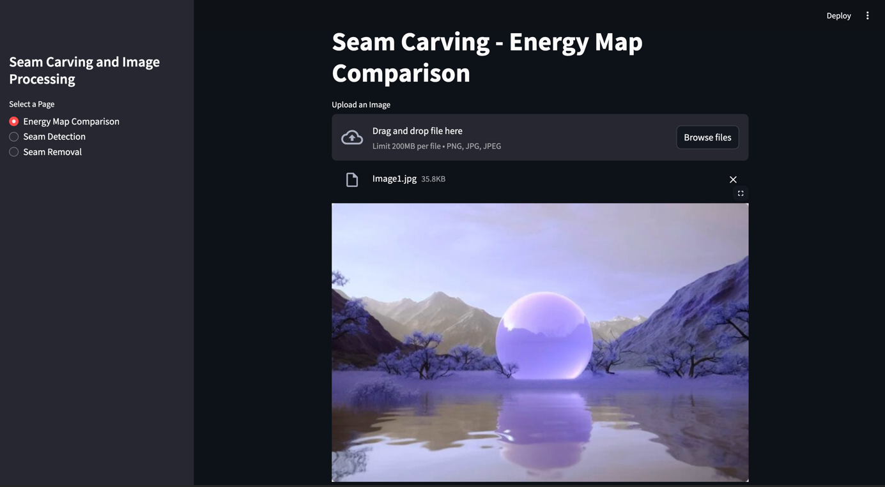
Fig.2. Seam Carving
In Fig.2. it shows the GUI of a seam carving and image processing tool, specifically focusing on the "Energy Map Comparison" feature. This interface allows the user to upload an image (supported formats: PNG, JPG, JPEG) with a file size limit of 200 MB. An uploaded image (Image1.jpg, 35.8 KB) is displayed in the preview area. The purpose of this interface seems to be analyzing energy maps used in seam carving, which help identify significant regions of the image to preserve while resizing. The navigation menu on the left provides options to explore related functionalities, including Seam Detection and Seam Removal.

Fig.3. Seam Detection
The "Seam Detection" in Fig.3. feature identifies the optimal path of least energy in an image for resizing while preserving important content. It compares the original image with a detected seam (highlighted in blue) and uses a Sobel Energy Map to visualize pixel importance, where bright areas represent high energy and dark areas indicate low energy. The seam path aligns with low-energy regions to minimize visual disruption during resizing, ensuring essential features remain intact.

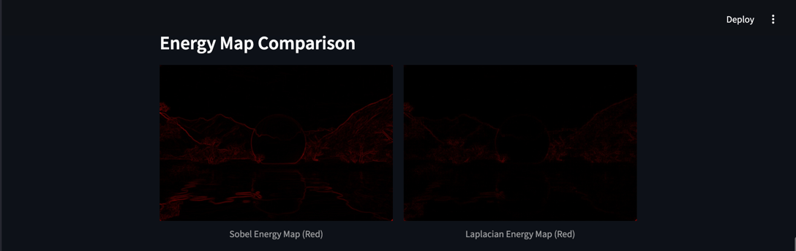
Fig.4. Energy Map Comparison
The image in Fig.4. compares energy maps generated using two edge-detection methods, Sobel and Laplacian, which are commonly used in image processing tasks like seam carving. The Sobel energy map emphasizes strong, directional edges by calculating gradient magnitudes in horizontal and vertical directions, making it ideal for detecting structured outlines and boundaries. In contrast, the Laplacian energy map, a second-order derivative method, highlights rapid intensity changes and fine details uniformly, capturing both large-scale edges and intricate textures. Together, these methods provide complementary insights into image features, with Sobel suited for directional edge analysis and Laplacian for broader edge detection.

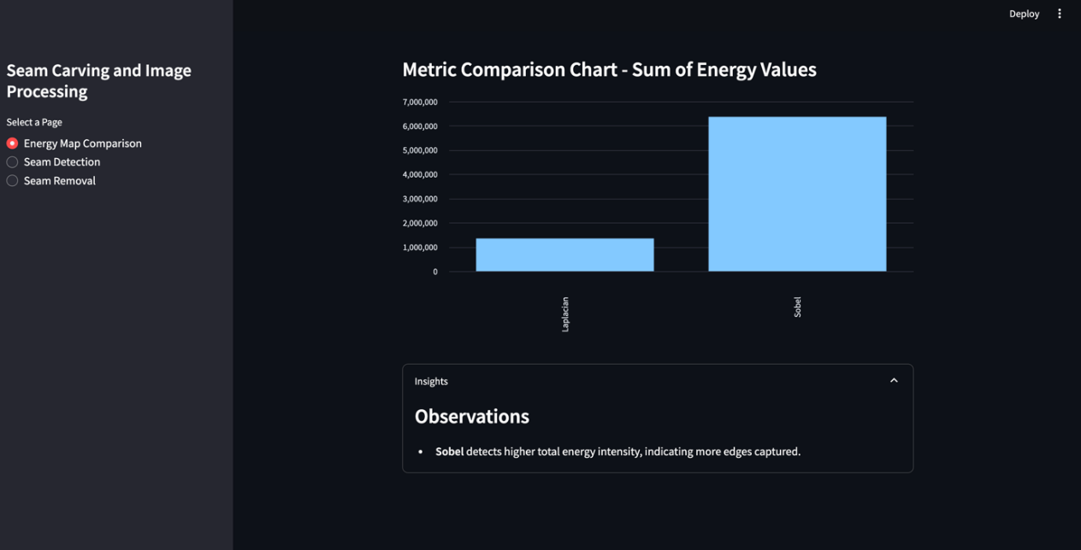
Fig.5. Metrics Comparison chart
The dashboard visualizes a comparison of energy maps using Sobel and Laplacian algorithms, with Sobel showing significantly higher total energy values, indicating its capability to detect more edges and regions of intensity. This highlights Sobel's effectiveness for tasks requiring detailed edge detection, while Laplacian captures fewer but broader features. The interface also includes options for further processing, such as seam detection and removal, offering a user-friendly and structured workflow for seam carving and image analysis.


Fig.6. Seam Removal Original Image
In Fig.6. It shows a web application designed for seam carving and image processing; a technique used for content-aware image resizing. The interface consists of key components: a left panel offering page options such as Energy Map Comparison (visualizing pixel importance), Seam Detection (displaying low-importance paths), and Seam Removal, which is the currently selected mode for resizing images by removing seams. The right panel displays the Original Image, a serene landscape featuring reflective water, distant mountains, and a translucent sphere.
At the bottom, there is a control slider that lets users select the number of seams to remove, ranging from 1 to 100, accompanied by a "Run Seam Removal" button to execute the resizing process. The application adopts a dark theme for better visual focus, with a sidebar for navigation and a large display area for the selected image.
Seam carving works by analyzing the image's energy map, which identifies pixel importance based on features like edges or textures. Low-energy regions are prioritized for removal, while high-energy areas are preserved. A seam is a connected path of low-energy pixels running vertically or horizontally, which is selectively removed or added to resize the image while retaining its essential content. This tool is ideal for resizing images without distorting critical features, removing unwanted content, or exploring advanced image processing techniques.

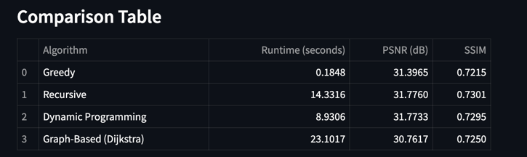
Fig.7. Comparison Table for all Algorithms
This table in Fig.7. compares the performance of four algorithms—Greedy, Recursive, Dynamic Programming, and Graph-Based (Dijkstra)—for an image processing task based on runtime, PSNR, and SSIM. The Greedy algorithm is the fastest (0.1848 seconds) but offers lower quality preservation (PSNR: 31.3965 dB, SSIM: 0.7215). The Recursive algorithm provides the best quality (PSNR: 31.7760 dB, SSIM: 0.7301) but is slower (14.3316 seconds). Dynamic Programming balances runtime (8.9306 seconds) and quality (PSNR: 31.7733 dB, SSIM: 0.7295), making it efficient and accurate. The Graph-Based algorithm is the slowest (23.1017 seconds) with the lowest PSNR (30.7617 dB), showing limited practicality despite decent structural preservation (SSIM: 0.7250). Overall, Recursive and Dynamic Programming methods strike a better trade-off between quality and efficiency.
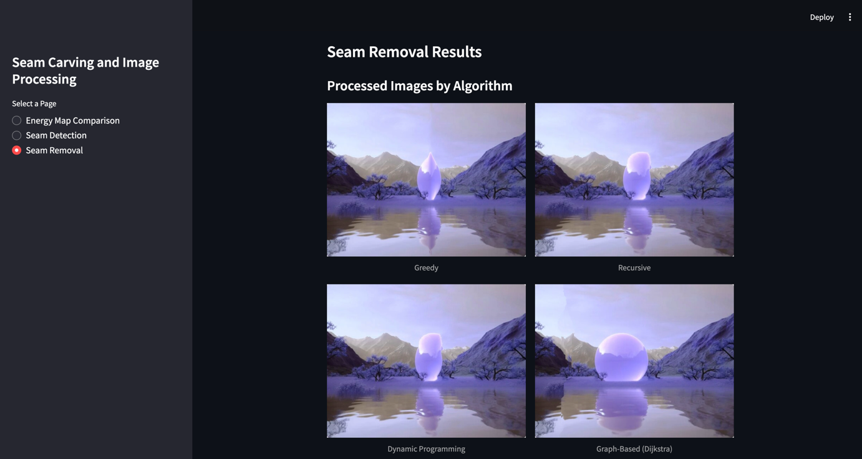Fig.8. Seam Removal Results (Processes Images by Algorithms)
In Fig.8. it compares the results of seam removal using four algorithms: Greedy, Recursive, Dynamic Programming, and Graph-Based (Dijkstra). The Greedy algorithm is the fastest but introduces significant distortions, compromising structural integrity. The Recursive algorithm improves quality but still has noticeable distortions. Dynamic Programming strikes a balance between speed and quality, with fewer distortions and better content preservation. The Graph-Based algorithm delivers the best results with minimal distortions and excellent structural preservation but is the slowest due to its higher computational cost.

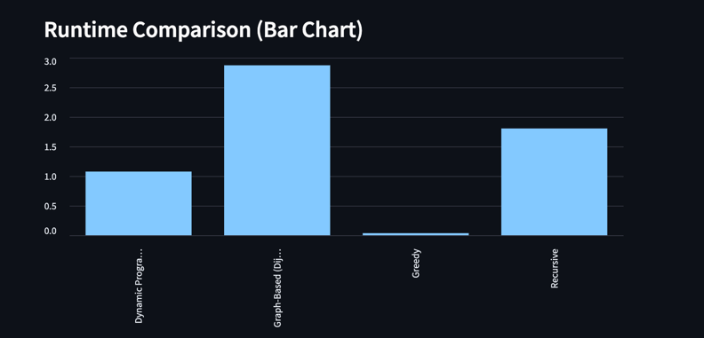
Fig.9. Runtime Comparison (Bar Chart)
This bar chart titled "Runtime Comparison" in Fig.9. compares the runtime performance of four algorithms: Dynamic Programming, Graph-Based (likely Dijkstra's algorithm), Greedy, and Recursive. The X-axis represents these algorithms, while the Y-axis shows their runtime in arbitrary units. Dynamic Programming has a moderate runtime (~1.0 unit), Graph-Based is the slowest (~3.0 units), Greedy is the fastest (close to 0), and Recursive has a runtime of ~2.0 units. The chart highlights trade-offs in computational efficiency, with Greedy being highly efficient but potentially suboptimal, Graph-Based being computationally expensive, and Recursive incurring overheads compared to Dynamic Programming. This comparison is useful for evaluating algorithm efficiency in tasks like optimization or pathfinding.

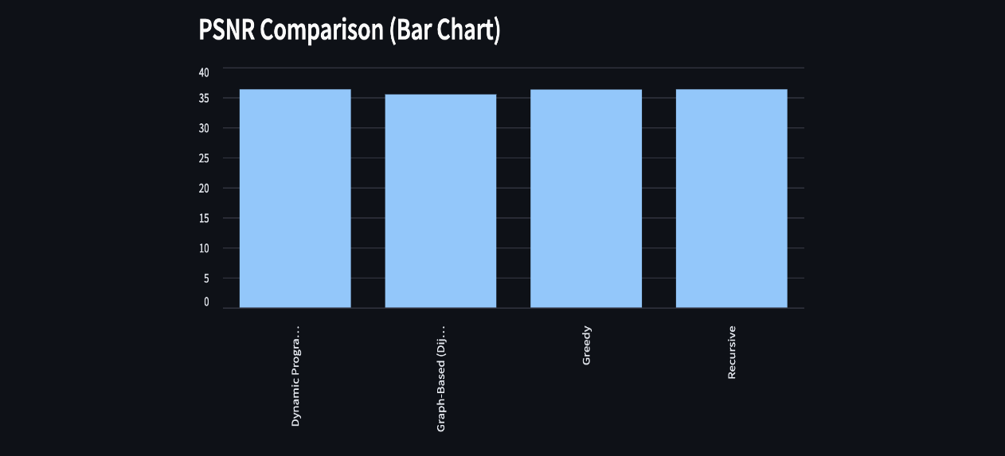
Fig.10. PSNR Comparison (Bar Chart)
This bar chart, titled "PSNR Comparison", in Fig.10. visually represents the Peak Signal-to-Noise Ratio (PSNR) values for four approaches: Dynamic Programming, Graph-Based (likely Dijkstra's algorithm), Greedy, and Recursive. The X-axis lists these methods, while the Y-axis indicates the PSNR values, measured on a scale from 0 to 40. All four approaches exhibit similar PSNR values, falling close to the 35-36 range, indicating consistent performance in terms of signal fidelity across methods. This suggests that all algorithms maintain a comparable quality of output, likely in a task involving image or signal processing.

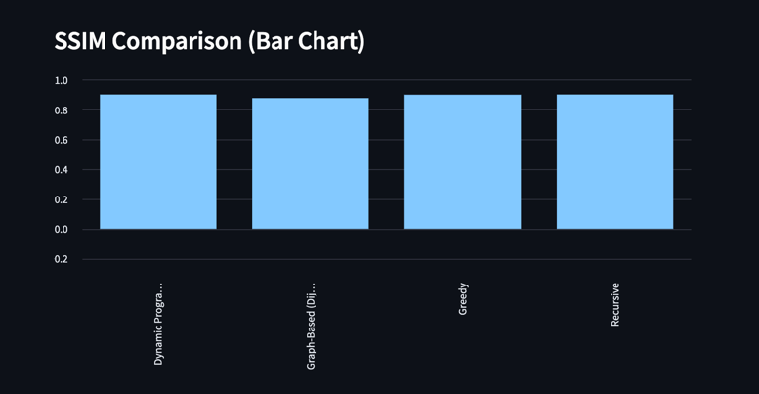
Fig.11. SSIM Comparison (Bar Chart)
This bar chart, titled "SSIM Comparison", in Fig.11. illustrates the Structural Similarity Index Measure (SSIM) values for four approaches: Dynamic Programming, Graph-Based (likely Dijkstra's algorithm), Greedy, and Recursive. The X-axis lists these methods, while the Y-axis measures SSIM values on a scale from 0.0 to 1.0, where values closer to 1.0 indicate higher similarity in structure or image quality. All four approaches exhibit nearly identical SSIM values, around 0.85-0.9, indicating consistently high structural similarity and quality in their outputs.


Fig.12. Best Algorithm Based on Metrics
The results in Fig.12. shows the performance evaluation of seam carving algorithms, with the Recursive algorithm identified as the best, achieving a top rank score of 5.00. It demonstrates a balanced performance across key metrics: a runtime of 14.3316 seconds, indicating efficient processing; a PSNR of 31.7760 dB, reflecting high-quality image reconstruction with minimal distortion; and an SSIM of 0.7301, suggesting good structural similarity preservation between the original and expanded images. While the Recursive algorithm excels overall, there is room for improvement in structural fidelity.

CHAPTER 7 – CONCLUSION AND FURTURE ENHANCEMENT

Conclusion:
To conclude, we have successfully demonstrated the efficiency and effectiveness of our proposed methods for Optimizing Seam Carving for Image Expansion. Our focus on algorithm optimization has led to a solution that is not only computationally efficient but also scalable, allowing it to handle large and high-resolution images in environments with limited system resources. The challenge of minimizing computational load while maintaining image quality was addressed through strategic improvements in the seam carving algorithms, ensuring that the proposed framework can be applied effectively in real-world scenarios where computational constraints are critical. The performance of our algorithms was high in terms of image quality preservation, making it a viable solution for content-aware image resizing applications that require both precision and resource efficiency.
Furthermore, integrating advanced edge detection methods like Sobel and Laplacian, alongside energy map optimization, has been instrumental in overcoming challenges related to preserving important image features during resizing. Through optimization techniques, we further enhanced the seam carving process, ensuring it remains computationally feasible without compromising image quality. The performance benchmarks confirmed that our solution can achieve accurate image resizing with a reduced computational footprint, making it suitable for use in systems with limited processing power and memory. This work contributes to the advancement of methodologies for scalable, efficient, and accessible image processing solutions, particularly in fields like digital media, medical imaging, and interactive design.

Future Enhancement:
The future scope of our project could be so promising as far as the field of
Optimizing Seam Carving for Image Expansion holds significant promise in the field of image processing and content-aware resizing. One potential enhancement is the incorporation of advanced machine learning techniques, particularly deep learning models, to improve the accuracy of seam detection and expand the algorithm’s ability to handle more complex images and diverse content. This could allow for better preservation of intricate details and structures during the resizing process, particularly in highly detailed or textured images. Additionally, leveraging specialized hardware, such as GPUs or TPUs, could greatly enhance the speed and efficiency of the seam carving process, enabling real-time image expansion and making the system more applicable to large-scale image editing tasks, including video processing and interactive media.
Another promising direction for future development is the integration of advanced features like automatic region selection, where users could specify areas of the image that need to be preserved, or the algorithm could automatically detect and prioritize important regions based on context. This would allow for more customized resizing, particularly in applications like interactive design, medical imaging, and multimedia content creation. Moreover, improving the robustness of our algorithms to handle noisy or low-quality images, such as those commonly found in real-world scenarios, would make the system more reliable and versatile across various domains. Further advancements could push the boundaries of computational efficiency and image quality, potentially enabling widespread adoption of this system in both research and commercial applications.
REFERENCES
[1] Garg, A., Nayyar, A. Singh, A.K. Improved seam carving for structure preservation using efficient energy function. Multimed Tools Appl 81, 12883–12924 (2022). https://doi.org/10.1007/s11042-022-12003-1
[2] Avidan, S. and Shamir, A., 2023. Seam carving for content-aware image resizing. In Seminal Graphics Papers: Pushing the Boundaries, Volume 2 (pp. 609-617).
[3] Hashemzadeh, M., Asheghi, B. and Farajzadeh, N., 2019. Contentaware image resizing: an improved and shadow-preserving seam carving method. Signal Processing, 155, pp.233-246.
[4] Patel, D. and Raman, S., 2019. Accelerated seam carving for image retargeting. IET Image Processing, 13(6), pp.885-895.
[5] Senturk, Z.K., Akgun, D. and Senturk, A., 2014. A performance analysis for seam carving algorithm. International Journal of Advanced Studies in Computers, Science and Engineering, 3(12), p.5.
[6] J. Shen, D. Wang and X. Li, ”Depth-Aware Image Seam Carving,” in IEEE Transactions on Cybernetics, vol. 43, no. 5, pp. 1453-1461, Oct. 2013, doi: 10.1109/TCYB.2013.2273270.
[7] Z. K. Senturk and D. Akgun, ”Seam Carving Based Image Retargeting: A Survey,” 2019 1st International Informatics and Software Engineering Conference (UBMYK), Ankara, Turkey, 2019, pp. 1-6, doi: 10.1109/UBMYK48245.2019.8965618.
[8] S. Jadhav and P. Dighe, ”Image resizing for thumbnail images by using seam carving,” 2015 International Conference on Energy Systems and Applications, Pune, India, 2015, pp. 636-640, doi: 10.1109/ICESA.2015.7503427.
[9] D. Patel, S. Shanmuganathan and S. Raman, ”Adaptive Multiplepixel Wide Seam Carving,” 2019 National Conference on Communications (NCC), Bangalore, India, 2019, pp. 1-6, doi: 10.1109/NCC.2019.8732245.
[10] M. Ahmadi, N. Karimi and S. Samavi, ”Image Seam-Carving by Controlling Positional Distribution of Seams,” 2020 International Conference on Machine Vision and Image Processing (MVIP), Iran, 2020, pp. 1-5, doi: 10.1109/MVIP49855.2020.9116888.
[11] N. K. and A. Narayanan, ”Video Synopsis: State-of-the-art and Research Challenges,” 2018 International Conference on Circuits and Systems in Digital Enterprise Technology (ICCSDET), Kottayam, India, 2018, pp. 1-10, doi: 10.1109/ICCSDET.2018.8821157.
[12] Dong, W., Zhou, N., Paul, J.C. and Zhang, X., 2009. Optimized image resizing using seam carving and scaling. ACM Transactions on Graphics (TOG), 28(5), pp.1-10.
[13] Yin, T., Yang, G., Li, L., Zhang, D. and Sun, X., 2015. Detecting seam carving based image resizing using local binary patterns. computers security, 55, pp.130-141.
[14] Swetha, T. and Anju, L., Image Compression Using Improved Seam Carving With Hybrid Compression Technique. International Journal of Advanced Research, 3.
[15] Celebi, N.H., Hsu, T.L. and Liu, Q., 2022. A comparison study to detect seam carving forgery in JPEG images with deep learning models. Journal of Surveillance, Security and Safety, 3(3), pp.88-100.
[16] M. Ahmadi, N. Karimi and S. Samavi, ”Image Seam-Carving by Controlling Positional Distribution of Seams,” 2020 International Conference on Machine Vision and Image Processing (MVIP), Iran, 2020, pp. 1-5, doi: 10.1109/MVIP49855.2020.9116888.
[17] Ayubi, J., Amirani, M.C. and Valizadeh, M., 2023. A new seam carving method for image resizing based on entropy energy and lyapunov exponent. Multimedia Tools and Applications, 82(13), pp.19417-19440.
[18] Han, D., Sonka, M., Bayouth, J. and Wu, X., 2010. Optimal multipleseams search for image resizing with smoothness and shape prior. The Visual Computer, 26, pp.749-759.
[19] Guo, D., Ding, J., Tang, J., Xu, M. and Zhao, C., 2015. NIF-based seam carving for image resizing. Multimedia Systems, 21, pp.603-613.

