**Database Design**

**AppUsers Database**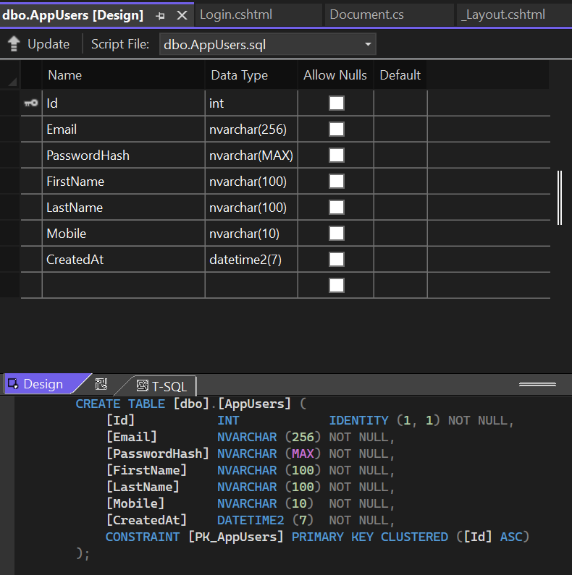

**

**Documents Database**

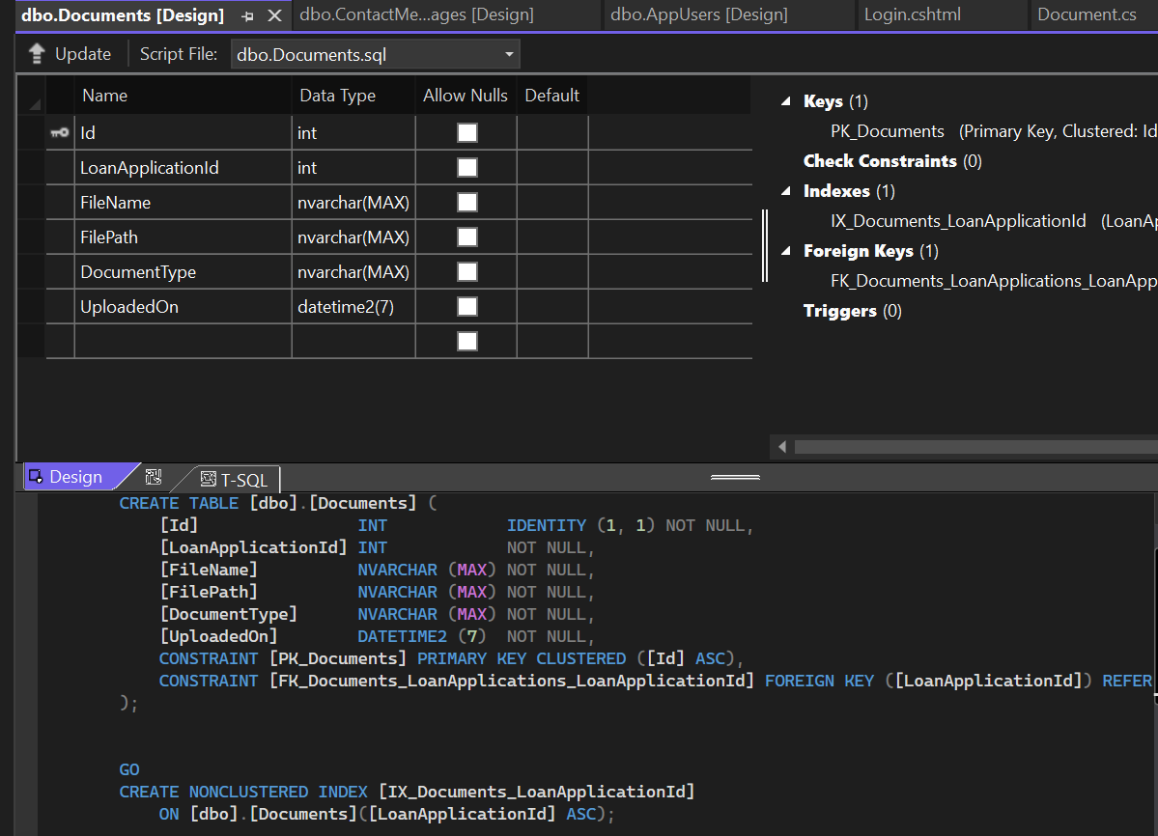

**LoanApllications Database**

