TECHNICAL PROJECT DOCUMENTATION
Shoe Category Image Classification
A Convolutional Neural Network for classifying Boots, Sandals and Slippers
Project | DL-CNN Project: Shoe Classification
Source artifact | CNN_DL_EQ1.ipynb (Google Colab notebook)
Framework | TensorFlow 2.20.0 / Keras, NumPy 2.1.3
Task type | Multi-class image classification (3 classes)
Headline result | 92.90% accuracy on the 155-image held-out validation split
Document date | October 3, 2026

Contents

1. Executive Summary
This project implements an end-to-end computer vision pipeline that classifies retail footwear images into three categories: Boots, Sandals and Slippers. A custom Convolutional Neural Network (CNN) was built in TensorFlow/Keras and trained on Google Colab using 778 labeled images stored on Google Drive.
Three training approaches were tried. A baseline Keras model trained with model.fit() reached a peak validation accuracy of 92.90% but was unstable. A model with data augmentation and early stopping underfit (validation accuracy near 50%). The final model uses a custom training loop built on tf.GradientTape, with a lower learning rate (0.0005) and lighter dropout (0.3). It reached 96.15% training accuracy and 92.90% accuracy on the held-out validation split.
Key results: 144 of 155 validation images were classified correctly. Boots achieved 100% recall (67/67). Slippers had high recall (96%) but lower precision (73%), because 8 sandals were misclassified as slippers.
Important caveat: the 89-image test folder is unlabeled, so no true test-set metrics exist. All reported accuracy figures come from the validation split. See Section 10 for limitations.

2. Objectives and Scope

2.1 Objectives
- Build a CNN classifier that categorizes product imagery into Boots, Sandals or Slippers.
- Control overfitting and training instability through regularization, augmentation and optimizer tuning.
- Implement a custom forward/backward propagation loop for fine-grained control of weight updates.
- Provide a single-image inference function that returns a predicted class and confidence score.

2.2 Scope
In scope: data loading and preprocessing, model design, training, evaluation on a validation split, and prototype inference. Out of scope: deployment infrastructure, an API service, monitoring, and labeled test-set evaluation.

3. Environment and Tooling
Component | Detail
Platform | Google Colab (Python 3 kernel)
Hardware | CPU only. The notebook reported that no GPU was available.
Deep learning | TensorFlow 2.20.0 with the Keras API
Numerics / plotting | NumPy 2.1.3, Matplotlib, Seaborn
Evaluation | scikit-learn (classification_report, confusion_matrix)
Storage | Google Drive mounted at /content/drive; dataset in /DL-CNN Project/Shoe Classification

4. Dataset

4.1 Composition
The dataset is organized in the Keras directory-per-class convention. The class labels are inferred from folder names, in alphabetical order: Boots (index 0), Sandals (index 1) and Slippers (index 2).
Split | Images | Notes
train/ (total) | 778 | Three class subfolders
Training subset | 623 | 80% of train/, seed 123
Validation subset | 155 | 20% of train/; Boots 67, Sandals 65, Slippers 23
test/ | 89 | Flat folder with no class subfolders, so no ground-truth labels

4.2 Class Balance
The validation split shows an imbalance: Slippers account for 23 of 155 images (about 15%), compared with 67 (43%) for Boots and 65 (42%) for Sandals. The training split is assumed to have a similar distribution, but its per-class counts were not printed in the notebook.

5. Data Pipeline
Data is loaded with tf.keras.utils.image_dataset_from_directory using a fixed seed (123) so that the 80/20 split is reproducible.
Stage | Configuration
Image size | Resized to 150 x 150 pixels, 3 channels (RGB)
Batch size | 32 (20 batches per epoch on the training subset)
Normalization | layers.Rescaling(1/255) maps pixel values from [0, 255] to [0, 1]
Performance | cache(), shuffle(1000) on training data, prefetch(AUTOTUNE)
Labels | Integer labels, used with SparseCategoricalCrossentropy

Note that normalization is applied in the data pipeline and not inside the model. Inference code must therefore divide pixel values by 255 manually, which predict_shoe_category() does.

6. Model Architecture
The model is a Sequential CNN with three convolution/pooling blocks followed by a dense classifier. The final model uses the same layout as the baseline, with dropout reduced from 0.5 to 0.3.
Layer | Output shape | Parameters | Configuration
Input | 150 x 150 x 3 | 0 | RGB image
Conv2D | 148 x 148 x 32 | 896 | 3x3, ReLU
MaxPooling2D | 74 x 74 x 32 | 0 | 2x2
Conv2D | 72 x 72 x 64 | 18,496 | 3x3, ReLU
MaxPooling2D | 36 x 36 x 64 | 0 | 2x2
Conv2D | 34 x 34 x 128 | 73,856 | 3x3, ReLU
MaxPooling2D | 17 x 17 x 128 | 0 | 2x2
Flatten | 36,992 | 0 | -
Dense | 128 | 4,735,104 | ReLU
Dropout | 128 | 0 | 0.5 baseline, 0.3 final
Dense (output) | 3 | 387 | Softmax

Total parameters: 4,828,739 (18.42 MB), all trainable. About 98% of the parameters sit in the first dense layer (4.74M), which is the main source of overfitting risk and the likely cause of the very large first-epoch loss values (see Section 7.4).

7. Training Methodology

7.1 Experiment Overview
Experiment | Setup | Outcome | Assessment
1. Baseline | model.fit(), Adam (default LR), dropout 0.5, 10 epochs | Train acc up to 94.4%; val acc 84.5% to 92.9%; final val loss 0.93 | Learns well but val metrics are unstable
2. Augmentation + early stopping | Random flip (H+V), rotation 0.2, zoom 0.2; EarlyStopping (patience 3, monitor val_loss); up to 15 epochs | Stopped after 5 epochs; val acc 44.5% to 53.6% | Underfit; augmentation too aggressive for the training budget
3. Custom loop (final) | GradientTape, Adam LR 0.0005, dropout 0.3, 10 epochs, no augmentation | Train acc 53.3% to 96.2%; val acc 92.90% | Selected model

7.2 Baseline Training
The baseline trained for 10 epochs with the default Adam optimizer. Training accuracy rose from 49.6% to about 94% by epoch 8, and validation accuracy peaked at 92.90% in epoch 7. The final epoch showed validation loss rising to 0.93 while validation accuracy fell to 86.5%, which is a typical sign of overfitting and noisy optimization on a small dataset.
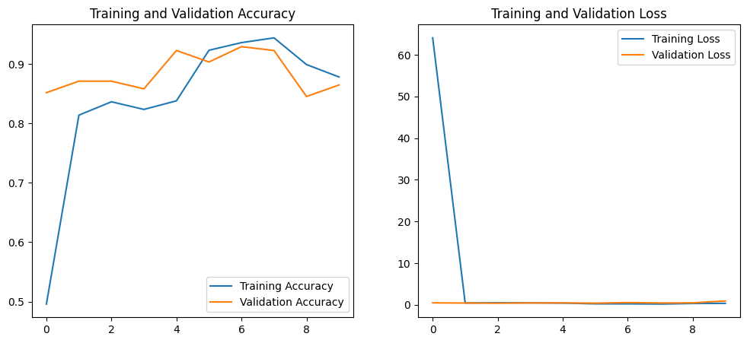
Figure 1. Baseline training and validation accuracy/loss curves (Experiment 1).

7.3 Augmentation and Early Stopping
A data augmentation block (horizontal and vertical flips, rotation of 0.2, zoom of 0.2) was added at the start of the model, and training was guarded by EarlyStopping with restore_best_weights=True. The model did not learn effectively: training accuracy stayed between 41% and 53% and validation loss never fell below about 1.02, so training stopped after five epochs. Likely contributing factors are vertical flips (footwear is rarely seen upside down in catalog images), the very large initial loss, and too few epochs for the harder augmented task.

7.4 Custom Training Loop (Final Model)
The final model is trained with an explicit @tf.function training step. For each batch the loop performs three operations:
- Forward propagation inside a tf.GradientTape context, with training=True so dropout is active.
- Backward propagation: the gradient of the loss with respect to every trainable variable is computed with tape.gradient.
- Weight update: Adam applies the gradients with a learning rate of 0.0005.

Epoch | Summed loss | Train accuracy | Comment
1 | 1205.96 | 53.29% | Very large initial loss
2 | 8.12 | 79.45%
4 | 5.32 | 91.01%
7 | 3.00 | 94.06%
10 | 2.18 | 96.15% | Final epoch

Two observations about these figures. First, the loss values are summed across the 20 batches in each epoch, not averaged, so the epoch 10 value of 2.18 corresponds to roughly 0.11 per batch. Second, training accuracy is a running average collected while weights are changing and dropout is active, so it is not directly comparable to the validation accuracy. The notebook also does not evaluate on the validation set during the custom loop, so there is no per-epoch validation curve for the final model.

8. Evaluation Results
The final model was evaluated on the 155-image validation split, which the custom loop never trained on. Because the test folder is unlabeled, this split serves as the proxy test set.

8.1 Overall and Per-Class Metrics
Class | Precision | Recall | F1-score | Support
Boots | 0.97 | 1.00 | 0.99 | 67
Sandals | 0.98 | 0.85 | 0.91 | 65
Slippers | 0.73 | 0.96 | 0.83 | 23
Accuracy |  |  | 0.93 | 155
Macro average | 0.90 | 0.93 | 0.91 | 155
Weighted average | 0.94 | 0.93 | 0.93 | 155

8.2 Confusion Matrix
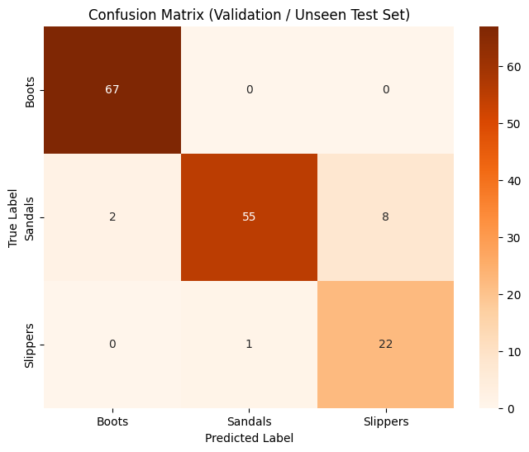
Figure 2. Confusion matrix on the validation split (rows = true class, columns = predicted class).
True \ Predicted | Boots | Sandals | Slippers
Boots | 67 | 0 | 0
Sandals | 2 | 55 | 8
Slippers | 0 | 1 | 22

8.3 Interpretation
- Boots: All 67 boots were identified correctly. Only 2 sandals were mistaken for boots, so Boots precision is 0.97.
- Sandals: 55 of 65 sandals were correct. The 8 sandals predicted as slippers account for most of the errors and are consistent with visual overlap between slide-style sandals and slippers.
- Slippers: 22 of 23 slippers were found (recall 0.96), but the 8 false positives from the Sandals class lower precision to 0.73. With only 23 slipper samples, each error moves these metrics noticeably.
Of the 11 total errors, 8 (73%) are Sandals predicted as Slippers, so that single confusion pair is the clearest target for improvement.

9. Inference Pipeline
The function predict_shoe_category(image_path) performs single-image prediction:
- Load the image with keras.utils.load_img at 150 x 150.
- Convert to an array, add a batch dimension, and divide by 255.
- Run model.predict, take the argmax as the predicted class, and report the maximum softmax probability as the confidence.
- Display the image with the predicted label and confidence as the title.
The notebook demonstrates this on the first test image and on three randomly sampled test images. Observed single-image latency was roughly 50 to 190 ms on CPU, including Keras predict overhead. Since the model already ends in a softmax layer, the extra tf.nn.softmax call inside the function (variable score) is unused and can be removed.

10. Limitations and Risks
Limitation | Detail
No labeled test set | The 89 images in test/ have no class subfolders, so reported accuracy comes from the validation split only. The validation split also guided the choice among the three experiments, so 92.90% may be slightly optimistic.
Small dataset | 778 images in total; 155 for validation. A single misclassification shifts accuracy by about 0.65 percentage points.
Class imbalance | Slippers are about 15% of the validation split, which makes their precision and recall estimates noisy.
Single run | Results come from one seed (123) and one split; run-to-run variance was not measured. The baseline run showed validation accuracy swinging between 84% and 93%.
Overfitting risk | 4.7M of 4.8M parameters are in one dense layer, with no batch normalization and no augmentation in the final model.
Unverified latency claim | The notebook cites under 200 ms per image and 90%+ cataloging time savings. The latency is roughly consistent with the observed CPU timings, but the time-savings figure is an estimate not measured in the notebook.
Domain coverage | Only three categories; other footwear types (sneakers, heels, loafers) would be forced into one of the three classes.

11. Recommendations
- Label the test set. Organize the 89 test images into Boots/Sandals/Slippers folders and report metrics on them as the true held-out evaluation.
- Cross-validate. Use stratified k-fold cross-validation to quantify variance and check that 92.9% holds.
- Use transfer learning. Fine-tune a pretrained backbone such as MobileNetV2 or EfficientNet-B0. This typically gives higher accuracy with small datasets and fewer trainable parameters.
- Revisit augmentation and architecture. Retry augmentation without vertical flips and with milder rotation and zoom, and train for more epochs. Replace Flatten with GlobalAveragePooling2D to shrink the dense layer.
- Address imbalance and the Sandals/Slippers confusion. Add class weights or oversample Slippers, and collect more slide-style sandal and slipper examples to address the main confusion pair.
- Improve the training loop. Log validation accuracy per epoch in the custom loop, average the loss per batch, and add a checkpoint on best validation loss.
- Prepare for deployment. Save the model (model.save), wrap inference in an API, and add confidence thresholds with human review for low-confidence predictions.

12. Business Impact (Projected)
The notebook outlines the following expected benefits. These are projections, not measured outcomes.
- Automated cataloging: Automatic classification at upload time removes manual tagging and reduces catalog inconsistencies.
- Search and discovery: Accurate categories improve search results and product discovery.
- Inventory and logistics: Automated labeling of incoming stock can reduce sorting errors in receiving workflows.

13. Reproducibility Checklist
Item | Value
Random seed | 123 (dataset split)
Split | 80% training / 20% validation of train/
Image size / batch | 150 x 150 / 32
Optimizer (final) | Adam, learning rate 0.0005
Loss | SparseCategoricalCrossentropy
Epochs (final) | 10
Dropout (final) | 0.3
Dataset path | /content/drive/My Drive/DL-CNN Project/Shoe Classification/{train,test}
Library versions | TensorFlow 2.20.0, NumPy 2.1.3

Note: model weights are not saved in the notebook. The final model exists only in the Colab session memory, so rerunning the notebook is required to reproduce it. Weight initialization is not seeded, so exact numbers will vary slightly between runs.

