PROJECT REPORT
Electric Vehicle Dataset
Analytics & Machine Learning Study
Exploratory Data Analysis • Clustering • PCA • Random Forest Classification

9,998  Records analysed | 3  K-Means clusters | 0.5052  Silhouette score | 99.85%  RF CV accuracy

Prepared from: EVdataset_small.ipynb
Professional Project Documentation

Contents
- 1. Executive Summary
- 2. Project Overview & Objectives
- 3. Dataset Overview
- 4. Analytical Methodology
- 5. Exploratory Data Analysis
- 6. Unsupervised Learning – K-Means
- 7. Hierarchical Clustering
- 8. Supervised Learning – Random Forest
- 9. Principal Component Analysis (PCA)
- 10. Integrated Findings
- 11. Conclusion
- 12. Limitations & Recommended Next Steps
- Appendix A – Key Results

1. Executive Summary
This project analyses an electric-vehicle dataset using a combination of exploratory analytics, unsupervised machine learning, dimensionality reduction, and supervised classification. The notebook uses 9,998 records and examines vehicle characteristics such as model year, make, electric range, MSRP, EV type, CAFV status, geography, and related identifiers.
The analytical workflow moves from descriptive exploration to segmentation and prediction. K-Means clustering is used with three clusters, hierarchical clustering is used as a comparison approach, Random Forest is used to predict EV type, and PCA is applied to the numerical variables before a second Random Forest evaluation.
Key recorded results include a K-Means silhouette score of 0.5052, cluster-to-EV-type alignment of 78.31%, mean five-fold Random Forest cross-validation accuracy of 0.9985 using the prepared full feature pipeline, and 0.9812 after using seven PCA components.

Project Highlights
- Dataset size: 9,998 records.
- PCA input: 7 numerical features; 7 components were retained to reach at least 95% explained variance.
- K-Means solution: k = 3.
- K-Means silhouette score: 0.5052.
- Cluster alignment accuracy against the recorded EV Type labels: 78.31%.
- Random Forest mean five-fold CV accuracy: 99.85% (standard deviation 0.0005).
- Random Forest with seven PCA components: mean five-fold CV accuracy 98.12% (standard deviation 0.0016).

2. Project Overview & Objectives
The project is structured as an end-to-end analytical study of electric-vehicle records. The objective is not only to describe the dataset, but also to identify natural vehicle groupings, understand the relationship between clusters and EV type, assess predictive capability, and examine whether dimensionality reduction changes classification performance.

Objectives
- Understand the composition and distributions of the EV dataset.
- Explore relationships among numerical variables through correlation analysis.
- Identify natural vehicle segments using K-Means clustering.
- Compare K-Means results with hierarchical clustering.
- Evaluate cluster quality using silhouette analysis.
- Characterize clusters using average numerical profiles and leading makes.
- Predict EV Type using a Random Forest classifier with cross-validation.
- Identify the most influential features used by the Random Forest model.
- Apply PCA to numerical variables and evaluate classification using PCA-transformed features.

3. Dataset Overview
The notebook loads an EV dataset and displays fields covering vehicle identity, geography, model information, EV classification, clean-fuel status, electric range, MSRP, legislative information, utility, and census tract information.
Field / Group | Examples from notebook | Role in analysis
Vehicle identifiers | VIN (1-10), DOL Vehicle ID | Identifiers; some are excluded from classification
Geography | County, City, State, Postal Code | Descriptive / categorical context
Vehicle attributes | Model Year, Make, Model | Core explanatory variables
EV classification | EV Type | Target / comparison label
Clean-fuel status | CAFV | Categorical predictor
Performance | Electric Range | Numerical predictor; highest RF importance
Pricing | Base MSRP | Numerical variable used in clustering/PCA
Policy / geography | Legislative District, Census Tract | Contextual numerical/categorical variables
Infrastructure | Electric Utility | Categorical context

9,998  Dataset records | 7  Numerical PCA inputs | 7  PCA components retained

4. Analytical Methodology
The notebook follows the analytical sequence below:
Stage | Description
1. Data loading | Load the EV dataset into a pandas DataFrame.
2. Visual EDA | Inspect EV type, model year, make, electric range, county and CAFV distributions.
3. Correlation analysis | Compute a correlation matrix for numerical variables.
4. K-Means clustering | Use scaled features and select k = 3 based on the notebook's stated elbow-method workflow.
5. Cluster evaluation | Assess the solution using silhouette score and cluster-to-EV-type alignment.
6. Hierarchical clustering | Use Ward linkage on the first 2,000 scaled observations and compare three clusters.
7. Random Forest | Build a preprocessing pipeline with scaling for numerical features and one-hot encoding for categorical features.
8. Feature importance | Extract and rank Random Forest feature importances.
9. PCA | Standardize seven numerical variables and retain seven components for at least 95% variance.
10. PCA + Random Forest | Evaluate a Random Forest using the PCA-transformed features with five-fold stratified CV.

5. Exploratory Data Analysis
The notebook contains visual EDA for six major dimensions: EV type, model year, top makes, electric range, top counties, and CAFV status. These views are intended to establish the dataset's composition before applying machine-learning methods.

EDA Views Included
- Distribution of EV Types
- Distribution of Model Years
- Top 10 EV Makes
- Distribution of Electric Range
- Top 10 Counties by EV count
- CAFV status distribution
- Correlation matrix for numerical features
Because the notebook stores the plotting outputs as figures rather than tabulated counts for these EDA charts, this report does not introduce additional numeric distribution claims beyond the values explicitly recorded in the notebook outputs.

6. Unsupervised Learning – K-Means
K-Means clustering was evaluated across candidate values of k using the elbow-method workflow. The notebook then sets the operational solution to three clusters and analyses their relationship with EV Type.
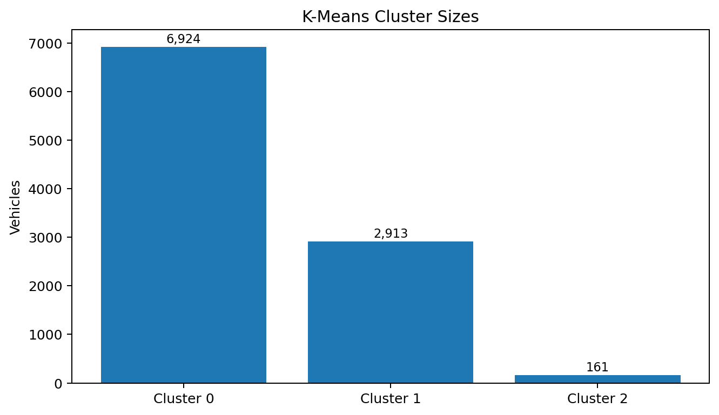
Figure 1. K-Means cluster sizes derived from the recorded cluster-by-type counts.
Cluster | BEV | PHEV | Total
0 | 5,406 | 1,518 | 6,924
1 | 2,316 | 597 | 2,913
2 | 107 | 54 | 161
Total | 7,829 | 2,169 | 9,998

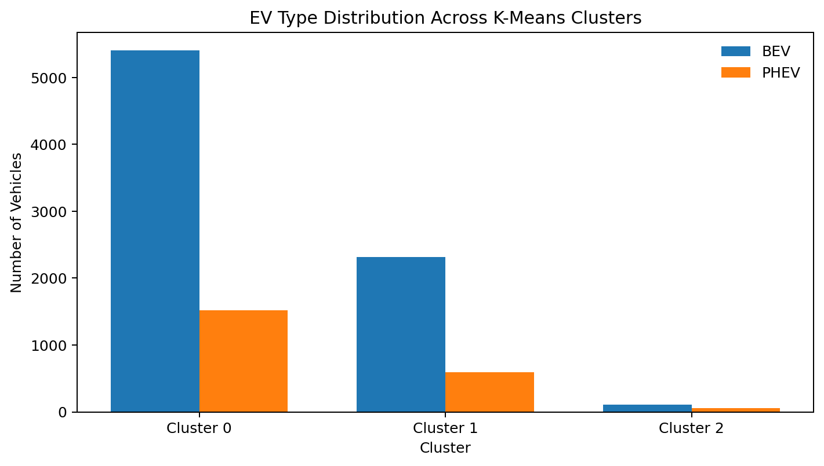
Figure 2. Recorded EV Type composition across the three K-Means clusters.

Cluster Characterization
Cluster | Mean Model Year | Mean Electric Range | Mean Base MSRP | Mean Legislative District
0 | 2022.63 | 6.14 | 0.00 | 32.73
1 | 2017.30 | 164.97 | 0.00 | 33.53
2 | 2015.36 | 127.66 | 59,050.96 | 34.43

The notebook also records the top makes within each cluster. Cluster 0 is led by Tesla, Jeep, BMW, Kia and Ford; Cluster 1 by Tesla, Nissan, Chevrolet, Ford and Toyota; and Cluster 2 by Tesla, Kia, BMW, Volvo and Chrysler.

Cluster Quality
3  Selected k | 0.5052  Silhouette score | 78.31%  Cluster alignment

The silhouette score of 0.5052 indicates the clustering has measurable separation under the notebook's chosen feature representation. The 78.31% alignment figure is calculated by mapping each cluster to its most common EV Type; it should be interpreted as cluster-label alignment rather than supervised classification accuracy.

7. Hierarchical Clustering
Hierarchical clustering is used as a second unsupervised approach. Ward linkage is applied to the first 2,000 scaled observations to keep the dendrogram manageable. Three hierarchical clusters are then extracted and compared with the K-Means labels for the same 2,000-record subset.
K-Means \ Hierarchical | H1 | H2 | H3
K0 | 1,289 | 0 | 21
K1 | 0 | 0 | 659
K2 | 0 | 31 | 0

The cross-tabulation shows a strong correspondence between several K-Means and hierarchical groupings in the sampled 2,000 observations, while the cluster labels themselves are method-specific and should not be interpreted as having identical semantic meanings simply because the numeric labels match.

8. Supervised Learning – Random Forest
The notebook applies a Random Forest classifier to predict EV Type. Identifier fields such as VIN, DOL Vehicle ID and Vehicle Location are removed from the classifier input. Numerical variables are standardized and categorical variables are one-hot encoded within a preprocessing pipeline.

Cross-Validation Results
Fold | Accuracy
1 | 0.9975
2 | 0.9990
3 | 0.9985
4 | 0.9990
5 | 0.9985
Mean | 0.9985
Std. deviation | 0.0005

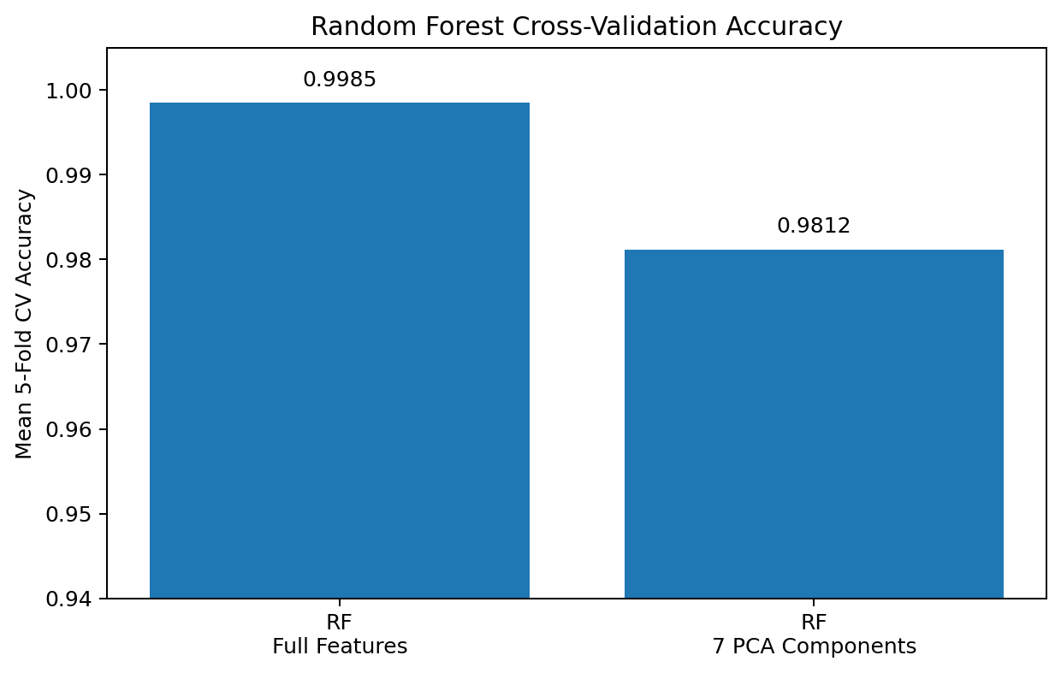
Figure 3. Mean five-fold Random Forest accuracy with and without PCA-transformed features.

Feature Importance
The recorded Random Forest feature-importance output identifies Electric Range as the largest individual feature importance, followed by CAFV categories and several make/model indicators.
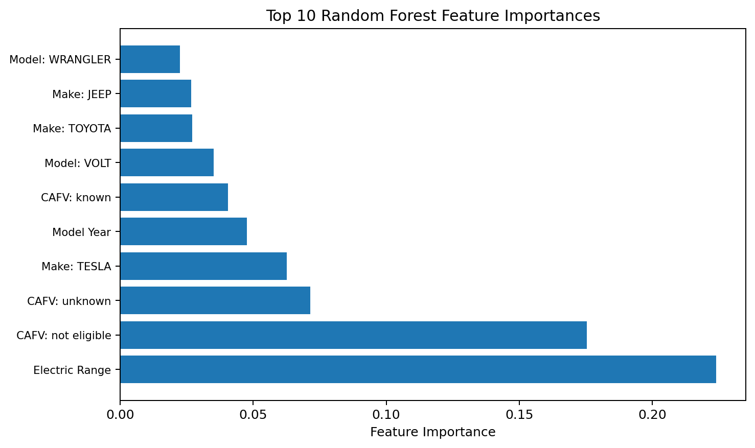
Figure 4. Top 10 feature importances recorded from the Random Forest model.
Rank | Feature | Importance
1 | Electric Range | 0.223896
2 | CAFV – not eligible | 0.175419
3 | CAFV – unknown | 0.071524
4 | Make – TESLA | 0.062556
5 | Model Year | 0.047696
6 | CAFV – known | 0.040560
7 | Model – VOLT | 0.035240
8 | Make – TOYOTA | 0.027008
9 | Make – JEEP | 0.026701
10 | Model – WRANGLER | 0.022559

9. Principal Component Analysis (PCA)
PCA is applied to the seven numerical variables after missing values are filled with the mean and the features are standardized. The notebook determines the number of components required to reach at least 95% cumulative explained variance.
9,998 × 7  Scaled data shape | 7  Components for ≥95% variance | 1.0000  Cumulative variance

The recorded result is seven components, meaning all seven numerical dimensions were retained to reach the 95% threshold. The resulting transformed dataset therefore remains 9,998 × 7.

Random Forest on PCA Features
Metric | Full feature pipeline | 7 PCA components
Mean 5-fold accuracy | 0.9985 | 0.9812
Standard deviation | 0.0005 | 0.0016
Cross-validation folds | 5 | 5

In the notebook's recorded experiment, the PCA-transformed representation produced a lower mean cross-validation accuracy than the original prepared feature representation. This is a descriptive result of the experiment; it does not by itself establish that PCA is unsuitable for every EV classification task.

10. Integrated Findings
Dataset structure: The project combines vehicle, geographic, EV classification, clean-fuel, performance and policy-related fields.
Segmentation: K-Means with three clusters produces a silhouette score of 0.5052 and three distinct cluster sizes, with Cluster 0 being the largest.
Cluster composition: All three clusters contain both BEV and PHEV records, although their proportions differ.
Cluster profiles: The recorded cluster means show clear differences in model year, electric range and Base MSRP.
Alternative clustering: Hierarchical clustering on a 2,000-record subset provides a useful method-level comparison with K-Means.
Classification: Random Forest achieves a mean five-fold CV accuracy of 0.9985 in the notebook's recorded pipeline.
Predictive drivers: Electric Range is the highest-ranked individual feature by recorded Random Forest importance.
Dimensionality reduction: Seven PCA components were needed to reach the notebook's 95% variance criterion, and PCA-based Random Forest CV accuracy was 0.9812.

11. Conclusion
The notebook demonstrates a complete analytical workflow for an EV dataset, progressing from exploratory analysis to segmentation, classification and dimensionality reduction. The combination of clustering and classification provides two complementary perspectives: clustering explores naturally occurring structure, while Random Forest evaluates how well the available variables can distinguish the recorded EV Type labels.
The strongest recorded supervised result is the 0.9985 mean five-fold cross-validation accuracy from the Random Forest pipeline. The clustering experiment provides a moderate silhouette score of 0.5052 and a 78.31% cluster-to-label alignment measure. PCA retains seven components for the stated variance threshold, and the PCA-based Random Forest experiment records a mean accuracy of 0.9812.

12. Limitations & Recommended Next Steps

Limitations observed from the notebook
- The notebook references an external CSV path, while the supplied project artifact is the notebook itself; this report therefore uses the notebook's recorded outputs rather than independently re-running the complete pipeline.
- Several EDA charts are saved as figure outputs without accompanying numeric summary tables, limiting the precision of distribution-level commentary.
- Hierarchical clustering is demonstrated on a 2,000-record subset rather than the full dataset.
- The cluster-alignment percentage is a post-hoc mapping of clusters to their dominant EV Type and is not equivalent to classifier accuracy.
- The extremely high Random Forest accuracy should be interpreted in the context of the feature set and target definition; feature leakage or highly target-proximal variables should be reviewed before production use.

Recommended next steps
- Add a formal data-quality section covering missing values, duplicates, cardinality and outlier treatment.
- Document the exact feature set used for K-Means, including the scaling and encoding steps before clustering.
- Validate the Random Forest with a held-out test set in addition to cross-validation.
- Investigate whether CAFV-related fields encode or closely reflect EV Type, which could explain their high feature importance.
- Add precision, recall, F1-score and a normalized confusion matrix for the supervised classifier.
- Compare additional models such as Logistic Regression, Gradient Boosting and XGBoost if appropriate.
- Extend clustering evaluation using Calinski-Harabasz and Davies-Bouldin indices.
- Add business-oriented segmentation labels and translate cluster profiles into practical EV market insights.

Appendix A – Key Results
Analysis | Recorded result
Dataset size | 9,998 records
K-Means k | 3
Silhouette score | 0.5052
Cluster alignment accuracy | 78.31%
Cluster 0 size | 6,924
Cluster 1 size | 2,913
Cluster 2 size | 161
Random Forest mean 5-fold CV accuracy | 0.9985
Random Forest CV standard deviation | 0.0005
Top RF feature | Electric Range (0.223896)
PCA numerical input shape | 9,998 × 7
PCA components for ≥95% variance | 7
PCA cumulative explained variance | 1.0000
RF mean 5-fold CV accuracy with PCA | 0.9812
RF CV standard deviation with PCA | 0.0016

Source note: All project-specific findings and numerical results in this report are derived from the supplied EVdataset_small.ipynb notebook. No external dataset or external research has been introduced.

