TECHNICAL PROJECT DOCUMENTATION
Twitter Sentiment Classification using Vanilla SimpleRNN
Three-class sentiment engine (Negative / Neutral / Positive) built under a strict no-LSTM, no-GRU, no-Transformer constraint
Field | Detail
Source artefact | RNN_DL_EQ2.ipynb (Google Colab, Python 3 / TensorFlow-Keras)
Task | 3-class text classification of tweets
Final model | Model 3: Masked Bidirectional SimpleRNN + GlobalMaxPooling1D
Final validation accuracy | 88.76% (3,400 held-out tweets); macro F1 0.87
Document date | 3 October 2026

Note on figures: this report uses the metrics actually printed in the notebook’s executed cells. Several narrative cells in the notebook quote slightly different numbers (e.g. 89.15% instead of 88.76%). These are listed in Section 10 so they can be corrected before the project is shared.

1. Executive Summary
This project builds an end-to-end deep learning classifier that labels tweets as Negative (0), Neutral (1) or Positive (2). The design is constrained to standard Keras SimpleRNN layers: gated cells (LSTM, GRU), attention, Transformers and classical classifiers such as Logistic Regression or SVM are excluded.
Four architectures were trained iteratively. The naive baseline collapsed to the majority class (47.41%). Adding bidirectionality and class weights alone made things worse (35.79%). The breakthrough came from a combination of input-handling and architecture changes: pre-padding, embedding-level masking, returning the full recurrent sequence, global max pooling, gradient clipping and a lower learning rate. This Model 3 reached 88.76% validation accuracy with balanced per-class F1 scores (0.77 / 0.91 / 0.91). A fourth experiment with frozen GloVe-Twitter-50 embeddings was attempted; the notebook does not retain its executed output, so its reported 61.79% cannot be verified from the file.
Model | Val. accuracy | Outcome
1. Baseline SimpleRNN | 47.41% | Majority-class collapse
2. BiRNN + class weights | 35.79% | Unstable, class flipping
3. Masked BiRNN + max pooling | 88.76% | Best; selected for inference
4. Frozen GloVe + cosine decay | 61.79%* | *Not reproducible from saved output

2. Business Context and Value
Brands and organisations receive large volumes of unstructured social media text. An automated sentiment engine supports:
- Customer feedback analysis: triaging mentions and reviews at scale to surface defects and PR issues early.
- Churn-risk mitigation: flagging negative sentiment so customer-success teams can intervene.
- Campaign tracking: measuring public reaction to launches and announcements in near real time.
- Operational efficiency: reducing manual review effort so agents focus on escalations.
Because the Negative class is the most actionable for the first three use cases, its weaker recall (0.74) is the most important quality gap to track (see Section 8.3).

3. Scope and Technical Constraints
- Allowed: Keras SimpleRNN (including Bidirectional wrapper), Embedding, Dense, Dropout, pooling layers.
- Excluded: LSTM, GRU, attention mechanisms, Transformers, and non-neural shallow classifiers.
- Target: Sentiment mapped to 0 = Negative, 1 = Neutral, 2 = Positive.
- Data discipline: the unlabeled test file is used only for final inference; tokenizer, class weights and splits are derived from training data only.
A code audit of the notebook confirms that only SimpleRNN recurrent layers are used and that no gated or attention layers appear anywhere in the pipeline.

4. Dataset
Two CSV files (tweets_train.csv, tweets_test.csv) are read from a mounted Google Drive folder. The tweets relate to the “The Social Dilemma” documentary discussion (hashtag evident in the text samples). Records carry user metadata (name, location, description, follower counts, verification status), tweet metadata (date, hashtags, source, retweet flag) and a pre-processed clean_text column. Only clean_text and Sentiment are used for modelling.
Property | Value | Comment
Training records | 17,000 | 14 columns, includes Sentiment label
Test records | 3,068 | 13 columns, no label
Missing clean_text (train) | 8 | Replaced with empty string
Missing user_location (train) | 3,607 | Unused feature
Missing hashtags (train) | 3,649 | Unused feature

4.1 Class distribution (training set)
Class | Label | Count | Share
Positive | 2 | 8,059 | 47.4%
Neutral | 1 | 5,927 | 34.9%
Negative | 0 | 3,014 | 17.7%
The imbalance is moderate, but it was sufficient to cause the baseline model to predict only the majority class.

5. Data Processing Pipeline
Raw text → clean → tokenise → pre-pad to 40 → integer tensor → SimpleRNN. The steps are:
- Cleaning. Lowercase; strip URLs (http/https/www); strip @handles; collapse whitespace. Missing text is set to “”.
- Label encoding. Negative→0, Neutral→1, Positive→2.
- Stratified split. 80/20 split of the training file with random_state=42: 13,600 training and 3,400 validation tweets, class proportions preserved.
- Tokenisation. Keras Tokenizer, vocabulary cap 20,000, out-of-vocabulary token <OOV>; fitted on the 13,600 training-split texts only (no validation leakage).
- Padding. Models 1–2: length 100, post-padding. Models 3–4: length 40, pre-padding, post-truncation. Token-length percentiles (P50/90/95/99 = 17/22/23/25) show that 40 comfortably covers almost every tweet.
- Class weights. Balanced weights w = N / (C × n_c) give Negative 1.880, Neutral 0.956, Positive 0.703.
Why pre-padding matters: a SimpleRNN’s final hidden state is dominated by its most recent inputs. With post-padding, the state at the last step has been pushed through many zero tokens and the signal from the actual words has decayed. Pre-padding places real tokens last.

6. Model Architectures
 | Model 1 | Model 2 | Model 3 (best) | Model 4
Embedding | 64-d, learned | 128-d, learned | 128-d, learned, mask_zero | 50-d GloVe, frozen, mask_zero
Recurrent | SimpleRNN 64 | Bi-SimpleRNN 64 | Bi-SimpleRNN 64, return_sequences | Bi-SimpleRNN 64, return_sequences
RNN dropout | 0.2 / 0.2 rec. | 0.3 / 0.3 rec. | 0.2 (no recurrent) | 0.2
Pooling | Last state | Last state | GlobalMaxPooling1D | GlobalMaxPooling1D
Dense | 32, ReLU | 64, ReLU | 64, ReLU | 64, ReLU
Dropout | 0.2 | 0.3 | 0.4 | 0.4
Padding | post, 100 | post, 100 | pre, 40 | pre, 40
Class weights | No | Yes | Yes | Yes
Optimizer | Adam (default) | Adam 1e-3 | Adam 5e-4, clipnorm 1.0 | Adam, cosine decay 1e-3→ floor 10%, clipnorm 1.0
Epochs | 5 | 8 | up to 30, early stop | up to 15, early stop

6.1 Why Model 3 works
- mask_zero=True: padding steps no longer update the recurrent state, so the hidden state is not diluted by zeros.
- return_sequences=True + GlobalMaxPooling1D: the classifier sees the strongest activation per feature across all time steps, rather than relying on a single decayed final state. This is the main workaround for the vanishing-gradient limitation of vanilla RNNs.
- Bidirectional: forward and backward passes give each position context from both sides.
- clipnorm=1.0 and a lower learning rate (5e-4): prevent exploding gradients and the unstable oscillation seen in Model 2.
- ReduceLROnPlateau + EarlyStopping: LR halved after 2 epochs without val-loss improvement; training stops after 4 epochs without val-accuracy improvement and weights are restored to the best epoch.

6.2 Parameter counts (computed)
The notebook’s model.summary() output shows “unbuilt” (0 parameters) because it was called before the first forward pass. The counts below are computed from the layer definitions.
Layer (Model 3) | Calculation | Parameters
Embedding | 20,000 × 128 | 2,560,000
Bidirectional SimpleRNN | 2 × 64 × (128 + 64 + 1) | 24,704
Dense (64) | 128 × 64 + 64 | 8,256
Dense (3) | 64 × 3 + 3 | 195
Total |  | 2,593,155
Roughly 99% of Model 3’s parameters sit in the embedding table, which explains the strong fit to training data (train accuracy 99.2% vs validation 88.1–88.8%).

7. Iterative Experiment Log

Model 1: Baseline
Validation accuracy stayed at exactly 0.4741 for all five epochs, which equals the Positive-class share of the validation set (1,612 / 3,400). The classification report confirms it predicted Positive for every tweet (Negative and Neutral F1 = 0.00). Diagnosis: majority-class collapse, with no class balancing and a final-state-only classifier over long, post-padded sequences.

Model 2: Bidirectional + class weights
Validation accuracy fluctuated between 17.7% and 47.2% and ended at 35.79%. The model now collapsed onto the Neutral class (recall 1.00) while Positive recall dropped to 0. Class weights removed the original bias but the optimisation itself was unstable: post-padding, no masking, last-state readout and no gradient clipping. Notably, adding class weights and bidirectionality alone did not fix the underlying memory problem.

Model 3: Masked Bidirectional RNN + max pooling
Training converged smoothly. Validation accuracy rose from 72.2% in epoch 1 to a peak of 88.76% at epoch 5, after which validation loss began to rise while training accuracy kept climbing, a classic overfitting signature. Early stopping triggered at epoch 9 and the epoch-5 weights were restored.
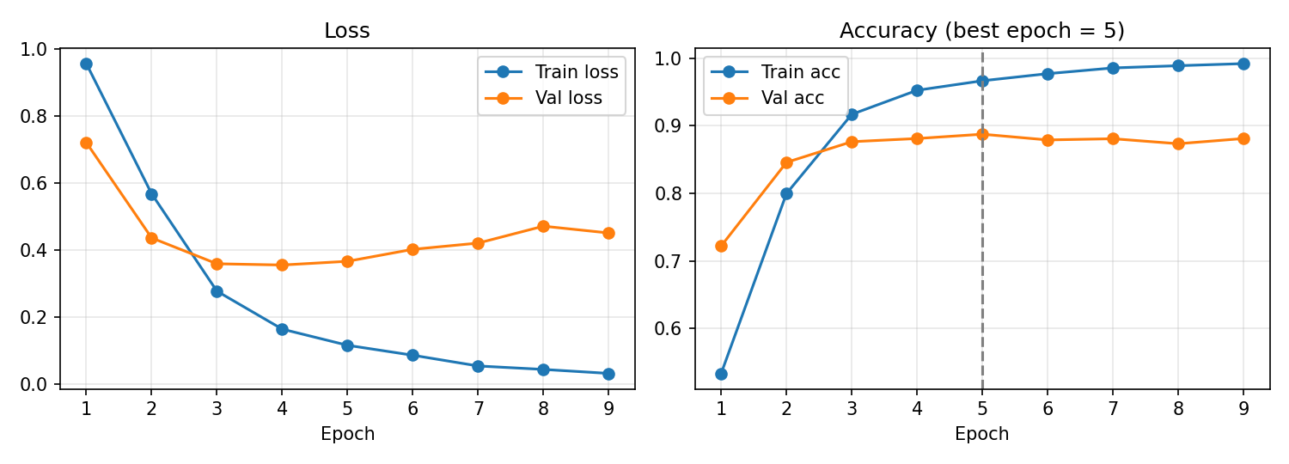
Figure 1. Model 3 training and validation curves (values transcribed from the notebook training log).

Model 4: Frozen GloVe-Twitter-50 + cosine decay
Pre-trained 50-d vectors (gensim “glove-twitter-50”) were loaded into a frozen embedding matrix; words missing from GloVe were initialised from N(0, 0.6). Note that GloVe is not literally Word2Vec, although the notebook labels it as such. The notebook’s narrative reports 61.79% accuracy, lower than Model 3, but the training cell has no saved output, so this figure and its per-class F1 values cannot be verified. A plausible reason for underperformance is that a frozen 50-d embedding has far less capacity than the 128-d trainable one, and the tweets’ domain-specific vocabulary (e.g. “thesocialdilemma”) is poorly covered.

8. Results

8.1 Model comparison
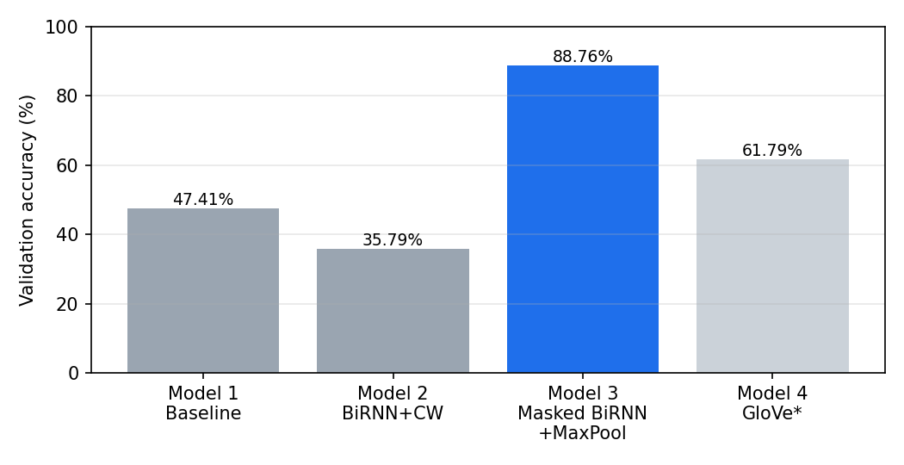
Figure 2. Validation accuracy by model. *Model 4 value taken from notebook narrative; not backed by saved output.
Model | Accuracy | F1 Negative | F1 Neutral | F1 Positive
1. Baseline | 47.41% | 0.00 | 0.00 | 0.64
2. BiRNN + CW | 35.79% | 0.10 | 0.52 | 0.00
3. Masked BiRNN + pool | 88.76% | 0.77 | 0.91 | 0.91
4. GloVe (unverified) | 61.79%* | 0.36* | 0.70* | 0.66*

8.2 Final model: classification report (validation, n = 3,400)
Class | Precision | Recall | F1-score | Support
Negative | 0.80 | 0.74 | 0.77 | 603
Neutral | 0.90 | 0.93 | 0.91 | 1,185
Positive | 0.91 | 0.91 | 0.91 | 1,612
Accuracy |  |  | 0.89 | 3,400
Macro average | 0.87 | 0.86 | 0.87 | 3,400
Weighted average | 0.89 | 0.89 | 0.89 | 3,400

8.3 Interpretation
- Neutral and Positive classes are handled well (F1 ≈ 0.91).
- Negative is the weakest class (recall 0.74): roughly one in four negative tweets is missed. It is also the minority class, and the weighting compensates but does not eliminate the gap. A confusion matrix is plotted in the notebook; the underlying counts were not printed, so the specific confusion pairs are not reported here.
- There is a train/validation gap (about 10 points at the end of training), so expected real-world accuracy should be quoted as roughly 88–89% for similar data, not higher.

9. Inference and Deliverables
Test inference uses the Model 3 weights restored by early stopping. Predictions on the 3,068 unlabeled tweets were mapped back to class names and written to a CSV in Google Drive.
Predicted class | Count | Share of test set
Positive | 1,483 | 48.3%
Neutral | 1,067 | 34.8%
Negative | 518 | 16.9%
The predicted distribution closely mirrors the training distribution (47.4 / 34.9 / 17.7), a useful sanity check that the model is not collapsing and that the test set is similar to training.
- Output file: /content/drive/MyDrive/RNN/test_predictions.csv (test_df with an added Predicted_Sentiment column).
- Not saved: the trained model weights and fitted tokenizer are not serialised in the notebook, so the model cannot be reused for new data without retraining.

10. Documentation Discrepancies Found in the Notebook
While reconciling narrative cells against executed outputs, the following inconsistencies were identified. This report follows the executed outputs.
Item | Narrative cells say | Executed output shows | Action
Final accuracy | 89.15% | 88.76% | Correct narrative
F1 Negative | 80.07% | 77.24% | Correct narrative
F1 Neutral | 90.84% | 91.17% | Correct narrative
F1 Positive | 91.23% | 91.11% | Correct narrative
Model 4 results | 61.79% / F1 36, 70, 66 | No output saved | Re-run and save
Model 2 F1 values | 10%, 52%, 0% | 0.10, 0.52, 0.00 (matches) | None
“Word2Vec” | Pre-trained Word2Vec | GloVe-Twitter-50 | Rename
Model 1 padding | Pre-padding described as global | Models 1–2 used post-padding, len 100 | Clarify
Additional code observations: the tokenizer and padding are defined twice with different settings (len 40 early, then len 100, then len 40 again), and the first-defined arrays (X_pad, X_train_p) are unused by any model. The Executive Summary also states “balanced F1-scores”; Negative F1 (0.77) trails the others by about 14 points.

11. Limitations and Risks
- Label provenance: the origin of the Sentiment labels (human vs automated, e.g. lexicon-based) is not documented. If labels were automatically generated, the model may be learning that labelling rule rather than true sentiment.
- Single topic and time window: all tweets concern one documentary discussion (September 2020); generalisation to other domains is untested.
- Single validation split: results come from one 80/20 split and one seed; no cross-validation or confidence intervals. Epoch selection on the same validation set used for reporting makes 88.76% mildly optimistic.
- Overfitting: large trainable embedding table, 99% train accuracy vs 88% validation.
- Pre-cleaned text: the clean_text column already has punctuation, emoji and apostrophes removed (“isn t”, “don t”), so negations are split into fragments and sarcasm/emoji signals are lost.
- Architecture ceiling: the vanilla-RNN constraint caps long-range dependency modelling; tweets are short, which is why the approach works here.
- No held-out labelled test set: the test file has no labels, so true generalisation accuracy is unmeasured.

12. Recommendations and Next Steps
- Save the trained model (model.save) and the fitted tokenizer so inference can be reused and deployed.
- Re-run and persist Model 4 outputs; try a trainable GloVe embedding (trainable=True) or a 100/200-d vector set, which is still within the SimpleRNN constraint.
- Improve Negative recall: tune class weights, try threshold adjustment on the softmax outputs, and review mislabelled negatives from the confusion matrix.
- Use stratified k-fold cross-validation and multiple seeds; report mean and spread rather than one number.
- Add regularisation to reduce overfitting (embedding dropout, L2, smaller embedding dimension).
- Preserve negation tokens and emoji in preprocessing; compare against the current pre-cleaned text.
- Document label provenance and, if possible, validate on a small manually labelled sample.
- Consolidate the notebook: remove duplicate preprocessing cells and fix the narrative figures listed in Section 10.

13. Environment and Reproducibility
Item | Detail
Platform | Google Colab, Python 3.13 runtime, Google Drive mounted at /content/drive
Libraries | TensorFlow / Keras, scikit-learn, pandas, NumPy, matplotlib, seaborn, gensim
Data location | /content/drive/MyDrive/RNN/ (tweets_train.csv, tweets_test.csv)
Seeds | train_test_split random_state=42; no global TensorFlow/NumPy seed set, so exact metrics may vary by a few points per run (the GloVe OOV initialisation also uses unseeded NumPy randomness)
Run order | Execute cells top to bottom; Models 3 and 4 depend on variables from the tokenisation cells
Known warnings | input_length deprecated (harmless); GlobalMaxPooling1D drops the mask (expected, since pooling follows the RNN)

Appendix A. End-to-End Flow
1. Mount Google Drive
2. Load train (17,000) and test (3,068) CSVs
3. Clean text (lowercase, strip URLs and @handles, normalise whitespace)
4. Encode labels (0 / 1 / 2)
5. Stratified 80/20 split (13,600 / 3,400)
6. Tokenise (vocab 20,000) and pre-pad to length 40
7. Compute balanced class weights
8. Train Models 1 → 4 and compare on validation
9. Select Model 3 (88.76%); report per-class metrics and confusion matrix
10. Predict on test set and save test_predictions.csv

