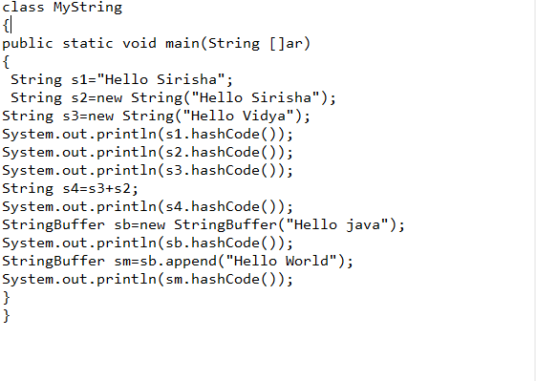

Polymorphism:One name many forms

Dynamic polymorphism or method overriding

Static polymorphism or method over loading