Factorial=5!=5x4x3x2x1=120

Step 1:input:number (int )

Step 2: output: number (int)

Step 3:apply multiply

Step 4:iteration process:while loop or for loop

Step 5:condition:number should reach upto 1🡺while(number >=1)

Step 6:n\*(n-1): number\* (number-1) till condition gets satisfied

Step 7: output return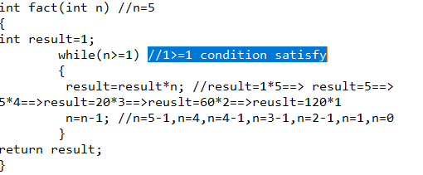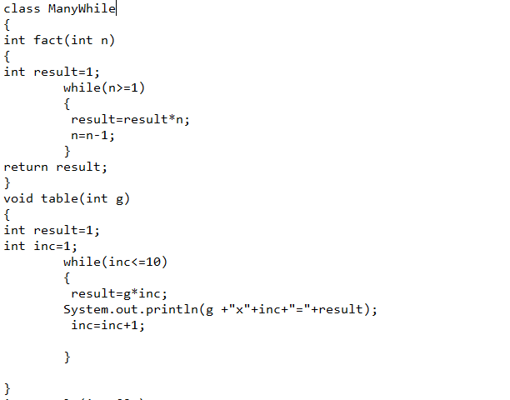

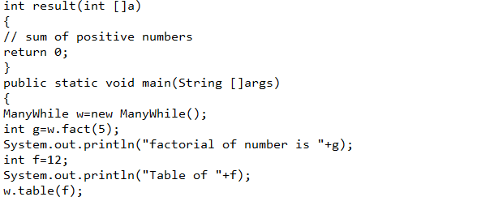

Break and continue statements:

Break: