Composition: two dependent objects compose releasing a new object

Ex:car🡪 engine 🡺 to run the car we need engine and also to make engine useful we need the car

Class A{}

Class b{}

Class C{

A a=new A();

He can use all A & B class attributes and methods

B b=new B();

}

It is called as has a relationship

**Inheitance:** It is called as is a relationship . child class extends the contents of parent class and also we add new functionalities in the child class which is not going to affect the parent class.

**Subclass completely knows the information about super class but super class does not have any info about the sub class**

Class A

{}

Class B extends A

Types of inheritance: simple inheritance parent class 🡪 child class

Multi inheritacen:A🡺 B🡺C🡺D

Hirerchial inheritance: **A**

G

F

E

D

C

B

**Multiple inheritance:**

C

B

A

In java multiple inheritance is not supported as it arises diamond problem

A

C

B

D

{}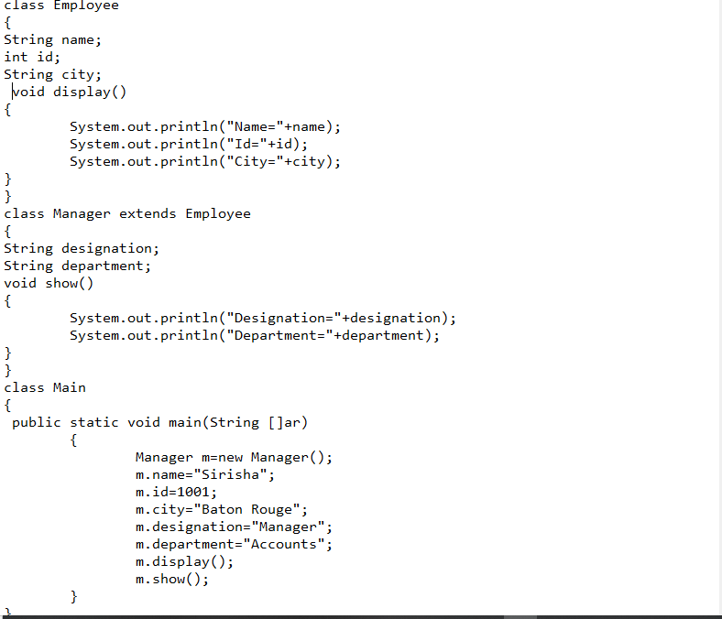

Inheritance:

Employee class

Name,City,Id

Engineer class

Name,city,id

Designation,department,timins

Sales Executive class

Name,city,id

Designation,department

Cashier class

Name,city,id

Desgination,department

Manager class

Name,city,Id

Designation,department