Packages: folders in java

Defualt package is available

Package statement shud be first stamt

Frst scenario

One packahe🡪 two different files

MAIN

Main()

Pack1

Func1

Lord

Abc

Main()

PeeCee

Gun()

god

Lord

Scenario1 : One package two files no public

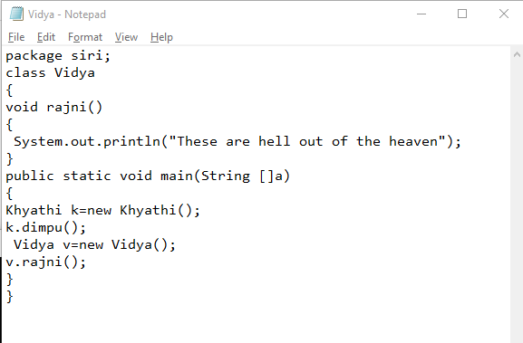

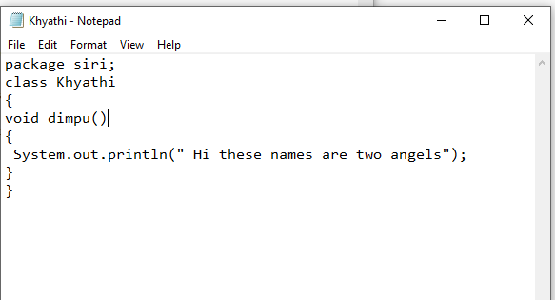

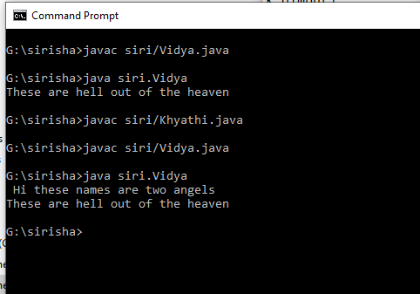

Scenario2: two different packages two different classes use of public :

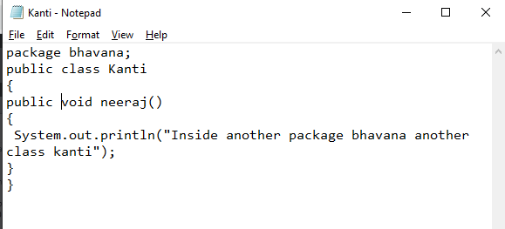

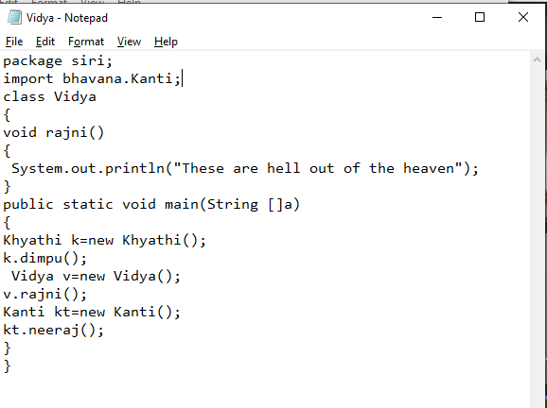

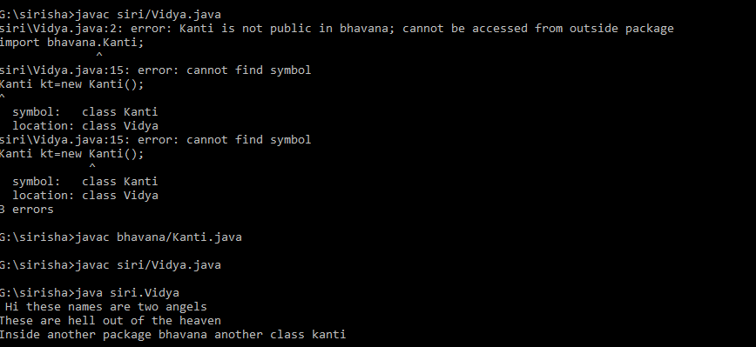

Import statement: import one package details into another package

Specific class : import god.PeeCee

One package all classes: import god.\*;