Local variable: If we are declaring variables inside a function

Local variable has to be initialized inside the function

Local variable cannot be accessed outside the function

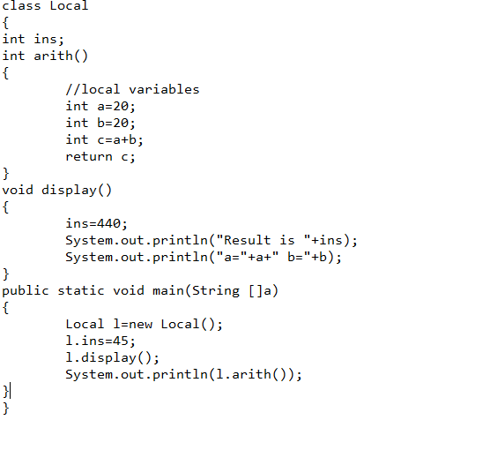

Parameters are local vairables they were declared inside the function’s parenthesis. The reason here is to give security and mobility

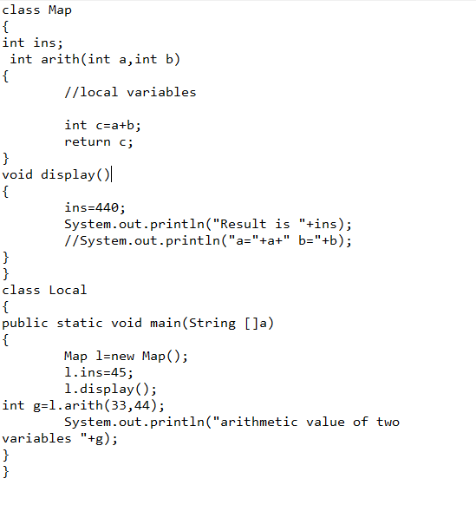

Static variable: in java static is a modifier ,

