Navigating the AI Research Tool Landscape: A Critical Reflection
Introduction
In today's rapidly evolving AI landscape, selecting the right research tool can significantly impact research efficiency and quality. This reflection explores my experience comparing various AI research tools and offers insights into their strengths, limitations, and optimal use cases.
Tool Comparison Challenges
Comparing AI research tools with extensive outputs presented several challenges. Each tool demonstrated unique approaches to handling research queries, structuring responses, and managing follow-up questions. The volume of sources reviewed varied dramatically across platforms:
- Grok DeepSearch processed over 100 sources in under a minute
- Gemini 1.5 Flash took approximately 7 minutes but offered research plan customization
To systematically evaluate these tools, I developed a comparison framework focusing on five key factors:
- Speed: How quickly results were generated
- Depth of Research: Number and quality of sources
- Structure of Output: Organization and clarity of responses
- Follow-Up Handling: Ability to revisit research or adapt prior findings
- Contextual Understanding: Capacity to engage meaningfully and refine questions
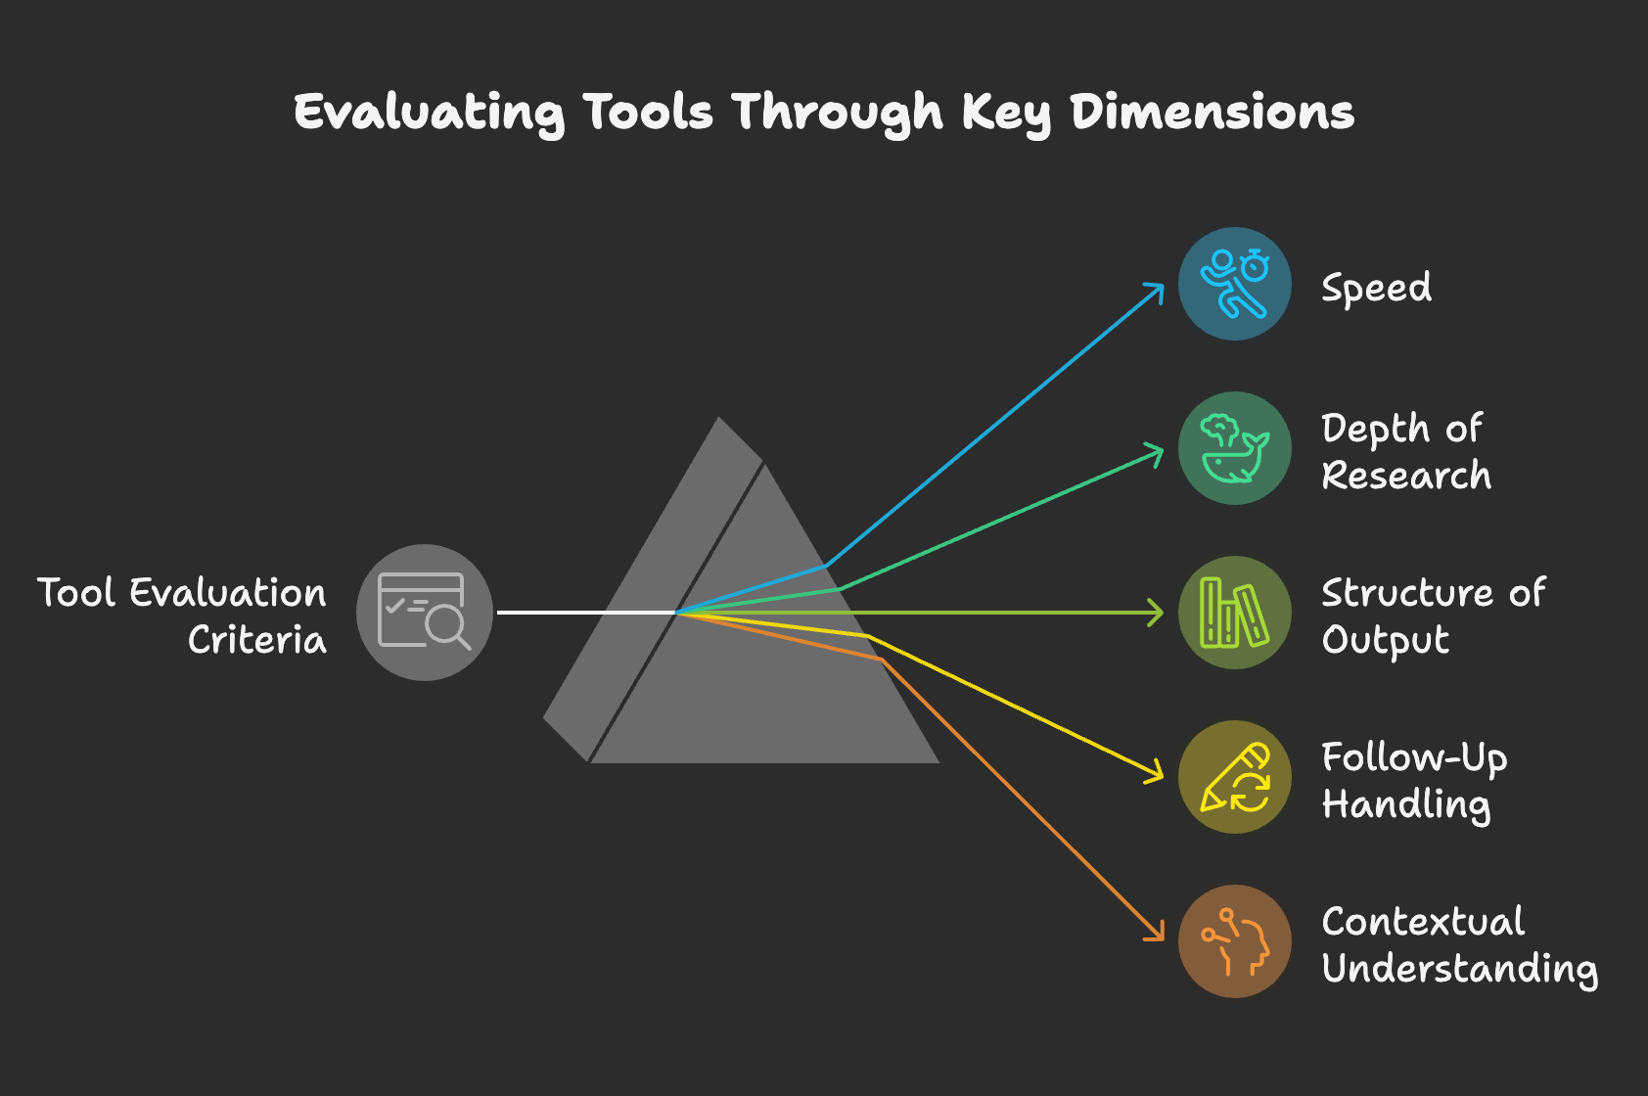
Source Accuracy and Trust
The reliability of sources cited by each system varied based on their retrieval and synthesis mechanisms:
- Perplexity Pro efficiently compiled structured summaries with citations but occasionally included non-peer-reviewed sources
- Grok DeepSearch retrieved numerous sources but lacked detailed reasoning or source validation
- Gemini 1.5 Flash enabled structured research planning but didn't conduct follow-up queries beyond its initial plan
- ChatGPT Deep Research offered contextual insights but didn't repeat research for follow-ups, making responses more conversational than data-driven
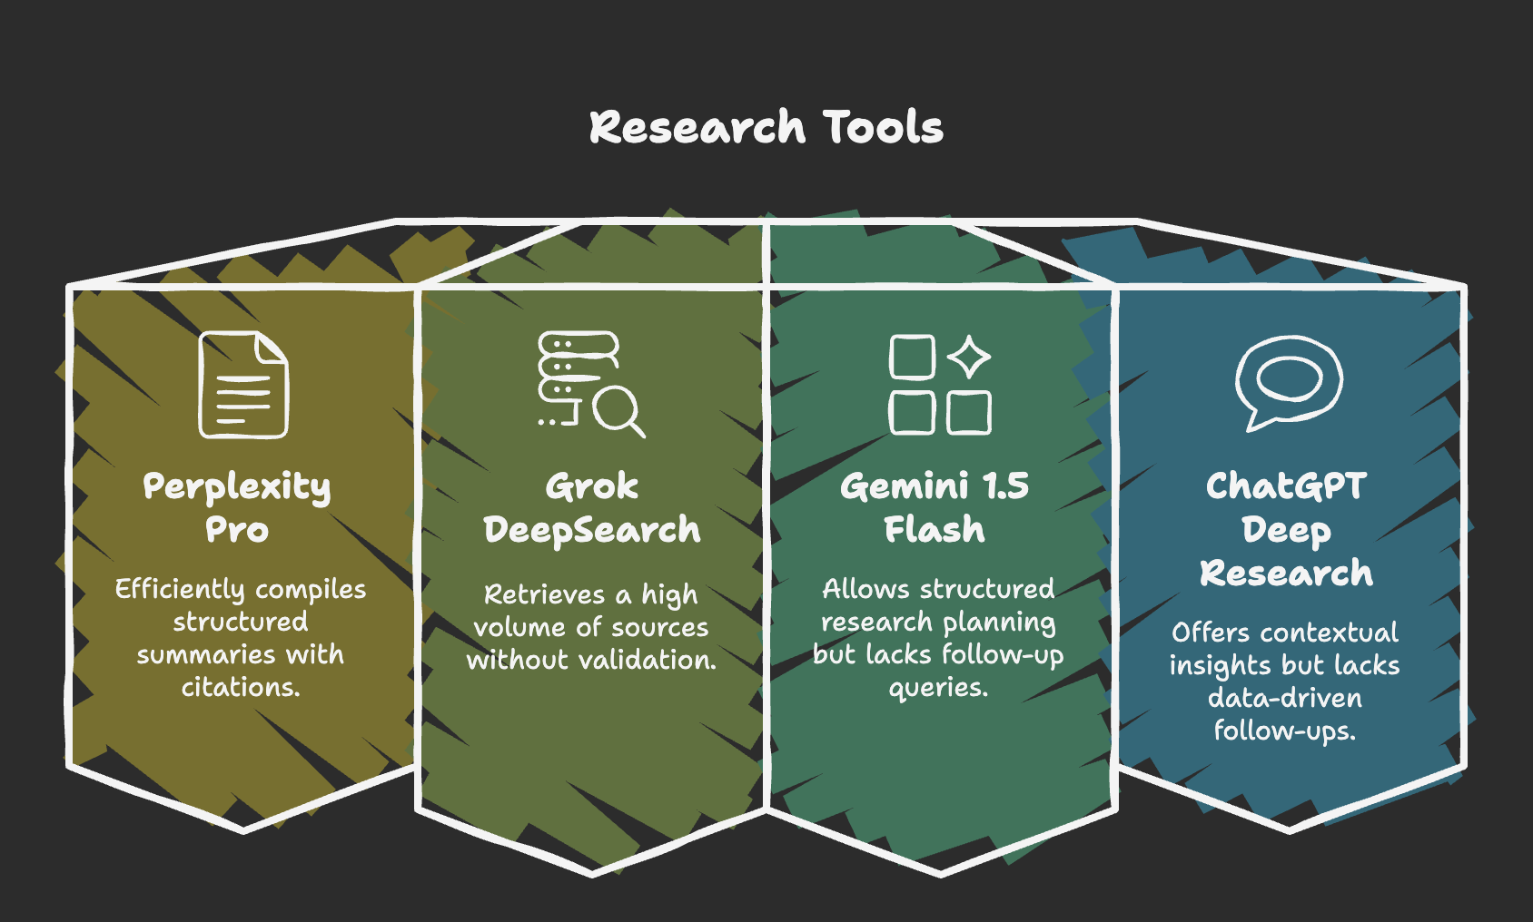
I found that verifying AI-generated research requires cross-referencing outputs with established academic databases such as Google Scholar, Semantic Scholar, and policy documents. Even if an AI tool achieves 90% accuracy, critical assessment remains essential before relying on it for academic or policy decisions.
Tool Literacy Development
This comparative analysis enhanced my ability to evaluate emerging AI research tools by identifying key distinctions in:
- Research Structure: Gemini 1.5 Flash and Perplexity Pro generate research plans, while Grok DeepSearch and ChatGPT Deep Research take more direct approaches
- Follow-up Query Handling: ChatGPT Deep Research adapts responses based on previous context, whereas Perplexity Pro and Grok DeepSearch conduct fresh research for each follow-up
- User Experience: Tools with interactive research planning (like Gemini 1.5 Flash) offer better control but require more time
This experience has prepared me for evaluating future iterations of deep research tools and agentic AI systems that may integrate autonomous research planning, multi-model synthesis, and adaptive learning frameworks.
Practical Applications
Each AI research tool demonstrated different strengths for specific use cases:
- Grok DeepSearch: Ideal for quick scans, prioritizing speed over depth
- Perplexity Pro: Offers balanced structuring but may lack transparency in full-source disclosure
- Gemini 1.5 Flash: Ensures methodical research but is slower and doesn't revisit queries after execution
- ChatGPT Deep Research: Excels in discourse and contextual refinement but may lack real-time source validation
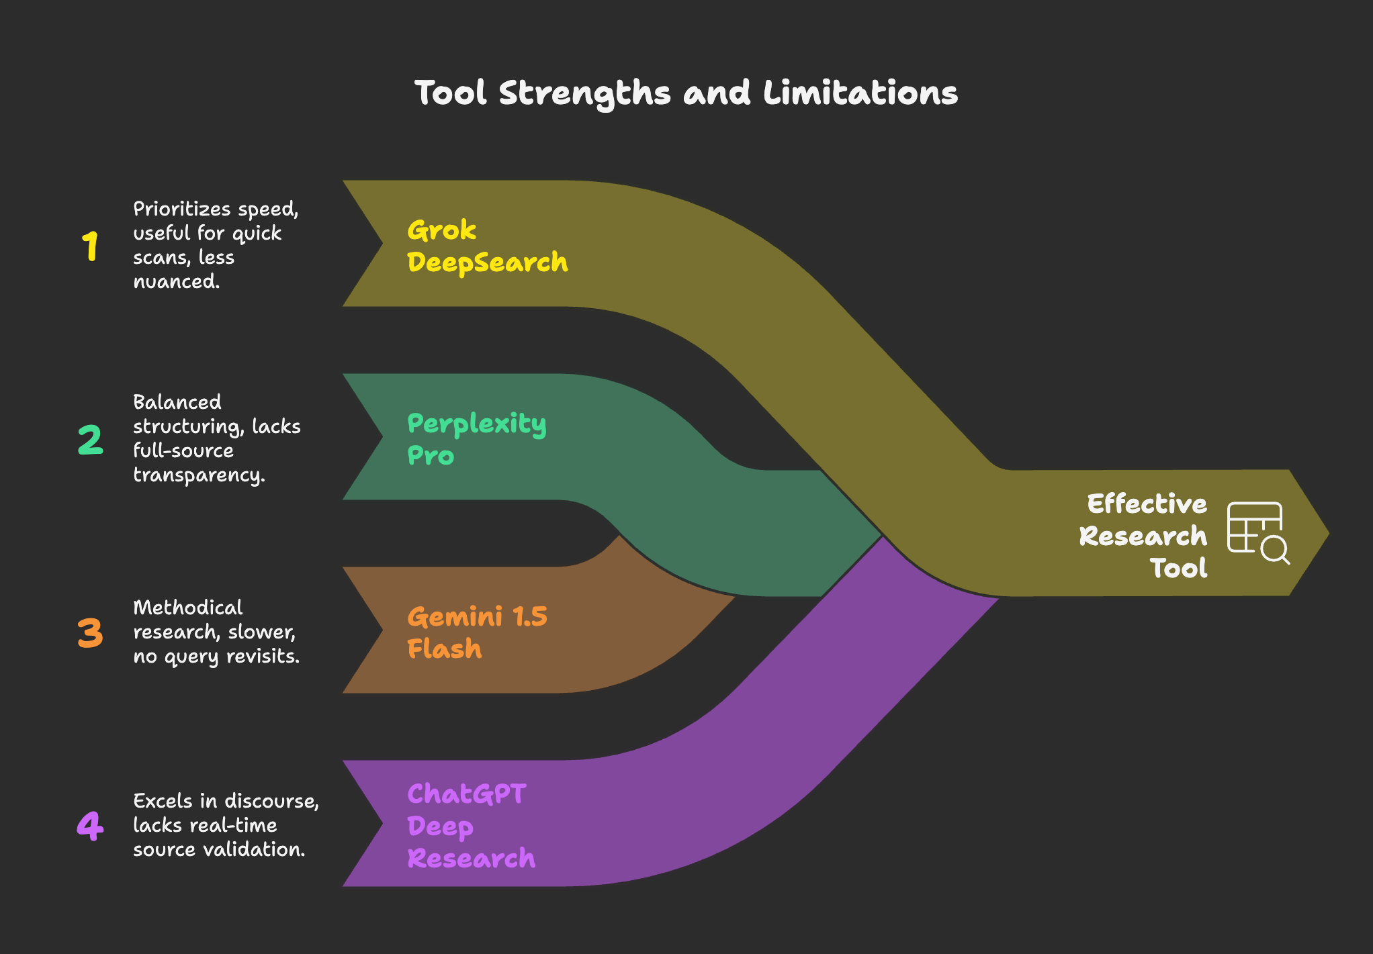

Selecting the Right AI Research Tool: A Decision Framework
The flowchart above illustrates a decision framework I developed for selecting the most appropriate AI research tool based on specific research priorities:
- If speed is your top priority: Choose Grok DeepSearch for rapid results
- If you need structured, cited research quickly: Perplexity Pro offers the best balance
- If you want to refine your research plan: Gemini 1.5 Flash provides interactive planning
- If contextual understanding and adaptation are crucial: ChatGPT Deep Research excels in this area
LLM Selection Guide
When selecting a Large Language Model for research purposes, consider the following framework:

LLM Recommendations by Research Need
- Academic research requiring citations
→ Recommended LLM: GPT-4 with Retrieval
→ Strength: Strong citation capabilities
- Quick exploratory research
→ Recommended LLM: Claude 3 Opus
→ Strength: Balanced speed and depth
- Complex, multi-step reasoning
→ Recommended LLM: Gemini 1.5 Pro
→ Strength: Structured thinking process
- Domain-specific research
→ Recommended LLM: Specialized vertical LLMs
→ Strength: Fine-tuned for specific fields
- Multilingual research
→ Recommended LLM: GPT-4 or Gemini 1.5
→ Strength: Superior multilingual capabilities
The selection should be guided by:
- Research complexity: More complex topics benefit from more capable models
- Time constraints: Consider the tradeoff between speed and thoroughness
- Citation requirements: Some models provide more reliable source attribution
- Integration needs: Consider API availability and ecosystem compatibility
- Cost considerations: More powerful models typically incur higher usage costs.
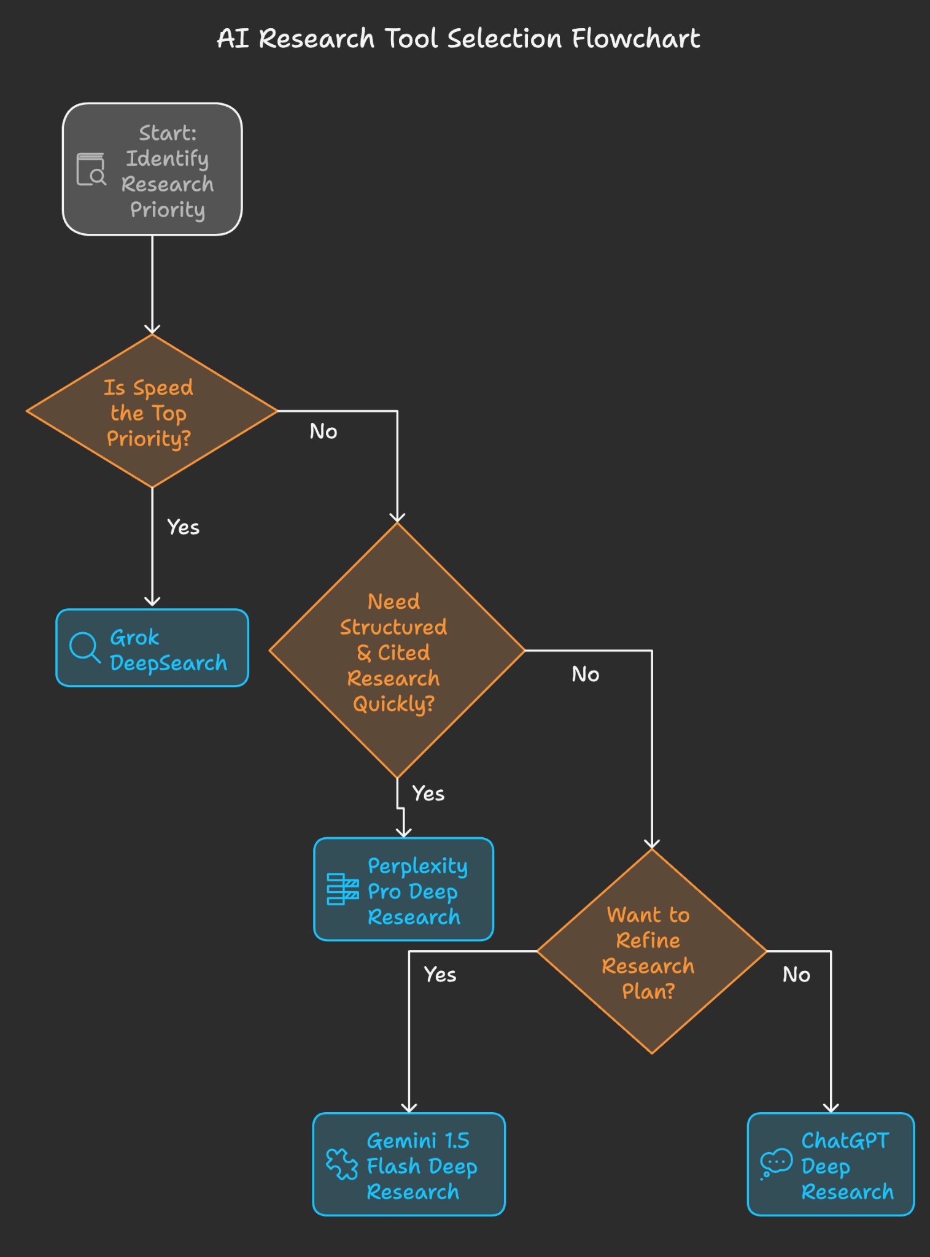
Sustainable Development Goals Applications
These AI research tools can enhance SDG initiatives by:
- Expediting policy research across diverse global contexts
- Synthesizing global best practices for implementation
- Ensuring equitable knowledge dissemination to underrepresented regions
However, ethical considerations such as bias mitigation, source transparency, and responsible AI use must guide their implementation in academic and professional research.
Conclusion
My comparison of AI research tools highlighted their unique strengths and limitations. While Grok DeepSearch provided rapid but less nuanced insights, Perplexity Pro offered structured yet sometimes opaque research. Gemini 1.5 Flash allowed controlled, structured research but lacked adaptability, whereas ChatGPT Deep Research excelled in contextual refinement.
Based on my experience, ChatGPT Deep Research provided the most engaging and adaptive user experience, making it my preferred tool for deep research requiring contextual understanding. However, the optimal tool varies based on specific research needs—whether speed, depth, structure, or contextual understanding is the priority.
This analysis reinforces the importance of:
- Critical engagement with AI-generated research
- Cross-referencing findings with established sources
- Selecting tools based on specific research priorities
- Understanding the limitations of each platform
As these tools continue to evolve, developing a systematic approach to evaluating their capabilities will become increasingly important for researchers seeking to leverage AI in their work.

