My Journey Creating a Personal Webpage with AI Tools
When I embarked on creating my personal webpage, I decided to leverage AI tools to streamline the process. This approach not only saved time but also provided insights into how modern web development can be enhanced through artificial intelligence.
AI Tools in My Arsenal
I primarily used two AI assistants for this project:
- Claude: I used Claude to generate my initial webpage template. Having a solid foundation to build upon made the entire process much more manageable, especially since I didn't have to start from scratch.
- ChatGPT: I turned to ChatGPT for specific error solving. Since I was already familiar with how to prompt ChatGPT effectively based on previous interactions, I found it particularly helpful for troubleshooting issues that arose during development.
What Worked Well
Getting an initial template from Claude was incredibly helpful and saved me significant time. However, I found that I needed to take more control when it came to the visual aspects of the site. Neither Claude nor ChatGPT provided color schemes that matched my vision, so I had to specify exactly what I wanted.
I also needed to be very precise about the types of transitions I wanted and provide specific code snippets for the AI to modify. This collaborative approach—where I directed the AI rather than letting it make all decisions—resulted in a more personalized final product.
Key Success Factors
The AI tools excelled in several critical areas:
- Rapid Debugging: AI quickly identified and fixed errors, like precisely adjusting CSS media queries when my navigation menu displayed incorrectly on mobile devices.
- Accelerated Development: Development time shrank from days to hours, enabling multiple design iterations until I found the perfect solution.
- Code Optimization: The AI tools recommended efficiency improvements I might have missed, such as CSS variables for consistent colors and better HTML structure for accessibility.
- Learning Opportunity: Working with AI expanded my web development knowledge, introducing me to modern CSS techniques and responsive design practices.
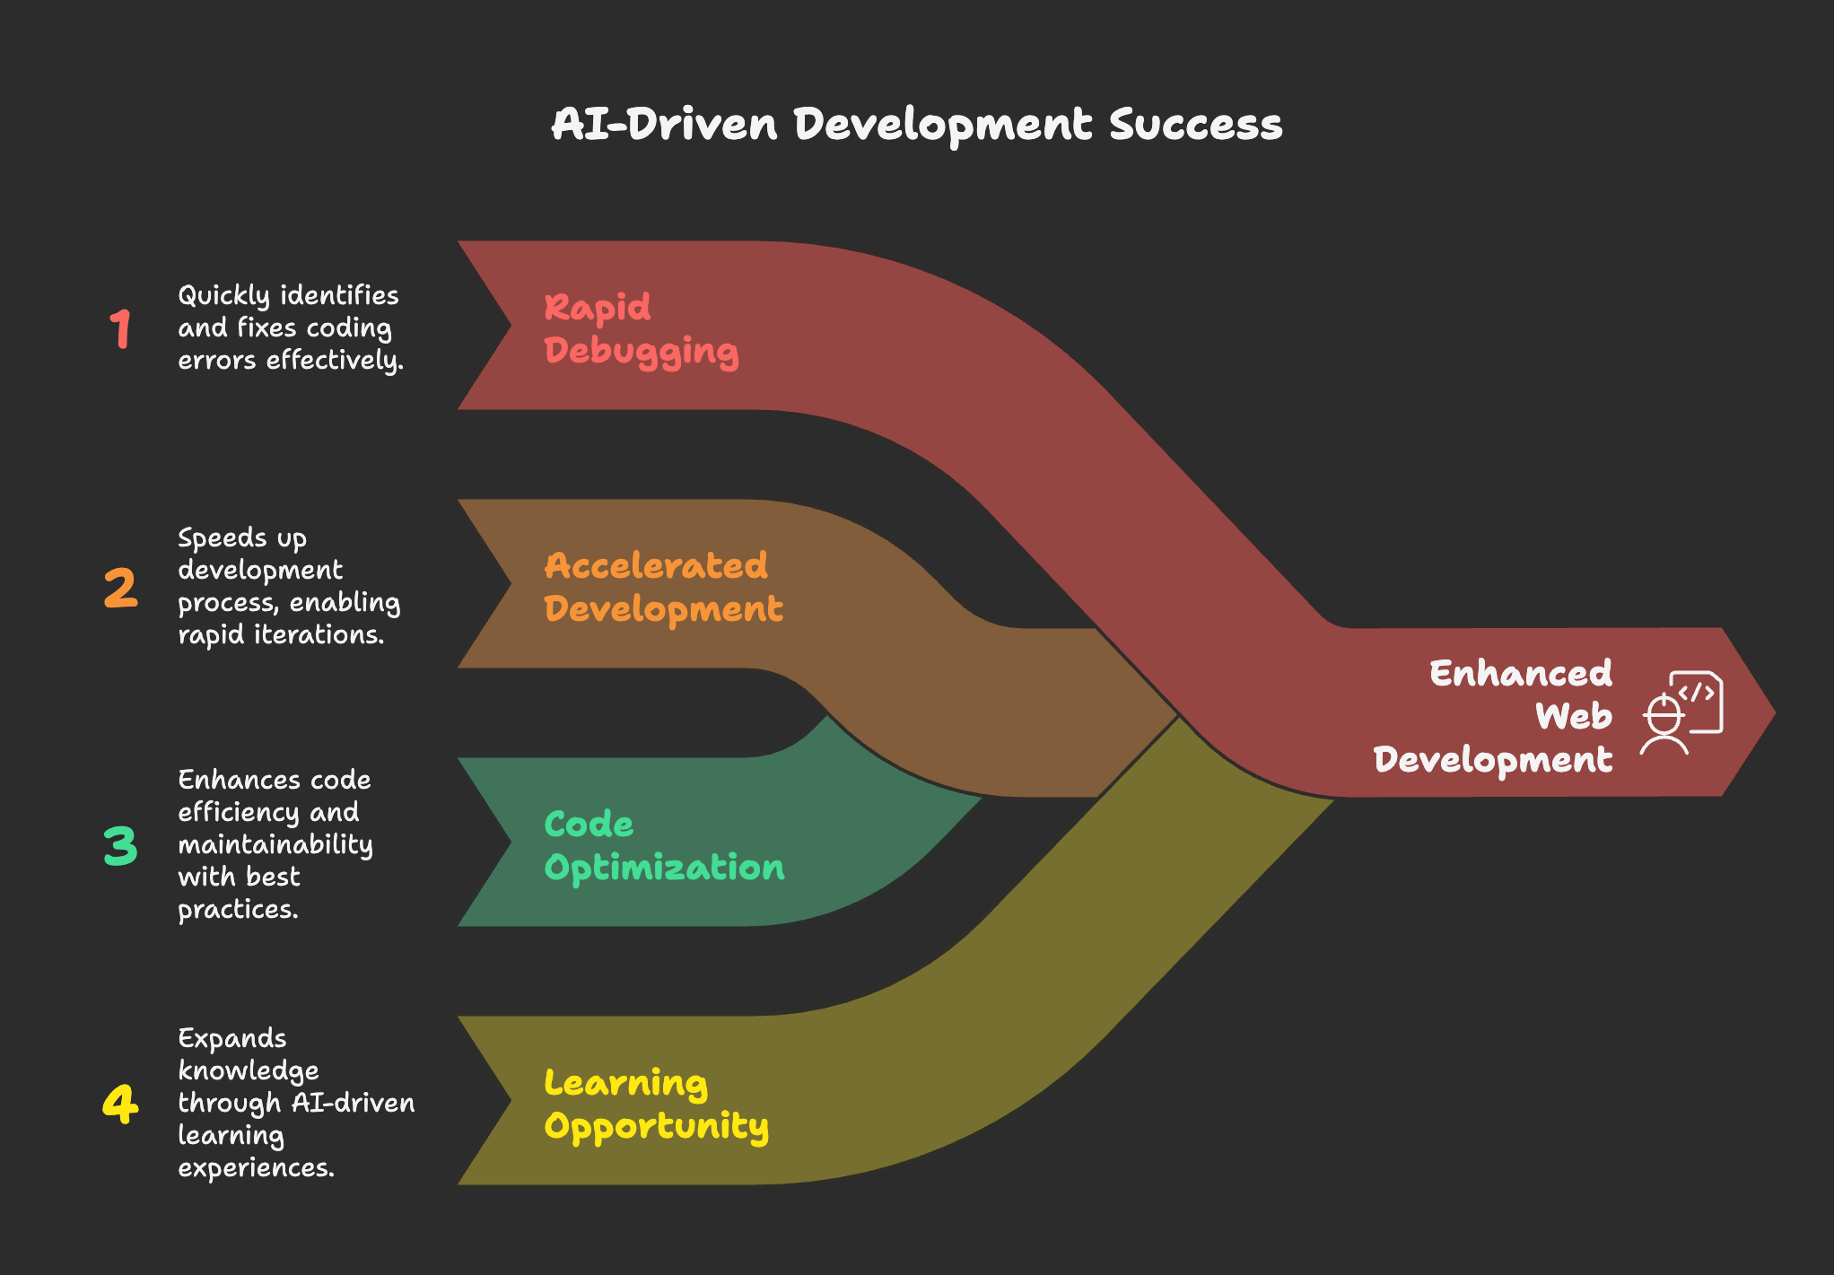
Challenges and Solutions
The main challenge I encountered was context management. When continuously prompting on the same page, the AI would sometimes forget previous code and replace it with new suggestions, creating more issues than it solved.
Solution: I learned to be extremely specific about which code snippets needed changes. Rather than asking for general improvements, I would identify the exact section that needed modification and request targeted changes. This approach was much more efficient.
Hands-on vs. App Creators
As a software engineer, I prefer using AI assistants like Claude or ChatGPT alongside development environments like Replit. This combination offers a side-by-side view that makes the development process more transparent and controllable.
That said, while I appreciate the assistance AI provides with helping and debugging, I still prefer to handle certain aspects myself. My background in software engineering gives me the confidence to know where and what to change to achieve my desired results.
Advice for Aspiring Web Page Creators
If you're looking to build your personal webpage, I have a few recommendations:
- Use Vercel with templates: Start with templates instead of building from scratch. Vercel offers seamless deployment and excellent template options for personal sites.
- Leverage AI for initial builds: Have AI create your webpage structure to save time. Be specific about layout, colors, and functionality needs.
- Focus on simple modifications: Use AI for basic HTML/CSS changes and track updates with a JSON file for easier site management.
- Know complexity limits: For simple personal pages, AI excels; complex sites still require UI development expertise.
- Iterate and refine: Use time saved by AI to improve your site through multiple versions.
- Learn from AI suggestions: Study AI-generated code to improve your development skills.
- Plan content first: Have a clear content strategy before coding for a more cohesive final product.
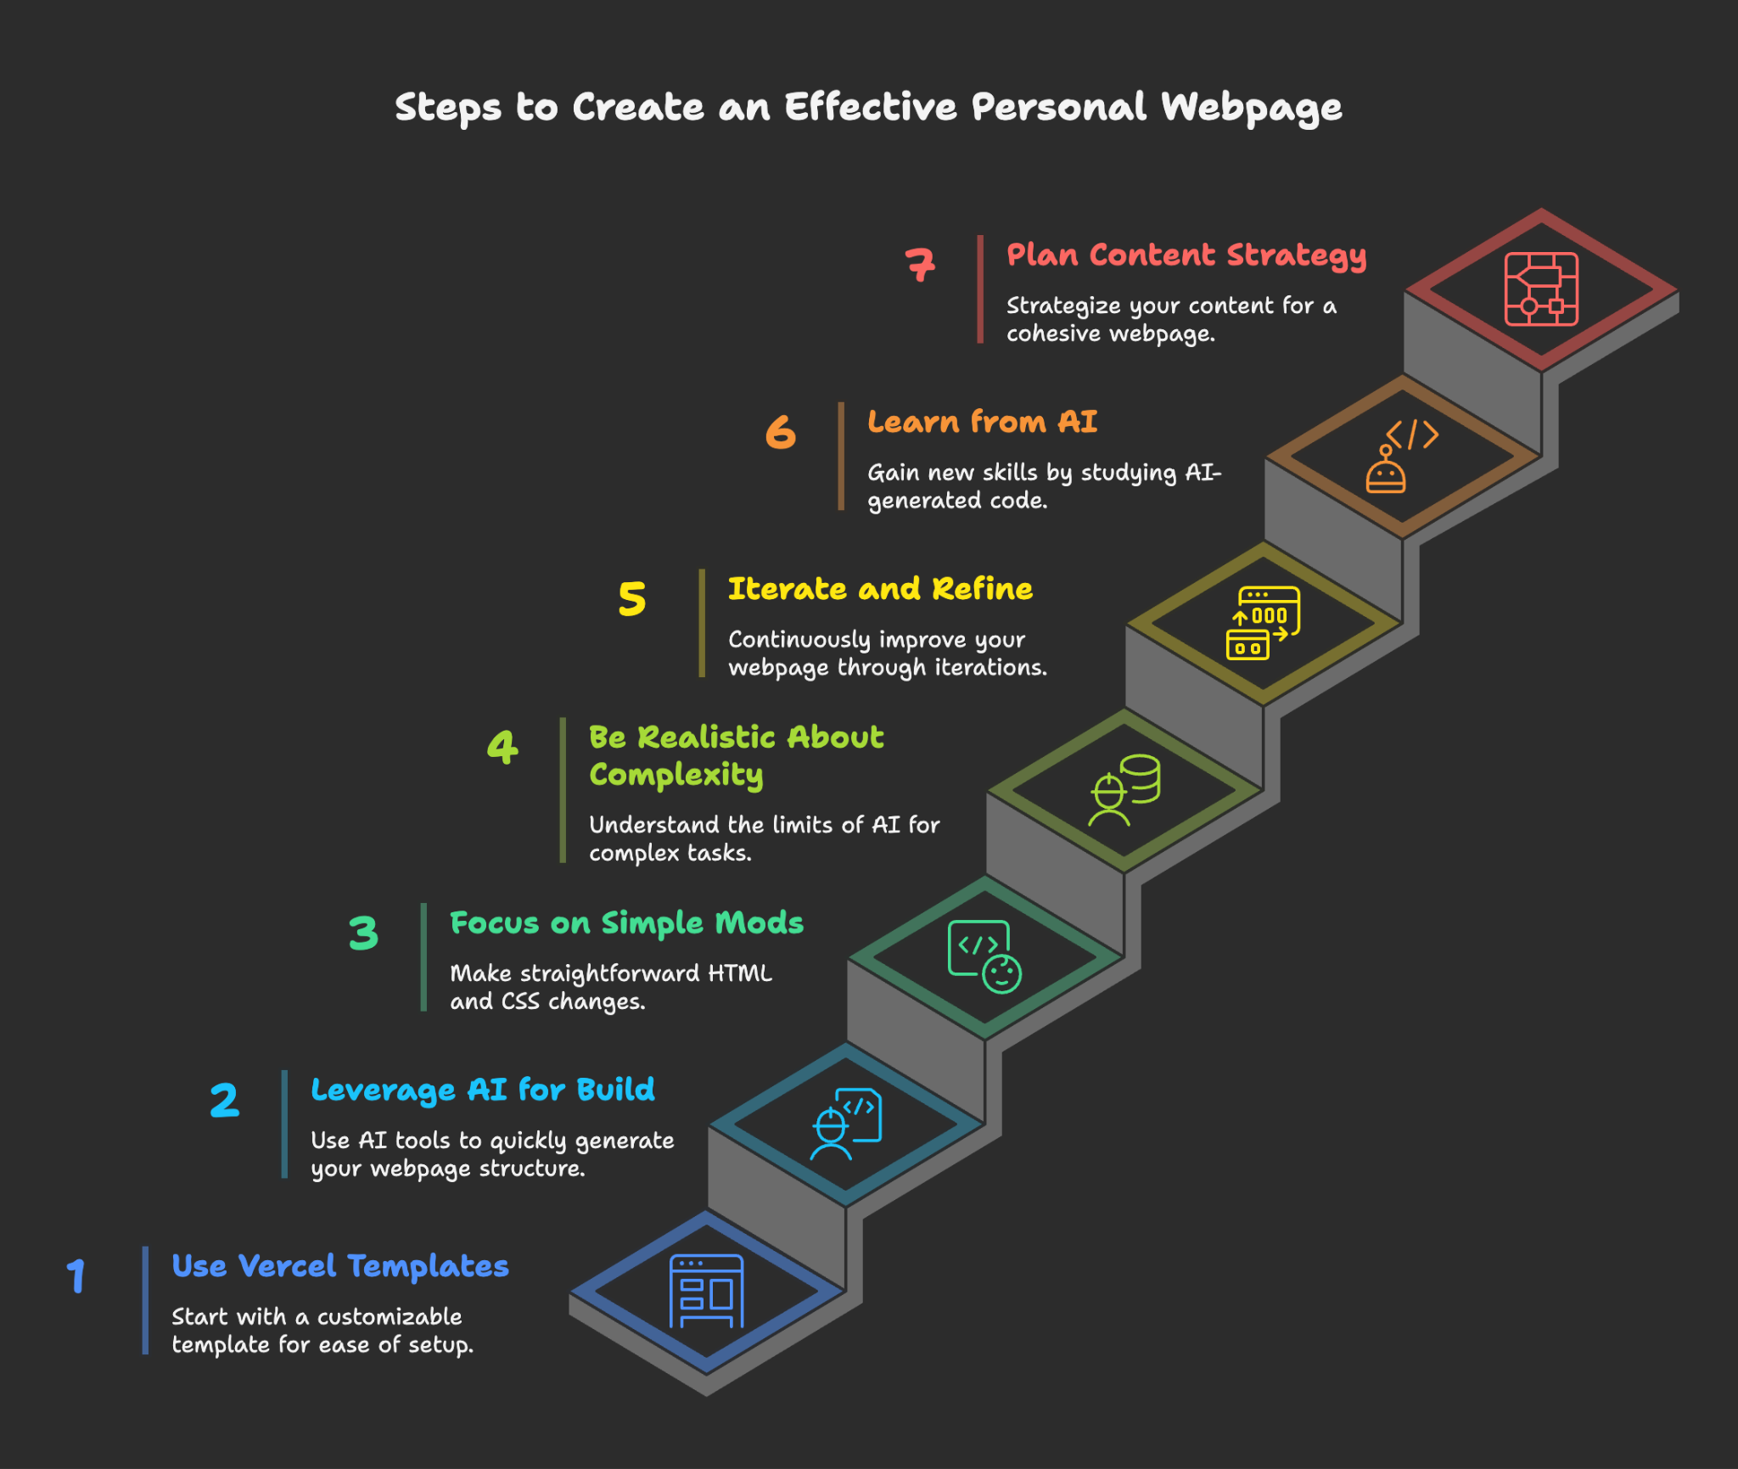
I'm amazed by how accessible webpage creation has become thanks to AI tools. For personal webpage creation, these tools can handle much of the heavy lifting, allowing you to focus on personalization and content. As someone who has experienced web development both with and without AI assistance, I can confidently say that these tools have transformed the landscape for the better.

