1. ***Find products with standard price less than $300***

**SQL Command:**

SELECT ProductDescription, ProductStandardPrice

FROM PRODUCT_T

WHERE ProductStandardPrice < 300 ;

**Oracle Apex Output Snapshot:**

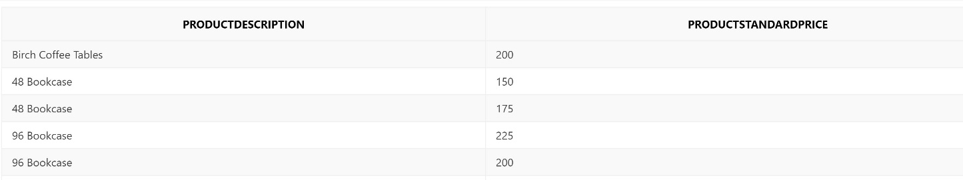

1. ***Usage of Alias***

**SQL Command:**

SELECT CUST.CUSTOMERNAME AS NAME, CUST.CUSTOMERADDRESS

FROM CUSTOMER_T CUST

WHERE CUSTOMERNAME = ‘Home Furnishings’;

**Oracle Apex Output Snapshot:**

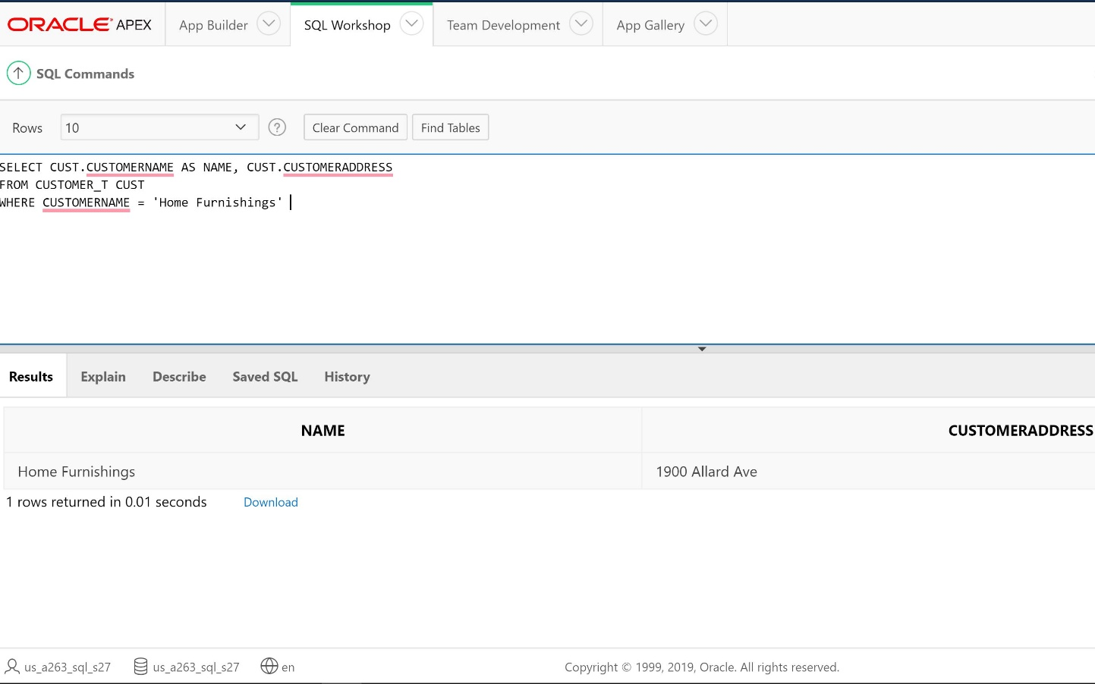

1. ***Usage of Aggregate functions COUNT (*) and AVG***

**SQL Command:**

SELECT COUNT(*) FROM PRODUCT_T

WHERE PRODUCTLINEID = 1;

**Oracle Apex Output Snapshot:**

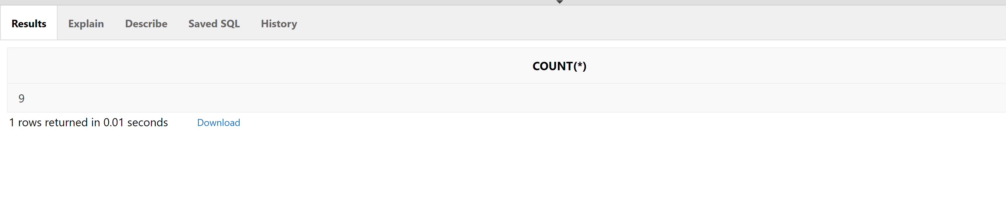

**SQL COMMAND:**

SELECT ROUND(AVG(MATERIALSTANDARDPRICE),2)

FROM RAWMATERIAL_T ***;***

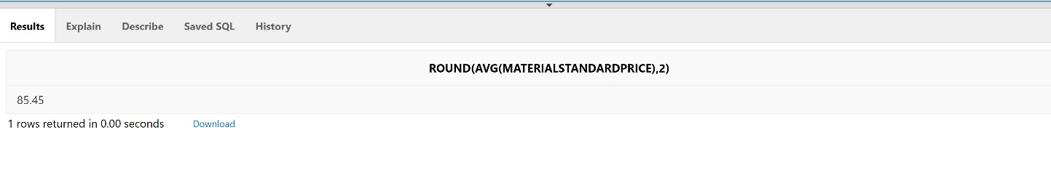

1. ***List the MaterialID, MaterialName, Material, MaterialStandardPrice, and Thickness for all raw materials made of cherry, pine, or walnut. Order the listing by Material, Standard Price, and Thickness.***

**SQL Command:**

SELECT MATERIALID, MATERIALNAME,MATERIAL, MATERIALSTANDARDPRICE, THICKNESS

FROM RAWMATERIAL_T

WHERE MATERIAL IN ('Cherry', 'Pine', 'Walnut')

ORDER BY MATERIAL, MATERIALSTANDARDPRICE, THICKNESS ;

**Oracle Apex Output Snapshot:**

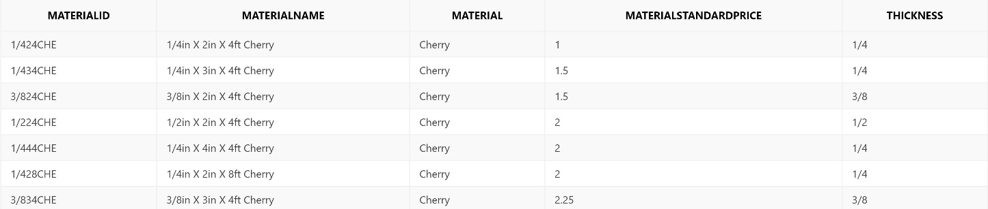

1. ***For each customer, list the CustomerID and total number of orders placed.***

**SQL Command:**

SELECT CUSTOMER_T.CUSTOMERID, COUNT(ORDER_T.ORDERID) AS TOTALORDERSPLACED

FROM CUSTOMER_T INNER JOIN ORDER_T ON

CUSTOMER_T.CUSTOMERID = ORDER_T.CUSTOMERID

GROUP BY CUSTOMER_T.CUSTOMERID ;

**Oracle Apex Output Snapshot:**

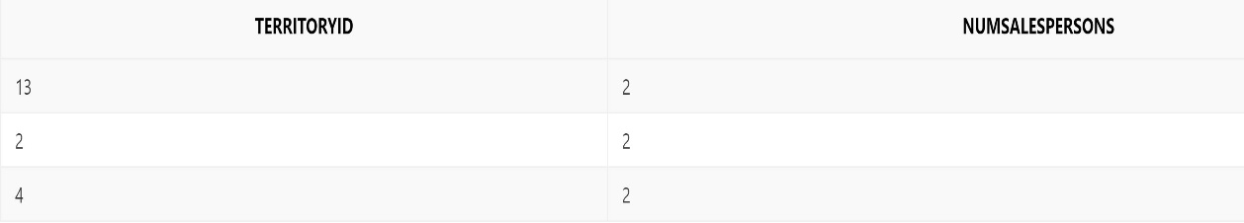

***6. Display the territory ID and the number of salespersons in the territory for all territories that have more than one salesperson. Label the number of salespersons NumSalesPersons.***

**SQL Command:**

SELECT TERRITORY_T.TERRITORYID, COUNT(SALESPERSON_T.SALESPERSONID) AS NumSalesPersons

FROM TERRITORY_T INNER JOIN SALESPERSON_T ON

TERRITORY_T.TERRITORYID = SALESPERSON_T.SALESTERRITORYID

GROUP BY TERRITORY_T.TERRITORYID

HAVING COUNT(SALESPERSON_T.SALESPERSONID)>1 ;

**Oracle Apex Output Snapshot:**

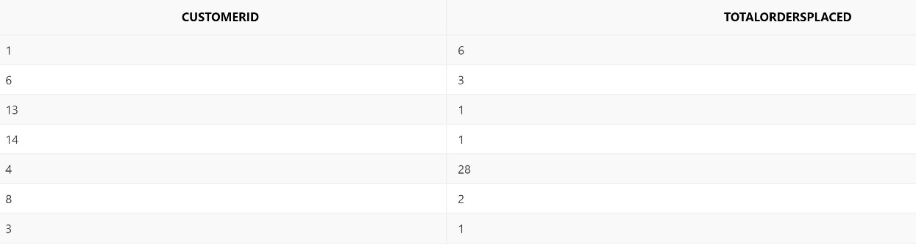

***7. Write an SQL query to display each item ordered for order number 1, its standard price, and the total price for each item ordered***

**SQL Command:**

SELECT ORDERLINE_T.ORDERID, PRODUCT_T.PRODUCTDESCRIPTION, PRODUCT_T.PRODUCTSTANDARDPRICE,(ORDERLINE_T.ORDEREDQUANTITY*PRODUCT_T.PRODUCTSTANDARDPRICE) AS TOTALPRICE

FROM ORDERLINE_T INNER JOIN PRODUCT_T ON

ORDERLINE_T.PRODUCTID = PRODUCT_T.PRODUCTID

WHERE ORDERLINE_T.ORDERID=1;

**Oracle Apex Output Snapshot:**

