Deepak Yadav
SE-IT
Batch D
2018140064

Dynamic Programming:-

1-Iron Man and Captain America start for a mission from Isengard to Middle-Earth. There are two different tracks from Isengard to Middle-Earth. Each track has N toll taxes where they have to pay and in between they can change track from any toll but for that they have to pay extra. By changing track from ith toll of first track one can reach (i+1)th toll of second track and vice versa. All you have to calculate is minimum cost required to reach from Isengard to Middle-Earth.

Input

The first line of input contains an integer T, the number of Test Cases.
The second line of input contains an integer N, denoting the number of tolls.
The third line of input contains N space separated integers, denoting the amount to pay at ith toll in first track.
The Fourth line of input contains N space separated integers, denoting the amount to pay at ith toll in second track.
The Next line of input contains N-1 space separated integers, denoting the amount to pay on changing track from ith toll of first track to (i+1)th toll in second track.
The Next line of input contains N-1 space separated integers, denoting the amount to pay on changing track from ith toll of second track to (i+1)th toll of first track.

Output

Output of each testcase will consist of a single integer denoting minimum cost required for bike trip from Leh to Ladakh.

Constraints

1 <= T <= 100
1 <= N <= 100000
1 <= Amount to pay at any point <= 100000

SAMPLE INPUT
2
2
15 6
5 21
1
7
3
7 2 5
5 2 4
7 6
2 2

SAMPLE OUTPUT
18
11

Explanation

Sample case 1 :- path of minimum cost will be 1st toll of second track --> 2nd toll of first track.total amount = 5 + 7 + 6 = 18. Here 7 is extra amount to pay on changing track from 1st toll of second track to 2nd toll of first track.

Code-

#include <stdio.h>
#include <stdlib.h>

int main(int argc, char const *argv[])
{
int test_case;
printf("Enter the number of test cases..: ");
scanf("%d", &test_case);
while(test_case-- > 0) {
int N;
printf("Enter the number of toll booths in the way..: ");
scanf("%d", &N);
int* A = (int*) malloc(N * sizeof(int));
int* B = (int*) malloc(N * sizeof(int));
int* Atrav = (int*) malloc((N-1) * sizeof(int));
int* Btrav = (int*) malloc((N-1) * sizeof(int));
printf("Enter the costs of toll in Iron Man's path..: \n");
for (int i = 0; i < N; i++) {
scanf("%d", (A+i));
}
printf("Enter the costs of toll in Captain America's path..: \n");
for (int i = 0; i < N; i++) {
scanf("%d", (B+i));
}
printf("Enter the costs of toll in Iron Man's path to change routes..: \n");
for (int i = 0; i < (N-1); i++) {
scanf("%d", (Atrav+i));
}
printf("Enter the costs of toll in Captain America's path to change routes..: \n");
for (int i = 0; i < (N-1); i++) {
scanf("%d", (Btrav+i));
}
int* Aroute = (int*) malloc(N * sizeof(int));
int* Broute = (int*) malloc(N * sizeof(int));
int* line1 = (int*) malloc((N-1) * sizeof(int));
int* line2 = (int*) malloc((N-1) * sizeof(int));
Aroute[0] = A[0];
Broute[0] = B[0];

for (int i = 1; i < N; i++) {
if(Aroute[i - 1] <= Broute[i - 1] + Btrav[i - 1]) {
Aroute[i] = Aroute[i - 1] + A[i];
line1[i - 1] = 1;
}
else {
Aroute[i] = Broute[i - 1] + Btrav[i - 1] + A[i];
line1[i - 1] = 2;
}

if(Broute[i - 1] <= Aroute[i - 1] + Atrav[i - 1]) {
Broute[i] = Broute[i - 1] + B[i];
line2[i - 1] = 2;
}
else {
Broute[i] = Aroute[i - 1] + Atrav[i - 1] + B[i];
line2[i - 1] = 1;
}
}
int finale, last;
if(Aroute[N - 1] > Broute[N - 1]) {
last = 2;
finale = Broute[N - 1];
}
else {
last = 1;
finale = Aroute[N - 1];
}
printf("The least toll incurral possible is..:- %d\n The path is..\n", finale);
printf("%d station -> %dth line\n",N, last);
for (int i = N-2; i >= 0; i--) {
if(last == 1) {
printf("%d station -> %dth line\n",i+1, line1[i]);
last = line1[i];
}
else {
printf("%d station -> %dth line\n",i+1, line2[i]);
last = line2[i];
}
}

}
return 0;
}
ScreenShots-
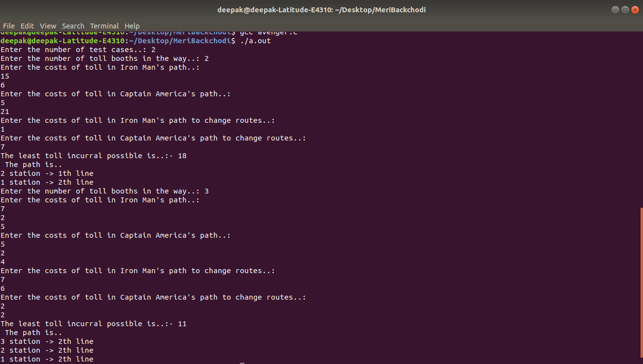

2-implement LCS

Code-

#include<stdio.h>
#include<string.h>

int i,j,m,n,c[20][20];
char x[20],y[20],b[20][20];

void printLCS(int i,int j)
{
if(i==0 || j==0)
return;
if(b[i][j]=='d')
{
printLCS(i-1,j-1);
printf("%c",x[i-1]);
}
else if(b[i][j]=='u')
printLCS(i-1,j);
else
printLCS(i,j-1);
}

void lcs()
{
m=strlen(x);
n=strlen(y);
for(i=0;i<=m;i++)
c[i][0]=0;
for(i=0;i<=n;i++)
c[0][i]=0;

//d -> diagonal entry
//u -> upside entry
//l -> leftside entry

for(i=1;i<=m;i++)
for(j=1;j<=n;j++)
{
if(x[i-1]==y[j-1])
{
c[i][j]=c[i-1][j-1]+1;
b[i][j]='d';
}
else if(c[i-1][j]>=c[i][j-1])
{
c[i][j]=c[i-1][j];
b[i][j]='u';
}
else
{
c[i][j]=c[i][j-1];
b[i][j]='l';
}
}
printf("The length of the Longest Common Subsequence is %d", c[m][n]);

}

int main()
{
printf("Implementing the LCS problem..\n");
printf("Enter 1st sequence:");
scanf("%s",x);
printf("Enter 2nd sequence:");
scanf("%s",y);
lcs();
printf("\nThe Longest Common Subsequence is ");
printLCS(m,n);
return 0;
}

Screenshot-

