Deepak Yadav
SE-IT
Batch D
2018140064

Fractional Knapsack..

#include<stdio.h>

void selection_sort(float v[],float w[],float profit[],int n)
{
int i, j, min, temp,t1,t2;
for (i=0; i<n; i++)
{
min = i;
for (j=i+1; j<n; j++)
{
if (v[j] > v[min])
min = j;
}
temp = v[i];
v[i] = v[min];
v[min] = temp;

t1=w[i];
w[i]=w[min];
w[min]=t1;

t2=profit[i];
profit[i]=profit[min];
profit[min]=t2;

}
}

void main()
{
int n;
float capacity;
printf("Enter the maximum capacity..:\n");
scanf("%f",&capacity);
printf("Enter the total number of items..:\n");
scanf("%d",&n);
float w[n];
float profit[n];
float v[n];
for(int i=0;i<n;i++)
{
printf("Enter weight and profit of the %dth object\n", i+1);
scanf("%f",&w[i]);
scanf("%f",&profit[i]);
v[i]=(float)profit[i]/w[i];
}
selection_sort(v,w,profit,n);
int c=0;
float finalprofit=0.0;
for(int i=0;i<n;i++)
{
if(capacity-w[i]>0){
capacity=capacity-w[i];
finalprofit=finalprofit+profit[i];
printf("Item %d inserted and the new capacity is %f\n",i,capacity);
c++;
}
else if(capacity - w[i] < 0)
{
float ratio;
ratio = (float)capacity/(float)w[i];
finalprofit = finalprofit + (float)profit[i]*ratio;
capacity = capacity - (float)w[i]*ratio;
break;
}
}
printf("%d elements inserted into the sack\n",c+1);
printf("Total profit %.5f...\n",finalprofit);
}

Screenshot-

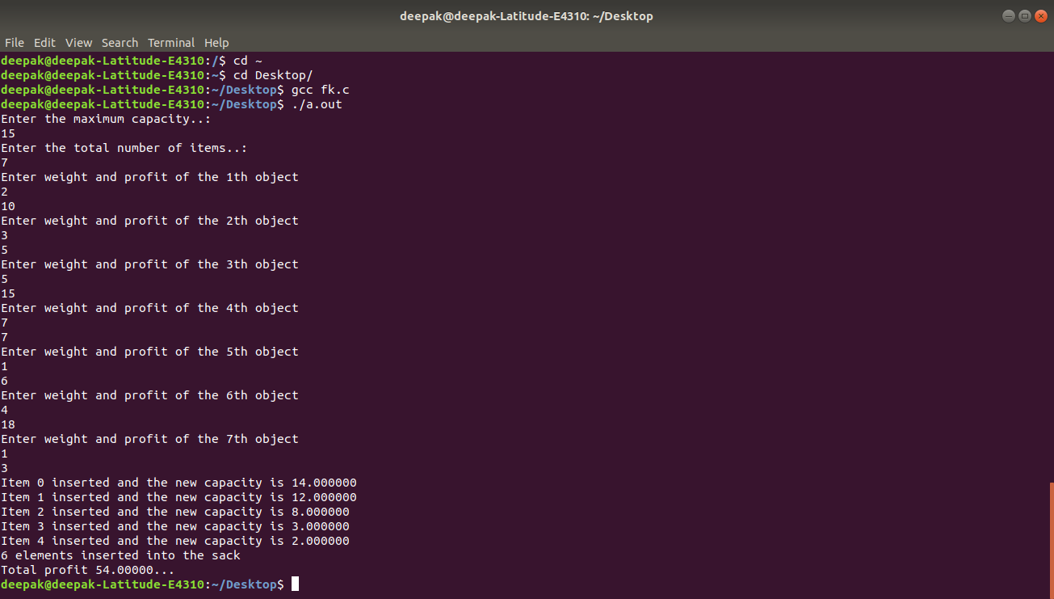
Padyatra Problem:-

Code-

#include<stdio.h>
#include<stdlib.h>
#include<limits.h>

int Map[300][300];

typedef struct road
{
int st_pt;
int weight;
int end_pt;
}Road;

int MinWeight(int a[],int visited[],int numRoads)
{
int minni=-1;
int min=INT_MAX;
for(int i=0;i<numRoads;i++)
{
if(a[i]<min&&visited[i]==0)
{
min=a[i];
minni=i;
}
}
return minni;
}
int padyatra(int distance[],int parent[],int visited[],int st_pt,int end_pt,int numRoads,int weight)
{
int s;
int dist=0;
distance[st_pt]=0;
parent[st_pt]=-1;
int count=0;
Map[st_pt][end_pt]=0;
Map[end_pt][st_pt]=0;
for(int i=0;i<numRoads;i++)
{
distance[i]=INT_MAX;
parent[i]=-1;
visited[i]=0;
}
while(count<numRoads)
{
s=MinWeight(distance,visited,numRoads);
if(s==-1)
{
distance[s]=0;
break;
}
for(int i=0;i<numRoads;i++)
{
if(Map[s][i]!=0)
{
if(distance[s]+Map[s][i]<distance[i])
{
distance[i]=distance[s]+Map[s][i];
parent[i]=s;
}
}
}
visited[s]=1;
if(s==end_pt)
{
break;
}
count ++;
}
Map[st_pt][end_pt]=weight;
Map[end_pt][st_pt]=weight;
return distance[s];
}
int main()
{
int numRoads;
int min;
int ans=INT_MAX;
printf("Enter the total number of roads..: \n");
scanf("%d",&numRoads);
for(int i=0;i<300;i++)
{
for(int j=0;j<300;j++)
{
Map[i][j]=0;
}
}
Road a[numRoads];
for(int i=0;i<numRoads;i++)
{
printf("Enter the starting point, end point and weight of %dth road : \n", (i+1));
scanf("%d",&a[i].st_pt);
scanf("%d",&a[i].end_pt);
scanf("%d",&a[i].weight);
Map[a[i].st_pt-1][a[i].end_pt-1]=a[i].weight;
Map[a[i].end_pt-1][a[i].st_pt-1]=a[i].weight;
}
int distance[numRoads];
int parent[numRoads];
int visited[numRoads];
for(int i=0;i<numRoads;i++)
{
int minimum=a[i].weight;
min=padyatra(distance,parent,visited,a[i].end_pt-1,a[i].st_pt-1,numRoads,a[i].weight);
minimum=minimum+min;
if(minimum<ans)
{
ans=minimum;
}
}
printf("\nMaximum possible cycle coverage path cost is %d\n",(ans));
}

Screenshot:-

