Introduction
MultiwiiParser is a Processing application to handle config.h files for Multiwii based multirotor "devices". For the user interface the ControlP5 library is used.

The idea for the program was to simplify the task to handle different configurations for all of my multicopters and incorporate the hand made configuration files into new versions of the multiwii software. So loading and parsing config.h files, but specifically comparing different configurations and applying changes as well as storing the result in condensed form.

MultiwiiParser is available here http://code.google.com/p/multiwiiparser/

You can also use this location for providing your feedback defects and enhancement requests. Since this has been based so far solely on my personal needs and only tesing with my own file, please let me know if you find any defect.

So far I have tested the application only on Windows (7), if you test it on other platforms, please let me know your experiences.

References

- Information on MultiWii can be found here http://www.multiwii.com/ and the correspdong source code is here http://code.google.com/p/multiwii/
- Processing is an open source programming language - http://processing.org/
- ControlP5 is a user interface library for processing by Andreas Schlegel. see http://www.sojamo.de/libraries/controlP5/

License

Copyright 2013 by Johannes Viegener

MultiWiiParser is free software: you can redistribute it and/or modify it under the terms of the Lesser GNU General Public License as published by the Free Software Foundation, either version 3 of the License, or (at your option) any later version.

MultiWiiParser is distributed in the hope that it will be useful, but WITHOUT ANY WARRANTY; without even the implied warranty of MERCHANTABILITY or FITNESS FOR A PARTICULAR PURPOSE. See the GNU General Public License for more details.

You should have received a copy of the Lesser GNU General Public License along with MultiWiiParser. If not, see <http://www.gnu.org/licenses/>.

Overview

Main screen after fresh start

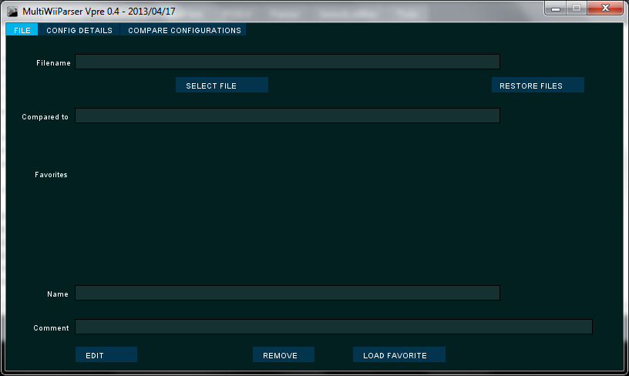

On the top level the three tabs that are described in subsequent sections can be selected. The active tab is usally show in light blue. Or more general active options or buttons are usually shown in light blue.

File tab is used for selecting files and maintaining a persistent catalog of favorite files (plus comments).

The Config Details tab is showing the details of a selected config.h file.

The Compare Configurations tab is used for showing two configuration files (or their differences) together with information marking the deviations.

The Config or Compare tab are only accesible if at least one or two (for compare) files are selected in the File tab.

A config.h file is read and structured with the following elements
- Sections are the (currently 7) different sections marked in the config.h file as comments. (e.g. SECTION 1 - BASIC SETUP)
- Subsections are the intermediate structure elements that separate bigger blocks in the respective section. They are marked with three line comments e.g.
/********************************************************/
/********* boards and sensor definitions *************/
/********************************************************/
Subsections are only used as qualifiers (additional names) for groups.
- Groups are smaller sets of configurations that are separated by comments e.g.
/********* The type of multicopter *****************/
- Entries are the single configurations (normally a single line in the config.h file). These can be active; meaning not part of a comment:
#define MINCOMMAND 1000
or inactive (part of a comment, e.g.
//#define GIMBAL
Beside the name (e.g. GIMBAL or MINCOMMAND), the entries might also have a value (e.g. 1000 for the definition of MINCOMMAND above) or can be self contained (e.g. GIMBAL). Due to the nature of the config.h file all names for ACTIVE entries must be unique.
There are different types of groups of configurations that are also handled specifically in the code
  - Same name - config.h might provide different values for the same entry name (e.g. MINTHROTTLE). Where only one out of these can be active in that group.
  - No value - a group of entries might be the exclusive selections. Where only a single one of these should be active although they have different names. (e.g. the type of multicopter is specific can not be both QUADX and TRI).
  - Mixed - Might contain subparts of the above. Not specifically checked, just for information tracked.
- Additional comments, that are not part of the structure (section names, subections etc) are also saved and shown together with the corresponding element in the structure. E.g. line comments after a specific entry in the config file
//#define HEX6H // New Model
Here "New Model" is a line comment for the entry
Active editor fields that can be used to change an entry (or favorite file) together with the buttons to save or cancel the edit are shown in red. Change between tabs is blocked when an editor is active.

File Tab

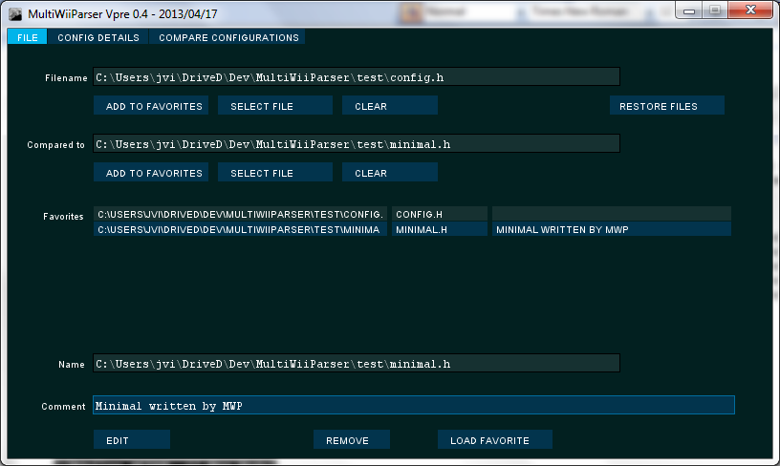

The file tab provides information about the currently open configurations.

Next to Filename is the main configuration that is used for the content of the Config Details tab (and on the left side of the Compare tab). All changes and save operations are only changing or using this configuration.

Next to compared to is the actual secondary config file shown.

Below both file names are buttons to add the current file to the favorites listbox in the lower half of the window, select another file or deselect (clear) the current file selection.

The restore file button can be used to restore the last file selection.

In the favorites list the path/filename and an optional comment is shown. With the edit button, the comment can be changed. A double click (or the "Load favorite" button) will load that file in the next available slot (either as primary or secondary file).

The favorites list (and the last file selection) is stored on any change in the app directory as "favorites.txt".

Config Details Tab

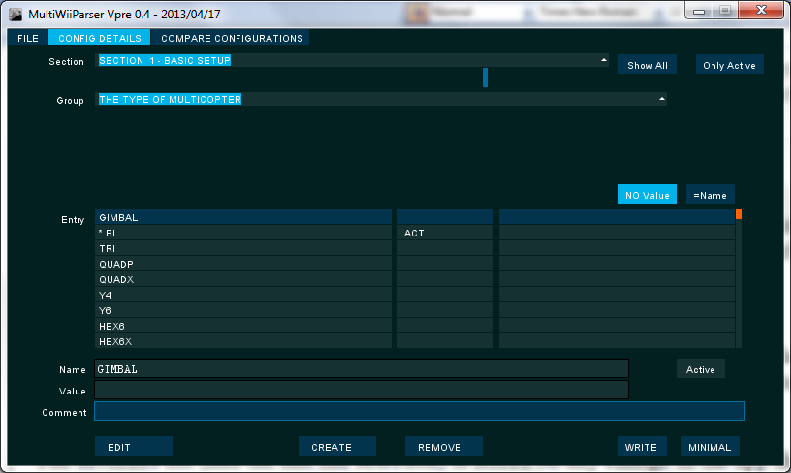

The Config Details tab allows the looking through the details of a config.h file.

Normally the structure (Section/Group) dropdown boxes are used to show a small amount of the configurations in the list of entries (lower part). The button "Show All" will change to a complete (sorted by name and value) list of all entries in the config file. "Only Active" is used to restrict the list to show only active entries.

The list contains three different display separate lists
- Name + Value as a specific formatting. e.g. MINTHROTTLE = '1300'
Active entries are prefixed with a *
- Options showing the specifics of the entry
  - ACT - Showing if the entry is active
  - EE - If the entry is stored in EEPROM of the microcontroller (see comments in config.h)
  - VAL - if the entry has a value assigned
  - // - if the entry has a line comment
- Line comment for the entry

Above the list the type of group is shown
- No Value - If all the entries in the group have no value
- =Name - If all the entries in the group (must) have the same name and therefore only a single entry can be active

Below the list the editor fields show the complete entry in separate fields. The fields are also used when changing an entry, plus the button Active. Only the fields that are currently changable will be editable.

Buttons are also available for creating a new entry in the current group or deleting an entry.

Additionally there are two buttons for writing the configuration to a file
- Write - Write a full configuration into a file (default same filename as currently opened)
- Minimal - Write only the active entries together with Sections into a file. This format is best for storing version independant only the most relevant configs
These buttons are marked red if unsaved changes exist for the current configuration

Compare Configurations
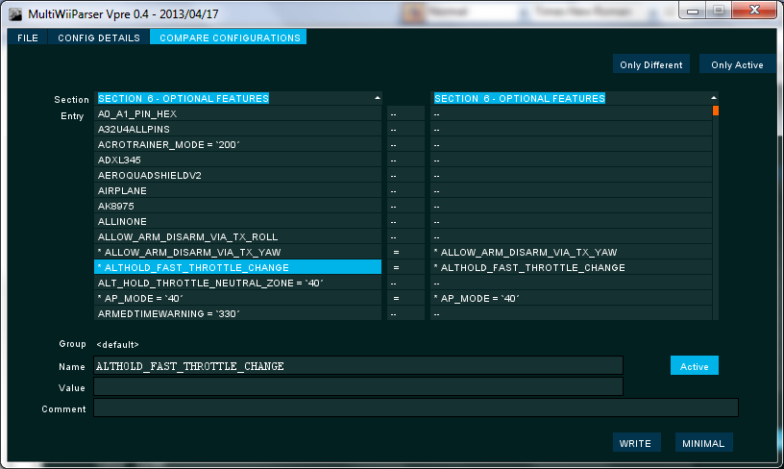

The Compare Configurations Tab is showing two different configurations side-by-side. On the left side the primary config file is shown and the other file on the right. All entries are compared by name (plus value). If no entry with the same name is existing an entry with "--" is shown instead.

In the middle column a status of the comparision is shown
- = : Entries are equal
- ++ : Entry is not existing on the left side (primary file)
- -- : Entry is not existing on the right side
- +A : Entry is activated in the right side (and deactive on the other side)
- -A : Entry is activated in the left side (and deactive on the other side)
- !V : Values not equal

On the top, buttons are there for restricting the display in the lists to only active entries or only different entries.

Below the detail fields buttons are given to align the differences in the entries. Activating/Deactivating the entry on the left side; Adding or removing the entry on the left side; Align (value or all parts).

Additionally there are the same buttons to store the primary configuration file.

