INTERNSHIP PROJECT REPORT

Customer Behavior Analytics & Customer Segmentation
Using Python, Machine Learning and Power BI

Submitted by
Vignesh L
Data Analyst Intern

Internship Organization
Intelmetrics Solutions

Submitted to
Hindusthan Institute of Technology

Internship Duration: 27 April 2026 - 24 May 2026
Academic Year: 2025-2026

CERTIFICATE
This is to certify that Mr. Vignesh L, a student of Hindusthan Institute of Technology, has successfully completed a 4-week internship at Intelmetrics Solutions from 27 April 2026 to 24 May 2026 as a Data Analyst Intern.
During the internship, he worked on the project titled "Customer Behavior Analytics & Customer Segmentation Using Python, Machine Learning and Power BI".
The project involved data cleaning, exploratory data analysis, customer segmentation using RFM analysis and K-Means clustering, dashboard development in Power BI, and business insight generation.
The work carried out during the internship was found to be satisfactory and demonstrates practical application of data analytics concepts and tools.

DECLARATION
I hereby declare that the internship project report entitled "Customer Behavior Analytics & Customer Segmentation Using Python, Machine Learning and Power BI" submitted to Hindusthan Institute of Technology is a record of the work carried out by me during my internship at Intelmetrics Solutions from 27 April 2026 to 24 May 2026.
I further declare that this project report has not been submitted to any other institution for the award of any degree, diploma, or certification.
Name: Vignesh L
Place: Coimbatore, Tamil Nadu

ACKNOWLEDGEMENT
I would like to express my sincere gratitude to Intelmetrics Solutions for providing me with the opportunity to undertake my internship as a Data Analyst Intern.
I am thankful to the management and mentors of Intelmetrics Solutions for their valuable guidance, support, and encouragement throughout the internship period.
I would also like to extend my heartfelt thanks to the faculty members of Hindusthan Institute of Technology for their continuous support and motivation during the completion of this project.
This internship enabled me to gain practical experience in data analytics, Python programming, machine learning, data visualization, and business intelligence tools such as Power BI. The knowledge and skills acquired during this internship have significantly enhanced my analytical and technical capabilities.
Finally, I would like to thank everyone who directly or indirectly contributed to the successful completion of this project.

EXECUTIVE SUMMARY
This internship project focuses on analyzing customer purchasing behavior using transactional retail data. The primary objective was to identify customer segments, understand purchasing patterns, and generate business insights that can support decision-making and customer retention strategies.
The project was carried out using Python libraries such as Pandas, NumPy, Matplotlib, Seaborn, and Scikit-Learn. Data cleaning and preprocessing techniques were applied to transform raw transactional data into an analysis-ready dataset. Exploratory Data Analysis (EDA) was performed to identify sales trends, customer behavior patterns, product performance, and regional revenue distribution.
RFM (Recency, Frequency, Monetary) analysis was conducted to evaluate customer value and classify customers into meaningful business segments such as Champions, Loyal Customers, Regular Customers, and At-Risk Customers. Furthermore, K-Means clustering was implemented to discover hidden customer groups based on purchasing behavior.
Interactive dashboards were developed in Power BI to visualize revenue trends, customer insights, sales performance, and customer segmentation results. The analysis revealed that revenue was highly concentrated among a small group of customers, November was the highest-performing month, and the United Kingdom contributed the majority of total revenue.
Based on the findings, strategic recommendations were proposed to improve customer retention, increase customer lifetime value, and optimize marketing efforts.

ABSTRACT
Customer analytics plays a crucial role in helping organizations understand consumer behavior and improve business performance. This project presents a comprehensive customer behavior analytics solution developed using Python, Machine Learning, and Power BI.
The project involves data cleaning, exploratory analysis, feature engineering, customer segmentation using the RFM methodology, and clustering using the K-Means algorithm. Various business metrics such as revenue, customer value, frequency of purchase, and recency were analyzed to gain actionable insights.
The final outcome includes an interactive Power BI dashboard capable of providing insights into sales performance, customer segments, product popularity, and geographical trends. The project demonstrates how data-driven decision-making can enhance business growth and customer engagement.
Keywords: Data Analytics, Customer Segmentation, RFM Analysis, K-Means Clustering, Power BI, Machine Learning, Business Intelligence.

TABLE OF CONTENTS
1. Introduction
2. Company Profile
3. Internship Overview
4. Problem Statement
5. Objectives
6. Dataset Description
7. Tools and Technologies
8. Methodology
9. Data Cleaning and Preparation
10. Exploratory Data Analysis
11. RFM Analysis
12. Customer Segmentation using K-Means
13. Power BI Dashboard Development
14. Results and Findings
15. Business Recommendations
16. Learning Outcomes
17. Conclusion
18. Future Scope
19. References
20. Appendix

1. INTRODUCTION
This internship report documents the end-to-end development of a customer behavior analytics project undertaken during the internship period at Intelmetrics Solutions. The project was designed to apply data analysis concepts learned during training to a realistic business problem in retail analytics.
The main purpose of the project was to analyze customer transactions, identify patterns in buying behavior, segment customers based on their value, and present the findings through interactive dashboards. This report covers the complete workflow from raw data collection to final visualization and business recommendation.

2. COMPANY PROFILE
Intelmetrics Solutions is the internship host organization where the project was carried out. The company environment provided exposure to practical data analytics workflows and encouraged the use of analytical tools to solve business problems.
During the internship, I worked under the position of Data Analyst Intern and applied Python, data visualization, and business intelligence techniques to complete the project deliverables.

3. INTERNSHIP OVERVIEW
- Internship Organization: Intelmetrics Solutions
- College: Hindusthan Institute of Technology
- Position: Data Analyst Intern
- Start Date: 27 April 2026
- Duration: 4 Weeks
- Project Theme: Customer Behavior Analytics & Customer Segmentation

4. PROBLEM STATEMENT
Retail organizations generate large volumes of customer transaction data, but raw data alone does not provide direct business value. The problem addressed in this project was how to convert transactional data into actionable customer insights that can improve retention, sales strategy, and marketing focus.
Specifically, the project aimed to answer the following questions: Which customers are most valuable? Which products and countries generate the most revenue? Which months are strongest in sales? Which customer groups are at risk of churn?

5. OBJECTIVES
- Clean and prepare the raw transaction data for analysis.
- Perform exploratory data analysis to identify sales and customer patterns.
- Apply RFM analysis to measure customer value.
- Segment customers using K-Means clustering.
- Develop an interactive Power BI dashboard for business reporting.
- Generate recommendations for marketing and retention strategy.

6. DATASET DESCRIPTION
The project used an online retail transaction dataset containing customer purchases, product information, invoice dates, quantities, prices, and country details. The dataset is well suited for customer segmentation, sales analysis, and revenue reporting.
Attribute | Description
Initial Rows | 525,461
Final Cleaned Rows | 400,916
Initial Columns | 8
Final Columns | 12
Key Variables | Invoice, StockCode, Description, Quantity, InvoiceDate, Price, Customer ID, Country
The cleaned dataset preserved only meaningful and valid records for analytics, while additional features such as Revenue, Year, Month, and Day were created to support business reporting.

7. TOOLS AND TECHNOLOGIES
- Python for data loading, cleaning, analysis, and feature engineering.
- Pandas for data manipulation.
- NumPy for numerical operations.
- Matplotlib and Seaborn for data visualization.
- Scikit-Learn for clustering and scaling.
- Power BI for dashboard development.
- Jupyter Notebook and Visual Studio Code for development.

8. METHODOLOGY
- Data Understanding: Reviewed structure, data types, missing values, and distribution of values.
- Data Cleaning: Handled missing values, removed duplicates, filtered invalid records, and standardized data types.
- Feature Engineering: Created Revenue and date-based features for analysis.
- Exploratory Data Analysis: Studied sales trends, customer spending, country contribution, and product performance.
- RFM Analysis: Calculated recency, frequency, and monetary values for each customer.
- Segmentation: Applied business rules and K-Means clustering to classify customers.
- Dashboarding: Developed multiple Power BI report pages for executive, sales, customer, and segmentation views.

9. DATA CLEANING AND PREPARATION
The raw dataset contained missing values in Description and Customer ID, duplicate records, negative quantities, and invalid price values. These issues were carefully handled to improve data quality and analytical accuracy.
- Removed rows with missing Customer ID because customer-level analysis requires an identifier.
- Removed rows with missing Description to ensure product-level analysis remained meaningful.
- Removed duplicate transactions to avoid double counting.
- Filtered out negative Quantity values, which typically represent returns or cancellations.
- Filtered out negative Price values, which are invalid for sales analysis.
- Converted Customer ID to string format for categorical analysis.
- Created Revenue as Quantity multiplied by Price.
- Extracted Year, Month, and Day from InvoiceDate for temporal analysis.
After cleaning, the dataset contained 400,916 valid transaction rows and no remaining missing values in the working analysis file.

10. EXPLORATORY DATA ANALYSIS
EDA was used to understand the structure of the business data and identify important trends. The main analyses included revenue trends, top countries, top products, customer spending distribution, and order frequency.
- Monthly revenue trend analysis showed clear seasonal movement.
- The United Kingdom contributed the majority of overall revenue.
- A small number of products contributed disproportionately to sales.
- Customer spending was highly skewed, with a few customers generating very high revenue.
- Purchase frequency analysis showed that repeat customers were valuable for the business.

11. RFM ANALYSIS
RFM analysis is a customer segmentation method based on three indicators: Recency, Frequency, and Monetary value. Recency measures how recently a customer purchased, Frequency measures how often the customer purchases, and Monetary measures how much the customer spends.
- Recency = days since last purchase
- Frequency = number of unique invoices per customer
- Monetary = total revenue contributed by a customer
Customers were scored using quintile-based scoring and grouped into business-friendly categories such as Champions, Loyal Customers, Regular Customers, and At Risk Customers.

12. CUSTOMER SEGMENTATION USING K-MEANS
To identify hidden groups in the customer base, the RFM features were standardized and clustered using the K-Means algorithm. The elbow method was used to determine an appropriate number of clusters.
- Standardized Recency, Frequency, and Monetary values using StandardScaler.
- Evaluated cluster inertia across multiple k values using the elbow method.
- Selected a practical number of clusters to balance interpretability and separation.
- Interpreted resulting clusters as segments such as High Value, Average, Premium, and Dormant customers.

13. POWER BI DASHBOARD DEVELOPMENT
A four-page Power BI dashboard was developed to communicate the findings in a business-friendly format. The dashboard included an Executive Overview, Sales Analysis, Customer Analysis, and Customer Segmentation page.
- Executive Overview page displayed Revenue, Orders, Customers, and AOV.
- Sales Analysis page presented monthly revenue and product performance.
- Customer Analysis page highlighted top customers and purchase behavior.
- Segmentation page summarized customer groups and cluster distribution.

14. RESULTS AND FINDINGS
- The cleaned dataset retained 400,916 valid transaction rows.
- Total revenue recorded in the dashboard was approximately 8.80M.
- Total orders were approximately 19K.
- Total customers were 4,312.
- Average order value was 457.93.
- November recorded the highest revenue month.
- The United Kingdom generated the highest sales contribution.
- The largest customer group was At Risk, followed by Loyal Customers.
- Champions represented a smaller but highly valuable customer group.

15. BUSINESS RECOMMENDATIONS
- Launch reactivation campaigns for At Risk customers.
- Offer loyalty rewards and early-access benefits to Champions.
- Run upselling and cross-selling campaigns for Loyal Customers.
- Plan inventory and promotions before peak months such as November.
- Focus on high-revenue markets, especially the United Kingdom, while exploring growth opportunities in other regions.

16. LEARNING OUTCOMES
- Learned how to clean and transform raw transaction data.
- Improved practical knowledge of Python, Pandas, NumPy, and visualization libraries.
- Understood customer segmentation concepts through RFM analysis.
- Applied machine learning clustering to business data.
- Developed Power BI dashboards for executive reporting.
- Strengthened reporting, storytelling, and documentation skills.

17. CONCLUSION
The internship project successfully transformed raw retail transaction data into a meaningful customer analytics solution. The project demonstrated how analytics can be used to understand customer behavior, identify value segments, and support decision-making.
By completing data cleaning, exploratory analysis, RFM segmentation, K-Means clustering, and Power BI dashboarding, I gained end-to-end exposure to a real-world analytics workflow. The internship improved both my technical knowledge and my ability to communicate data-driven insights.

18. FUTURE SCOPE
- Build a churn prediction model to identify customers likely to stop buying.
- Estimate customer lifetime value using predictive modeling.
- Create a recommendation engine for personalized product suggestions.
- Automate data refresh and dashboard updates.
- Extend the solution to a live business environment with scheduled reporting.

19. REFERENCES
- Pandas Documentation: https://pandas.pydata.org/pandas-docs/stable/
- NumPy Documentation: https://numpy.org/doc/stable/
- Matplotlib Documentation: https://matplotlib.org/stable/contents.html
- Seaborn Documentation: https://seaborn.pydata.org/
- Scikit-Learn Documentation: https://scikit-learn.org/stable/
- Microsoft Power BI Documentation: https://learn.microsoft.com/power-bi/

20. APPENDIX
The following dashboard screenshots document the final reporting output developed during the internship.
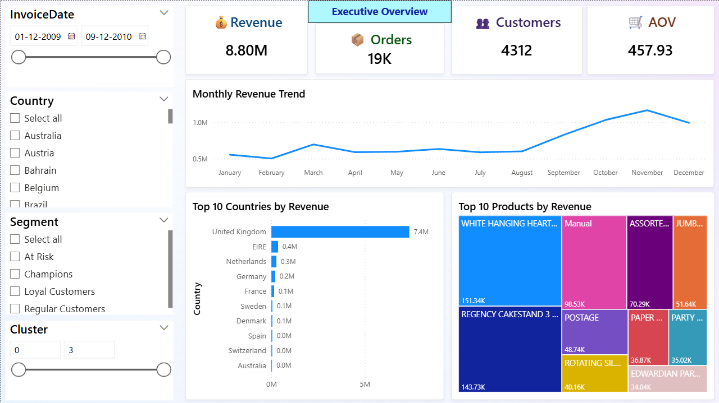
Figure A1: Executive Overview Dashboard

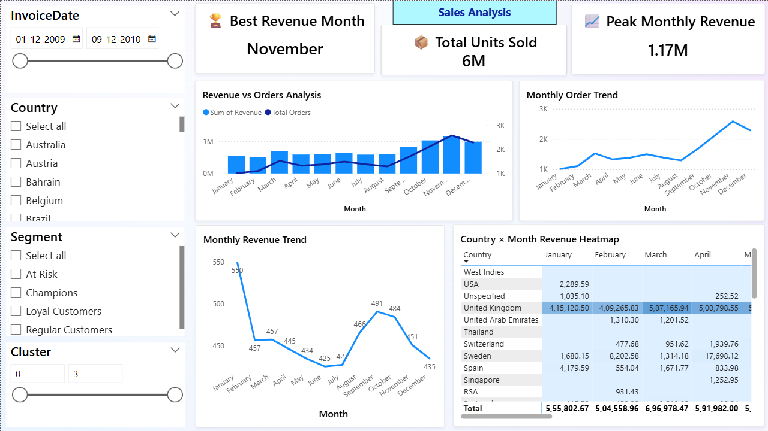
Figure A2: Sales Analysis Dashboard

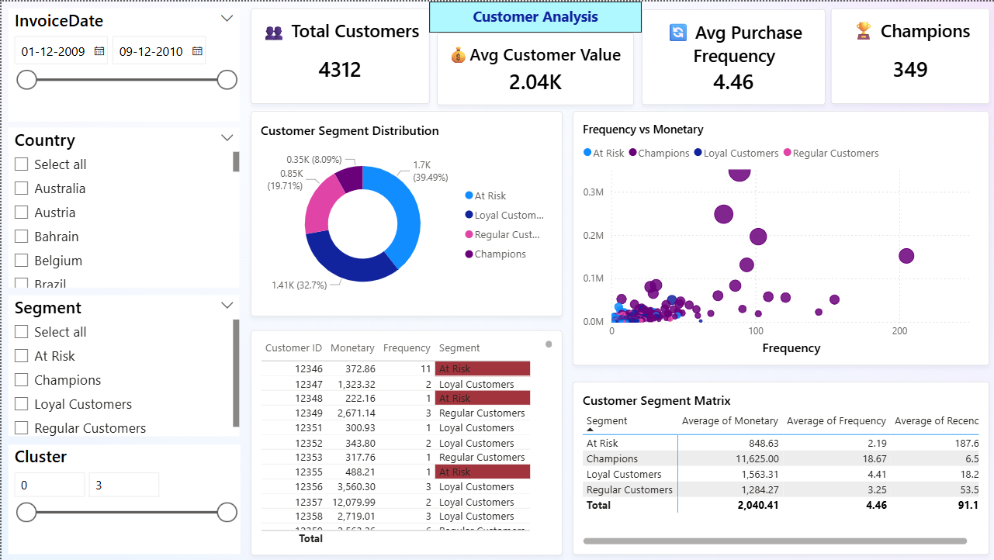
Figure A3: Customer Analysis Dashboard

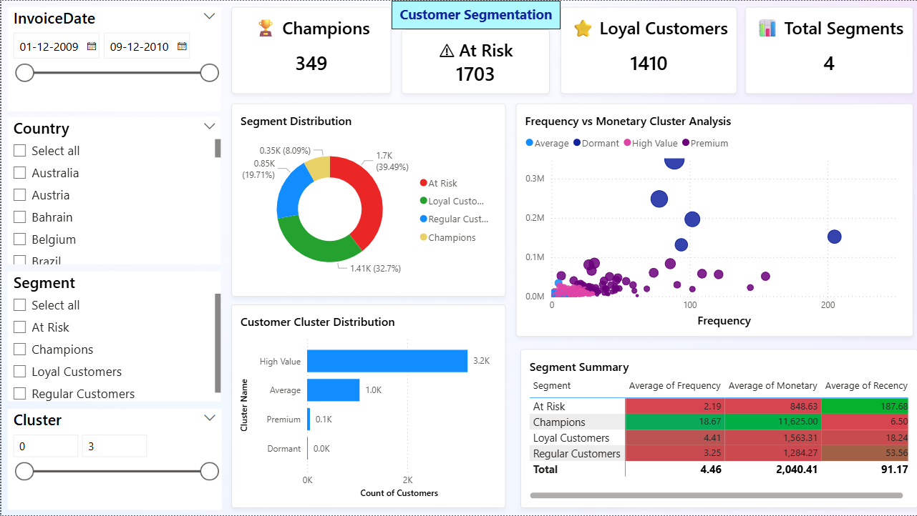
Figure A4: Customer Segmentation Dashboard

END OF REPORT
Prepared by Vignesh L

