Cài đặt xampp

* Phiên bản 5.6.8
* PHP version: 5.6.8
* Apache: 2.4.12
* MySQL 5.0.11

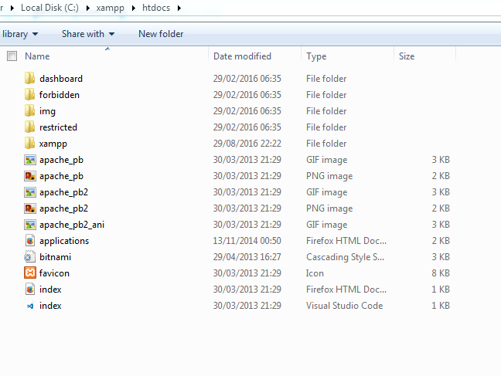

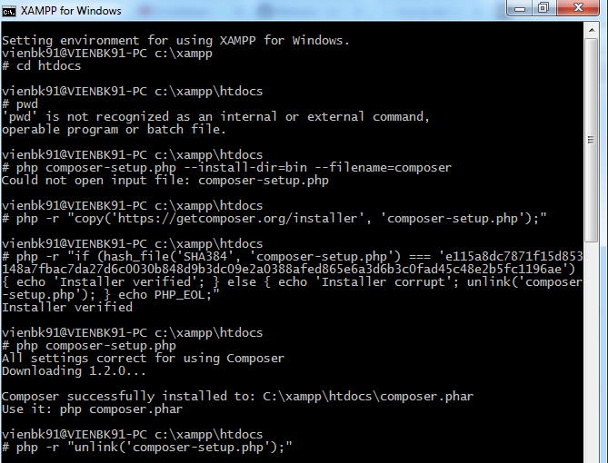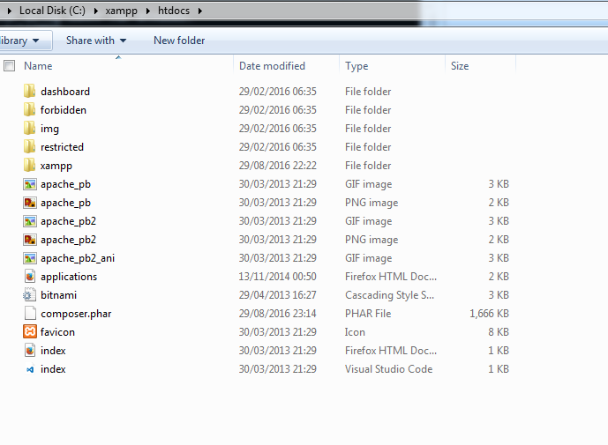

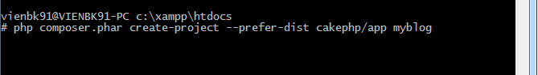

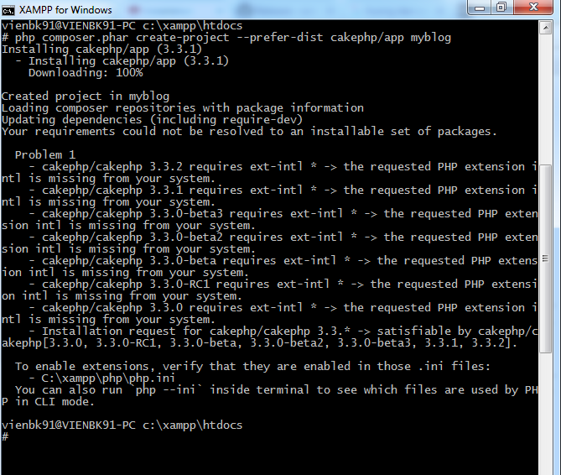

**Solution Xampp (Windows)**

1. Open /xampp/php/php.ini
2. Change ;extension=php_intl.dll to extension=php_intl.dll (remove the semicolon)
3. Copy all the /xamp/php/ic*.dll files to /xampp/apache/bin
4. Restart apache in the Xampp control panel

