Alcantara Group 1

Fuentes

EEE 298 Deep Learning Final Project

How to use:

python3 vaegan.py

Specifications:

A deep learning model was constructed by combining a variational autoencoder (VAE) and a generative adversarial network (GAN). The VAE output was utilized as an input of the GAN to form a more complex model. Following the paper by Larsen, et. al., this was implemented in Python using Keras. As Keras allows for modular construction of deep learning models, layers were simply added based on the paper’s specifications. Based from the fundamental loss functions, new loss functions were implemented to facilitate training.

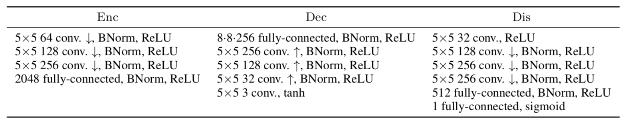

The group was able to perform a compile with 1000 steps and produced images.

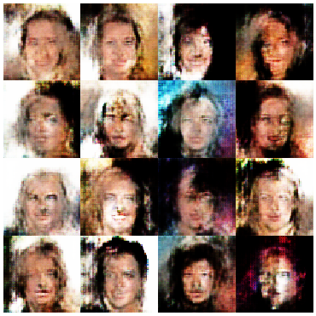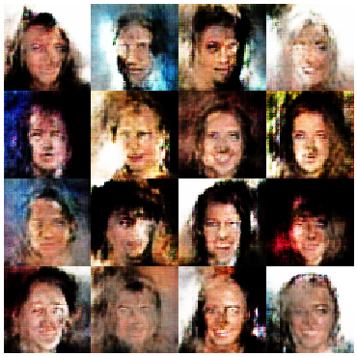

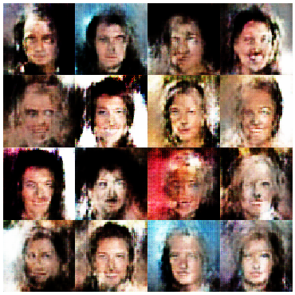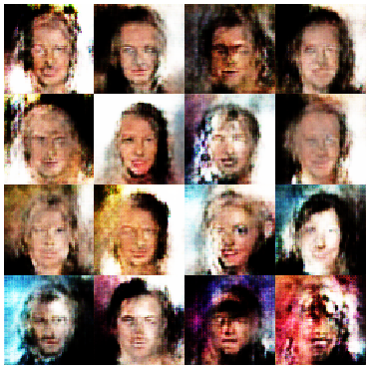

While pixelated, the group believes with more runs, we could have been able to produce clearer and more detailed images. A possible improvement to this is to use conditional models to be able to detect and create more specific features on the image.