Table of Contents

Configure Selenium in Eclipse 2

Pre-requisites: 2

Eclipse 2

Installation of TestNG in Eclipse 2

Adding TestNG to Java Build Path 3

Pre-requisites: 3

Eclipse 3

Configuring Git in Eclipse 3

Pre-requisites: 3

Adding Git in Eclipse 3

Commit to Git in Eclipse 4

Pre-requisites: 4

Your first commit 4

# Configure Selenium in Eclipse

## Pre-requisites:

* Selenium Server and Client is already downloaded and extracted
* JRE files has been included in the Build Path on Eclipse

## Eclipse

1. Open Eclipse and create a Project
2. Right click on the Project Name and select Properties
3. Select Java Build Path > Libraries Tab
4. Click Add External JARs
5. Locate the Selenium JAR files and select all the JAR files
6. Click Open
7. Click Apply and Close

Eclipse can successfully locate Selenium JAR Files.

# Installation of TestNG in Eclipse

1. On Eclipse, click on Help > Eclipse Marketplace
2. On Marketplace, search for TestNG
3. Click on Install
4. On Custom Selected Features for TestNG, do not select or install TestNG M2E Integration (Optional)

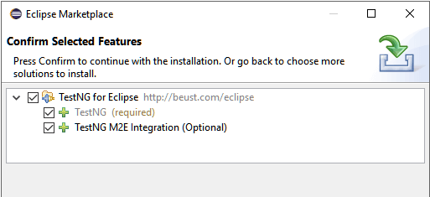

*If you install TestNG M2E Integration, you’ll encounter problems on launching your test cases but this has already been fixed on TestNG M2E Integration 6.12 and up.

1. Click on Confirm
2. Click NEXT
3. Tick I accept the terms of the license agreement
4. Click FINISH
5. If you encounter a Security Warning, click OK
6. Click Yes when Eclipse prompt you to restart
7. After restart, click on Window > Preferences and you’ll see TestNG

# Adding TestNG to Java Build Path

## Pre-requisites:

* Configure Selenium in Eclipse
* Installation of TestNG in Eclipse

## Eclipse

1. Open existing Project
2. Right click on the Project Name and select Properties
3. Select Java Build Path > Libraries Tab
4. Click Add Library
5. Click OK
6. Click Apply and Close

You are now ready to automate your test cases using TestNG

# Configuring Git in Eclipse

## Pre-requisites:

* User must have a Git Account
  1. Go to <https://github.com/>
  2. Sign up if you don’t have an account or sign in if you have existing account
  3. Create a repository for your project and copy the respository URL

## Adding Git in Eclipse

1. Open Eclipse
2. On upper right of Eclipse IDE click on Quick Access textbox

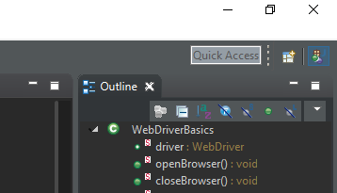

1. Key in and select Git Repositories
2. On Git Repositories tab, click Clone a Git Repository and add it to this view
3. Paste the repository URL on URL textbox
4. On Authentication, enter username and password of your Git account
5. Click in Store in Secure Store (to avoid prompting and entering credentials again)
6. Click NEXT
7. Select a destination in your local machine
8. Click FINISH

Your repository is displayed on Git Repositories tab on Eclipse.

# Commit to Git in Eclipse

## Pre-requisites:

* Project is created in Eclipse
  1. On Eclipse, click File
  2. Select New > Project
* Project is shared to Git Repository
  1. On Eclipse Project Explorer, right click on a Project
  2. Select Team > Share Project
  3. Select the created Git Repository
  4. Click FINISH

## Your first commit

1. On Project Explorer, select a project or a file to commit
2. Right click on the project or file and select Team
3. Select Commit
4. Drag file(s) under Unstaged Changes to Staged Changes
5. Enter a commit message
6. Click on Commit
7. Select a Brach (master or branch)
8. Click NEXT
9. Enter your Git Credentials and click OK

Your changes is displayed on your local repository or remote repository.

Note:

If you want to commit your changes to your local repository click on Commit.

If you want to commit your changes to a remote repository, click on Commit and Push