VTraining
For Training
UserName: vientran08
Vien.Tran@bcsh.ca.gov
Password: VienTran!1

For CalICH
CA-HDIS-IICS/DQ: Data Qualification for AB977
We may type: https://github.com then the caches will show.
Links: Hello World - GitHub Docs
- Creating an account on Github Creating an account on GitHub - GitHub Docs
Signing up for a new personal account
- Navigate to https://github.com/.
- Click Sign up.
- Alternatively, click on Continue with Google to sign up using social login.
- Follow the prompts to create your personal account.
We get
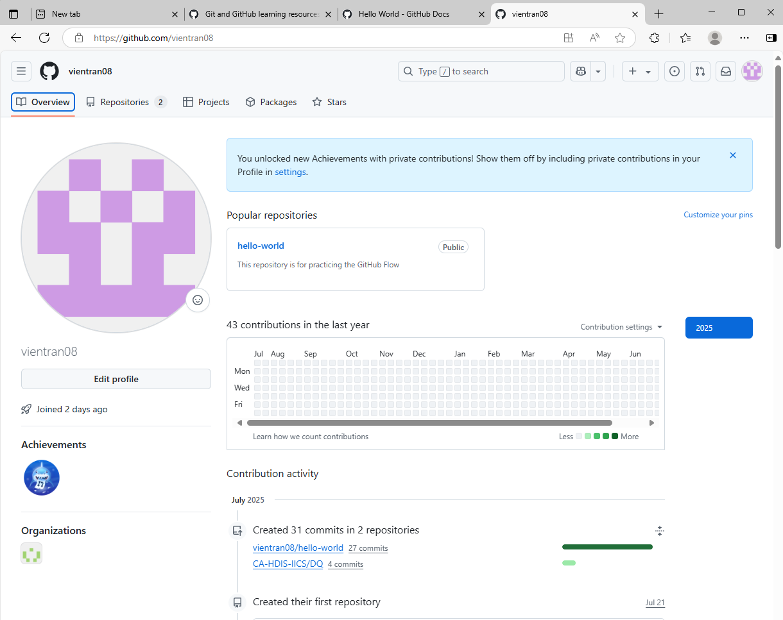
- Create and use a repository.
  - The first thing we'll do is create a repository. You can think of a repository as a folder that contains related items, such as files, images, videos, or even other folders. A repository usually groups together items that belong to the same "project" or thing you're working on.
  - Often, repositories include a README file, a file with information about your project. README files are written in Markdown, which is an easy-to-read, easy-to-write language for formatting plain text. We'll learn more about Markdown in the next tutorial, Setting up your profile.
  - GitHub lets you add a README file at the same time you create your new repository. GitHub also offers other common options such as a license file, but you do not have to select any of them now.
  - Your hello-world repository can be a place where you store ideas, resources, or even share and discuss things with others.
  - In the upper-right corner of any page, select , then click New repository.
  - 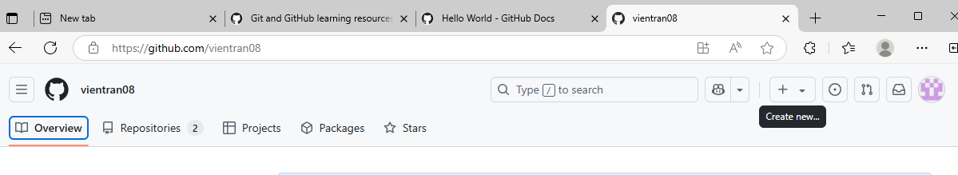
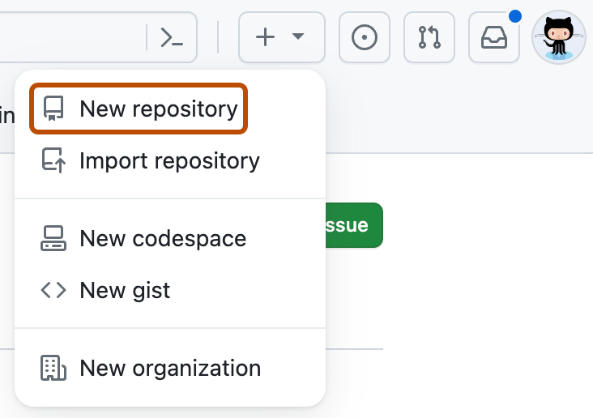
We get
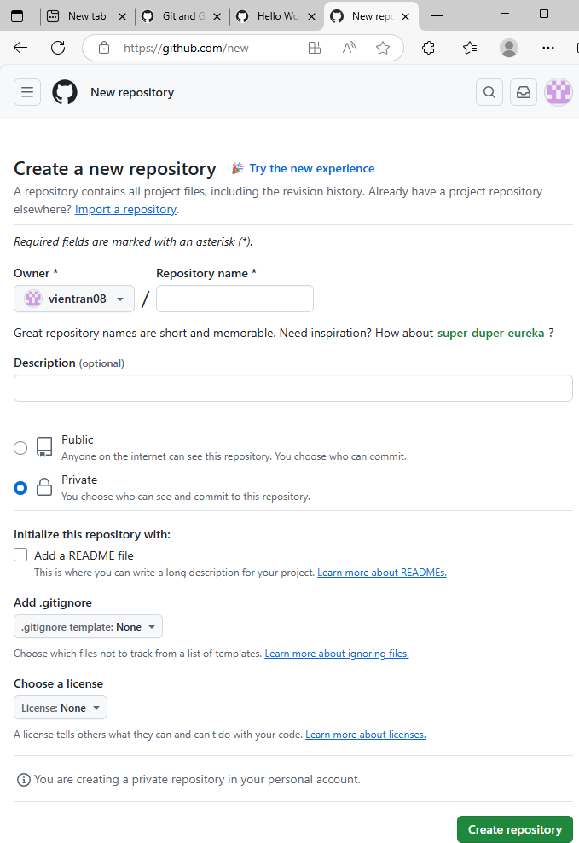

- In the "Repository name" box, type hello-world-1
- In the "Description" box, type a short description. For example, type "This repository is for practicing the GitHub Flow."
- Select whether your repository will be Public or Private.
- Select Add a README file. Very important
- Click Create repository.
We get
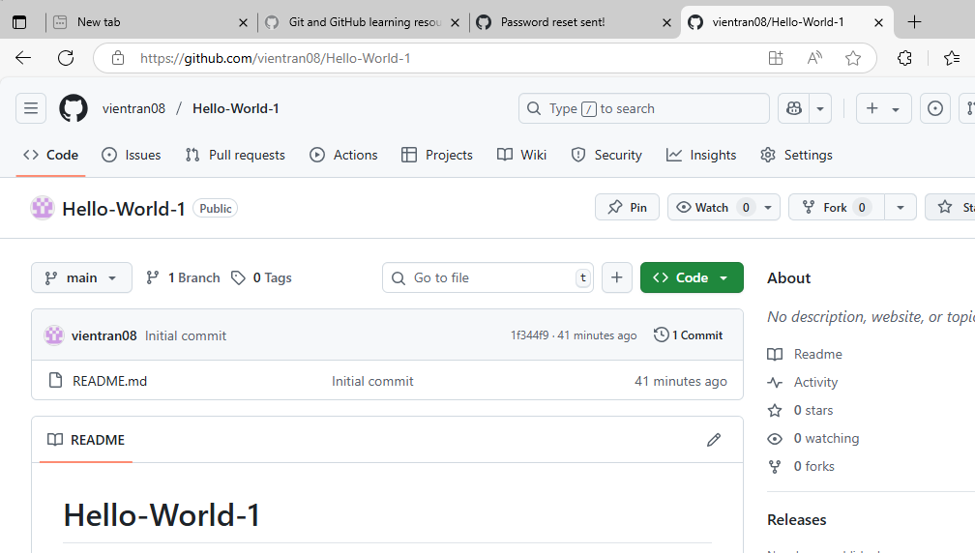
- Start and manage a new branch.
Step 2: Create a branch
Branching lets you have different versions of a repository at one time.
By default, your repository has one branch named main that is considered to be the definitive branch. You can create additional branches off of main in your repository.
Branching is helpful when you want to add new features to a project without changing the main source of code. The work done on different branches will not show up on the main branch until you merge it, which we will cover later in this guide. You can use branches to experiment and make edits before committing them to main.
When you create a branch off the main branch, you're making a copy, or snapshot, of main as it was at that point in time. If someone else made changes to the main branch while you were working on your branch, you could pull in those updates.
This diagram shows:
- The main branch
- A new branch called feature
- The journey that feature takes through stages for "Commit changes," "Submit pull request," and "Discuss proposed changes" before it's merged into main
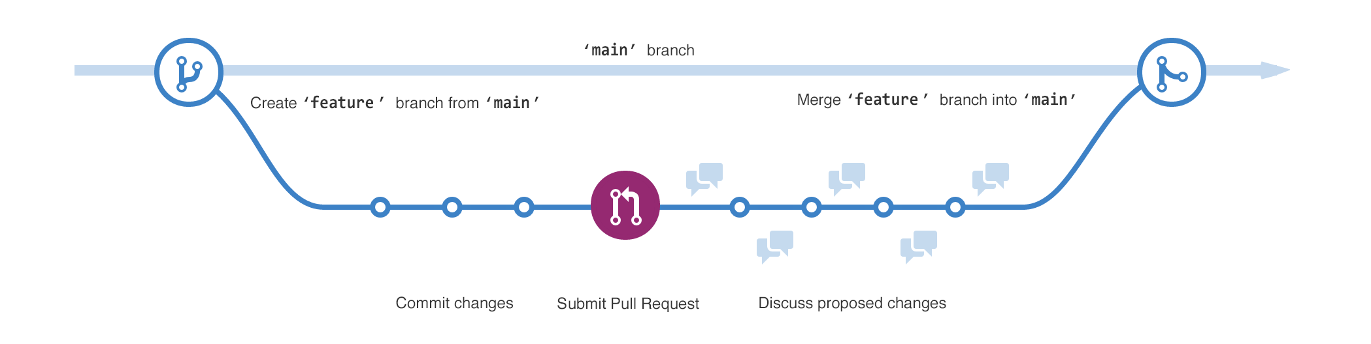
Creating a branch
- Click the Code tab of your hello-world repository.
- Above the file list, click the dropdown menu that says main.
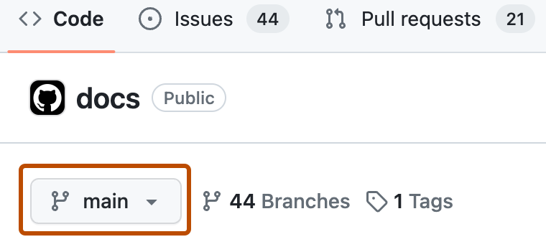
  - Type a branch name, readme-edits, into the text box.
  - Click Create branch: readme-edits from main.
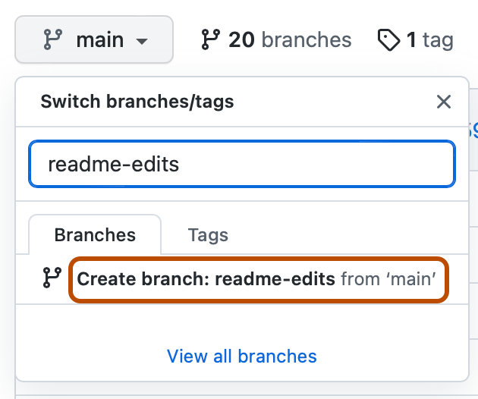
Now you have two branches, main and readme-edits. Right now, they look exactly the same. Next you'll add changes to the new readme-edits branch.
- Make changes to a file and push them to GitHub as commits.
Step 3: Make and commit changes
When you created a new branch in the previous step, GitHub brought you to the code page for your new readme-edits branch, which is a copy of main.
You can make and save changes to the files in your repository. On GitHub, saved changes are called commits. Each commit has an associated commit message, which is a description explaining why a particular change was made. Commit messages capture the history of your changes so that other contributors can understand what you’ve done and why.
- Under the readme-edits branch you created, click the README.md file.
- To edit the file, click pencil icon
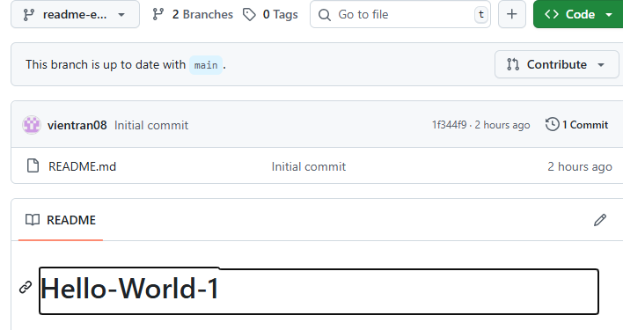.
- In the editor, write a bit about yourself.
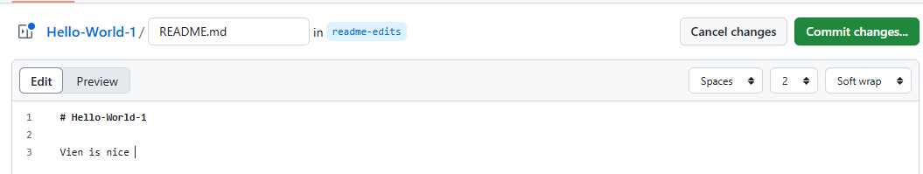
- Click Commit changes.
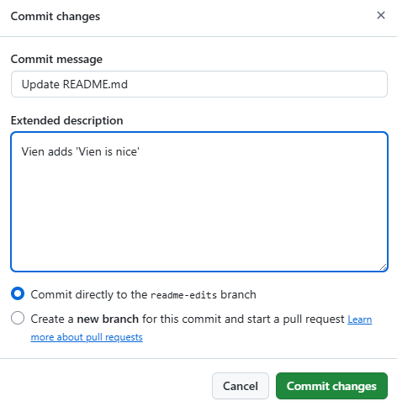 Mean Save to readme-edits
- In the "Commit changes" box, write a commit message that describes your changes.
- Click Commit changes.
These changes will be made only to the README file on your readme-edits branch, so now this branch contains content that's different from main.
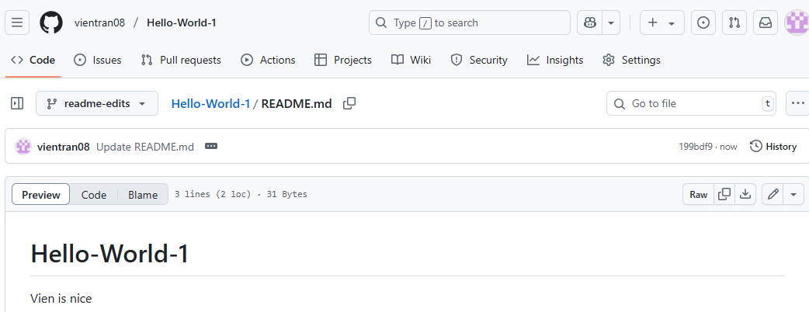
- Open and merge a pull request.
Now that you have changes in a branch off of main, you can open a pull request.
Pull requests are the heart of collaboration on GitHub. When you open a pull request, you're proposing your changes and requesting that someone review and pull in your contribution and merge them into their branch. Pull requests show diffs, or differences, of the content from both branches. The changes, additions, and subtractions are shown in different colors.
As soon as you make a commit, you can open a pull request and start a discussion, even before the code is finished.
In this step, you'll open a pull request in your own repository and then merge it yourself. It's a great way to practice the GitHub flow before working on larger projects.
- Click the Pull requests tab of your hello-world repository.
- Click New pull request.
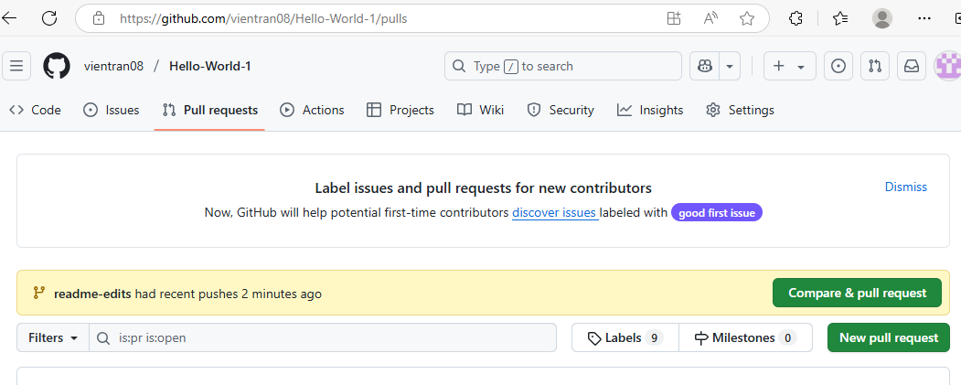
- In the Example Comparisons box, select the branch you made, readme-edits, to compare with main (the original).
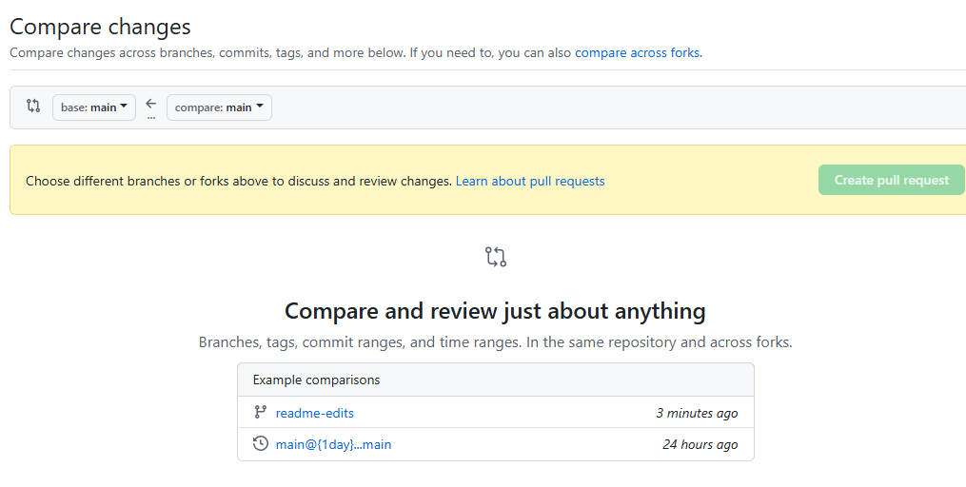
Click on readme-edits
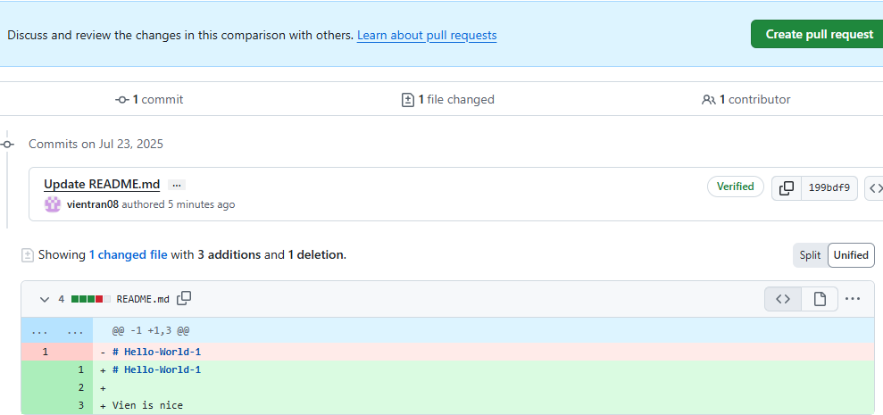
Minus is original, Plus is new
- Look over your changes in the diffs on the Compare page, make sure they're what you want to submit.
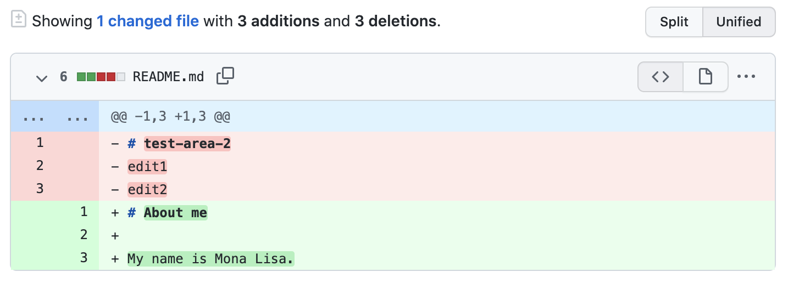
- Click Create pull request.
(see the above screenshot)
- Give your pull request a title and write a brief description of your changes. You can include emojis and drag and drop images and gifs.
- Click Create pull request.
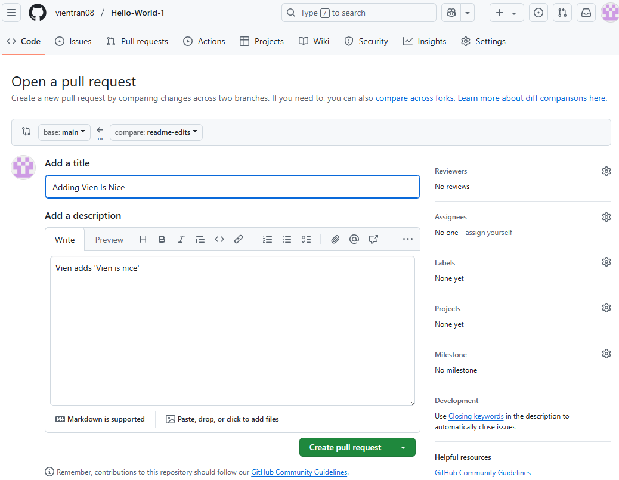
Reviewing a pull request
When you start collaborating with others, this is the time you'd ask for their review. This allows your collaborators to comment on, or propose changes to, your pull request before you merge the changes into the main branch.
We won't cover reviewing pull requests in this tutorial, but if you're interested in learning more, see About pull request reviews. Alternatively, try the GitHub Skills "Reviewing pull requests" course.

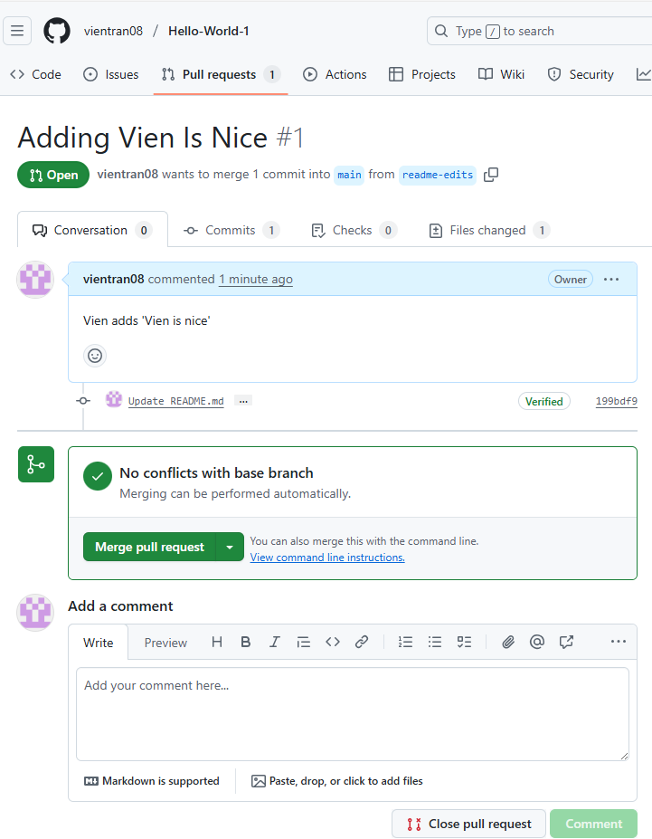
Step 5: Merge your pull request
In this final step, you will merge your readme-edits branch into the main branch. After you merge your pull request, the changes on your readme-edits branch will be incorporated into main.
Sometimes, a pull request may introduce changes to code that conflict with the existing code on main. If there are any conflicts, GitHub will alert you about the conflicting code and prevent merging until the conflicts are resolved. You can make a commit that resolves the conflicts or use comments in the pull request to discuss the conflicts with your team members.
In this walk-through, you should not have any conflicts, so you are ready to merge your branch into the main branch.
- At the bottom of the pull request, click Merge pull request to merge the changes into main.
- Click Confirm merge. You will receive a message that the request was successfully merged and the request was closed.
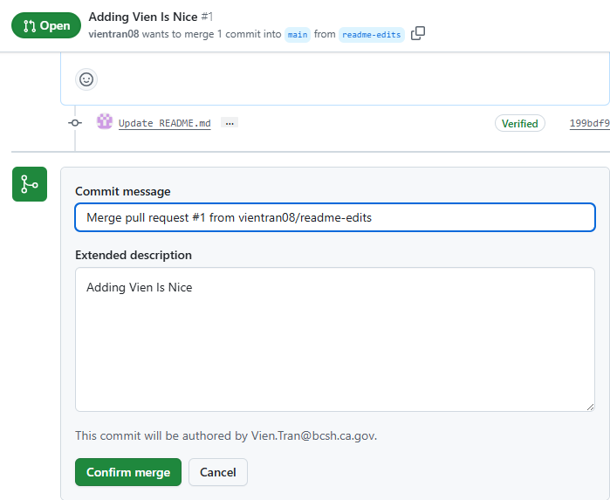
- Click Delete branch. Now that your pull request is merged and your changes are on main, you can safely delete the readme-edits branch. If you want to make more changes to your project, you can always create a new branch and repeat this process.
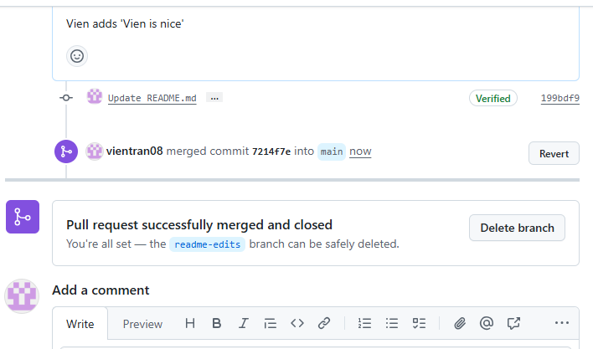
This is option. I think we should keep
-----------------------------------------------------------------------------------------------------------------------------
We can delete branch at any time:
Click Hello-World-1 repository, to return to repository .
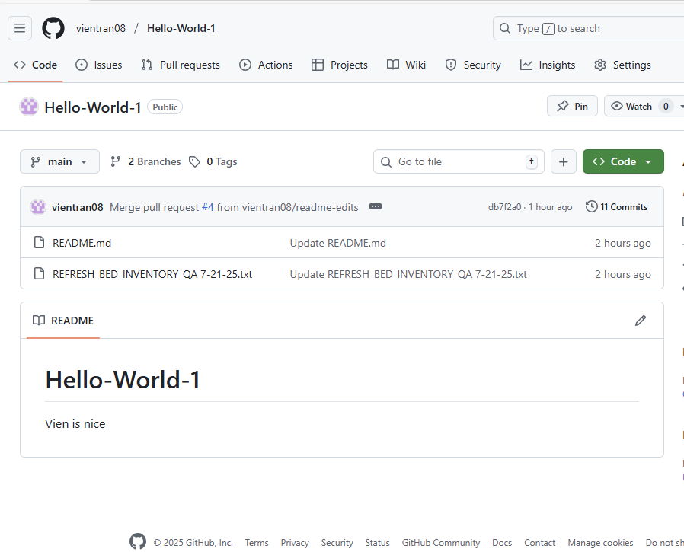
Click Second to go to branches summary.
Click First to come back to repository
Then click on Branches, we get
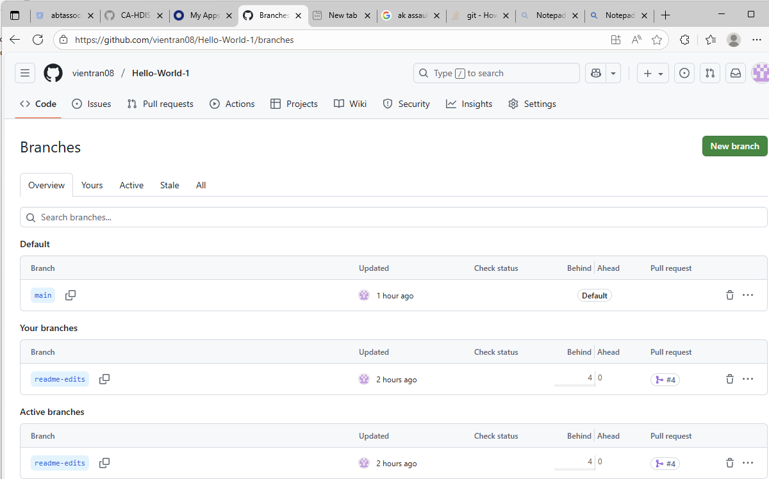
Now, we can delete any branches
---------------------------------------------------------------------------------------------------------------------------------------

- Click back to the Code tab of your hello-world repository to see your published changes on main.
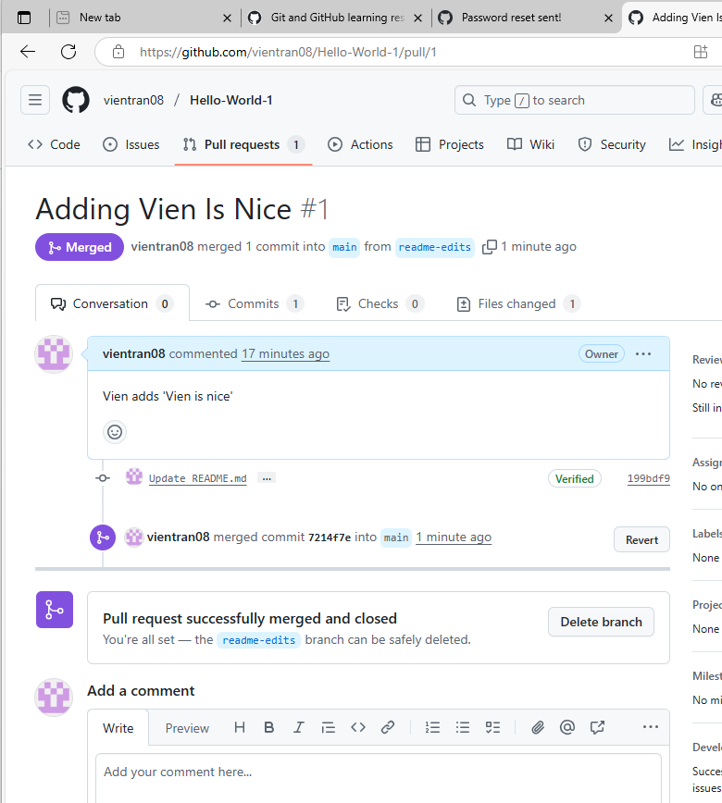

--------------------------------------------------------------------------------------------------------------------------------------------------
How to Delete a Repository
Go to that repository via
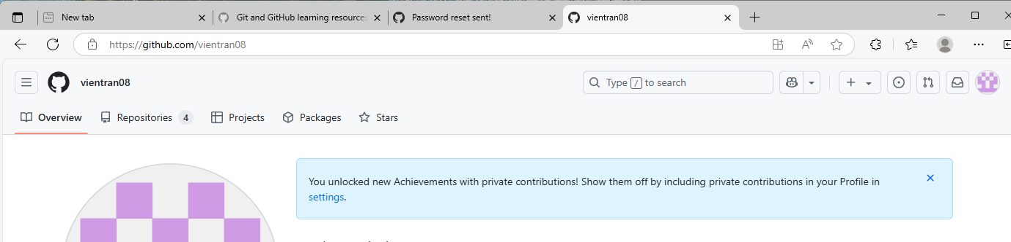
Click on Repository Menu tab
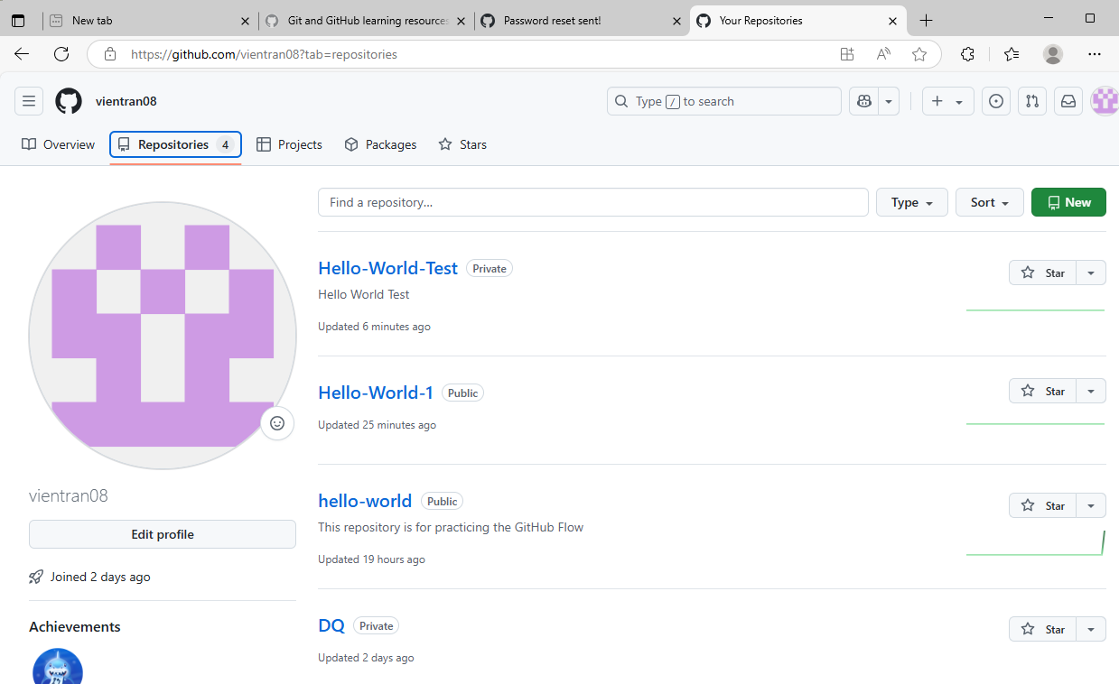
Click on Hello-World-Test, we get
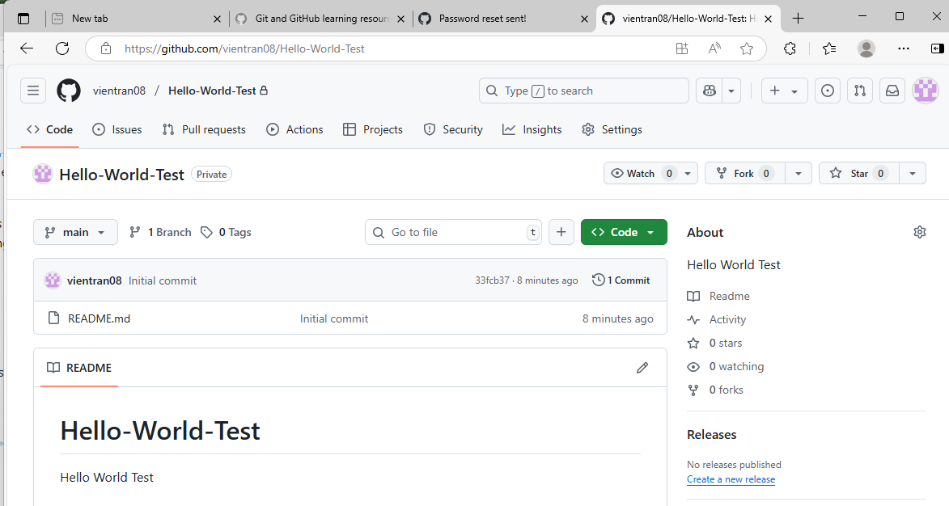
Click on Settings Menu
Then, go to Danger Zone and click on Delete this repository
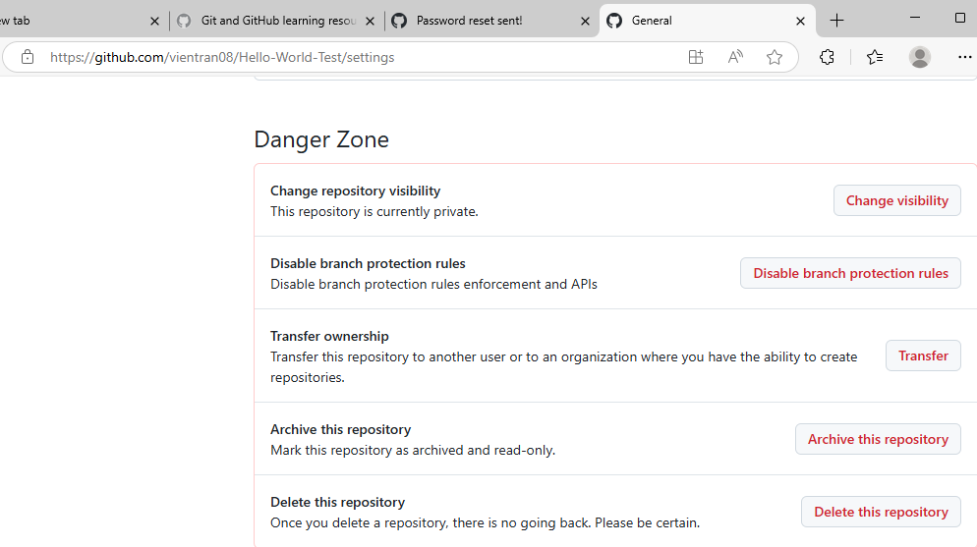
Then follow instruction to delete
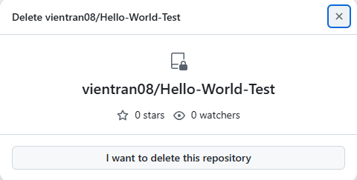
Click on ‘I want to delete this repository’, we get
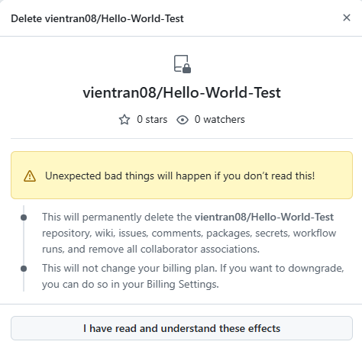
Click on ‘I have read and understand these effects’
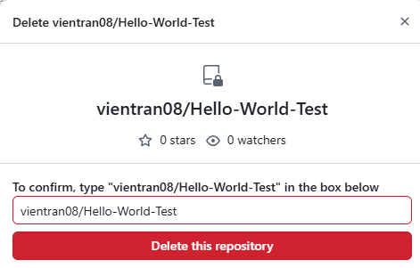
Click on Delete this repository, we get
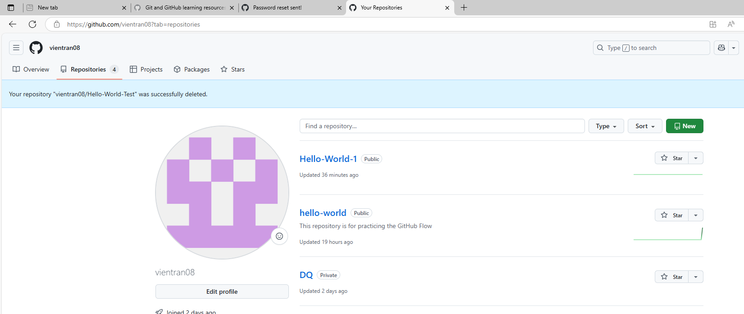
Hello-World-Test is missing.
------------------------------------------------------------------------------------------------------------
How to delete Branches
Click on Code Menu on top left and then click on Branches
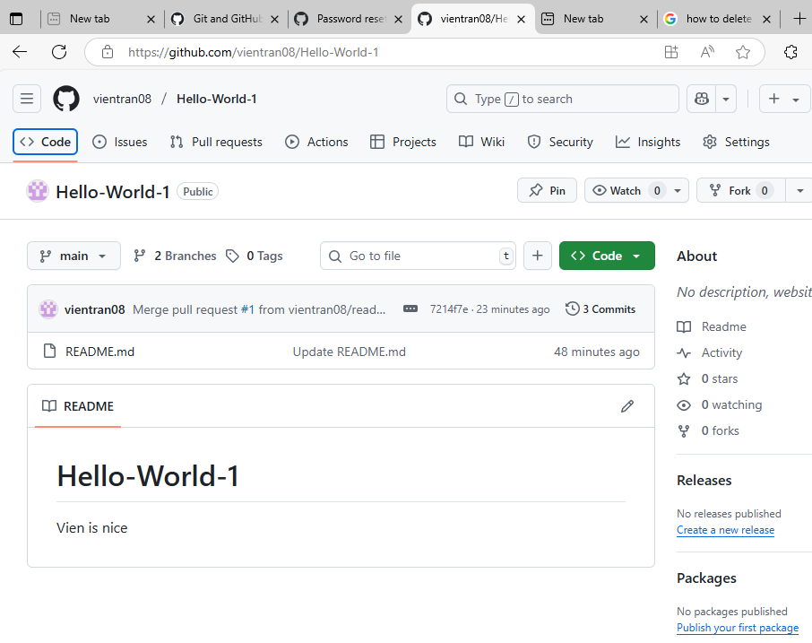

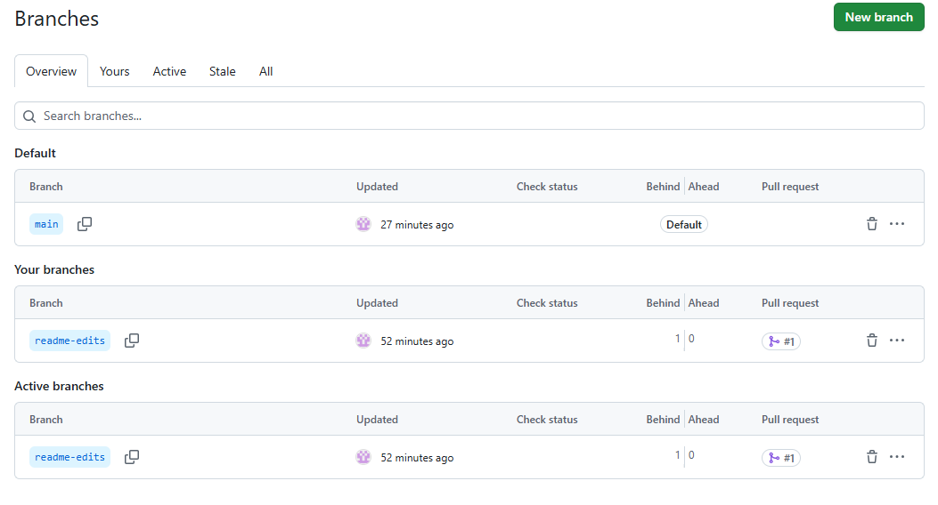
Select what garbage bin to delete
How to Add Files to Branches or Main.
Click on <>Code menu and click ‘Add file’ in readme-edits branch and select upload (We can select create new file)
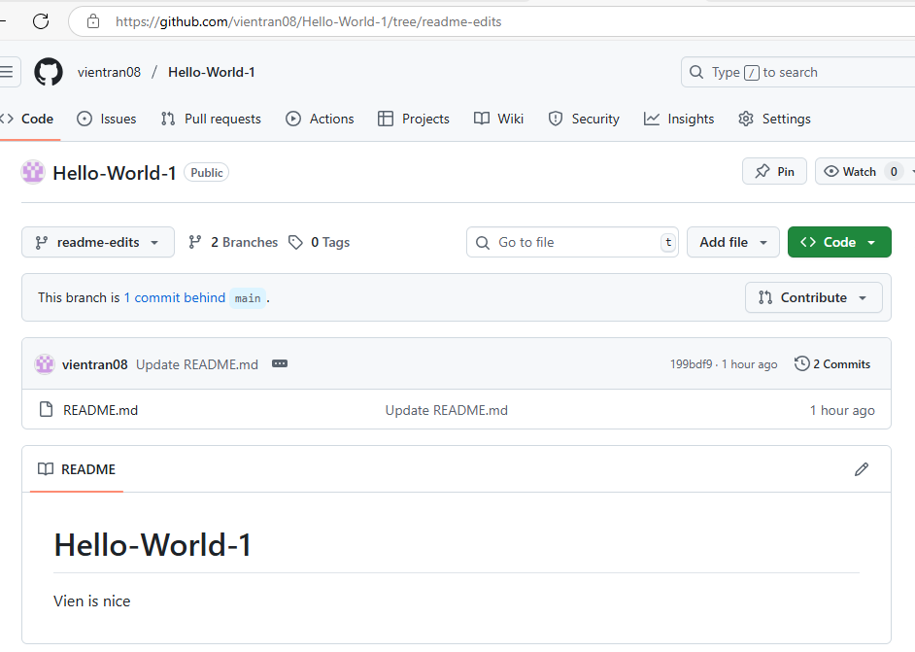
We get 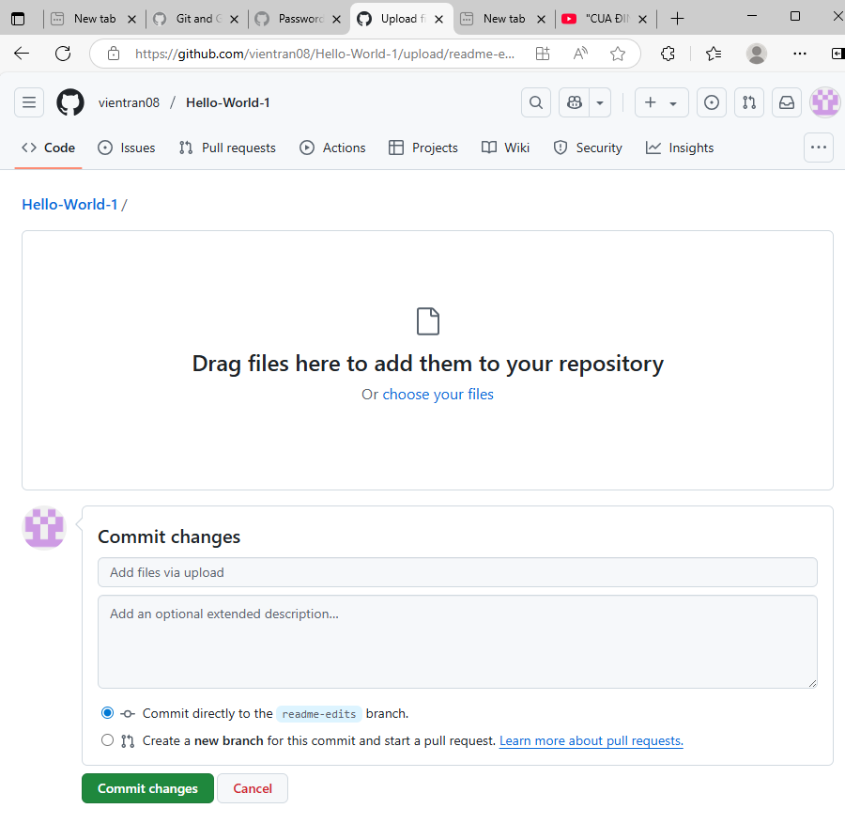
Drag files to ‘Drag files here to add then to your repository’ then click ‘Commit changes’ Then do as we edit readme files
- We do the same for Main.

How to Get Files at Specific Times In The Past
Click on <>Code menu in readme-edits, we get
All 2 Commits
Last Commit
Click on Last Commit to see the last commit. We see file changes
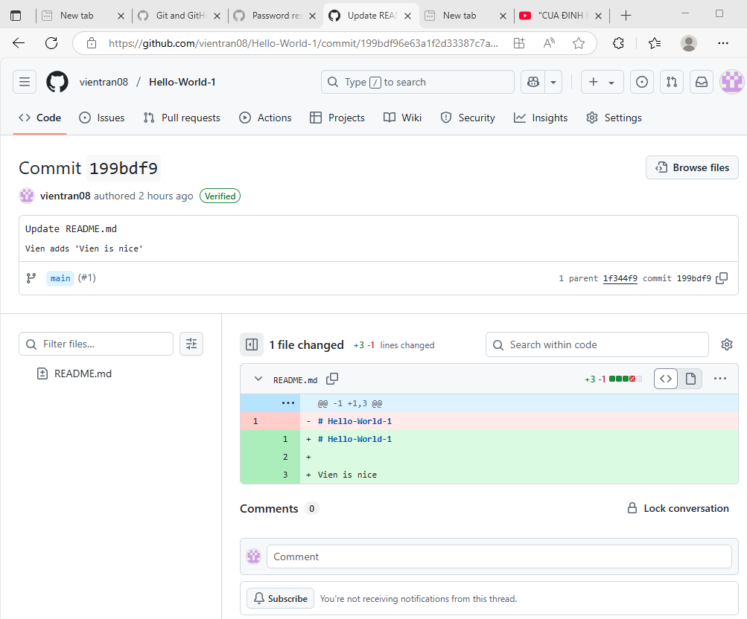
Click to see Last Commit File Name
Last Commit Name
Click on ‘All 2 Commit’ to see all of the commits. Then, we can go to each commit and click Browse files to see files for each commit.
How to get files from Repository
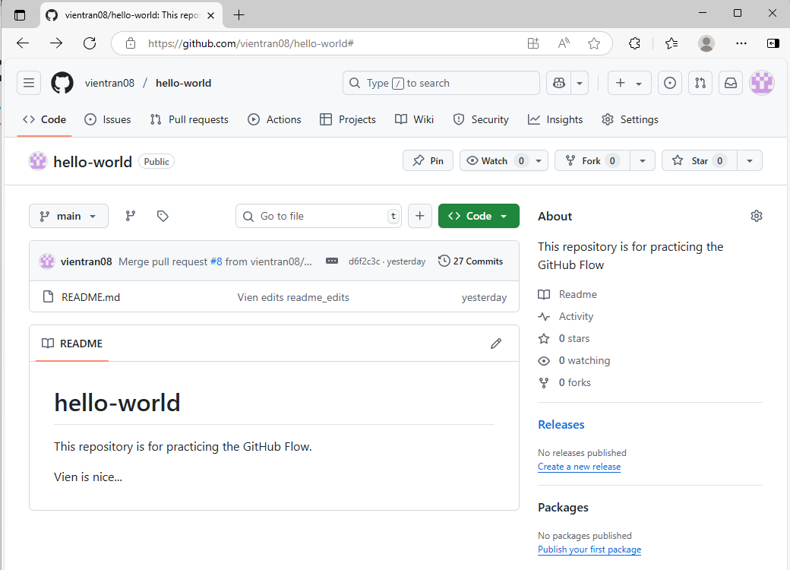
Click on <>Code menu. Right click on <>Code button and select Download zip
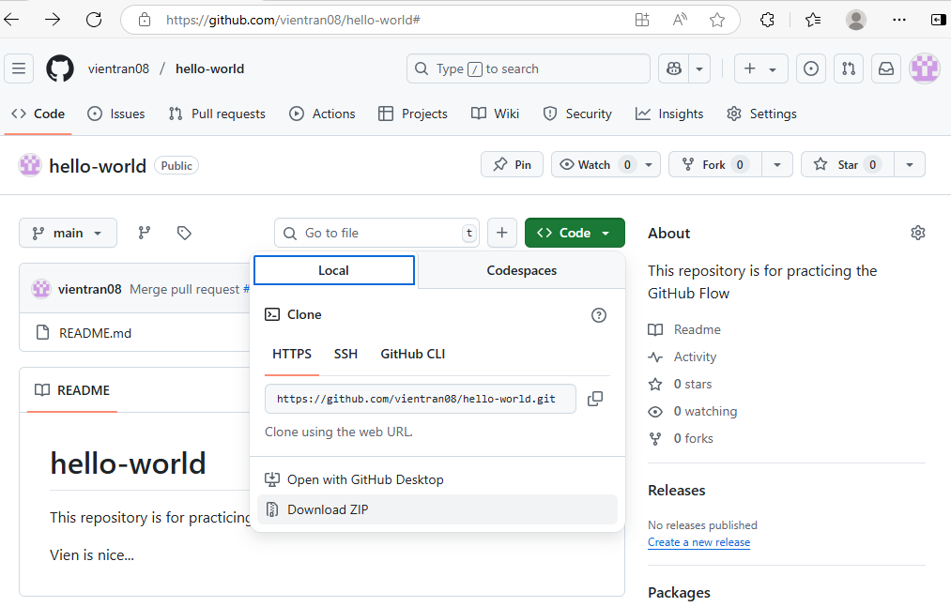
-------------------------------------------------------------------------------------------------------------
How to download a file to local computer
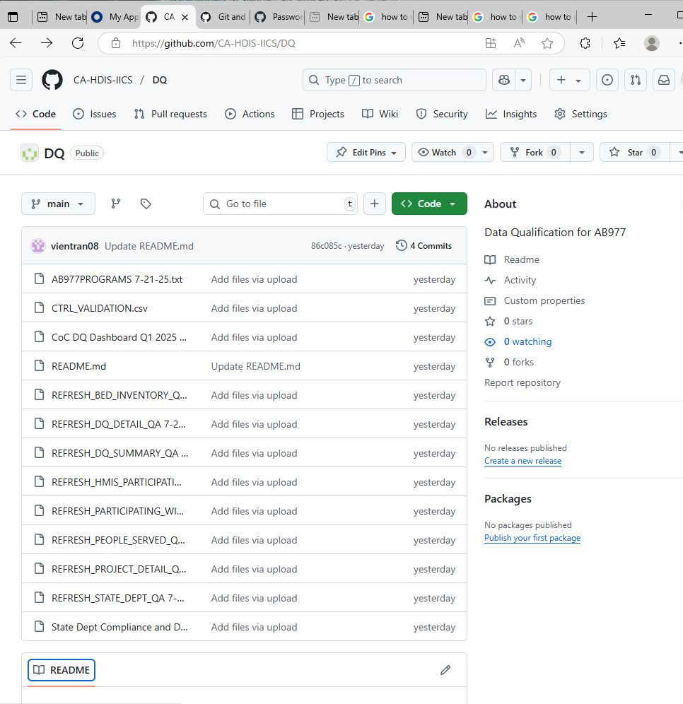
Click on <>Code, we will see a list of files. Click on a specific file, we get
REFRESH_BED_INVENTORY_QA 7-2-25, we get 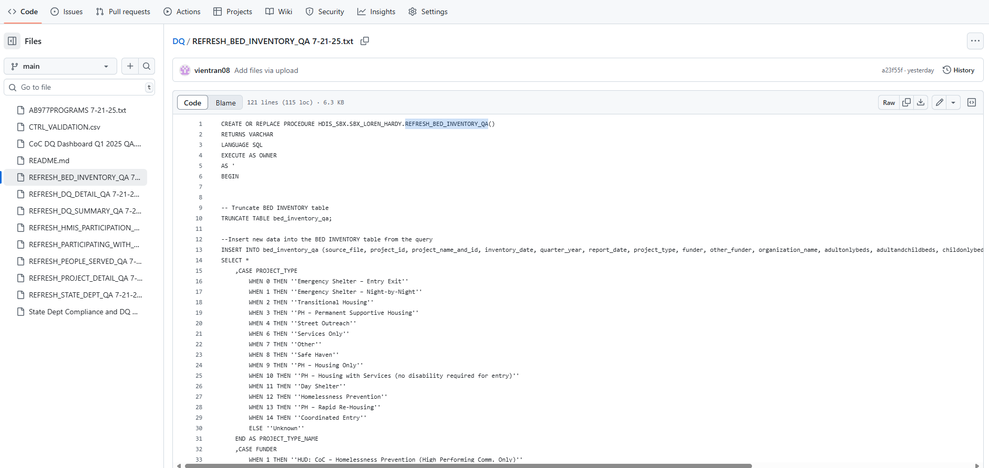
Click on Download, we will get download code.
------------------------------------------------------------------------------------------------------------------------
How to delete a file to local computer
Click on <>Code, we will see a list of files. Click on a specific file, we get
REFRESH_BED_INVENTORY_QA 7-2-25, we get
Click on More File Action and select delete.
How to compare 2 different branches one by one files.
In https://github.com/vientran08/Hello-World-1, we want to compare branches, main and readme-edits,
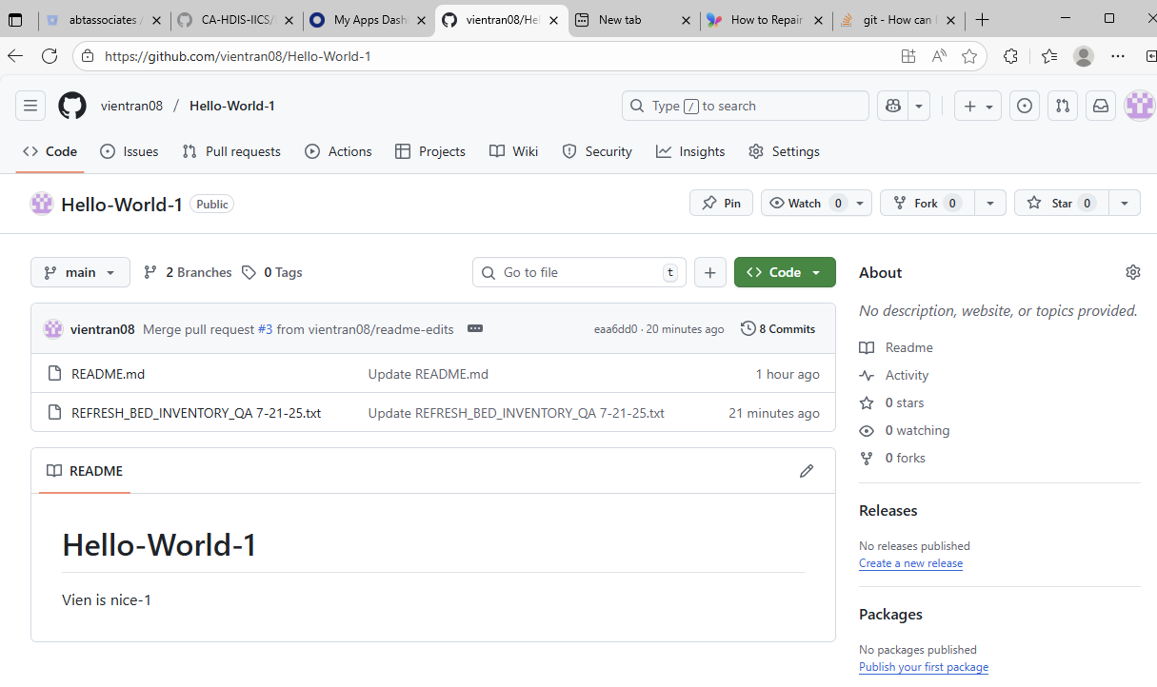
repository
Click on Hello-World-1 repository, we get
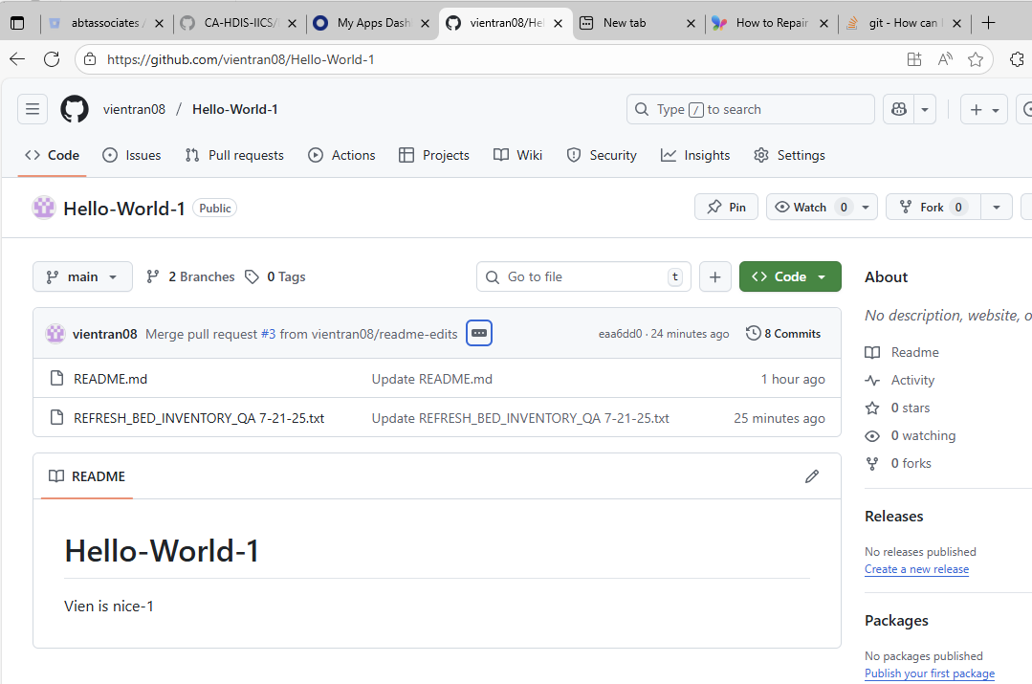
Click on main and select ‘readme-edits’, we get ‘readme-edits’ branch
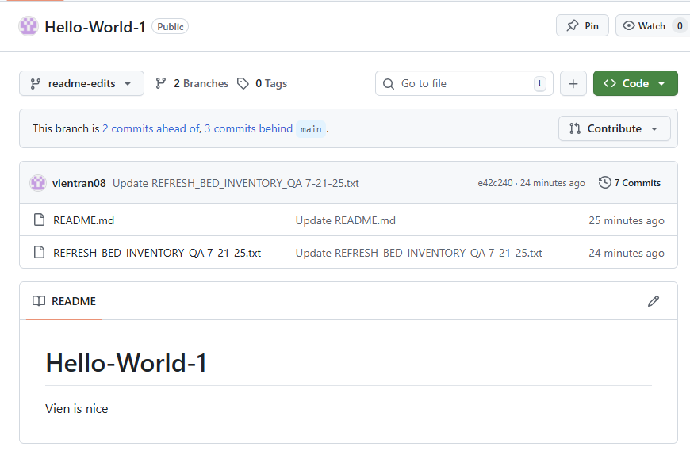
Click on ‘Contribute’, we get
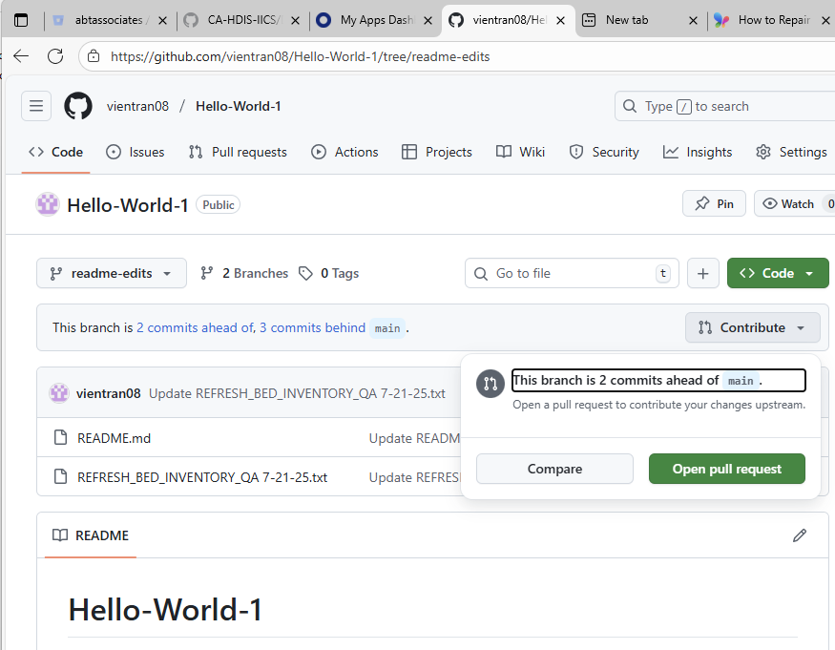
Click ‘Compare’ button, we get
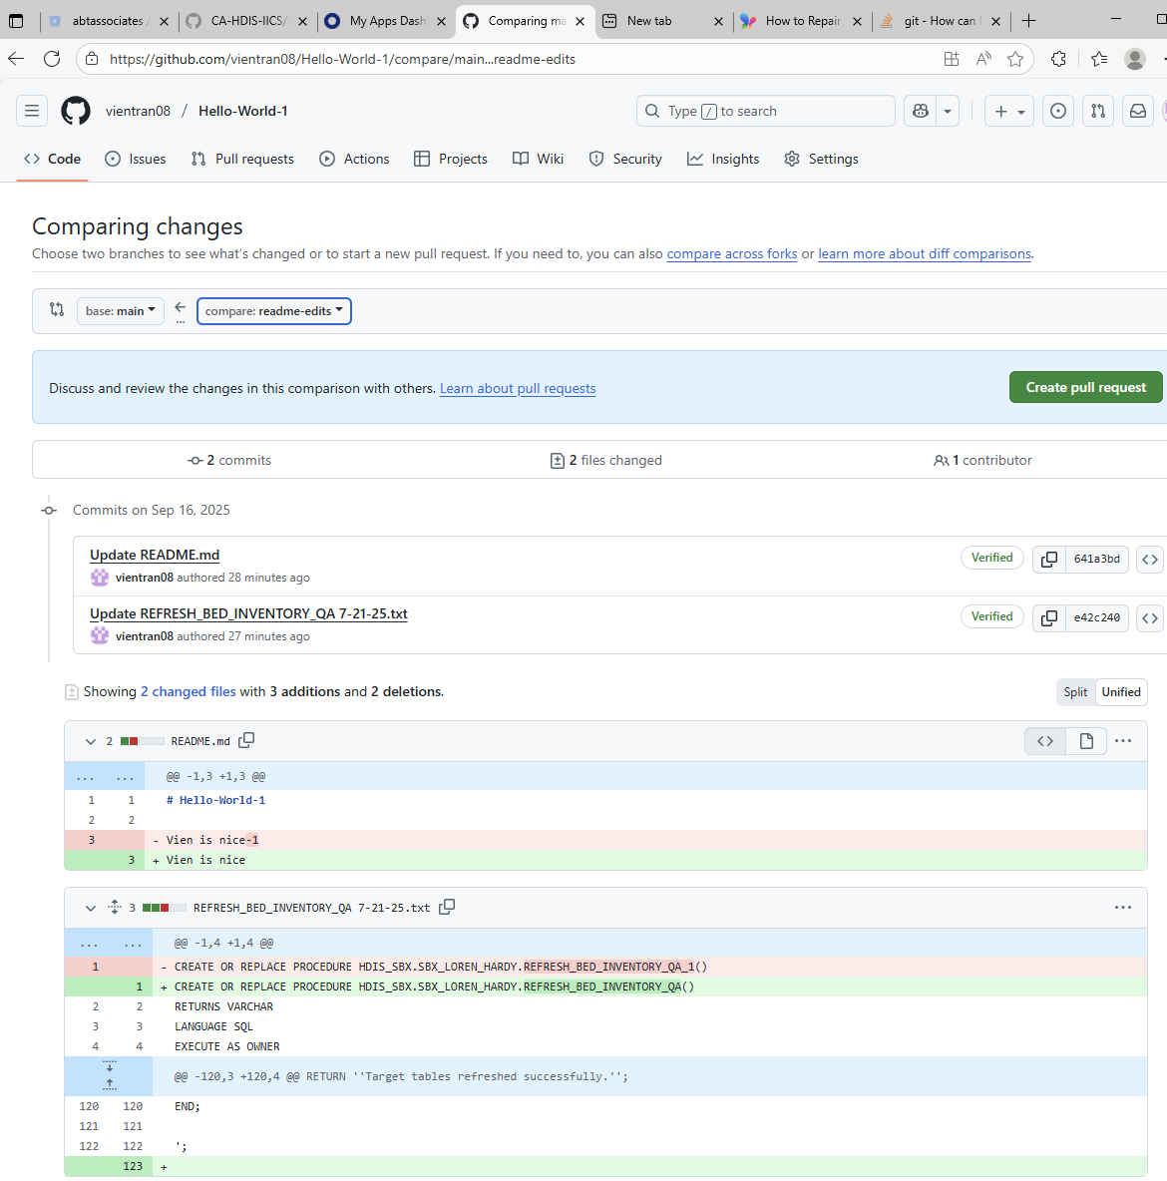
Click on ‘Hello-World-1’ to come back to main
Click on ‘Create pull request’ to update main branch. Follow instruction
Select to compare the different between branches.

