Nguyễn Thị Bạch Viên

MSSV: 1150080122

Mở Visual Studio → Create a new project → chọn Windows Forms App (.NET Framework)

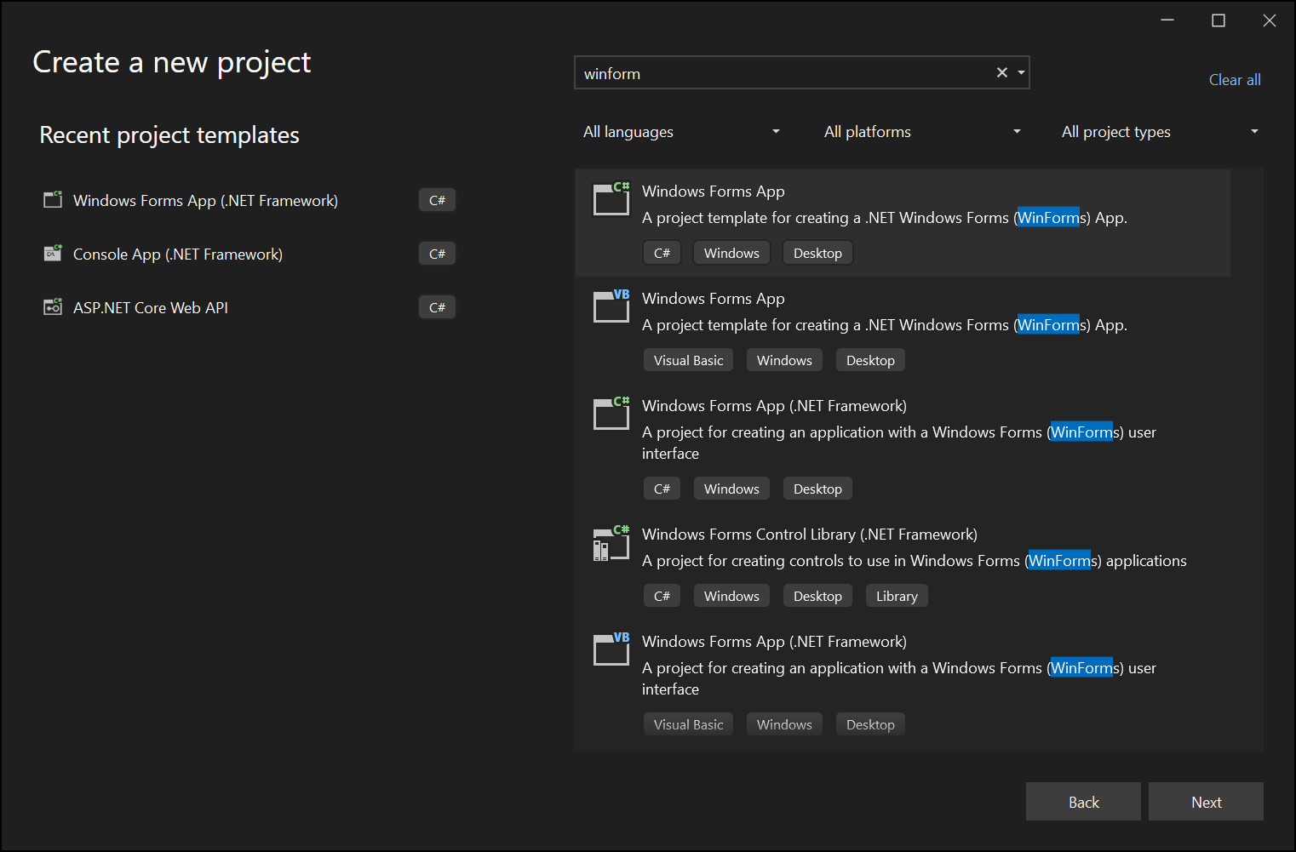

**THỰC HÀNH 1**

**CODE design.cs**

namespace _1150080122_OODB6

{

partial class Form1

{

private System.ComponentModel.IContainer components = null;

protected override void Dispose(bool disposing)

{

if (disposing && (components != null))

{

components.Dispose();

}

base.Dispose(disposing);

}

#region Windows Form Designer generated code

private void InitializeComponent()

{

this.cboBan = new System.Windows.Forms.ComboBox();

this.label1 = new System.Windows.Forms.Label();

this.pictureBox1 = new System.Windows.Forms.PictureBox();

this.groupBox1 = new System.Windows.Forms.GroupBox();

this.dgvOrder = new System.Windows.Forms.DataGridView();

this.btnHeader = new System.Windows.Forms.Button();

this.btnComChien = new System.Windows.Forms.Button();

this.btnOcRang = new System.Windows.Forms.Button();

this.btnBanhMi = new System.Windows.Forms.Button();

this.btnLipton = new System.Windows.Forms.Button();

this.btnCoca = new System.Windows.Forms.Button();

this.btn7up = new System.Windows.Forms.Button();

this.btnKhoaiTay = new System.Windows.Forms.Button();

this.btnCam = new System.Windows.Forms.Button();

this.btnMyXao = new System.Windows.Forms.Button();

this.btnCafe = new System.Windows.Forms.Button();

this.btnPepsi = new System.Windows.Forms.Button();

this.btnCaVien = new System.Windows.Forms.Button();

this.btnBurger = new System.Windows.Forms.Button();

this.btnDuiGa = new System.Windows.Forms.Button();

this.btnBunBoHue = new System.Windows.Forms.Button();

this.btnXoa = new System.Windows.Forms.Button();

this.btnOrder = new System.Windows.Forms.Button();

((System.ComponentModel.ISupportInitialize)(this.pictureBox1)).BeginInit();

this.groupBox1.SuspendLayout();

((System.ComponentModel.ISupportInitialize)(this.dgvOrder)).BeginInit();

this.SuspendLayout();

//

// cboBan

//

this.cboBan.FormattingEnabled = true;

this.cboBan.Location = new System.Drawing.Point(249, 320);

this.cboBan.Name = "cboBan";

this.cboBan.Size = new System.Drawing.Size(121, 24);

this.cboBan.TabIndex = 1;

//

// label1

//

this.label1.AutoSize = true;

this.label1.Font = new System.Drawing.Font("Microsoft Sans Serif", 9F);

this.label1.Location = new System.Drawing.Point(158, 324);

this.label1.Name = "label1";

this.label1.Size = new System.Drawing.Size(76, 18);

this.label1.TabIndex = 2;

this.label1.Text = "Chọn bàn:";

//

// pictureBox1

this.pictureBox1.Image = global::_1150080122_OODB6.Properties.Resources.Screenshot_2025_10_06_142028;

this.pictureBox1.Location = new System.Drawing.Point(-4, 12);

this.pictureBox1.Name = "pictureBox1";

this.pictureBox1.Size = new System.Drawing.Size(148, 88);

this.pictureBox1.TabStop = false;

//

// groupBox1

//

this.groupBox1.Controls.Add(this.btnBunBoHue);

this.groupBox1.Controls.Add(this.btnDuiGa);

this.groupBox1.Controls.Add(this.btnBurger);

this.groupBox1.Controls.Add(this.btnCaVien);

this.groupBox1.Controls.Add(this.btnPepsi);

this.groupBox1.Controls.Add(this.btnCafe);

this.groupBox1.Controls.Add(this.btnMyXao);

this.groupBox1.Controls.Add(this.btnCam);

this.groupBox1.Controls.Add(this.btnKhoaiTay);

this.groupBox1.Controls.Add(this.btn7up);

this.groupBox1.Controls.Add(this.btnCoca);

this.groupBox1.Controls.Add(this.btnLipton);

this.groupBox1.Controls.Add(this.btnBanhMi);

this.groupBox1.Controls.Add(this.btnOcRang);

this.groupBox1.Controls.Add(this.btnComChien);

this.groupBox1.Location = new System.Drawing.Point(-4, 106);

this.groupBox1.Name = "groupBox1";

this.groupBox1.Size = new System.Drawing.Size(547, 201);

this.groupBox1.TabStop = false;

this.groupBox1.Text = "Danh sách món ăn:";

//

// dgvOrder

//

this.dgvOrder.ColumnHeadersHeightSizeMode = System.Windows.Forms.DataGridViewColumnHeadersHeightSizeMode.AutoSize;

this.dgvOrder.Location = new System.Drawing.Point(-4, 359);

this.dgvOrder.Name = "dgvOrder";

this.dgvOrder.RowHeadersWidth = 51;

this.dgvOrder.RowTemplate.Height = 24;

this.dgvOrder.Size = new System.Drawing.Size(547, 169);

this.dgvOrder.TabIndex = 6;

//

// btnHeader

//

this.btnHeader.BackColor = System.Drawing.Color.LimeGreen;

this.btnHeader.Font = new System.Drawing.Font("Times New Roman", 17F);

this.btnHeader.ForeColor = System.Drawing.SystemColors.ButtonHighlight;

this.btnHeader.Location = new System.Drawing.Point(144, 12);

this.btnHeader.Name = "btnHeader";

this.btnHeader.Size = new System.Drawing.Size(399, 88);

this.btnHeader.TabIndex = 8;

this.btnHeader.Text = "Quán ăn nhanh Hưng Thịnh";

this.btnHeader.UseVisualStyleBackColor = false;

//

// Các nút món ăn

//

this.btnComChien.Location = new System.Drawing.Point(16, 21);

this.btnComChien.Size = new System.Drawing.Size(119, 33);

this.btnComChien.Text = "Cơm chiên trứng";

this.btnBanhMi.Location = new System.Drawing.Point(148, 21);

this.btnBanhMi.Size = new System.Drawing.Size(119, 33);

this.btnBanhMi.Text = "Bánh mì ốp la";

this.btnCoca.Location = new System.Drawing.Point(282, 21);

this.btnCoca.Size = new System.Drawing.Size(119, 33);

this.btnCoca.Text = "Coca";

this.btnLipton.Location = new System.Drawing.Point(417, 21);

this.btnLipton.Size = new System.Drawing.Size(119, 33);

this.btnLipton.Text = "Lipton";

this.btnOcRang.Location = new System.Drawing.Point(16, 60);

this.btnOcRang.Size = new System.Drawing.Size(119, 33);

this.btnOcRang.Text = "Ốc rang muối";

this.btnKhoaiTay.Location = new System.Drawing.Point(148, 60);

this.btnKhoaiTay.Size = new System.Drawing.Size(119, 33);

this.btnKhoaiTay.Text = "Khoai tây chiên";

this.btn7up.Location = new System.Drawing.Point(282, 60);

this.btn7up.Size = new System.Drawing.Size(119, 33);

this.btn7up.Text = "7 up";

this.btnCam.Location = new System.Drawing.Point(417, 60);

this.btnCam.Size = new System.Drawing.Size(119, 33);

this.btnCam.Text = "Cam";

this.btnMyXao.Location = new System.Drawing.Point(16, 99);

this.btnMyXao.Size = new System.Drawing.Size(119, 33);

this.btnMyXao.Text = "Mỳ xào hải sản";

this.btnCaVien.Location = new System.Drawing.Point(148, 99);

this.btnCaVien.Size = new System.Drawing.Size(119, 33);

this.btnCaVien.Text = "Cá viên chiên";

this.btnPepsi.Location = new System.Drawing.Point(282, 99);

this.btnPepsi.Size = new System.Drawing.Size(119, 33);

this.btnPepsi.Text = "Pepsi";

this.btnCafe.Location = new System.Drawing.Point(417, 99);

this.btnCafe.Size = new System.Drawing.Size(119, 33);

this.btnCafe.Text = "Cafe";

this.btnBurger.Location = new System.Drawing.Point(16, 138);

this.btnBurger.Size = new System.Drawing.Size(119, 33);

this.btnBurger.Text = "Burger bò nướng";

this.btnDuiGa.Location = new System.Drawing.Point(148, 138);

this.btnDuiGa.Size = new System.Drawing.Size(119, 33);

this.btnDuiGa.Text = "Đùi gà rán";

this.btnBunBoHue.Location = new System.Drawing.Point(282, 138);

this.btnBunBoHue.Size = new System.Drawing.Size(254, 33);

this.btnBunBoHue.Text = "Bún bò Huế";

//

// btnXoa

//

this.btnXoa.Location = new System.Drawing.Point(12, 315);

this.btnXoa.Name = "btnXoa";

this.btnXoa.Size = new System.Drawing.Size(93, 33);

this.btnXoa.Text = "Xóa";

this.btnXoa.UseVisualStyleBackColor = true;

//

// btnOrder

//

this.btnOrder.Location = new System.Drawing.Point(437, 315);

this.btnOrder.Name = "btnOrder";

this.btnOrder.Size = new System.Drawing.Size(93, 33);

this.btnOrder.Text = "Order";

this.btnOrder.UseVisualStyleBackColor = true;

//

// Form1

//

this.AutoScaleDimensions = new System.Drawing.SizeF(8F, 16F);

this.AutoScaleMode = System.Windows.Forms.AutoScaleMode.Font;

this.ClientSize = new System.Drawing.Size(542, 525);

this.Controls.Add(this.btnOrder);

this.Controls.Add(this.btnXoa);

this.Controls.Add(this.btnHeader);

this.Controls.Add(this.dgvOrder);

this.Controls.Add(this.groupBox1);

this.Controls.Add(this.pictureBox1);

this.Controls.Add(this.cboBan);

this.Controls.Add(this.label1);

this.Text = "Quán ăn nhanh Hưng Thịnh";

this.Load += new System.EventHandler(this.Form1_Load);

((System.ComponentModel.ISupportInitialize)(this.pictureBox1)).EndInit();

this.groupBox1.ResumeLayout(false);

((System.ComponentModel.ISupportInitialize)(this.dgvOrder)).EndInit();

this.ResumeLayout(false);

this.PerformLayout();

}

#endregion

private System.Windows.Forms.ComboBox cboBan;

private System.Windows.Forms.Label label1;

private System.Windows.Forms.PictureBox pictureBox1;

private System.Windows.Forms.GroupBox groupBox1;

private System.Windows.Forms.DataGridView dgvOrder;

private System.Windows.Forms.Button btnHeader;

private System.Windows.Forms.Button btnComChien;

private System.Windows.Forms.Button btnOcRang;

private System.Windows.Forms.Button btnBanhMi;

private System.Windows.Forms.Button btnLipton;

private System.Windows.Forms.Button btnCoca;

private System.Windows.Forms.Button btn7up;

private System.Windows.Forms.Button btnKhoaiTay;

private System.Windows.Forms.Button btnCam;

private System.Windows.Forms.Button btnMyXao;

private System.Windows.Forms.Button btnCafe;

private System.Windows.Forms.Button btnPepsi;

private System.Windows.Forms.Button btnCaVien;

private System.Windows.Forms.Button btnBurger;

private System.Windows.Forms.Button btnDuiGa;

private System.Windows.Forms.Button btnBunBoHue;

private System.Windows.Forms.Button btnXoa;

private System.Windows.Forms.Button btnOrder;

}

}

**CODE Form.cs**

using System;

using System.Data;

using System.IO;

using System.Windows.Forms;

namespace _1150080122_OODB6

{

public partial class Form1 : Form

{

DataTable dtOrder = new DataTable();

public Form1()

{

InitializeComponent();

}

private void Form1_Load(object sender, EventArgs e)

{

// Danh sách bàn

cboBan.Items.AddRange(new string[] { "Bàn 1", "Bàn 2", "Bàn 3", "Bàn 4", "Bàn 5" });

cboBan.SelectedIndex = 0;

// Cấu trúc bảng hiển thị món ăn

dtOrder.Columns.Add("Tên món");

dtOrder.Columns.Add("Số lượng");

dgvOrder.DataSource = dtOrder;

dgvOrder.AutoSizeColumnsMode = DataGridViewAutoSizeColumnsMode.Fill;

// Gắn sự kiện Click cho tất cả các nút món ăn

GanSuKienMonAn();

}

// Hàm gắn sự kiện động cho các nút món ăn

private void GanSuKienMonAn()

{

btnComChien.Click += (s, e) => ThemMon("Cơm chiên trứng");

btnBanhMi.Click += (s, e) => ThemMon("Bánh mì ốp la");

btnCoca.Click += (s, e) => ThemMon("Coca");

btnLipton.Click += (s, e) => ThemMon("Lipton");

btnOcRang.Click += (s, e) => ThemMon("Ốc rang muối");

btnKhoaiTay.Click += (s, e) => ThemMon("Khoai tây chiên");

btn7up.Click += (s, e) => ThemMon("7 Up");

btnCam.Click += (s, e) => ThemMon("Cam ép");

btnMyXao.Click += (s, e) => ThemMon("Mỳ xào hải sản");

btnCaVien.Click += (s, e) => ThemMon("Cá viên chiên");

btnPepsi.Click += (s, e) => ThemMon("Pepsi");

btnCafe.Click += (s, e) => ThemMon("Cafe sữa đá");

btnBurger.Click += (s, e) => ThemMon("Burger bò nướng");

btnDuiGa.Click += (s, e) => ThemMon("Đùi gà rán");

btnBunBoHue.Click += (s, e) => ThemMon("Bún bò Huế");

btnXoa.Click += btnXoa_Click;

btnOrder.Click += btnOrder_Click;

}

// 🥘 Hàm thêm món (nếu món đã có thì tăng số lượng)

private void ThemMon(string tenMon)

{

foreach (DataRow row in dtOrder.Rows)

{

if (row["Tên món"].ToString() == tenMon)

{

int sl = int.Parse(row["Số lượng"].ToString());

row["Số lượng"] = sl + 1;

return;

}

}

dtOrder.Rows.Add(tenMon, 1);

}

// Nút Xóa

private void btnXoa_Click(object sender, EventArgs e)

{

if (dgvOrder.CurrentRow != null)

{

dgvOrder.Rows.RemoveAt(dgvOrder.CurrentRow.Index);

}

else

{

MessageBox.Show("Vui lòng chọn món cần xóa!", "Thông báo", MessageBoxButtons.OK, MessageBoxIcon.Warning);

}

}

// 📦 Nút Order (ghi ra file txt)

private void btnOrder_Click(object sender, EventArgs e)

{

if (dtOrder.Rows.Count == 0)

{

MessageBox.Show("Chưa có món nào để order!", "Thông báo", MessageBoxButtons.OK, MessageBoxIcon.Information);

return;

}

string tenFile = $"Order_{cboBan.Text.Replace(" ", "_")}.txt";

using (StreamWriter sw = new StreamWriter(tenFile))

{

sw.WriteLine($"--- DANH SÁCH ORDER CHO {cboBan.Text} ---");

sw.WriteLine($"Thời gian: {DateTime.Now}");

sw.WriteLine("----------------------------------------");

foreach (DataRow row in dtOrder.Rows)

{

sw.WriteLine($"{row["Tên món"],-25} : {row["Số lượng"]}");

}

sw.WriteLine("----------------------------------------");

sw.WriteLine("Cảm ơn quý khách!");

}

MessageBox.Show($"Đã lưu order của {cboBan.Text} vào file:\n{tenFile}",

"Thành công", MessageBoxButtons.OK, MessageBoxIcon.Information);

}

// Nút Thoát (nếu bạn muốn thêm)

private void btnThoat_Click(object sender, EventArgs e)

{

if (MessageBox.Show("Bạn có chắc muốn thoát không?",

"Xác nhận", MessageBoxButtons.YesNo, MessageBoxIcon.Question) == DialogResult.Yes)

{

Application.Exit();

}

}

}

}

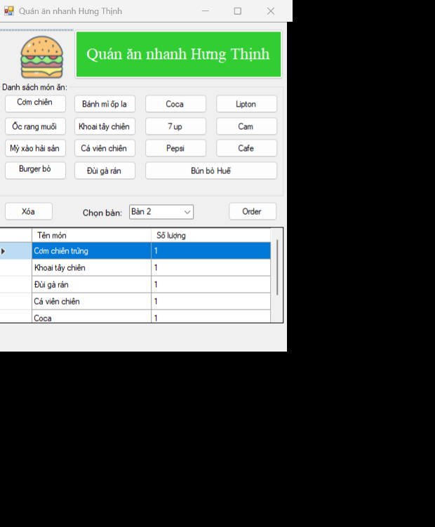

**THỰC HÀNH 2:**

**Tạo form 2: Add New item**

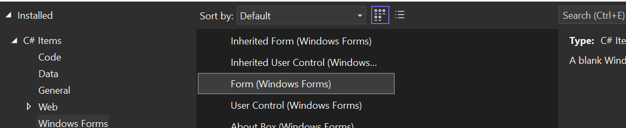

**Sửa lại trong Program.cs để chạy form2**

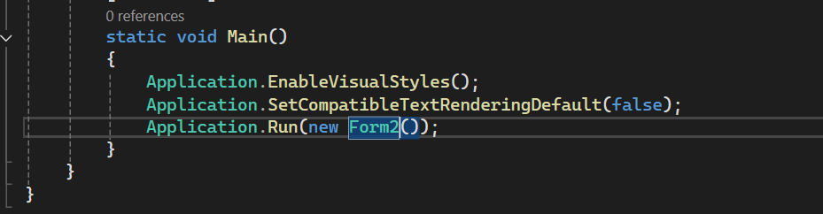

**CODE design .cs**

using System;

namespace _1150080122_OODB6

{

partial class Form2

{

/// <summary>

/// Required designer variable.

/// </summary>

private System.ComponentModel.IContainer components = null;

protected override void Dispose(bool disposing)

{

if (disposing && (components != null))

{

components.Dispose();

}

base.Dispose(disposing);

}

#region Windows Form Designer generated code

private void InitializeComponent()

{

this.labelTitle = new System.Windows.Forms.Label();

this.groupBox1 = new System.Windows.Forms.GroupBox();

this.txtDiaChi = new System.Windows.Forms.TextBox();

this.label4 = new System.Windows.Forms.Label();

this.dtpNgaySinh = new System.Windows.Forms.DateTimePicker();

this.label3 = new System.Windows.Forms.Label();

this.txtLop = new System.Windows.Forms.TextBox();

this.label2 = new System.Windows.Forms.Label();

this.txtHoTen = new System.Windows.Forms.TextBox();

this.label1 = new System.Windows.Forms.Label();

this.groupBox2 = new System.Windows.Forms.GroupBox();

this.btnThoat = new System.Windows.Forms.Button();

this.btnXoa = new System.Windows.Forms.Button();

this.btnSua = new System.Windows.Forms.Button();

this.btnThem = new System.Windows.Forms.Button();

this.groupBox3 = new System.Windows.Forms.GroupBox();

this.dgvSinhVien = new System.Windows.Forms.DataGridView();

this.colHoTen = new System.Windows.Forms.DataGridViewTextBoxColumn();

this.colNgaySinh = new System.Windows.Forms.DataGridViewTextBoxColumn();

this.colLop = new System.Windows.Forms.DataGridViewTextBoxColumn();

this.colDiaChi = new System.Windows.Forms.DataGridViewTextBoxColumn();

this.groupBox1.SuspendLayout();

this.groupBox2.SuspendLayout();

this.groupBox3.SuspendLayout();

((System.ComponentModel.ISupportInitialize)(this.dgvSinhVien)).BeginInit();

this.SuspendLayout();

//

// labelTitle

//

this.labelTitle.Dock = System.Windows.Forms.DockStyle.Top;

this.labelTitle.Font = new System.Drawing.Font("Microsoft Sans Serif", 18F, System.Drawing.FontStyle.Bold);

this.labelTitle.ForeColor = System.Drawing.Color.DodgerBlue;

this.labelTitle.Location = new System.Drawing.Point(0, 0);

this.labelTitle.Name = "labelTitle";

this.labelTitle.Size = new System.Drawing.Size(810, 40);

this.labelTitle.TabIndex = 0;

this.labelTitle.Text = "DANH MỤC SINH VIÊN";

this.labelTitle.TextAlign = System.Drawing.ContentAlignment.MiddleCenter;

//

// groupBox1

//

this.groupBox1.Controls.Add(this.txtDiaChi);

this.groupBox1.Controls.Add(this.label4);

this.groupBox1.Controls.Add(this.dtpNgaySinh);

this.groupBox1.Controls.Add(this.label3);

this.groupBox1.Controls.Add(this.txtLop);

this.groupBox1.Controls.Add(this.label2);

this.groupBox1.Controls.Add(this.txtHoTen);

this.groupBox1.Controls.Add(this.label1);

this.groupBox1.Location = new System.Drawing.Point(12, 43);

this.groupBox1.Name = "groupBox1";

this.groupBox1.Size = new System.Drawing.Size(596, 100);

this.groupBox1.TabIndex = 1;

this.groupBox1.TabStop = false;

this.groupBox1.Text = "Thông tin sinh viên:";

//

// txtDiaChi

//

this.txtDiaChi.Location = new System.Drawing.Point(372, 60);

this.txtDiaChi.Name = "txtDiaChi";

this.txtDiaChi.Size = new System.Drawing.Size(200, 26);

this.txtDiaChi.TabIndex = 7;

//

// label4

//

this.label4.AutoSize = true;

this.label4.Location = new System.Drawing.Point(315, 63);

this.label4.Name = "label4";

this.label4.Size = new System.Drawing.Size(61, 20);

this.label4.TabIndex = 6;

this.label4.Text = "Địa chỉ:";

//

// dtpNgaySinh

//

this.dtpNgaySinh.Format = System.Windows.Forms.DateTimePickerFormat.Short;

this.dtpNgaySinh.Location = new System.Drawing.Point(90, 60);

this.dtpNgaySinh.Name = "dtpNgaySinh";

this.dtpNgaySinh.Size = new System.Drawing.Size(200, 26);

this.dtpNgaySinh.TabIndex = 5;

//

// label3

//

this.label3.AutoSize = true;

this.label3.Location = new System.Drawing.Point(22, 63);

this.label3.Name = "label3";

this.label3.Size = new System.Drawing.Size(82, 20);

this.label3.TabIndex = 4;

this.label3.Text = "Ngày sinh:";

//

// txtLop

//

this.txtLop.Location = new System.Drawing.Point(372, 25);

this.txtLop.Name = "txtLop";

this.txtLop.Size = new System.Drawing.Size(200, 26);

this.txtLop.TabIndex = 3;

//

// label2

//

this.label2.AutoSize = true;

this.label2.Location = new System.Drawing.Point(315, 28);

this.label2.Name = "label2";

this.label2.Size = new System.Drawing.Size(40, 20);

this.label2.TabIndex = 2;

this.label2.Text = "Lớp:";

//

// txtHoTen

//

this.txtHoTen.Location = new System.Drawing.Point(90, 25);

this.txtHoTen.Name = "txtHoTen";

this.txtHoTen.Size = new System.Drawing.Size(200, 26);

this.txtHoTen.TabIndex = 1;

//

// label1

//

this.label1.AutoSize = true;

this.label1.Location = new System.Drawing.Point(22, 28);

this.label1.Name = "label1";

this.label1.Size = new System.Drawing.Size(65, 20);

this.label1.TabIndex = 0;

this.label1.Text = "Họ tên: ";

//

// groupBox2

//

this.groupBox2.Controls.Add(this.btnThoat);

this.groupBox2.Controls.Add(this.btnXoa);

this.groupBox2.Controls.Add(this.btnSua);

this.groupBox2.Controls.Add(this.btnThem);

this.groupBox2.Location = new System.Drawing.Point(12, 149);

this.groupBox2.Name = "groupBox2";

this.groupBox2.Size = new System.Drawing.Size(596, 60);

this.groupBox2.TabIndex = 2;

this.groupBox2.TabStop = false;

this.groupBox2.Text = "Chức năng:";

//

// btnThoat

//

this.btnThoat.Location = new System.Drawing.Point(460, 20);

this.btnThoat.Name = "btnThoat";

this.btnThoat.Size = new System.Drawing.Size(90, 30);

this.btnThoat.TabIndex = 3;

this.btnThoat.Text = "Thoát";

this.btnThoat.UseVisualStyleBackColor = true;

//

// btnXoa

//

this.btnXoa.Location = new System.Drawing.Point(320, 20);

this.btnXoa.Name = "btnXoa";

this.btnXoa.Size = new System.Drawing.Size(90, 30);

this.btnXoa.TabIndex = 2;

this.btnXoa.Text = "Xóa";

this.btnXoa.UseVisualStyleBackColor = true;

//

// btnSua

//

this.btnSua.Location = new System.Drawing.Point(180, 20);

this.btnSua.Name = "btnSua";

this.btnSua.Size = new System.Drawing.Size(90, 30);

this.btnSua.TabIndex = 1;

this.btnSua.Text = "Sửa";

this.btnSua.UseVisualStyleBackColor = true;

//

// btnThem

//

this.btnThem.Location = new System.Drawing.Point(40, 20);

this.btnThem.Name = "btnThem";

this.btnThem.Size = new System.Drawing.Size(90, 30);

this.btnThem.TabIndex = 0;

this.btnThem.Text = "Thêm";

this.btnThem.UseVisualStyleBackColor = true;

//

// groupBox3

//

this.groupBox3.Controls.Add(this.dgvSinhVien);

this.groupBox3.Location = new System.Drawing.Point(12, 215);

this.groupBox3.Name = "groupBox3";

this.groupBox3.Size = new System.Drawing.Size(596, 150);

this.groupBox3.TabIndex = 3;

this.groupBox3.TabStop = false;

this.groupBox3.Text = "Thông tin chung sinh viên:";

//

// dgvSinhVien

//

this.dgvSinhVien.ColumnHeadersHeightSizeMode = System.Windows.Forms.DataGridViewColumnHeadersHeightSizeMode.AutoSize;

this.dgvSinhVien.Columns.AddRange(new System.Windows.Forms.DataGridViewColumn[] {

this.colHoTen,

this.colNgaySinh,

this.colLop,

this.colDiaChi});

this.dgvSinhVien.Dock = System.Windows.Forms.DockStyle.Fill;

this.dgvSinhVien.Location = new System.Drawing.Point(3, 22);

this.dgvSinhVien.Name = "dgvSinhVien";

this.dgvSinhVien.RowHeadersWidth = 82;

this.dgvSinhVien.Size = new System.Drawing.Size(590, 125);

this.dgvSinhVien.TabIndex = 0;

//

// colHoTen

//

this.colHoTen.HeaderText = "Họ tên";

this.colHoTen.MinimumWidth = 10;

this.colHoTen.Name = "colHoTen";

this.colHoTen.Width = 150;

//

// colNgaySinh

//

this.colNgaySinh.HeaderText = "Ngày sinh";

this.colNgaySinh.MinimumWidth = 10;

this.colNgaySinh.Name = "colNgaySinh";

this.colNgaySinh.Width = 200;

//

// colLop

//

this.colLop.HeaderText = "Lớp";

this.colLop.MinimumWidth = 10;

this.colLop.Name = "colLop";

this.colLop.Width = 200;

//

// colDiaChi

//

this.colDiaChi.HeaderText = "Địa chỉ";

this.colDiaChi.MinimumWidth = 10;

this.colDiaChi.Name = "colDiaChi";

this.colDiaChi.Width = 150;

//

// Form2

//

this.ClientSize = new System.Drawing.Size(810, 508);

this.Controls.Add(this.groupBox3);

this.Controls.Add(this.groupBox2);

this.Controls.Add(this.groupBox1);

this.Controls.Add(this.labelTitle);

this.Name = "Form2";

this.Text = "Danh sách sinh viên";

this.Load += new System.EventHandler(this.Form2_Load);

this.groupBox1.ResumeLayout(false);

this.groupBox1.PerformLayout();

this.groupBox2.ResumeLayout(false);

this.groupBox3.ResumeLayout(false);

((System.ComponentModel.ISupportInitialize)(this.dgvSinhVien)).EndInit();

this.ResumeLayout(false);

}

private void Form2_Load(object sender, EventArgs e)

{

}

#endregion

private System.Windows.Forms.Label labelTitle;

private System.Windows.Forms.GroupBox groupBox1;

private System.Windows.Forms.TextBox txtDiaChi;

private System.Windows.Forms.Label label4;

private System.Windows.Forms.DateTimePicker dtpNgaySinh;

private System.Windows.Forms.Label label3;

private System.Windows.Forms.TextBox txtLop;

private System.Windows.Forms.Label label2;

private System.Windows.Forms.TextBox txtHoTen;

private System.Windows.Forms.Label label1;

private System.Windows.Forms.GroupBox groupBox2;

private System.Windows.Forms.Button btnThoat;

private System.Windows.Forms.Button btnXoa;

private System.Windows.Forms.Button btnSua;

private System.Windows.Forms.Button btnThem;

private System.Windows.Forms.GroupBox groupBox3;

private System.Windows.Forms.DataGridView dgvSinhVien;

private System.Windows.Forms.DataGridViewTextBoxColumn colHoTen;

private System.Windows.Forms.DataGridViewTextBoxColumn colNgaySinh;

private System.Windows.Forms.DataGridViewTextBoxColumn colLop;

private System.Windows.Forms.DataGridViewTextBoxColumn colDiaChi;

}

}

**CODE form2.cs**

using System;

using System.Windows.Forms;

namespace _1150080122_OODB6

{

public partial class Form2 : Form

{

public Form2()

{

InitializeComponent();

// Cấu hình DataGridView

dgvSinhVien.SelectionMode = DataGridViewSelectionMode.FullRowSelect;

dgvSinhVien.MultiSelect = false;

dgvSinhVien.AllowUserToAddRows = false;

dgvSinhVien.ReadOnly = true;

// Nếu chưa có cột trong Designer thì tạo ở đây

EnsureColumns();

// Gắn sự kiện (nếu bạn đã gắn trong Designer rồi thì vẫn OK, không lỗi)

btnThem.Click += btnThem_Click;

btnXoa.Click += btnXoa_Click;

btnSua.Click += btnSua_Click;

btnThoat.Click += btnThoat_Click;

dgvSinhVien.SelectionChanged += dgvSinhVien_SelectionChanged;

}

// Tạo cột nếu thiếu – tên cột TRÙNG với code Sửa/Chọn dòng

private void EnsureColumns()

{

if (dgvSinhVien.Columns.Count == 0)

{

dgvSinhVien.Columns.Add("colHoTen", "Họ tên");

dgvSinhVien.Columns.Add("colNgaySinh", "Ngày sinh");

dgvSinhVien.Columns.Add("colLop", "Lớp");

dgvSinhVien.Columns.Add("colDiaChi", "Địa chỉ");

}

else

{

// Đảm bảo name đúng để Cells["colXYZ"] không lỗi

if (!dgvSinhVien.Columns.Contains("colHoTen"))

dgvSinhVien.Columns[0].Name = "colHoTen";

if (dgvSinhVien.Columns.Count > 1 && !dgvSinhVien.Columns.Contains("colNgaySinh"))

dgvSinhVien.Columns[1].Name = "colNgaySinh";

if (dgvSinhVien.Columns.Count > 2 && !dgvSinhVien.Columns.Contains("colLop"))

dgvSinhVien.Columns[2].Name = "colLop";

if (dgvSinhVien.Columns.Count > 3 && !dgvSinhVien.Columns.Contains("colDiaChi"))

dgvSinhVien.Columns[3].Name = "colDiaChi";

}

}

// ✅ Thêm sinh viên

private void btnThem_Click(object sender, EventArgs e)

{

string hoTen = txtHoTen.Text.Trim();

string lop = txtLop.Text.Trim();

string diaChi = txtDiaChi.Text.Trim();

string ngaySinh = dtpNgaySinh.Value.ToShortDateString();

if (string.IsNullOrEmpty(hoTen))

{

MessageBox.Show("Họ tên sinh viên không được để trống!",

"Thông báo", MessageBoxButtons.OK, MessageBoxIcon.Warning);

txtHoTen.Focus();

return;

}

// Thêm đúng thứ tự cột: Họ tên – Ngày sinh – Lớp – Địa chỉ

dgvSinhVien.Rows.Add(hoTen, ngaySinh, lop, diaChi);

ClearInput();

}

// ✅ Xóa sinh viên

private void btnXoa_Click(object sender, EventArgs e)

{

if (dgvSinhVien.SelectedRows.Count == 0)

{

MessageBox.Show("Vui lòng chọn 1 sinh viên cần xóa!",

"Thông báo", MessageBoxButtons.OK, MessageBoxIcon.Information);

return;

}

if (MessageBox.Show("Bạn có chắc muốn xóa dòng này?", "Xác nhận",

MessageBoxButtons.YesNo, MessageBoxIcon.Question) == DialogResult.Yes)

{

dgvSinhVien.Rows.RemoveAt(dgvSinhVien.SelectedRows[0].Index);

ClearInput();

}

}

// ✅ Sửa thông tin sinh viên

private void btnSua_Click(object sender, EventArgs e)

{

if (dgvSinhVien.SelectedRows.Count == 0)

{

MessageBox.Show("Vui lòng chọn 1 sinh viên cần sửa!",

"Thông báo", MessageBoxButtons.OK, MessageBoxIcon.Information);

return;

}

string hoTen = txtHoTen.Text.Trim();

string lop = txtLop.Text.Trim();

string diaChi = txtDiaChi.Text.Trim();

string ngaySinh = dtpNgaySinh.Value.ToShortDateString();

if (string.IsNullOrEmpty(hoTen))

{

MessageBox.Show("Họ tên sinh viên không được để trống!",

"Thông báo", MessageBoxButtons.OK, MessageBoxIcon.Warning);

txtHoTen.Focus();

return;

}

DataGridViewRow row = dgvSinhVien.SelectedRows[0];

row.Cells["colHoTen"].Value = hoTen;

row.Cells["colNgaySinh"].Value = ngaySinh;

row.Cells["colLop"].Value = lop;

row.Cells["colDiaChi"].Value = diaChi;

MessageBox.Show("Đã cập nhật thông tin sinh viên!",

"Thông báo", MessageBoxButtons.OK, MessageBoxIcon.Information);

ClearInput();

}

// ✅ Thoát chương trình (đóng form hiện tại)

private void btnThoat_Click(object sender, EventArgs e)

{

if (MessageBox.Show("Bạn có chắc muốn thoát?", "Xác nhận",

MessageBoxButtons.YesNo, MessageBoxIcon.Question) == DialogResult.Yes)

{

this.Close(); // dùng Close() thay vì Application.Exit() cho an toàn

}

}

// ✅ Khi chọn 1 dòng trong DataGridView

private void dgvSinhVien_SelectionChanged(object sender, EventArgs e)

{

if (dgvSinhVien.SelectedRows.Count > 0)

{

DataGridViewRow row = dgvSinhVien.SelectedRows[0];

txtHoTen.Text = row.Cells["colHoTen"].Value?.ToString();

txtLop.Text = row.Cells["colLop"].Value?.ToString();

txtDiaChi.Text = row.Cells["colDiaChi"].Value?.ToString();

if (DateTime.TryParse(row.Cells["colNgaySinh"].Value?.ToString(), out DateTime ns))

dtpNgaySinh.Value = ns;

}

}

// ✅ Hàm xóa trắng ô nhập

private void ClearInput()

{

txtHoTen.Clear();

txtLop.Clear();

txtDiaChi.Clear();

dtpNgaySinh.Value = DateTime.Now;

dgvSinhVien.ClearSelection();

}

}

}

