Họ và tên: Nguyễn Thị Bạch Viên_1150080122
LAB 10

Bài 1. THIẾT LẬP API BASETEST VÀ KIỂM THỬ GET CƠ BẢN
1. Mục tiêu
- Thiết lập lớp dùng chung ApiBaseTest cho API testing
- Cấu hình RequestSpecification và ResponseSpecification
- Thực hiện kiểm thử API GET với REST Assured
- Kiểm tra status code, response body và response time
- Làm quen với việc tái sử dụng cấu hình trong test framework
2. Các bước thực hiện
Bước 1: Tạo project Maven
Bước 2: Thêm dependency vào file pom.xml
<project xmlns="http://maven.apache.org/POM/4.0.0"
xmlns:xsi="http://www.w3.org/2001/XMLSchema-instance"
xsi:schemaLocation="http://maven.apache.org/POM/4.0.0
http://maven.apache.org/xsd/maven-4.0.0.xsd">
<modelVersion>4.0.0</modelVersion>
<groupId>org.example</groupId>
<artifactId>Lab10ApiTesting</artifactId>
<version>1.0-SNAPSHOT</version>
<properties>
<maven.compiler.source>11</maven.compiler.source>
<maven.compiler.target>11</maven.compiler.target>
<project.build.sourceEncoding>UTF-8</project.build.sourceEncoding>
</properties>
<dependencies>
<dependency>
<groupId>io.rest-assured</groupId>
<artifactId>rest-assured</artifactId>
<version>5.4.0</version>
<scope>test</scope>
</dependency>
<dependency>
<groupId>io.rest-assured</groupId>
<artifactId>json-path</artifactId>
<version>5.4.0</version>
<scope>test</scope>
</dependency>
<dependency>
<groupId>org.testng</groupId>
<artifactId>testng</artifactId>
<version>7.10.2</version>
<scope>test</scope>
</dependency>
<dependency>
<groupId>org.hamcrest</groupId>
<artifactId>hamcrest</artifactId>
<version>2.2</version>
<scope>test</scope>
</dependency>
<dependency>
<groupId>com.fasterxml.jackson.core</groupId>
<artifactId>jackson-databind</artifactId>
<version>2.17.0</version>
<scope>test</scope>
</dependency>
</dependencies>
<build>
<plugins>
<plugin>
<groupId>org.apache.maven.plugins</groupId>
<artifactId>maven-surefire-plugin</artifactId>
<version>3.2.5</version>
<configuration>
<suiteXmlFiles>
<suiteXmlFile>src/test/resources/testng.xml</suiteXmlFile>
</suiteXmlFiles>
</configuration>
</plugin>
</plugins>
</build>
</project>
Bước 3: Tạo cấu trúc project
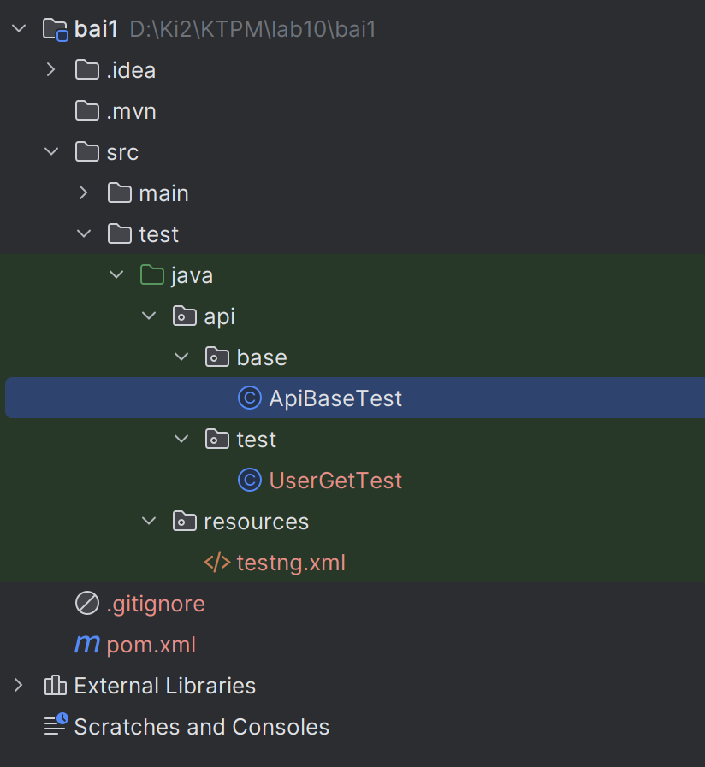
Bước 4: Tạo file ApiBaseTest.java
package api.base;
import io.restassured.builder.RequestSpecBuilder;
import io.restassured.builder.ResponseSpecBuilder;
import io.restassured.filter.log.LogDetail;
import io.restassured.filter.log.RequestLoggingFilter;
import io.restassured.filter.log.ResponseLoggingFilter;
import io.restassured.http.ContentType;
import io.restassured.specification.RequestSpecification;
import io.restassured.specification.ResponseSpecification;
import org.testng.annotations.BeforeClass;
import static org.hamcrest.Matchers.lessThan;
public class ApiBaseTest {
protected RequestSpecification requestSpec;
protected ResponseSpecification responseSpec;
@BeforeClass
public void setUpApiSpecs() {
// Hard-code API key để test nhanh
String apiKey = "reqres_fb830d8fcaf1490fa8c8d22601ef18a7";
requestSpec = new RequestSpecBuilder()
.setBaseUri("https://reqres.in")
.setContentType(ContentType.JSON)
.addHeader("x-api-key", apiKey)
.addFilter(new RequestLoggingFilter(LogDetail.ALL))
.addFilter(new ResponseLoggingFilter(LogDetail.ALL))
.build();
responseSpec = new ResponseSpecBuilder()
.expectContentType(ContentType.JSON)
.expectResponseTime(lessThan(3000L))
.build();
}
}

Bước 5: Tạo package test và file test UserGetTest.java
package api.test;

import api.base.ApiBaseTest;
import org.testng.annotations.Test;

import static io.restassured.RestAssured.given;
import static org.hamcrest.Matchers.*;

public class UserGetTest extends ApiBaseTest {

@Test(description = "Test 1: GET /api/users?page=1")
public void testGetUsersPage1() {
given()
.spec(requestSpec)
.queryParam("page", 1)
.when()
.get("/api/users")
.then()
.spec(responseSpec)
.statusCode(200)
.body("page", equalTo(1))
.body("total_pages", greaterThan(0))
.body("data.size()", greaterThanOrEqualTo(1));
}

@Test(description = "Test 2: GET /api/users?page=2")
public void testGetUsersPage2AndValidateUserFields() {
given()
.spec(requestSpec)
.queryParam("page", 2)
.when()
.get("/api/users")
.then()
.spec(responseSpec)
.statusCode(200)
.body("page", equalTo(2))
.body("data.size()", greaterThan(0))
.body("data.id", everyItem(notNullValue()))
.body("data.email", everyItem(not(blankOrNullString())))
.body("data.first_name", everyItem(not(blankOrNullString())))
.body("data.last_name", everyItem(not(blankOrNullString())))
.body("data.avatar", everyItem(not(blankOrNullString())));
}

@Test(description = "Test 3: GET /api/users/3")
public void testGetSingleUserById3() {
given()
.spec(requestSpec)
.when()
.get("/api/users/3")
.then()
.spec(responseSpec)
.statusCode(200)
.body("data.id", equalTo(3))
.body("data.email", containsString("@reqres.in"))
.body("data.first_name", not(blankOrNullString()));
}

@Test(description = "Test 4: GET /api/users/9999")
public void testGetUserNotFound() {
given()
.spec(requestSpec)
.when()
.get("/api/users/9999")
.then()
.statusCode(404)
.body(equalTo("{}"));
}
}
Bước 6: Chạy test
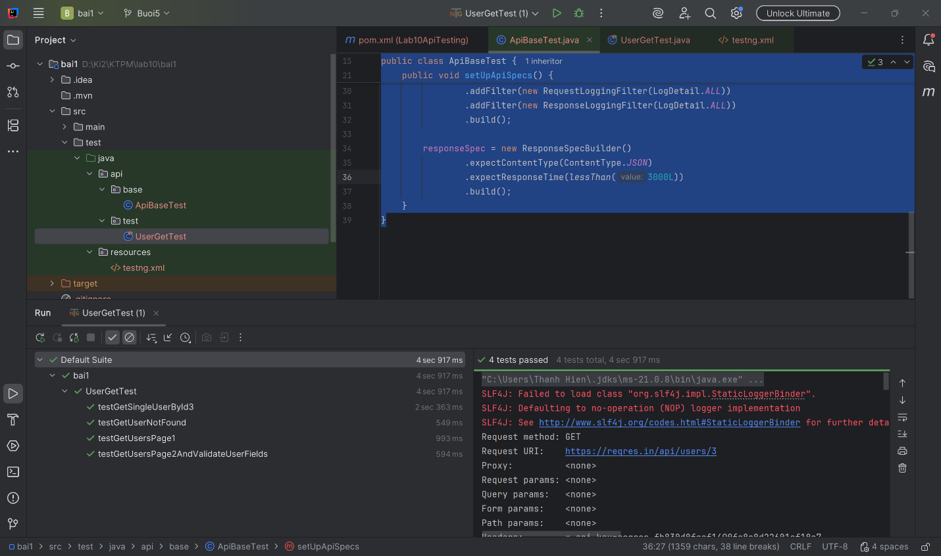

Bài 2: KIỂM THỬ POST, PUT, DELETE - CRUD ĐẦY ĐỦ
1. Mục tiêu
- Thực hiện kiểm thử đầy đủ CRUD cho API User
- Viết test cho POST, PUT, PATCH, DELETE bằng REST Assured
- Kiểm tra status code và dữ liệu trả về sau mỗi thao tác
- Tái sử dụng requestSpec và responseSpec từ ApiBaseTest
2. Các bước thực hiện
Bước 1: Tạo project Maven
Bước 2: Thêm dependency vào file pom.xml
<project xmlns="http://maven.apache.org/POM/4.0.0"
xmlns:xsi="http://www.w3.org/2001/XMLSchema-instance"
xsi:schemaLocation="http://maven.apache.org/POM/4.0.0
http://maven.apache.org/xsd/maven-4.0.0.xsd">
<modelVersion>4.0.0</modelVersion>

<groupId>org.example</groupId>
<artifactId>lab10_bai2</artifactId>
<version>1.0-SNAPSHOT</version>

<properties>
<maven.compiler.source>17</maven.compiler.source>
<maven.compiler.target>17</maven.compiler.target>
<project.build.sourceEncoding>UTF-8</project.build.sourceEncoding>
</properties>

<dependencies>
<dependency>
<groupId>io.rest-assured</groupId>
<artifactId>rest-assured</artifactId>
<version>5.4.0</version>
<scope>test</scope>
</dependency>

<dependency>
<groupId>io.rest-assured</groupId>
<artifactId>json-path</artifactId>
<version>5.4.0</version>
<scope>test</scope>
</dependency>

<dependency>
<groupId>org.testng</groupId>
<artifactId>testng</artifactId>
<version>7.10.2</version>
<scope>test</scope>
</dependency>

<dependency>
<groupId>org.hamcrest</groupId>
<artifactId>hamcrest</artifactId>
<version>2.2</version>
<scope>test</scope>
</dependency>

<dependency>
<groupId>com.fasterxml.jackson.core</groupId>
<artifactId>jackson-databind</artifactId>
<version>2.17.0</version>
<scope>test</scope>
</dependency>
</dependencies>

<build>
<plugins>
<plugin>
<groupId>org.apache.maven.plugins</groupId>
<artifactId>maven-surefire-plugin</artifactId>
<version>3.2.5</version>
<configuration>
<suiteXmlFiles>
<suiteXmlFile>src/test/resources/testng.xml</suiteXmlFile>
</suiteXmlFiles>
</configuration>
</plugin>
</plugins>
</build>
</project>
Bước 3: Tạo cấu trúc thư mục
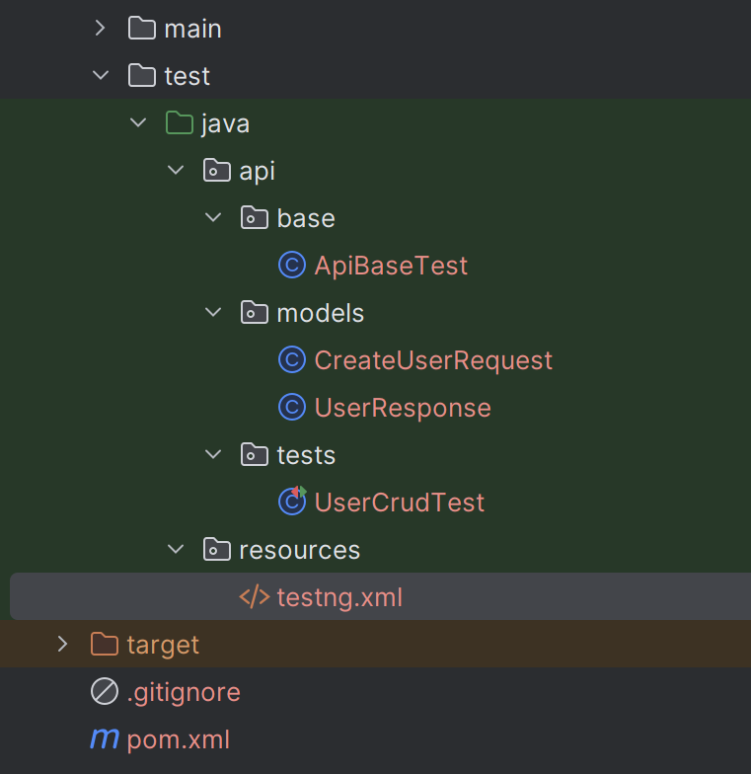
Bước 4: Tạo file ApiBaseTest.java
package api.base;
import io.restassured.builder.RequestSpecBuilder;
import io.restassured.builder.ResponseSpecBuilder;
import io.restassured.filter.log.LogDetail;
import io.restassured.filter.log.RequestLoggingFilter;
import io.restassured.filter.log.ResponseLoggingFilter;
import io.restassured.http.ContentType;
import io.restassured.specification.RequestSpecification;
import io.restassured.specification.ResponseSpecification;
import org.testng.annotations.BeforeClass;
import static org.hamcrest.Matchers.lessThan;
public class ApiBaseTest {
protected RequestSpecification requestSpec;
protected ResponseSpecification responseSpec;
@BeforeClass
public void setUpApiSpecs() {
String apiKey = "reqres_fb830d8fcaf1490fa8c8d22601ef18a7";
requestSpec = new RequestSpecBuilder()
.setBaseUri("https://reqres.in")
.setBasePath("/api")
.setContentType(ContentType.JSON)
.addHeader("Accept", "application/json")
.addHeader("x-api-key", apiKey)
.addFilter(new RequestLoggingFilter(LogDetail.ALL))
.addFilter(new ResponseLoggingFilter(LogDetail.ALL))
.build();
responseSpec = new ResponseSpecBuilder()
.expectContentType(ContentType.JSON)
.expectResponseTime(lessThan(3000L))
.build();
}
}
Bước 5: Tạo file CreateUserRequest.java
package api.models;

import com.fasterxml.jackson.annotation.JsonIgnoreProperties;
import com.fasterxml.jackson.annotation.JsonProperty;

@JsonIgnoreProperties(ignoreUnknown = true)
public class CreateUserRequest {

@JsonProperty("name")
private String name;

@JsonProperty("job")
private String job;

public CreateUserRequest() {
}

public CreateUserRequest(String name, String job) {
this.name = name;
this.job = job;
}

public String getName() {
return name;
}

public String getJob() {
return job;
}

public void setName(String name) {
this.name = name;
}

public void setJob(String job) {
this.job = job;
}
}
Bước 6: Tạo file UserResponse.java
package api.models;

import com.fasterxml.jackson.annotation.JsonIgnoreProperties;
import com.fasterxml.jackson.annotation.JsonProperty;

@JsonIgnoreProperties(ignoreUnknown = true)
public class UserResponse {

@JsonProperty("name")
private String name;

@JsonProperty("job")
private String job;

@JsonProperty("id")
private String id;

@JsonProperty("createdAt")
private String createdAt;

@JsonProperty("updatedAt")
private String updatedAt;

public UserResponse() {
}

public String getName() {
return name;
}

public String getJob() {
return job;
}

public String getId() {
return id;
}

public String getCreatedAt() {
return createdAt;
}

public String getUpdatedAt() {
return updatedAt;
}

public void setName(String name) {
this.name = name;
}

public void setJob(String job) {
this.job = job;
}

public void setId(String id) {
this.id = id;
}

public void setCreatedAt(String createdAt) {
this.createdAt = createdAt;
}

public void setUpdatedAt(String updatedAt) {
this.updatedAt = updatedAt;
}
}
Bước 7: Tạo file UserCrudTest.java
package api.tests;

import api.base.ApiBaseTest;
import api.models.CreateUserRequest;
import api.models.UserResponse;
import io.restassured.response.Response;
import org.testng.Assert;
import org.testng.annotations.Test;

import static io.restassured.RestAssured.given;
import static org.hamcrest.Matchers.*;

public class UserCrudTest extends ApiBaseTest {

private static String createdUserId;
private static String createdAtValue;

@Test(description = "POST /api/users - tạo user mới")
public void testCreateUser() {
CreateUserRequest requestBody = new CreateUserRequest("Bach Vien"QA Engineer");

UserResponse response =
given()
.spec(requestSpec)
.body(requestBody)
.when()
.post("/users")
.then()
.spec(responseSpec)
.statusCode(201)
.body("name", equalTo("Bach Vien"))
.body("job", equalTo("QA Engineer"))
.body("id", notNullValue())
.body("createdAt", notNullValue())
.extract()
.as(UserResponse.class);

createdUserId = response.getId();
createdAtValue = response.getCreatedAt();

Assert.assertNotNull(createdUserId, "ID không được null");
Assert.assertNotNull(createdAtValue, "createdAt không được null");
}

@Test(description = "PUT /api/users/2 - cập nhật toàn bộ user")
public void testUpdateUserWithPut() {
CreateUserRequest requestBody = new CreateUserRequest("Bach Vien", "Senior QA");

UserResponse response =
given()
.spec(requestSpec)
.body(requestBody)
.when()
.put("/users/2")
.then()
.spec(responseSpec)
.statusCode(200)
.body("name", equalTo("Bach Vien"))
.body("job", equalTo("Senior QA"))
.body("updatedAt", notNullValue())
.extract()
.as(UserResponse.class);

Assert.assertNotNull(response.getUpdatedAt(), "updatedAt không được null");

if (createdAtValue != null) {
Assert.assertNotEquals(response.getUpdatedAt(), createdAtValue,
"updatedAt nên khác createdAt");
}
}

@Test(description = "PATCH /api/users/2 - cập nhật một phần")
public void testPatchUser() {
Response response =
given()
.spec(requestSpec)
.body("{\"job\":\"Lead QA\"}")
.when()
.patch("/users/2")
.then()
.spec(responseSpec)
.statusCode(200)
.body("job", equalTo("Lead QA"))
.body("updatedAt", notNullValue())
.extract()
.response();

String updatedAt = response.jsonPath().getString("updatedAt");
Assert.assertNotNull(updatedAt, "updatedAt không được null");
}

@Test(description = "DELETE /api/users/2 - xóa user")
public void testDeleteUser() {
given()
.spec(requestSpec)
.when()
.delete("/users/2")
.then()
.statusCode(204)
.body(emptyOrNullString());
}

@Test(description = "POST rồi lấy id để xác nhận")
public void testCreateThenGetConfirm() {
CreateUserRequest requestBody = new CreateUserRequest("Lan", "Tester");

Response postResponse =
given()
.spec(requestSpec)
.body(requestBody)
.when()
.post("/users")
.then()
.spec(responseSpec)
.statusCode(201)
.body("name", equalTo("Lan"))
.body("job", equalTo("Tester"))
.body("id", notNullValue())
.extract()
.response();

String newId = postResponse.jsonPath().getString("id");
Assert.assertNotNull(newId, "ID sau khi tạo không được null");

given()
.spec(requestSpec)
.when()
.get("/users/2")
.then()
.spec(responseSpec)
.statusCode(200)
.body("data.id", equalTo(2))
.body("data.email", notNullValue());
}
}
Bước 8: Chạy test
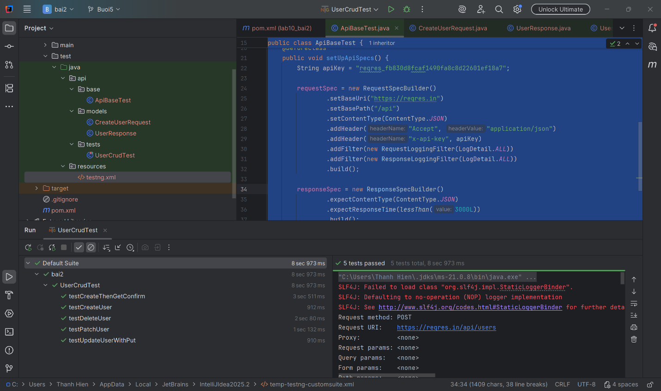

Bài 3: JSON SCHEMA VALIDATION
1. Mục tiêu
- Tạo project mới để kiểm thử cấu trúc JSON response.
- Tạo schema cho các endpoint chính của ReqRes.
- Viết test dùng REST Assured để validate response theo schema.
- Dùng additionalProperties: false để phát hiện backend thêm field ngoài mong đợi.
2. Các bước thực hiện
Bước 1: Tạo project Maven
Bước 2: Thêm dependency vào file pom.xml
<project xmlns="http://maven.apache.org/POM/4.0.0"
xmlns:xsi="http://www.w3.org/2001/XMLSchema-instance"
xsi:schemaLocation="http://maven.apache.org/POM/4.0.0
http://maven.apache.org/xsd/maven-4.0.0.xsd">
<modelVersion>4.0.0</modelVersion>

<groupId>org.example</groupId>
<artifactId>lab10_bai3</artifactId>
<version>1.0-SNAPSHOT</version>

<properties>
<maven.compiler.source>17</maven.compiler.source>
<maven.compiler.target>17</maven.compiler.target>
<project.build.sourceEncoding>UTF-8</project.build.sourceEncoding>
</properties>

<dependencies>
<dependency>
<groupId>io.rest-assured</groupId>
<artifactId>rest-assured</artifactId>
<version>5.4.0</version>
<scope>test</scope>
</dependency>

<dependency>
<groupId>io.rest-assured</groupId>
<artifactId>json-schema-validator</artifactId>
<version>5.4.0</version>
<scope>test</scope>
</dependency>

<dependency>
<groupId>io.rest-assured</groupId>
<artifactId>json-path</artifactId>
<version>5.4.0</version>
<scope>test</scope>
</dependency>

<dependency>
<groupId>org.testng</groupId>
<artifactId>testng</artifactId>
<version>7.10.2</version>
<scope>test</scope>
</dependency>

<dependency>
<groupId>org.hamcrest</groupId>
<artifactId>hamcrest</artifactId>
<version>2.2</version>
<scope>test</scope>
</dependency>

<dependency>
<groupId>com.fasterxml.jackson.core</groupId>
<artifactId>jackson-databind</artifactId>
<version>2.17.0</version>
<scope>test</scope>
</dependency>
</dependencies>

<build>
<plugins>
<plugin>
<groupId>org.apache.maven.plugins</groupId>
<artifactId>maven-surefire-plugin</artifactId>
<version>3.2.5</version>
<configuration>
<suiteXmlFiles>
<suiteXmlFile>src/test/resources/testng.xml</suiteXmlFile>
</suiteXmlFiles>
</configuration>
</plugin>
</plugins>
</build>
</project>
Bước 3: Tạo cấu trúc thưu mục
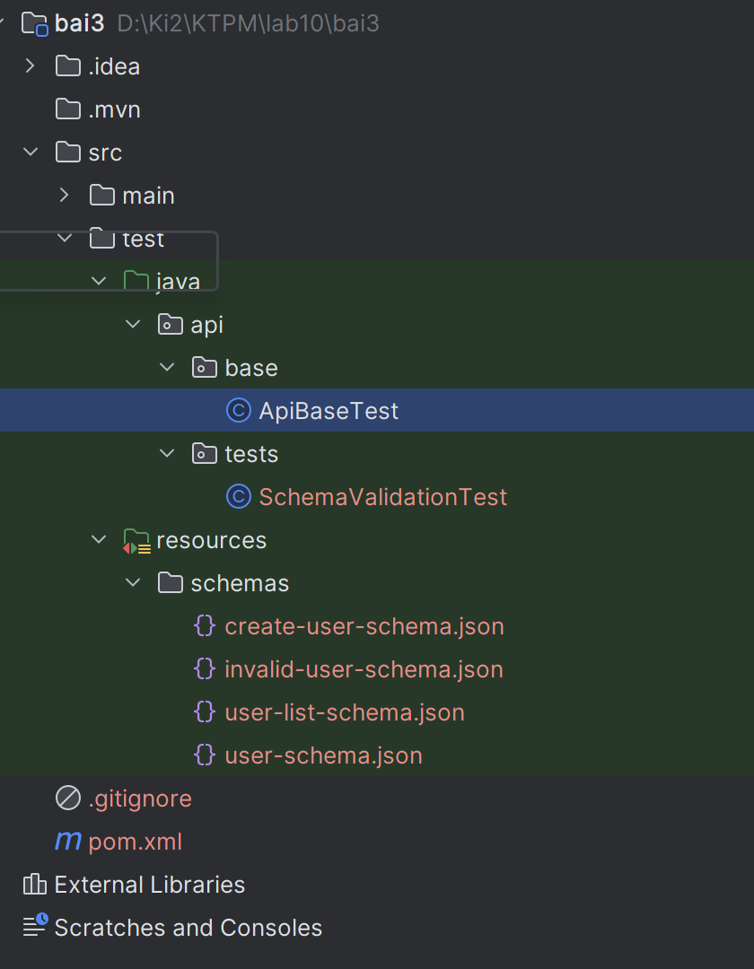
Bước 4: Tạo file ApiBaseTest.java
package api.base;
import io.restassured.builder.RequestSpecBuilder;
import io.restassured.builder.ResponseSpecBuilder;
import io.restassured.filter.log.LogDetail;
import io.restassured.filter.log.RequestLoggingFilter;
import io.restassured.filter.log.ResponseLoggingFilter;
import io.restassured.http.ContentType;
import io.restassured.specification.RequestSpecification;
import io.restassured.specification.ResponseSpecification;
import org.testng.annotations.BeforeClass;
import static org.hamcrest.Matchers.lessThan;
public class ApiBaseTest {
protected RequestSpecification requestSpec;
protected ResponseSpecification responseSpec;
@BeforeClass
public void setUpApiSpecs() {
String apiKey = "reqres_fb830d8fcaf1490fa8c8d22601ef18a7";
requestSpec = new RequestSpecBuilder()
.setBaseUri("https://reqres.in")
.setBasePath("/api")
.setContentType(ContentType.JSON)
.addHeader("Accept", "application/json")
.addHeader("x-api-key", apiKey)
.addFilter(new RequestLoggingFilter(LogDetail.ALL))
.addFilter(new ResponseLoggingFilter(LogDetail.ALL))
.build();
responseSpec = new ResponseSpecBuilder()
.expectContentType(ContentType.JSON)
.expectResponseTime(lessThan(6000L))
.build();
}
}

Bước 5: Tạo file user-list-schema.json
{
"$schema": "http://json-schema.org/draft-07/schema#",
"type": "object",
"required": ["page", "per_page", "total", "total_pages", "data", "support", "_meta"],
"properties": {
"page": {
"type": "integer",
"minimum": 1
},
"per_page": {
"type": "integer",
"minimum": 1
},
"total": {
"type": "integer",
"minimum": 0
},
"total_pages": {
"type": "integer",
"minimum": 1
},
"data": {
"type": "array",
"items": {
"type": "object",
"required": ["id", "email", "first_name", "last_name", "avatar"],
"properties": {
"id": {
"type": "integer",
"minimum": 1
},
"email": {
"type": "string",
"format": "email"
},
"first_name": {
"type": "string",
"minLength": 1
},
"last_name": {
"type": "string",
"minLength": 1
},
"avatar": {
"type": "string",
"format": "uri"
}
},
"additionalProperties": false
}
},
"support": {
"type": "object",
"required": ["url", "text"],
"properties": {
"url": {
"type": "string",
"format": "uri"
},
"text": {
"type": "string"
}
},
"additionalProperties": false
},
"_meta": {
"type": "object"
}
},
"additionalProperties": false
}

Bước 6: Tạo file user-schema.json
{
"$schema": "http://json-schema.org/draft-07/schema#",
"type": "object",
"required": ["data", "support", "_meta"],
"properties": {
"data": {
"type": "object",
"required": ["id", "email", "first_name", "last_name", "avatar"],
"properties": {
"id": {
"type": "integer",
"minimum": 1
},
"email": {
"type": "string",
"format": "email"
},
"first_name": {
"type": "string",
"minLength": 1
},
"last_name": {
"type": "string",
"minLength": 1
},
"avatar": {
"type": "string",
"format": "uri"
}
},
"additionalProperties": false
},
"support": {
"type": "object",
"required": ["url", "text"],
"properties": {
"url": {
"type": "string",
"format": "uri"
},
"text": {
"type": "string"
}
},
"additionalProperties": false
},
"_meta": {
"type": "object"
}
},
"additionalProperties": false
}

Bước 7: Tạo file create-user-schema.json
{
"$schema": "http://json-schema.org/draft-07/schema#",
"type": "object",
"required": ["name", "job", "id", "createdAt", "_meta"],
"properties": {
"name": {
"type": "string",
"minLength": 1
},
"job": {
"type": "string",
"minLength": 1
},
"id": {
"type": "string",
"minLength": 1
},
"createdAt": {
"type": "string",
"minLength": 1
},
"_meta": {
"type": "object"
}
},
"additionalProperties": false
}

Bước 8: Tạo file invalid-user-schema.json
{
"$schema": "http://json-schema.org/draft-07/schema#",
"type": "object",
"required": ["data", "support"],
"properties": {
"data": {
"type": "object",
"required": ["id", "email", "firstName", "last_name", "avatar"],
"properties": {
"id": {
"type": "integer",
"minimum": 1
},
"email": {
"type": "string",
"format": "email"
},
"firstName": {
"type": "string",
"minLength": 1
},
"last_name": {
"type": "string",
"minLength": 1
},
"avatar": {
"type": "string",
"format": "uri"
}
},
"additionalProperties": false
},
"support": {
"type": "object",
"required": ["url", "text"],
"properties": {
"url": {
"type": "string",
"format": "uri"
},
"text": {
"type": "string"
}
},
"additionalProperties": false
}
},
"additionalProperties": false
}

Bước 9: Tạo file SchemaValidationTest.java
package api.tests;
import api.base.ApiBaseTest;
import org.testng.annotations.Test;
import static io.restassured.RestAssured.given;
import static io.restassured.module.jsv.JsonSchemaValidator.matchesJsonSchemaInClasspath;
public class SchemaValidationTest extends ApiBaseTest {
@Test(description = "Schema validation cho GET /api/users?page=2")
public void testUserListSchema() {
given()
.spec(requestSpec)
.queryParam("page", 2)
.when()
.get("/users")
.then()
.spec(responseSpec)
.statusCode(200)
.body(matchesJsonSchemaInClasspath("schemas/user-list-schema.json"));
}
@Test(description = "Schema validation cho GET /api/users/2")
public void testSingleUserSchema() {
given()
.spec(requestSpec)
.when()
.get("/users/2")
.then()
.spec(responseSpec)
.statusCode(200)
.body(matchesJsonSchemaInClasspath("schemas/user-schema.json"));
}
@Test(description = "Schema validation cho POST /api/users")
public void testCreateUserSchema() {
String requestBody = """
{
"name": "Bach Vien",
"job": "Tester"
}
""";
given()
.spec(requestSpec)
.body(requestBody)
.when()
.post("/users")
.then()
.spec(responseSpec)
.statusCode(201)
.body(matchesJsonSchemaInClasspath("schemas/create-user-schema.json"));
}
@Test(description = "Demo schema sai để quan sát test FAIL", enabled = false)
public void testInvalidSchemaDemo() {
given()
.spec(requestSpec)
.when()
.get("/users/2")
.then()
.spec(responseSpec)
.statusCode(200)
.body(matchesJsonSchemaInClasspath("schemas/invalid-user-schema.json"));
}
}

Bước 10: Chạy test
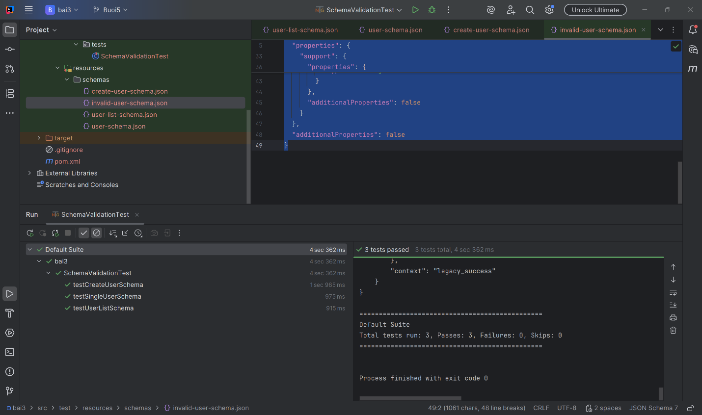

Bài 4: KIỂM THỬ AUTHORIZATION VÀ ERROR HANDLING
1. Mục tiêu
- Tạo project mới để kiểm thử login/register API.
- Viết test cho các trường hợp thành công và lỗi.
- Dùng @DataProvider để chạy nhiều bộ dữ liệu login khác nhau.
- Kiểm tra status code, token, id, và message lỗi trả về.
2. Các bước thực hiện
Bước 1: Tạo project Maven
Bước 2: Thêm dependency vào file pom.xml
<project xmlns="http://maven.apache.org/POM/4.0.0"
xmlns:xsi="http://www.w3.org/2001/XMLSchema-instance"
xsi:schemaLocation="http://maven.apache.org/POM/4.0.0
http://maven.apache.org/xsd/maven-4.0.0.xsd">
<modelVersion>4.0.0</modelVersion>

<groupId>org.example</groupId>
<artifactId>lab10_bai4</artifactId>
<version>1.0-SNAPSHOT</version>

<properties>
<maven.compiler.source>17</maven.compiler.source>
<maven.compiler.target>17</maven.compiler.target>
<project.build.sourceEncoding>UTF-8</project.build.sourceEncoding>
</properties>

<dependencies>
<dependency>
<groupId>io.rest-assured</groupId>
<artifactId>rest-assured</artifactId>
<version>5.4.0</version>
<scope>test</scope>
</dependency>

<dependency>
<groupId>io.rest-assured</groupId>
<artifactId>json-path</artifactId>
<version>5.4.0</version>
<scope>test</scope>
</dependency>

<dependency>
<groupId>org.testng</groupId>
<artifactId>testng</artifactId>
<version>7.10.2</version>
<scope>test</scope>
</dependency>

<dependency>
<groupId>org.hamcrest</groupId>
<artifactId>hamcrest</artifactId>
<version>2.2</version>
<scope>test</scope>
</dependency>

<dependency>
<groupId>com.fasterxml.jackson.core</groupId>
<artifactId>jackson-databind</artifactId>
<version>2.17.0</version>
<scope>test</scope>
</dependency>
</dependencies>

<build>
<plugins>
<plugin>
<groupId>org.apache.maven.plugins</groupId>
<artifactId>maven-surefire-plugin</artifactId>
<version>3.2.5</version>
<configuration>
<suiteXmlFiles>
<suiteXmlFile>src/test/resources/testng.xml</suiteXmlFile>
</suiteXmlFiles>
</configuration>
</plugin>
</plugins>
</build>
</project>
Bước 3: Tạo cấu trúc thư mục
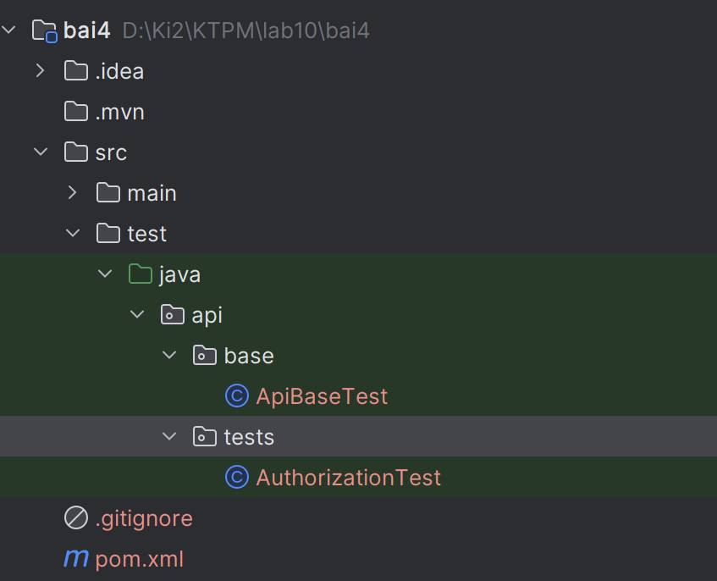
Bước 4: Tạo file ApiBaseTest.java
package api.base;
import io.restassured.builder.RequestSpecBuilder;
import io.restassured.builder.ResponseSpecBuilder;
import io.restassured.filter.log.LogDetail;
import io.restassured.filter.log.RequestLoggingFilter;
import io.restassured.filter.log.ResponseLoggingFilter;
import io.restassured.http.ContentType;
import io.restassured.specification.RequestSpecification;
import io.restassured.specification.ResponseSpecification;
import org.testng.annotations.BeforeClass;
import static io.restassured.RestAssured.given;
import static org.hamcrest.Matchers.lessThan;
public class ApiBaseTest {
protected RequestSpecification requestSpec;
protected ResponseSpecification responseSpec;
@BeforeClass
public void setUpApiSpecs() {
String apiKey = "reqres_fb830d8fcaf1490fa8c8d22601ef18a7";
requestSpec = new RequestSpecBuilder()
.setBaseUri("https://reqres.in")
.setBasePath("/api")
.setContentType(ContentType.JSON)
.addHeader("Accept", "application/json")
.addHeader("x-api-key", apiKey)
.addFilter(new RequestLoggingFilter(LogDetail.ALL))
.addFilter(new ResponseLoggingFilter(LogDetail.ALL))
.build();
responseSpec = new ResponseSpecBuilder()
.expectContentType(ContentType.JSON)
.expectResponseTime(lessThan(6000L))
.build();
}
protected String getAuthToken() {
return given()
.spec(requestSpec)
.body("{\"email\":\"eve.holt@reqres.in\",\"password\":\"cityslicka\"}")
.when()
.post("/login")
.then()
.statusCode(200)
.extract()
.jsonPath()
.getString("token");
}
}
Bước 6: Tạo file AuthorizationTest.java
package api.tests;
import api.base.ApiBaseTest;
import io.restassured.response.ValidatableResponse;
import org.testng.Assert;
import org.testng.annotations.DataProvider;
import org.testng.annotations.Test;
import java.util.HashMap;
import java.util.Map;
import static io.restassured.RestAssured.given;
import static org.hamcrest.Matchers.containsString;
import static org.hamcrest.Matchers.not;
import static org.hamcrest.Matchers.emptyString;
import static org.hamcrest.Matchers.notNullValue;
public class AuthorizationTest extends ApiBaseTest {
@Test(description = "Login thành công -> trả về token")
public void testLoginSuccess() {
String token = given()
.spec(requestSpec)
.body("{\"email\":\"eve.holt@reqres.in\",\"password\":\"cityslicka\"}")
.when()
.post("/login")
.then()
.spec(responseSpec)
.statusCode(200)
.body("token", notNullValue())
.body("token", not(emptyString()))
.extract()
.jsonPath()
.getString("token");
Assert.assertFalse(token.isEmpty(), "Token không được rỗng");
}
@Test(description = "Login thiếu password -> 400")
public void testLoginMissingPassword() {
given()
.spec(requestSpec)
.body("{\"email\":\"eve.holt@reqres.in\"}")
.when()
.post("/login")
.then()
.spec(responseSpec)
.statusCode(400)
.body("error", containsString("Missing password"));
}
@Test(description = "Login thiếu email -> 400")
public void testLoginMissingEmail() {
given()
.spec(requestSpec)
.body("{\"password\":\"cityslicka\"}")
.when()
.post("/login")
.then()
.spec(responseSpec)
.statusCode(400)
.body("error", containsString("Missing email or username"));
}
@Test(description = "Register thành công -> 200, có id và token")
public void testRegisterSuccess() {
given()
.spec(requestSpec)
.body("{\"email\":\"eve.holt@reqres.in\",\"password\":\"pistol\"}")
.when()
.post("/register")
.then()
.spec(responseSpec)
.statusCode(200)
.body("id", notNullValue())
.body("token", notNullValue())
.body("token", not(emptyString()));
}
@Test(description = "Register thiếu password -> 400")
public void testRegisterMissingPassword() {
given()
.spec(requestSpec)
.body("{\"email\":\"sydney@fife\"}")
.when()
.post("/register")
.then()
.spec(responseSpec)
.statusCode(400)
.body("error", containsString("Missing password"));
}
@DataProvider(name = "loginScenarios")
public Object[][] loginScenarios() {
return new Object[][]{
{"eve.holt@reqres.in", "cityslicka", 200, null},
{"eve.holt@reqres.in", "", 400, "Missing password"},
{"", "cityslicka", 400, "Missing email or username"},
{"notexist@reqres.in", "wrongpass", 400, "user not found"},
{"invalid-email", "pass123", 400, "user not found"}
};
}
@Test(dataProvider = "loginScenarios", description = "Data-driven login scenarios")
public void testLoginScenarios(String email, String password,
int expectedStatus, String expectedError) {
Map<String, String> body = new HashMap<>();
if (!email.isEmpty()) {
body.put("email", email);
}
if (!password.isEmpty()) {
body.put("password", password);
}
ValidatableResponse response = given()
.spec(requestSpec)
.body(body)
.when()
.post("/login")
.then()
.spec(responseSpec)
.statusCode(expectedStatus);
if (expectedError != null) {
response.body("error", containsString(expectedError));
} else {
response.body("token", notNullValue());
response.body("token", not(emptyString()));
}
}
}
Bước 7: Chạy test
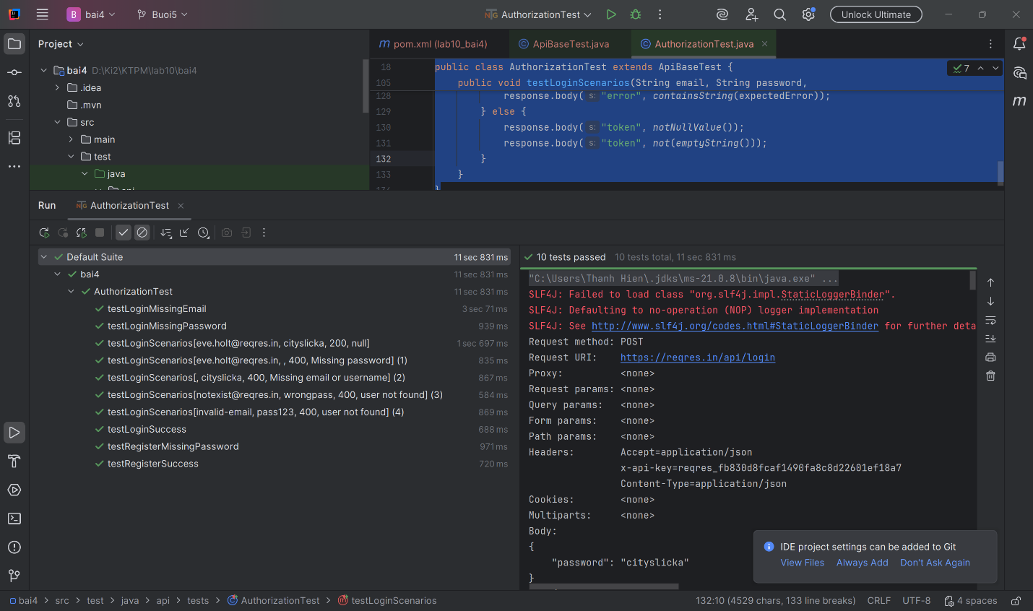

Bài 5: PERFORMANCE ASSERTION VÀ SLA MONITORING
1. Mục tiêu
- Tạo project mới để kiểm thử hiệu năng API.
- Xây dựng bộ test giám sát SLA cho các endpoint chính.
- Dùng @DataProvider để gom nhiều endpoint vào một method test.
- Kiểm tra đồng thời status code, response body, và response time.
2. Các bước thực hiện
Bước 1: Tạo project Maven
Bước 2: Thêm dependency vào file pom.xml
<project xmlns="http://maven.apache.org/POM/4.0.0"
xmlns:xsi="http://www.w3.org/2001/XMLSchema-instance"
xsi:schemaLocation="http://maven.apache.org/POM/4.0.0
http://maven.apache.org/xsd/maven-4.0.0.xsd">
<modelVersion>4.0.0</modelVersion>

<groupId>org.example</groupId>
<artifactId>lab10_bai5</artifactId>
<version>1.0-SNAPSHOT</version>

<properties>
<maven.compiler.source>17</maven.compiler.source>
<maven.compiler.target>17</maven.compiler.target>
<project.build.sourceEncoding>UTF-8</project.build.sourceEncoding>
</properties>

<dependencies>
<dependency>
<groupId>io.rest-assured</groupId>
<artifactId>rest-assured</artifactId>
<version>5.4.0</version>
<scope>test</scope>
</dependency>

<dependency>
<groupId>io.rest-assured</groupId>
<artifactId>json-path</artifactId>
<version>5.4.0</version>
<scope>test</scope>
</dependency>

<dependency>
<groupId>org.testng</groupId>
<artifactId>testng</artifactId>
<version>7.10.2</version>
<scope>test</scope>
</dependency>

<dependency>
<groupId>org.hamcrest</groupId>
<artifactId>hamcrest</artifactId>
<version>2.2</version>
<scope>test</scope>
</dependency>

<dependency>
<groupId>com.fasterxml.jackson.core</groupId>
<artifactId>jackson-databind</artifactId>
<version>2.17.0</version>
<scope>test</scope>
</dependency>
</dependencies>

<build>
<plugins>
<plugin>
<groupId>org.apache.maven.plugins</groupId>
<artifactId>maven-surefire-plugin</artifactId>
<version>3.2.5</version>
<configuration>
<suiteXmlFiles>
<suiteXmlFile>src/test/resources/testng.xml</suiteXmlFile>
</suiteXmlFiles>
</configuration>
</plugin>
</plugins>
</build>
</project>

Bước 3: Tạo cấu trúc thư mục
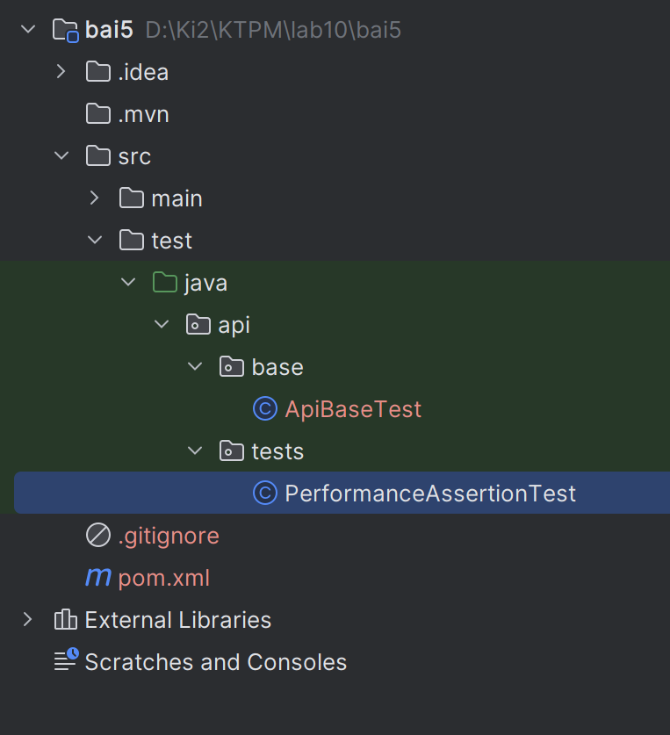
Bước 4: Tạo file ApiBaseTest.java
package api.base;
import io.restassured.builder.RequestSpecBuilder;
import io.restassured.specification.RequestSpecification;
import org.testng.annotations.BeforeClass;
import static io.restassured.RestAssured.baseURI;
public class ApiBaseTest {
protected RequestSpecification requestSpec;
@BeforeClass
public void setup() {
baseURI = "https://reqres.in/api";
requestSpec = new RequestSpecBuilder()
.setBaseUri(baseURI)
.addHeader("x-api-key", "reqres_fb830d8fcaf1490fa8c8d22601ef18a7")
.addHeader("Content-Type", "application/json")
.addHeader("Accept", "application/json")
.build();
}
}

Bước 5: Tạo file PerformanceAssertionTest.java
package api.tests;
import api.base.ApiBaseTest;
import io.qameta.allure.Step;
import io.restassured.response.Response;
import org.testng.Assert;
import org.testng.annotations.DataProvider;
import org.testng.annotations.Test;
import java.util.HashMap;
import java.util.Map;
import static io.restassured.RestAssured.given;
import static org.hamcrest.Matchers.*;
public class PerformanceAssertionTest extends ApiBaseTest {
@DataProvider(name = "apiPerformanceData")
public Object[][] apiPerformanceData() {
return new Object[][]{
{"GET", "/users", 200, 2000L, "LIST_USERS"},
{"GET", "/users/2", 200, 1500L, "GET_SINGLE_USER"},
{"POST", "/users", 201, 3000L, "CREATE_USER"},
{"POST", "/login", 200, 2000L, "LOGIN"},
{"DELETE", "/users/2", 204, 1000L, "DELETE_USER"}
};
}
@Test(dataProvider = "apiPerformanceData",
description = "Kiểm thử SLA cho 5 API chính bằng 1 method test")
public void testSlaMonitoring(String method,
String endpoint,
int expectedStatus,
long maxMs,
String scenario) {
Response response = callApi(method, endpoint, maxMs, scenario);
long actualMs = response.time();
System.out.println("[SLA] " + method + " " + endpoint + " -> " + actualMs + "ms");
Assert.assertEquals(response.statusCode(), expectedStatus,
"Sai status code cho " + method + " " + endpoint);
Assert.assertTrue(actualMs < maxMs,
"Response time " + actualMs + "ms vượt SLA " + maxMs + "ms");
switch (scenario) {
case "LIST_USERS":
response.then().body("data.size()", greaterThanOrEqualTo(1));
break;
case "GET_SINGLE_USER":
response.then().body("data.id", equalTo(2));
break;
case "CREATE_USER":
response.then()
.body("id", notNullValue())
.body("id", not(emptyString()));
break;
case "LOGIN":
response.then()
.body("token", notNullValue())
.body("token", not(emptyString()));
break;
case "DELETE_USER":
Assert.assertTrue(response.getBody().asString().isEmpty(),
"DELETE phải trả body rỗng");
break;
default:
throw new IllegalArgumentException("Scenario không hỗ trợ: " + scenario);
}
}
@Step("Gọi {method} {endpoint} - SLA: {maxMs}ms")
public Response callApi(String method, String endpoint, long maxMs, String scenario) {
switch (method.toUpperCase()) {
case "GET":
return given()
.spec(requestSpec)
.when()
.get(endpoint);
case "POST":
return given()
.spec(requestSpec)
.body(getRequestBody(scenario))
.when()
.post(endpoint);
case "DELETE":
return given()
.spec(requestSpec)
.when()
.delete(endpoint);
default:
throw new IllegalArgumentException("Method không hỗ trợ: " + method);
}
}
@Test(description = "Chạy cùng API 10 lần liên tiếp và log average/min/max response time")
public void testSimpleMonitoring10Runs() {
String endpoint = "/users/2";
int runs = 10;
long min = Long.MAX_VALUE;
long max = Long.MIN_VALUE;
long total = 0;
for (int i = 1; i <= runs; i++) {
Response response = given()
.spec(requestSpec)
.when()
.get(endpoint);
long current = response.time();
total += current;
if (current < min) {
min = current;
}
if (current > max) {
max = current;
}
System.out.println("[Monitoring] Lần " + i + ": GET " + endpoint + " -> " + current + "ms");
Assert.assertEquals(response.statusCode(), 200);
}
double average = (double) total / runs;
System.out.println("SIMPLE MONITORING RESULT ");
System.out.println("API: GET " + endpoint);
System.out.println("Runs: " + runs);
System.out.println("Average: " + average + "ms");
System.out.println("Min: " + min + "ms");
System.out.println("Max: " + max + "ms");
}
private Map<String, String> getRequestBody(String scenario) {
Map<String, String> body = new HashMap<>();
switch (scenario) {
case "CREATE_USER":
body.put("name", "Bach Vien");
body.put("job", "Tester");
break;
case "LOGIN":
body.put("email", "eve.holt@reqres.in");
body.put("password", "cityslicka");
break;
}
return body;
}
}
Bước 6: Chạy test
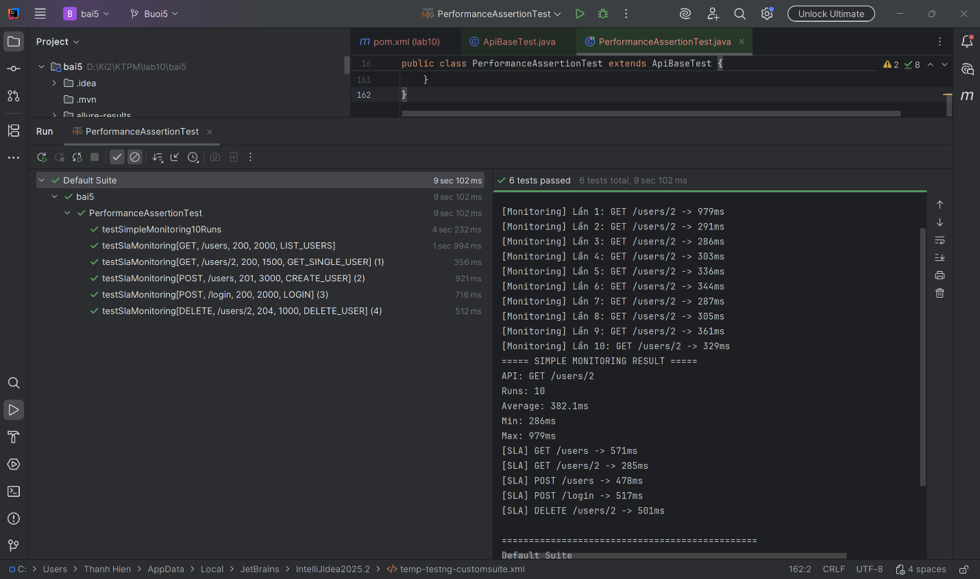

Bài 6: TÍCH HỢP API + UI: SETUP QUA API, VERIFY QUA UI
1. Mục tiêu
Tạo project mới để kết hợp API test và UI test trong cùng một luồng.
Dùng API làm điều kiện tiên quyết trước khi chạy UI test.
Nếu precondition API thất bại thì skip UI test.
Kiểm tra luồng UI của SauceDemo sau khi điều kiện API đã đạt.
2. Các bước thực hiện
Bước 1: Tạo project Maven
Bước 2: Thêm dependency vào file pom.xml
<project xmlns="http://maven.apache.org/POM/4.0.0"
xmlns:xsi="http://www.w3.org/2001/XMLSchema-instance"
xsi:schemaLocation="http://maven.apache.org/POM/4.0.0
http://maven.apache.org/xsd/maven-4.0.0.xsd">
<modelVersion>4.0.0</modelVersion>
<groupId>org.example</groupId>
<artifactId>lab10_bai6</artifactId>
<version>1.0-SNAPSHOT</version>
<properties>
<maven.compiler.source>17</maven.compiler.source>
<maven.compiler.target>17</maven.compiler.target>
<project.build.sourceEncoding>UTF-8</project.build.sourceEncoding>
</properties>
<dependencies>
<dependency>
<groupId>io.rest-assured</groupId>
<artifactId>rest-assured</artifactId>
<version>5.4.0</version>
<scope>test</scope>
</dependency>
<dependency>
<groupId>org.testng</groupId>
<artifactId>testng</artifactId>
<version>7.10.2</version>
<scope>test</scope>
</dependency>
<dependency>
<groupId>org.hamcrest</groupId>
<artifactId>hamcrest</artifactId>
<version>2.2</version>
<scope>test</scope>
</dependency>
<dependency>
<groupId>org.seleniumhq.selenium</groupId>
<artifactId>selenium-java</artifactId>
<version>4.28.1</version>
<scope>test</scope>
</dependency>
<dependency>
<groupId>io.github.bonigarcia</groupId>
<artifactId>webdrivermanager</artifactId>
<version>5.9.2</version>
<scope>test</scope>
</dependency>
<dependency>
<groupId>io.qameta.allure</groupId>
<artifactId>allure-testng</artifactId>
<version>2.29.0</version>
<scope>test</scope>
</dependency>
</dependencies>
<build>
<plugins>
<plugin>
<groupId>org.apache.maven.plugins</groupId>
<artifactId>maven-surefire-plugin</artifactId>
<version>3.2.5</version>
<configuration>
<suiteXmlFiles>
<suiteXmlFile>src/test/resources/testng.xml</suiteXmlFile>
</suiteXmlFiles>
</configuration>
</plugin>
</plugins>
</build>
</project>

Bước 3: Tạo cấu trúc thư mục
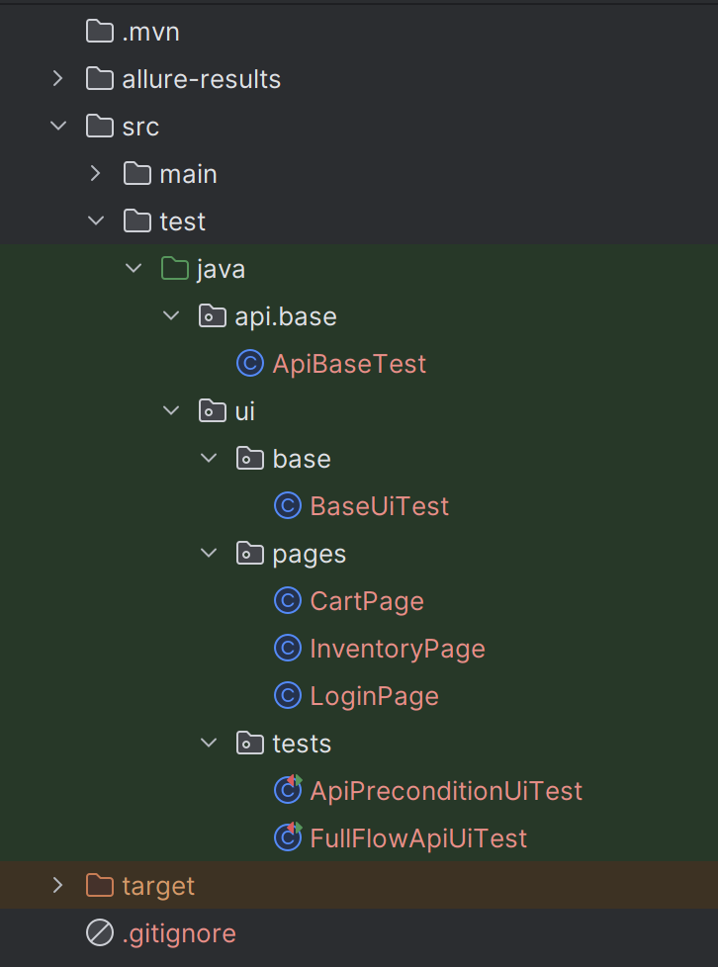
Bước 4: Tạo file ApiBaseTest.java
package api.base;
import io.restassured.builder.RequestSpecBuilder;
import io.restassured.specification.RequestSpecification;
import org.testng.annotations.BeforeClass;
public class ApiBaseTest {
protected RequestSpecification requestSpec;
@BeforeClass
public void setupApiSpec() {
requestSpec = new RequestSpecBuilder()
.setBaseUri("https://reqres.in")
.setBasePath("/api")
.addHeader("x-api-key", "reqres_fb830d8fcaf1490fa8c8d22601ef18a7")
.addHeader("Accept", "application/json")
.addHeader("Content-Type", "application/json")
.build();
}
}

Bước 5: Tạo file BaseUiTest.java
package ui.base;
import api.base.ApiBaseTest;
import io.github.bonigarcia.wdm.WebDriverManager;
import org.openqa.selenium.WebDriver;
import org.openqa.selenium.chrome.ChromeDriver;
import org.openqa.selenium.chrome.ChromeOptions;
import org.testng.annotations.AfterMethod;
import org.testng.annotations.BeforeMethod;
import java.time.Duration;
public class BaseUiTest extends ApiBaseTest {
protected WebDriver driver;
@BeforeMethod(alwaysRun = true)
public void setupDriver() {
WebDriverManager.chromedriver().setup();
ChromeOptions options = new ChromeOptions();
options.addArguments("--start-maximized");
driver = new ChromeDriver(options);
driver.manage().timeouts().implicitlyWait(Duration.ofSeconds(10));
}
@AfterMethod(alwaysRun = true)
public void tearDownDriver() {
if (driver != null) {
driver.quit();
}
}
public WebDriver getDriver() {
return driver;
}
}
Bước 6: Tạo file LoginPage.java
package ui.pages;
import org.openqa.selenium.By;
import org.openqa.selenium.WebDriver;
public class LoginPage {
private final WebDriver driver;
private final By usernameInput = By.id("user-name");
private final By passwordInput = By.id("password");
private final By loginButton = By.id("login-button");
public LoginPage(WebDriver driver) {
this.driver = driver;
}
public void open() {
driver.get("https://www.saucedemo.com/");
}
public void login(String username, String password) {
driver.findElement(usernameInput).sendKeys(username);
driver.findElement(passwordInput).sendKeys(password);
driver.findElement(loginButton).click();
}
}

Bước 7: Tạo file InventoryPage.java
package ui.pages;
import org.openqa.selenium.By;
import org.openqa.selenium.WebDriver;
public class InventoryPage {
private final WebDriver driver;
private final By pageTitle = By.className("title");
private final By addBackpackButton = By.id("add-to-cart-sauce-labs-backpack");
private final By addBikeLightButton = By.id("add-to-cart-sauce-labs-bike-light");
private final By cartBadge = By.className("shopping_cart_badge");
private final By cartLink = By.className("shopping_cart_link");
public InventoryPage(WebDriver driver) {
this.driver = driver;
}
public boolean isLoaded() {
return driver.getCurrentUrl().contains("inventory")
&& driver.getTitle().equals("Swag Labs")
&& driver.findElement(pageTitle).isDisplayed();
}
public void addTwoProducts() {
driver.findElement(addBackpackButton).click();
driver.findElement(addBikeLightButton).click();
}
public String getCartBadgeText() {
return driver.findElement(cartBadge).getText();
}
public void openCart() {
driver.findElement(cartLink).click();
}
}

Bước 8: Tạo file CartPage.java
package ui.pages;
import org.openqa.selenium.By;
import org.openqa.selenium.WebDriver;
import java.util.List;
public class CartPage {
private final WebDriver driver;
private final By cartItems = By.className("cart_item");
public CartPage(WebDriver driver) {
this.driver = driver;
}
public int getItemCount() {
List<?> items = driver.findElements(cartItems);
return items.size();
}
}

Bước 9: Tạo file ApiPreconditionUiTest.java
package ui.tests;
import io.restassured.response.Response;
import org.testng.Assert;
import org.testng.annotations.BeforeMethod;
import org.testng.annotations.Test;
import ui.base.BaseUiTest;
import ui.pages.InventoryPage;
import ui.pages.LoginPage;
import static io.restassured.RestAssured.given;
public class ApiPreconditionUiTest extends BaseUiTest {
private boolean apiPreconditionPassed = false;
private String token;
@BeforeMethod(alwaysRun = true)
public void setupApiPrecondition() {
Response response = given()
.spec(requestSpec)
.body("{\"email\":\"eve.holt@reqres.in\",\"password\":\"cityslicka\"}")
.when()
.post("/login");
apiPreconditionPassed = response.statusCode() == 200;
token = response.jsonPath().getString("token");
System.out.println("API token = " + token);
Assert.assertTrue(apiPreconditionPassed,
"API login thất bại, không được chạy tiếp UI test");
}
@Test(description = "UI login chỉ chạy khi API precondition pass")
public void testLoginUiAfterApiPrecondition() {
LoginPage loginPage = new LoginPage(getDriver());
InventoryPage inventoryPage = new InventoryPage(getDriver());
loginPage.open();
loginPage.login("standard_user", "secret_sauce");
Assert.assertTrue(getDriver().getCurrentUrl().contains("inventory"),
"URL phải chứa inventory");
Assert.assertEquals(getDriver().getTitle(), "Swag Labs",
"Title phải là Swag Labs");
Assert.assertTrue(inventoryPage.isLoaded(),
"Trang inventory phải hiển thị");
}
}
Bước 10: Tạo file FullFlowApiUiTest.java
package ui.tests;
import io.restassured.response.Response;
import org.testng.Assert;
import org.testng.SkipException;
import org.testng.annotations.BeforeMethod;
import org.testng.annotations.Test;
import ui.base.BaseUiTest;
import ui.pages.CartPage;
import ui.pages.InventoryPage;
import ui.pages.LoginPage;
import static io.restassured.RestAssured.given;
public class FullFlowApiUiTest extends BaseUiTest {
private boolean isApiAlive = false;
@BeforeMethod(alwaysRun = true)
public void checkApiHealth() {
Response response = given()
.spec(requestSpec)
.when()
.get("/users");
isApiAlive = response.statusCode() == 200;
System.out.println("isApiAlive = " + isApiAlive);
}
@Test(description = "Luồng tích hợp đầy đủ: API check -> UI login -> add 2 items -> verify cart")
public void testFullIntegrationFlow() {
if (!isApiAlive) {
throw new SkipException("API reqres.in không sống, skip UI test");
}
LoginPage loginPage = new LoginPage(getDriver());
InventoryPage inventoryPage = new InventoryPage(getDriver());
CartPage cartPage = new CartPage(getDriver());
loginPage.open();
loginPage.login("standard_user", "secret_sauce");
Assert.assertTrue(inventoryPage.isLoaded(),
"Phải vào được trang inventory sau login");
inventoryPage.addTwoProducts();
Assert.assertEquals(inventoryPage.getCartBadgeText(), "2",
"Badge giỏ hàng phải là 2");
inventoryPage.openCart();
Assert.assertEquals(cartPage.getItemCount(), 2,
"Giỏ hàng phải có đúng 2 sản phẩm");
}
}
Bước 11: Chạy test
