目录
一、 Maven配置： 2
二、 配置application.properties的mybatis.mapper-locations属性 5
三、 通过maven，database的表自动生成mybatis,自动的步骤； 6
四、 在IDEA工具中运行命令: run-->Edit Configurations 9

Maven配置：
Maven配置文件
Pom.xml
注意：需要指定Mybatis-generator.xml的对应路径
<?xml version="1.0" encoding="UTF-8"?>
<project xmlns="http://maven.apache.org/POM/4.0.0" xmlns:xsi="http://www.w3.org/2001/XMLSchema-instance"
xsi:schemaLocation="http://maven.apache.org/POM/4.0.0 http://maven.apache.org/xsd/maven-4.0.0.xsd">
<modelVersion>4.0.0</modelVersion>
<groupId>com.miaoshaproject</groupId>
<artifactId>miaosha</artifactId>
<version>1.0-SNAPSHOT</version>
<name>miaosha</name>
<!-- FIXME change it to the project's website -->
<url>http://www.example.com</url>
<parent>
<groupId>org.springframework.boot</groupId>
<artifactId>spring-boot-starter-parent</artifactId>
<version>2.0.5.RELEASE</version>
</parent>
<properties>
<project.build.sourceEncoding>UTF-8</project.build.sourceEncoding>
<maven.compiler.source>1.7</maven.compiler.source>
<maven.compiler.target>1.7</maven.compiler.target>
</properties>
<dependencies>
<dependency>
<groupId>org.springframework.boot</groupId>
<artifactId>spring-boot-starter-web</artifactId>
</dependency>
<dependency>
<groupId>mysql</groupId>
<artifactId>mysql-connector-java</artifactId>
<version>8.0.11</version>
</dependency>
<dependency>
<groupId>com.alibaba</groupId>
<artifactId>druid</artifactId>
<version>1.1.3</version>
</dependency>
<dependency>
<groupId>org.mybatis.spring.boot</groupId>
<artifactId>mybatis-spring-boot-starter</artifactId>
<version>1.3.1</version>
</dependency>
<dependency>
<groupId>junit</groupId>
<artifactId>junit</artifactId>
<version>4.11</version>
<scope>test</scope>
</dependency>
</dependencies>
<build>
<pluginManagement><!-- lock down plugins versions to avoid using Maven defaults (may be moved to parent pom) -->
<plugins>
<!-- clean lifecycle, see https://maven.apache.org/ref/current/maven-core/lifecycles.html#clean_Lifecycle -->
<plugin>
<artifactId>maven-clean-plugin</artifactId>
<version>3.1.0</version>
</plugin>
<!-- default lifecycle, jar packaging: see https://maven.apache.org/ref/current/maven-core/default-bindings.html#Plugin_bindings_for_jar_packaging -->
<plugin>
<artifactId>maven-resources-plugin</artifactId>
<version>3.0.2</version>
</plugin>
<plugin>
<artifactId>maven-compiler-plugin</artifactId>
<version>3.8.0</version>
</plugin>
<plugin>
<artifactId>maven-surefire-plugin</artifactId>
<version>2.22.1</version>
</plugin>
<plugin>
<artifactId>maven-jar-plugin</artifactId>
<version>3.0.2</version>
</plugin>
<plugin>
<artifactId>maven-install-plugin</artifactId>
<version>2.5.2</version>
</plugin>
<plugin>
<artifactId>maven-deploy-plugin</artifactId>
<version>2.8.2</version>
</plugin>
<!-- site lifecycle, see https://maven.apache.org/ref/current/maven-core/lifecycles.html#site_Lifecycle -->
<plugin>
<artifactId>maven-site-plugin</artifactId>
<version>3.7.1</version>
</plugin>
<plugin>
<artifactId>maven-project-info-reports-plugin</artifactId>
<version>3.0.0</version>
</plugin>
<!--mybatis生成插件-->
<plugin>
<groupId>org.mybatis.generator</groupId>
<artifactId>mybatis-generator-maven-plugin</artifactId>
<version>1.3.5</version>
<dependencies>
<dependency>
<groupId>org.mybatis.generator</groupId>
<artifactId>mybatis-generator-core</artifactId>
<version>1.3.5</version>
</dependency>
<dependency>
<groupId>mysql</groupId>
<artifactId>mysql-connector-java</artifactId>
<version>8.0.11</version>
</dependency>
</dependencies>
<executions>
<execution>
<id>mybatis generator</id>
<phase>package</phase>
<goals>
<goal>generate</goal>
</goals>
</execution>
</executions>
<configuration>
<!--允许移动生成的文件-->
<verbose>true</verbose>
<!--允许自动覆盖文件-->
<overwrite>true</overwrite>
<configurationFile>
src/main/resources/mybatis-generator.xml
</configurationFile>
</configuration>
</plugin>
</plugins>
</pluginManagement>
</build>
</project>

配置application.properties的mybatis.mapper-locations属性
注意：mybatis.mapper-locations在应用里默认路径src\main\resources下。
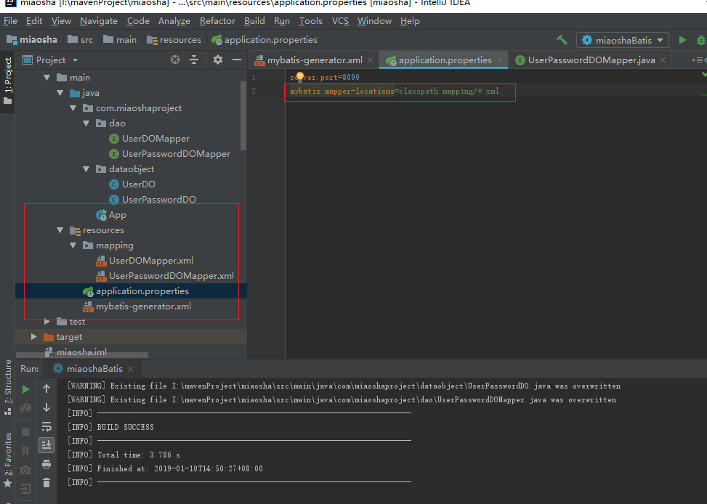

文本内容：
server.port=8090
mybatis.mapper-locations=classpath:mapping/*.xml

通过maven，database的表自动生成mybatis,自动的步骤；
Mybatis-generator.xml配置：
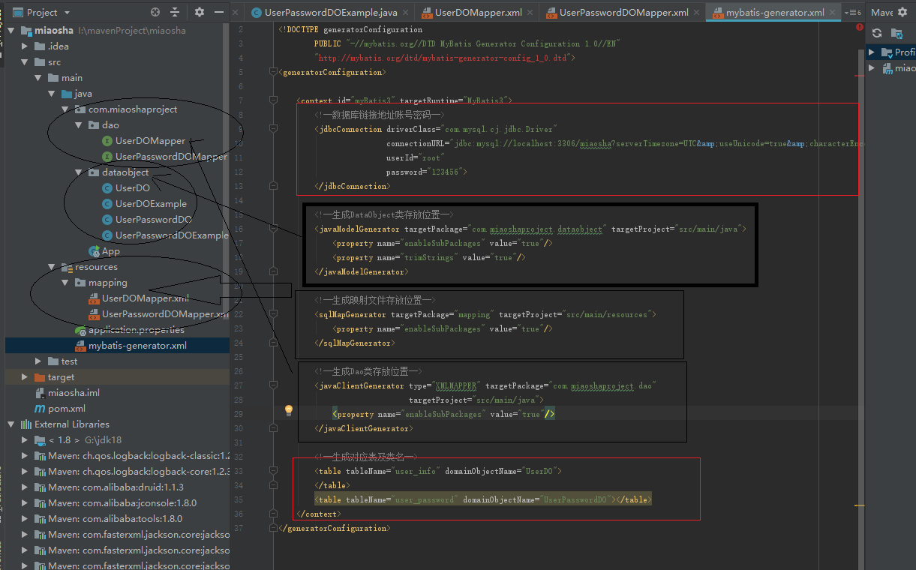

文件文本内容：
注意：
- 设置好数据库的连接，
- 所需要生成的数据库的表名(tableName)，java类所对应的类名(domainObjectName).
- 当不需要生成Example类时，要添加这几个属性
enableCountByExample="false" enableUpdateByExample="false"
enableDeleteByExample="false" enableSelectByExample="false"
selectByExampleQueryId="false"

<?xml version="1.0" encoding="UTF-8"?>
<!DOCTYPE generatorConfiguration
PUBLIC "-//mybatis.org//DTD MyBatis Generator Configuration 1.0//EN"
"http://mybatis.org/dtd/mybatis-generator-config_1_0.dtd">
<generatorConfiguration>
<context id="myBatis3" targetRuntime="MyBatis3">
<!--数据库链接地址账号密码-->
<jdbcConnection driverClass="com.mysql.cj.jdbc.Driver"
connectionURL="jdbc:mysql://localhost:3306/miaosha?serverTimezone=UTC&amp;useUnicode=true&amp;characterEncoding=utf8&amp;useSSL=false"
userId="root"
password="123456">
</jdbcConnection>
<!--生成DataObject类存放位置-->
<javaModelGenerator targetPackage="com.miaoshaproject.dataobject" targetProject="src/main/java">
<property name="enableSubPackages" value="true"/>
<property name="trimStrings" value="true"/>
</javaModelGenerator>
<!--生成映射文件存放位置-->
<sqlMapGenerator targetPackage="mapping" targetProject="src/main/resources">
<property name="enableSubPackages" value="true"/>
</sqlMapGenerator>
<!--生成Dao类存放位置-->
<javaClientGenerator type="XMLMAPPER" targetPackage="com.miaoshaproject.dao"
targetProject="src/main/java">
<property name="enableSubPackages" value="true"/>
</javaClientGenerator>
<!--生成对应表及类名-->
<table tableName="user_info" domainObjectName="UserDO"
enableCountByExample="false" enableUpdateByExample="false"
enableDeleteByExample="false" enableSelectByExample="false"
selectByExampleQueryId="false">
</table>
<table tableName="user_password" domainObjectName="UserPasswordDO"
enableCountByExample="false" enableUpdateByExample="false"
enableDeleteByExample="false" enableSelectByExample="false"
selectByExampleQueryId="false"></table>
</context>
</generatorConfiguration>

在IDEA工具中运行命令: run-->Edit Configurations
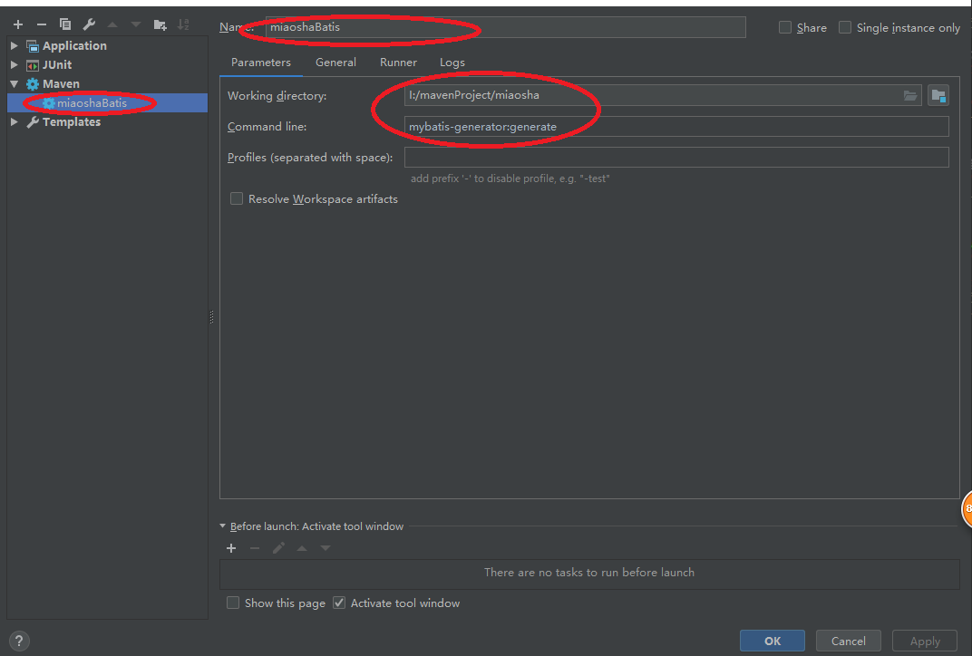

注意：command line: mybatis-generator:generate
运行就能生成多个文件，一个表四个文件。
结果如图所示：
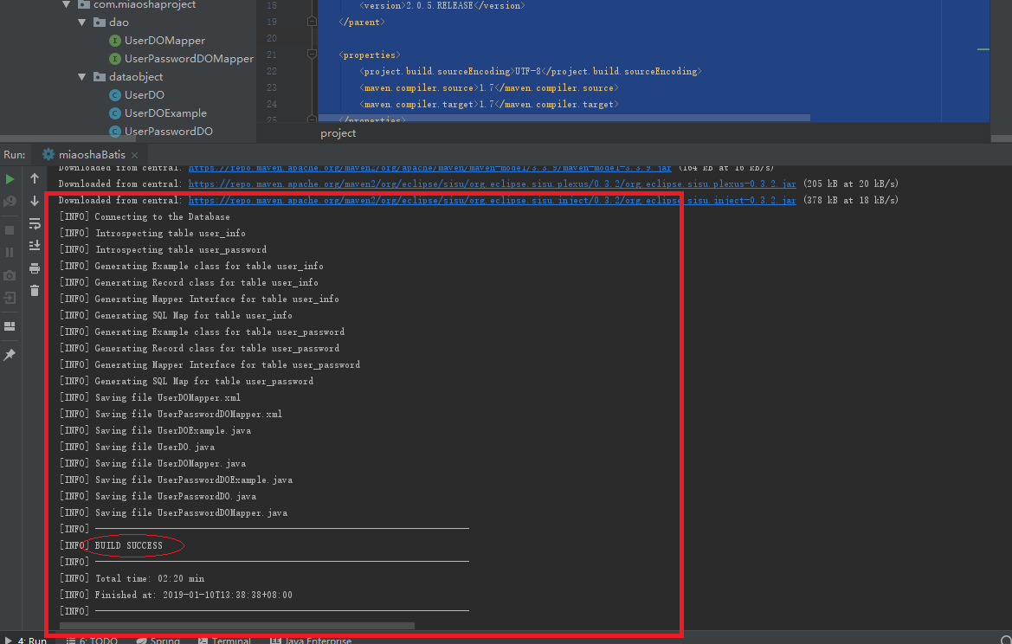

生成的文件列表（去掉Example的话一个表对应3个文件。）
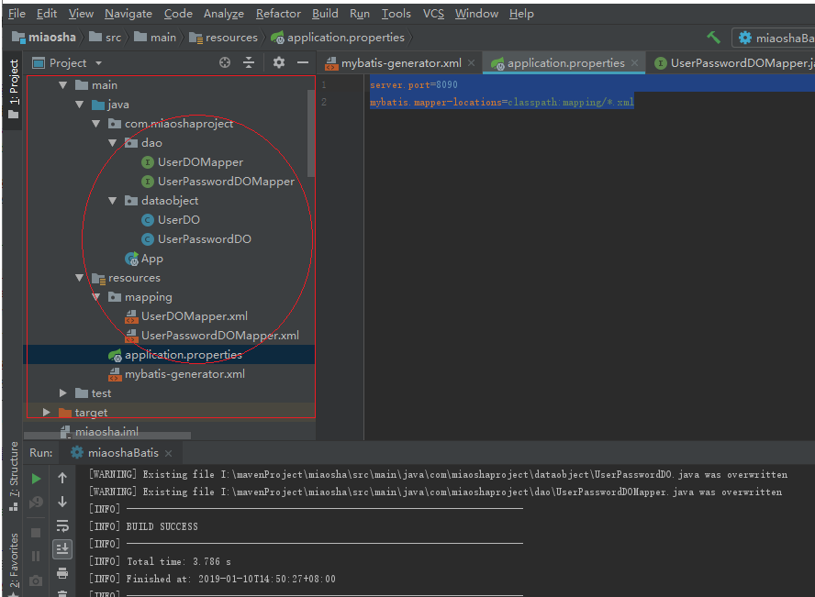

注意--IDE检测注入对象报错
注意：IDEA开发时候,关于注入对象，系统检测会报错，实际已经在容器中注入了，将IDEA检查界别改为warning。
File-->Settings.

