USER MANUAL
FOR FARM SIMULATOR
Group 1: Nguyễn Việt Anh, Trần Thị Thoa, Bùi Thị Phương Anh, Trần Vũ Hải

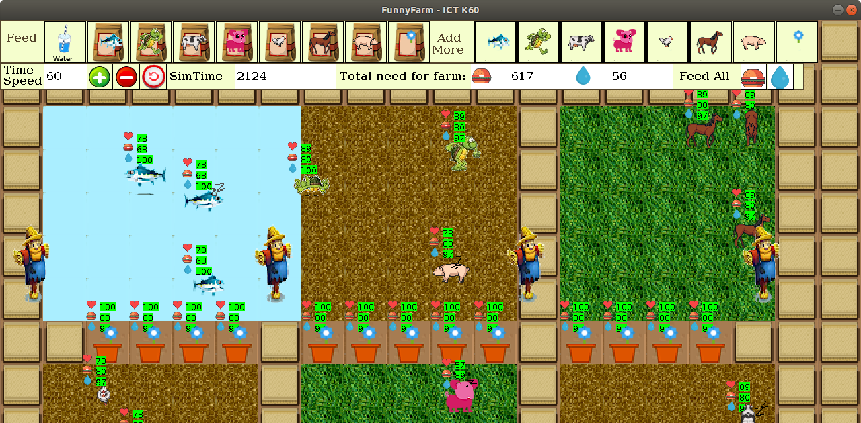

Overview
This simulator software brings you a visual farm where you can have some animals and grow flowers.
- Scroll the screen by using WASD or the arrow keys.
- There are 7 animals and 1 flower are available.
- Each creature has its own living environment and body status. Their body status is show on the head of the creature:
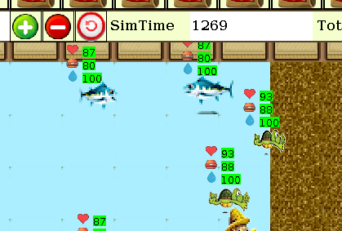
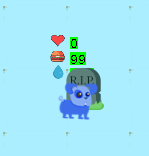
- The health (heart), the food (hamburger) and the water level (water drop) in a creature body will decrease time by time. If you don’t supply these creature with suitable food and water, they will move slowly and finally die. Beside is a image of a dead dog.

- Sometimes when you click a creature they also create sound. For example, when you click a dog, it will bark.

1. Feed the creatures
You can feed the creature by click the suitable kind of food / drink on the top of the window and click the creature after that. If it is a suitable drink / food, they will say “thank you” to you, otherwise, they will say “It’s not my food”.
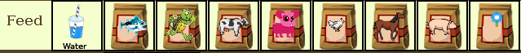

2. Add more creature
Select a creature from “Add more” toolbar then click into a space of a suitable environment to release the creature. Note that a creature will die right after it is put to inappropriate environment.


Suitable environments:
- Fish: water
- Turtle: water, grass, dirt
- Cow, Dog, Chicken, Horse, Pig: grass, dirt
- Flower: flowerpot, grass, dirt

3. Other functions

- The smaller tool bar will help you:
+ Change the time speed of the simulator
+ Calculate the total need of food and water for continue this farm (ensure that no creature will die)
+ Buttons for feed and water all the creature on the farm at once.

